Annex 02 – Recommendation #2: Empowering the Community through Consensus: Engagement, Escalation, Enforcement
1st reading Key Conclusions:
- Address concern expressed by many that escalation timelines are too tight and aggressive by simplifying some decision steps in the process, while ensuring that the issues remain widely discussed within the Community.
  - Jordan Carter is tasked to make a proposal along these lines – tracked changes shown below.
  - Make it mandatory for petitioning party to reach out to SO/ACs to socialize relevant information before Community Forum.
  - Removing the mandatory community conference call will allow for extension of timeline if so requested by an SO or AC. Additionally, should the petitioning group need a call, ICANN will provide resources upon request.
- Acknowledging concern raised by ALAC and others regarding the thresholds adjustment in case the number of Decisional Participant is lower (paragraph 62 – page 12), the group is considering the option to lower the requirement of support for Fundamental Bylaw change only.
  - Since the Fundamental Bylaw change process is a requirement for “approval” and not a “rejection” option, this would preserve the requirement for stronger protection of Fundamental Bylaws. (see page 11)
  - Note was made that this approach was still raising some concerns
- The use of percentage for thresholds can be suggested as guidelines for discussion basis in the event of the creation of new SO/ACs but there would need to be a conscious decision, depending on the circumstances.
  - Clarify that if such a new SO/AC were to become a decisional participant in the Empowered Community, this change would require a change to the Fundamental Bylaws.

1. Summary
- Engagement
- Today, the Internet Corporation for Assigned Names and Numbers (ICANN) Board voluntarily consults with the community on a variety of decisions, including the Annual Budget and changes to the ICANN Bylaws. To gather feedback, the ICANN Board uses mechanisms such as public consultations and information sessions to gauge community support and/or identify issues on the topic. These consultation mechanisms are referred to as an “engagement process.”
- The CCWG-Accountability is recommending that engagement processes for specific ICANN Board actions be constituted in the Fundamental Bylaws. Although the ICANN Board engages voluntarily in these processes today, this recommendation would formally require the ICANN Board to undertake an extensive engagement process before taking action on any of the following:
  - Approving ICANN’s Five-Year Strategic Plan
  - Approving ICANN’s Five-Year Operating Plan
  - Approving ICANN’s Annual Operating Plan & Budget
  - Approving The Internet Assigned Numbers Authority (IANA) Functions Budget
  - Approving any modifications to Standard or Fundamental Bylaws
  - ICANN Board decisions relating to reviews of IANA Functions, including the triggering of Post-Transition IANA (PTI) separation
- If it is determined that there is divergence between the ICANN Board and the community after the engagement process, the community may choose to use a Community Power as an Empowered Community by way of a respective “escalation process.”
- The community may begin an escalation process to:
  - Reject a Five-Year Strategic Plan, Five-Year Operating Plan, Annual Operating Plan & Budget, or the IANA Functions Budget.
  - Reject a change to ICANN Standard Bylaws.
  - Approve changes to Fundamental Bylaws and/or Articles of Incorporation.
  - Remove an individual ICANN Board Director.
  - Recall the entire ICANN Board.
  - Initiate a binding Independent Review Process (IRP) (where a panel decision is enforceable in any court recognizing international arbitration results).
  - Reject ICANN Board decisions relating to reviews of IANA Functions, including the triggering of PTI separation.
- Escalation
- The escalation process can differ, sometimes significantly, from one Community Power to another.
- One of the most standardized versions of the escalation process is required for all Community Powers to “reject,” remove individual Nominating Committee-appointed Board Directors, or recall the entire Board.
- This escalation process is comprised of the following steps:
- An individual starts a petition in a Supporting Organization (SO) or Advisory Committee (AC) that is part of the Empowered Community (see Recommendation #1: Establishing an Empowered Community for Enforcing Community Powers).
- If the petition is approved by that SO or AC, it proceeds to the next step.
- If the petition is not approved by that SO or AC, the escalation process is terminated.
- The SO or AC that approved the petition contacts the other SOs or ACs to ask them to support the petition.
- At least one additional SO and/or AC must support the petition (for a minimum of two) for a Community Forum to be organized to discuss the issue.
  - If the threshold is not met, the escalation process is terminated.
  - Else if the threshold is met, a Community Forum is organized to discuss the petition.

- The petitioning SO and/or AC circulate a detailed rationale for proposing to use the Community Power to all SO/ACs.
- It will also designate a representative(s) to liaise with SO/ACs to answer questions from the SO/ACs.
- Any SO or AC may contribute preliminary thoughts or questions in writing via a specific publicly archived email list set up for this specific issue.
- The petitioning SO and/or ACs may request (optional) that ICANN organize a conference call for the community to discuss the issue.

- An open one – two-day Community Forum is organized for any interested stakeholder in the community to participate.
- If the ICANN Board and the Empowered Community can resolve their issues before or at the Community Forum, the escalation process is terminated.
- Else the Empowered Community must decide if it wishes to use its Community Power.
- The Empowered Community considers use of a Community Power.
- If the threshold to use a Community Power is not met, or there is more than one objection, then the escalation process is terminated.
- Else if the threshold is met for using the Community Power, and there is no more than one objection, the Empowered Community advises the ICANN Board of the decision and asks it to comply with the decision (as outlined in the Fundamental Bylaws for this Community Power).

- The Empowered Community advises the ICANN Board.
- If the Empowered Community has decided to use its power, it will advise the ICANN Board of the decision and direct the Board to take any necessary action to comply with the decision.
  - If the ICANN Board refuses or fails to comply, the Empowered Community decides whether to begin the “enforcement process.”
- Enforcement
- If the ICANN Board refuses or fails to comply with a decision of the Empowered Community using a Community Power, the Empowered Community must decide if it wishes to begin the enforcement process.
- The enforcement process can proceed in two ways:
1. Initiate mediation and community IRP procedures.
2. Initiate an escalation process to recall the entire ICANN Board.
- The escalation process may terminate with a resolution or proceed into an enforcement process. The results of both enforcement processes are legally enforceable in court.

2. CCWG-Accountability Recommendations
- Establish a Fundamental Bylaw that requires the ICANN Board to undertake an extensive engagement process before taking action on any of the following:
  - Approving ICANN’s Five-Year Strategic Plan.
  - Approving ICANN’s Five-Year Operating Plan.
  - Approving ICANN’s Annual Operating Plan & Budget.
  - Approving the IANA Functions Budget.
  - Approving any modifications to Standard or Fundamental Bylaws.
  - ICANN Board decisions relating to reviews of IANA Functions, including the triggering of PTI separation.
- Include the engagement and enforcement processes in the Fundamental Bylaws. Note: The escalation processes for each Community Power is outlined in Recommendation #4: Ensuring Community Involvement in ICANN Decision-making: Seven New Community Powers.

3. Detailed Explanation of Recommendations
- Engagement
- Today, the ICANN Board voluntarily consults with the community on a variety of decisions such as the Annual Budget and changes to the ICANN Bylaws. To gather feedback, the ICANN Board uses mechanisms such as public consultations to gauge community support and/or identify issues on the topic. These consultation mechanisms are referred to as an engagement process.
- The CCWG-Accountability is recommending that this engagement process be constituted in the Fundamental Bylaws. Although the ICANN Board already convenes this process, this recommendation would require the ICANN Board to undertake an extensive engagement process before taking action on any of the following:
  - Approving ICANN’s Five-Year Strategic Plan.
  - Approving ICANN’s Five-Year Operating Plan.
  - Approving ICANN’s Annual Operating Plan & Budget.
  - Approving the IANA Functions Budget.
  - Approving any modifications to Standard or Fundamental Bylaws.
  - ICANN Board decisions relating to reviews of IANA Functions, including the triggering of PTI separation.
- If it is determined that there is divergence between the ICANN Board and the community during the engagement process, the community may choose to use a Community Power as an Empowered Community by way of a respective escalation process.
- The community may begin an escalation process to:
  - Reject a Five-Year Strategic Plan, Five-Year Operating Plan, Annual Operating Plan & Budget, or the IANA Functions Budget.
  - Reject a change to ICANN Standard Bylaws.
  - Approve changes to Fundamental Bylaws and/or Articles of Incorporation.
  - Remove an individual ICANN Board Director.
  - Recall the entire ICANN Board.
  - Initiate a binding IRP (where a panel decision is enforceable in any court recognizing international arbitration results).
  - Reject ICANN Board decisions relating to reviews of IANA Functions, including the triggering of PTI separation.

- Escalation
- The escalation process can differ, sometimes significantly, from one Community Power to another. One of the most standardized versions of the escalation process is required for all Community Powers to “reject,” remove individual Nominating Committee-appointed Board Directors, or recall the entire Board.
- Note: The power to approve changes to Fundamental Bylaws and remove individual Directors nominated by a SO or AC contain special features that are covered in Recommendation #4: Ensuring Community Involvement in ICANN Decision-making: Seven New Community Powers.
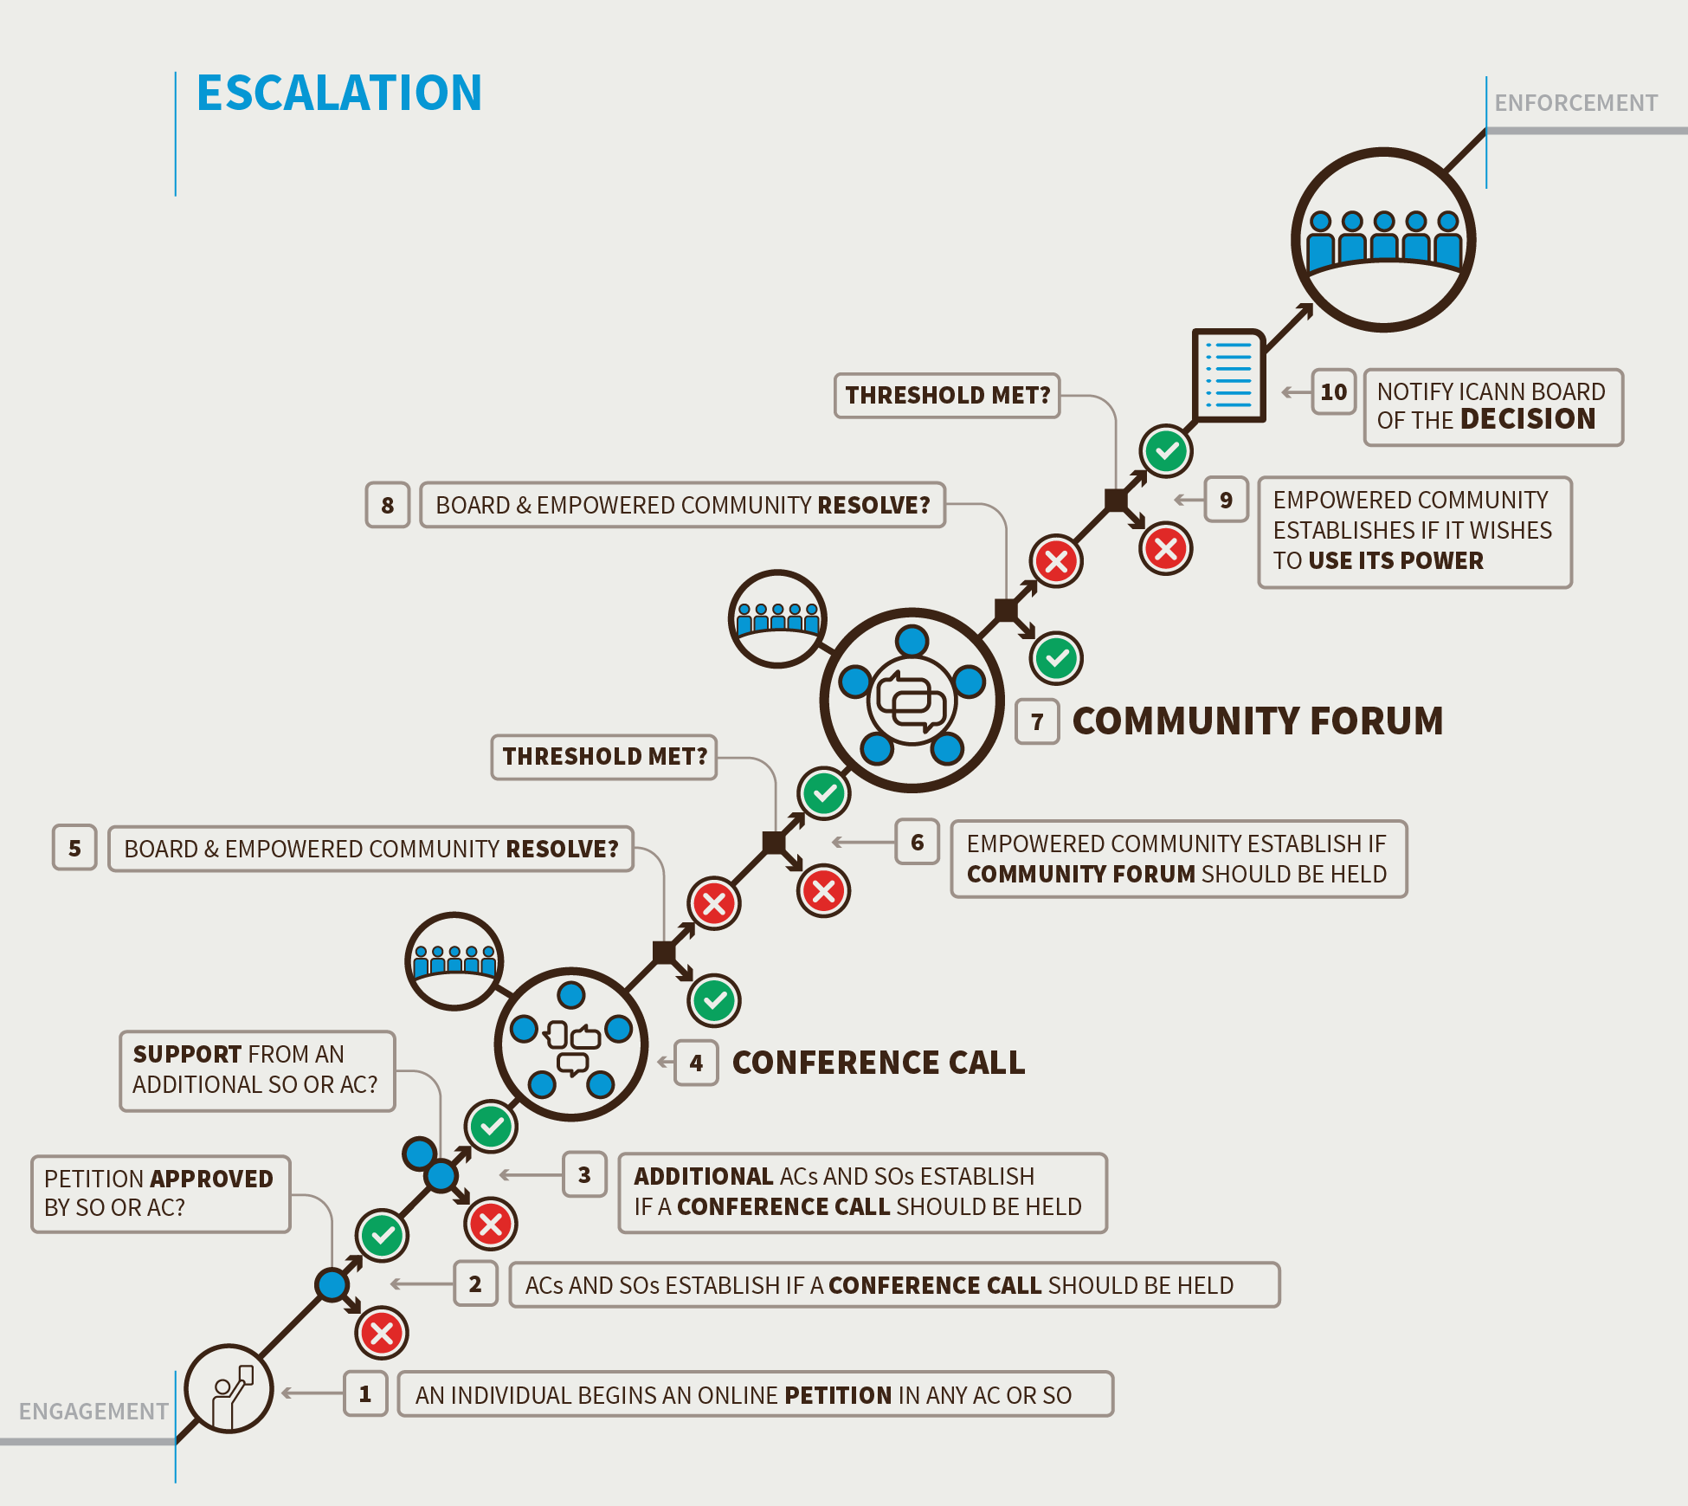

- Step 1. Triggering Review by Community Petition (21 Days) or by Board Action
- Note: To exercise any of the rejection powers, such rejection of a budget, the 21-day period begins at the time the Board publishes its vote on the element to be rejected. If the first step of the petition is not successful within 21 days of the Board publication of the vote, the rejection process cannot be used. A petition begins in an SO or AC.
- Any individual can begin a petition as the first step to using a Community Power.
- For the petition to be accepted, the SO or AC, in accordance with its own mechanisms, must accept the petition.
- Decision point:
- If the SO or AC does not approve the petition within 21 days, the escalation process terminates.
- If the SO or AC approves the petition, it can proceed to the next step.

- Step 2. Triggering Review by Community Petition Part Two (Seven Days from the End of the Previous Step)
- The SO or AC that approved the petition contacts the other SOs or ACs to ask them to support the petition. At least one additional SO and/or AC must support the petition (for a minimum of two) for a Community Forum to be organized to discuss the issue. To petition for a community forum to consider the recall of the entire ICANN Board requires three SO/ACs to support the petition.
- Decision point:
- If a minimum of two SOs or ACs support the petition within seven days, a Community Forum is organized.
- If the petition fails to gather the required level of support within six days, the escalation process terminates (except for removal of individual Director).

Note: For ICANN Board resolutions on changes to Standard Bylaws, Annual Budget, and Strategic or Operating Plans, the Board would be required to automatically provide a 28-day period before the resolution takes effect to allow for the escalation to be confirmed. If the petition is supported by a minimum of two SOs or ACs within the 28-day period, the Board is required to put implementation of the contested resolution on hold until the escalation and enforcement processes are completed. The purpose of this is to avoid requiring ICANN to undo things (if the rejection is approved), which could be potentially very difficult.

- Step 3. The petitioning SO and/or AC circulate a detailed rationale for proposing to use the Community Power to all SO/ACs. (Seven Days from the End of the Previous Step)
- It will also designate a representative(s) to liaise with SO/ACs to answer questions from the SO/ACs.
- Any SO or AC may contribute preliminary thoughts or questions in writing via a specific publicly archived email list set up for this specific issue.
- The petitioning SO and/or ACs may request (optional) that ICANN organize a conference call for the community to discuss the issue.

- Step 4. Holding a Community Forum (21 Days to Organize and Hold the Event from the Date of the Petition Causing It)
- The purpose of the Community Forum is information-sharing (the rationale for the petition, etc.) and airing views on the petition by the community. Accordingly, any SO or AC may circulate in writing their preliminary views on the exercise of this Community Power, before or at the Community Forum.
- The Forum is to be held within 21 days of the successful petition being made.
- Community Forum format:
  - It is expected that for most powers, this will only involve remote participation methods such as teleconferences and Adobe Connect-type meetings over a period of one or two days at most. Unless the timing allows participants to meet at a regularly scheduled ICANN meeting, there is no expectation that participants will meet face to face. The one exception to this is the power to recall the entire Board, which would require a face-to-face meeting.
  - The SOs or ACs that approved the Petition would decide if holding the Community Forum can wait until the next regularly scheduled ICANN meeting or if a special meeting is required to bring participants together. In both these cases, the SOs or ACs that have approved the Petition leading to the Community Forum will publish the date for holding the event, which will not be subject to the 21-day limitation set out in Step 5 below. In this case, the Community Forum would be considered completed at the end of the face-to-face meeting. Note: this extension is not available for exercise of the Community Power regarding the ICANN or IANA Budgets, due to the importance of maintaining a timely budget approval process.
  - Open to all interested participants.
  - Managed and moderated in a fair and neutral manner.
  - ICANN to provide support services. ICANN support staff will collect and publish a public record of the Forum(s), including all written submissions.
  - Representatives of the ICANN Board are expected to attend and be prepared to address the issues raised.
  - Should the relevant SOs or ACs determine a need for further deliberation, a second and third session of the Community Forum could be held.
  - The Forum will not make decisions or seek consensus, and will not decide whether to advance the petition to the decision stage. This decision is up to the SOs and/or ACs to determine after the Forum.
- Decision point:
- If the Empowered Community and ICANN Board can resolve the issue in the Community Forum, the escalation process terminates.
- If the Empowered Community and ICANN Board cannot resolve the issue, the community must decide if it wishes to take further action.

- Step 5. Decision to use a Community Power as an Empowered Community (21 Days from the Conclusion of the Community Forum)

- Decision point:
- If four or more (for some powers, three) SOs and/or ACs support and no more than one objects within the 21-day period, the Sole Designator will use its power. The community will also publish an explanation of why it has chosen to do so. The published explanation can reflect the variety of underlying reasons.
- If the proposal to instruct the Sole Designator to use its power does not meet the required thresholds during the 21-day period, the escalation process terminates.

- Step 6. Advising the ICANN Board (1 day)
- If the Empowered Community has instructed the Sole Designator to use its power, it will advise the ICANN Board of the decision and direct the Board to take any necessary action to comply with the decision.

- Enforcement
- If the ICANN Board refuses or fails to comply with a decision of the Empowered Community to use a Community Power, the Empowered Community must decide if it wishes to begin the enforcement process.
- The enforcement process can proceed in two ways:
- Option 1: Initiate mediation and community IRP procedures.
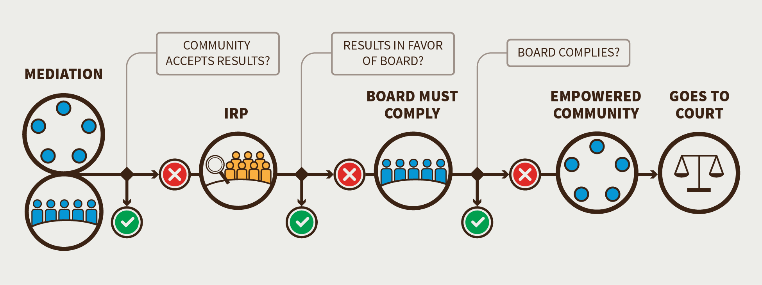
a) Representatives from ICANN Board and community undertake a formal mediation phase.
- If the community accepts the results from the mediation phase, the enforcement process would be terminated.
- If the community does not accept the results from the mediation phase, the community will proceed with a community IRP (which could only be initiated using the escalation process described above).

b) Representatives from the ICANN Board and community undertake a formal and binding IRP.
- If the results of the community IRP are in favor of the ICANN Board, the enforcement process is terminated.
- If the results of the binding IRP are in favor of the community, then the ICANN Board must comply.

c) If the ICANN Board not comply with the decision of the IRP, the Empowered Community has two options:
- The Empowered Community can legally enforce the results of the IRP in court.
- The Empowered Community can leverage the escalation process to use its Community Power to recall the entire ICANN Board.

- Option 2: Initiate an escalation process to recall the entire ICANN Board.
- If the requisite threshold of community support is achieved, the Empowered Community removes all of the members of the ICANN Board (except the CEO) and replaces them with an Interim Board until a new Board can be seated.
- The Empowered Community may legally enforce the power to recall the entire Board in court.

Table: Required Thresholds for the Various Escalation and Enforcement Processes (Based on a Minimum of Five SOs or ACs Participating)
Required Community Powers? | Petition Threshold to convene a Community Forum. | Is there consensus support to exercise a Community Power?
- 1. Reject a proposed Operating Plan/Strategic Plan/Budget | - Two AC/SOs | - Four support rejection, and no more than one objection
- 2. Approve changes to Fundamental Bylaws and Articles of Incorporation | - N/A | - [Four OR Three] support approval, and no more than one objection
- 3. Reject changes to regular Bylaws | - Two AC/SOs | - Three support rejection, and no more than one objection
- 4a. Remove an individual Board Director appointed by a SO or AC | - Majority within appointing AC/SO | - Invite and consider comments from all SO/ACs. 3/4 majority within the appointing AC/SO to remove their director
- 4b. Remove an individual Board Director appointed by the Nominating Committee | - Two AC/SOs | - Three support, and no more than one objection.
- 5. Recall the entire board of directors | - Three AC/SOs | - Four support, and no more than one objection
- 6. Initiate a binding IRP | - Two AC/SOs | - Three support, and no more than one objection.  - Require mediation before IRP begins
- 7. Reject ICANN Board decisions relating to reviews of IANA Functions, including the triggering of PTI separation | - Two AC/SOs | - Four support, and no more than one objection

- Implementation of the Empowered Community currently anticipates that all of ICANN’s SOs, the At-Large AC and Governmental Advisory Committee (GAC) would participate in the Empowered Community (that is, they will be listed in the Bylaws as the five Decisional Participants).
- The thresholds presented in this document were determined based on this assessment. If fewer than five of ICANN’s SOs and ACs agree to be Decisional Participants, these thresholds for consensus support may be adjusted. Thresholds would also have to be adjusted if ICANN changes to have more SOs or ACs.
- In the event of the creation (or removal) of SO/ACs, the corresponding percentage could be used as useful guidelines in refining the thresholds. There would however need to be a conscious decision, depending on the circumstances, regarding these adjustments. If such a change were to affect the list of Decisional Participants in the Empowered Community, the change would follow the Fundamental Bylaw change process, which enables such a conscious decision to be undertaken.

- The CCWG-Accountability also recommends that in a situation where use of a Community Power only attracts a decision to support or object to that power by four Decisional SOs or ACs, and the threshold is set at four in support (for Community Powers to block a budget, approve changes to Fundamental Bylaws, or recall the entire ICANN Board), the power will still be validly exercised if three are in support and no more than one objects. The CCWG-Accountability came to this decision after considering the extended escalation process now proposed prior to the use of Community Powers, and to avoid the risk of powers being un-useable (especially the risk of making changes to ICANN's Fundamental Bylaws effectively impossible).

4. Changes from the “Second Draft Proposal on Work Stream 1 Recommendations”
- In the Second Draft Proposal, a voting-based, three-step process (petition, discussion, decision) was proposed. However, there was no agreement on how to allocate and count votes in this model. The changes made in the Third Draft Proposal respond to expressions of concern received during the Second Public Comment Period about the potential for unintended concentrations of power in the voting-based model.
- Overview of differences:
- The new decision-making model of “Engage, Escalate, Enforce” encourages community disputes with Board decisions to be solved through ongoing dialogue at all stages of the process rather than seeing enactment of enforcement powers as the goal of the process.
- The voting process has been replaced by consensus decision-making. Consensus is deemed to have been achieved according to slightly different thresholds of “support”/”don’t support” depending on the Community Power that is using the decision-making model.

5. Stress Tests Related to this Recommendation
- ST5, 6, 7, 8, 9, 10, 16, 24, powers
- ST12
- ST13
- ST27
- ST28

6. How does this meet the CWG-Stewardship Requirements?
- The CWG-Stewardship required Community Empowerment Mechanisms that would be able to:
- Appoint and remove members of the ICANN Board and to recall the entire ICANN Board.
- Exercise oversight with respect to key ICANN Board decisions (including with respect to the ICANN Board’s oversight of the IANA Functions) by reviewing and approving (i) ICANN Board decisions with respect to recommendations resulting from an IANA Function Review (IFR) or Special IFR and (ii) the ICANN budget.
- The ability to approve amendments to ICANN’s Fundamental Bylaws.
- The defined escalation and decision-making mechanism recommended by the CCWG-Accountability provide the processes needed to meet these requirements.

7. How does this address NTIA Criteria?
- Support and enhance the multistakeholder model.
- Decentralizing power within ICANN through an Empowered Community.
- Solidifying consultation processes between the ICANN Board and community into the ICANN Bylaws.
- Establishing a public Community Forum to ensure that all voices and perspectives are heard before execution of a Community Power.
- Retaining decision-making based on consensus rather than voting

- Maintain the security, stability, and resiliency of the Internet DNS.
- Proposing a series of procedures that ensure both sides have had the chance to completely and thoroughly discuss any disagreements and have multiple opportunities to resolve any such issues without having to resort to the powers of the Sole Designator for accountability or enforceability.
- Embedding thresholds into procedures to eliminate any risks of capture.

- Meet the needs and expectation of the global customers and partners of the IANA services.
- Including limited timeframes, transparent processes and associated thresholds to maintain operational viability

- Maintain the openness of the Internet.
- Establishing a public Community Forum to ensure that all voices and perspectives are heard.
- Preserving policies of open participation in ICANN’s SOs and ACs.

- NTIA will not accept a proposal that replaces the NTIA role with a government-led or an inter-governmental organization solution.
- Retaining decision-making based on consensus rather than voting
- Maintaining the advisory role of governments in the SO and AC structure, including the GAC
- All interested stakeholders can join consultations through SOs and ACs or through the Community Forum

A minority of CCWG-Accountability participants prefer to require five SOs and ACs, or allow one objection to block consensus.

