Fulfillment of Requirements
Draft version, 21 July

- NTIA Requirements
The National Telecommunications and Information Administration (NTIA) has requested that ICANN “convene a multistakeholder process to develop a plan to transition the U.S. government stewardship role” with regard to the IANA Functions and related Root Zone management. In making its announcement, the NTIA specified that the transition proposal must have broad community support and meet the following principles:

- Support and enhance the multistakeholder model
- Maintain the security, stability, and resiliency of the Internet DNS
- Meet the needs and expectation of the global customers and partners of the IANA services
- Maintain the openness of the Internet.

NTIA also specified that it would not accept a proposal that replaces the NTIA role with a government-led or an intergovernmental organization solution.

The group has assessed these criteria against CCWG-Accountability Work Stream 1 proposals. The following table documents how these proposals meet the relevant criteria and where in this report the relevant measures and details can be found. This includes a list of the stress tests conducted to assess whether the proposals would also meet the criteria in case of contingencies.

Criteria | Key proposals | Relevant stress tests | Assessment
Support and enhance the multistakeholder model | Enhancements of ICANN’s Accountability are all enhancements to ICANN’s multistakeholder model  The community empowerment mechanism relying on the Sole Member Community Model is deeply multistakeholder | Stress Test #12: Capture by one or several groups of stakeholders.  Stress Test #18: Governments in ICANN’s Government Advisory Committee (GAC) amend their operating procedures to change from consensus decisions to majority voting for advice to ICANN’s Board.  Stress Test #31: “Rogue” voting, where an AC/SO vote on a community power is not exercised in accord with the express position of the AC/SO.  Stress Test #32: (NTIA-1) Several AC/SOs opt-out of exercising community powers (blocking budget, blocking op plan, blocking changes to bylaws, approving changes to fundamental bylaws, recalling board members)  Stress Test #33: (NTIA-2) Participants in an AC/SO could attempt to capture an AC/SO, by arranging over-representation in a working group, in electing officers, or voting on a decision.  Stress Test #34: (NTIA-3) Stakeholders who attempt to join an ICANN AC/SO encounter barriers that discourage them from participating. | Requirement Met
Maintain the security, stability, and resiliency of the Internet DNS | Community powers related to budget or strategic plan veto, as well as Director removal or Board recall, include specific measures to guarantee continuity of operations. | Stress Test #5: Domain industry financial crisis.  Stress Test #6: General financial crisis.  Stress Test #7: Litigation arising from private contract, e.g., breach of contract.  Stress Test #1: Change authority for the root zone ceases to function, in part or in whole.  Stress Test #2: Delegation authority for the root zone ceases to function, in part or in whole.  Stress Test #11: Compromise of credentials.  Stress Test #17: ICANN attempts to add a new top-level domain in spite of security and stability concerns expressed by technical community or other stakeholder groups | Requirement Met
Meet the needs and expectation of the global customers and partners of the IANA services | The proposals address the needs of the CWG-Stewardship (see below)  Specific requests from the numbering community have been included to avoid interference with other, specific mechanisms related to numbering policies.  See CWG-Stewardship Proposal. | N/A | Requirement Met
Maintain the openness of the Internet | Mission and core values of ICANN are updated to ensure that the scope of ICANN’s mission remains limited to a coordination function, and will provide a standard of review for appeal in front of ICANN’s enhanced appeal mechanisms.  See Section 3A of the CCWG-Accountability proposal. | N/A | Requirement Met
Would not accept a proposal that replaces the NTIA role with a government-led or an intergovernmental organization solution | The proposals are based on Mutual Accountability enhancements, instead of accountability towards a government led or intergovernmental organization.  Governments are recognized as key stakeholders, especially in their role with regards to public policy.  Also see Section 5A of the CCWG-Accountability proposal. | Stress Test #18: Governments in ICANN’s Government Advisory Committee (GAC) amend their operating procedures to change from consensus decisions to majority voting for advice to ICANN’s Board.  Stress Test #35: (NTIA-4) Unintended consequences of “operationalizing” groups that formerly only gave advice to the ICANN Board (for example, the GAC). | Requirement Met

- CWG-Stewardship dependencies
In the transmittal letter for the CWG-Stewardship transition plan to the ICG the CWG-Stewardship noted the following regarding its dependencies on the CCWG-Accountability work:
“The CWG-Stewardship proposal is significantly dependent and expressly conditioned on the implementation of ICANN-level accountability mechanisms proposed by the Cross Community Working Group on Enhancing ICANN Accountability (CCWG-Accountability). The co-Chairs of the CWG-Stewardship and the CCWG-Accountability have coordinated their efforts and the CWG-Stewardship is confident that the CCWG-Accountability Work Stream 1 recommendations, if implemented as expected, will meet the requirements that the CWG-Stewardship has previously communicated to the CCWG-Accountability. If any element of these ICANN level accountability mechanisms is not implemented as contemplated by the CWG-Stewardship proposal, this proposal will require revision.”
The CWG-Stewardship requirements of the CCWG-Accountability are detailed on pages 20-21 of the CWG-Stewardship proposal transmitted on 25 June 2015, and outlined below as follows, as well as a dependency relating to a Post-Transition IANA (PTI):
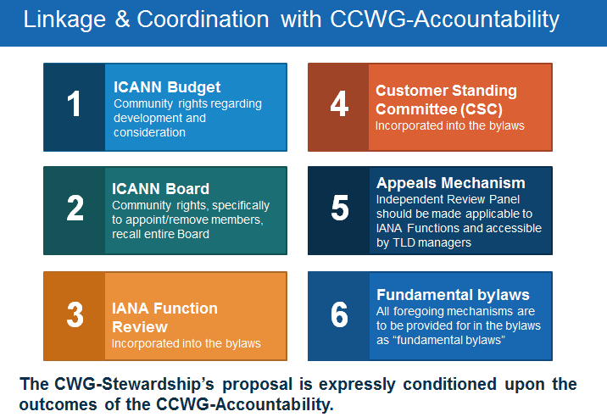
[Revise boxes above to reflect edits below]
The Work Stream 1 proposals from the CCWG-Accountability address all of these conditions.

- ICANN Budget and IANA Budget
The proposal related to community rights regarding the development and consideration of the ICANN Budget and the IANA Budget can be found in Section [X].
<To be detailed further here>

- ICANN Board and Community Empowerment Mechanisms
The proposals include the ability for the community to appoint and remove members of the Board, recall the entire Board, exercise oversight with respect to certain key ICANN Board decisions and approve amendments to ICANN’s Fundamental Bylaws. Description of these mechanisms can be found in Section [X].
<To be detailed further here>

- IANA Function Review and Separation Process
CCWG-Accountability proposals include the incorporation into the ICANN Bylaws of the sections of the Affirmation of Commitments related to the regular mandated reviews. A section related to the IANA Function Review and Special IANA Function Review will fit into these new sections of the Bylaws. Its specifications will be based on the requirements detailed by the CWG-Stewardship and the Bylaw drafting process will include the CWG-Stewardship.
The incorporation into the Bylaws of the procedure to implement a Separation Process should it arise from a Special IANA Function Review, including provision for the creation of the Separation Cross-Community Working Group (SCWG), its functions and voting thresholds for approving the end-result of the SCWG process (which could include a separation) is agreed on. Its specifications will be based on the requirements detailed by the CWG-Stewardship and the Bylaw drafting process will include the CWG-Stewardship.

- Customer Standing Committee
The incorporation into the Bylaws of the Customer Standing Committee is agreed on, and the CWG-Stewardship can either draft its own Bylaw proposal or be included into a joint effort.

- Appeals Mechanism
CCWG-Accountability proposals include significant enhancement of ICANN’s existing appeals mechanisms, including the IRP. The IRP will be available to TLD managers to challenge ICANN decisions including with respect to issues relating to the IANA functions (with the exception of ccTLD delegations and redelegations, as requested by the CWG-Stewardship). Its standard of review will be based on ICANN’s Mission and Core Values, which includes compliance with documented policies. The decisions of the IRP will be binding on the ICANN Board.
Further detail on the IRP can be found in Section 4.

- [Post-Transition IANA (PTI) Governance

The incorporation into the Bylaws of governance provisions related to PTI is anticipated. Specifications with respect to these PTI governance provisions will be based on the requirements to be detailed by the CWG-Stewardship and the Bylaw drafting process will include the CWG-Stewardship.]

- Fundamental Bylaws
The list of Bylaw sections that will be granted the status of Fundamental Bylaws includes all Bylaw sections relating to community powers (including Budget and Board removal/recall), the enhancements of the IRP, the IANA Function Review and Separation Process, the Customer Standing Committee and PTI Governance.
Changing these Fundamental Bylaws will require, upon proposal by the Board, prior approval of the community with a 75% threshold, through the Community Mechanism as Sole Member (CMSM).
Further detail on the Fundamental Bylaws can be found in Section 3B.

