Memo on Proposed Approach for Community Enforceability

The purpose of the proposed new Multistakeholder Enforcement Mechanism (MEM) is to provide a straightforward extension to the current ICANN multistakeholder governance structure that provides the community with a way to enforce ICANN’s compliance with its Fundamental Bylaws.Why Only Fundamental Bylaws?

Through the MEM, the Supporting Organizations (SO) and Advisory Committees (AC) may:

- through arbitration, challenge a decision or action of the Board that, in the consensus view of the SOs and ACs, violates the Fundamental Bylaws; and
Comments
- Why Only Fundamental Baws where as in the CCWG there a 5/6 other areas subject to the community empowerment
- Is the Arbitration challenging /process that proposed by ICANN is equivalent to IRP as contained in the CCWG proposal?
- Why Consensus whereas CCWG proposed a different approach

(ii) if successful in the arbitration, obtain a binding arbitration decision that may be enforced in California courts.

Establishment of the MEM is not intended to replace existing IRP procedures. The MEM provides a legally enforceable arbitration decision on violations of ICANN’s Fundamental Bylaws.

Key characteristics of the MEM are:

Binding Enforcement: In California, final decisions may be turned into enforceable court judgments. So an arbitration decision issued following an MEM proceeding can be enforced in a court in California.

Process to Initiate MEM Arbitration:

1. Any single SO or AC, by some measure of consensus? ( rough Consensus, HUM approach, UN type consensus or what , can initiate a petition to commence MEM Arbitration.

2. The SO or AC would provide a notice of the petition to all other SOs and ACs and begin a discussion phase (individually within each SO or AC) with all other SOs and ACs (15 days).

3. The SOs and ACs will then have 21 days to consider whether to support the petition.
Question
What is the process of supporting? Consensus ( Rough or HUM or UN type consensus ) Collectively or individually

4. To initiate formal MEM proceedings, the agreed number of SOs and ACs ( what is that agreed number ? must support the petition. If there is sufficient support ( what is sufficient support ) amongst the SOs and ACs then representatives ( e.g chairs of SO and AC ) of those supporting SOs and ACs would become the MEM Issue Group
What is the legal status of the MEM ISSUE GROUP? SEE PAGE 1 para i referring to consensus ?

5. The MEM Issue Group would then submit a Request for Arbitration to the Standing Panel alleging a violation of at least one Fundamental Bylaw and including the grounds upon which that alleged violation occurred. Time frames within which Requests for Arbitration may be filed will need to be discussed and agreed.
Question
How Standing panel makes its decision, by unanimity, consensus, 2/3 or simple majority ?

Here is an example of the process:

- The GNSO has reached a consensus view that a decision or action by the ICANN Board violated a Fundamental Bylaw.
If there is no consensus, nothing would happen?
And if there are violation /actions or inactions other than fundamental Bylaws, nothing would happened too ?

2. The GNSO drafts a petition setting out the basis for the alleged violation of a
FundamentalBylaw.
3. The GNSO provides notice of the petition to all other SOs and ACs and initiates a discussion phase over the petition

4. Following the 15-day discussion phase, each SOs and ACs will have 21 days to consider the petition and determine whether it has consensus to support pursuing MEM arbitration. If there is no consensus, nothing would happen

5. If enough (what are the criteria to decide whether enough SOs and ACS supported ….? SOs and ACs support the petition, a MEM Issue Group would be formed.( what is the legal status/standing of this MEM Isuue Group ? ) This could be comprised of – as one example – the individual people serving as chairs of the participating SOs/ACs. These individuals would have legal standing to initiate arbitration and have legal standing ( HOW? to enforce the outcome of the arbitration in court. The MEM Issue Group, as directed by the participating SOs and ACs, would then submit a Request for Arbitration to a Standing Panel, which will be created.
a) How the individual mentioned above would have legal standing?
If they obtain individual legal standing in order to be able to act collectively ( to have a collective legal standing) to enforce a decision made without forming an unincorporated association
b) The arbitration/standing panel is different from the MEM Issue Group?
The task of MEM Issue Group is to just submit a request for arbitration to the Standing Arbitration Panel? i.e the outcome of MEM Issue Group thus does not need to be enforced unless that Issue Group could be able to send its outcome for implementation to to ICANN Board .
The procedure, mandate and the outcome of MEN Issue Group is totally mixed up with those of Standing Panel
Howeverm,if we read the parts relating to MEM Isuue Group and That od Standing Panel ,then language contained in paragraphb5vof the MEM is not consistent with these two parts

A Standing Panel: A standing panel (Standing Panel) will be tasked with reviewing and deciding complaints brought through the MEM process. A three-member panel (MEM Panel) drawn from the Standing Panel would decide the dispute. Under limited circumstances it may be possible to require a dispute to be decided by the full Standing Panel.

Decision Making //

Members of the Standing Panel should possess significant, advanced legal expertise, particularly in the fields of international law, corporate governance, and judicial systems/dispute resolution/arbitration. The Standing Panel will have diversity requirements and must be independent from ICANN, the SOs and ACs, and without conflict of interest.

Possible Outcomes of MEM Arbitration: A MEM arbitration will result in a decision declaring that the challenged Board decision or action did or did not comply with ICANN’s Fundamental Bylaws. The decision will be binding on the Board and subject to any appeal to the full required to remedy that violation, within the Board’s discretion. If the Board fails to remedy a violation, the MEM Issue Group may enforce the arbitration decision in the California courts.

Standard of Review by the MEM Panel: The standard of review will be an objective examination as to whether the complained-of Board decision violates ICANN’s Fundamental Bylaws. The decision will be based on each panelist’s assessment of the merits of the case. MEM panelists should be able to consider and rely on prior decisions of other MEM Panels addressing similar issues.

Accessibility and Cost: ICANN will bear the administrative costs of maintaining the MEM (including panelist salaries) as well as reasonable attorney’s fees (with caps) to support the MEM Issue Group. MEM arbitration panels should complete their work expeditiously, generally issuing decisions within a standard time frame (6 months).

Implementation: The MEM provisions would be adopted as Fundamental Bylaws.

Review: The MEM process would be subject to periodic community review.

ICANN Board Comments on CCWG-Accountability 2nd Draft Proposal 2
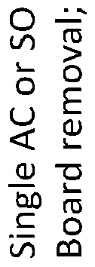
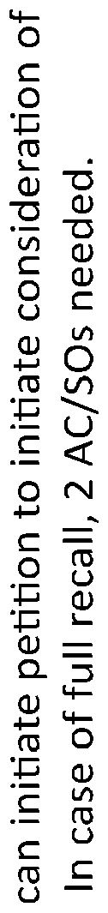
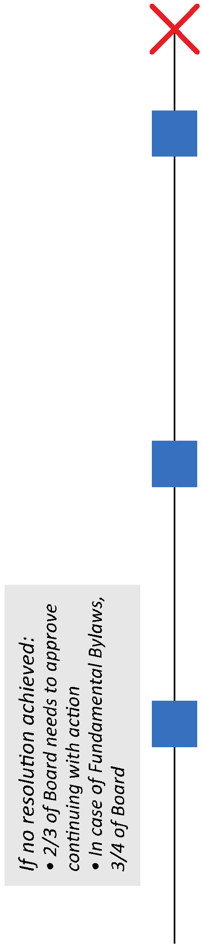


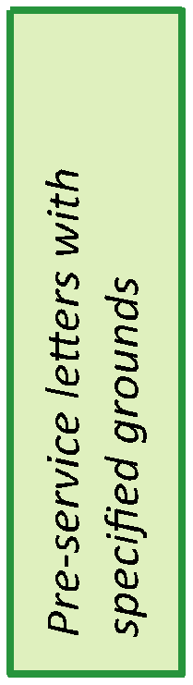
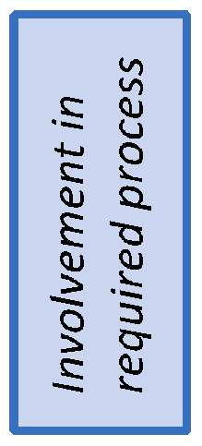
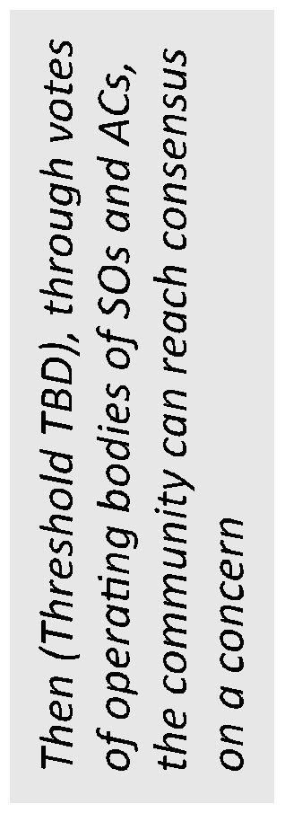
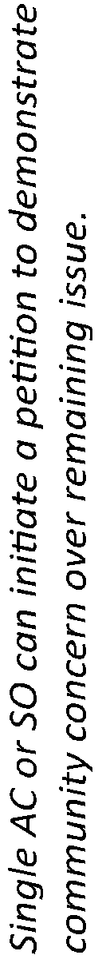
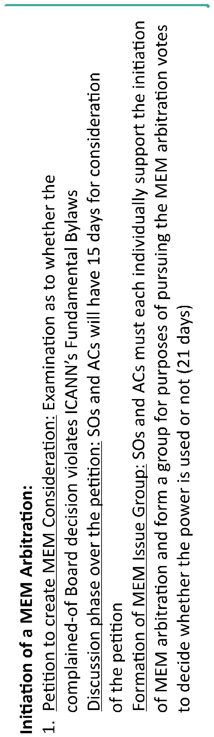
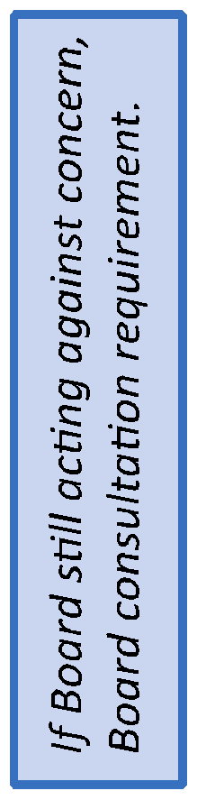


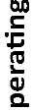




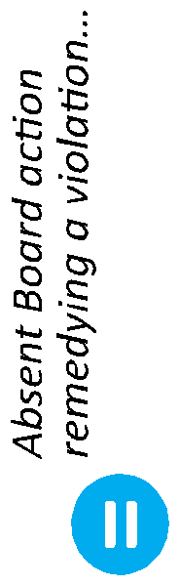

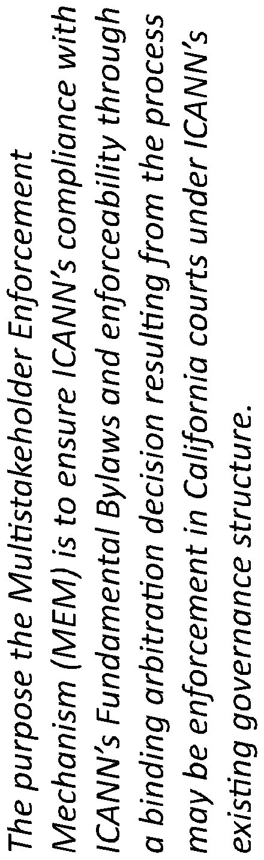

ICANN Board Comments on CCWG-Accountability 2nd Draft Proposal 3

