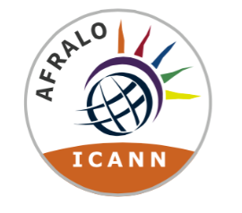

AFRALO Outreach & Engagement Strategic Plan FY26 – Gathering AFRALO Members Feedback

Introduction:

AFRALO is the home of the individual Internet user community for the African region. It provides news, participation opportunities, key resources and interactive information sharing tools for individuals and end user groups in the African region who are interested in ICANN and in shaping the future of the Internet.
Prior to developing AFRALO Outreach and Engagement Strategic Plan for FY26, AFRALO leadership team would like to gather AFRALO members’ feedback. Please note that AFRALO Outreach and Engagement Plan is derived from ICANN Africa Regional Plan and that the CROP and discretionary funding needs to align and support AFRALO O&E Strategy.

Objectives:
In your opinion what should be the main objectives of AFRALO Strategic Plan for FY26? – Please refer to ICANN Regional 26-30 Africa Regional Plan prior to providing your answer
The strategic objective in relation to the region focuses on evolving and promoting ICANN’s inclusive approach to Internet governance in Africa.
The outreach efforts should focus on engaging local communities through existing global organizations and strengthening ties with key stakeholders. Successful integration will be measured by greater diversity and the active participation of new members from Africa in ICANN community groups.
Activities:
In your opinion what should be AFRALO main activities to achieve the identified Objectives?
- Collaborating and inviting African Experts in specific events
- Including topics related to new technologies

Communication Strategy:

The implementation of the AFRALO FY25 Outreach and Engagement Strategy will require an effective communication strategy tailored to the targeted audience in their respective communities. Please identify some strategic approaches

● Strategic Objective 1: Evolve and Promote ICANN’s Multistakeholder Model to Sustain Its Inclusive Approach to Internet Governance
● Strategic Objective 2: Enhance Organizational Excellence
● Strategic Objective 3: Collaborate with Relevant Stakeholders to Evolve the Internet’s Unique Identifier Systems
● Strategic Objective 4: Strengthen the Stability and Security of the Internet’s Unique Identifier Systems

