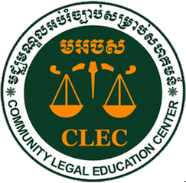 |  | 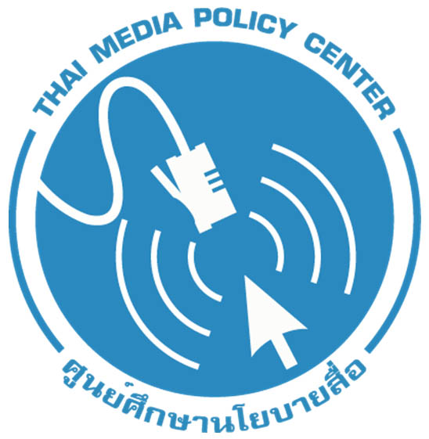   |  | 
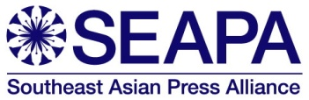 |  |  |  |  | 

Statement of Civil Society Delegates from Southeast Asia to
2012 Asia-Pacific Regional Internet Governance Forum (APrIGF)

31 July 2012

Southeast Asian Civil Society Groups Highlight Increasing Rights Violations Online, Call for Improvements to Internet Governance Processes in the Region

We, the undersigned civil society delegates from Southeast Asia who attended and participated in the 2012 Asia-Pacific Regional Internet Governance Forum (APrIGF) on 18-20 July 2012 in Tokyo, Japan, make this statement upon the conclusion of the meeting to highlight the concerns that we raised throughout the forum.

We engaged in this meeting with the objective of raising human rights concerns in relation to the Internet, particularly on issues of freedom of expression and access to information online, as well as the role of civil society in Internet governance and policymaking. We organised two panel discussions, namely “Internet in Asia: Space for Free Expression and Information” and “Civil Society in Internet Governance/Policymaking” during the 2012 APrIGF. Through these panel discussions, as well as in other sessions that we participated in, we raised the following human rights concerns in relation to the Internet:

Increasing censorship and attacks to online expression

The space for free expression on the Internet is shrinking. Many governments are extending censorship and control of traditional media to the Internet. In most cases, censorship measures are implemented in a non-transparent manner, which makes it difficult to determine whether the measures taken are in accordance with international laws and standards.

In some countries, citizens who make use of the free space on the internet as bloggers, citizen journalists or social media users become targets of attacks, arrest, and/or threats by state security agents. These actions by state authorities produce a chilling effect on internet users resulting in widespread self-censorship of social and political expression for fear of reprisals from the government or its agents.

We thus call upon all governments to ensure that any measure to limit freedom of expression and the right to information are in accordance with international human rights laws and standards, particularly Article 19(3) of the International Covenant on Civil and Political Rights (ICCPR), which allows for limitations only on narrow and clearly-defined grounds, by passing the “three-part, cumulative test” following the principles of necessity, proportionality (ensuring that it is the least restrictive measure) and transparency. Furthermore, any limitation to freedom of expression, including censorship measures, must be determined by an independent judicial body, and not left to the arbitrary powers of governments or intermediaries. These parameters must apply in all circumstances including during state of emergency and in name of national security or public order.

New laws and legislative amendments that curb freedom of speech online

We are further alarmed by the growing number of laws and policies in Southeast Asia that negatively impact freedom of expression on the Internet. While we recognise the need to address cybercrime and legitimate national security concerns, we are concerned that such laws seek to extend media censorship and criminal defamation to the internet, and are also being used to criminalize individuals or organizations expressing or sharing legitimate social or political critique.

We reiterate that any restriction to freedom of expression on the Internet must not risk citizens’ rights to hold opinions without interference and to freedom of thought, conscience and religion as stipulated in Article 18 of the ICCPR, and it must not be subject to lawful derogation as outlined in UN General Comment No. 34. We stress that any introduction of new laws or legislative amendments, particularly those that could potentially impact human rights, must involve extensive, inclusive and meaningful public consultations. We further urge all governments in Southeast Asia to decriminalise defamation both online and offline.

Additionally, we emphasize that the rule of law and the independence of the judiciary remain among the key challenges to democracy in Southeast Asia. Law-enforcement agencies and justice systems must presume innocence until defendants are proven guilty, regardless of whether or not defamation is criminal. Certain legislation, including those laws that criminalize online speech and expression, are worth noting here as examples of legislation in Southeast Asia that warrant close monitoring of their enactment or enforcement:

- Burma – The 2004 Electronic Transactions Act
- Cambodia – The 2012 Draft Cyber-Law, the 1995 Press Law, and the 2010 Penal Code
- Malaysia – The 2012 Amendment to the Evidence Act and the 2011 Computing Professionals Bill
- Indonesia – The 2008 Law on Information and Electronic Transaction and the 2008 Law on Pornography
- The Philippines – The 2012 Data Privacy Act
- Thailand – The 2007 Computer Crimes Act, the Article 112 of the Penal Code, and the 2004 Special Case Investigation Act
- Vietnam – The 1999 Penal Code, the 2004 Publishing Law, the 2000 State Secrets Protection Ordinance, and the 2012 Draft Decree on Internet Management

Intermediary liability

We express our deep concern over the increasing pressures by governments on internet service providers and content hosts to monitor, regulate and censor online content. Consequently, such intermediaries are increasingly being held legally and criminally liable for online content, including content posted by other users.

We reiterate that the regulation of content on the Internet should be determined by an independent judicial body, and not be left to intermediaries. We further echo the call by the UN Special Rapporteur on the promotion and protection of the right to freedom of opinion and expression that intermediaries should not be held liable for online content.

Violations by non-State actors, including those employed by governments

Finally, we are alarmed at the rise of internet vigilante groups acting on behalf of governments or powerful institutions to help monitor sensitive information posted over the Internet through personal websites and social media. Such groups often target persons expressing unpopular opinions and subject them to abusive behaviour and threats. In some cases, such threats have been carried out off-line in the form of discriminatory treatment, physical attacks and even state prosecution of these targets. In addition, critical and independent websites are frequently being targeted for hacking and DDoS attacks.

We strongly remind all governments that it is their primary obligation to promote and protect human rights, and this includes protecting its citizens’ exercise of the right to freedom of opinion and expression from violations by non-state actors online.

Improving the APrIGF Process

While we support and uphold the multi-stakeholder process of the IGF, and value the opportunity to contribute to the global dialogue around these crucial issues, several aspects of the APrIGF are in need of improvement:
- Participation by governments across Asia was minimal despite the multi-stakeholder framework that this forum purports to promote. This has inevitably limited the dialogues between the different stakeholders on Internet governance in the Asia-Pacific region.
- Similarly, there was also inadequate civil society participation at the APrIGF 2012. One of the reasons to this is that there is a perception that the APrIGF is a largely ineffective forum in making needed efforts to advance human rights in cyberspace.
- Multi-stakeholder discussions on and approaches to emerging human rights issues concerning the Internet were largely limited at the APrIGF 2012.
- Finally, there was a marked absence or lack of critical assessment of the progress with regard to the implementation of recommendations made at the previous APrIGF. This has contributed to the perception of the APrIGF’s ineffectiveness.

Recommendations to the APrIGF Multi-stakeholder Strategy Group

In view of these shortcomings and with the hope of improving upon the 2012 APrIGF, we offer the following recommendations to the APrIGF Multi-stakeholder Strategy Group for future iterations of this event:
- To facilitate more robust dialogue and more engagement of those participants who are not speaking on panels, we recommend a more participatory process for sessions, with fewer time spent on panel presentations, and more time dedicated to questions and comments from those in the audience.
- In the interest of more a diverse dialogue, we recommend that efforts be made to enlarge and broaden the spectrum of attendees at the event. Special effort should be made to encourage government and civil society participation, especially in view of the rare opportunity to discuss such issues within the host country. Additionally, the affordability of the host city and the need for financial assistance should be taken into account as a factor that may make civil society participation more or less likely.
- To encourage broader participation in session dialogues and bolster engagement of civil society, we recommend that strong efforts be made to facilitate inbound remote participation via video conferencing. In addition to the valuable service of live web-casting, remote participants should be empowered to ask questions and make comments within a panel. This could be facilitated with greater integration of social media, within the APrIGF website.
- To ensure that all issues are well-represented within the conversations at the APrIGF, we recommend that at least one plenary session be dedicated to social issues in internet governance, such as online freedom of expression, access to information and digital divide.
- To ensure that progress is made on issues discussed at the APrIGF from one year to another, we recommend that one plenary session be dedicated to looking back at the issues raised and recommendations made at the previous APrIGF, and critically assessing progress made on those issues.

Recommendations to Southeast Asian governments

In addition, we make the following specific recommendations to our respective governments in Southeast Asia:
- ASEAN governments must ensure that the ASEAN Human Rights Declaration explicitly and unequivocally protects the right to freedom of expression and freedom of information in accordance with international human rights laws and standards.
- ASEAN governments should issue a joint statement to pronounce their commitment to uphold Internet freedom.

- All regional governments should involve civil society meaningfully and inclusively in Internet policymaking, especially in drafting laws and policies that potentially impact human rights, including in regional-policy arena that involve the issues related to ICT and internet governance, such as:
  - Regional economic integration by 2015 under the ASEAN Economic Community (AEC). The AEC’s areas of cooperation include a focus on internet governance, such as: “enhanced infrastructure and communications connectivity”; and “development of electronic transactions through e-ASEAN”. Currently, the AEC encourages only business sector participation and not civil society.
  - The ASEAN CIO Forum under the ASEAN ICT Master Plan 2015 also opens participation only to business sectors. The forum focuses on CIO16 and its objective is to “Taking leadership in collaboration and transformation for a competitive, highly productive and envisage a concrete/positive ASEAN ICT community.” The master plan aims to minimize digital divide and make ICT in the region be empowering, transformational, inclusive, vibrant, and integrated for the people by 2015.
- All regional governments should attend and engage in regional IGFs to dialogue with other stakeholders, including civil society, on regional issues concerning the Internet.

Signed by:

Arthit SURIYAWONGKUL  Coordinator  Thai Netizen Network  Bangkok, Thailand  E-mail: arthit@gmail.com  Tel: +66 87 504 2221 | Pirongrong RAMASOOTA  Director  Thai Media Policy Center Bangkok, Thailand  E-mail: pirongrong.r@gmail.com  Tel: +66 89 770 8911 | Triana DYAH  Head, Information & Documentation Division  The Institute for Policy Research and Advocacy (ELSAM)  Jakarta, Indonesia  E-mail: office@elsam.or.id  Tel: +62 21 7972662, 79192564  Fax: +62 21 79192519
Edgardo LEGASPI  Alerts & Communication officer  Southeast Asian Press Alliance (SEAPA)  Bangkok, Thailand  E-mail: epl@seapa.org  Tel: +66 8 1116 5137  Fax: +66 2 2448749 | Sean ANG  Executive Director  Southeast Asian Centre for e-Media (SEACeM)  Kuala Lumpur, Malaysia  E-mail: sean@seacem.com  Tel: +60 3 2284 3367  Fax: +60 3 2289 2579 | Victorius (Ndaru) EPS  Jakarta, Indonesia
NGETH Moses  Communication Coordinator  Community Legal Education Center (CLEC)  Phnom Penh, Cambodia  E-mail: Moses@clec.org.kh  Tel: (855) 66 777 010  Fax: (855) 23 211 723 | Sovathana (Nana) NEANG  Phnom Penh, Cambodia | YAP Swee Seng  Executive Director  Asian Forum for Human Rights and Development (FORUM-ASIA)  E-mail: yap@forum-asia.org  Tel: +66 81 868 9178  Fax: +66 2 6379128
Endorsed by:
 | ICT Watch (Indonesian ICT Partnership Association)  Jakarta, Indonesia  Email: info@ictwatch.com  Tel: (021) 98495770  Fax: (021) 8280691

