APRALO HOT TOPICS SURVEY SUMMARY
December 27, 2018
The number of respondents to the survey are 30.
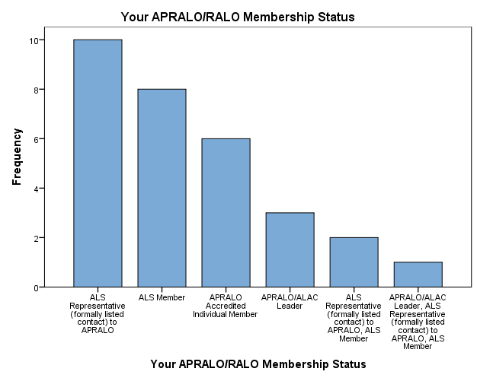

Your APRALO/RALO Membership Status | Frequency | Percent
ALS Representative (formally listed contact) to APRALO | 10 | 33.3
ALS Member | 8 | 26.7
APRALO Accredited Individual Member | 6 | 20.0
APRALO/ALAC Leader | 3 | 10.0
ALS Representative (formally listed contact) to APRALO, ALS Member | 2 | 6.7
APRALO/ALAC Leader, ALS Representative (formally listed contact) to APRALO, ALS Member | 1 | 3.3
Total | 30 | 100.0

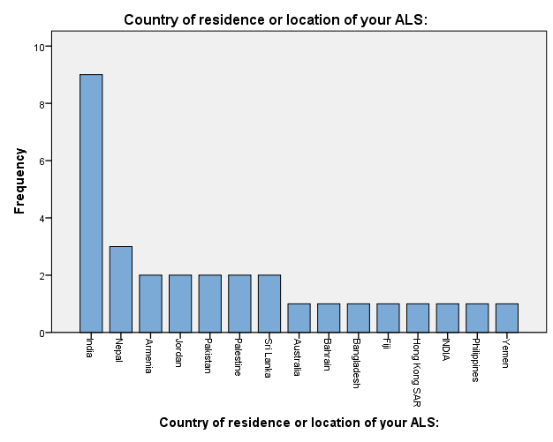

Country of residence or location of your ALS: | Frequency | Percent
India | 9 | 30.0
Nepal | 3 | 10.0
Armenia | 2 | 6.7
Jordan | 2 | 6.7
Pakistan | 2 | 6.7
Palestine | 2 | 6.7
Sri Lanka | 2 | 6.7
Australia | 1 | 3.3
Bahrain | 1 | 3.3
Bangladesh | 1 | 3.3
Fiji | 1 | 3.3
Hong Kong SAR | 1 | 3.3
INDIA | 1 | 3.3
Philippines | 1 | 3.3
Yemen | 1 | 3.3
Total | 30 | 100.0

ICANN Policy priorities relevant to APRALO | Competition, Consumer Trust and Consumer Choice | Geographic Names gTLDs | New gTLD Subsequent Rounds --- general subsequent procedures | New gTLD Subsequent Rounds --- specific procedures
High priority | 17 | 17 | 9 | 11
Medium priority | 9 | 9 | 13 | 13
Low priority | 2 | 2 | 7 | 4
Not familiar with this issue | 2 | 2 | 1 | 2

Technical Topics | DNSSEC including DNS Security and Abuse | Internationalized Domain Names (IDNs) and Universal Acceptance
High priority | 24 | 19
Medium priority | 5 | 9
Low priority | 1 | 2
Not familiar with this issue | 0 | 0

Cross-Community Topics | Temporary Specification on gTLD Registration Data | ICANN's Accountability and Transparency
High priority | 15 | 20
Medium priority | 14 | 8
Low priority | 1 | 2
Not familiar with this issue | 0 | 0

Capacity Building | Schools of Internet Governance | Training and developing the skills of members in ICANN policy drafting and commenting. | Supporting members in ICANN public policy drafting and commenting. | Development of local language or language neutral materials for Regional and Local use
High priority | 22 | 26 | 21 | 18
Medium priority | 4 | 4 | 8 | 9
Low priority | 4 | 0 | 1 | 3
Not familiar with this issue | 0 | 0 | 0 | 0

Internet Governance issues | Human Rights in terms of ICANN's Mission | Privacy, Data Protection, Surveillance, Censorship | Extra-territorial jurisdiction of Data Protection legislation | Diversity relating to ICANNs Mission and mandate | The Internet Governance Ecosystem -expanding on RIRs/IETF
High priority | 16 | 23 | 10 | 17 | 12
Medium priority | 10 | 6 | 15 | 11 | 15
Low priority | 4 | 1 | 5 | 2 | 2
No Opinion | 0 | 0 | 0 | 0 | 1

New Trends and its Impact on Domain Names | Internet of Things (IoT) | Blockchain Technologies | Over the Top (OTT) services | Artificial Intelligence and Machine Learning | Dark Web/Onion Router
High priority | 20 | 18 | 8 | 19 | 14
Medium priority | 9 | 9 | 14 | 8 | 9
Low priority | 0 | 2 | 6 | 1 | 5
No Opinion | 1 | 1 | 2 | 2 | 2

Q What other issue(s) of interest would you propose for APRALO? (Optional)

Net neutrality, Fake news were issues where ALS’s had more interest. The other issues of interest were online trust deficit; access and affordability; inclusion and participation; encouraging next level leadership; Enhancing Gender diversity in terms of participation and in the policy process; local or regional policy issues that can affect domain names and numbers; Ethics in AI, Machine Learning; development of cost effective solutions for developing and under developed countries; concerns of divided internet; encouraging startups to opt for domain name reseller business; understanding of the domain name business and New GTLD Application Process.

Q What challenges have you experienced in engagement and involvement in ICANNs policy process? (Optional)

The challenges that were listed in terms of engagement and involvement in ICANNs policy process which were cited, include high demands on time; steep learning curve; unfriendly process for newcomers; lack of information, trainings and knowledge on ICANNs policy process; need for mentoring and guidance; sustaining interest especially of newcomers and young people; challenges of language; few topics may not be of interest to ALS’s, need for more involvement of ALS and their leadership in the process; limitation of fellowships; the online wiki’s quite difficult to understand and workon and complexity and length of the policy documents.

Q In what ways could the engagement of ALSes and APRALO Members in At-Large's activities be improved? (Optional)

Suggestions share by ALSes to improve their engagement in At-Large's activities include having an effective and complete closed loop of communication, resourcing and engagement support; enhancing local level engagement and capacity building activities through local leadership with a bottom up approach; encouraging local leadership to be more active; having guides for new comers; encourage new voices in the discussion; providing remote mentorship and support; simplifying the policy discussions so that new members can understand the process; limit policy discussion to one during monthly calls and explain the same in details with open Q& A; encourage ALS representatives to take an active role in passing ICANN knowledge and better understanding to their communities; come up with out of the box suggestions on how to conduct policy development discussion and bring diversity to the discussions and support SIGs for more engagement of ALSes.

