IFRT Plenary Meeting #18
IFRT PLENARY MEETING , 15 September 2020 RT Members: If you have corrections, please email Amy at amy.creamer@icann.org

Agenda:
- Welcome
- Agenda Bashing
- Administrative Items
- Review draft initial report (continue)
- Timeline changes
Bylaw change recommendation
Contract change
- Meeting during ICANN69 | Thursday, 22 October 2020 |7:00-8:00 UTC | Block 1
- AOB

MEETING NOTES: TOPIC #1: Recommendation on int

REFERENCE MATERIAL

IANA Naming Functions Contract Sections referenced in this discussion:

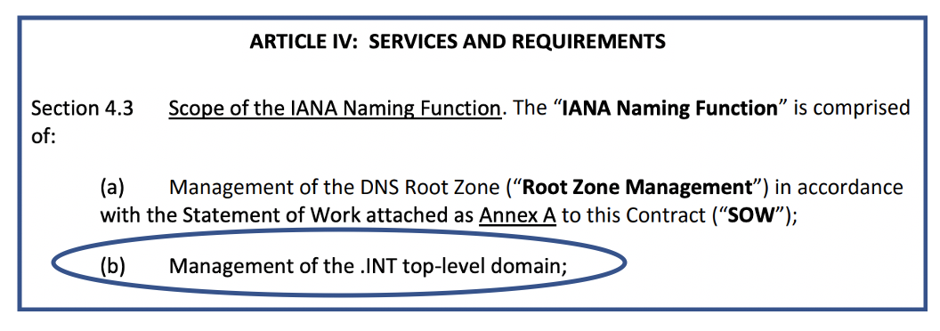
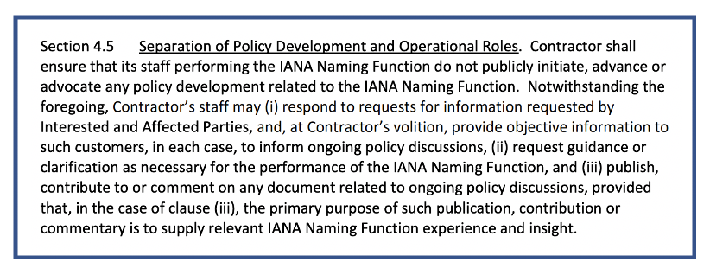

DISCUSSION

PART A: The wording of Rec 2

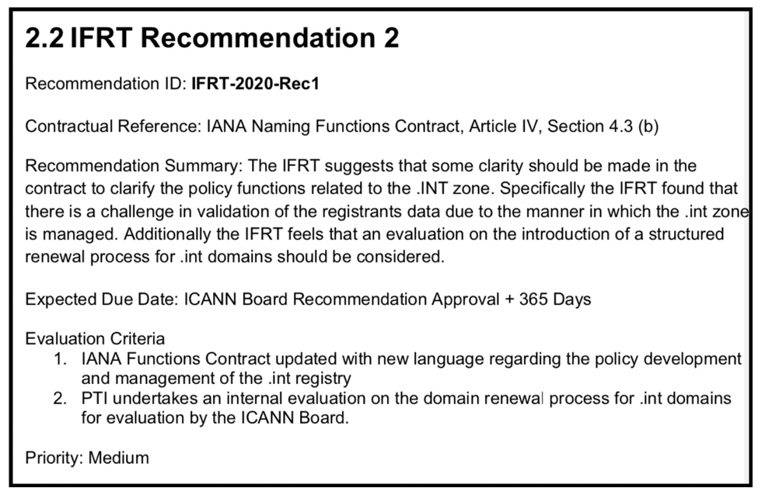
Concerns that the Recommendation could:
- suggest that .int domain should be treated like a gtld. This is not in the IFR’s scope
- the IFRT’s concerns with .int are not substantive (agreed) and having a recommendation about it brings it into community focus and could make it seems more important then it is
- unexpected outcomes….could easily be misinterpreted by community

What Recommendation should convey:
- IFRT is making an operational observation.
- Operational suggestions can be dealt with internally by PTI without needing the Board to direct ICANN/PTI to do so
- We want to draw attention to .int operational issues, without risking raising larger issues like policy of .int

Part B: Whether to Keep of Remove Rec 2
Reasons to keep Recommendation:
- If it isn’t a recommendation, there is no impetuous to get it done.
- Allows the next IFR to ensure that PTI made operational changes as they need to judge execution of the Board approved recommendations
- We actually do have a recommendation, we want PTI to make/update some operational housekeeping for .int
- There are operational gaps that Kim Davies has pointed out
- Kim Davies shared that PTI has refrained from making any operational changes to .int due to concerns that PTI could be perceived as going into policy; or that making changes would bring attention to .int and lead to community work that PTI did not have resources to follow or support. By making this a recommendation, it gives PTI a platform to move forward with said changes without concerns of negative fall-out from community

Reasons to drop Recommendation but Keep the IFRT’s “Finding” statement
- distinction here leaving it as a finding points out the issue is operational ambiguity or potential gap and operational processes, but the current Recommendation #2 text is framed in terms of identifying policy gaps.
- As a finding we can draw attention to the operational issues without creating big challenges with the community interpreting the Recommendation

Part C: The wording of the Finding

Original Finding Text
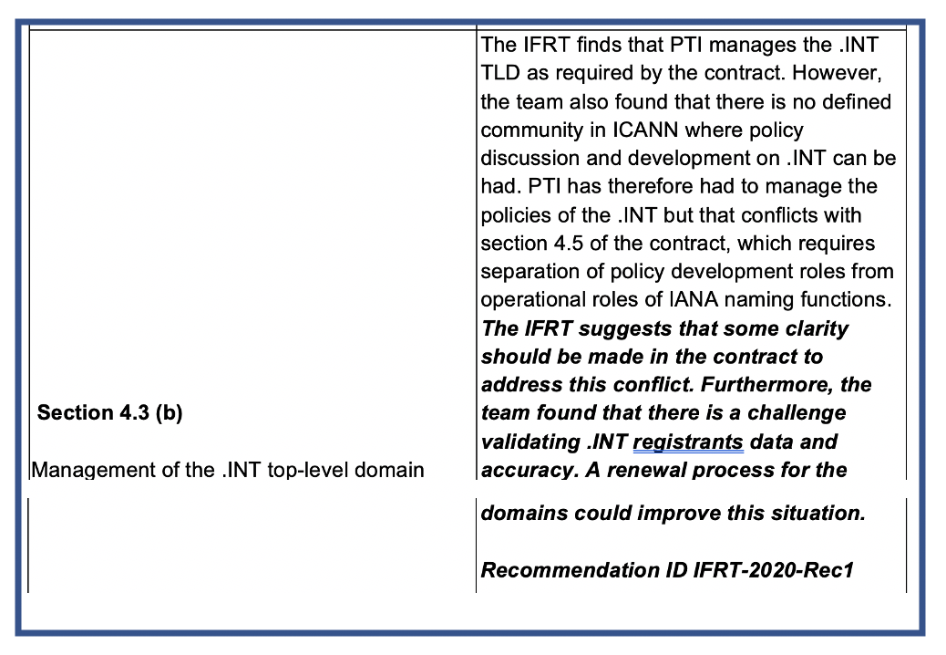
Reasons to keep original wording of FINDING
- Recommendation #2 text is framed in terms of identifying policy

Reasons to change wording of Finding
- By stating that PTI’s operational ownership of .int is in direct conflict with Section 4.5 that PTI cannot be involved in policy setting, you have to make a recommendation to prevent this conflict. If we are dropping the Recommendation then we cannot believe this current finding’s statement
- Section 4.5 starts out by saying “Contractor shall ensure that its staff performing the IANA Naming Function do not publicly initiate, advance or advocate any policy development related to the IANA Naming Function.” HOWEVER it goes on to say, “Contractor’s staff may ….. (ii) request guidance or clarification as necessary for the performance of the IANA Naming Function, and (iii) publish, contribute to or comment on any document related to ongoing policy discussions, provided that, in the case of clause (iii), the primary purpose of such publication, contribution or commentary is to supply relevant IANA Naming Function experience and insight.”
  - The later part of this section would allow PTI to request the community start policy development if PTI felt a policy was necessary, etc. in order for PTI to make operational changes we suggest in the finding.
  - in the abstract, by identifying policy areas of concern to the ICANN Board, and if the ICANN Board creates a mandate to perform a policy review, PTI has facilitated it but this section allows that
  - Statement by KIM from PTI: The difference between PTI handling .int operations compared to all of PTI’s responsibilities is that for .int PTI would probably need to take direct responsibility for addressing an issue, whereas in the other areas of our work, we rely upon other organizations to take the lead in structuring policy engagement. But PTI could assist in “stage managing” the start of policy development. For example, PTI might convene a panel of our customers; engage some 3rd party assistance; build an ad hoc consortium to talk about the policy or to bounce a draft policy off. Then PTI would take that to the community for consideration, and implement the final proposal. So I think that's how I would look at navigating this in a way that doesn't conflict with section 4.5 where we are not developing policy for ourselves. PTI would just need to take a unique approach, making sure that the policy is properly reviewed by the Community

- Just because a declaring out right that there's a conflict here is going to invite people to create mechanisms and it mechanisms for creating new policy and I'm not sure that's either borne out by the situation or a good idea.

FINAL DECISIONS

1. .int Recommendation was removed. In the Findings section , found within the Initial Draft under Bylaws 18.3.(c), then page 16 where Article IV, Section 4.3 Scope of the IANA Naming Function is listed, was re-written to read:
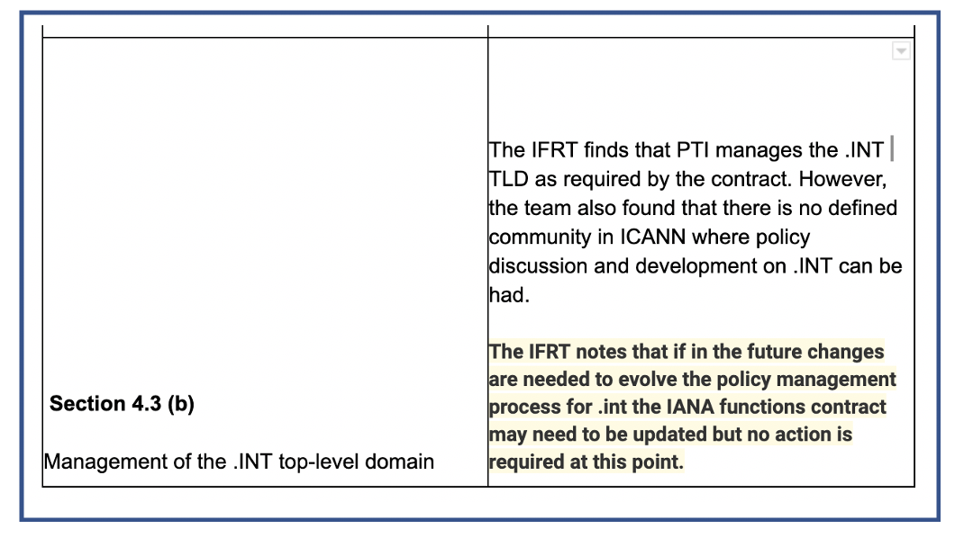

MEETING NOTES: TOPIC #2: Recommendation that touches contract

New Notice to the IFRT: Any recommendations that will require an amendment to the IANA Naming Functions Requirements has specific requirements from the IFR portion of the Bylaws.

The IFRT must
- Consult with the Board
- Consult with PTI
- Consult with CSC
- Conduct a public input session for cc/g operators
-Could be a session at ICANN69
-Could be a webinar- need to announce somehow
-Cannot be the public comment for the initial report
- Seek public comment on the amendments
-This can be combined with the Public Comment for the Initial Report, if we have done the prior consultations first. If the consultations are not done prior to the Initial Report’s Public Comment, then a 2nd Public Comment will need to be held just for the Contract Amendment Recommendation

FINAL DECISION
To avoid a 2nd public comment the IFRT will perform the consultations in this manner:

IFRT must
- Consult with the Board
-IFRT will send a letter to the Board. The Board could handle via email (vs. waiting for the next Board meeting). Amy to draft.

- Consult with PTI
-this is completed due to Kim’s presence

- Consult with CSC
-will be handled by James & Amy at the upcoming CSC meeting on 16 Sept 2020

- Conduct a public input session for cc/g operators
-will hold a webinar- need to announce somehow

- Seek public comment on the amendments
-This can be combined with the Public Comment for the Initial Report, if we have done the prior consultations first. If the consultations are not done prior to the Initial Report’s Public Comment, then a 2nd Public Comment will need to be held just for the Contract Amendment Recommendation

DECISIONS REACHED
- Removed the Recommendation on .int. See Meeting Notes for details on this decision.
- Reword the "FINDINGS" on .int. See Meeting Notes for details on this decision.
- In order to prevent additional Public Comments besides for the Initial Report and Final Report, do required/Best Practice consultations with PTI, the Board, the CSC, g & cctld operators for the Recommendation that will require an IANA Naming Functions Contract amendment. PTI has already been consulted; the co-chairs will send a letter to the Board; Amy & James will discuss with CSC during their monthly meeting; the co-chairs will conduct a community webinar for communication with c & gtld operators. The Initial Report Public Comment will also highlight the contract amendment recommendation so that this Public Comment acts also a Public Comment for contract amendments.

ACTION ITEMS
      - James and Amy to consult with CSC on contract amendment recommendation
      - Amy to draft letter for Fred and Tomslin to edit and send to board regarding contract amendment recommendation
      - Amy to get announcements out regarding webinar for contract amendment recommendation
      - Amy to draft some slides for webinar

