Purpose
ATRT 2 is considering engaging an independent expert to assist with its work. The Review Team has contemplated an independent expert that could:
- assist in developing a survey that could be a "repeatable" tool used by ICANN and future review teams;
- assist in analysis and perhaps do case studies (as Berkman Center did for ATRT1)
- assist in the development of accountability and transparency metrics
- assist with the analysis/assessment of how recommendations are being implemented

The purpose of this memo is to provide initial notes and considerations as background information to assist the Review Team with its decision regarding Independent Experts.
Process
Information below is based on the ICANN Procurement Guidelines and will be useful in informing the Review Team’s decision making process regarding engaging outside experts.
- Define scope of work
  - What is the desired deliverable? Timeline?
  - How will the deliverable tie into ATRT2 final report?
  - How will the work of independent expert support the defined Work Streams?
- Establish business case and expected value.
- Selection process
  - Define skills and experience needed – establish selection criteria
  - Identify potential candidates and evaluate against criteria
  - Determine appropriate approach based on ICANN Procurement Guidelines:
Procurement Methodology | When Recommended? | When Required?
Request for Proposal (RFP) or Request for Quotation (RFQ) | Estimated procurement with the supplier will exceed $50k in the aggregate. | Estimated procurement with the supplier will exceed $150k for an individual purchase or in the aggregate.
Broad Solicitation | Estimated procurement with the supplier will exceed $150k in the aggregate. | Estimated procurement with the supplier will exceed $250k for an individual purchase or in the aggregate.
Individual Direct Contracting | If costs for RFP process exceed potential savings, if appropriate under the circumstances, and when strategic impact of the purchase decision is not critical for ICANN. | Not applicable

- Requisition and procurement process - Request, approval, contracting
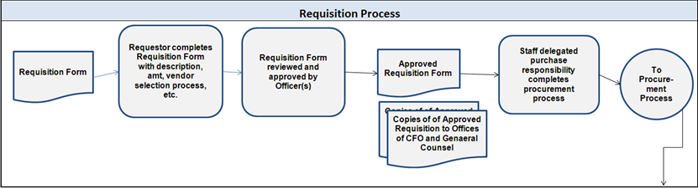
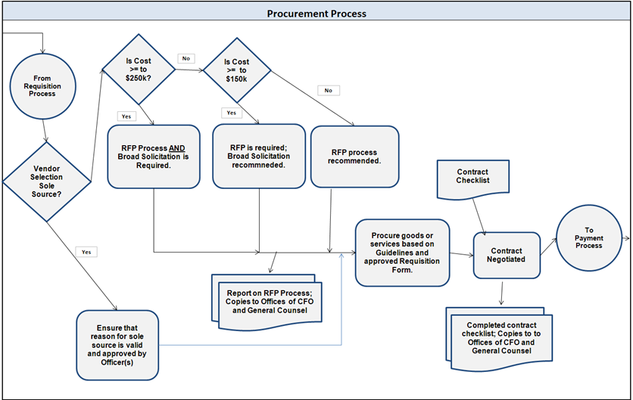
Excerpt from ICANN Procurement Guideline
RFP features that should be considered up front include:
  - Method of developing the potential vendor or provider list.
  - Pre-bid conference call to ensure equal information for all vendors or providers.
  - Deadlines for proposals.
  - Format and structure of proposals; in person, email, or conference call.
  - In-person or telephonic presentations.
  - FAQs for all venders or providers, and protocols for questions from, and answers to, potential vendors or providers.
  - Importance of pricing on the proposal versus other more subjective criteria; consider score card with criteria, weighting and ranking methodology.
  - Makeup of evaluation team and each member’s roles and responsibilities.
  - Level of detail provided in drafting of RFP.
  - Documentation required including draft contract and nondisclosure agreement (NDA).
  - Pricing terms such as price per hour, price per unit, expected additional costs, not to exceed terms, and expected total costs.
  - Contract terms and conditions (e.g., liability limitations, disclosures, warranties, substitution policy).

Direct contracting selection process
In certain circumstances, contracting directly with a vendor or service provider without calling for competitive bidding is appropriate for procurement decisions, such as:
  - Emergency situations.
  - Specialized professional services including, but not limited to, staff, audio-visual experts, lobbyists, advisors to CEO or departmental functions, law firms and economists.
  - When small or less significant items are required in which the costs to implement competitive bidding outweigh the potential benefits.
  - When there is a natural continuation of previous work carried out by the vendor or service provider, and in which competitive bidding would not improve value to ICANN.
  - When there is only one potential provider or when the provider has a measurably superior capacity, expertise and/or knowledge, which might be subjectively determined.
  - When the incumbent provider demonstrates a clear historic pattern of charging reasonable prices and providing consistently good quality service.
Potential Service Providers (starting point)
The following organisations have been listed as a starting point, based on discussion on 9 May.

- One World Trust: making global governance more accountable (http://www.oneworldtrust.org/about-us)
Excerpts from web site:
  - The One World Trust is an independent charity that conducts research, develops recommendations and advocates for reform to make policy and decision-making processes in global governance more accountable to the people they affect now and in the future, and to ensure that international laws are strengthened and applied equally to all.

To achieve this we develop practical tools and recommendations in support of organisational reform, identifying gaps in the accountability of governance systems, and highlighting opportunities for cross-sector learning.
Key to the effectiveness of our research and advocacy in all our strategic areas is the objectivity of our findings, and the constructive engagement with those whose efforts for reform we would like to support, including leaders, senior decision- and policy-makers and opinion-formers in global organisations, parliaments and governments, civil society organisations, and the media.

  - Engaged in 2007 to undertake an independent review of standards of accountability and transparency within ICANN - Independent Review of ICANN’s Accountability and Transparency – Structures and Practices
http://www.icann.org/en/news/announcements/announcement-4-29mar07-en.htm

- Berkman Center for Internet and Society http://cyber.law.harvard.edu/
Excerpts from web site:
  - Mission is to explore and understand cyberspace; to study its development, dynamics, norms, and standards; and to assess the need or lack thereof for laws and sanctions.
  - We are a research center, premised on the observation that what we seek to learn is not already recorded. Our method is to build out into cyberspace, record data as we go, self-study, and share. Our mode is entrepreneurial nonprofit.

  - Engaged in 2010 by ATRT 1 http://www.icann.org/en/about/aoc-review/atrt/review-berkman-final-report-20oct10-en

- Transparency International, the global coalition against corruption http://www.transparency.org/

Excerpts from web site:
  - In 1993, a few individuals decided to take a stance against corruption and created Transparency International. Now present in more than 100 countries, the movement works relentlessly to stir the world’s collective conscience and bring about change.
  - Our Mission is to stop corruption and promote transparency, accountability and integrity at all levels and across all sectors of society. Our Core Values are: transparency, accountability, integrity, solidarity, courage, justice and democracy.

  - Anti-Corruption Research Network (ACRN) is an online platform and the global meeting point for a research community that spans a wide range of disciplines and institutions http://corruptionresearchnetwork.org/about
  - Custom research capabilities are not referenced

