Page 6
ICANN Multistakeholder Organizational Chart

ICANN Board of Directors

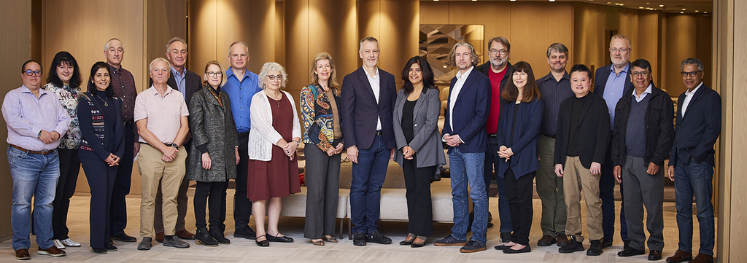

Left to Right: León Sánchez-Board Member (At-Large), Katrina Sataki-Board Member (ccNSO), Manal Ismail-Liaison, James Galvin-Liaison, Alan Barrett-Board Member (ASO), Chris Chapman-Board Member (NomCom), Becky Burr-Board Member (GNSO), Matthew Shears-Board Member (GNSO), Avri Doria-Board Member (NomCom), Sally Costerton-Interim President and CEO, Danko Jevtović-Vice-Chair (NomCom), Tripti Sinha-Chair (NomCom), Christian Kaufmann-Board Member (ASO), Harald Alvestrand-Liaison, Sarah Deutsch-Board Member (NomCom), Wes Hardaker-Liaison, Edmon Chung-Board Member (NomCom), Maarten Botterman-Board Member (NomCom), Patricio Poblete-Board Member (ccNSO), Sajid Rahman-Board Member (NomCom). For more information on the ICANN Board, visit here.

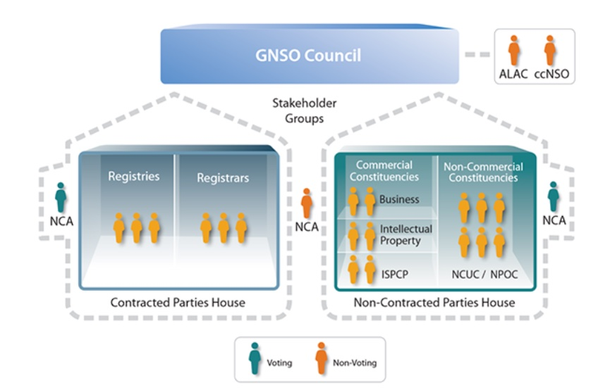
GNSO Council Leadership
Greg DiBiase  Vice-Chair, CPH – US (AGM 2023) | Sebastien Ducos  Chair – EU (AGM 2023) *** |  | John McElwaine  Vice-Chair, NCPH – US (AGM 2023)
Contracted Party House {6+1} |  | Non-Contracted Party House {12+1}
Registries  Stakeholder  Group {3}  Registries  Kurt Pritz NA  End of term 2: AGM 2024  Years on Council: 3  Sebastien Ducos AAPAC  End of term 2: AGM 2023  Years on Council: 4  Nacho Amadoz EU  End of term 1: AGM 2024  Years on Council: 1 | Registrars  Stakeholder  Group {3}  Registrars  Antonia Chu AAPAC  End of term 1: AGM 2023  Years on Council: 2  Greg DiBiase NA  End of term 1: AGM 2023  Years on Council: 4¹  Theo Geurts EU  End of term 1: AGM 2024  Years on Council: 1 | Commercial  Stakeholder  Group {6}  Business (BC)  Intellectual Property (IPC)  Internet Service Providers (ISPCP)  BC  Marie Pattullo EU  End of term 2: AGM 2023  Years on Council: 5²  Mark Datysgeld LAC  End of term 2: AGM 2024  Years on Council: 3  IPC  John McElwaine NA  End of term 2: AGM 2023  Years on Council: 4  Susan Payne EU  End of term 1: AGM 2024  Years on Council: 1  ISPCP  Osvaldo Novoa LAC  End of term 1: AGM 2024  Years on Council: 1  Thomas Rickert EU  End of term 1: AGM 2023  Years on Council; 2 | Non-Commercial  Stakeholder  Group {6}  Non-Commercial Users  Not-for-Profit Operational Concerns Constituency  Wisdom Donkor AF  End of term 2: AGM 2024  Years on Council: 2  Stephanie Perrin NA  End of Term 2: AGM 2024  Years on Council: 3  Manju Chen AP  End of term 1: AGM 2023  Years on Council: 2  Bruna Martins dos Santos LAC  End of term 1 AGM 2024  Years on Council: 1  Farell Folly AF  End of term 2: AGM 2023  Years on Council: 4  Tomslin Samme-Nlar AP  End of term replacement: AGM 2023  Years on Council: 3³
GNSO Council NomCom Appointees
Desiree Miloshevic NCA CPH- EU (AGM 2023) | Anne Aikman Scalese NCA, non-voting – US (AGM 2024)* |  | Paul McGrady NCA NCPH – NA (AGM 2023)

GNSO Council Liaisons/Observers
Maarten Simon ccNSO liaison – EU ** | Jeffrey Neuman GNSO Liaison to the GAC – NA** | Justine Chew ALAC Liaison – AAPAC **

¹ Completed Darcy Southwell's term, started own term AGM 2021
² Completed Philip Corwin's term, started own term AGM 2019
³ Completed a one-year term 2020 – 2021, started two-year term AGM 2021
Legend
{} Voting
[] Non-Voting
* Non-Voting Liaison – Counted as a Member
** Observer – Not Counted as a Member
*** The GNSO Council Chair is elected for a one-year term
AGM = Annual General Meeting
Regions
- AF = Africa
- NA = North America
- EU = Europe
- LAC = Latin America/Caribbean
- AAPAC = Asia/Australia/Pacific

This is the updated page 7 (basically same format but it views different as I updated names)

Contracted Party House
Registries Stakeholder Group Executive Committee
Samantha Demetriou (Chair)
Beth Bacon (V. Chair, Policy)
Alan Woods (V. Chair, Administration)
Karen Day (Treasurer)
Sue Schuler (Secretariat)
Registrar Stakeholders Group
Ashley Heineman (Chair)
Jothan Frakes (V. Chair)
Owen Smigelski (V. Chair)
Benny Samuelsen (Treasurer)
Eric Rokobauer (Secretary)
Zoe Bonython (Secretariat)

Non-Contracted Party House
Commercial Stakeholders Group | Noncommercial Stakeholders Group*  * The groups’ officers are omitted here
Business Constituency  Mason Cole (Chair)  Steve DelBianco (V. Chair, Policy Coordination)  Lawrence Olawale-Roberts (V. Chair, Finance & Operations)  Tim Smith (CSG Rep) | Noncommercial Users Constituency*  Benjamin Akinmoyeje (AF) (Chair)  Ines Hfaiedh (AF)  Olga Kyryliuk (EU)  Cláudio Lucena (LAC)  Ken Herman (NA)  Mili Semlani (AP)
Intellectual Property Constituency  Lori Schulman (President)  Brian King (V. President & CSG Rep)  Damon Ashcraft (Treasurer)  Jan Janssen (Secretary) | Not-for-Profit Operational Concerns Constituency  Raoul Plommer (Chair)  Bikram Shrestha (V. Chair)  Adisa Bolutife (Communications Committee Chair)  Caleb Ogundele (Membership Committee Chair)  Juan Manuel Rojas (Policy Committee Chair)  Emmanuel Vitus (Secretary)
Internet Service Providers & Connectivity Providers Constituency
Philippe Fouquart (Chair& CSG Rep)
Susan Mohr (V. Chair)
Christian Dawson (ExComm)

Page 8 please update following only:
2023 Nominating Committee Members
Large Business Seat
Jordyn Buchanan (no photo)
Small Business Seat
Vivek Goyal (no photo)

