

BC Outreach Activity Report in Kabul, Afghanistan
29 - 30 March, 2017

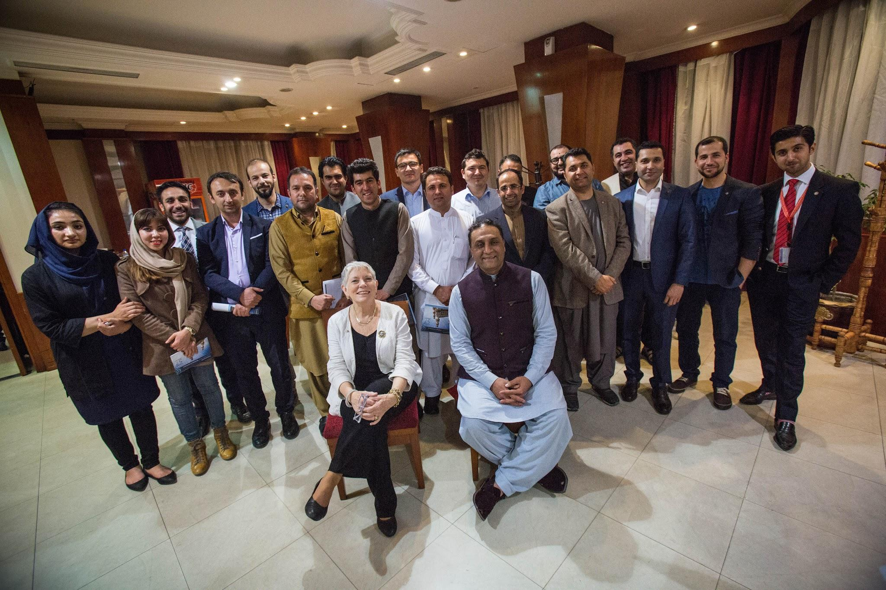

Submitted by:
Omar Mansoor Ansari, President, TechNation
oansari@technation.af

Contribution from:
Marilyn Cade, CEO, mCade llc - ICT Strategies

- Overview:
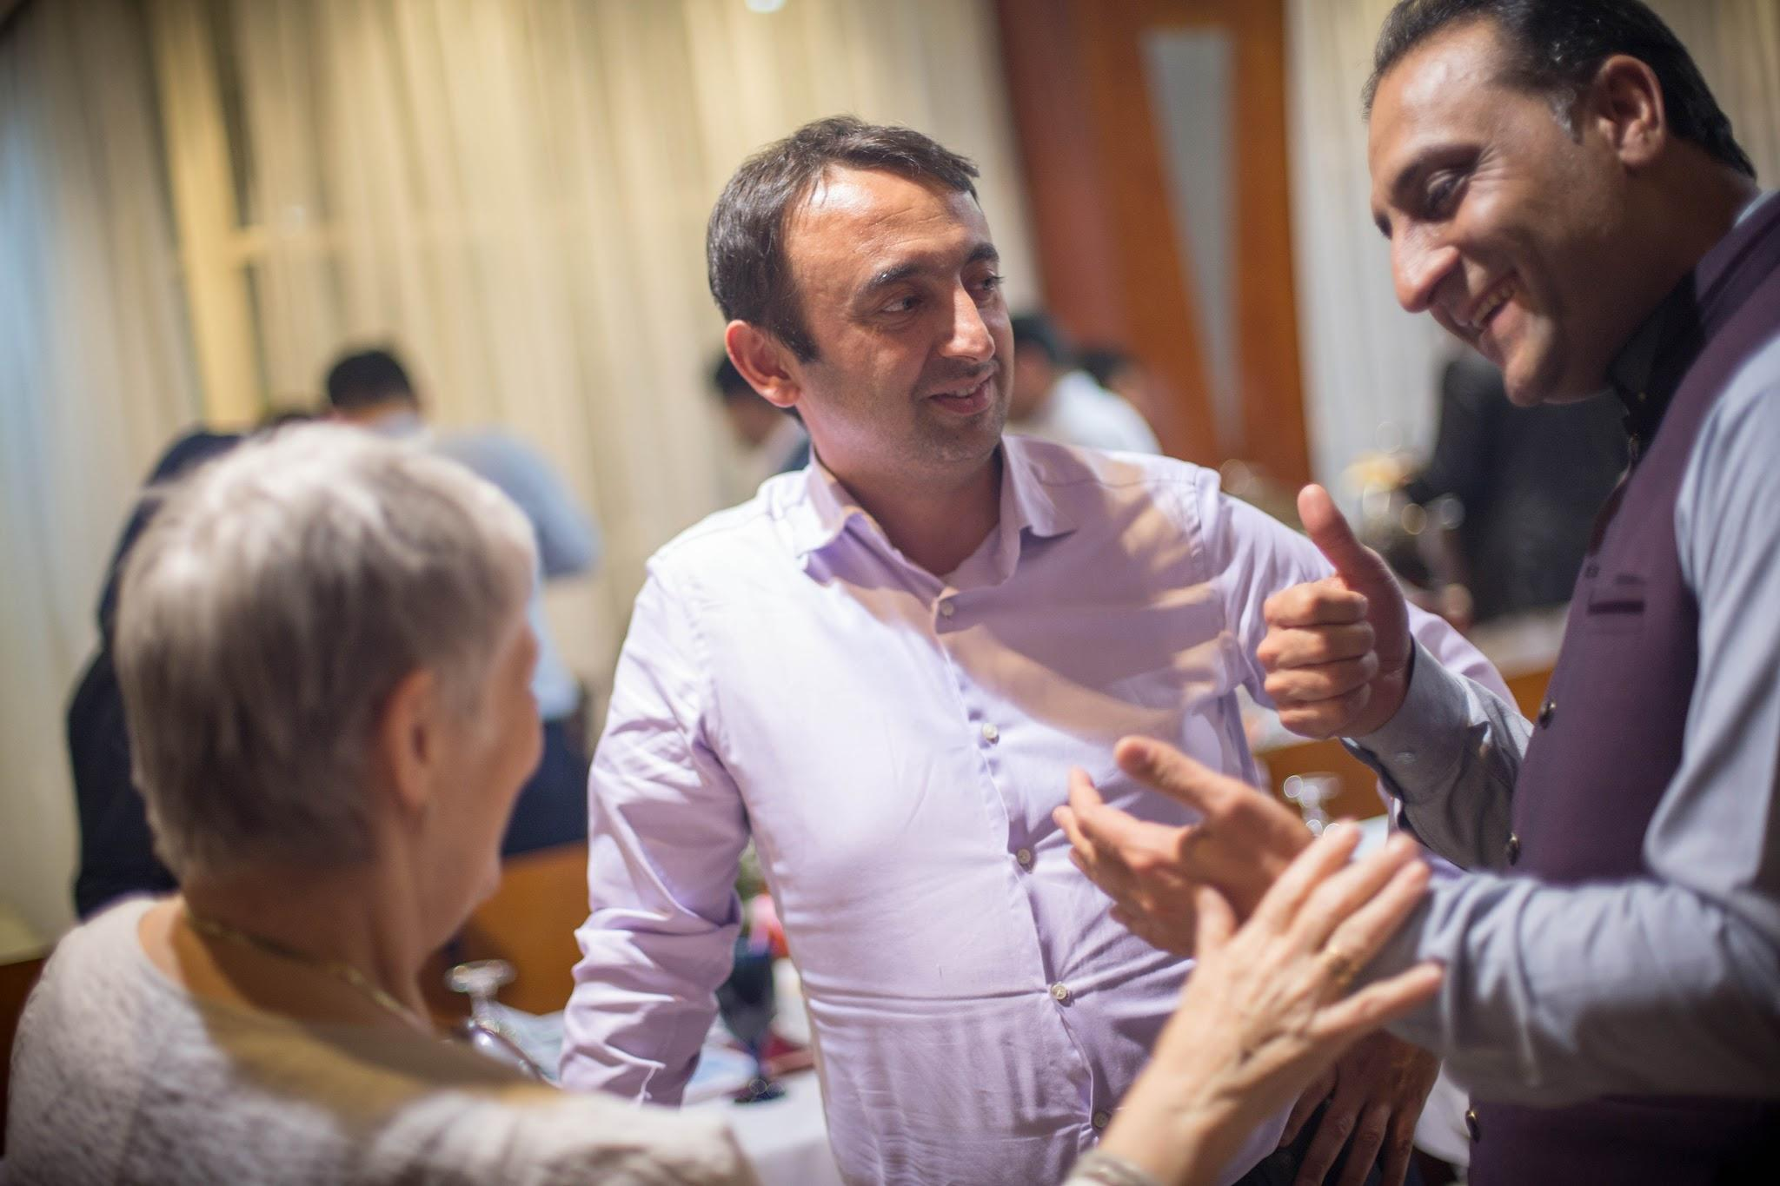
Afghanistan, being a landlocked and war-affected country, is under-represented at the global Internet Governance (IG) platforms, including ICANN. ICANN, over several meetings, had 5 Afghan fellows who take active roles in the local government, civil society and the industry. ICANN Business Constituency has had only one member from the Afghan private sector -- TechNation, led by Omar Mansoor Ansari who also plays a leading role in the ICT sector in Afghanistan. Omar was also aware of ICANN through his role as Board Member of World IT and Services Alliance (WITSA), and upon his appointment as an ICANN fellow, immediately established engagement with the ICANN BC through contacts with Jimson Olufuye, fellow vice chair at WITSA, and Marilyn Cade, former policy advisor at WITSA, and member of the BC Outreach Committee. In addition to engaging actively at ICANN, Omar led the engagement of Afghanistan-- government, business and civil society-- in the Internet Governance Forum (IGF), and has attended 4 IGFs. His engagement has included participating in business oriented workshops; engaging in briefing the Afghan government participants, supporting the development of a TechNation/ TechWomen Afghanistan organized workshop; and speaking at the opening session of IGF 2016 as the official business high level speaker. Omar Mansoor Ansari was appointed by the UN Secretary General to the Internet Governance Forum (IGF) multistakeholder advisory group (MAG) in 2016-- becoming the first Afghan ever appointed. Engagement in both ICANN and in the IGF have helped the Afghan stakeholders become more aware and thus active in IG fora. Building from engagement with ICANN, and the IGF, a multi stakeholder organizing group was developed in the country, and consequently the first Internet Governance Forum Afghanistan (IGFA) took place between March 29 and 30, 2017 in Kabul. The event brought together 200 key stakeholders under one platform to discuss pressing IG issues.

To support more visibility for ICANN with this community, two activities were developed: a) Inclusion of ICANN speakers in the overall program, and b) a special BC Outreach Program, proposed and organized and hosted by TechNation. The proposal was approved by the BC Outreach Committee and funding was allocated to TechNation to organize BC outreach activities..

During the IGFA itself, both Omar and Marilyn Cade, mCADE Strategies, attending as a speaker and participant in the IGFA, discussed ICANN BC interests and also distributed the BC newsletter. ICANN was highlighted through expert speakers, including Patrick Jones, Senior Director of ICANN's Global Stakeholder Engagement (GSE) team.

In addition, a special business outreach event was organized with an informal reception, followed by dinner, and a presentation about the Business Constituency@ICANN, jointly delivered by Marilyn Cade and Omar Mansoor Ansari -- both as members of the BC Outreach Committee.

- Highlights:
Following are some highlights from the event:

- First ever ICANN BC outreach in the region, particularly in Afghanistan;
- BC outreach material, presentation and information shared with about 200 individuals in the country;
- Within the core two day program, there were multiple sessions with BC focus, as well as invited ICANN staff speakers;
- Of 70 businesses and key stakeholders invited to the dinner, 30 prominent figures participated in the reception and dinner;
- Several businesses have shown interest in joining BC and follow up is ongoing.This includes encouraging Afghan SMEs and associations to apply for membership at ICANN BC;
- In addition, TechNation and team is encouraging individuals from all stakeholders to apply for ICANN Fellowship as well as NextGen, and, when ICANN meets in the applicable region.
- Possibilities exist to establish an ongoing exchange with the American University of Afghanistan (AUAF) and Kabul University to encourage ICANN to support NextGen participation from Afghanistan.

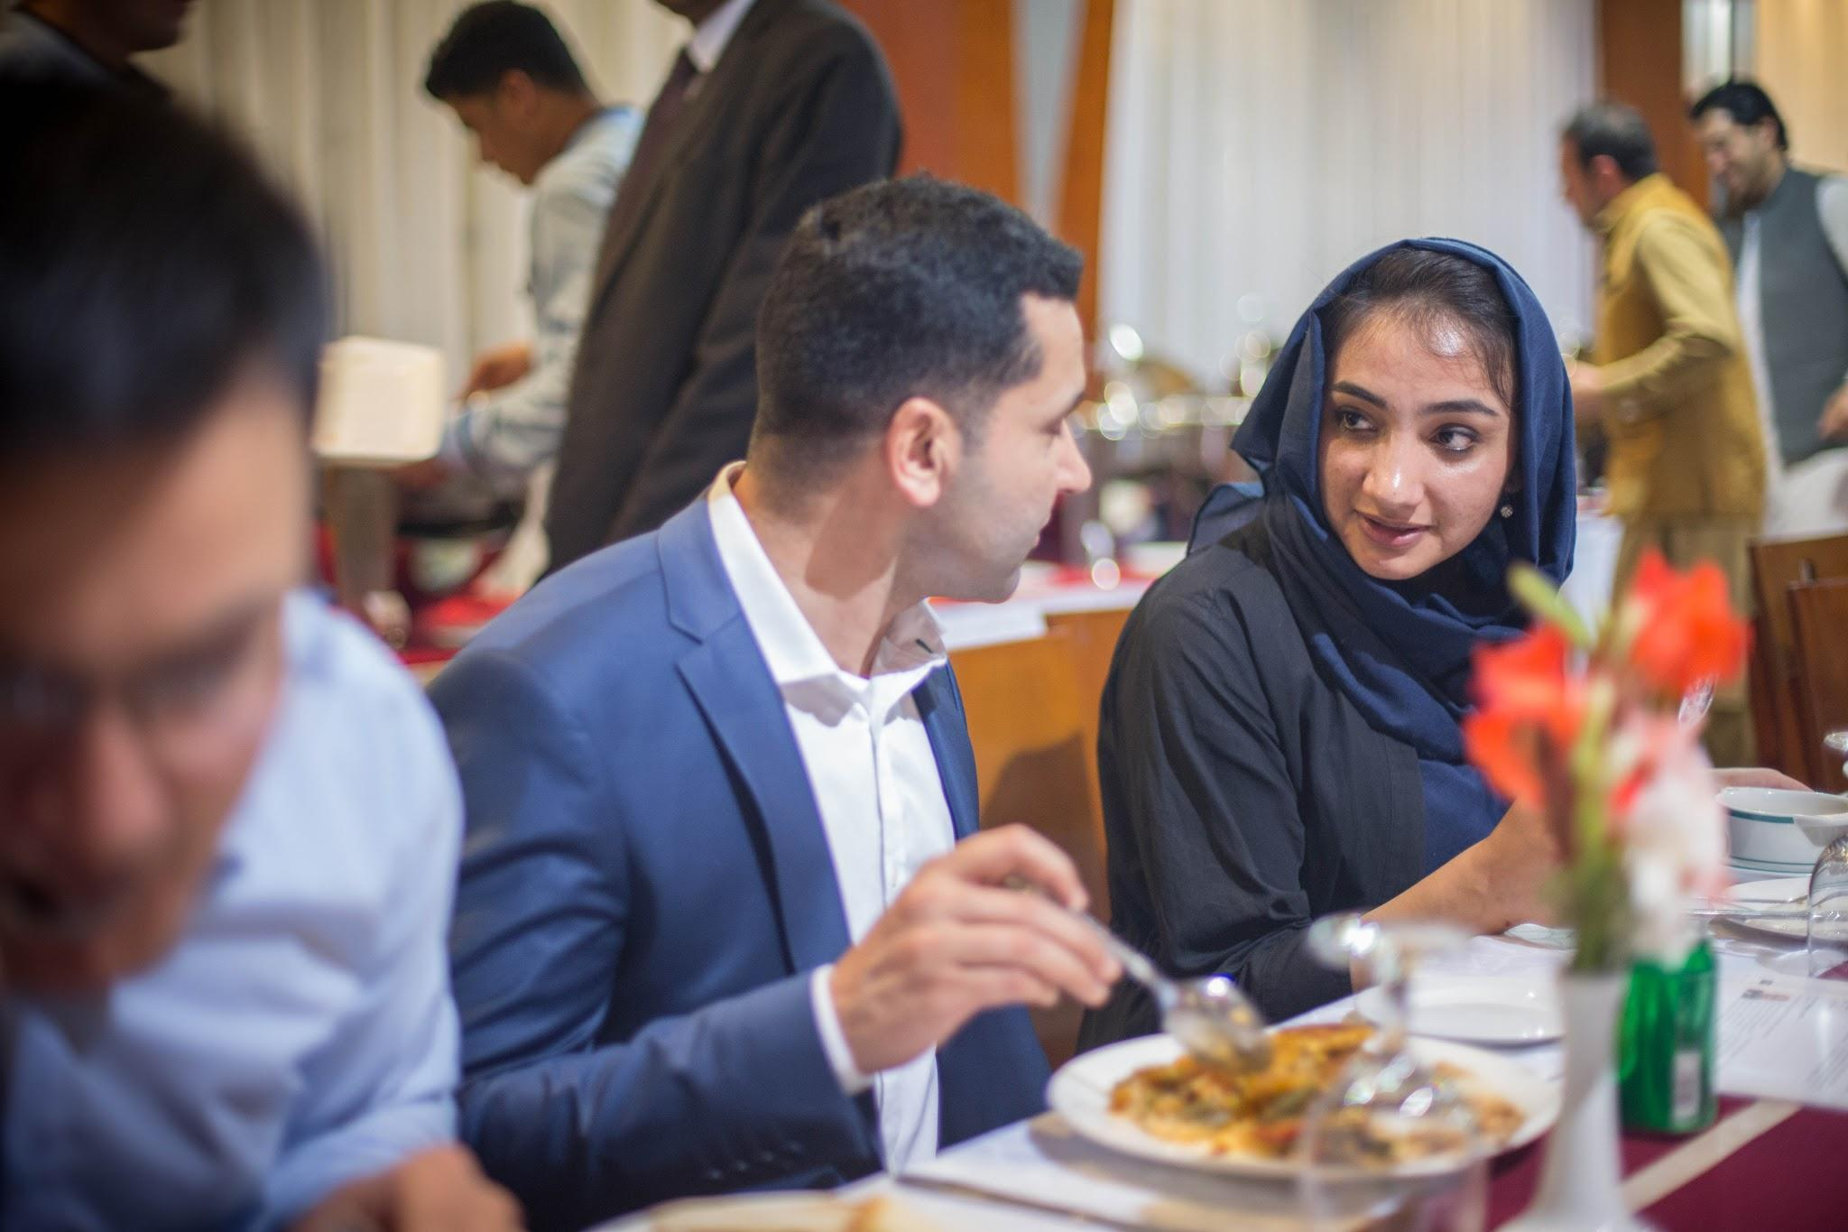
- Outreach Event Summary:
ICANN@BC held its first ever outreach activity in Kabul, Afghanistan, between March 29 and 30, 2017. The outreach activities were organized in three categories: a) Lunch sponsorship at IGFA for 200 participants; b) Information sessions through the IGFA workshops; and c) Dinner with the key private actors and high officials.

This activity was the first of its kind in the region. The BC@ICANN was represented by its members, Omar Mansoor Ansari, president of TechNation, and Marilyn Cade, CEO of mCade Strategies.

Omar and Marilyn spoke during various sessions of the IGFA on BC and its work worldwide, the importance of getting involved in the BC by the Afghan players, and how participants could become involved in the BC and within ICANN; and what the benefits are of becoming involved. Marilyn, as a key contributor/subject matter expert, attended sessions on Day Zero and Day 1 and Day 2. The Day Zero included an IG 101 workshop, which also included an overview of what is ICANN. Over 100 participants were introduced to new terms and topics in preparation for their active engagement in the three day IGFA. Another session was the “IG Academy for Kids” -- a 2 hour session, which included topics such as the Internet, ICANN and the Online world for children from ages 6-12 [a first ever event at an NRI].

Four (4) companies were interested in submitting an application, Omar has followed-up with them, to answer any questions, in the hopes of having them join the BC.

The BC sponsored the lunch for the event, and ICANN sponsored a dinner for business leaders and high officials and staff of TechNation.

Note: Afghanistan faces many challenges in inclusion of women in events, especially when these take place in the evening. While this was recognized, and other women initially confirmed, it is always challenging to host events in the evening. While this was recognized as a challenge, both Marilyn and Omar agreed that a first step is to create more BC awareness and members from the ICT sector, while separately addressing other challenges regarding programs that focus on gender engagement, and participation, which is not a priority focus of the BC@ICANN, but may be of interest to BC members from developing countries to explore as a further inclusion in the BC strategy.

- Lessons Learnt:
- Language translation was a major issue, as it was required to have three languages : English, Pashto and Dari. This significantly added to the accessibility of the information to the largely Afghan audience;
- Due to security challenges, the “usual” speakers from ICANN, ISOC, and elsewhere declined to travel to Afghanistan. Marilyn Cade, as BC Outreach Committee member, accepted the invitation to attend in person, and then worked directly with a number of expert speakers to have high quality and well organized remote participation;
- It is possible that IGFA, supported by the ICANN BC Outreach Committee, had more remote expert speakers integrated into its sessions than any other similar event. This required significant pre and on site coordination and skilled moderation and consumed a significant amount of Marilyn’s time on site;
- Explaining ICANN to SMEs and entrepreneurs is a real challenge, and needs more consideration within the BC’s outreach materials. Proposing travel to ICANN meetings is not a solution to the majority of participants but engaging locally through a possible quarterly briefing /webinar may offer a significant way to support not just Afghanistan, but other developing country businesses from CASA region, from Latin America, etc;
- Need to clarify what role participants can play by joining ICANN, particularly useful for smaller companies, e.g. more frequent sessions with the smaller sessions (remote webinars) would help increase understanding about how other small companies can be active in the BC and contribute to ICANN overall;
- Engagement can be expanded to Central Asian and South Asian participants, as current participation from this region is quite low. CASA countries business groups are being encouraged via contacts from Marilyn and Omar to apply for fellowship program at ICANN as an initial path to attending an ICANN meeting;
- Remote participation is actually quite expensive in terms of needed onsite management, and also robust access facilities. The BC’s support was integral to enabling the remote participation that helped to bring BC@ICANN into true visibility to the Afghan community.

- Outcomes:
The outcomes of the BC outreach activity in Kabul include followings:

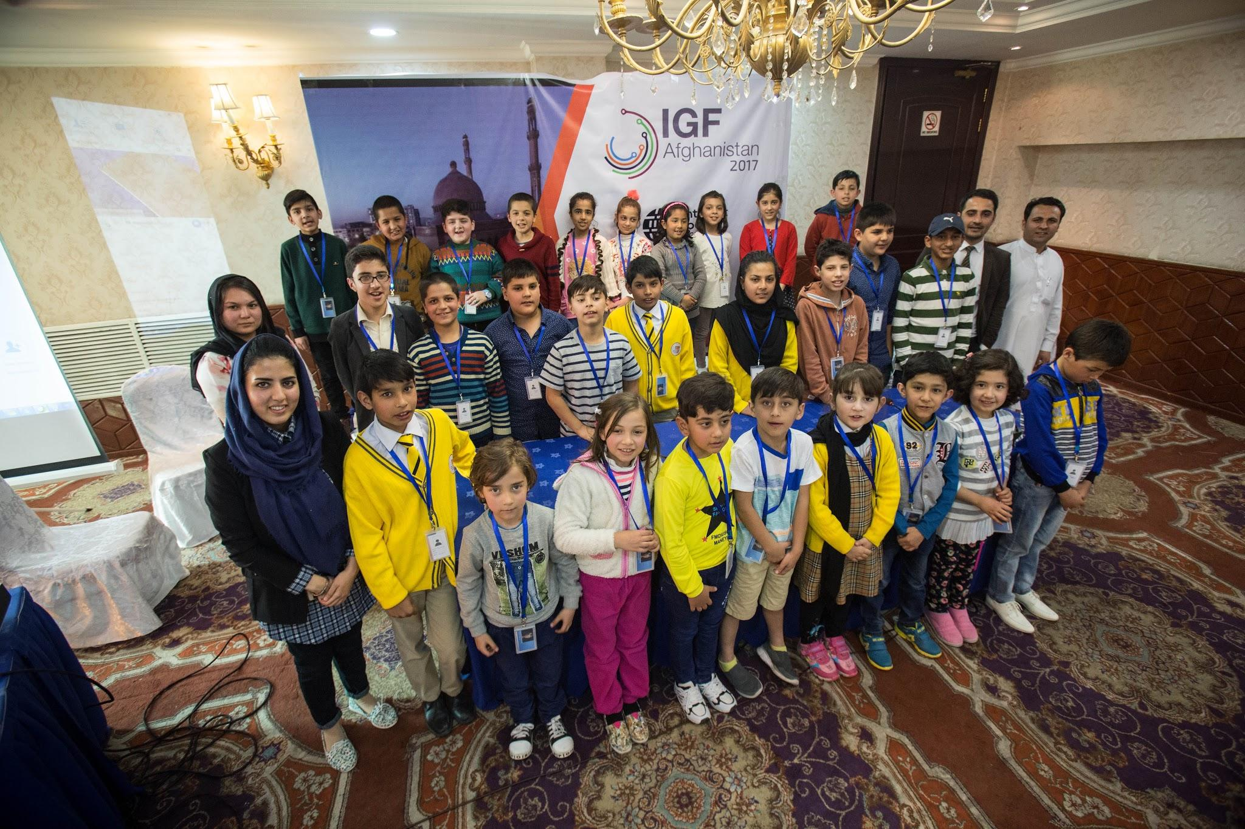
- Increased awareness about ICANN and ICANN BC in the CASA region, particularly in Afghanistan. This was done not only through BC sponsored activities, but also through BC member participation in several IGFA sessions; These sessions included the “IG for Kids Academy,” and IG 101 on Day 0, both sessions included an ICANN overview;
- Tetra Tech, IO Global, Mastercard and Afghan Wireless Services have more recently been contacted regarding becoming a BC member, learning about it through a briefing by Marilyn Cade regarding IGF and ICANN. Marilyn and Omar have follow up contacts;
- Increased number of remote speakers helped Afghanistan organize a premier IGF for the first time. Marilyn Cade did extensive outreach to contacts to organize remote speakers, and each session during IGFA did have the needed international expert speakers, engaging remotely.

- Challenges:
- ICANN’s presence and engagement with Afghanistan has been quite limited, partly because they have assigned Afghanistan to the MENA region -- where there is no alignment or affinity, and the government itself does not accept this “designation”. This assignment seems to be solely based on IDN alignment. Fortunately, the assigned ICANN MENA V.P. is highly receptive to engagement on a broader perspective, and further discussions are underway regarding ICANN’s engagement within Afghanistan;
- Afghanistan considers itself part of CASA-- Central Asia and South Asia, part of Asia Pacific (AP), and is served for IP addresses by APNIC. When Afghans travel to other countries, they naturally turn to the CASA countries, which include APNIC and APrIGF events. Afghanistan has no direct flights to any of the MENA countries, except for UAE (Dubai) and Iran (Tehran), both countries have tough visa regulations for Afghans. Afghanistan does not have direct land transport routes with any of the MENA countries, except for Iran. While, it has direct air and ground routine with 4 CASA countries-- visas are comparatively easy. It, therefore, makes more sense to include the country in the AP region than MENA;
- Security within Afghan can be a challenging issue for engaging within country with Afghans -- both business and government -- regarding security concerns. Both ISOC and ICANN staff refused to travel to Afghanistan, as did invited speakers from global businesses.

- Recommendations:
- Make the “business case” of why the Afghanistan and other CASA-based businesses should participate in gTLD policy and ICANN governance via the BC;
- Omar to speak at the NRI Networking informal gathering during ICANN59, Johannesburg, about the importance of ICANN’s continued engagement with the BC and other constituencies at the national level;
- Short insert about ICANN BC Outreach at the IGF Afghanistan (IGFA) in the ICANN WIKI through ICANN60, Abu Dhabi;
- Afghanistan to regain its ICANN GAC seat, several communications with the government underway. This will help Afghanistan’s engagement in the ICANN which will help in attracting more businesses to join;
- Additional players from business and other constituencies, such as ISPs, to be encouraged should be invited to get involved with ICANN;
- Continued follow up with potential members: Tetra Tech and IOGlobal regarding BC membership;
- Engage with businesses attending IGF 2017. This can be done by the BC members attending IGF 2017 contact details be gathered by Chantelle, Secretariat, including sessions speaking at;
- ICANN BC to support activities in the next IGFA 2018 to increase engagement, and also identify ways on how to engage differently with other countries co-located in the immediate subregion;
- Omar as a potential presenter and speaker at WITSA 2018, in India, March 2018, should use CROP support to support BC outreach at an event that will attract potentially 2500-3000 business attendees. (Note: WITSA is a global ICT world conference, that primarily attracts businesses and high level government speakers).
- Move Afghanistan into the AP region to help increase engagement with the ICANN and neighboring countries and countries in the region.

