Minister Shahzad Aryobee, Minister of Communications and IT meeting with Omar Ansari, ICANN BC Outreach Committee and IGF MAG Member, to Discuss Key IG Issues

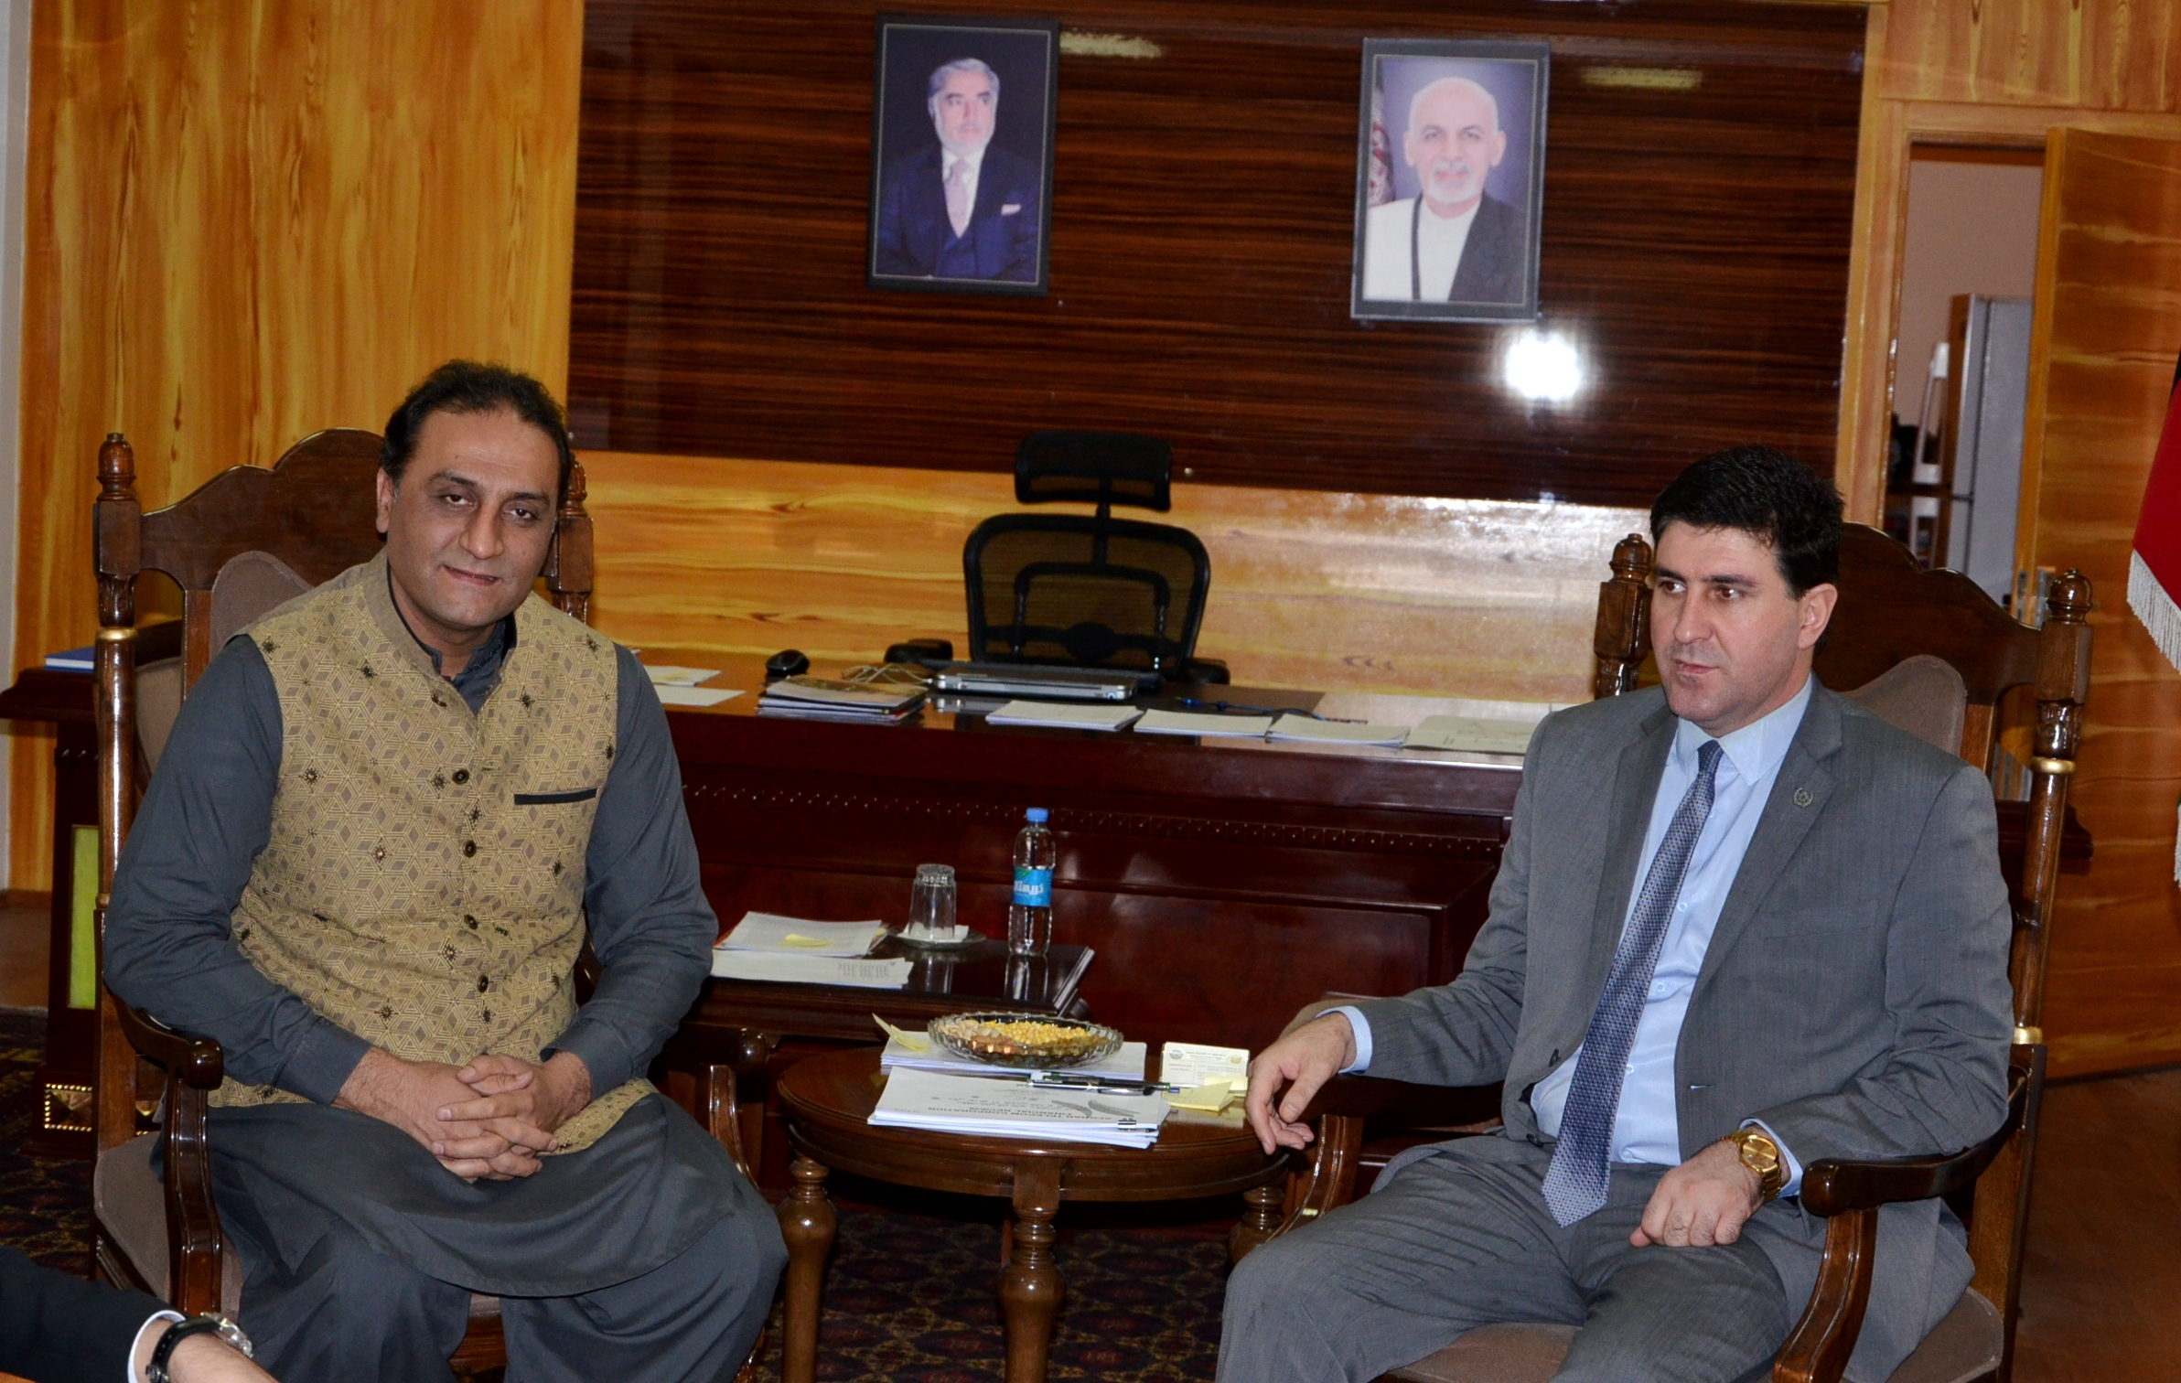
Kabul (18/10/2017): The Afghan Minister of Communications and IT, H.E. Shahzad Aryobee, received Mr. Omar Mansoor Ansari, a senior executive and entrepreneur in Afghanistan’s ICT Sector, who is a member of the Multistakeholder Advisory Group (MAG) of the Internet Governance Forum (IGF) and a member of ICANN Business Constituency (BC)’s Outreach Committee to discuss important Internet Governance issues. Mr. Anar Jahangirli, International Advisor to the Minister, was also present in the meeting.

The purpose of the meeting was to discuss key Internet Governance (IG) issues and challenges. These included: Afghanistan’s active participation at ICANN and the IGF, and related initiatives on national, regional and global levels. Detailed discussions also included the plans for participation of the Afghan government, and other stakeholders in the IGF2017, Geneva, Switzerland, 18-21 December, 2017.

Mr. Ansari shared views on how the country can play a role in the Internet Governance issues: such as: a) Collaborating with the local ICT/IG community on policy and regulatory enhancement activities; b) Collaborating with Internet Society Afghanistan and other players on IGF Afghanistan (IGFA), a national forum advocating for reform, building capacity, raising awareness and collaborating on IG issues; c) Afghanistan’s active participation at the other regional and global IGFs, such as Silk Road IGF (SRIGF). Asia Pacific regional IGF (APrIGF) and Global UN IGF; d) Afghanistan’s participation at ICANN through active re-engagement in the ICANN Government Advisory Committee (GAC); d) Encouraging other local stakeholders, such as private sector, civil society, technical and academia, to get involved in various ICANN constituencies, such as Business Constituency (BC), ISP and Connectivity Providers Constituency (ISPPC), Intellectual Property Constituency (IPC) and others.

As a member of IGF MAG, Mr. Ansari extended invitation to the Minister to participate at the IGF2017, along with a delegation to include government, industry, and civil society representatives. The Minister accepted the invitation, and both parties agreed to work on a plan for engagement during the IGF2017 for the Afghan delegation, to ensure Afghanistan takes maximum benefits from its participation.
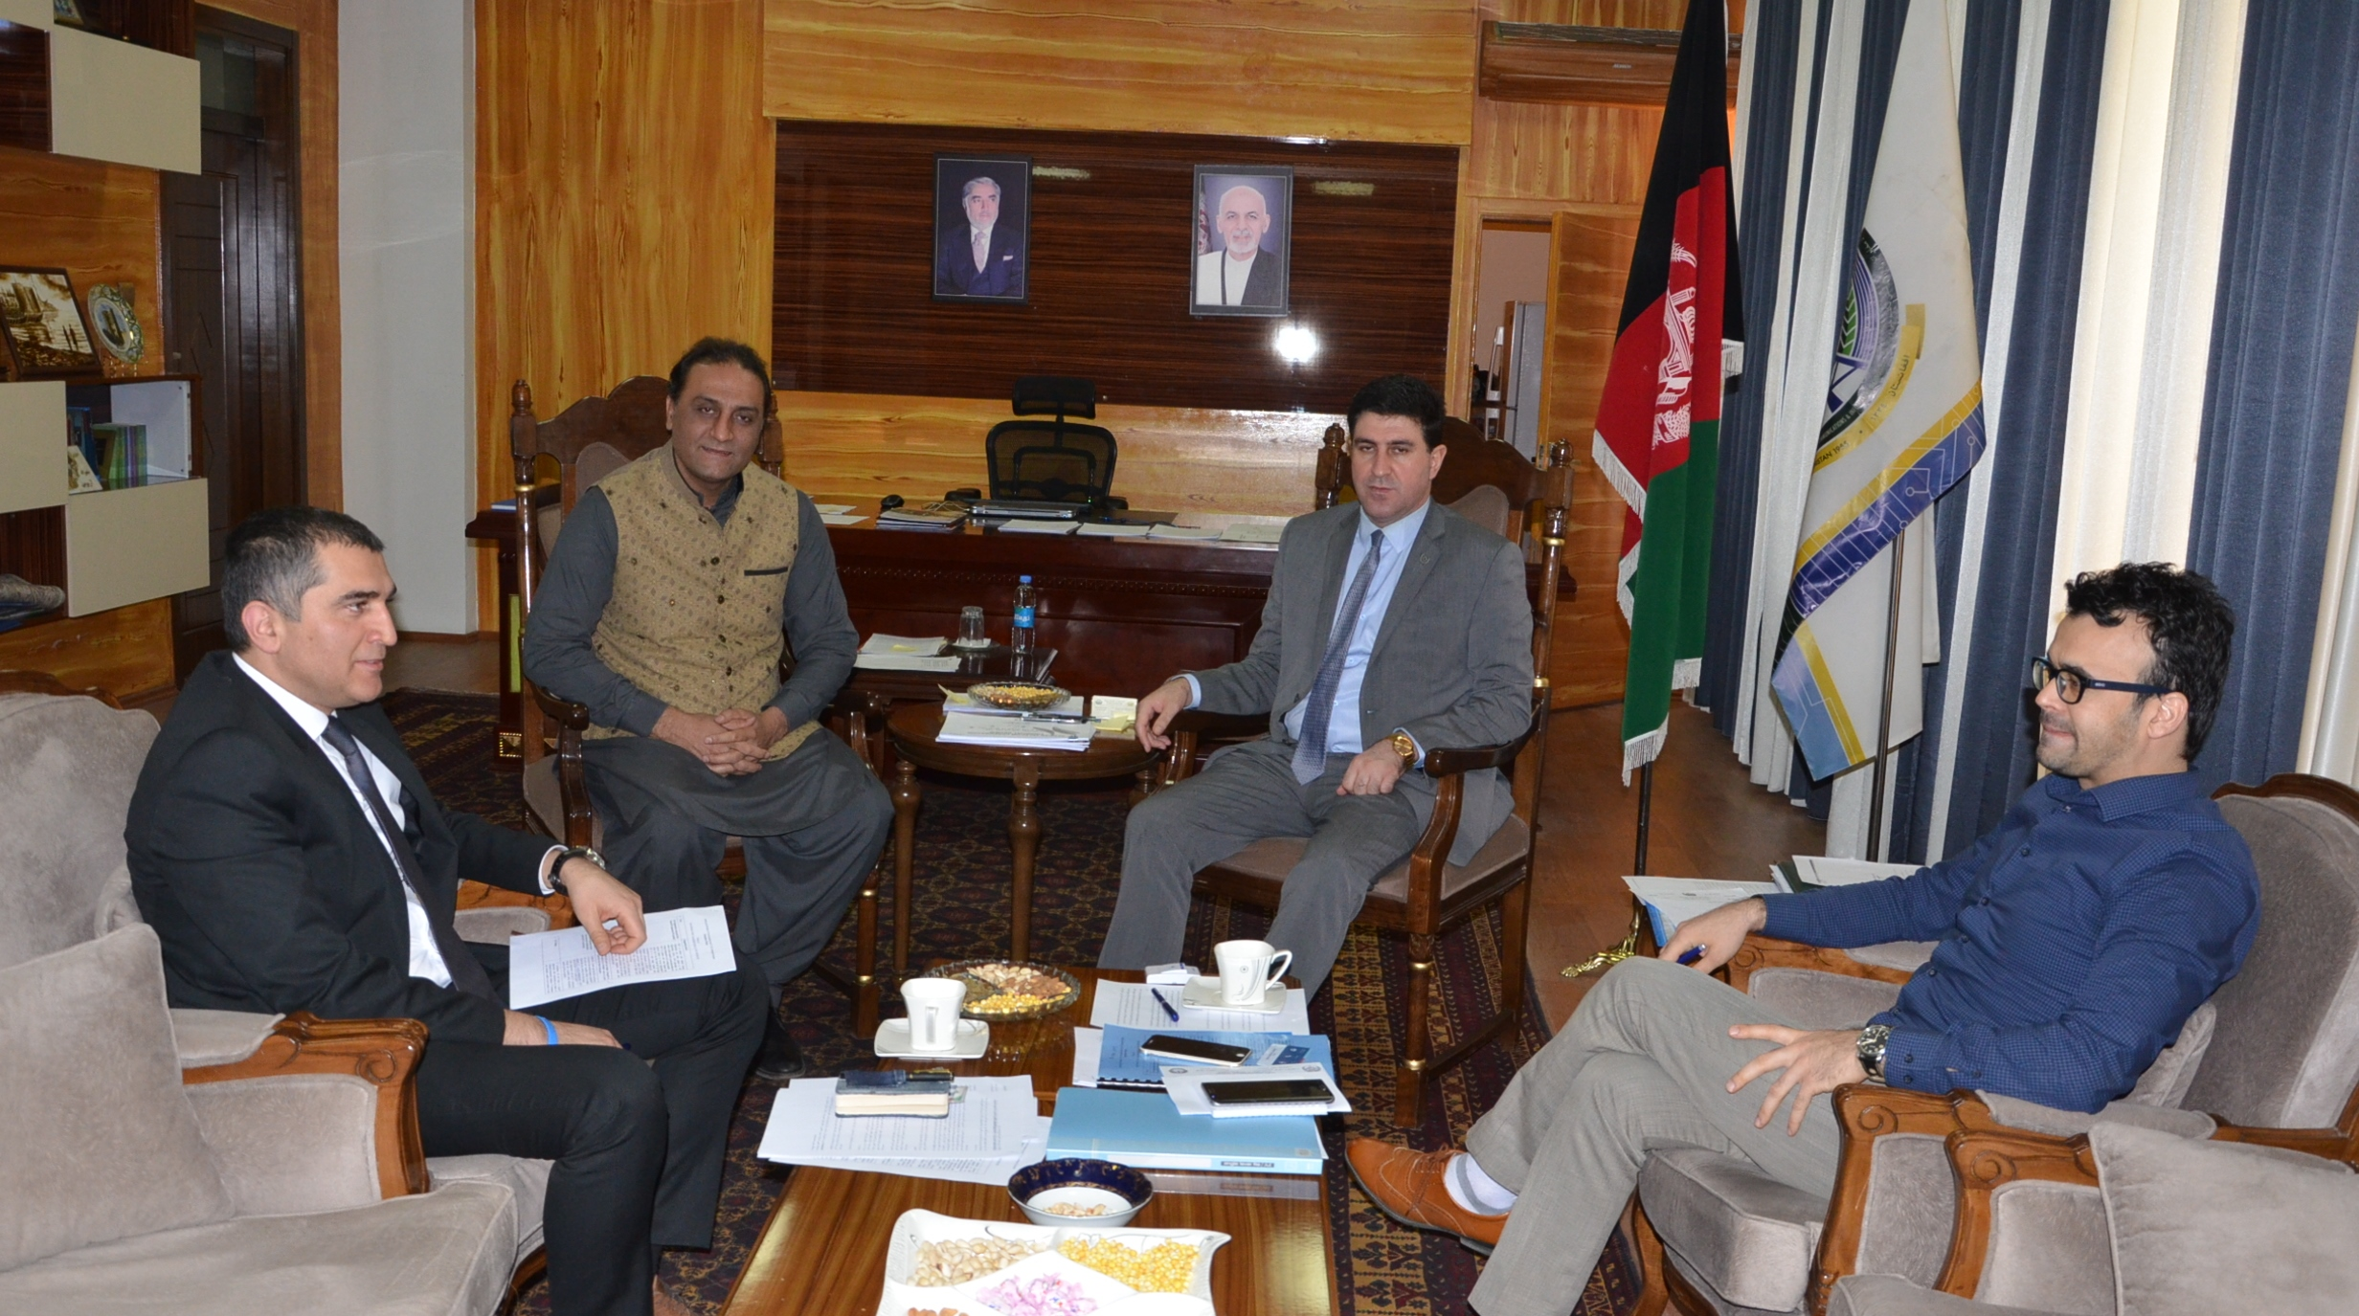
The meeting adjourned with an emphasis on exploring ways to ensure more collaboration among the local ICT/IG community resulting in better programming, plans and strategies, and an enhanced IG ecosystem as well as enhanced policy and regulatory environment. One of the issues, identified by the Minister, is focusing on is the revival of the National ICT Council of Afghanistan, which is an interministerial ICT council ensuring coordination among various government agencies and non-government actors.

About ICANN BC:
The Business Constituency (BC) is the voice of commercial Internet users within ICANN – the Internet Corporation for Assigned Names and Numbers. ICANN is a global body with responsibility for certain policies that relate to the domain name system (DNS), including domain names themselves. Domain names are the words that consumers and businesses rely upon to find websites for legitimate products and services on the Internet.

Business users rely on a stable and secure Internet and e-commerce experience, one that serves their users and customers on a global basis. For more information about participation in ICANN, and in the Business Constituency: http://www.bizconst.org.

About IGF:
Established by the World Summit on the Information Society (WSIS) in 2006, the IGF has become the leading global multi-stakeholder forum on public policy issues related to Internet governance. Its UN mandate gives it convening power and the authority to serve as a neutral space for all actors on an equal footing. As a space for dialogue it can identify issues to be addressed by the international community and shape decisions that will be taken in other forums. The IGF can thereby be useful in shaping the international agenda and in preparing the ground for negotiations and decision-making in other institutions. For the IGF mandate and other information on IGF: http://www.intgovforum.org/cms/aboutigf.

