
OUTREACH
@


The Event:
The Africa Internet Summit (AIS) is an annual, regional, multi-stakeholder ICT conference. It is the pinnacle educational and business ICT event in Africa where key players in the Internet industry can interact with the global Internet community. The Summit consists of seminars, workshops, tutorials, conference sessions, birds-of-a-feather (BOFs), and other forums for sharing ICT knowledge within the African region.
The Summit aims to bring the ICT business and technical community in Africa together under one roof to discuss ICT issues and challenges. The annual summit attracts internationally renowned Instructors, Experts and Speakers to share the latest innovations and Best practices in the Internet industry. This is the place where the African Technical Institutions such as AfNOG, AFRINIC, AfREN, AfricaCERT, AfTLD - AROC, ISOC Africa, AfrICANN, AfGWG etc meet. Delegates to the last conference held in Garborne in 2018 had an audience cutting across 17 African countries with over 1000 professionals across different continents of the world in attendance. The annual event features an ICANN Day and witnessed an elaborate outreach by the NCUC at the last edition.
This year’s event spots Workshop sessions from the 21st to the 28th of May and a conference belt from the 29th of May to the 2nd of June, 2017. The conference period is the target for the BC outreach. The event’s website and its sponsors can be found here, whilst their sponsorship page provides some additional statistics.

Introduction:

In line with its FY17 Outreach Strategy, the BC seeking to encourage diversity and new membership recruitment in Africa and other developing regions of the world, this proposal presents the BC with a unique opportunity to broaden its engagement and seek to recruit more businesses that align with its mission into the Constituency at the AIS 2017 conference holding in Nairobi, Kenya from the 29th to the 2nd of June, 2017.

BC Outreach initiatives in Africa has witnessed a massive increase since outreach interventions in the region increased. This is yet another opportunity to grow the membership and diversity of the BC in Africa.

Outreach Model:
- I have commitments to meet with some business leaders attending the AIS conference session in Nairobi, and would leverage on the huge networking potential this gathering presents to promote the BC. I have sort further introductions to the business community billed to be in attendance form the event organizers, leveraging on my relationship with Afrinic (as I have in the past organized and hosted a 4 day training event for them in Nigeria).

- I am awaiting confirmation on my proposal to lead a BOF (Birds of the Same Feather) session on “Start-Up Incubation and the Future of the Internet”. I await details of the room and scheduling of the day on which it would hold where approved. This session is perceived as a high interest topic as more African governments and the private sector imbibe the culture of incubating small tech companies and entrepreneurs under a common shelter to allow for mentorship, sharing, growth and collaboration.

- Participant at the birds of the same feather session on Start-up incubation would be introduced to the BC and provided copies of our Newsletters, Factsheets in English and French, copies of the recent “Meet the BC” bulletin and a small pocket card that introduces the process of applying for a BC membership in 3 easy steps would be handed out at the session.

- Copies of these fore mentioned materials would also be placed at strategic points around the conference venue, the ICANN booth and distributed at other business sessions during the conference.

Projected Outcomes:
- This Outreach activity would result in at least 3 new membership applications from the African region after the Summit.

- Businesses would be better informed about how to onboard into the BC and more awareness created locally about the BC and how businesses engage in the constituency.

- The presence of the BC would allow for more visibility across the Continent and diverse stakeholders participating at the summit. It would be an opportunity to promote our values, mission and objectives, our stakes in the empowered community and crucial role in the overall stability, reliability and resiliency of ICANN.

- This would be one way of addressing the volunteer burn-out phenomenon; by bringing fresh minds into the constituency hence this outreach would help reach out to potential members of the BC.

- Diversity. The issue of membership diversity is important for the BC and this outreach event will foster diversity within BC as new participants join our constituency to contribute to its diversity.

Request to BC Outreach Committee:

I propose to use BC budgeted fund to argument my travel to Nairobi, Kenya for the duration of the conference period. For this I request support in the sum of $1,500. To aid in the production of information materials in English and French, including newsletters, bulletins and cards to be distributed at the event, I request an additional support of $1,000.

The sum of two thousand, five hundred dollars $2,500 is therefore requested and approval in time to have the translation done and printing effected before my travel date so I can have them hand carried with my luggage to Nairobi.

Budget Breakdown:.

S/N | ITEM | UNIT | TOTAL COST ($)
1. | Production of BC Factsheet in English | 300 | 200
2. | Translation and production of BC Factsheet in French | 200 | 150
3. | Production of Meet The BC bulletin | 200 | 550
4. | Production of Join the BC Complimentary cards | 500 | 100
5. | Travel Support and logistics for Lawrence | 1 | 1500
TOTAL |  | $ 2,500

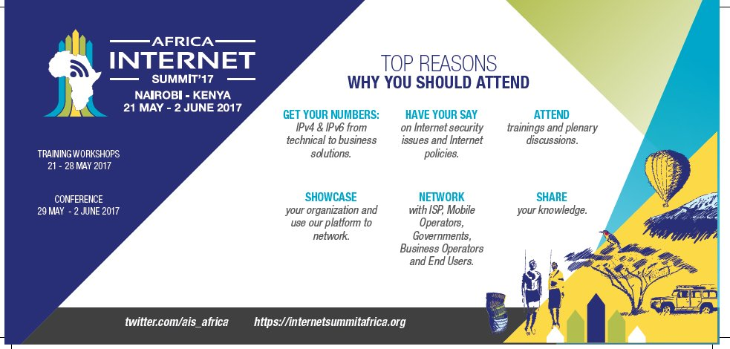

Therefore, the Outreach Committee is requested to approve $2,500 to fund outreach in Kenya from the 26th of May – 2nd June, 2017.

Submitted by Lawrence Olawale-Roberts; MD, MicroBoss & member, BC Outreach Committee.

