Outline ccNSO Policy Implementation Assistance process
Version 1 | 18 July 2023
Council Feed-back:
Community Feed-back
Adopted by Council:

Outline ccNSO roles and responsibilities implementation of ccNSO policies

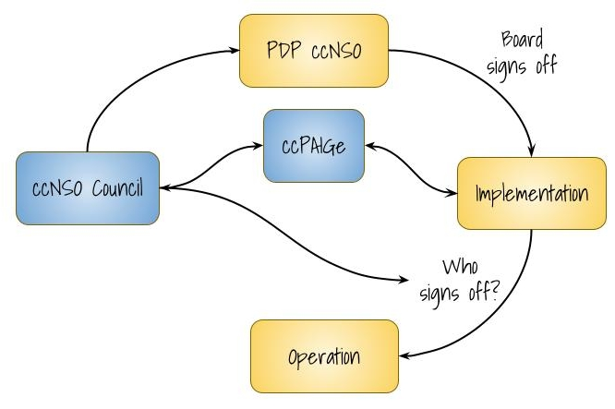

Introduction
This outline proposes roles and responsibilities for the ccNSO Council and the creation of a ccNSO Policy Assistance Implementation Group (ccPAIGe) to monitor and, if so requested by ICANN, provide assistance with implementing adopted ccNSO policies. The GNSO Implementation Review Team (IRT) Principles & Guideline serve as the model for this proposal.

A ccPAIGe’s roles and responsibilities involve interacting with ICANN to assist in confirming the intent of the policy recommendations during their implementation. In addition, the role of the ccNSO Council is detailed.

The roles and responsibilities of ICANN concerning the implementation of policies developed by the ccNSO are not considered in detail in this Outline:
- Firstly, it is the understanding of the ccNSO that the subject of each policy will inform how ICANN allocates resources to implement a specific ccNSO-developed policy.
- Secondly, although the ccNSO believes and there is an expectation that a ccPAIGe and ICANN should work together while recognizing each other's roles and responsibilities, it is not up to the ccNSO to define ICANN’s responsibilities, including those appointed by ICANN to implement the policy.
This Outline starts with the presumption that there is a need for rules of engagement between ICANN and the ccNSO. Every ccNSO Policy implementation project will need to agree upon the basic principles outlined in the balance paper.

Purpose of a ccPAIGe
Purpose of a ccPAIGe – To assure that the implementation conforms to the policy recommendations after the Board has adopted the ccNSO recommended policy, the ccNSO Council may convene a ccPAIGe for the purpose to assist if so requested by ICANN and monitor the implementation details.

Limitation of Scope of ccPAIGe
Avoid re-litigation of policy as part of implementation – A ccPAIGe is not a forum for opening or revisiting policy discussions. When issues emerge that may require possible policy discussion, ccPAIGe must escalate them using the escalation path.

No involvement in individual cases – A ccPAIGe is neither a forum to discuss individual cases nor to open policy discussions to address specific cases. When issues emerge that may require possible policy discussion, ccPAIGe must escalate them using the escalation path.

ccPAIGe Escalation Path – If there is a disagreement between ICANN and a ccPAIGe on the implementation details proposed by ICANN, the issue should be referred to ccNSO Council by the chair of the ccPAIGe as soon as possible. The ccPAIGe may advise Council on suggested next steps.

Include Purpose, Scope, and Escalation Path in Rules of Engagement – To clarify, the rules of engagement (see below, section 5) should include a reference to the purpose of a ccPAIGe, limitation of scope and the escalation path for both the ccPAIGe and ICANN.

Activities of ccPAIGe
Monitor and advice on implementation against recommended policy

Communication – The ccNSO expects ICANN to estimate the expected contributions from ccNSO and the anticipated implementation schedule. A ccPAIGe is expected to regularly provide written updates to the ccNSO Council on the progress made regarding the implementation.

High-level work plan/roadmap of implementation & ccNSO Work Plan – Milestones from a policy’s implementation plan will be integrated by the ccNSO into its Portfolio of Activities (with the expectations that the ccNSO Triage committee will monitor progress as well).

Rules of Engagement – It is expected one of the first joint activities between ICANN and a ccPAIGe is to develop and agree upon the Rules of Engagement for the specific implementation process (see also section 5 below). Once the ccPAIGe adopts these Rules, it will inform the ccNSO Council accordingly.

Membership of a ccPAIGe
Membership – The membership of each ccPAIGe will follow the ccNSO Committee outline:
https://ccnso.icann.org/sites/default/files/filefield_47785/outlines-working-groups-30mar16-en.pdf

When the ccNSO is seeking membership for a ccPAIGe, former members of the relevant PDP WG are invited and encouraged to participate as they can provide insight into the original reasoning behind policy recommendations.

One of the members of a ccPAIGe will act as liaison to the ccNSO Council (In light of the escalation path and the expectation that a ccPAIGe regularly updates the ccNSO Council on progress, the liaison would preferably be a Councillor).

Participants – Only the stakeholder groups involved in the Policy Development effort will receive invitations to participate in the ccPAIGe.

Bringing volunteers up to speed – Participants in a ccPAIGe are expected to be educated on the topic to undertake the work necessary to enable informed participation. Education may be essential when significant time has elapsed since the close of the working group.

Transparency – A ccPAIGe will operate with full transparency, with, at a minimum, a publicly archived mailing list and recordings of all ccPAIGe calls. In the extraordinary event that a ccPAIGe should require confidentiality, a ccPAIGe is encouraged to conduct its meeting(s) per the Chatham House Rule (comments and remarks should not be attributable to any of the individual contributors).

- ICANN Implementation team and ccPAIGe Rules of Engagement
The Rules of Engagement are expected to include and detail the following aspects of cooperation between a ccPAIGe and ICANN staff:
- Section 2 of this Outline.
- Frequency of updates on implementation progress by ICANN to the ccPAIGe.
- Meeting frequency and organization of meetings between the ICANN Implementation team and ccPAIGe.
- Minutes & notes taking, chairmanship of the meetings.
- Decision-making during the meetings, if any.
- Deadlines and response times - If the ccPAIGe’s input or comments are required, ICANN will establish clear deadlines for the ccPAIGe to provide feedback and comments on documents and implementation plans. ICANN will promptly send documents to the ccPAIGe to ensure sufficient time for their review. If ICANN provides these deadlines, the ccPAIGe should respect them.
- Milestones in implementation planning documentation (to be included in the ccNSO Portfolio, however, this is a responsibility of the ccNSO Council’s Triage committee.
- The requirement that the ccPAIGe will need to check whether the procedures developed as part of the implementation plan align with the policy recommendations.

Closure of ccPAIGe
If ICANN informs a ccPAIGe that the implementation work is completed or cannot be achieved, the ccPAIGe will subsequently inform the ccNSO Council accordingly, including assessing whether the implementation details meet the policy.

The Council will then close a ccPAIGe and inform ICANN of the group’s closure. A ccPAIGe is closed by a resolution of the ccNSO Council, referencing and considering the ccPAIGe report.

If, according to a ccPAIGe, the implementation details do not meet the policy requirements and/or implementation cannot be achieved, the ccNSO Council will inform the ICANN Board of Directors accordingly.

Miscellaneous
Review of Outline after the first implementation is completed - This outline will be reviewed after the first implementation process has been completed and a ccPAIGe closed. As part of this first review, the ccPAIGe is expected to conduct a self-evaluation. After the first review, it will be reviewed every 5 years or whenever deemed necessary by the ccNSO Council.

The updated Outline must be adopted by the Council and published on the ccNSO website to become effective. Before publishing the updated Outline, the Secretariat will include the version number and insert the date of adoption.

Omission in or unreasonable impact of the Outline - If this outline does not provide guidance and/or the impact is unreasonable, the Chair of the ccNSO Council will decide upon any questions or issues. However, once adopted by the ccPAIGe, the Rules of Engagement will be paramount.

Annex A: Lifecycle of policies
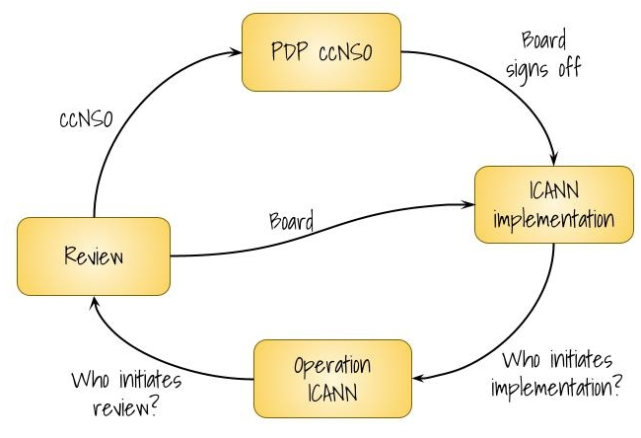

Lifecycle of policies and the roles and responsibilities of the ccNSO and ICANN
One of the core responsibilities of the ccNSO is to develop policies related to ccTLDs and directed to at ICANN. (Annex C, ICANN Bylaws). The process for developing these policies is defined in Annex B of the ICANN Bylaws. Once a policy has been developed, i.e. supported and endorsed by the ccNSO, it is submitted to the ICANN Board for consideration and adoption, (Annex B), following its procedures which, including a public comment period and an invitation to the GAC to provide advice.

As part of the result of adopting the policy proposals, the ICANN Board will typically upon adoption of the policy proposals direct the ICANN CEO or a designate to implement the policy. As there has not been a need to date to develop documentation of the roles and responsibilities of the ccNSO and ICANN (Board and Staff) org for the period of the implementation (due to lack of need).

The Board is expected to adopt the policy and direct the ICANN CEO or its designate to implement the policy, and after implementation, a policy becomes operational i.e. is executed through contracts or in another way (for example adjusted procedures). To complete the cycle, the operational policy is expected to be reviewed, which may result in an update of the implementation of the policy or a renewed policy development process.

Documentation of the roles and responsibilities of the ccNSO, Board and ICANN staff is desirable to ensure clear lines of communication, predictability of the process throughout the lifecycle, and align expectations. The outline implementation is the first iteration of such a framework. Its goal is to describe the various roles and responsibilities starting with the adoption of a ccNSO policy by the board, up to and including the implementation of that policy.

In developing such a framework related to ccTLDs policies, the ccNSO has looked at and reviewed the experiences with respect to GNSO-developed policies. , which focuses mainly on the role of the GNSO and ICANN with respect to implementation of the adopted policy. .

Based on this review it has developed a set of principles that could describe the role of the ccNSO during the implementation. However, the ccNSO believes that such a broader framework requires a broader discussion, including but not limited to the implementation, but also focusing on the processes to review the implementation of a ccNSO developed policy, how to make changes to the implementation plan of already implemented policies.

In developing a framework the assumption is that implementation is the phase between adoption of a policy and the moment the policy is operational. It is also assumed that this time is needed and will be used to understand and obtain resources to operationalize the policy, as well as to enable those parties who will be implementing and are affected by the policy (ICANN ccTLD operators and/or others) to prepare. Once implementation is completed, it becomes operational and, it is assumed that ICANN directly or indirectly (though contracting or otherwise) is responsible for the operation under the policy.

Over time it has become standard practice that policies and their implementations are reviewed after they have been in operation for a period of time. Two examples, historical RFC 1591 and the implementation of the principles described in it were reviewed through the ccNSO Delegation and Redelegation review Working Group.
The IDN Fast Track Process has been reviewed 3 three times at the instigation of the ICANN Board, (per requirement as required by the Fast Track Implementation Plan) and at the initiative of the ccNSO, (which resulted in the IDNccPDP4 Issue report). In addition, some of the ccNSO proposed policies explicitly require a review after an event or time period. To date, the roles and responsibilities of the ccNSO and ICANN org with respect to these reviews have not been delineated.

Finally, reviews may demonstrate a need to update implementations, or to modify or create policy depending on the outcome of a review, the implementation could change (FoI and aspects of the Fast Track), or the policy may needs to be revised (IDNccTLD selection process) or newly developed (Retirement of ccTLDs and Review Mechanism). If a policy needs to be revised or newly developed, Annex B of the Bylaws applies, in which the roles and responsibilities of the ccNSO and ICANN are described.

Again however, for amendments to implementations, the roles and responsibilities of the ccNSO and ICANN with respect to amending the implementation have not been well described. If a policy needs to be revised or newly developed; , Annex B of the Bylaws applies, where in which the roles and responsibilities of the ccNSO and ICANN are described.

If the ccNSO Council convenes an ccPAIGe, it will be convened for the implementation of one specific ccNSO PDP.
For example, provide guidance or launch a ccNSO PDP
It is expected that a ccPAIGe provides updates at or in advance of a ccNSO Council meeting.
The Membership definition will be included once the SoI/CoI Guideline has been adopted. Which of the following groups are eligible will be determined at a later stage. The categories of people identified under the SoI/CoI are: Members- Members are representatives from ccTLD managers or their nominees. With respect to members of a ccNSO Group there is no requirement for the ccTLD managers to be a ccNSO Member. Members are appointed by the ccNSO Council. Participants – Any person who participates in a ccNSO group on equal footing as members. Participants are not appointed by Council. Expert - The ccNSO Council or chair of a ccNSO Group may also invite and appoint a person as advisors to the Group, because of their special knowledge or expertise. Experts shall not be considered members of the WG, but are entitled to participate on an equal footing in their area of expertise. 7
See Annex C of the ICANN Bylaws, according to a process defined in Annex B of the ICANN Bylaws.

