Report on SOPC Session at ICANN74

- The session started with the brief introduction of Planning at the ccNSO in general:
ccNSO Triage Committee (internal focused) – explained by Jordan Carter
SOPC (external, ICANN planning focused)
- Reasons to revisit SOPC’s Scope of Work and Working Method:
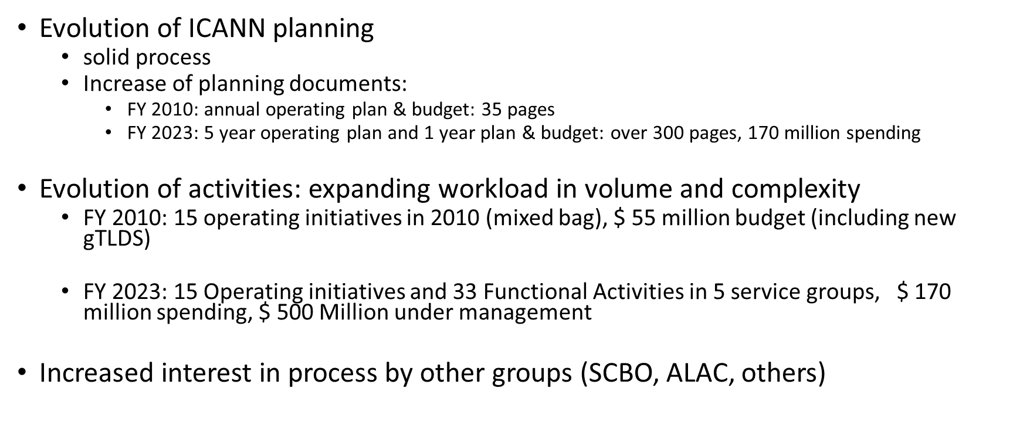
- Revised SOPC purpose statement?
Was developed during SOPC meetings in April-May
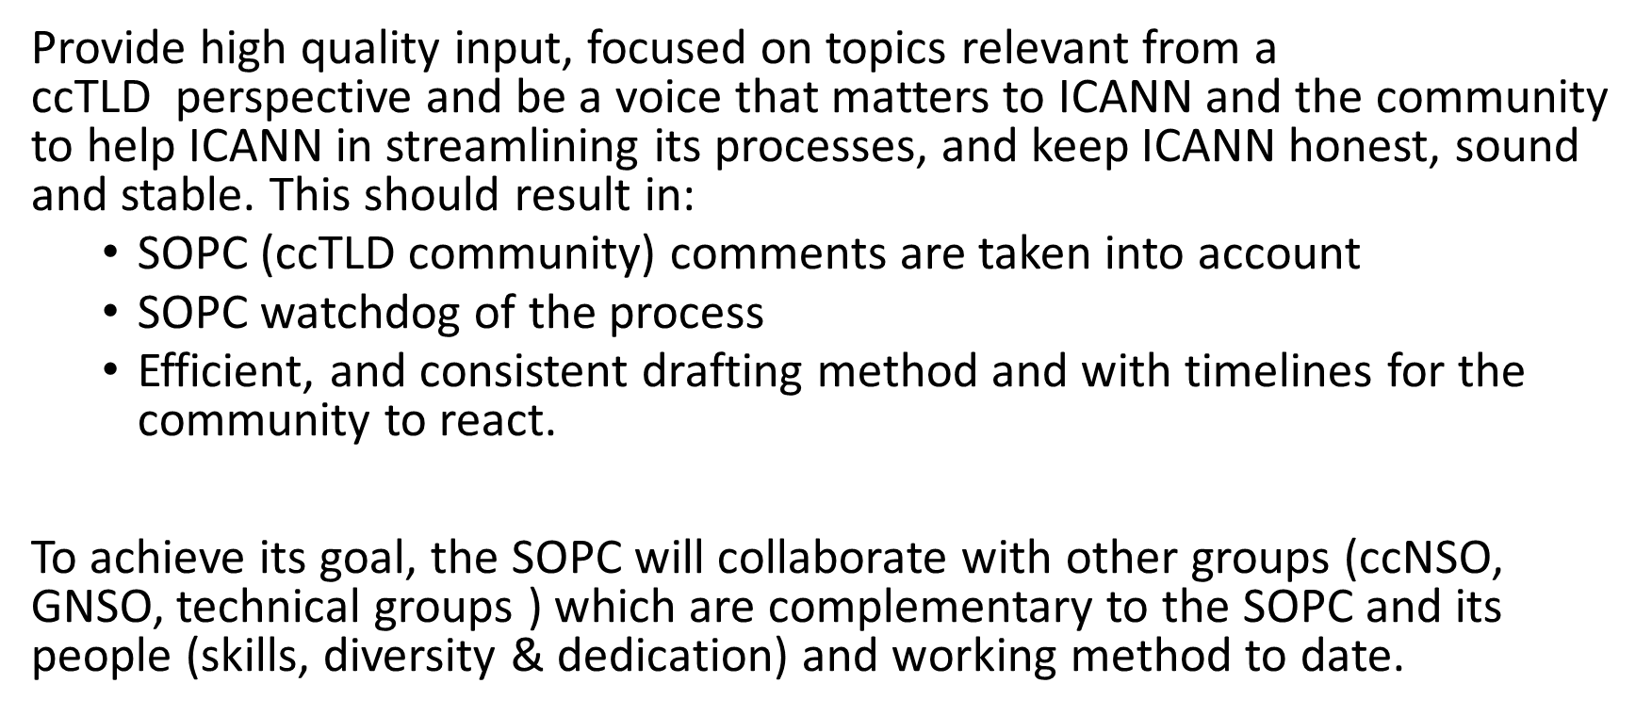
Polling results demonstrated strong support for the statement

- Limitation of SOPC focus
- The SOPC comments on all ICANN’s planning documents, ranging from the full 5 year- Strategic Plan to ad-hoc consultation on reserve funds.
- Alternative approach: SOPC should comment only on Operational Initiatives relevant for the ccTLDs
Polling results
- Only ccTLD-relevant strategic initiatives - 36%
- ICANN's strategic & operational planning and budget - 50%
- All ICANN planning initiatives – 14%
Comments:
Pierre Bonis: It’s almost impossible to look at priority if you don’t look at others. We cannot ask for prioritization of something that is of concern for ccTLDs if we don’t give our views on the other priorities
Roelof Meijer (in the chat): the difference is strategic planning vs very detailed operational planning

- Coordination with community
Poll 3 on consultation:
The SOPC should
- Consult with ccTLDs first, before submitting comments – 40%
- Submit comments first, then alert the community – 50%
- Not sure – 0%
- No opinion – 10%
Pablo: It only make sence to me that if we are going to make an informed decision we should consult it first, discuss it, and if we agree, then we submit. But if someone were to submit the SEC – who would make the decision to make a comment and then we’ll discuss it. That doesn’t seem to be something that I feel comfortable with.
Allan: what does it mean proactively?
Jordan: 2nd option. As long as SOPC shares it’s alert before the deadline people can make there own comments if they have different point of view.
Annebeth Lange: Juicing th WG to do the work for us, we are giving them a mandate. And that goes for all working goups. It’s no point in going back and consult the ccTLDs
Roelof Meijer: agree with Annebeth. Timelines and trust.

- SOPC internal collaboration
The SOPC should collaborate with other ccNSO Working Groups and Committees
- Yes, I agree - 81%
- Not sure – 10%
- No, I do not agree – 5%
- No opinion – 5%

- SOPC external collaboration
The SOPC should collaborate with same kind of groups in other SO/ACs – strong support
- Yes, I agree - 83%
- Not sure – 13%
- No, I do not agree – 0%
- No opinion – 4%
Pierre Bonis: I read ‘should” like we are asking so busy members to systematically coordinate or collaborate with others. I think it's very heavy. If it’s useful for you to have an exchange of ideas with other SO/AC – do it.

- Next steps

- SOPC to review guidance of community
- SOPC to propose update of its charter to the ccNSO Council
- Building on results Strenghts, Opportunities, Aspiraration, Result (SOAR) analysis, develop action plan to prepare SOPC for its future work

