Accuracy verifications ccNSO Member Database

By Joke Braeken, 14 October 2019

- Introduction

As a follow-up of the discussions during the ICANN65 Marrakech ccNSO Council meeting (26 June 2019), the ccNSO Secretariat reached out to those ccTLD managers that are member of the ccNSO. As approved by the Council in Marrakech, the approach for each ccTLD was determined on a case-by-case basis, under the auspices of the ccNSO membership application manager, Souleymane Oumtanaga.

- Verifications

The following actions were completed:

- Match with IANA database

The ccNSO Secretariat checked whether the organisation listed as ccTLD Manager in the IANA delegation record, matched with the entry as member in the ccNSO Member Database. In case discrepancies were noticed, the current ccTLD manager as well as the contacts in the ccNSO member database were approached.
Following this action, 7 ccTLDs were informed they are not a member of the ccNSO. (See further details under heading 3 of this document.) Since the September 2019 ccNSO Council meeting, there are no outstanding issues for any of the ccTLDs that are currently a member of the ccNSO.

- General accuracy check

For each of the 169 ccNSO members, the ccNSO Secretariat reached out to the primary contact from the ccNSO member database, the IANA admin-c and the IANA tech-c. An export from the ccNSO member database was sent to the aforementioned email addresses, on a per ccTLD basis.
Instructions sent to the ccTLD managers:
  - Verify the membership details of your ccTLD as included in this email. Please pay special attention to the email address of the primary contact for your ccTLD.
  - Reply to this email if changes are needed.
Consult annex A to this report for further details on the type of response, including statistics on a per-region basis.

- Total number of ccNSO Members

In 2019, the following 8 ccTLDs were informed they are not a member of the ccNSO. According to the ICANN Bylaws, ccNSO membership is limited to ccTLD Managers (originally Sponsoring Organisation), which are the entities listed as ccTLD Manager in the IANA TLD Delegation record. For some ccTLDs, the current ccTLD Manager applied in the meanwhile to become a ccNSO member.

ccTLD | Country | Status on 13 September 2019
.ec | Ecuador | No longer a member of the ccNSO
.ml | Mali | No longer a member of the ccNSO
.tg | Togo | No longer a member of the ccNSO
.tr | Turkey | Current ccTLD manager joined the ccNSO
.vg | Virgin Islands, British | No longer a member of the ccNSO
.vu | Vanuatu | Current ccTLD manager joined the ccNSO
.zm | Zambia | Current ccTLD manager joined the ccNSO
.bj | Benin | Current ccTLD manager joined the ccNSO

Status on 14 October 2019:

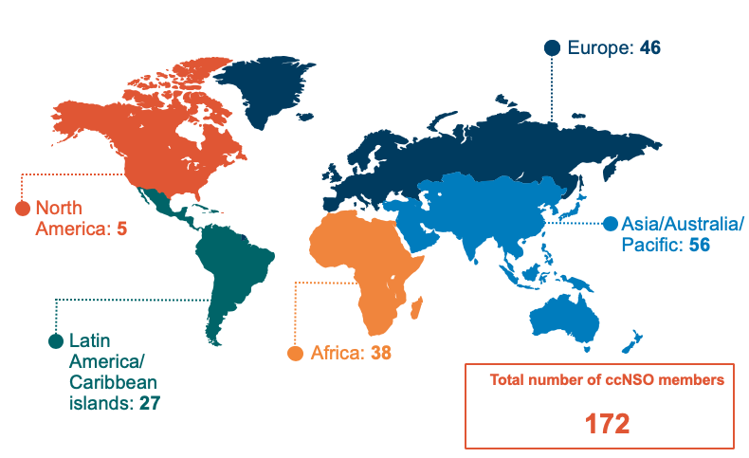

- Conclusion

- On 4 October 2019, the ccNSO counted 170 members. All ccNSO Member data matches with the data of the ccTLD Managers in the ccNSO Member Database.
- There are no further issues that require follow-up actions.
- IANA Services staff was invited to let the ccNSO Secretariat know, once a ccTLD transfer was completed, to avoid future discrepancies between the ccNSO Member Database and the IANA delegation record. According to the ICANN Bylaws, ccNSO membership is limited to ccTLD Managers (originally Sponsoring Organisation), which are the entities listed as ccTLD Manager in the IANA TLD Delegation record.

ANNEX A: Results general accuracy check
Latest clean-up statistics, as per 4 October 2019

