Contents
Background 2
Timelines: 3
Tone: 3
Goals 3
Outputs 4
Target Audiences, Expected Actions and Key Messages 5
Tactics 6
Activities Calendar 8

Background
In March 2014 the United States Department of Commerce (hereafter referred to as the NTIA) announced its intent to transition the oversight of the IANA contract to an international, multi-stakeholder group. ICANN has been tasked with developing a proposal for the development of the alternate oversight body.
ccTLDs can influence the IANA oversight transition process through two parallel processes: IANA stewardship (CWG-IANA) and ICANN accountability (CCWG-Accountability). Both the CWG to Develop an IANA Stewardship Transition Proposal on Naming Related Functions and the CCWG on Enhancing ICANN Accountability are expected to release documents for public comment during the week of April 20 identifying their proposed mechanisms to ensure effective oversight of the IANA functions and to enhance ICANN’s accountability. The public comment period will be open for 30 days.
To ensure the overall transition is successful, and to ensure legitimacy in the process leading up to the submission of a proposal to the IANA Stewardship Transition Coordination Group (ICG), it is critical that ccTLD operators have the awareness, knowledge and opportunity to submit comments and otherwise feed into the process.
The global ccTLD community is diverse, and engagement to date in the process has been limited. This poses unique challenges for engaging the community.
- By definition they operate within different cultural and linguistic communities and operate under diverse legal frameworks
- ccTLDs range in size from a few thousand domain names under management to a few with tens of millions under management.
- Some ccTLDs are member-based and/or not-for-profits. Others are government departments, and some are privately held.
- While some ccTLDs are not-for-profits and generate income only to reinvest it in their host nation’s Internet community, others are run as for-profit business. There are a number of ccTLDs that are subsidized by other entities, such as governments.
- ccTLDs organize themselves in many different ways. Most (>150, or 60 per cent) are members of the ccNSO. Those registries represent more than 90 per cent of all domain names under management by ccTLDs. Others are members of respective Regional Organizations (RO), and some are members of both the ccNSO and an RO. A small but significant portion is non-aligned, not organized with any group(s) whatsoever.
- ICANN has five defined regions: Africa (AF), Asia/Australia/Pacific (AP), Europe (EU), Latin America/Caribbean (LAC), and North America (NA).
A two phase plan to enhance awareness and increase participation among ccTLD operators in the IANA stewardship transition process is proposed:
- The first phase will involve ensuring ccTLD operators submit comments on the CWG-IANA proposal and the CCWG-Accountability document during their public comment periods. The details of this phase are identified in this plan. The activities in this phase will be coordinated with the broader engagement activities of the CWG.
- The second phase will involve engaging ccTLD operators in the decision-making process for the CWG-IANA proposal. This phase will be initiated after the close of the public comment period, and is expected to be led by the ccNSO Council, CWG members and participants. The engagement plan will be developed by mid-May, taking into considerations lessons learned through the implementation of the first phase.

Key Milestones:
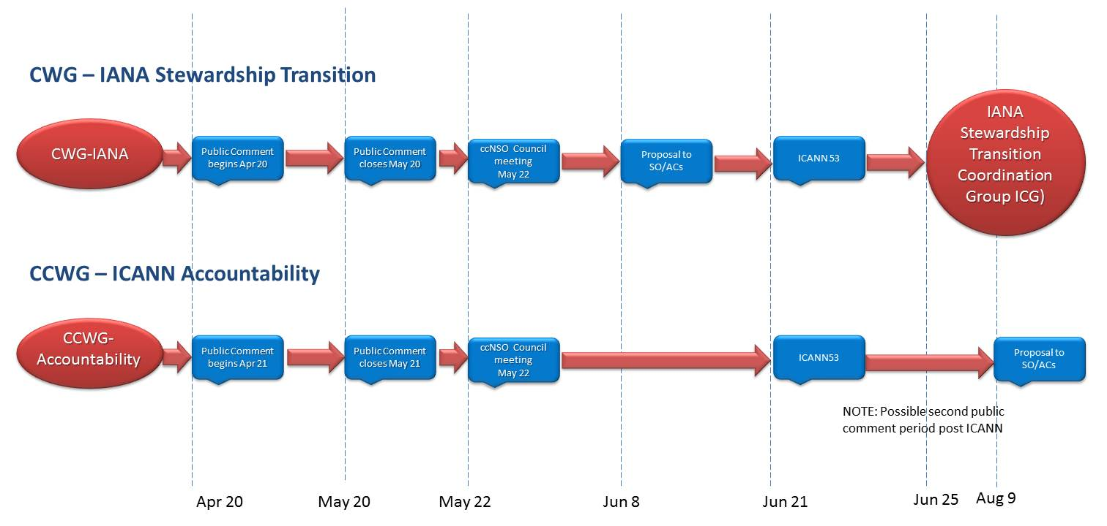

Tone:
The majority of ccTLD operators are generally not engaged in Internet governance processes and are not native English speakers. Therefore, the tone of the communications should be engaging and accessible – written communications should not exceed a Grade 6 level in English, and should be made available in the UN’s official languages: Arabic, Chinese, English, French, Russian, and Spanish.
The following questions will be answered in the communications outputs:
- What is the IANA stewardship transition and ICANN accountability processes and why do they matter to ccTLD operators?
  - Background to the NTIA announcement, CWG and CCWG processes and linkages, key dates and milestones.
- How will the transition affect that relationship? What are the consequences for ccTLDs?
  - Identification of issues, explanation of proposed mechanisms/processes.
- How can ccTLD operators get involved?
  - Call to action: engage community in public comment periods.

Goals
- Global ccTLD operators will submit comments on the CWG-IANA proposal during the public comment period.
  - To achieve this goal, ccTLD operators that have demonstrated engagement in the IANA oversight transition process to date will be targeted.
  - Specifically, ccTLD operators that have submitted comments on the December 2014 draft; have members on the CWG, CCWG or ICG; or have publicly commented on a regular basis on the transition.
- To enhance awareness of the CWG’s proposal among ccTLD operators that a) understand the importance, but do not have the capacity or sufficient interest to look at the details, or b) ccTLD operators who are not interested in the IANA stewardship transition at all.
  - If possible (unlikely), move them to engage in the process by submitting comments on the proposal through formal channels.
Fundamentally, it is necessary to ensure a sufficient number of comments from the ccTLD community on the CWG proposal by moving highly engaged ccTLD operators to become champions, and by moving previously engaged operators to become re-engaged. Furthermore, it is necessary to raise awareness of the IANA stewardship transition among those operators that have not engaged in the process to date in to ensure they have they both understand the process and have the necessary information order to comment should they choose to do so.
Not engaged /
minimal awareness
Highly
engaged
Aware but
not engaged
Future
Current
Previous
Future
Current
Previous
Future
Current
Previous
Engaged

Outputs
- Webinar videos
- Webinar transcripts, presentations
- Email updates
- Summary document(s)
- Whiteboard animation
- Podcast interviews.
- Blog posts
- Tweets, other social posts.

Target Audiences, Expected Actions and Key Messages
Audience | Expected action | Key Messages
Highly-engaged ccTLD operators | Comment on the CWG proposal during the public comment period.  Amplify the voice of the global ccTLD community in the IANA stewardship transition process by submitting comments on the CWG proposal; engage in meaningful discussions with their global counterparts via social media, blogging, other. | To ensure the best possible outcome and credibility of the IANA oversight transition process, it is imperative that as many ccTLD operators as possible provide input into the ccTLD-specific activities to inform the proposal development.
Previously engaged ccTLD operators | Comment on the CWG proposal; engage in meaningful discussions with their global counterparts via social media, blogging, other. | The development of the Internet is at a critical juncture in its history; your input is needed for the ongoing success of the global ccTLD community.
Non-engaged ccTLD operators | Understand the IANA stewardship transition and its importance to ccTLD operators. | The ccTLD community is carrying out a broad consultation with its global community about the IANA transition.

Tactics
Activity | Notes | Responsible | Dates
- Regular email updates about the IANA stewardship transition and ICANN accountability processes and related processes/proposals. | World list, ccTLD list, regional email lists.  Topics:  Announcement of public comment period.  Reminder to comment.  Reminder to comment 2, next steps in process. |  | April 20  May 11  May 25
- Develop a plain language summary(ies) explaining the IANA functions, current role of the NTIA and the proposed mechanisms in the CWG and CCWG proposal/document. | Identifying: scope of decision, rationale (why so and not differently), impact and risks involved.  Translated into the five UN operating languages. |  | April 28
- Record podcasts with key informants on ccTLD issues related to the IANA transition. | Topics (note there may be several podcasts to elaborate on a single topic):  - What is the IANA stewardship transition and why does it matter to ccTLD operators?  - How will the transition affect that relationship? What are the consequences for ccTLDs?  - How can ccTLD operators get involved?  Potential interviewees:  ccNSO CWG members, BH, African ccTLD representative, South American ccTLD representative, others to be determined. |  | April 24  May 8  May 22
- Sponsor key national/regional Internet governance events to include information in delegate bags. | Potential events:  Benin IGF 2015: May 9  LACNIC, Lima Peru: May 18-20  European Dialogue on Internet Governance 2015, Sofia: June 4-5 |  | Ongoing from April 27
- Whiteboard animation of transition and the role of ccTLDs in the process. | A simplified explanation of the IANA transition with a particular focus on how it affects ccTLD operators. |  | May 4
- Host ccTLD-specific webinars, including Q and A, on the CWG proposal and CCWG document. | First webinar April 29: overview of CWG proposal.  Second webinar week of May 11: how will the process evolve after close of public comment? En courage those that have yet to comment to do so.  Post translated transcripts to web.  Post slides to web. |  | April 29  Week of May 11
- Develop and maintain a social/online, plain language clearinghouse of information related to the IANA stewardship transition and ICANN accountability processes and related proposals/documents. | A ‘one stop shop’ for information.  Scribd, SlideShare library of documents. |  | Ongoing from April 20
- Engage in industry media relations. | Pitching articles to domain name and Internet governance eblogs, regional industry publications (telco, etc.). |  | Ongoing from April 20
- Continue regular, in-depth blogging on Public Domain on issues related to the IANA transition.  Identify allies to guest post on ICANN blog, Public Domain, etc. | Cross-posting on CirceID, ICANN blog.  Posts as required. |  | Ongoing from April 20

Activities Calendar
 | Week 1 (Apr. 19-25) | Week 2 (Apr. 26-May 2) | Week 3 (May 3-9) | Week 4 (May 10-16) | Week 5 (May 17-23) | Week 6 (May 24-30) | Week 7 (May 31-Jun. 6) | Week 8 (Jun. 7-13) | Week 9 (Jun. 14-20) | Week 10 (Jun. 21-27
Milestone | Comment period opens |  |  |  | Comment period closes  Council meeting |  |  | Proposal delivered to SO/ACs |  | ICANN 53, Buenos Aires  Deliver proposal to ICG
Activity | Blog (BH): launch of public comment period on ICANN site and Public Domain. | Host webinar 1: CWG chairs (April 24)  Host webinar 2: CWG chairs regional webinars (April 27)  - Erick – South America (Spanish)  - Vika – Africa  - Staffan – Europe/North America  - Paul – Asia | Host webinar 3: Regional TLD organizations | Blog (BH): process – how the proposal will evolve after close of public comment period. | Record and release podcasts. | Blog (BH): review of public comments. |  | Blog (BH): Proposal status. |  | Ongoing meetings, presentations at ICANN 53
 | Reach out to ccTLDs to promote blog. | Translate webinar transcript and distribute to global cc list via email and posting online. Promote transcript. | Translate webinar transcript and distribute to global cc list via email and posting online. Promote transcript. | Translate webinar transcript and distribute to global cc list via email and posting online. Promote transcript. |  | Email to ccNSO, global ccTLD list, reminder to comment, next steps. |  |  |  | Blog (BH): review of process, looking forward.
 | Sponsor strategic Internet governance events to include information in delegate bags. | Develop and distribute a brief on proposal. Plain language, translated into UN languages, with graphics. | Blog: comments received to date on CircleID. | Post slides from webinar on SlideShare.
 | Record and release podcast interviews with key participants in the CWG processes (co-chairs, BH). | Post slides from webinar on SlideShare. | Encourage allies to blog about their comments on the proposal. | Email to ccNSO, global ccTLD list, reminder to comment.
 | Promote webinar through email to global cc list. | Blog: webinar outcomes on CircleID and Public Domain. | Record and release podcasts.
 | Email to ccNSO, global ccTLD list announcing public comment period.

