Proposed actions for the UAC to leverage drivers and lower barriers of UA readiness

Barriers
Looking at the various concepts raised with respect to barriers, the following structure emerged:
- Lack of Demand / lack of need
  - Lack of awareness,
  - Almost no demand form local community,
  - Lack of interest,
  - Need for government decisions, including need for procurement rules & policy,
  - Lack of demand by registrars
- Lack of Technical solutions
  - Need for Emoji Domain Support,
  - Adoption of UA by “big tech”, working email,
  - EAI challenges, but also
  - Lack of demand
- Internal ccTLD focus
  - size of the operation,
  - lack of funding,
  - Lack of UA technical expertise,
  - Third party dependencies

The UAC identified actions to address and lower barriers
- Lack of Demand / lack of need
  - Lack of awareness to be addressed by:
    - UNESCO and the SDG around multilingualism has a way forward to drive the multilingual and inclusive Internet
    - Liaise with other stakeholders ambassador role
    - Highlight the non-business benefits
of languages online (cultural, inclusion,...)
  - Almost no demand form local community, to be addressed by:
    - Lack of demand is the issue. adjust the communication, based on the audience. (e.g. SMEs)
    - Have more ccTLD involved. e.g. IDN marketing
  - Lack of interest to be addressed by:
    - Highlight the non-business benefits
of languages online (cultural, inclusion,...)
  - Need for government decisions, including need for procurement rules & policy, to be addressed by:
    - UNESCO and the SDG around multilingualism has a way forward to drive the multilingual and inclusive Internet
    - Highlight the non-business benefits
of languages online (cultural, inclusion,...)
    - UAC strengthen the cooperation to other communities interested
in UA
    - Future discussion:
a policy driven approach with Government for enforcement
OR a market driven approach focusing on creating demand through
key ecosystem players or sectors
  - Lack of demand by registrars to be addressed by:
    - Apply UA roadmap for Registry systems and report annually how much UA ready they are
    - Lack of demand is the issue. adjust the communication, based on the audience. (e.g. SMEs)
    - UAC to Liaise with other stakeholders in ambassador role
    - Highlight the non-business benefits
of languages online (cultural, inclusion,...)

- Lack of Technical solutions
  - Need for Emoji Domain Support to be addressed by:
    - Technical standards to include letters from more languages
  - Adoption of UA by “big tech, working email to be addressed by:
    - ensure more big tech is UA ready through local branches
  - EAI challenges to be addressed by:
    - UAC library development + UA-ready software lists relevant for ccTLD
    - Use the EAI self certification guide and self certify the email
systems that are provided locally. Report on progress

  - Lack of demand to be addressed by:
    - UAC Provides used cases and reward them
    - UAC strengthen the cooperation to other communities interested
in UA

- Internal ccTLD focus
  - Size of the operation to be addressed by:
    - UAC Provides used cases and reward them
    - UAC offers support with implementation and awareness
  - lack of funding to be addressed by:
    - UAC gives Free Technical Solutions to the ccTLDs and
small companies
  - Lack of UA technical expertise to be addressed by:
    - UAC offers support with implementation and awareness.
    - Apply UA roadmap for Registry systems and report annually how
much UA ready they are
    - Relevant portion of the UA curriculum could be applied to
ccTLD staff training programs
    - UAC library development + UA-ready software lists relevant for ccTLD
    - Agree barriers complexity/ impact and start with the ones that can be more achievable/ have higher impact.
    - UAC library development + UA ready software lists relevant for ccTLD
  - Third party dependencies

Note that some of the actions address multiple barriers. For example the action highlighting the non-business benefits of languages online (cultural, inclusion,...), is anticipated to address and lower the folowing barriers:
- Lack of UA awareness
- Need for government decisions, including need for procurement rules & policy
- Lack of demand by registrars

Prioritization
Given the limited mandate and capacity of the UAC, the committee will need to prioritize its actions and work items. To determine the priority of work items / actions for the UAC, the actions focusing on the role of government are already in the pipeline will not be re-prioritized. These actions include: UNESCO and the SDG around multilingualism and inclusive Internet, highlighting the non-business benefits of languages online, setting up theme for future discussion: a policy driven approach with Government or a market driven approach focusing on creating demand through key ecosystem players or sectors.

To set priorities the committee coukld focus on one of the following approaches:
- What are the major threshold, and are in remit of UAC to address?
- Which actions by UAC create the most leverage and provides most impact i.e. “biggest bang for the buck”?

BACKGROUND
Drivers
The UAC consulted the community in Seattle (ICANN82) on potential drivers for UA Readiness. In earlier work the following set of drivers were identified:
- Get more international customers
- Be more competitive
- Implement UA before the next round
- Regional Customer needs
- Support local language communities
- Act as role model
- Stay compatible with recent standards

When asked, the community members present in Seattle also listed the following:
- Digital Inclusion
- Digital Literacy
- Capacity in own organization to understand and do the work
- Legal Requirements
- Including multiple languages ( ranging from 16 recognized to over 800) in one country

On the question whether the ccTLD would expand its effort in UA or IDNs, the message was mixed at best. Although the average was favorable, there was a wide distribution of responses going from negative to strongly positive.

Looking at the various concepts, the main, underlying drivers/goals why ccTLDs get involved in UA and UA readiness appear to be
- Digital Inclusion and
- Competitive advantage

In turn these drivers or goals are determined by sub-level goals or drives, which all appear to contribute to the goal/driver.

Digital Inclusion includes and is determined by Digital Literacy, Inclusion of multiple languages, level of support for local languages, and legal & public policy requirements.

Competitive advantage includes and is determined by Capacity in own organization to understand and do the work, Regional Customer needs, and to get more international customers

From this overview the following picture emerges:

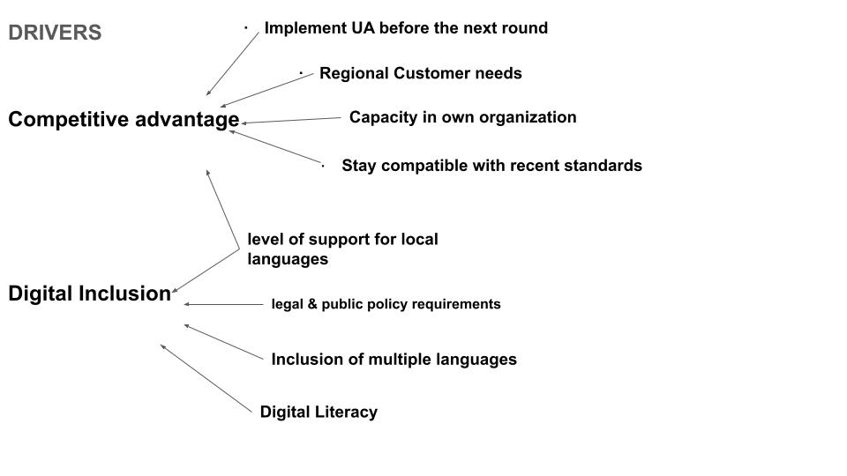

Barriers
In Prague (ICANN83) the focus of consultation changed to barriers. Again based on previous work the following barriers were identified, which impede UA:
- Lack of UA technical expertise
- Third party dependencies
- Policy-related hurdles
- Lack of demand
- Political situation in the region
- No trust in open source
- Other priorities
From these barriers the 3 most important ones were:
- Lack of demand
- Lack of technical expertise
- Other priorities

In addition the community present identified the following barriers:
- Lack of Technical solutions in the market
- No interest from registrars
- EAI continues to be challenge
- Almost no demand from local community
- Lack of awareness
- Size of the ccTLD
- Economic hurdles
- No procurement policy
- Lack of funding
- Lack of awareness and lack of policy
- Lack of interest by users (to accustomed to ASCII)

To understand, what was considered the main barrier the following emerged:
- Need for Demand, change lack of need
- Government decision, Government should require all suppliers to gov to be UA ready
- Emoji Domain Support
- Adoption of UA by “big tech”, working email
- Remove/Reduce policies imposed by government
- Get management to understand the importance
- Government department leading use of IDN and EAI

Looking at the various concepts raised with respect to barriers, the main overarching barriers appear to be the following:
- Lack of Demand / lack of need
- Lack of Technical solutions
- Internal ccTLD focus
Each of these overarching barriers include and are determined by some of the others.

The Lack of demand/lack of need appears to include: Lack of awareness,
Almost no demand form local community, Lack of interest, Need for government decisions, including need for procurement rules & policy, Lack of demand by registrars,

The Lack of Technical solutions appears to include: need for Emoji Domain Support, Adoption of UA by “big tech”, working email, EAI challenges, but also lack of demand.

The Internal ccTLD Focus as barrier encapsulates the following: size of the operation, lack of funding, Lack of UA technical expertise, Third party dependencies

From this overview the following picture emerges:

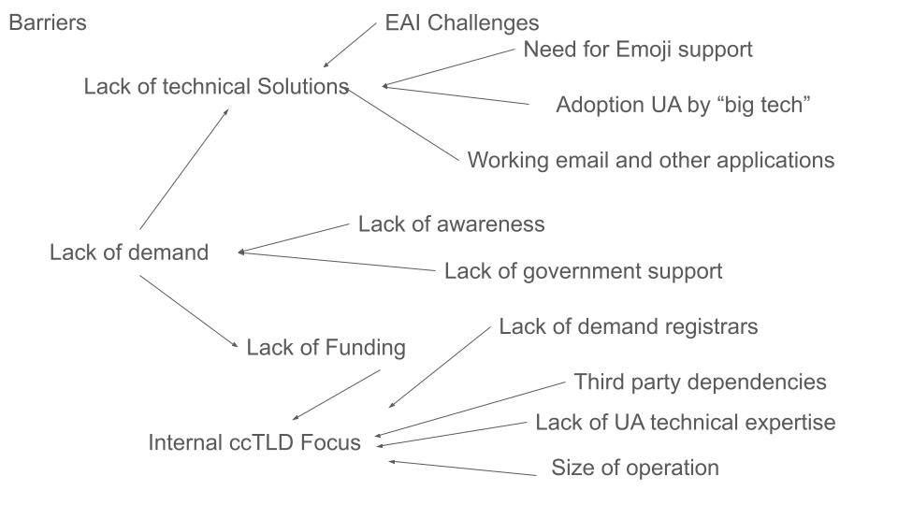

From this overview the following questions could be raised:
- How can the drivers be leveraged? what is the role for UAC?
- What can be done to lower or even overcome each of the the barriers?
- What is role for UAC?

