Proposal for a Chinese Script Root Zone LGR
LGR Version 1.1
Date: 2017-12-12
Document version:10.1
Authors: CGP (Chinese Generation Panel)

General Information/ Overview/ Abstract
The purpose of this document aims to give an overarching view of the label generation rules for the Chinese Script (Hani) including rationale behind the design decisions taken. This includes a discussion of the relevant features of the script, the communities and languages using it, as well as the process and methodology used and information of the contributors. The formal specification of the LGR can be found in the accompanying XML document: •
Proposed-LGR-Hani-20171205.xml
Labels for testing can be found in the accompanying text document: •
Labels-Hani-20171205.txt

Script for which the LGR is proposed
ISO 15924 Code: Hani
ISO 15924 Key N°: 500
ISO 15924 English Name: Han
Latin transliteration of native script name: Hanzi, Kanji, Hanja
Native name of the script: 汉字, 漢字, 한자
Maximal Starting Repertoire (MSR) version: MSR-2

Background on Script and Principal Languages Using It

Background
Chinese Script (Hani in ISO 15924) are a sort of logograms used in the writing system of Chinese and some other Asian languages. They are called Hanzi in Chinese, Kanji in Japanese and Hanja in Korean.
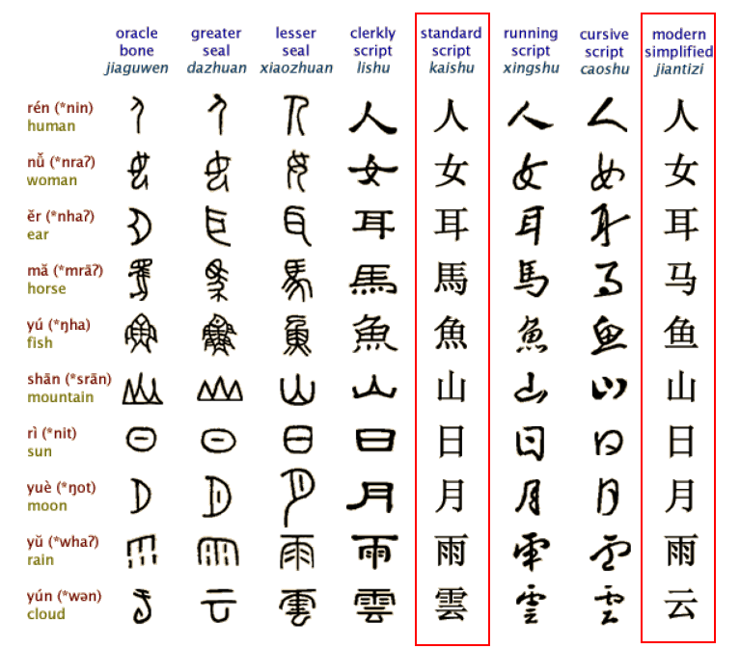
Figure 1: Evolution of Chinese Characters
Hanzi originated from inscriptions on bones or tortoise shells in the Shang Dynasty (c. 16th-11th century B.C.), known as the "Oracle" and was unified in the Qin dynasty (221-207 B.C.). In modern times, the most important changes in Chinese Hanzi occurred in the middle of the 20th century when more than two thousand simplified characters were introduced as the official forms in Mainland China. As a result, the Chinese language has two sub writing systems: Simplified Chinese (Hans) and Traditional Chinese (Hant). Both systems are expressed using different subsets under the Unicode definition of the same Hanzi script. The two writing systems use Hans and Hant respectively while sharing a large common "unchanged" Hanzi subset that accounts for around 60% in contemporary use. The common "unchanged" Hanzi subset enables a simplified Chinese user to understand texts written in traditional Chinese with little difficulty and vice versa. Hanzi character in Hans and Hant share the same meaning and the same pronunciation and are typical variants.
Chinese script has been adopted as Japanese kanji for recording the Japanese language since the 5th century AD. Chinese words borrowed into Japanese could be written using Chinese characters, while Japanese words could be written using the characters for Chinese words of similar meaning. Finally, in Japanese, all three scripts (kanji, and the hiragana and katakana syllabaries) are used as main scripts.
Chinese script spread to Korea together with Buddhism from the 2nd century BC to the 5th century AD. In times past, until the 15th century, in Korea, Literary Chinese was the dominant form of written communication, prior to the creation of Hangul, the Korean alphabet. In the modern Hangul-based Korean writing system, Chinese characters are no longer officially used to represent native morphemes, but still sometimes used in daily life.
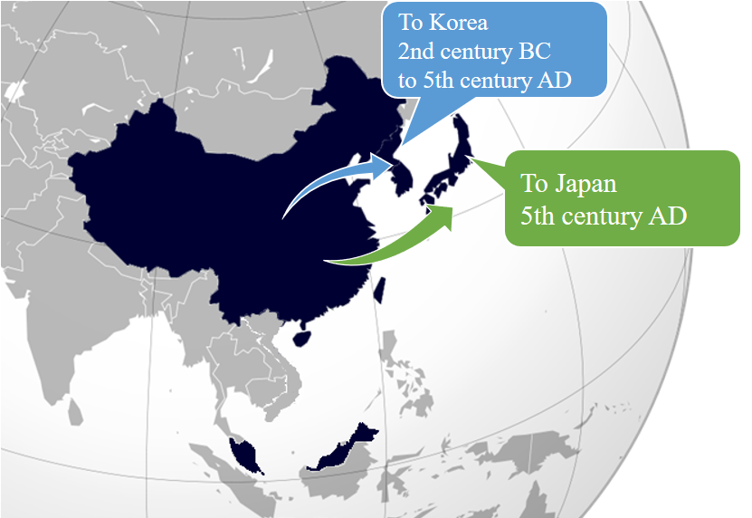
Figure 2: Chinese script spread to Japan and Korea
Chinese script was also used in Mongolia and Vietnam, but not anymore. Accordingly, Chinese Generation Panel does not take into account the usage of Chinese script in Mongolia and Vietnam.

Countries with Significant Usage for Chinese Script
Chinese script is used to write a diverse set of languages across East Asia and South East Asia. Countries and regions using Chinese script are depicted as follows:
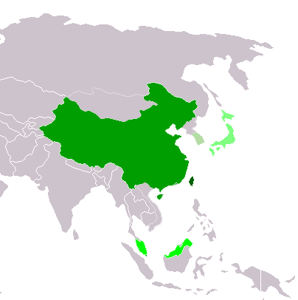
Traditional Chinese script used exclusively or almost exclusively
(Taiwan, Macau and Hong Kong)
Simplified Chinese script used exclusively or almost exclusively
(Mainland China and Singapore)
Simplified Chinese script used formally but Traditional script still used widely
(Malaysia)

Chinese script used with other systems of writing in the same language
Kanji (Japan)
Chinese script daily used but no longer officially used
Hanja (Republic of Korea)
Figure 3: Countries using Chinese script

Principal Languages using the Script
As shown in the following non-exhaustive table, Chinese, Japanese and Korean are three main languages using the Chinese script today but it does not imply that unlisted languages are less significant. For example, there are cases where a language may have a large population, but only a small part of it writes in Chinese script. Such languages are excluded from this list. For these language all ISO 639-3 available as "living" are included from http://www-01.sil.org/ISO639-3/codes.asp, which may refer to a macro or an individual language.
Language | Language Code in ISO 639 | Native Script Name | Locations
Chinese | cdo (Min Dong Chinese)  cjy (Jinyu Chinese)  cmn (Mandarin Chinese)  cpx (Pu-Xian Chinese)  czh (Huizhou Chinese)  czo (Min Zhong Chinese)  gan (Gan Chinese)  hak (Hakka Chinese)  hsn (Xiang Chinese)  mnp (Min Bei Chinese)  nan (Min Nan Chinese)  wuu (Wu Chinese)  yue (Yue Chinese)  zho (Chinese) | 汉字 Hanzi | China Mainland  Taiwan  Hong Kong  Macao  Singapore  Malaysia
Japanese | jpn | 漢字 Kanji | Japan
Korean | kor | 한자 Hanja | Korea

- Hanzi normally consists of two subsets, Simplified Chinese characters (Hans) and Traditional Chinese characters (Hant).
- Kanji is used in Japanese in addition to two other scripts (hiragana and katakana), together known as Jpan (ISO 15924 code).
- Hanja is used in Korean in addition to the Hangul script, together known as Kore (ISO 15924 code).
The relationship between Hanzi, Kanji and Hanja is as shown below, Hanzi (Hans & Hans), Kanji and Hanjia are both therefore covered by CGP.
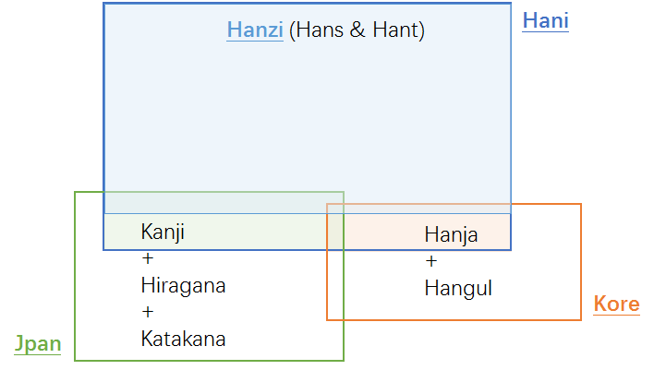
Figure 4: Hanzi, Kanji & Hanja

Overall Development Process and Methodology

Previous work
In April 2004, the Joint Engineering Team (JET), a group composed of members of CNNIC, TWNIC, KRNIC, JPNIC as well as other individual experts, produced RFC 3743 "Joint Engineering Team (JET) Guidelines for Internationalized Domain Names (IDN) Registration and Administration for Chinese, Japanese and Korean", a guideline for zone administrators, including but not limited to registry operators and registrars and information for all domain names holders on the administration of domain names that contain characters drawn from the Chinese, Japanese, and Korean scripts. It includes concepts for variant handling, such as bundling, atomic IDL Packages, and reserved variants. It also defines a standard table as well as an algorithm to generate the preferred variant and reserved variants. The key mechanisms of this specification utilize a three-column table, called a Language Variant Table, for each language permitted to be registered in the zone.
Collectively, the CDNC (Chinese Domain Name Consortium) has devised solutions to handle Chinese domain name variants, such as the bundling of Simplified Chinese (SC) and Traditional Chinese (TC) ("TC-SC Equivalence") domain names — as defined by the JET in RFC 3743 (April 2004) and for the Chinese language as defined in RFC 4713 (October 2006) — and delegating the applied label, one preferred SC label and one preferred TC label to the same applicant. CDNC’s registration policy on handling TC-SC Equivalence is widely accepted. The CDNC IDN Table, developed by many Chinese linguistic and domain name experts over the last 10 years, is currently adopted by the Chinese, Taiwanese, Hong Kong, Macau and Singaporean governments, as well as by many new gTLD applicants. Over a decade of operating experience indicates CDNC’s TC-SC Equivalence solution is a market-proven successful practice for handling Chinese variants in domain names.
Meanwhile, dotAsia, the registry of .ASIA and the member of CDNC, extended the CDNC IDN Table by importing characters from HKSCS (Hong Kong Supplementary Character Set) and the Singapore set, developed its dotAsia IDN table under the framework of CDNC rules, to cover needs from the Hong Kong and Singaporean local communities.
There has already been a detailed analysis of the Chinese script done by the community in an earlier phase of the LGR program, which resulted in a Chinese Case Study Team Report (https://archive.icann.org/en/topics/new-gtlds/chinese-vip-issues-report-03oct11-en.pdf).
All these above previous efforts made by the Chinese script community have been used as a basis for the current work, especially the Chinese Study Report and RFC 4713, in addition to other literature and the expertise available in the current task force.

Team Diversity
The current work is undertaken by experts from CDNC, who represent the Chinese language ccTLDs to a large extent, as well as experts from a variety of backgrounds.
Geographically, the CGP has members from Chinese language regions across east Asia, including China mainland, Taiwan, Hong Kong, Macau, Singapore, Malaysia, as well as members from Europe and North America, totally 23 members belonging to 10 countries/regions listed in Appendix A.
The CGP consists of members with a diverse set of disciplines and very different perspectives. The members represent national and regional policy makers, the technical community directly working with the DNS, the security and law enforcement community, academia (technical and linguistic), and experience with local language computing using Unicode and specifically IDNs.
Besides, the CGP is pleased to have Edmon CHUNG, CEO of dotAsia and Co-Chair of the Universal Acceptance Steering Group, as the IDN advisor.

Work Process

The work has been carried out since September 2014, when the group formed to put forward a "proposal for generation panel for Chinese script label generation rule set for the root zone". Since then, the group has had fortnightly conference calls, as well as 4 face-to-face meetings along with the CDNC meeting, in July 2015, March 2016, March 2017 and July 2017. In addition, the group has been actively engaged over email, through the public mailing list of the task force.
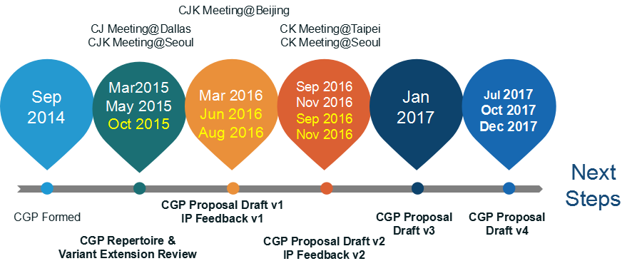
The group also maintains frequent communication with the JGP and KGP, to coordinate the Chinese code points and variant characters among three parties. The three Parties held 5 joint face-to-face meetings, in March 2015, May 2015, March 2016, September 2016 and November 2016, and had successive CJK joint sessions in ICANN meetings since ICANN 51 Los Angeles.
The work process includes the following steps:
- Define and finalize the code point repertoire
In the range of the MSR, the CDNC and most CGP members urged to add CDNC characters into the CGP repertoire as much as possible, to reach consistency between the CDNC SLD operation and future TLD operation. Both CDNC IDN table and dotAsia IDN table are taken into account.
Besides, Table of General Standard Chinese Characters (TGSCC) published by China State Council in 2013, and JGP repertoire and KGP repertoire are also referred.
- Define and finalize the code point variant sets
CDNC has provided a market-proven variant set in the CDNC IDN table. Following CDNC rules, dotAsia extended CDNC repertoire and variant set to meet the requirements from the Hong Kong and Singaporean local communities. The CGP adopted CDNC variant rules directly and then made necessary updates related to dotAsia variant rules.
The CGP recognizes that different panels (C, J and K) have different views on the variants corresponding to the same Chinese character; some CGP variant mappings conflict with KGP and JGP’s perception and practice. The CGP would work closely with JGP & KGP to make necessary compromises to reach a consensus for all three parties and meet the IP’s requirement that "The variant mappings must agree for the same code point for all LGRs".
- Define and finalize the whole label evaluation ruleset
The CGP WLE follows the spirit of the CDNC ruleset, "TC-SC equivalence", which assigns all variant labels to the same applicant, while allocating the original applied label as well as only preferred SC label(s) and preferred TC label(s), generally no more than three labels, and blocks all other labels.
The CGP also acknowledges that some multiple preferred variant mappings work for SLD but may overproduce allocatable labels in the root zone. The CGP worked together with J, K and the IP to design an ideal solution to set applicants’ preferred labels allocatable as well as to limit the amount of allocatable labels to a reasonable number (for example, three).
- Create XML LGR for Chinese script LGR proposal
Considering the fact that the coordination on repertoire, variant mappings and WLE between CJK and IP is still in progress, the CGP work was carried out in a fast iteration model as indicated in the following figure:
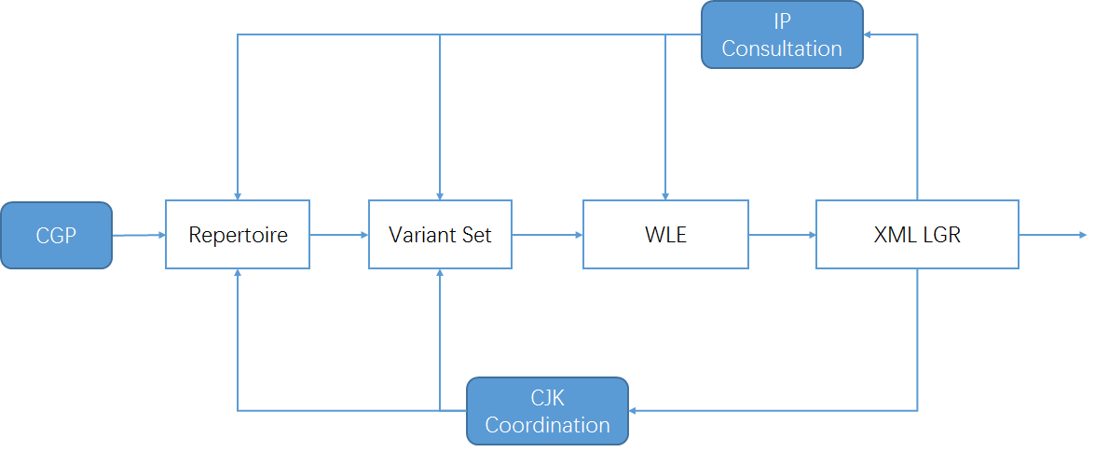
Figure 5: Iteration model of CGP work process

Repertoire

Basic character set
In 2004, according to RFC 3743 and RFC 4713, the Chinese Domain Name Consortium (CDNC) drafted CDNC Chinese IDN Table. The CDNC Table has been used for second level domain (SLD) name registration under .CN, .TW, .HK and many CDN TLDs. In March, 2005, CNNIC and TWNIC submitted .CN Chinese Character Table and .TW Chinese Character Table separately, which included repertoire and variant mappings information.
In 2012, CDNC reviewed, proofread and published its combined IDN Table for the implementation of Chinese IDN registrations at gTLDs, including 37 ASCII code points and 19520 Chinese characters (http://www.cdnc.org/gb/research/file/CDNC_unicode.txt).

Repertoire formation process

19561 Basic Repertoire
In October 2015, CDNC published the latest version of its IDN Table; 41 new Chinese characters were added into the character set as requested by HKIRC on behalf of the Hong Kong local community in 2013 and 2015, increasing the number of Chinese characters to 19561.
Among the 41 Hong Kong characters, two characters (3A5C㩜 and 58B5墵) are out of scope of MSR2, which means only 19559 are included in MSR2. CGP has formally requested to add these two characters into MSR-3.
All these 19561 code points form the basic set of the CGP repertoire. (CGP R0=CDNC IDN Table)

124 dotAsia characters
The dotAsia extended CDNC IDN Table 2012 to 19683 Chinese characters, by adding 163 additional code points, of which 156 are part of HKSCS included in the IICORE collection, 4 are Non-IICORE and GS (Singapore Characters), 3 are Non-IICORE and part of various other Chinese sources that are necessary to insure full transitivity in variant processing, made up the dotAasia repertoire of 19683 code points.
(https://www.iana.org/domains/idn-tables/tables/asia_zh_1.1.txt)
39 of 163 are already included in CDNC IDN Table 2015, the remaining 124 extended the CGP repertoire up to 19685 code points (CGP R1, covering the whole dotAsia IDN Table).

55 characters located in the Basic Multilingual Plane as well as in IICORE:

Unicode | Hanzi | CDNC | dotAsia | TGSCC | JGP | KGP | IICore | G | T | J | H | K | M | KP | S
65FF | 旿 |  | .ASIA | N |  | KGP | IICORE |  |  |  |  | K0A |  | P0A | A
4C81 | 䲁 |  | .ASIA | V |  |  | IICORE |  | T4B |  |  |  |  |  | C
5605 | 嘅 |  | .ASIA | V |  |  | IICORE |  |  |  | H1F |  | M1F |  | B
6335 | 挵 |  | .ASIA | V |  |  | IICORE |  | T3B |  |  |  |  |  | C
656D | 敭 |  | .ASIA | V |  | KGP | IICORE |  |  |  |  | K0A |  | P0A | A
681E | 栞 |  | .ASIA | V | JGP | KGP | IICORE |  |  | J1A |  | K1C |  |  | B
7460 | 瑠 |  | .ASIA | V | JGP | KGP | IICORE |  | T3D | J1A |  | K0A |  | P0A | A
74C8 | 瓈 |  | .ASIA | V |  |  | IICORE |  | T3G |  |  |  |  |  | C
9771 | 靱 |  | .ASIA | V | JGP |  | IICORE |  |  | J1A |  |  |  |  | C
34E4 | 㓤 |  | .ASIA |  |  |  | IICORE |  |  |  | H1F |  |  |  | C
3577 | 㕷 |  | .ASIA |  |  |  | IICORE |  | T3B |  |  |  |  |  | C
35A1 | 㖡 |  | .ASIA |  |  |  | IICORE |  |  |  | H1F |  |  |  | C
35AD | 㖭 |  | .ASIA |  |  |  | IICORE |  |  |  | H1F |  |  |  | C
35BF | 㖿 |  | .ASIA |  |  |  | IICORE |  |  |  | H1F |  |  |  | C
35CE | 㗎 |  | .ASIA |  |  |  | IICORE |  |  |  | H1F |  | M1F |  | B
35F3 | 㗳 |  | .ASIA |  |  |  | IICORE |  |  |  | H1F |  |  |  | C
35FE | 㗾 |  | .ASIA |  |  |  | IICORE |  |  |  | H1F |  |  |  | C
39F8 | 㧸 |  | .ASIA |  |  |  | IICORE |  |  |  | H1F |  |  |  | C
39FE | 㧾 |  | .ASIA |  |  |  | IICORE |  |  |  | H1F |  |  |  | C
3A18 | 㨘 |  | .ASIA |  |  |  | IICORE |  |  |  | H1F |  |  |  | C
3A52 | 㩒 |  | .ASIA |  |  |  | IICORE |  |  |  | H1F |  | M1F |  | B
3A67 | 㩧 |  | .ASIA |  |  |  | IICORE |  |  |  | H1F |  |  |  | C
3B39 | 㬹 |  | .ASIA |  |  |  | IICORE |  |  |  | H1F |  |  |  | C
3DE7 | 㷧 |  | .ASIA |  |  |  | IICORE |  |  |  | H1F |  |  |  | C
3DEB | 㷫 |  | .ASIA |  |  |  | IICORE |  |  |  | H1F |  |  |  | C
3E74 | 㹴 |  | .ASIA |  |  |  | IICORE |  |  |  | H1F |  |  |  | C
3ED0 | 㻐 |  | .ASIA |  |  | KGP | IICORE |  |  |  |  |  |  | P0A | C
4065 | 䁥 |  | .ASIA |  |  |  | IICORE |  |  |  | H1F |  |  |  | C
406A | 䁪 |  | .ASIA |  |  |  | IICORE |  |  |  | H1F |  |  |  | C
40BB | 䂻 |  | .ASIA |  |  |  | IICORE |  |  |  | H1F |  |  |  | C
40DF | 䃟 |  | .ASIA |  |  |  | IICORE |  |  |  | H1E |  |  |  | C
44EA | 䓪 |  | .ASIA |  |  |  | IICORE |  |  |  | H1D |  |  |  | C
4606 | 䘆 |  | .ASIA |  |  |  | IICORE |  |  |  | H1F |  |  |  | C
47F4 | 䟴 |  | .ASIA |  |  |  | IICORE |  |  |  | H1F |  |  |  | C
4AB8 | 䪸 |  | .ASIA |  |  | KGP | IICORE |  |  |  |  | K3D |  |  | C
4C7D | 䱽 |  | .ASIA |  |  |  | IICORE |  |  |  | H1F |  |  |  | C
4C85 | 䲅 |  | .ASIA |  |  |  | IICORE |  | T4B |  |  |  |  |  | C
4EEE | 仮 |  | .ASIA |  | JGP |  | IICORE |  |  | J1A |  |  |  |  | A
51B4 | 冴 |  | .ASIA |  | JGP |  | IICORE |  |  | J1A |  |  |  |  | A
5689 | 嚉 |  | .ASIA |  |  |  | IICORE |  |  |  | H1F |  |  |  | C
57DE | 埞 |  | .ASIA |  |  |  | IICORE |  |  |  | H1F |  |  |  | C
60E3 | 惣 |  | .ASIA |  | JGP |  | IICORE |  |  | J1A |  |  |  |  | A
62A6 | 抦 |  | .ASIA |  |  |  | IICORE |  |  |  | H1F |  |  |  | C
637F | 捿 |  | .ASIA |  |  | KGP | IICORE |  |  |  |  | K0A |  | P0A | A
6667 | 晧 |  | .ASIA |  | JGP | KGP | IICORE |  |  | J1A |  | K0A |  | P0A | A
701E | 瀞 |  | .ASIA |  | JGP | KGP | IICORE |  | T3G | J1A |  | K0A |  | P0A | A
7534 | 甴 |  | .ASIA |  |  |  | IICORE |  |  |  | H1F |  | M1C |  | B
757A | 畺 |  | .ASIA |  |  | KGP | IICORE |  |  |  |  | K0A |  | P0A | A
7AC3 | 竃 |  | .ASIA |  | JGP |  | IICORE |  |  | J1A |  |  |  |  | A
8420 | 萠 |  | .ASIA |  | JGP |  | IICORE |  |  | J1A |  |  |  |  | C
9244 | 鉄 |  | .ASIA |  | JGP |  | IICORE |  |  | J1A |  |  |  |  | A
932C | 錬 |  | .ASIA |  | JGP |  | IICORE |  |  | J1A |  |  |  |  | A
98C7 | 飇 |  | .ASIA |  |  | KGP | IICORE |  |  |  |  | K0A |  | P0A | A
98E1 | 飡 |  | .ASIA |  |  | KGP | IICORE |  |  |  |  | K0A |  | P0A | A
99C5 | 駅 |  | .ASIA |  | JGP |  | IICORE |  |  | J1A |  |  |  |  | A

7 characters located in the Basic Multilingual Plane, but not in IICORE
Unicode | Hanzi | CDNC | dotAsia | TGSCC | JGP | KGP | IICore | G | T | J | H | K | M | KP | S
39DB | 㧛 |  | .ASIA
3BA3 | 㮣 |  | .ASIA
43D3 | 䏓 |  | .ASIA
4443 | 䑃 |  | .ASIA
4882 | 䢂 |  | .ASIA
4C9D | 䲝 |  | .ASIA
4C9E | 䲞 |  | .ASIA

62 code points from Supplementary Ideographic Plane (Plane 2)
Unicode | Hanzi | CDNC | dotAsia | TGSCC | JGP | KGP | IICore | G | T | J | H | K | M | KP | S
2070E | 𠜎 |  | .ASIA |  |  |  | IICORE |  |  |  | H1F |  | M1E |  | B
20731 | 𠜱 |  | .ASIA |  |  |  | IICORE |  |  |  | H1F |  |  |  | C
20779 | 𠝹 |  | .ASIA |  |  |  | IICORE |  |  |  | H1F |  | M1C |  | B
20C53 | 𠱓 |  | .ASIA |  |  |  | IICORE |  |  |  | H1F |  |  |  | C
20C78 | 𠱸 |  | .ASIA |  |  |  | IICORE |  |  |  | H1F |  |  |  | C
20C96 | 𠲖 |  | .ASIA |  |  |  | IICORE |  |  |  | H1F |  |  |  | C
20CCF | 𠳏 |  | .ASIA |  |  |  | IICORE |  |  |  | H1F |  |  |  | C
20CD5 | 𠳕 |  | .ASIA |  |  |  | IICORE |  |  |  | H1F |  |  |  | C
20D15 | 𠴕 |  | .ASIA |  |  |  | IICORE |  |  |  | H1F |  |  |  | C
20D7C | 𠵼 |  | .ASIA |  |  |  | IICORE |  |  |  |  |  | M1E |  | C
20D7F | 𠵿 |  | .ASIA |  |  |  | IICORE |  |  |  | H1F |  |  |  | C
20E0E | 𠸎 |  | .ASIA |  |  |  | IICORE |  |  |  | H1F |  |  |  | C
20E0F | 𠸏 |  | .ASIA |  |  |  | IICORE |  |  |  | H1F |  |  |  | C
20E77 | 𠹷 |  | .ASIA |  |  |  | IICORE |  |  |  | H1F |  |  |  | C
20E9D | 𠺝 |  | .ASIA |  |  |  | IICORE |  |  |  | H1F |  |  |  | C
20EA2 | 𠺢 |  | .ASIA |  |  |  | IICORE |  |  |  | H1F |  |  |  | C
20ED7 | 𠻗 |  | .ASIA |  |  |  | IICORE |  |  |  | H1F |  |  |  | C
20EF9 | 𠻹 |  | .ASIA |  |  |  | IICORE |  |  |  | H1F |  | M1F |  | B
20EFA | 𠻺 |  | .ASIA |  |  |  | IICORE |  |  |  | H1F |  |  |  | C
20F2D | 𠼭 |  | .ASIA |  |  |  | IICORE |  |  |  | H1F |  |  |  | C
20F2E | 𠼮 |  | .ASIA |  |  |  | IICORE |  |  |  | H1F |  |  |  | C
20F4C | 𠽌 |  | .ASIA |  |  |  | IICORE |  |  |  | H1F |  |  |  | C
20FB4 | 𠾴 |  | .ASIA |  |  |  | IICORE |  |  |  | H1F |  |  |  | C
20FBC | 𠾼 |  | .ASIA |  |  |  | IICORE |  |  |  | H1F |  |  |  | C
20FEA | 𠿪 |  | .ASIA |  |  |  | IICORE |  |  |  | H1F |  |  |  | C
2105C | 𡁜 |  | .ASIA |  |  |  | IICORE |  |  |  | H1F |  |  |  | C
2106F | 𡁯 |  | .ASIA |  |  |  | IICORE |  |  |  | H1F |  |  |  | C
21075 | 𡁵 |  | .ASIA |  |  |  | IICORE |  |  |  | H1F |  |  |  | C
21076 | 𡁶 |  | .ASIA |  |  |  | IICORE |  |  |  | H1F |  |  |  | C
2107B | 𡁻 |  | .ASIA |  |  |  | IICORE |  |  |  | H1F |  |  |  | C
210C1 | 𡃁 |  | .ASIA |  |  |  | IICORE |  |  |  | H1F |  |  |  | C
210C9 | 𡃉 |  | .ASIA |  |  |  | IICORE |  |  |  | H1F |  |  |  | C
211D9 | 𡇙 |  | .ASIA |  |  |  | IICORE |  |  |  | H1F |  |  |  | C
220C7 | 𢃇 |  | .ASIA |  |  |  | IICORE |  |  |  | H1E |  |  |  | C
227B5 | 𢞵 |  | .ASIA |  |  |  | IICORE |  |  |  | H1F |  |  |  | C
22AD5 | 𢫕 |  | .ASIA |  |  |  | IICORE |  |  |  | H1F |  |  |  | C
22B43 | 𢭃 |  | .ASIA |  |  |  | IICORE |  |  |  | H1F |  | M1F |  | B
22BCA | 𢯊 |  | .ASIA |  |  |  | IICORE |  |  |  | H1F |  |  |  | C
22C51 | 𢱑 |  | .ASIA |  |  |  | IICORE |  |  |  | H1F |  |  |  | C
22C55 | 𢱕 |  | .ASIA |  |  |  | IICORE |  |  |  | H1F |  |  |  | C
22CC2 | 𢳂 |  | .ASIA |  |  |  | IICORE |  |  |  | H1F |  |  |  | C
22D08 | 𢴈 |  | .ASIA |  |  |  | IICORE |  |  |  | H1F |  |  |  | C
22D4C | 𢵌 |  | .ASIA |  |  |  | IICORE |  |  |  | H1F |  |  |  | C
22D67 | 𢵧 |  | .ASIA |  |  |  | IICORE |  |  |  | H1F |  |  |  | C
22EB3 | 𢺳 |  | .ASIA |  |  |  | IICORE |  |  |  | H1F |  |  |  | C
23CB7 | 𣲷 |  | .ASIA |  |  |  | IICORE |  |  |  | H1F |  |  |  | C
244D3 | 𤓓 |  | .ASIA |  |  |  | IICORE |  |  |  | H1F |  |  |  | C
24DB8 | 𤶸 |  | .ASIA |  |  |  | IICORE |  |  |  | H1F |  |  |  | C
24DEA | 𤷪 |  | .ASIA |  |  |  | IICORE |  |  |  | H1F |  |  |  | C
2512B | 𥄫 |  | .ASIA |  |  |  | IICORE |  |  |  | H1F |  |  |  | C
26258 | 𦉘 |  | .ASIA |  |  |  | IICORE |  |  |  | H1F |  |  |  | C
267CC | 𦟌 |  | .ASIA |  |  |  | IICORE |  |  |  | H1F |  | M1C |  | B
269F2 | 𦧲 |  | .ASIA |  |  |  | IICORE |  |  |  | H1F |  |  |  | C
269FA | 𦧺 |  | .ASIA |  |  |  | IICORE |  |  |  | H1F |  |  |  | C
27A3E | 𧨾 |  | .ASIA |  |  |  | IICORE |  |  |  | H1F |  |  |  | C
2815D | 𨅝 |  | .ASIA |  |  |  | IICORE |  |  |  | H1F |  |  |  | C
28207 | 𨈇 |  | .ASIA |  |  |  | IICORE |  |  |  | H1F |  |  |  | C
282E2 | 𨋢 |  | .ASIA |  |  |  | IICORE |  |  |  | H1F |  | M1C |  | B
28CCA | 𨳊 |  | .ASIA |  |  |  | IICORE |  |  |  | H1F |  |  |  | C
28CCD | 𨳍 |  | .ASIA |  |  |  | IICORE |  |  |  | H1F |  |  |  | C
28CD2 | 𨳒 |  | .ASIA |  |  |  | IICORE |  |  |  | H1F |  |  |  | C
29D98 | 𩶘 |  | .ASIA |  |  |  | IICORE |  |  |  | H1F |  | M1C |  | B

60 characters from TGSCC, JGP and KGP

18 TGSCC characters
After CDNC revealed Chinese Character Table version 2012, in 2013, China's State Council published Table of General Standard Chinese Characters通用规范汉字表 (TGSCC) as
http://www.gov.cn/zwgk/2013-08/19/content_2469793.htm (8105 characters).
To stay consistent with the official document, the CGP studied the TGSCC and found 18 characters outside CGP R1 that fall in the range of the MSR. The CGP imported these 18 characters into the repertoire, making the total number 19703. (CGP R2)
Unicode | Hanzi | CDNC | dotAsia | TGSCC | JGP | KGP | IICore | G | T | J | H | K | M | KP | S
48BC | 䢼 |  |  | N |  |  | IICORE | G3D |  |  |  |  |  |  | C
732F | 猯 |  |  | N | JGP
9EB9 | 麹 |  |  | N | JGP |  | IICORE |  |  | J1A |  |  |  |  | A
5227 | 刧 |  |  | V | JGP
524F | 剏 |  |  | V | JGP
6060 | 恠 |  |  | V | JGP
74A2 | 璢 |  |  | V | JGP
750E | 甎 |  |  | V | JGP
754A | 畊 |  |  | V | JGP
7ADA | 竚 |  |  | V | JGP
8262 | 艢 |  |  | V | JGP
88B5 | 袵 |  |  | V | JGP
894D | 襍 |  |  | V | JGP
8B0C | 謌 |  |  | V | JGP
8F19 | 輙 |  |  | V | JGP
945A | 鑚 |  |  | V | JGP |  | IICORE |  |  | J1A |  |  |  |  | C
984B | 顋 |  |  | V | JGP
9DC0 | 鷀 |  |  | V

42 CJK Coordination characters
Since the meaning is inherent to the symbol, the same logographic system can theoretically be used to represent different languages like Chinese, Japanese and Korean.
In the early 2000s, CDNC experts developed CDNC IDN Table (CGP R0) in which some IICORE Hani characters used in the Japanese or Korean writing systems are excluded. Under the framework of CJK coordination, the Hani characters included in the JGP repertoire or KGP repertoire need to be reviewed as regards the variant relationships to the CGP repertoire, to reach a tripartite consensus on the characters and variant mappings.
To ensure that the CGP repertoire will not bring any confusion or conflict to global Chinese character users and applicants at the root level, the CGP reviewed 99 IICORE characters in the MSR but not covered in CGP R2, and found 42 characters included in the JGP repertoire (version 201703, Appendix C) and KGP repertoire (version 201703, Appendix D) with variant relationships with CGP R1.
Unicode | Hanzi | CDNC | dotAsia | TGSCC | JGP | KGP | IICore | G | T | J | H | K | M | KP | S
967A | 険 |  |  |  | JGP |  | IICORE |  |  | J1A |  |  |  |  | A
7E4A | 繊 |  |  |  | JGP |  | IICORE |  | T3D | J1A |  |  |  |  | A
9421 | 鐡 |  |  |  | JGP |  | IICORE |  |  | J1A |  |  |  |  | C
9D8F | 鶏 |  |  |  | JGP |  | IICORE |  |  | J1A |  |  |  |  | A
4FAD | 侭 |  |  |  | JGP |  | IICORE |  |  |  |  |  |  |  | A
6442 | 摂 |  |  |  | JGP |  | IICORE |  |  | J1A |  |  |  |  | A
685F | 桟 |  |  |  | JGP |  | IICORE |  |  | J1A |  |  |  |  | A
7E4B | 繋 |  |  |  | JGP |  | IICORE |  |  | J1A |  |  |  |  | A
81D3 | 臓 |  |  |  | JGP |  | IICORE |  |  | J1A |  |  |  |  | A
8217 | 舗 |  |  |  | JGP |  | IICORE |  |  | J1A |  |  |  |  | A
9039 | 逹 |  |  |  | JGP |  | IICORE |  |  | J1A |  |  |  |  | C
9EBA | 麺 |  |  |  | JGP |  | IICORE |  |  | J1A |  |  |  |  | A
3960 | 㥠 |  |  |  |  | KGP | IICORE |  |  |  |  | K3D |  |  | C
51E6 | 処 |  |  |  | JGP |  | IICORE |  |  | J1A |  |  |  |  | A
61F4 | 懴 |  |  |  | JGP |  | IICORE |  |  | J1A |  |  |  |  | C
685C | 桜 |  |  |  | JGP |  | IICORE |  |  | J1A |  |  |  |  | A
6D9C | 涜 |  |  |  | JGP |  | IICORE |  |  |  |  |  |  |  | A
6E8C | 溌 |  |  |  | JGP |  | IICORE |  |  | J1A |  |  |  |  | A
731F | 猟 |  |  |  | JGP |  | IICORE |  |  | J1A |  |  |  |  | A
784F | 硏 |  |  |  |  | KGP | IICORE |  |  |  |  | K0A |  | P0A | A
7C14 | 簔 |  |  |  | JGP |  | IICORE |  |  | J1A |  |  |  |  | C
7D9A | 続 |  |  |  | JGP |  | IICORE |  |  | J1A |  |  |  |  | A
8133 | 脳 |  |  |  | JGP |  | IICORE |  |  | J1A |  |  |  |  | A
86CD | 蛍 |  |  |  | JGP |  | IICORE |  |  | J1A |  |  |  |  | A
8E99 | 躙 |  |  |  | JGP |  | IICORE |  |  | J1A |  |  |  |  | C
91A4 | 醤 |  |  |  | JGP |  | IICORE |  |  | J1A |  |  |  |  | A
91C8 | 釈 |  |  |  | JGP |  | IICORE |  |  | J1A |  |  |  |  | A
96B2 | 隲 |  |  |  | JGP |  | IICORE |  |  | J1A |  |  |  |  | C
982C | 頬 |  |  |  | JGP |  | IICORE |  |  | J1A |  |  |  |  | A
98EE | 飮 |  |  |  | JGP | KGP | IICORE |  |  |  |  | K0A |  | P0A | A
9A12 | 騒 |  |  |  | JGP |  | IICORE |  |  | J1A |  |  |  |  | A
9A13 | 験 |  |  |  | JGP |  | IICORE |  |  | J1A |  |  |  |  | A
9C2E | 鰮 |  |  |  | JGP |  | IICORE |  |  | J1A |  |  |  |  | C
9D0E | 鴎 |  |  |  | JGP |  | IICORE |  |  | J1A |  |  |  |  | A
9D2C | 鴬 |  |  |  | JGP |  | IICORE |  |  | J1A |  |  |  |  | A
56A2 | 嚢 |  |  |  | JGP |  | IICORE |  |  | J1A |  |  |  |  | A
663B | 昻 |  |  |  |  | KGP | IICORE |  |  |  |  | K0A |  | P0A | A
7A36 | 稶 |  |  |  |  | KGP | IICORE |  |  |  |  | K0A |  | P0A | A
7B86 | 箆 |  |  |  | JGP |  | IICORE |  |  | J1A |  |  |  |  | A
839F | 莟 |  |  |  | JGP |  | IICORE |  |  | J1A |  |  |  |  | C
83B5 | 莵 |  |  |  | JGP |  | IICORE |  |  | J1A |  |  |  |  | C
9A28 | 騨 |  |  |  | JGP |  | IICORE |  |  | J1A |  |  |  |  | A

The CGP imported these 42 characters into the repertoire, raising the total number to 19745 (CGP R3). However, all these 42 characters will have reflexive mappings of type "out-of-repertoire" in Chapter 6.
Finally, CGP generated the repertoire through the steps from 5.2.1 to 5.2.4, the formation process is llustrated as the following figure:
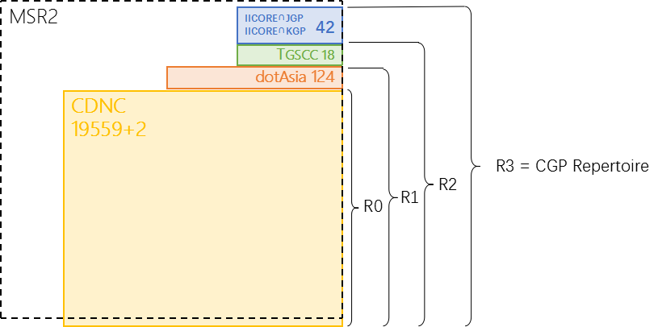
Figure 6: CGP R3 repertoire components

19745 Characters’ source information
The CDNC IDN Table (version 2015) has 17561 Hani/Hanzi characters, all included in CGP Repertoire.
The dotAsia IDN Table (version 1.1) has 19683 Hani Chartres, all included in CGP Repertoire.
The TGSCC provided 10986 Hani/Hanzi characters to CGP Repertoire, including 7846 general standard characters and related 3140 variant characters in comparison table/对照表.
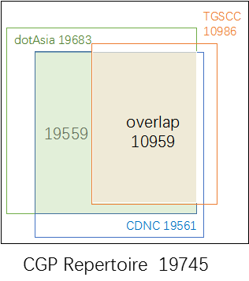
Figure 7：Source of CGP repertoire
The JGP repertoire (version 201703, Appendix C) has 6358 Hani/Kanji characters. 6253 are overlapped characters in the CGP R3 repertoire. CGP will treat the other 105 as Japanese UNIQUE Kanji characters and will not seek to import any of them into the CGP repertoire. The JGP agreed to follow the CGP variant mappings of the overlapping 6267 characters as illustrated in Section 6.2.5.
The KGP repertoire (version 201703, Appendix D) has 4758 Hani/Hanja characters. 4749 are overlapping characters in the CGP R3 repertoire. The KGP agreed to follow the CGP variant mappings of the overlapping 4749 characters as illustrated in Section 6.2.5.
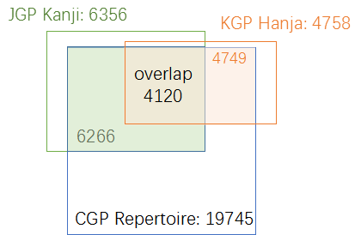
Figure 8：Source of CGP repertoire
CGP provides the detailed source information of every character in the repertoire in Appendix B.

Attempt to limit the size of the repertoire
In Section 5.2, the CGP generated a repertoire containing 19745 code points / characters. It is remarkable that the CGP repertoire has such a large size compared with most other GPs. CGP would attribute it to the nature of the Chinese writing system, similar to other logographic writing systems with large repertoires.
Unlike a segmental writing system (e.g. alphabetic, Abjad, Abugida) which has limited graphemes to represent the phonemes (basic units of sound) of a language, or Syllabaries (e.g. Kana) which has limited graphemes to represent syllables or moras, a logographic writing system has glyphs/logograms to represent words or morphemes rather than phonetic elements. In Chinese, a logogram is a single written character which represents a complete grammatical word (or, more precisely, a morpheme). As each character represents a single word, many logograms are required to write all the words of the language.
There are two reasons to explain why there are so many characters in the Chinese writing system. First, each Chinese character is an independent unit representing a word. 3000 years ago, the Shang Dynasty (16th-11th century B.C.) oracle bones included 3500 ~ 4500 characters already. During the course of history, more characters were invented to represent new words created along with social development. Second, massive numbers of variants occurred with the spread of Chinese characters and and the development of written communication in the continent of east Asia. Chinese variants are characters with different visual forms but with the same pronunciations and with the same meanings as the corresponding official forms. In the Chinese writing system, variants are deemed as exchangeable, the classic case is simplified characters and traditional characters. Generally, each Chinese character has at least one non-reflexive variant character (in CDNC IDN Table, 1 non-reflexive variant on average, at most 7 non-reflexive variants).
Statistically, "Text Notes and Word Explanations 说文解字/說文解字" in Han Dynasty (202 B.C.-220 A.D.) includes 9353 characters, "Lei Pian 类篇/類篇" in Song Dynasty (960-1279 A.D.) includes 31319 characters. In 1710, Emperor Kangxi released the "Kangxi Dictionary 康熙字典" including 47035 characters. In 1959, the Japanese scholar Tetsuji Morohashi compiled "Dai Kan-Wa Jiten大汉和辞典" covering 49964 characters. In 1994, the Chinese Zhonghua Book Company published "Zhonghua Zihai 中华字海" containing 87019 characters. In 2004, the Taiwan Ministry of Eduction released "Dictionary of Chinese Character Variants異體字字典" containg 106,230 characters.
It is obvious that, among the tens of thousands of Chinese characters, not all are frequently used in modern society. The Chinese Ministry of Education requires that the students must handle 3500 characters after nine years of compulsory education, the number is 3500-4500 in Taiwan and 3500 in Hong Kong. However, everyday Chinese script users are able to "write" and "read" many more characters than what they actually learned in school due to two reasons.
The first reason is that Chinese variant characters have same pronunciation. Because of that, modern internet users who have received compulsory education prefer to use phonetic-based input methods (e.g. Pinyin拼音 in China mainland, Zhuyin注音 in Taiwan, Jyutping粤拼 in Hong Kong), which allow users to input phonetic symbols and select characters/labels from the alternative variant characters/labels with the same pronunciation in the selection box. Moreover, a few users prefer other input methods like shape-based input methods (e.g. Wubi五笔 in China, Simplified Tsang-jei 速成 in Hong Kong), handwriting recognition or speech recognition, however, most of them provide a phonetic-based selection box as a basic function to enable users to input variants with no barriers.
The second reason is, generally, a set of Chinese variant characters share the same radical or components, and thus have a certain degree of visual similarity, allowing educated readers to recognize the variant relationship easily. For example, the character for "fight" has 6 variants with similar visual forms, 鬪(9B2A)闘(95D8)鬥(9B25)鬦(9B26)鬬(9B2C)鬭(9B2D). More importantly, almost every variant character does not appear alone in any domain label, but together with other characters in a word or phrase, providing semantic context and helping the readers to recognize the meaning of domain labels more effectively and conveniently. (For example 头发/头髪 ‘hair’ and 发展/發展 ‘development’)
The above two natural characteristics give Chinese variant characters great acceptability, usability and exchangeability in real life, especially in information systems. Hence, the developement and popularization of the internet promote Chinese character usage in cyberspace. In terms of Computer Coding Standards, the early Taiwan BIG5 standard includes 13053 characters, the current Taiwan state standard CNS11643(4.0) includes 76,067 characters. China GB2312 standard included 6763 characters, while the latest standard GB18030 included 20912 characters. The current Unicode standard (as of 10 October 2015), including CJK Unified Ideographs Extensions A-E, contains 80,388 characters. In terms of internet application and daily usage, in 2007, the paper "A Survey on the Usage of Chinese Characters and Phrases in the Newspapers, Radio, TV, and Web" in Applied Linguistics [1003-5397(2007)01-0029-09] shows 8128 independent characters are used in daily life. Another paper in 2010, "Survey on Chinese Weblog Wording" in Journey of Xianning University [1006-5342(2010)01-0076-03], shows 20923 characters are used.
The most symbolic event is, in 2016, China’s Ministry of Civil Affairs issued Notification 2016[33], requiring government departments to update the naming related information system in public service and administration areas, to cover the characters in national standard GB13000 (20902 chars) or GB18030 (70244 chars). The two standards cover the CGP repertoire entirely.
http://www.gov.cn/xinwen/2016-05/09/content_5071481.htm

Actually, most of the above concerns were taken into account when the CDNC generated its Chinese IDN Table in the early 2000s. To create an IDN Table with broad applicability and backwards compatibility, the CDNC referred to multiple source files about Chinese characters and variants, including:
- Complete List of Simplified Characters简化字总表 (2235 chars)
- List of Commonly Used Characters in Modern Chinese现代汉语通用字表 (7000 chars)
- China National Standard GB2312 (6763 chars)
- Taiwan standard BIG5 (13053 chars)
- Chinese Variants Collation Table 第一批异体字整理表 (810 variant groups)
- Chinese Big Dictionary 汉语大字典 (54678 chars)
- Chinese Relationship Table for Unihan Project
- International Standard Chinese Big Dictionary国际标准汉字大辞典
- Unicode 3.2
- Unihan Database and extension A (20992 + 6582 chars)
The CDNC took Reference 1 – Reference 4 as sources to set up a fundamental character set, then imported variant characters from Reference 5 – Reference 8 to develop variant mappings, generated the CDNC IDN table with 19520 Chinese characters. All fall in the range of Reference 9 (Unicode 3.2) and Reference 10 (Unihan Database and extension A).
In the early stage of developing the GP repertoire, CGP members attempted to replace the CDNC IDN table with a smaller character set, hoping the reduction would help decrease the computational complexity of the LGR and speed up the coordination work with J & K. The CGP generated a reduced repertoire called MSS (Minimum Shared Set) of 12563 characters, most of them are historically registered in SLD under .CN/.TW/.HK/.网址 (7722 chars) or come from the Table of General Standard Chinese Characters (4612 chars) published by China PRC State Council in 2013.
The CGP generated the MSS and expected that this limited repertoire could significantly decrease the complexity and workload of coordination between CJK, however, this reduction attempt caused a heated discussion among the CGP members, especially for those registry representatives who had already adopted the CDNC IDN Table for second level registrations.
The core issue is that many members tend to believe that it is the variant mapping rules, not the repertoire size that directly affects the computational complexity of the LGR. The storage capacity and processing power of the modern computer is much more than what is needed to deal with a repertoire of about 20000 characters. Since the 2000s, many IDN registries adopted the CDNC IDN Table and developed IDN registration systems without decreasing the computational performance of the EPP service. Considering the SLD market acceptance of the existing CDNC IDN Table (adopted by over 5 ccTLDs and 20 new gTLDs) and the continuity of registries’/registrars’/registrants’ experience, many CGP members suggested the inheritance of the characters of the CDNC IDN Table to the maximum extent.
Moreover, CJK coordination work shows that the JGP has no dissent with the CGP repertoire and variant mappings. The KGP has no dissent with the CGP repertoire either, but only concerns about the mapping relationships of specific 258 variant groups.
For all the above reasons, the CGP decided to keep CGP R3 as the final repertoire with high capacity and compatibility, which means, to implement the consistency of user experiences, registry practices as well as the local regulations .

Variants

Variant definition in CGP
In the Chinese language, there are two types of variants:
The first type is created by regional variations in the standard writing system. There are now two common writing systems: Simplified Chinese and Traditional Chinese. Both writing systems use different subsets of the same Unicode Han script, but they are not mutually exclusive to each other.
The second type is the generic variant. Several Chinese characters are visually different in form, but treated equally with universal interchangeability. This relationship of interchangeability is much stronger than the relationship between the Traditional and Simplified forms.
In the Chinese Case Study Team Report mentioned in 2.1, CHINESE (CHARACTER) VARIANTS are:
"characters with different visual forms but with the same pronunciations and with the same meanings as the corresponding official forms in the given language contexts."
This understanding and variants mapping rule has been reflected in the CDNC IDN Table, and inherited in the current CGP LGR document.
In alignment with RFC 4713 and CDNC practice, generally, every code point in the CGP repertoire has its preferred/allocatable simplified variant(s), preferred/allocatable traditional variant(s), and reserved/blocked variant(s). In some cases, a code point has a reflexive preferred variant. In others, a code point has no reserved variant.
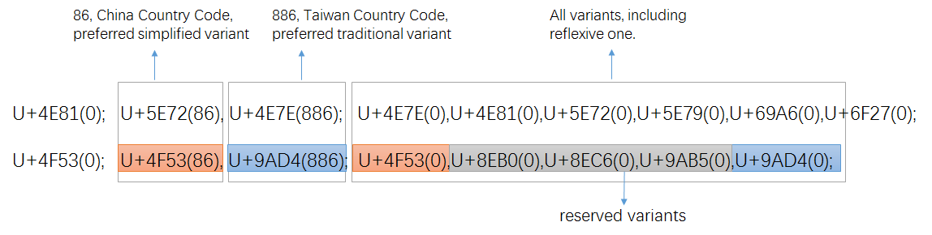
Figure 9: variant setting in CDNC IDN Table
Once transformed into XML-format (draft-davies-idntables-10, Representing Label Generation Rulesets using XML, https://datatracker.ietf.org/doc/draft-davies-idntables/), all preferred variant char(s) are "allocatable", all reserved variant char(s) are "blocked", with sub-types as:
Sub-Type | Type | Comment
simp | Allocatable | preferred simplified variant char;
r-simp | Allocatable | reflexive preferred simplified variant char;
trad | Allocatable | preferred traditional variant char
r-trad | Allocatable | reflexive preferred traditional variant char
both | Allocatable | preferred simplified and traditional variant chars are the same
r-both | Allocatable | reflexive preferred simp and trad variant chars are the same
r-neither | Blocked | Non-allocatable reflexive/original char
blocked | Blocked | Non-allocatable variant char

In alignment of XML rules, the two variant mappings in Figure8 will be transformed into the following text:
<char cp="4F53" tag="sc:Hani" >
<var cp="4F53" type="r-simp" comment="identity" />
<var cp="8EB0" type="blocked" />
<var cp="8EC6" type="blocked" />
<var cp="9AB5" type="blocked" />
<var cp="9AD4" type="traded" />
</char>
<char cp="4E81" tag="sc:Hani" >
<var cp="4E7E" type="trad" />
<var cp="4E81" type="r-neither" comment="identity" />\
<var cp="5E72" type="simp" />
<var cp="5E79" type="blocked" />
<var cp="69A6" type="blocked" />
<var cp="6F27" type="blocked" />
</char>

Considering that there are some characters borrowed/imported from JGP and KGP, and are not really used in modern Chinese language region, the sub-type of "out-of-repertoire" is needed for the reflexive mappings of these characters.
Sub-Type | Type | Comment
out-of-repertoire | Invalid | Non-CGP chars imported from other GPs

Original Simplified Traditional All Variants
硏(784F) 研(7814) 研(7814) 揅(63C5)研(7814)硏(784F)
[JGP] [CGP] [CGP] [CGP][CGP][JGP]
<char cp="784F" tag="sc:Hani" >
<var cp="63C5" type="blocked" />
<var cp="7814" type="both" />
<var cp="784F" type="out-of-repertoire" comment="identity" />
</char>

Note: To eliminate the overproduction of allocatable labels caused by multiple allocatable variant mappings, CGP designed some new sub-types under the type of "Allocatabbe", the related definition and WLE will be illustrated in Section 6.2.2 and Section 6.2.3.

Variant Mappings formation process

18974 basic variant mappings from CDNC
CDNC IDN Table (repertoire and variant mappings), generated in early 2000s and extended in 2015, along with RFC3743 and RFC 4713, is the most wildly accepted rules for Chinese domain name registration at the second level, has been applied to .CN, .TW, .MO, .HK, .SG for decades. The dotAsia IDN Table imports 99.5% of its variant mappings from CDNC IDN Table. Taking all these factors into account, CGP borrowed the variant mappings in the CDNC IDN Table directly and developed the basic variant mappings table corresponding to CGP Repertoire 0 (19561 characters).
However, among the 19561 characters and their variant mappings, there are a few variant mappings changed later due to the further coordination work from Section 6.2.2 to Section 6.2.4.
In the final CGP proposal, 18911 variant mappings are kept as same as CDNC and dotAsia, 63 are the same as CDNC but different with dotAsia . These 18974 (18909 + 62) variant mappings forms up the basic CGP variant mappings table as Appendix D [Sheet 6.2.1-18971].

128 more variant mappings from dotAsia
In the early 2000s, when drafting the IDN table, CDNC experts focused on modern frequently used characters in China mainland, Taiwan and Hong Kong, excluded some specific local used characters and rared used IICORE characters from CDNC IDN Table 2015 (CGP R0). dotAsia extended CDNC IDN table, by adding 124 new regional characters and modifying some old variant mappings according to local requirement. By comparing two tables, we found the slight difference between dotAsia and CDNC, 108 different variant mappings of the old characters, 124 new variant mappings along with 124 new added characters.
CGP and Edmon CHUNG, the CEO of dotAsia, discussed the issue of inconsistency between CDNC variant mappings and dotAsia variant mappings, and agreed that the dotAsia table was created as an experiment for Hong Kong local characters, but the intent has always been to merge it and make it consistent with CGP rules once it is integrated for root zone and gTLD purpose. Thus, dotAsia agreed to synchronize and update the IDN table in IANA once the CGP rules are finalized in 5 steps:
Step 1, keep consistent with CDNC IDN table by giving up the 108 different variant mappings.
Step 2, in September 2015, CGP & CDNC held joint meetings and invited linguistic experts from China mainland, Taiwan and Hong Kong, reviewed 55 new added dotAsia characters in section 5.2.2.1, together with 18 TGSCC characters in section 5.2.3 and 43 CJK coordination characters in section 5.2.4. reset the variant mappings of them as Appendix E.
Step 3, in May 2016, city of Haikou, CGP & CDNC joint meeting reviewed 7 unique dotAsia Hanzi characters in section 5.2.2.2. These Hanzi characters are not included in the CDNC IDN table, nor in TGSCC, nor in IICORE, only exist in the dotAsia IDN table submitted to IANA. The variant mappings of the 7 characters were reset as Appendix E:
Step 4, for the 62 dotAsia code points from Unicode Plane 2 as in section 5.2.2.3, CGP directly accepted their variant mappings from dotAsia IDN Table into CGP rules.
Step 5, recheck and alter 32 old CDNC variant mappings related to the above 124 characters.
However, some variant mappings were changed once again due to the further coordination work from Section 6.2.3 to Section 6.2.5.
In the final CGP proposal, we have 27 variant mappings kept the same as dotAsia but different with CDNC, 99 Non-CDNC dotAsia variant mappings unchanged. These 126 (27+101) variant mappings forms up the dotAsia variant mappings table as Appendix D [Sheet 6.2.2-126].

202 variant mappings from review team

17 variant mappings from TGSCC
Section 5.2.3 listed 18 characters in TGSCC which are not not covered by CDNC IDN Table or dotAisa IDN Table. In September 2015, CGP & CDNC invited linguistic experts from China mainland, Taiwan and Hong Kong, reviewed all these 18 TGSCC characters and gave the variant mappings of them as Appendix Review.
However, 1 variant mappings were changed due to the coordination between CGP and KGP in Section 6.2.4. In the final CGP proposal, we kept 17 variant mappings in Appendix D [Sheet 6.2.3.1-17].

41 variant mappings from JGP and KGP
Section 5.2.4 provided 42 characters imported from JGP and KGP. In September 2015, CGP & CDNC invited linguistic experts from China mainland, Taiwan and Hong Kong, reviewed all these 42 JGP and KGP characters and gave the variant mappings of them as Appendix Review. All these 42 characters will have reflexive mappings of type "out-of-repertoire".
However, 1 J&K variant mappings were changed due to the coordination between CGP and KGP in Section 6.2.5. In the final CGP proposal, we kept 41 variant mappings in Appendix D [Sheet 6.2.3.2-41]..

144 variant mappings interacted
With the increase of variant mappings from Section 6.2.1 to Section 6.2.4, some new comers influence the original CDNC variant mappings and dotAsia variant mappings, according to the CGP & CDNC joint review work in September 2015, there are 144 original related variant mappings got affected. The new variant mappings are listed in Appendix D [Sheet 6.2.3.3-144].

441 Variant mappings from CJK coordination

Principle and Framework
A coordination mechanism among three parties is needed to realize unified Chinese script generation rules in the DNS root zone. During the CDNC meeting in Shanghai (May, 2014), the IP proposed the basic principles of the coordination scheme:
- Each CJK panel creates an LGR and each LGR includes a repertoire and variants.
- If an LGR includes Han characters, the variant mappings must agree for all three panels.
- The variant types may be different (blocked or allocatable), the variant types do not have to be agreed on across LGRs.
Based on the principles above, the CGP, JGP and KGP started coordination work at the IETF Dallas meeting in 2015, trying to define a unified variant mapping table for Chinese scripts, then define each party’s variant types/sub-types (e.g., allocatable or blocked) for characters contained in this table. According to the consensus at the IETF Dallas meeting, the JGP initiated work called "CJK Integration Procedure" as follows:
Step 1: Each CJK GP generates its own LGR (hereinafter, LGR-alpha)
Step 2: CJK GPs collectively generate a merged table of each LGR-alpha (hereinafter, LGR-M)
Step3: Each CJK GP extracts its original repertoire with integrated variants from LGR-M.
Step 4: Each CJK GP adds "Out of Repertoire" code points for symmetry.
Step 5: Each CJK GP merges WLE in LGR-alpha into one.
Step 6: Each CJK GP generates an integrated LGR (hereinafter, LGR-beta).
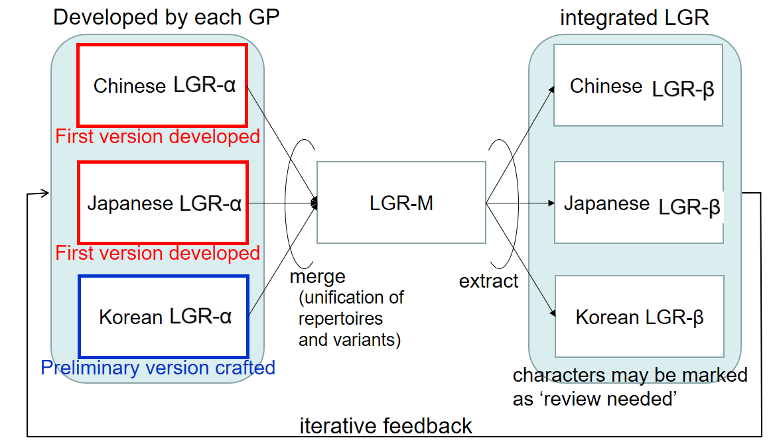
Figure 10: Framework of CJK LGR integration for Han characters, by JGP

Coordination between C and J
Some Kanji characters are in a simplified form (called the "new character form"), derived from the traditional imported form (called the "old character form"). In the Japanese language environment and writing system, it is appropriate to distinguish NEW and OLD forms as different and independent characters instead of pure variants. This understanding has been reflected in the IANA IDN table developed by the .JP registry, JPRS, in which no variants are identified for Kanji.
Some characters in a CGP variant group have the same pronunciations and meanings, but have different meanings in Japanese language environments. For example, (U+673机) means [desk, small table] and (U6A5F機) means [machine] in Japanese, but both mean [machine] in Chinese.
The JGP showed great openness and agreed to import all CGP variant mappings into the JGP ones. Thus, both parties eliminated the potential conflict caused by variant inconsistency. The CGP would like to express its appreciation for the JGP’s openness, tolerance and compromise.

Pre-integration between C and K
Hanja characters are no longer used in official documents (a law enacted on April 14th, 2011 orders all ROK official government documents to be written only in Hangul; Hanja or other scripts can only be written within parentheses if allowed by presidential decree), but are still sometimes used by a few Korean people in daily life. In August 2016, the KGP generated its first version of its LGR, and raised 258 Hanja/Hanzi variant groups whose variant mappings in the CGP LGR are NOT acceptable to the KGP (Appendix F).
Unlike the JGP, the KGP adopted another strategy and approach to resolve differences on variant mappings, asking the CGP to review and reset the variant mapping related to the 258 variant groups case by case.
As requested, the CGP made statistics and analysis of all the disputed 258 variant groups, including the number of registered labels containing disputed characters under .CN/.TW/.HK/.网址, and the semantics of all these registered labels. The CGP separated 258 variant groups into 5 types and 2 categories, the variant groups the CGP would RESERVE, the ones the CGP would give up and split into INDEPENDENT characters.
Reserved 1 | All registered number of variants are not zero, the actual meaning of the variants are the same, suggest to follow CGP rules | 139
Reserved 2 | One variant’s registration number is almost zero, but the actual meaning of the variants are the same, suggest to follow CGP rules | 139
Independent 1 | All registered numbers of variants are zero, not commonly used in domain registration, suggest dealing with independently | 119
Independent 2 | All registered numbers of variants are not zero, meaning of variants are different, suggest dealing with independently | 119
Independent 3 | One variant’s registration numbers are almost zero, not commonly used in domain registration, suggest dealing with independent | 119
The KGP invited linguistic experts from the local community and separated the 258 groups into 2 categories, 149 groups the KGP would KEEP and 109 groups the KGP would DROP.
Keep | Some CGP variant mappings don’t make any sense in the Korean Hangul environment, instead, these characters are used independently with their own semantic meanings. Hence, KGP intended to keep them as independent characters. | 149
Drop | Some CGP variant mappings are weakly related in the Korean Hangul environment; the KGP intends to drop their independence and accept the CGP’s variant mappings. | 109

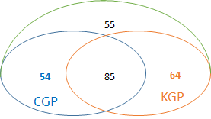
Figure 11: coordination before C&K Taiwan meeting

In September 2016, the KGP and CGP held the first round coordination meeting and reduced the number of variant groups in disagreement to 60. In the IETF meeting, in November 2017, the KGP and CGP reduced the number to 2. Finally, in December 2017, the KGP and CGP solved all 258 variant groups and reached complete agreement on the variant mappings. For the 258 unacceptable variant groups, 112 will go with CGP rules, the remaining 146 will go with KGP rules.
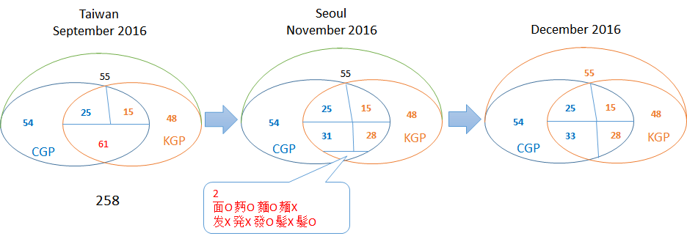
Figure 12: C&K coordination process

Accordingly, CGP updated 445 variant mappings related to 146 groups as Appendix G, and KGP generated its Hanja variant mappings table as Appendix H.
However,through the processes from 6.2.1 to 6.2.3, there are 2 variant mappings remained the same as original CDNC rules, and 2 ones remained as original dotAsia rules, so only 441 variant mappings could be considered as the result of KGP pre-intergration as Appendix D [Sheet 6.2.3.1-17].

After all above steps from Section 6.2.1 to 6.2.4, CGP finalized the whole 19745 CGP variant mapping table corresponding to CGP R3 as Appendix D [Sheet All Variant Mappings], including 18974 basic variant mappings, 128 dotAsia variant mappings, 441 variant mappings from TSGCC, JGP and KGP, 441 KGP pre-integration variant mappings.

19745 Variant mappings’ source information
To illustrate the relationship between the CGP variant mappings and the existing SLD practice and some other variant mappings work. CGP provides the reference/source information of every variant mapping in the XML document as well as in the EXCEL appendix I.
- The variant mappings consistent with the existing practice of CDNC.
- The variant mappings consistent with the existing practice of dotAsia.
- The variant mappings consistent with the CGP review settings.
- The variant mappings changed with the pre-integration with KLGR.
The variant mappings different from existing practice of CDNC or dotAsia as also indicated in reference/source information in XML document as well as in the EXCEL appendix J
- 587 variant mappings different from the existing practice of CDNC as Appendix J [Sheet CDNC]
- 646 variant mappings different from the existing practice of dotAsia as Appendix J [Sheet dotAsia]

Effort to reduce the number of multiple allocatable labels
In the Chinese writing system, there a quite a few characters have multiple simplified variant characters or multiple traditional variant characters. These multiple allocatable variant mappings might lead to the issue of overproduction of allocatalbe labels.
Unicode | Original Char | Preferred Simplified Char | Preferred Traditional Char
5925 | 夥 | 夥(5925) 伙(4F19) | 夥(5925)
647A | 摺 | 摺(647A) 折(6298) | 摺(647A)
9EBD | 麽 | 麽(9EBD) 么(4E48) | 麼(9EBC)
5347 | 升 | 升(5347) | 升(5347) 昇(6607) 陞(965E)
53F0 | 台 | 台(53F0) | 台(53F0 )檯(6AAF) 臺(81FA)
590D | 复 | 复(590D) | 复(590D) 復(5FA9) 複(8907)
5C40 | 局 | 局(5C40) | 局(5C40) 侷(4FB7) 跼(8DFC)
5E76 | 并 | 并(5E76) | 并(5E76) 並(4E26) 併(4F75)
Multiple preferred variant mapping examples
To avoid the overproduction issue, in SLD practice, CDNC members and dotAsia designed a ranking selection function or human interaction mechanism, to enable the applicants to SELECT at most one all-simplified and at most one all-traditional label from the multiple alternatives. Once the selection is complete, all the other allocatable labels are reserved, the reserved allocatable labels could be reactivated later at the request of an applicant later, to make sure the applicant could get all his desired labels.
However, unlike the SLD practice, according to Root Zone LGR framework, the "human select" or "reserve and reactive" are not allowed in LGR, all generated labels are either ALLOACATABLE or BLOCKED, and the blocked labels will never be activated. So a new mechanism is needed to generate a limited number of allocatalbe labels, as well as to satisfy the applicant’s requirement in maximum degree.
CGP checked the variant mappings in Appendx D, found that there are only 136 multiple allocatable variant mappings out of all 19745 cases, 3 with 2 PSV(Preferred Simplified Variant)s, 127 with 2 PTV (Preferred Traditional Variant)s, 5 with 3 PTVs and 1 with 4 PTVs. These 136 multiple variant mappings are listed in Appendix K. After analyzing the 136 variant mappings one by one, CGP would propose a engineering method to optimize generation rules, to reduce the number of allocatable labels without eliminating multiple mappings.

Find out "redundant" variants
The 136 multiple allocatable variant mappings are divided into 6 categories:
number | Original | Allocatable Simp | Allocatble Trad
2 | A | AB | A
1 | A | AB | C
103 | A | A | AB
23 | A | A | BC
5 | A | A | ABC
1 | B | B | CD
1 | A | A | ABCD

By case analysis and simulation computation, CGP found that these 136 variant mappings could be transferred to the following format without causing serous problem for TLD applicant.
number | Original | Allocatable Simp | Allocatble Trad
2 | A | A (muting, reflexive )  B | A
1 | A | A (muting, reflexive )  B | C
103 | A | A | A (muting, reflexive )  B
23 | A | A | B (trad-1, no mixed with trad-2)  C (trad-2, no mixed with trad-1)
5 | A | A | A (muting, reflexive )  B (trad-1, no mixed with trad-2)  C (trad-2, no mixed with trad-1)
1 | A | B | C (trad-1, no mixed with trad-2)  D (trad-2, no mixed with trad-1)
1 | A | A | A (muting, reflexive )  B (muting, not in Modern Chinese Common Used Table in China mainland, nor Common used Chinese standard table in Taiwan)  B (trad-1)  C (trad-2)

The "muting" variant characters will be treated as "BLOCKED". The muting variants are redundant, either the reflexive, or rared used (not covered by Modern Chinese Common Used Table in China mainland or Common used Chinese standard table in Taiwan).
The "trad-1" and "trad-2" variant characters will be treated like two independent sub groups, which means, the mixture of "trad-1" ad "trad-2" will be blocked as redundant ones. If a specific mixed label happens to be the desired one, the applicant is suggested to input this specific label as original label, at the cost of losing some "less desired" traditional label.
Given any valid input label, the optimized rules will generate at most 4 allocatable labels -- the original label, an all simplified label, an all traditional label-1 and an all traditional label-2. The engineering mechanism include three steps.
The merit of the above mechanism is that it retains the same form of simplified and traditional mappings with the existing SLD as possible as it can. It doesn’t change the simplified type or traditional type of each variant characters of these 136 variant mappings, instead, it subdivides them into common simplified/traditional ones and extra simplified/traditional ones, and generates extra disposition rules. The disadvantage is it doesn’t guarantee the applicant could get any specific label from an infinite allocatable label list, but allows the applicant to replace the original input label with the desired specific variant label. CGP regards it as an acceptable trade-off to reduce the number of multiple allocatable labels.

Create new sub-types for multiple mapping variants
According to the designs in Section 6.3.1, CGP created 6 new sub-types, to identify the corresponding variant characters in multiple mappings.
Sub-Type | Type | Comment
"r-both-ms" | Allocatable | Reflexive preferred simp and trad variant chars are the same  Reflexive preferred simp is one of multiple simp variant mappings  Set reflexive preferred simp as "r-both-ms"
"r-both-mt" | Allocatable | Reflexive preferred simp and trad variant chars are the same  Reflexive preferred trad is one of multiple trad variant mappings  Set reflexive preferred trad as "r-both-ms"
"r-simp-m" | Allocatable | Reflexive preferred simp is one of multiple simp variant mappings  Set reflexive preferred simp as "r-simp-m"
"trad-m" | Allocatable | Preferred trad is rare used, not in Modern Chinese Common Used Table in China mainland, nor Common used Chinese standard table in Taiwan  Set the preferred trad as "trad-m"
"trad-1" | Allocatable | Among the multiple preferred traditional variants  Set the preferred trad with the smallest hex-code as "trad-1"
"trad-2" | Allocatable | Among the multiple preferred traditional variants  Set the preferred trad with the largest hex-code as "trad-2"

Create new evaluation rules
According to the designs in Section 6.3.1, CGP created some new evaluation rules to reduce the number of multiple allocatable labels, keep the number under FOUR.
<action disp="allocatable" only-variants="simp r-simp both r-both r-both-mt" />
<action disp="allocatable" only-variants="trad r-trad both r-both r-both-ms trad-1" />
<action disp="allocatable" only-variants="trad r-trad both r-both r-both-ms trad-2" />
<action disp="blocked" any-variant="r-both-ms r-both-mt r-simp-m trad-m trad-1 trad-2" />

Whole Label Evaluation Rules (WLE)

Delegating all simplified, all tradition and original applied labels
To keep consistent with "TC-SC Equivalence" rule in RFC4713, which means, delegating the original applied label, all simplified labels and all traditional labels to the same applicant, blocking all the other labels, CGP generates its own XML table of CGP repertoire and variant mappings according to the XML-format transforming regulations (Representing Label Generation Rulesets using XML, https://datatracker.ietf.org/doc/draft-davies-idntables/), and marks every variant code point with the following tags:
"r-simp", "r-trad", "r-both", "simp", "trad", "both", "r-neither", "blocked", "out-of-repertoire"
The CGP WLE is designed as follows:
<rules>
<!--Action elements - order defines precedence-->
<action disp="invalid" any-variant="out-of-repertoire" comment="action for imported variant" />
<action disp="blocked" any-variant="blocked" comment="default action for blocked variant" />

<action disp="allocatable" only-variants="simp r-simp both r-both" comment="all simplified label" />
<action disp="allocatable" only-variants="trad r-trad both r-both" comment="all traditional label"/>
<action disp="allocatable" only-variants="r-simp r-trad r-both r-neither" comment="original label"/>

<action disp="blocked" any-variant="simp trad both r-simp r-trad r-both r-neither" comment="block any simp&trad mixed labels" />
<action disp="allocatable" comment="catch-all" />
</rules>

Blocking redundant all simplified or all tradition labels
To limit the number of allocatable labels within FOUR, CGP created new sub-types for variants within multiple allocatable variant mappings, and marks corresponding variant code point with the following tags:
"r-both-ms", "r-both-mt", "r-simp-m", "trad-m", "trad-1", "trad-2"
Consequently, the WLE is changed and extended as follows:
<rules>
<!--Action elements - order defines precedence-->
<action disp="invalid" any-variant="out-of-repertoire" comment="action for imported variant" />
<action disp="blocked" any-variant="blocked" comment="default action for blocked variant"/>

<action disp="allocatable" only-variants="simp r-simp both r-both r-both-mt" comment="all simplified label" />
<action disp="allocatable" only-variants="trad r-trad both r-both r-both-ms trad-1" comment="all traditional label category one"/>
<action disp="allocatable" only-variants="trad r-trad both r-both r-both-ms trad-2" comment="all traditional label category two"/>
<action disp="allocatable" only-variants="r-simp r-trad r-both r-neither" comment="original label"/>

<action disp="blocked" any-variant="simp trad both r-simp r-trad r-both r-neither r-both-ms r-both-mt r-simp-m trad-m trad-1 trad-2" comment="block any other mixed labels" />
<action disp="allocatable" comment="catch-all" />
</rules>

Contributors
List of CGP expert team
Name | Organization | Country/Region | Language Expertise
Chao QI | CNNIC | China | Chinese
Chris DILLON | University College London | UK | Chinese, Japanese, Korean
Connie Hon | IP Mirror | Singapore | Chinese
Di MA | ZDNS | China | Chinese
Guoying LI | Beijing Normal University | China | Chinese
Holmes LEONG | MONIC | Macao | Chinese
James SENG | 21ViaNet Group Limited | Malaysia | Chinese
Jean-Jacques Subrenat | ATLAC ICANN | France | French, English, Chinese, Japanese.
Jenifer CHUNG | Dot Asia | USA/Hongkong | Chinese
Jiagui XIE | CONAC | China | Chinese
Jonathan SHEA | HKIRC | Hong Kong | Chinese
Joseph YEE | Afilias | Canada | Simplified Chinese, Traditional Chinese, (Familiar with Japanese)
Kenny HUANG  (Co-Chair) | TWNIC | Taiwan | Chinese
Linlin ZHOU | CNNIC | China | Chinese
Lu QIN | Hong Kong Polytechnic University | Hong Kong | Chinese
Nai-Wen HSU | TWNIC | Taiwan | Chinese
Ryan TAN | SGNIC | Singapore | Chinese
Shutian CUI | Ministry of Industry and Information Technology | China | Chinese
Wei WANG  (Co-Chair) | CNNIC | China | Chinese
Xiaodong LEE | CNNIC | China | Chinese
Yuxiao LI | Beijing University of Posts and Telecommunications | China | Chinese
Zheng WANG |  | China | Chinese
Zhiwei YAN | CNNIC | China | Chinese
Zhoucai ZHANG | UniHan Digital Tech., Ltd. | China | Chinese mainly

Advisor Edmon CHUNG
ICANN Staff Dr. Sarmad HUSSAIN

References
[Procedure] Internet Corporation for Assigned Names and Numbers, "Procedure to Develop and Maintain the Label Generation Rules for the Root Zone in Respect of IDNA Labels." (Los Angeles, California: ICANN, March, 2013) http://www.icann.org/en/resources/idn/variant-tlds/draft-lgr-procedure-20mar13-en.pdf
[Requirements] Integration Panel "Requirements for LGR Proposals from Generation Panels" available online as https://www.icann.org/en/system/files/files/Requirements-for-LGR-Proposals-20150424.pdf
[UCD] The Unicode Consortium, Unicode Character Database, available online as http://www.unicode.org/Public/UCD/latest/
[IDN Table] CDNC IDN Table http://www.cdnc.org/gb/research/file/unicode.txt
[IDN Table] DotAsia ZH IDN Table http://www.iana.org/domains/idn-tables/tables/asia_zh_1.1.txt
[Chinese Character Set] China's State Council Table of General Standard Chinese Characters (TGSCC)
http://www.gov.cn/zwgk/2013-08/19/content_2469793.htm
[Chinese Character Set] International Ideographs Core
http://appsrv.cse.cuhk.edu.hk/~irg/irg/IICore/IRGN1067R2_IICore22_MappingTable.txt
[IETF RFC] Klensin, J., "Suggested Practices for Registration of Internationalized Domain Names (IDN)", RFC 4290, December 2005.
[IETF RFC] Konishi, K., Huang, K., Qian, H., and Y. Ko, "Joint Engineering Team (JET) Guidelines for Internationalized Domain Names (IDN) Registration and Administration for Chinese, Japanese, and Korean", RFC 3743, April 2004.
[IETF RFC] Lee, X., Mao, W., Chen, E., Hsu, N., and J. Klensin, "Registration and Administration Recommendations for Chinese Domain Names", RFC 4713, October 2006.
[IETF RFC] Seng, J., Yoneya, Y., Huang, K., and Kyongsok, K., "Han Ideograph (CJK) for Internationalised Domain Names", Internet Draft. Available at <http://tools.ietf.org/html/draft-ietf-idn-cjk-01>
[IETF RFC] K. Davies, A. Freytag, Representing Label Gneration Rulesets using XML, https://datatracker.ietf.org/doc/draft-davies-idntables/
[ICANN Documents] Guidelines for the Implementation of Internationalised Domain Names (2003). http://www.icann.org/en/general/idn-guidelines-20jun03.htm
[ICANN Documents] New gTLD draft Applicant Guidebook. 2011, http://www.icann.org/en/topics/new-gtlds/rfp-clean-19sep11-en.pdf
[ICANN Documents] Chinese Case Study Team Report, Report on Chinese Variants in Internationalized Top-Level Domains, 2011, https://archive.icann.org/en/topics/new-gtlds/chinese-vip-issues-report-03oct11-en.pdf

Appendix A: CGP Repertoire
CGP Repertoire EXCEL document includes 19745 Unicode code points, as well as their utf-8 characters and source information.

Appendix B: JGP Repertoire
JGP Repertoire EXCEL document includes 6533 Unicode code points, 6356 of which are Hani/Kanji characters.

Appendix C: KGP Repertoire
KGP Repertoire EXCEL document includes 4758 Hani/Hanja Characters and their Unicode code points.

Appendix D: CGP Variant Mappings Table

Appendix E: CGP Variant Review on new added characters
CGP & CDNC joint review team worked on 172 IICORE characters and 7 dotAsia characters.

Appendix F: KGP Unacceptable 258 Variant Groups
KGP proposed 258 variant groups whose variant mappings are unacceptable to Korean community in August 2016, CGP and KGP coordinated on these 258 variant groups (445 variant mappings).

Appendix D: KGP CGP Pre-Integration on 445 Variant Mappings
The output of coordination work on 258 unacceptable variant groups proposed by KGP.

Appendix I: CGP Variant Mappings Matching Existing Practice
CGP provides the reference/source information of every variant mapping that consistent with the existing practice of CDNC, dotAsia, as well as with the CGP review output and KLGR pre-integration.

Appendix J: CGP Variant Mappings Differ from Existing Practice
The variant mappings different from existing practice of CDNC or dotAsia.

Appendix K CGP Multiple Mappings
3 multiple allocatable simplified mappings and 103 multiple allocatable traditional mappings

http://www.iana.org/domains/idn-tables/tables/cn_zh-cn_4.0.html
http://www.iana.org/domains/idn-tables/tables/tw_zh-tw_4.0.1.html

