CJK & CDNC 2018 Spring Joint Meeting

Time： April 23rd to April 24th
Venue： Liaoning International Hotel 辽宁大厦
No.2 A North 4th Ring Road West, Haidian District, Beijing P.R. China
Tel: 8610-62589999
Email: reservation@liaoninginternationalhotel.com
Schedule：
April 23rd afternoon CGP & KGP meeting
April 24th morning CDNC & CJK meeting
April 24th afternoon The second forum for Creative Application
of Chinese Domain Names

Attendees:
JGP Hiro HOTTA (REMOTELY)
KGP Prof. KIM (REMOTELY)
Asia University Prof. TSENG曾宪雄
Brandma Ching QIAO乔敬 （CEO）
CAICT liuyue 刘越
CNIC Prof. QIAN钱华林， Wei WANG 王伟
CNNIC Jiankang YAO 姚健康， Linlin ZHOU周琳琳
CONAC LEO俞阳
DotAsia Edmon钟宏安 (CEO)
HKIRC Nelson Lo, Erica Cheung
ICANN Singapore Jia-rong LOW，Jianchuan ZHANG, Sarmad Hussain (REMOTELY)
ICANN IP TBD (REMOTELY)
ICT Xiaodong LEE李晓东
KNET Wenzhe LU 卢文哲
MONIC Holmes LIANG梁耀汉 (CEO)
SGNIC Siping GUO郭思平(CEO) Ryan Tan陈耀辉
TWNIC Kenny HUANG黃勝雄 (CEO), Ai-chin LU呂愛琴
Naiwen Hsu许乃文，Ean江進榮
ZDNS Di MA 马迪
James Seng 庄振宏

Contact：孟可莹 mengkeying@zdns.cn +86.15110083771
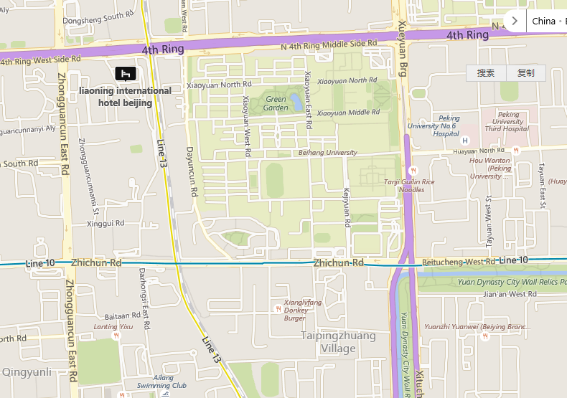

April 23rd Monday Afternoon

Time | Session | Speaker
14:00-15:30 | CGP Update  - CGP Repertoire  - CGP Variant Mappings  - “Visual Similarity” Issue | Wei WANG  Kenny HUANG  Edmon CHUNG
16:00-1800 | CGP & KGP discussion  - KGP updates  - Discussion on variant mappings  - Discussion on “Visual Similarity” | CGP  KGP  CDNC
18:00- | Dinner

April 24th Monday Morning

Time | Session | Speaker
10:00-11:00 | IP presentation  Discussion between IP, CJK and CDNC | CJK  CDNC  ICANN
11:00-12:00 | CJK and CDNC discussion | CJK  CDNC
12:00-13:30 | Lunch

