A Draft Definition of Variants
Within One Language Or Across CJK Languages for ICANN LGR

ICANN/CGP
2015-02-07 Co-Written by Zhang Zhoucai and Chris Dillon
2015-02-23 Revised By Zhang Zhoucai
2015-03-10 Updated By Zhang Zhoucai,
- The comments from Yoneya have been accepted
- The comments on Chinese notes/term from Prof. Wang Tiekun and Ms.Wang Cuiye have been accepted too.
- New examples illustrated.

- Attempt to Redefine Variants Within One Language Context
VARIANT GROUP DEFINITION
Within one language context (CHS, CHT, KR, or JP), the ideographs with different glyphs are defined as Variant Groups whose major /modern pronunciations, meanings and usages are the same.

【参考中译-变体字组】在单一语境下，其当代主要字音、字义和字用都相同而字形不同的一组汉字。
Note1: For an ideograph in a language, if any variant exists, there would be two or more variants corresponding to the code, which shall be called a “variant group”.
【注1】一个编码汉字在一种语境中若有变体字对应，那么该语境中对应该代码就存在两个或多个变体字，称作该变体字的“变体字组”。
Note2: Examples of different usages of variant-like ideographs, such as 一, 壹 are not replaceable for example in finance, although the sound and meaning are the same.
【注2】也有“字用”不同之例，如“壹”在财务中是不可用“一”代替的，尽管二者音义相同。

- Attempt to Define Variants across Language Contexts
CJK VARIANT GROUP DEFINITION
In the CJK language environments, if in each Variant Group (CHS, CHT, KR, and JP) there exists at least one identical ideograph, those Variants Groups shall be integrated as a CJK Variant Groups .
【CJK变体字组】在CJK语境中，如果每种语言的变体字组中都至少存在同一个汉字，则各语境的这些变体字组可合并为一个CJK变体字组。
According to the transivity principle, the members of Variant Groups in different language contexts can be treated as CJK Variants of each other.
【CJK变体字】根据可传递性原则，不同语境变体字组的成员可互称为CJK变体字。
In a CJK Variant Group, there will be one, two or three TYPICAL, ORTHOGRAPHIC, or PREFERRED VARIANTs coming from different languages.
【典型变体字】在CJK变体字组中，各语境都有一个或多个典型变体字（或称规范字、正则字、期望字。）
Look at the CJK Unicode chart:
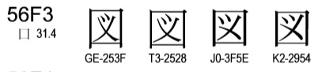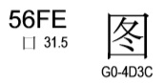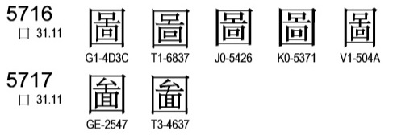
Variant Groups in each language: Taking图図圖圗 into account.

Variant  Groups | Lang Tag | Variant1 | Variant2-  Identical | Variant3 | Typical  Variant
GroupCN | CHS | 图 | 圖 |  | 图
GroupTW | CHT | 図 | 圖 | 圗 | 圖
GroupKR | KR | 図 | 圖 |  | 圖
GroupJP | JP | 図 | 圖 |  | 図

- 4 Variant Groups are formed respectively in CHS, CHT, KR and JP.
- 圖(U+5716) is the identical ideograph amongst the 4 Variant Groups.
- The 4 Variant Groups are integrated into a union- CJK Variant Group, including the following variants: 图図圖 and 圗.
- The Typical Variants of each languages are图,圖,圖and図 respectively, corresponding to CHS, CHT, Kr and JP.

3. Additional Notes on Variants in CJK
- On the other hand, if it is a variant in any language, it is a variant for the script.
换言之，一种语言的变体字，必定是整个文字系的变体字。
- The CJK Variant definition is based on the following assumptions:
  - All related parties agree to establish a UNIFIED Repertoire of COMMON and MODEN CJK Ideographs for TLDs, and using the strict definition of VARIANT GROUP.
  - The CJK Variants here and their transcriptions in Chinese (CHS and CHT), Japanese or Korean, 异体字，異體字and 異体字 are regarded as purely neutral terms, a lexical alternate only, not implying any derogatory or negative sense corresponding to their official or normalized counterparts. （Variants-中性無貶義）, therefore these transcriptions are recommended to use in LGR project: 变(U+5909)体字,變(U+8B8A)體字 and 变(U+53D8)体字.
