For any Hanzi in CGP repertoire, it belong to a variant mapping set (minimum set size is 1 which means there is no variant for the code point) under the current rules borrowed from CDNC; and for any Kanji code point in JGP repertoire, it may also belong to some variant mapping set (we acknowledge that there is no variant in JPRS practice so far, but we assume that there will be a kind of variant mapping definition in JGP repertoire).

All the variant mapping sets can be divided into FIVE scenarios:

- the variant mapping set in JPRS ∈ variant mapping set in CDNC
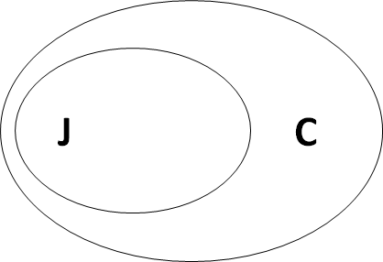
In CGP
愛 611B (0);爱(86),愛(886);愛(0),爱(0);
爱 7231 (0);爱(86),愛(886);愛(0),爱(0);

In JGP
愛611B(2,3);611B(2,3);

- the variant mapping set in CDNC ∈ the variant mapping set in JPRS
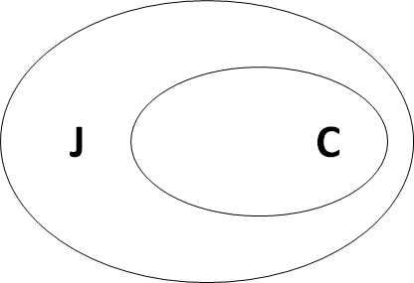
In CGP:
刊520A (0);刊520A(86),刊520A(886);刊(0),刋(0);
刋520B (0);刊520A(86),刊520A(886);刊(0),刋(0);

In JGP:
刊 520A(2,3);520A(2,3);
刋 520B(2,3);520B(2,3);
栞 681E(2,3);681E(2,3);
*: this example is ONLY an assumption

- the variant mapping set in CDNC = the variant mapping set in JPRS
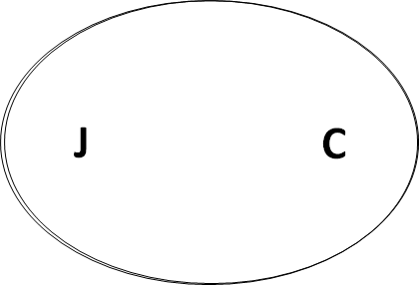
In CGP
一4E00 (0); 一4E00(86),一4E00(886); 一(0),壱(0),壹(0),弌(0);
壱58F1 (0); 壹58F9(86),壹58F9(886); 一(0),壱(0),壹(0),弌(0);
壹58F9 (0); 壹58F9(86),壹58F9(886); 一(0),壱(0),壹(0),弌(0);
弌5F0C (0); 一4E00(86),一4E00(886); 一(0),壱(0),壹(0),弌(0);

In JGP:
一 4E00(2,3);4E00(2,3);
壱 58F1(2,3);58F1(2,3);
壹 58F9(2,3);58F9(2,3);
弌 5F0C(2,3);5F0C(2,3);
*: this example is ONLY an assumption

- the variant mapping set in CDNC ∩ the variant mapping set in JPRS = 0
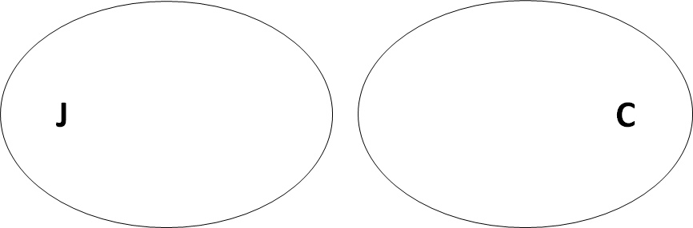
The code point UNIQUELY exists in JGP table
辻8FBB(2,3);8FBB(2,3);

- the variant mapping set in CDNC ∩ the variant mapping set in JPRS ≠ 0
and
the variant mapping set in CDNC ≠ the variant mapping set in JPRS
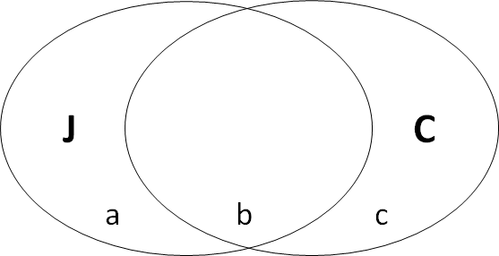
No specified example so far
\

In the past, we discussed the variants problem for many times, but mainly based on the two types: allocatable and blocked. However, we think another type ("out-of- repertoire") in the XML draft, may help the conflicted issue between JGP and CGP, which was recommended by Asmus' mail.
The basic principle is "any variant label with a code point out-of-repertoire is invalid". We think this “out-of-repertoire” type and consequent “invalid” action will tremendously decrease the complexity of variant mapping coordination between us.

For scenario 1:
In CGP
愛 611B (0);爱(86),愛(886);愛(0),爱(0);
爱 7231 (0);爱(86),愛(886);愛(0),爱(0);
In JGP
愛 611B(2,3);611B(2,3);

JGP take爱 7231 into variant mapping set, but mark it as “out-of-repertoire” and take “invalid” action for WLG process, which means, 爱 7231 will never be generated into the labels.

JGP LGR:
<language>und-Jpan</language>
<char cp="611B" tag="sc:Hani">
<var cp="611B" type="alloc" comment="identity" />
<var cp="7231" type="out-of-repertoire-var" /> <!--Hans, JGP should exist.-->
</char>
WLE rules:
<action disposition="invalid" any-variant="out-of-repertoire-var"
comment="any variant label with a code point out of repertoire is invalid"/>
<action disp="allocatable" all-variant="alloc" />

CGP LGR:
<language>und-Hani</language>
<char cp="611B" tag="sc:Hani">
<var cp="611B" type="trad" comment="identity" /> <!-- Jpan -->
<var cp="7231" type="simp" />
</char>
<char cp="7231" tag="sc:Hani">
<var cp="611B" type="trad" /> <!-- Jpan -->
<var cp="7231" type="simp" comment="identity" />
</char>
WLE rules:
<action disp="blocked" any-variant="block" />
<action disp="allocatable" only-variants="simp both" />
<action disp="allocatable" only-variants="trad both" />
<action disp="blocked" any-variant="simp trad" />
<action disp="allocatable" comment="catch-all" />

For scenario 2:
In CGP:
刊520A (0);刊520A(86),刊520A(886);刊(0),刋(0);
刋520B (0);刊520A(86),刊520A(886);刊(0),刋(0);

In JGP:
刊 520A(2,3);520A(2,3);
刋 520B(2,3);520B(2,3);
栞 681E(2,3);681E(2,3);

Now it is CGP’s turn to take栞 681E into variant mapping set, but mark it as “out-of-repertoire” and take “invalid” action for WLG process, which means, 栞 681E will never be generated into the labels.

CGP LGR
<language>und-Hani</language>
<char cp="520A" tag="sc:Hani">
<var cp="520A" type="both" comment="identity" />
<var cp="520B" type="block" />
<var cp="681E" type="out-of-repertoire-var" /> <!-- Jpan -->
</char>
<char cp="520B" tag="sc:Hani">
<var cp="520A" type="both" />
<var cp="520B" type="block" comment="identity" />
<var cp="681E" type="out-of-repertoire-var" /> <!-- Jpan -->
</char>
<char cp="681E" tag="sc:Hani"> <!-- Jpan -->
<var cp="520A" type="block" />
<var cp="520B" type="block" />
<var cp="681E" type="out-of-repertoire-var" comment="identity"/>
</char>
WLE rules:
<action disp="invalid" any-variant="out-of-repertoire-var"
comment="any variant label with a code point out of repertoire is invalid"/>
<action disp="blocked" any-variant="block" />
<action disp="allocatable" only-variants="simp both" />
<action disp="allocatable" only-variants="trad both" />
<action disp="blocked" any-variant="simp trad" />
<action disp="allocatable" comment="catch-all" />

JGP LGR:
<language>und-Jpan</language>
<char cp="520A" tag="sc:Hani">
<var cp="520A" type="alloc" comment="identity" />
<var cp="520B" type="block" />
<var cp="681E" type="block" />
</char>
<char cp="520B" tag="sc:Hani">
<var cp="520A" type="block" />
<var cp="520B" type="alloc" comment="identity" />
<var cp="681E" type="block" />
</char>
<char cp="681E" tag="sc:Hani">
<var cp="520A" type="block" />
<var cp="520B" type="block" />
<var cp="681E" type="alloc" comment="identity"/>
</char>
WLE rules:
<action disp="blocked" any-variant="block" />
<action disp="allocatable" all-variant="alloc" />

For Scenario 3:

In CGP
一4E00 (0); 一4E00(86),一4E00(886); 一(0),壱(0),壹(0),弌(0);
壱58F1 (0); 壹58F9(86),壹58F9(886); 一(0),壱(0),壹(0),弌(0);
壹58F9 (0); 壹58F9(86),壹58F9(886); 一(0),壱(0),壹(0),弌(0);
弌5F0C (0); 一4E00(86),一4E00(886); 一(0),壱(0),壹(0),弌(0);

In JGP:
一 4E00(2,3);4E00(2,3);
壱 58F1(2,3);58F1(2,3);
壹 58F9(2,3);58F9(2,3);
弌 5F0C(2,3);5F0C(2,3);

JGP needs to create its own mapping set including all above 4 code points and corresponding rules, otherwise, it will fall into scenario 1..

For Scenario 4:
Like UNIQUE code point ONLY exists in JGP table
辻8FBB(2,3);8FBB(2,3);

CGP probably will not include this code point into its repertoire.
No extra work or rule are needed.

For Scenario 5:
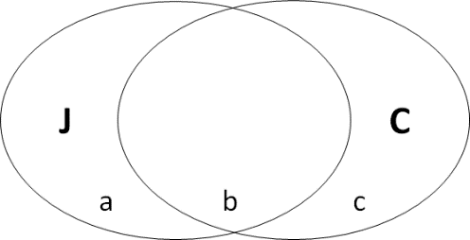

Actually, we have not find the code points which fit into this scenario.
But the solution will refer to scenario 1 or 2, like:

For JGP, “C” will be included but marked as “out-of-repertoire”
For CGP, “A” will be included but marked as “out-of-repertoire”

In conclusion, “out-of –repertoire type” and “invalid action” provide us a conservative and simple way to reach a consensus for the variant mapping and rules.
According to our analysis on CGP table and JPRS table
There are 4983 code points fit for Scenario 1
There are 840 code points fit for Scenario 3
There are 170 code points fit for Scenario 4

Since JGP has not decided yet if variant relationship exist in JGP repertoire, we don’t have analytical number about scenario 3 and scenario 5. But what we believe is that the above solution can also be applied for scenario 3 and 5 no matter what kind of variant mapping JGP will produce.

