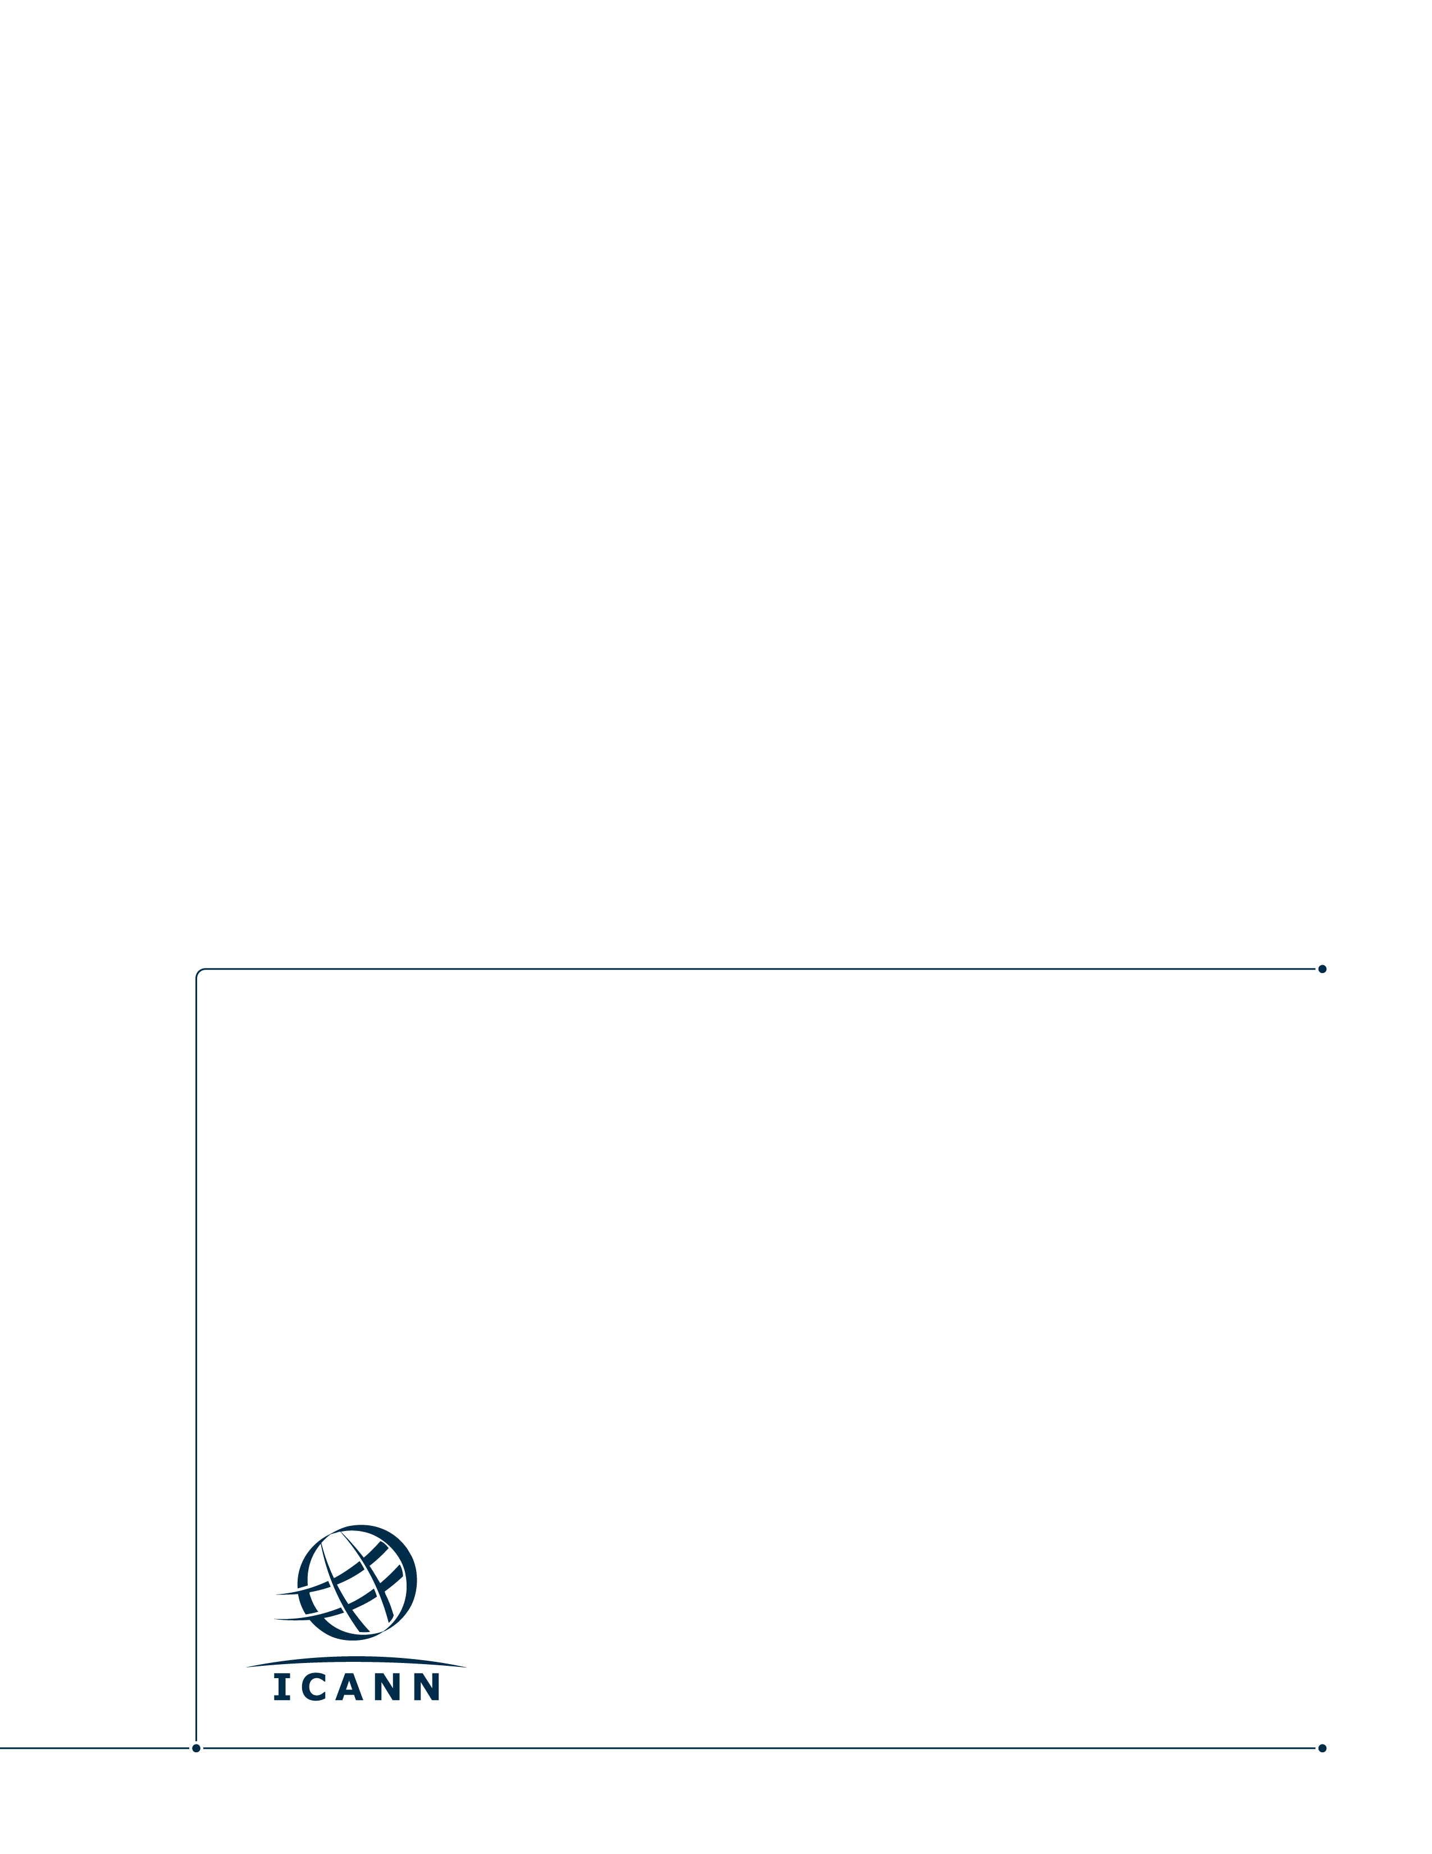
Meeting Strategy: Incremental Changes for Community Review
Draft Report
13 October 2017

Table of Contents
Brief Overview 3
1 Location Selection Criteria 3
2 Meeting Format & Duration 4
3 Dates and Regional Rotation Planning 5
3.1 ICANN Meetings 2021 – 2023 Proposed Dates 6
4 Resources 6

Brief Overview

On 17 August 2017, ICANN.org hosted a call with community leaders and representatives to discuss questions about the criteria for ICANN Meeting venue selection, and potential updates to the current strategy for ICANN Public Meetings, which was approved by the ICANN Board in 2014 (See: https://community.icann.org/display/soaceinputfeedback/Event+Calendar.
Community leaders and representatives on the call included: At-Large Advisory Committee (ALAC) and RALO Chairs, Commercial Stakeholder Group (CSG), Country Code Names Supporting Organization (ccNSO), Generic Names Supporting Organization (GNSO), Non-Commercial Stakeholder Group (NCSG), Registrar Stakeholder Group (RrSG), Registry Stakeholder Group (RySG), Root Server System Advisory Committee (RSSAC), and Security and Stability Advisory Committee (SSAC), and the Government Advisory Committee (GAC) .

This document summarizes the discussion, and provides a detailed report of proposed incremental changes to the current meeting strategy, for the purposes of future consultation with the community.

Fundamental changes to the meeting strategy were also discussed, however participants agreed to wait for a more comprehensive review of the current meeting strategy with the community to examine those issues and make informed recommendations for change.

ICANN.org will present this paper to community leaders and representatives on 13 October 2017 and solicit feedback from the group at a meeting on 2 November 2017 at 0800 am in Capital Suite 3 at the ICANN60 Annual General Meeting in Abu Dhabi. Following that discussion, community leaders and representatives will determine next steps and whether the proposed incremental changes outlined in this document should go out for consultation with the ICANN community. ICANN.org will await further guidance and direction from the community before amending the current meeting strategy.

Location Selection Criteria

Background

ICANN.org has responsibility for arranging ICANN meeting venue selection and operations. A set of general criteria for venue selection is used in the process, including requirements focused on supporting the work of ICANN’s Supporting Organizations and Advisory Committees and ensuring easy access to the meeting for all those who wish to attend.

ICANN Meetings are complicated to arrange, mostly due to the logistics. Since there are so many sessions running concurrently, a meeting venue large enough to accommodate them, and available over our meeting dates, must be found. Also, at times there are other challenges such as changing visa regulations, and requests for additional sessions before and during the meeting.

The Meeting Strategy Working Group (MSWG) recommendations adopted by the ICANN Board in June 2014, state the following when it comes to regional rotation for ICANN Public Meetings:

Continue regional rotation for all meetings and coordinate rotation to balance global coverage on a multi-year cycle, but evolve the rotation strategy to take advantage of the smaller mid-year meeting (Policy Forum) to rotate through new geographic locations previously unavailable to the ICANN meetings due to the attendance and logistical requirements of the current meeting structure.

The MSWG also recommended that the meeting staff should be given the flexibility to make the necessary arrangements to organize the meetings even if the rotation period for a region is not respected assuming that each region should have accommodated the 3 kinds of meetings during a 5-year cycle.

Recommendations

Community leaders and representatives were asked the following question related to location selection criteria:

Q: Is there a preference from SO/AC leaders to adopt new criteria for the selection of ICANN Meeting locations based on factors such as gender issues, democratic principles, and strict rules in observance of religious holidays?

The consensus among community leaders and representatives was that no new criteria for the selection of ICANN Meeting locations should be added.

Community leaders and representatives also expressed that ICANN.org should continue to focus on ease of securing visas as a criterion in evaluating meeting locations and that regional rotation should continue to be as regular as possible.

Meeting Format & Duration

Background

The Meeting Strategy Working Group (MSWG) recommendations adopted by the ICANN Board in June 2014, defined the focus and length of ICANN's triannual public meetings as follows:

Community Forum (Current Duration: 6 Days)
    - Timing of this meeting would be the first meeting in the three-meeting annual cycle
    - Duration would be up to six (6) total days.

Policy Forum (Current Duration: 4 Days)
    - Timing of this meeting would be the second meeting in the three-meeting annual cycle
    - Duration would be up to four (4) total days, and would be focused on SO/AC policy development work as well as cross community interaction and outreach

Annual General Meeting (Current Duration: 7 Days)
    - Timing of this meeting would be the third meeting in the three-meeting annual cycle and would include the Annual General Meeting (AGM) and would have a focus on showcasing ICANN’s work to a broader global audience.
    - Duration would be up to eight (8) total days, but should be optimized to allow some groups to conduct their activities over a shorter duration within the overall meeting timeframe.

Recommendations

Community leaders and representatives were asked what consideration, if any, should be made for changes to the meeting duration.

  - Community Forum
There were no recommendations for change to the duration of the Community Forum.

  - Policy Forum
Input suggests one additional day dedicated to outreach should be added for the mid-year Policy Forum for a total of five days.

  - Annual General Meeting
Community leaders raised concerns about the underutilization of the last day (Day 7) at the Annual General Meeting. They also ask that the announced meeting dates of the official ICANN Public Meetings guarantee constructive use of the participants’ time. Thus, we have two potential recommendations for the Annual General Meeting:

      - Keep the Annual General Meeting to seven days, but reorganize the work so that there is better use of participants’ time on day seven.
Or
      - Reduce the official dates published for the Annual General Meetings to six days, while keeping day seven available for the community to hold internal working meetings and wrap-ups.

Dates and Regional Rotation Planning

Background

The Meeting Strategy Working Group (MSWG) recommendations adopted by the ICANN Board in June 2014, identified specified goals for selecting meeting dates:

    - Maximize the quality of participation through global rotation of locations, remote participation, translation, outreach, and newcomer onboarding.
    - Avoid conflicts with community events and globally recognized non-working or religious observance days.
    - Schedule meetings, as much as possible, on recognized working days (Monday through Thursday).
    - Rotate meeting locations so that in a period of five years, each geographic region hosts three meetings.
    - Maintain a transparent process and solicit community feedback on the proposed dates.

While the community continues to examine the overall structure of the meeting format, it is important that ICANN.org continue to identify dates for future meetings well in advance. ICANN.org seeks to publish future dates at least five years out to prevent conflicts with other community events, and allow meeting participants reasonable time to plan for their attendance.

Potential meeting dates for ICANN Meetings 2021-2023 were identified with careful avoidance of major religious and national holidays, and related Internet industry events that could have an impact on participation. Community feedback was solicited through a public comment proceeding which ended on 2 October 2017.

Current Status

The community identified religious and regional holiday conflicts for four of the proposed dates for future meetings. As a result, staff has amended the dates for five meetings and will extend the comment period for final review.

ICANN Meetings 2021 – 2023 Proposed Dates

Event | Proposed Dates | Revised Dates | Conflict / Justification
ICANN70 | Community Forum | 20 - 25 Mar 2021 | no change
ICANN71 | Policy Forum | 28 Jun - 01 Jul 2021 | 14 - 17 Jun 2021 | Midsummer Holiday; Canada Day
ICANN72 | Annual General Meeting | 23 - 29 Oct 2021 | no change
ICANN73 | Community Forum | 05 - 10 Mar 2022 | no change
ICANN74 | Policy Forum | 20 - 23 Jun 2022 | 13 - 16 Jun 2022 | Midsummer Holiday
ICANN75 | Annual General Meeting | 15 - 21 Oct 2022 | 17 - 23 Sept 2022 | Shmini Atzeret, Simchat Torah, (Diwali week of 22 Oct)
ICANN76 | Community Forum | 25 - 30 Mar 2023 | 18 - 23 Mar 2023 | Moved earlier to ensure sufficient time before the June meeting.  (11 weeks)
ICANN77 | Policy Forum | 19 - 22 Jun 2023 | 12 - 15 Jun 2023 | Midsummer Holiday
ICANN78 | Annual General Meeting | 21 - 27 Oct 2023 | no change

Resources

- Meeting Location Selection Criteria

- 2014 Meeting Strategy Working Group Recommendations

- Proposed Dates for ICANN Public Meetings 2021-2023

