RESULTS OF THE GGP APPLICANT SUPPORT SURVEY QUESTIONS 1-9
36 people responded (27 August 2023)
Key: B-Blue, R-Red, O-Orange , G-Green
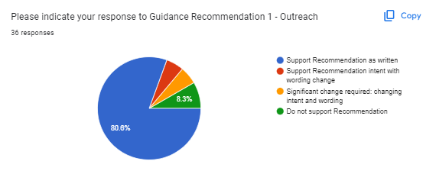 | 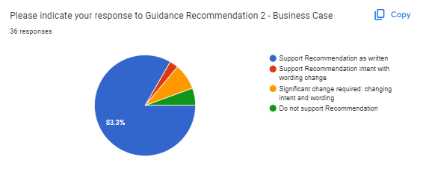
(1) B= 29 (80.6%) R= 2 (5.6%) O= 2 (5.6%) G= 3 (8.3%) | (2) B= 30 (83.3%) R= 1 (2.8%) O= 3 (8.3%) G= 2 (5.6%)
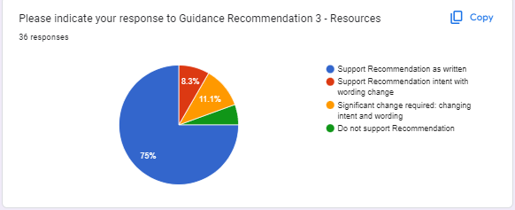 | 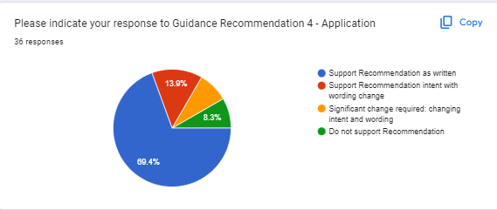
(3) B= 27 (75%) R= 3 (8.3%) O= 4 (11.1%) G= 2 (5.6%) | (4) B= 25 (69.4%) R= 5 (13.9%) O= 3 (8.3%) G= 3 (8.3%)
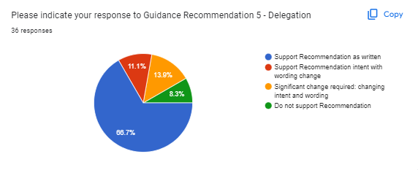 | 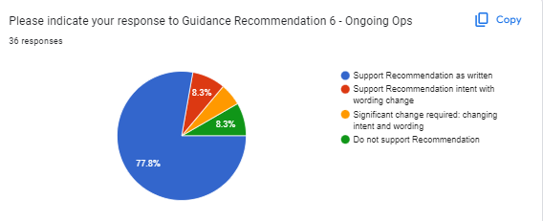
(5) B= 24 (66.7%) R= 4 (11.1%) O= 5 (13.9%) G= 3 (8.3%) | (6) B= 28 (77.8%) R= 3 (8.3%) O= 2 (5.6%) G= 3 (8.3%)
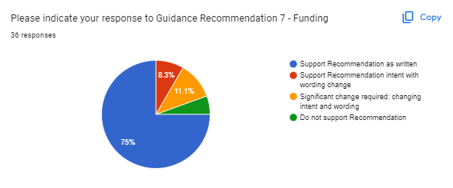 | 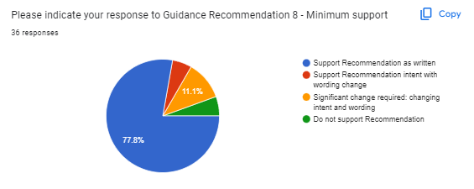
(7) B= 27(75%) R= 3 (8.3%) O= 4 (11.1%) G= 2 (5.6%) | (8) B= 28 (77.8%) R= 2 (5.6%) O= 4 (11.1%) G= 2 (5.6%)
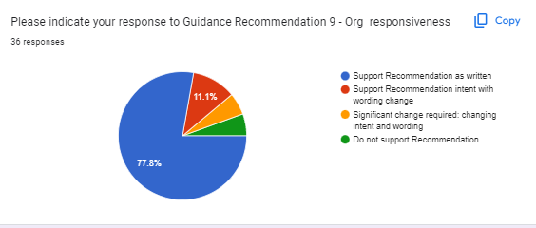
(9) B= 28 (77.8%) R= 4 (11.1%) O= 2 (5.6%) G= 2 (5.6%)

