Cross Community Working Group (CCWG) Life Cycle

1.0 Introduction
The Cross Community Working Group (CCWG) is a mechanism to allow any number of ICANN’s Supporting Organizations (SOs) and Advisory Committees (ACs) to work together to address issues that are of common interest. This document is intended to provide a general and shared framework for establishing, operating and closure of CCWGs; The framework is not intended to be prescriptive, but it draws upon lessons learned from previous CCWG efforts and is expected to serve as best practices for future efforts.

Fundamental Concepts
Based on analysis and discussion to date, a CCWG would have the following basic characteristics:

- Two or more Supporting Organizations or Advisory Committees adopt a single charter, and are hence known as chartering organizations.
- The working group members conduct their business under that adopted charter and report regularly to the chartering organizations.
- The deliverables of the WG are submitted to the chartering organizations for adoption/approval/support/non-objection
- Adoption/approval/support/non-objection by all chartering organization is required to take further steps.

2.0 High Level Description of the Cross Community Working Group (CCWG) Life Cycle

The process flow below is intended to show the entire life cycle of a CCWG at a high level. The following steps of this process will be described individually in further detail in Section 3.0:
- Initiation of CCWG – Supporting Organization(s) and/or Advisory Committee(s) makes a determination if a CCWG is the proper vehicle to resolve the issue that has been identified
- Formation of CCWG – A Drafting Team develops a charter to address a topic of mutual interest for two or more Supporting Organizations and/or Advisory Committees (SOs/ACs) . Only after adoption of the charter by two or more of the SOs/ACs, the CCWG is created and the SOs/ACs who adopted the charter have become chartering organization. Volunteers are requested and appointed according to the own rules and procedures of each of the Chartering Organizations and co-chairs are assigned.
- Operation of CCWG – Agreed Operating Principles are established, a work plan is developed, and the CCWG works to execute against that work plan to produce a set of consensus-based outputs that are then submitted to each Chartering Organization for approval.
- Decision-Making and Closure of CCWG – The Chartering Organizations will review the outputs from the CCWG to determine if they can be approved/supported by each, in accordance with its rules and processes. Only after adoption of deliverables according to the mechanism proposed in the charter, further steps (implementation, submission of Recommendations, provide input into other processes, etc.) can be taken if proposed. The Chartering Organizations will agree to formally close the CCWG once the final CCWG outputs have been received and a final decision has been rendered,.

Alternative: The CCWG will close once the Chartering Organizations have taken a final decision on the final CCWG output and informed the co-chairs of the CCWG accordingly
- Post-Closure of CCWG – The recommendations from the CCWG, if adopted, will be implemented and subsequently monitored against the success criteria identified previously by the CCWG (in step three of the life cycle).

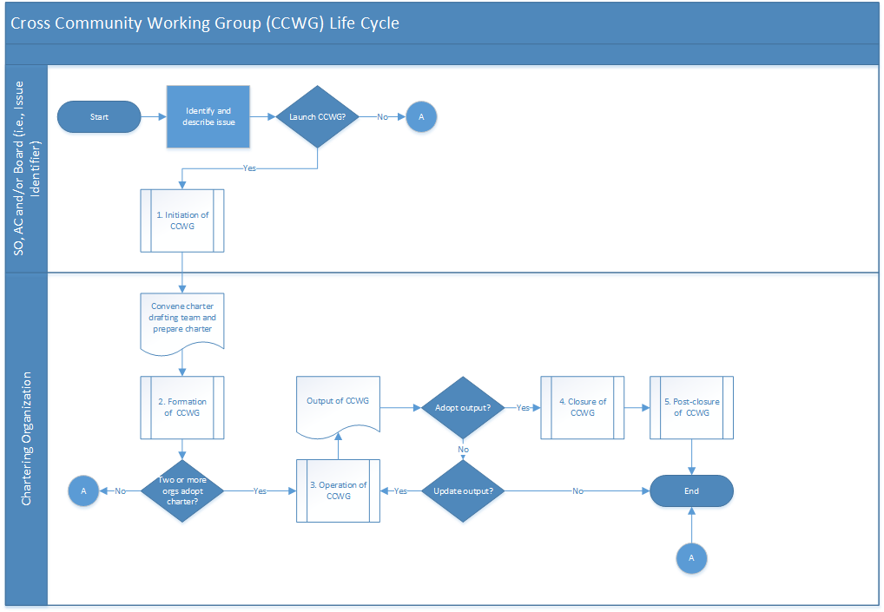

A CCWG will have several critical decision points during its life cycle and should consider these core characteristics of a CCWG:
- Determining whether or not the CCWG is the best mechanism to address the issue.
- If yes, determining if the participating organizations are able to adopt a shared charter (it topic within scope, is there an interest in the topic)
- If yes, determining if the participating organizations are able to all adopt the consensus outputs of the CCWG.

*A note about the detailed descriptions of each process step
While this process and framework is intended to act as guidance for CCWGs and is not prescriptive, all steps should be considered “required” unless noted otherwise, in order for the process to execute as designed so as to achieve consistency in practice.

The process-driven depiction of this framework is inspired by the European Federation for Quality Management (EFQM) Excellence Model. The model encourages a holistic look at the process to understand the broad implications of each action, but also delves deeper into the intricacies of each step. The goal is to understand the cause and effect relationships between each aspect of the process and to ultimately develop sustainable excellence. One of the key components of the model is to strive for continuous improvements, so while this CCWG life cycle documentation is intended to serve as a set of best practices, it is expected that new lessons will be learned and the framework can be improved.

3.0 Detailed Descriptions of the Life Cycle

3.1 Initiation of Cross Community Working Group (CCWG)

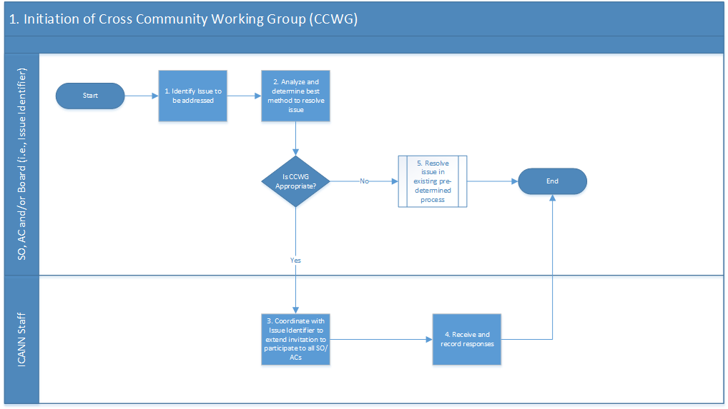

1. | Identify Issue to be addressed
Description | One or more of the Actors will determine that there is an issue that requires solving.
Actor | Supporting Organization (SO), Advisory Committee (AC), and/or ICANN Board
Documents | Issue Identification Request (per Steps below) to be submitted to all other Actors who might be expected to participate in a CCWG
Steps | The Issue Identification Request should:  - Describe with some specificity the particular issue requiring resolution through the multi stakeholder model (i.e. what the issue is and why it requires a CCWG).  - The issue identifier may be a single SO/AC, joint SO and/or ACs, or the ICANN Board.  - Provide information (including supporting documentation) on the specific issue, cause(s) of issue, affected parties, rationale for a CCWG, and hoped for outcome by resolving issue through a CCWG  - DESIRABLE: other relevant information that can assist with the decision whether or not to form a CCWG

2. | Analyze and determine best method to resolve issue
Description | The party that identified the issue in the previous step will submit Issue Identification request to all other SO/ACs [that it believes should participate in the CCWG] with notification to the ICANN Board
Actor | Issue Identifier
Documents | As noted under Steps in Stage 1, above
Steps | Each recipient SO/AC will:  - Review the Issue Identification Request and accompanying documentation  - Consider whether the issue is within the scope of an individual organization’s (i.e., GNSO, ccNSO, ASO) Policy Development Process. If yes, the issue should be addressed through the respective SO/AC process (note that this may involve two or more SO/ACs engaging in their own processes, each within its own remit)  - Consider whether the issue and its resolution will have broad impact across the ICANN community, including specifically affecting other SO/ACs. If no, the issue may not warrant a CCWG.  - If the answer to 3 is yes, further consider this non-exhaustive list of questions to help determine if a CCWG is the most appropriate mechanism to resolve the issue:  - Is other (non-participating) SO/AC decision-making critical?  - Will substantive reporting to non-participating SO/ACs be needed?  - Will specific input or comment of non-participating SO/ACs be required?

3. | If an SO/AC decides that a CCWG is appropriate, coordinate with Issue Identifier to extend invitation to participate to all other SO/ACs
Description | ICANN Staff contacts all SOs/ACs (regardless if they have been specified by the Issue Identifier) to invite them to participate in CCWG effort
Actor | ICANN Staff
Documents | Communication materials
Steps | - Invitation should include:  - Identity of Issue Identifier  - Description of issue, which may include cause(s) of issue, affected parties, hoped for outcome by resolving issue, any other important or related information  - Anticipated roles of participants (e.g., decision-making, desired subject matter expertise)  - Expected timing for CCWG initiation (DESIRABLE)  - Start/End dates for response  - For certainty, request that a SO/AC should specifically decline the invitation to participate, rather than simply not responding  - Staff to work with SO/ACs to ensure wide distribution of the request.  - Allow for adequate time to receive response and follow up at least once for SO/ACs that have not provided their answer.

4. | Receive and record responses
Description | ICANN Staff will manage response period
Actor | ICANN Staff
Documents | None
Steps | - Manage responses against Start/End dates  - Note accept/decline responses  - Follow up where necessary to ensure response is received from all SO/ACs  - Notify ICANN Board of pending chartering/initiation of new CCWG

3.2. Formation of Cross Community Working Group (CCWG)

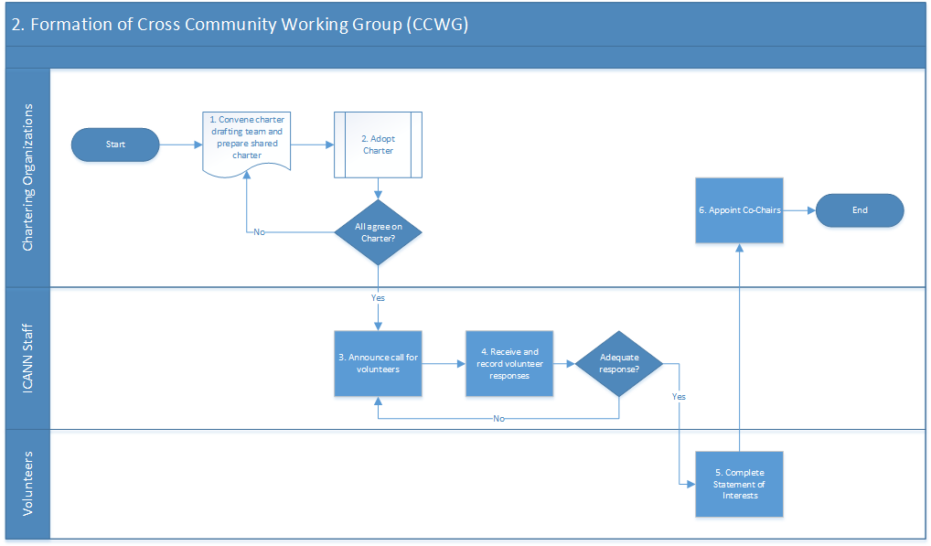

1. | Convene charter drafting team
Description | Participating SO/ACs to appoint/invite members (minimum of one per participating SO/AC) to form Charter Drafting Team
Actor | Chartering Organizations
Documents | Charter Template; and  Confirmation by non-participating SO/ACs of intention not to participate
Steps | - Drafting Team develops CCWG Charter with ICANN staff support. There should ultimately be only one charter sent to each participating SO/AC for adoption. Recommended sections include:  - Purpose/problem statement; goals and objectives; scope  - Deliverables, timeframes, and reporting (i.e., work plan)  - Membership, staffing, roles, and identity of participating organizations  - Rules of engagement, including decision-making methodologies, process for modification of charter, etc.  - Processes for CCWG adoption of output, consensus building mechanisms, problem/issue escalation if there is no consensus, solicitation methods, and dispute resolution processes  - Clear outline of how recommendations of CCWG are to be adopted by chartering organizations  - Draft Charter submitted to Chartering Organizations for approval, noting the date of submission

2. | Adopt Charter
Description | Chartering Organizations will put the draft charter through the normal approval mechanisms applicable to their organization
Actor | Chartering Organizations
Documents | None additionally required
Steps | - The Chartering Organizations will use their regular approval mechanisms to approve the charter.  - If there are edits requested by any of the Chartering Organizations, the charter may need to be sent back to the drafting team, in which case, the process would return to Step 1.  - The editing process should continue until a single Charter is developed to the satisfaction of all Chartering Organizations.

3. | Announce call for volunteers
Description | ICANN Staff will publish a call for volunteers
Actor | ICANN Staff
Documents | None
Steps | - Staff will prepare an announcement for publication  - Announcement will be posted on each of the Chartering Organization’s web sites (at minimum). The announcement must include definitions of members and participants if they are defined as different in the charter.  - Send notice to all SO/AC chairs to distribute to their network of members

4. | Receive and record volunteer responses
Description | ICANN Staff will accept volunteer responses
Actor | ICANN Staff
Documents | None
Steps | - Manage responses against a reasonable timeline (e.g., three weeks)  - Accept responses and add volunteers to appropriate mailing lists and Wikis as applicable  - If there does not appear to be adequate levels of participation from particular Chartering Organizations to ensure meaningful representation, Staff to work with the Chartering Organization(s) in question to facilitate greater participation.

5. | Complete Statement of Interests
Description | Community volunteers will complete a statement of interest (where?)
Actor | Volunteers
Documents | None
Steps | - Volunteers will complete a statement of interest (SOI) via the appropriate mechanism for their SO/AC  - If volunteers do not complete their SOI in a timely manner, staff to follow up with them

6. | Appoint Co-Chairs
Description | Each Chartering Organizations will nominate one co-chair
Actor | Chartering Organizations
Documents | None
Steps | - The Chartering Organizations will nominate one co-chair each (unless more is expressly agreed to). There is no approval mechanism needed at the CCWG level and will instead occur via the normal mechanisms within each Chartering Organization.

3.3 Operation of Cross Community Working Group (CCWG)

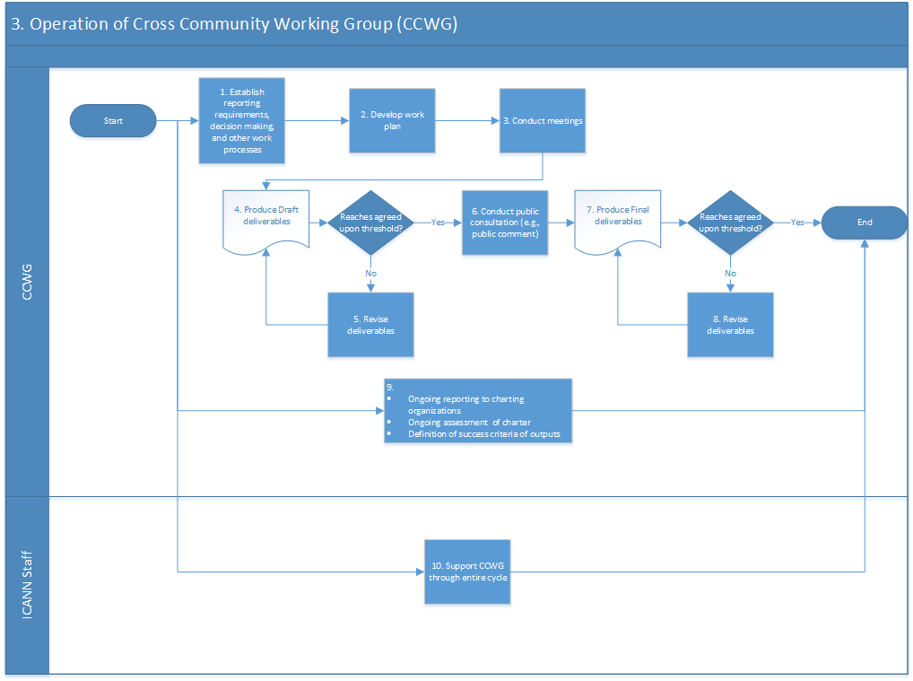

1. | Establish reporting requirements, decision making, and other work processes
Description | The CCWG must establish agreed-upon operating principles.
Actor | CCWG
Documents | Operating Principles documentation per Steps below
Steps | - Establish the CCWG operating principles. Some of the elements that should be considered include:  - Process for amending Charter  - Regular reporting requirements, including but not limited to the general public and all Chartering Organizations  - Rules for handling feedback from Chartering Organizations  - Rules for decision making, including establishing approval thresholds  - Handling of minority positions  - Escalation of disputes  - Communication methods (e.g., email, teleconferences, face to face sessions)  - The use of public comment periods and how public comments received will be handled

2. | Develop work plan
Description | The CCWG will develop a work plan, with agreed-upon milestones, to achieve its chartered goals
Actor | CCWG
Documents | Work Plan
Steps | - Agree upon deliverables, to be based on the charter, and establish a timeline to achieve those deliverables.  - The group may want to consider having deliverables driven by ICANN meetings to take advantage of face to face interactions and widespread focus on ICANN matters  - The group should agree on a general meeting schedule, such as frequency and time.  - Enter the work plan into a project management tool (ICANN Staff may facilitate)

3. | Conduct meetings
Description | CCWG will meet per the general meeting schedule
Actor | CCWG
Documents | None
Steps | - Meet per the general meeting schedule as agreed in step 2  - Revise as necessary to accommodate deliberations and generation of deliverables

4. | Produce draft deliverables
Description | CCWG will generate the deliverables as identified in the Work Plan developed in Step 2
Actor | CCWG
Documents | Deliverables
Steps | - The CCWG will work in accordance with its Operating Principles and Work Plan, to generate the deliverables set out in its Work Plan  - In the event of disagreement by one or more Chartering Organization(s) with a deliverable generated by the CCWG, the CCWG may revise that deliverable in accordance with Step 5, below.

5. | Revise deliverables (if necessary)
Description | CCWG will revise the deliverables
Actor | CCWG
Documents | None
Steps | - The CCWG will work to produce a set of deliverables that all group members and chartering organizations can agree to. DESIRABLE: Any modification to its Work Plan or Charter as a result should be considered at this stage.

6. | Conduct public consultation (e.g., public comment)
Description | The CCWG will periodically call for public comments as feedback on its work and progress
Actor | CCWG
Documents | None
Steps | - The CCWG will conduct public consultations as defined in step 1, which may consist of a public comment period lasting at least 40 days. (ICANN Staff may be able to assist in these efforts).  - The public consultation may be extended in rare circumstances; a decision on whether this is necessary in any one instance will be made by the CCWG co-chairs.

7. | Produce final deliverables following public comments received
Description | CCWG will finalize its deliverables as identified in its Work Plan developed in step 2
Actor | CCWG
Documents | Deliverables
Steps | - The CCWG will finalize all its deliverables in accordance with its Work Plan (as modified, if applicable)  - The group members and the chartering organizations should come to agreement on the deliverables based on the rules for decision making developed in step 1.  - If agreement is reached, proceed to step End.  - If agreement is NOT reached, proceed to step 8

8. | Revise deliverables
Description | CCWG will revise the deliverables if feedback is received from a Chartering Organization that it will not be able to adopt the recommendations made
Actor | CCWG
Documents | Documented feedback from Chartering Organizations
Steps | - The CCWG will work to produce a set of deliverables that all group members and chartering organizations can agree to.

9. | Ongoing activities
Description | CCWG will have a set of agreed upon ongoing activities to help the group properly execute against its charter
Actor | CCWG
Documents | Activities to be listed, and frequency and timing outlined, in either its Charter, Work Plan or both
Steps | The CCWG will have a number of ongoing activities it will undertake to ensure accountability and community feedback. This is a non-exhaustive list of possible ongoing activities:  - Ongoing reporting to chartering organizations  - Ongoing reporting to the public  - Briefing the ICANN Board, at least as frequently as at each ICANN meeting during the life cycle of the CCWG  - Ongoing review of charter to ensure it continues to be fit for the tasks

10. | Support CCWG through entire cycle
Description | ICANN Staff will support the needs of the CCWG
Actor | ICANN Staff
Documents | None
Steps | ICANN Staff will support the CCWG as needed. A non-exhaustive list of supporting activities include:  - General support through each step of the life cycle  - Setting up meetings, including arranging call details, Adobe Connect support, arranging for dial-outs, etc.  - Development of draft materials  - Coordination with chartering organizations  - Update and maintenance of collaboration vehicles such as Wikis, web sites, email, etc.

3.4 Decision-Making and Closure of Cross Community Working Group (CCWG)
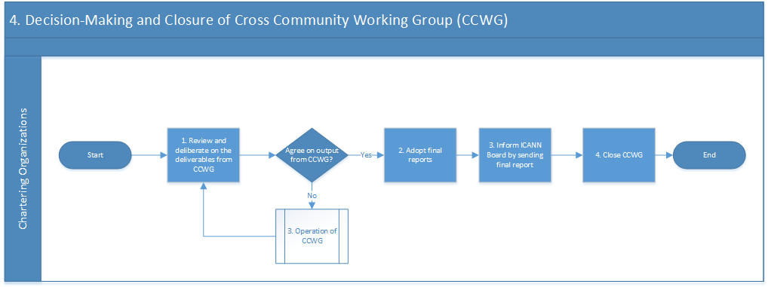

1. | Review and deliberate on the deliverables from the CCWG
Description | Chartering Organizations will review the deliverables (i.e., recommendations) from the CCWG
Actor | Chartering Organizations
Documents | Deliverables
Steps | - The deliverables will be sent to all of the Chartering Organizations at the same time for their review and deliberations.  - The Chartering Organizations may seek additional information from the CCWG.  - The expectation is that the Chartering Organizations will mutually agree to the CCWG deliverables unchanged. If this is not possible, the work may need to be returned to the Operation of CCWG phase of the life cycle to revise the deliverables.

2. | Adopt final recommendations (as amended by the CCWG, if applicable)
Description | All Chartering Organizations to adopt or reject the CCWG’s final recommendations
Actor | Chartering Organizations
Documents | None
Steps | - Each Chartering Organization will consider and adopt or reject the CCWG’s deliverables in accordance with its own internal rules and processes.  - To minimize the possibility that the CCWG’s recommendations are rejected at this stage, members appointed by the Chartering Organizations are encouraged to provide early and regular updates and feedback to the Chartering Organizations and vice versa.  - Should a Chartering Organization believe it has a reasonable basis for rejecting a CCWG’s final recommendations even after the CCWG has attempted to amend its initial recommendations in accordance with feedback, the Chartering Organization is encouraged to discuss its concerns with the other Chartering Organizations and the CCWG, to avoid having to reject (if possible).  - If it is not possible for all Chartering Organizations to agree on the same path forward for the CCWG’s recommendations, the objecting Chartering Organization(s) shall provide its reasons for disagreement in writing. This minority statement shall be attached to the Board report (see Step 3, below)  - If not possible to reach consensus support from the chartering organizations, the CCWG will close (see above in alternative).,

3. | If appropriate, Inform ICANN Board by sending final report
Description | A single report from all the Chartering Organizations (including, where applicable, minority statement(s)) to be sent to the ICANN Board, including any requests for further action by the Board or ICANN Staff.
Actor | Chartering Organizations
Documents | Report
Steps | - Board to acknowledge receipt, and if appropriate, discuss the CCWG report.  - A CCWG may not be formally closed by its Chartering Organizations until acknowledgment of receipt has been provided by the Board.

4. | Close CCWG
Description | Once a final decision has been rendered, the CCWG will formally close amd subsequent steps can occur.
Actor | Chartering Organizations
Documents | None
Steps | 1. Once the Chartering Organizations reach a final decision on the outputs of the CCWG, it may formally close. Closure can be the result of achieving consensus adoption of the final outputs or if consensus cannot not be reached. The determining factor is a final decision.

3.5. If appropriate Post-Closure of Cross Community Working Group (CCWG)

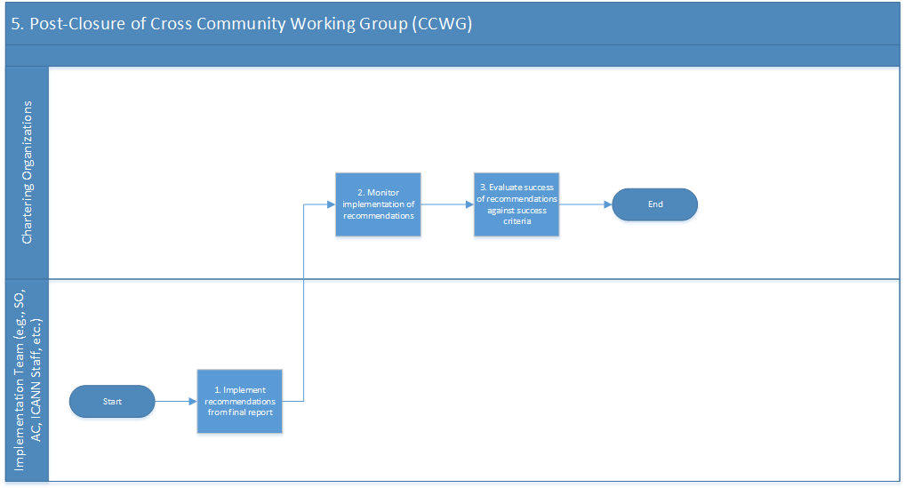

1. | Implement recommendations from final report
Description | Implementation Team implements recommendations from final report as adopted by Chartering Organizations
Actor | Implementation Team (e.g., SO, AC, ICANN Staff, etc.)
Documents | Work Plan
Steps | - If appropriate, an IRT will be formed comprising ICANN Staff and volunteers from each of the Chartering Organizations  - Implement the recommendations from the final report  - Establish baseline data and metrics for measurement against success criteria post implementation (if this has not previously been done by the CCWG)

2. | Monitor implementation of recommendations
Description | Chartering Organizations will monitor efforts to implement recommendations
Actor | Chartering Organizations
Documents | None
Steps | - IRT to provide periodic updates to the Chartering Organizations.

3. | Evaluate success of recommendations against success criteria
Description | Chartering Organizations will evaluate whether the implemented recommendations meet success criteria on at least a periodic basis (for a period to be determined by the CCWG during its Operation phase)
Actor | Chartering Organizations
Documents | None
Steps | - Analyze, preferably using data and metrics, to determine whether the implementation of the recommendations meet success criteria established during the Operation of CCWG phase of the life cycle.

Section 4. Basic Observations/areas for further work

Members and other volunteers (participants)

- Appointment mechanism for members and other volunteers differs per SO/AC. Mechanism to inform leadership of CCWG and support staff of appointments.

- Allow for participants, if so how? Through SO and AC call for volunteers, call for participants by the CCWG itself?
- Requirement for SOI, some SO/AC always require an SOI, some do not.

Internal processes working group
- Decision making by consensus: what is meant by consensus (different interpretations)?

Decision Making
- Make distinction between formal call for consensus and working consensus?
- SO and AC decision-making
- Submission process
- Mechanism to inform CCWG and other Chartering Orgs of decision.

Overarching Question
- Experience to date is that a prescriptive method and/or highly detailed method would impair work of a CCWG. Based on experience with DSSA, CWG Stewardship and CCWG Accountability, suggest that including the need for consensus suffices (full consensus or consensus), with backstop call for consensus/vote by the appointed members, in combination with two readings of final proposed documents.

