Dear…

I’m writing to you to thank you for the help of the (name of the ALS), a valued member of the European regional At Large organization of ICANN, in furthering the interests of Internet end-users, and to find ways of strengthening our cooperation even further towards that end. I would also like to get feedback from you on how EURALO could help you in your national/local activities.

1) Since 2003, the At-Large Advisory Committee (ALAC) has developed over 300 pieces of advice on ICANN policies and issues impacting Internet users. As one of the five regional At Large organizations, EURALO contributes, especially from the point of view of European end-users, to ALAC working groups discussing and drafting policy advice.

Compared to many other global processes that are framing our lives today, multistakeholder governance of internet identifiers is unique because it offers end-users a genuine opportunity to be part of decision-making on issues affecting them. However, the end-user community is not able to use this opportunity to the fullest.

As far EURALO is concerned, there is a devoted group of activists, drawn from a number of European At Large Structures, that does its best to keep up with ICANN’s sprawling policy development and to offer its input to the formulation of ALAC advice. But this group is rather small. Workload on the select few may grow too heavy, opportunities for input may slip away because of lack of resources, and the advice may not reflect the actual grassroots thinking in parts of Europe.

One of the recommendations of the Second At Large Summit (London, June 2014) suggests a solution to the problem, ie. to map the current expertise and interests (in the ALS’s) to identify Subject Matter Experts and to facilitate policy communication. Statistical studies were made on the topic, but they are not of much help when concrete help from concrete experts is needed.

That is why I’m now asking you, as our contact point to (name of ALS), to help us identify subject matter experts in your organization who would be willing to participate in the drafting of EURALO input to the ALAC advice, reflecting the specific circumstances in your country and the topics that (name of ALS) knows best. For the most relevant subject matter areas, please take a look at the diagram on the ALAC website https://atlarge.icann.org/, also reproduced here.

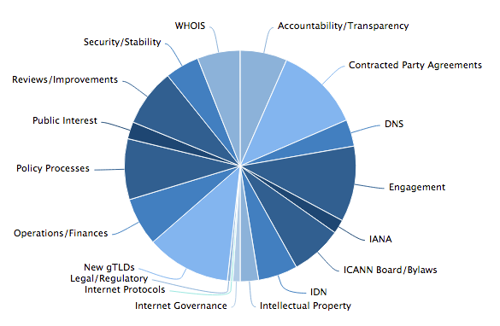

In order to be able to draw upon the help from your experts, we would need their contact information, preferably e-mail addresses. They would be at the disposal of EURALO board and At Large staff only (not published).

2) Mirroring global cooperation among different internet communities, multistakeholder approach on national level in internet matters has taken hold in many countries. National IGF’s are a prominent example of a growing tendency for national multistakeholder dialogues throughout Europe. This is something that EURALO would like to foster by facilitating, eg. exchange of information and best practices, and well as contacts among stakeholders. I’m very much looking forward to your feedback and suggestions.

3) Just by looking at the websites and Facebook pages of the 37 European ALS’s, their diversity jumps out. Some cover a broad spectrum of internet and information society issues. Some are interested in a more narrow segment among them. Some are NGO's engaged in other fields that have joined the At Large because of the importance of the internet in their core activities. Thus, their engagement in At Large varies greatly in relevance and subject matter interest from one ALS to the next, and one size most certainly does not fit all. This is why I would like to suggest to you and your colleagues a teleconference with a mutually convenient time during the fall season 2016 in order to discuss with my EURALO colleagues and me the above issues and anything else the EURALO might help you with.

