Recent activities in the realm of Internet governance: Nov-Dec 2024
Pari Esfandiari

Empowering End-User Voices in Internet Governance
At the Internet Governance Forum (IGF), I had the honor of moderating Workshop #138 on December 18 (11 am - 12:30 pm GMT+3, Room 1). Organized by the Global TechnoPolitics Forum, the session focused on empowering end users in internet governance by addressing barriers to their meaningful participation and exploring ways to overcome them.
Watch this session: https://lnkd.in/e4kEkrq6
Read more about our session here: https://lnkd.in/e9iaqb5T
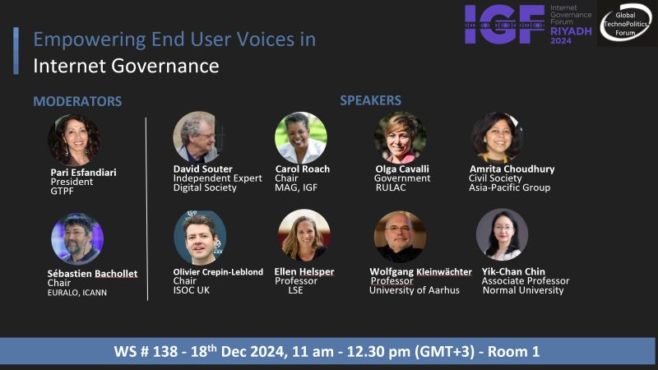
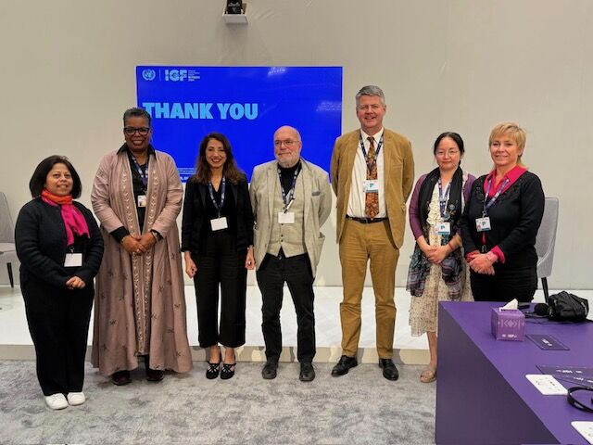
-----------------------------------------------------------------------------
UK Stakeholders and WSIS+20 Review - ICANN
On December 4, 2024, I had the privilege of participating in the "UK Stakeholders and WSIS+20 Review" event in London. Organized by ICANN in collaboration with the UK Department for Science, Innovation and Technology (DSIT) and Nominet UK, the event focused on the upcoming WSIS+20 Review, the outcomes of the Summit of the Future, and the Global Digital Compact. This gathering provided a crucial platform to advocate for the multistakeholder model and to engage in meaningful dialogue on the evolving landscape of global digital governance.
During the event, I had the honor of reading a statement on behalf of EURALO and its Chair, Sébastien Bachollet. The statement included a note of appreciation to Sally Costerton for her exceptional leadership and dedication during her tenure as ICANN's Interim President and CEO. Sally’s inspiring guidance has left an indelible mark on the organization, and it was a privilege to publicly acknowledge her exemplary service. Thank you, Sally, for your outstanding contributions and commitment to the global internet community.

Celebrating the Internet's 50th Anniversary with PCI
The People-Centered Internet (PCI) invited me to share a message celebrating the 50th Anniversary of the Internet. My message reflects on this remarkable achievement while looking ahead to what lies on the horizon. Watch the message here: https://www.youtube.com/watch?v=ZkroBWDA76M&feature=youtu.be


Australia’s Social Media Ban: A Flawed Approach to Protecting Children
In this opinion piece, I critique Australia's recent social media restrictions as a misguided attempt to protect children. Read my article on the Hill here:
https://thehill.com/opinion/technology/5027074-australias-social-media-ban-is-a-flawed-approach-to-protecting-children/



UN's Internet Governance Forum - UK Panel Discussion: ‘20 years on from WSIS'
On November 5, I had the pleasure of speaking on this panel focused on the geopolitics of Internet governance, reflecting on the successes of the WSIS process and envisioning the future of digital development.
Watch the Discussion: https://www.youtube.com/watch?v=ohS8c94K7kI&t=3s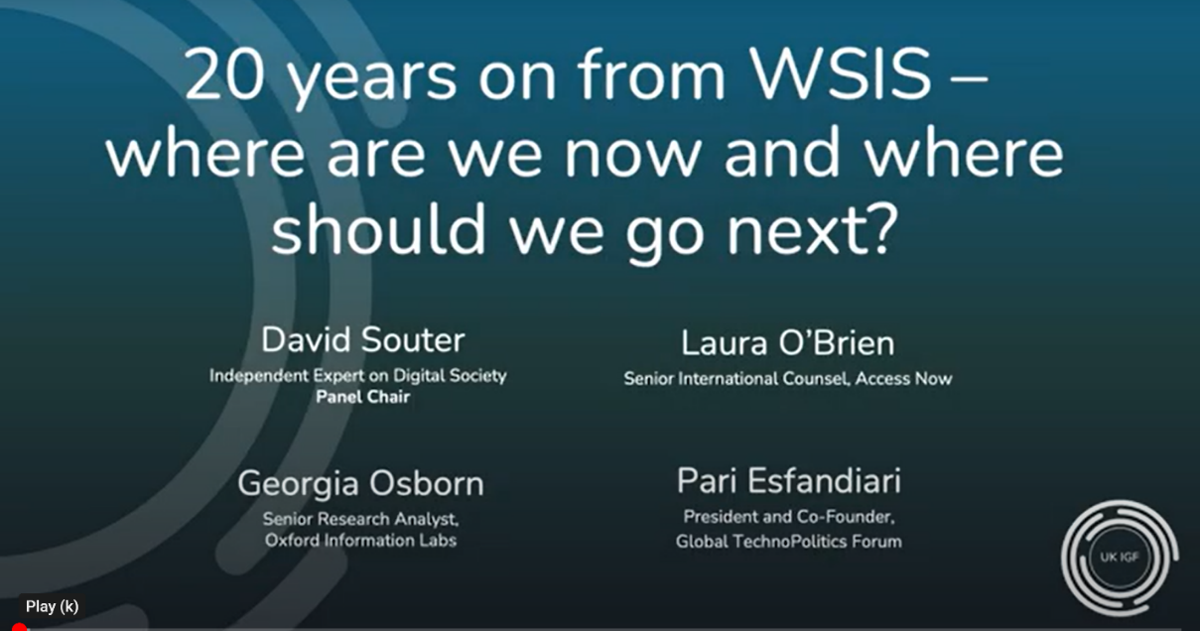
Shifting Paradigms: Multistakeholderism, Geopolitics, and Emerging Internet Infrastructures.
I was delighted to speak in this ICANN81 community plenary panel discussion which I co-proposed. The panel explored the power of the multistakeholder model amidst evolving geopolitical tensions and emerging internet infrastructures. The session, was moderated by RamMohan and featured insights from notable experts including: PariEsfandiari, OlgaCavalli, ChaficChaya, NigelHickson and KevinK. on stage, and AmritaChoudhury, JorgeCancioMelia from the floor. Session Recording: https://lnkd.in/e8WBJUBR
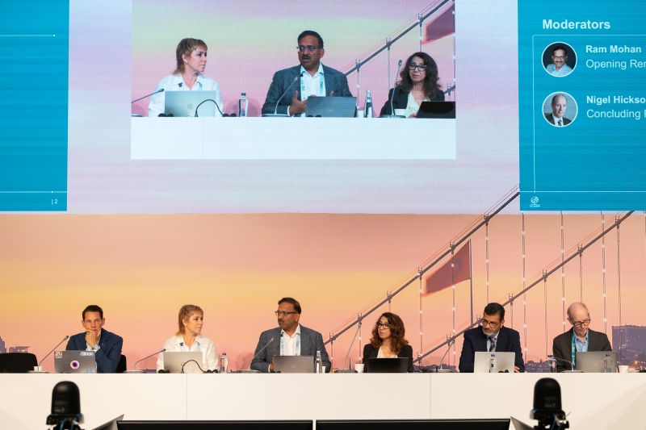

Europe-China AI Forum: Can Europe and China Cooperate on AI?
It was an honor to join this Oxford Global Society event alongside Prof. Jinghan Zeng and Dr. Brian Wong, moderated by Prof. Robert Wade. The panel brought together leaders in AI governance, research, and industry to explore the potential for collaboration between Europe and China.
Event Details:
https://oxgs.org/event/europe-china-ai-forum-can-europe-and-china-cooperate-on-ai/
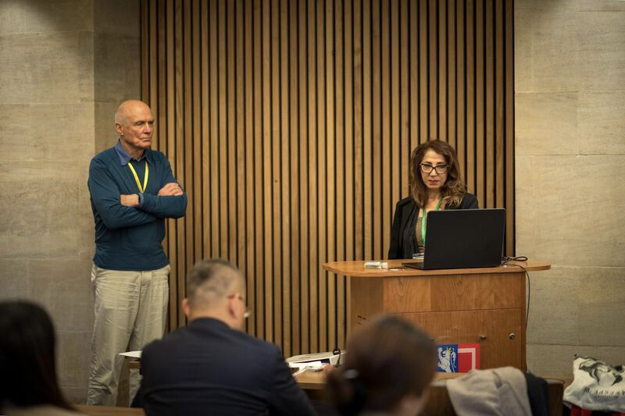

AI: Innovation and Governance- South Korea, Regional Dynamics
As moderator of this event, hosted by the Global TechnoPolitics Forum in collaboration with the University of Southern California and supported by the Pacifica Center Institute, I delved into South Korea's role in AI innovation and governance.
Watch the Program:
https://technopolitics.org/ai-innovation-and-governance-south-korea/
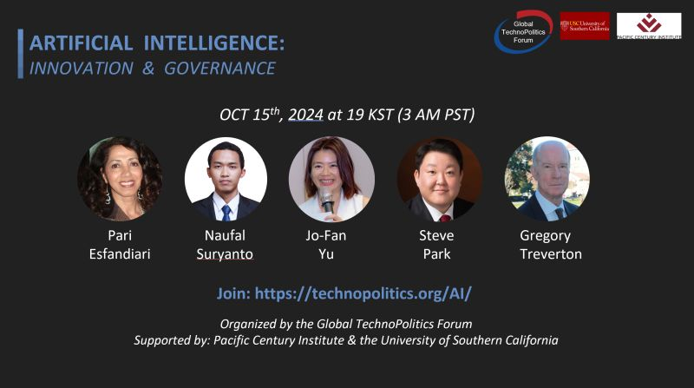

I look forward to further engaging in discussions, collaborations, and initiatives that shape the future of our digital world. Let’s make 2025 a year of growth and meaningful progress in these critical areas!
Regards,
Pari Esfandiari,
EURALO and ALAC Member

