Core Internet Values: Evolution and Challenges for ICANN
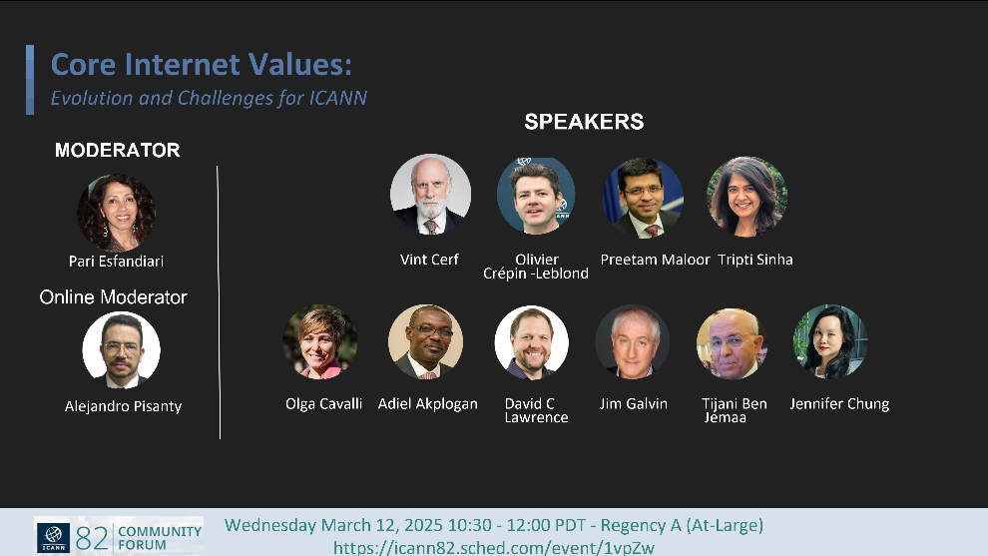
On March 12, 2025, Pari Esfandiari organized and moderated the ICANN82 At-Large Plenary session titled “Core Internet Values: Evolution and Challenges for ICANN.” This high-level 90-minute session convened a distinguished panel of global Internet governance leaders, including Internet pioneer Vint Cerf, Tripti Sinha (ICANN Board Chair), Preetam Maloor (ITU- Head of Emerging Technologies), and Olivier Crépin-Leblond (Chair, Dynamic Coalition on Core Internet Values). They were joined by key representatives from across the ICANN stakeholder community: Adiel Akplogan (ICANN), James Galvin (SSAC), David Lawrence (IETF), Olga Cavalli (ccNSO), Jennifer Chung (GNSO), Tijani Ben Jemaa (At-Large), and Alejandro Pisanty, who co-moderated the online discussion.
Esfandiari opened the session by contextualizing the enduring relevance and evolving challenges of core Internet values—such as openness, decentralization, interoperability, and user-centricity. The conversation explored the growing tensions between global connectivity and digital sovereignty, the governance implications of emerging technologies like AI and blockchain, and the increasing strain on ICANN’s multistakeholder model in an era of regulatory fragmentation and platform consolidation. The session was widely praised for its strategic framing and inclusive dialogue, and was commended for advancing critical discourse at a pivotal time for the future of Internet governance.
Session Recordings:
Zoom Archive
English audio archive
Archivo de audio en español
Archive audio en français

Conspiracy Theories and the Crisis of Truth
Pari Esfandiari has published a new study titled Conspiracy Theories and the Crisis of Truth, which offers an interdisciplinary analysis of the psychological, philosophical, political, and sociological roots of conspiratorial thinking. The study places particular emphasis on the role of media, digital platforms, and algorithmic amplification in spreading and legitimizing conspiracy narratives. It explores how today’s information ecosystem is reshaping public trust, distorting truth, and posing significant challenges to democratic institutions.

