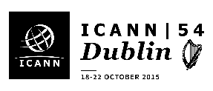

Joint European stakeholders / European At Large Organisation (EURALO) networking event

18:30-20:00 Wednesday October 21, Lobby 2 Foyer, Convention Centre Dublin

At the occasion of ICANN54, and following the General Assembly of EURALO and the coordination session of ICANN’s European stakeholder communities,

We are delighted to invite all EURALO members and European stakeholders
to a civil networking event and cocktail reception on Wednesday, October 21 from 1830-2000.

This will be an opportunity to meet and spend an enjoyable moment with fellow Europeans taking part in ICANN54, in the informal setting of a cocktail event.

We look forward to seeing you there!



