REFERENCE GUIDE TO THE OPEN TMCH QUESTIONS POLL – INCLUDING DEFINITIONS AND EXAMPLES
17 June 2017

Definitions used in the poll:

- “Stylized Marks” mean pure text marks where the font is stylized, including such marks that are registered in specific colors.

- “Composite Marks” mean marks that consist of text plus a design element (also called a figurative mark – meaning a mark comprising words or letters combined with pictures, graphics or images - in some jurisdictions)

Examples of Stylized and Composite Marks:

- Example of a Stylized Mark:

“OWN YOUR POWER” (this was Example #6 in the Annex to the Working Group’s follow up questions to Deloitte), reproduced here –



- Description of Mark - The color(s) light blue is/are claimed as a feature of the mark. The mark consists of light blue scripted letters which create the words Own Your "Power."

- Example of a Stylized Mark comprised of an individual letter:

The stylized letter “A” (this was Example #5 in the Annex to the Working Group’s follow up questions to Deloitte), reproduced here –

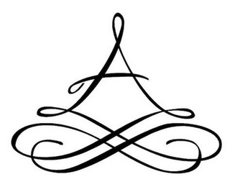

Description of Mark - Color is not claimed as a feature of the mark. The mark consists of a stylized letter "A".

- Example of a Composite Mark:

MUSIC (this was Example #4 in the Annex to the Working Group’s follow up questions to Deloitte), reproduced here –



Disclaimer - NO CLAIM IS MADE TO THE EXCLUSIVE RIGHT TO USE "MUSIC" APART FROM THE MARK AS SHOWN

Description of Mark - Color is not claimed as a feature of the mark. The mark consists of the stylized wording "MUSIC" and the design of two parallel lines. One parallel line is longer than the other, the lines slant to the right, and form the letter "P".

- Example of a Composite Mark where the text has not been expressly disclaimed:

CARS (this was Example #3 in the Annex to the Working Group’s follow up questions to Deloitte), reproduced here –

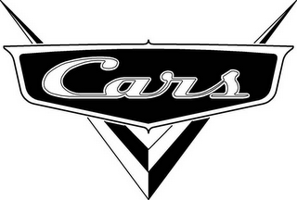

Description of Mark - Color is not claimed as a feature of the mark. The mark consists of the word "CARS" in stylized lettering, surrounded by a dark oblong and superimposed over a stylized "V

- Example of a Composite Mark or Stylized Mark where the text portion is descriptive in nature:

(i) CARS (see above)

(ii) PARENTS:



