Opening and Editing Google Doc documents

If you open a Google Doc from a folder, and not directly through a link sent to you, you will need to click “Open with Google Docs” to send the document into editing mode.
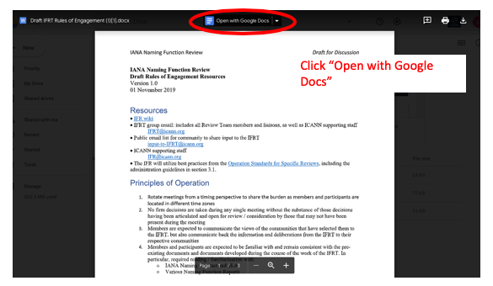

If you open a document directly via link, and do not see the screen set-up from the first photo above, you are already in edit mode. However, to track your changes, please click on the Edit Icon and select “Suggesting”.

