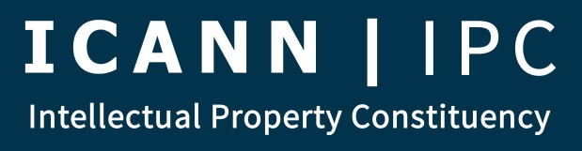
Membership Meeting
PRELIMINARY AGENDA

August 11, 2015
11:30 AM – 1:00 PM EDT
15:30 -17:00 UTC
(Meeting extended 30 minutes for special presentation on UDRP rules)
- Introduction
- Brief Updates
  - New Members
  - Secretariat Update
  - Public Email list
- IPC Elections
- IPC Outreach & Engagement
  - Outreach & Engagement Task Force
  - Outreach & Engagement Strategic Plan
  - ICANN Fellowships
  - CROPP
- GNSO Council Matters
  - Report from Council
  - GNSO Council Chair Elections
  - GNSO Council Vice Chair Selection Process
- IP and Human Rights Task Force
- Dublin Planning
  - CSG Activities
    - Meetings (Closed, Open)
    - Breakfast (with ALAC)
    - Board Roundtable
  - IPC Meetings (Closed, Open)
  - Dinner
  - Coordinate Notes/Overlaps
  - ICANN Leadership Training Program
- NCPH Intersessional Planning
- IPC Public Comments
  - Open Comments
    - Next Gen RDS
    - Data & Metrics
    - .SHARP Searchable WHOIS
    - GNSO Policy & Implementation Bylaws Amendments
    - ICG IANA Transition Combined Proposal
    - CCWG-Accountability
  - Notable Closed Comments
    - .TRAVEL, .CAT and .PRO RA Renewal
    - PPSAI Initial Report
- IPC gTLD Data Portal Project (Claudio)
- SPECIAL PRESENTATION ON REVISED URDP RULES (Brian Beckham, Ty Gray of WIPO) (12:30 PM EDT, 16:30 UTC)
- All Other Business
- Adjourn

