8 Nov. 2016
Hiro Hotta

Ideas to live with the limitation of the number of allocatable variant

CGP, JGP, and KGP have cooperatively worked to define RootLGR for CJK TLD labels. Here CJK means Chinese, Japanese, Korean languages, which have Han (also called as Kanji in Japanese and Hanja in Korean) script in common. As these three languages have different rules in using the same script, RootLGRs for CJK are different and thus allocatable variant label set as the result of each LGR will be different. This fact makes it difficult for CJK GPs to produce RootLGRs that are consistent with each other and satisfy all of CGP, JGP, and KGP..

This paper is to ask ICANN to devise a TLD application/evaluation process to complement the function of RootLGR to solve the above-mentioned difficulty.

<Problem statement>

Language Generation Panels (GPs) intensively work on the definition of RootLGRs for their respective languages.

[original intention of CGP, JGP, and KGP]

CGP and KGP respectively intend to define variant relationships among characters in their respective repertoire. However, JGP intends to have no variant definition, i.e., all characters in its repertoire are independent.

For a language whose character set (repertoire) contains variant characters, the number of variant labels of a specific label may be more than one - even thousands or more in some cases. For such cases, reduction of the number of allocatable labels to a moderate number is requested by Integration Panel (IP). And each GP tries to introduce a rule to limit the pattern of allocatable labels and thus reduce the number of allocatable labels.
CGP basically intends to limit the allocatable labels to be original input label, labels with only simplified characters, and labels with only traditional characters. This limitation generally works well. But in cases where a character has 2 or more variants is used, the number of allocatable labels may become bigger than 3.

In some languages, such as Japanese, all characters in its repertoire are considered to be independent and any combinations of characters within its repertoire is allowed as living words. In Japanese LGR (J-LGR for later reference; C-LGR and K-LGR will be used as well), JGP intends to define no variant relationships among characters in its repertoire. This solely does not cause issues of the big number of allocatable labels, because any label has no variant labels and only the original input label is marked ‘allocatable’.

[what will happen when LGRs intended by CGP, JGP, and KGP are integrated]

When LGRs are integrated without any remedial measures, J-LGR imports (aka. inherits) the variant definition of C-LGR and K-LGR. It generates only one allocatable label, which is the original input label. Other labels that are variant labels in C-LGR or K-LGR context are marked ‘blocked’ or ‘invalid’.

For instance, if C-LGR defines 応 and 應 are variants, and 学 and 學 are variants, 慶応大学, 慶応大學, 慶應大学, 慶應大學 (all means Keio University) are all variant labels of each other. This will result in the situation where 3 other labels will be blocked when one of them is applied for. This may go against the will of applicant. As a matter of fact, these 4 labels are registered and used by a single registrant as 2nd level domain label under .jp.

Since the variant definitions of K-LGR is a subset the variant definitions of C-LGR, K-LGR need to import the C-LGR variants, which will cause the same issue as JGP’s.

[what can be done at LGR level

As stated above, any combination of characters is allowed as a Japanese word. This means no general algorithmic rules do not exist to limit the allocatable labels into proper subset of all the variant labels. This further means that J-LGR be either of the following extreme cases :
- all characters are independent and allocatable label is only the original input label, by employing automatic integration that IP provides
- variants for J-LGR are defined by applying the C-LGR and K-LGR, and all the labels that are variants to the original input labels are all marked ’allocatable’
No other definition cannot have been devised after considerable efforts by JGP. Note that the following option (3) is ignored to give respect to C-LGR and K-LGR.
- no variants are defined in C-LGR and K-LGR as well

Either of (1) or (2) does not solve the problem. First one limits the allocatable labels to one, which is too strict. Second one may generate many allocatable variant labels, which JP may reject.

[how to solve the problem not by LGR level]

As stated above, J-LGR can only take either of the following cases, provided J-LGR follows IP’s request and inherits the C-LRG and K-LGR variant definitions.
- all characters are defined independent and allocatable label is only the original input label, by employing automatic integration that IP provides
- variants for J-LGR repertoire characters are defined by applying the C-LGR and K-LGR, and all the labels that are variants to the original input labels are all marked ’allocatabe’

Ideas to solve the situation in case (1) and in case (2) are shown below.

For case (1) :

Usually, a TLD applicant knows what TLD labels are wished to be delegated at the time of application. Thus, if multiple labels can become input to LGR and the generated allocatable labels are the very original input labels, it may satisfy the applicant. However, multiple input is not allowed for current LGR concept.

The above can be emulated if TLD application/evaluation process can be modified. That is, TLD application/evaluation process is modified to receive one or more strings, which are variant labels of each other. And LGR is executed with one of the received labels as input, and generates the original input label as ‘allocatable’ and other labels as ‘blocked’ or ‘invalid’. Similarly, LGR is executed as many times as the number of original input label in parallel and generates the original input label as ‘allocatable’. If application/evaluation process outputs the union of allocatable labels of each LGR execution, the output itself is what the applicant wants. Image is shown in the following figure.

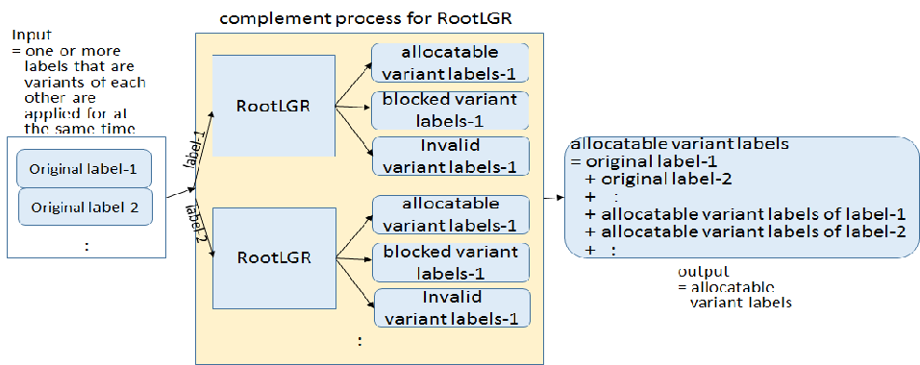
allocatable variant labels of label-1 and allocatable variant labels of label-2 can be label-1 and label-2.

For case (2) :
Usually, a TLD applicant knows what TLD labels are wished to be delegated at the time of application. Thus, if TLD application/evaluation process can be modified to limit the number of really-delegatable labels, the issue will be solved. That is, TLD application/evaluation process is modified to receive one or more strings, which are variant labels of each other. And LGR is executed with one of the received labels as input, and generates all the variant labels of the original label as ‘allocatable’. After that, the application/evaluation process picks up the applied-for labels from the ‘allocatable’ labels and make them really-delegatable. This idea may leave many ‘allocatable’ labels after LGR and such allocatable labels cannot be really-delegated only by application/evaluation process. However from the view point of IP, no assurance for allocatable labels not to be delegated. Therefore, this may contradict the concept of LGR.

<conclusion>

In general, the applicant knows which string he/she wants to use when he/she applies for TLDs, and that’s why he/she applies for a TLD of such a string. And in some cases, applicant wants to use one or more variant labels when he/she applies for a TLD. Therefore, in general, if applied-for labels are all marked as ‘allocatable’, he/she will not demand further delegation of more variant labels in the future. This is the background of this request.

JGP believes this is the way to satisfy the minimal requirement from any language TLD applicants.

<Another example where multiple input variant labels are wished to be delegated>

For example, Chinese has general principles demanding “traditional and simplified characters cannot be mixed in a word”. However some words may have comingled use of traditional and simplified characters, especially when traditional proper noun is followed by a simplified attribution, such as ‘國立臺北大学’, where國 and 臺 are traditional while 学 is simplified. Sometimes more than one variant labels that contain comingled use of simplified and traditional characters are wished to be registered. Even in the case “allocatable labels must consist of all-traditional characters or all-traditional characters” is forced, if a traditional character has variants, more than one variant labels may be wished to be registered

