In-Script Visual Variant Analysis
Latin GP Member: Dennis Tan

Diacritics Evaluation

Diacritics analyzed: Combining Cedilla (Below), Ogonek and Comma Below

Code Points Analyzed:

Code Point | Glyph | Name
01D2 | ǒ | Letter O with Caron
01A1 | ơ | Letter O with Horn
01D4 | ǔ | Letter U with Caron
01B0 | ư | Letter U with Horn

Findings:
- Letters are different.

ǒ (01D2) - ơ (01A1)

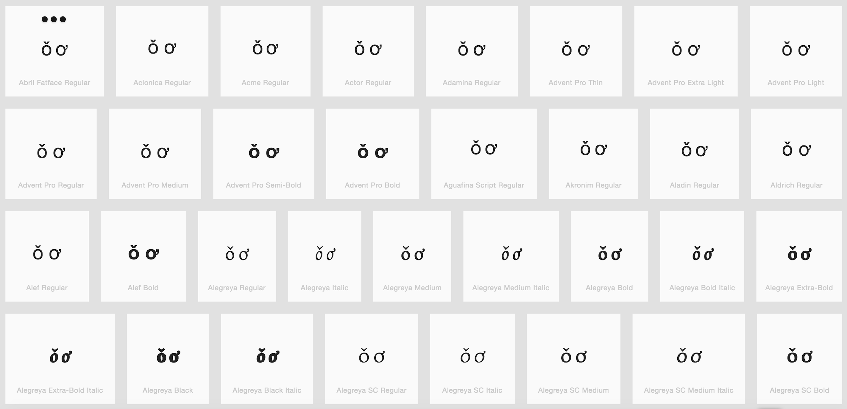

ǔ (01D4) - ư (01B0)

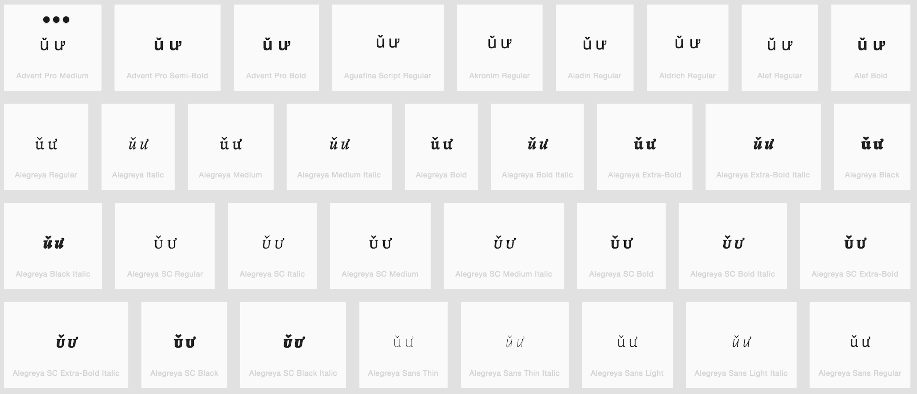

Diacritics Stacking Evaluation

Code Point: U+1EE1 (ỡ) Letter O with Horn and Tilde

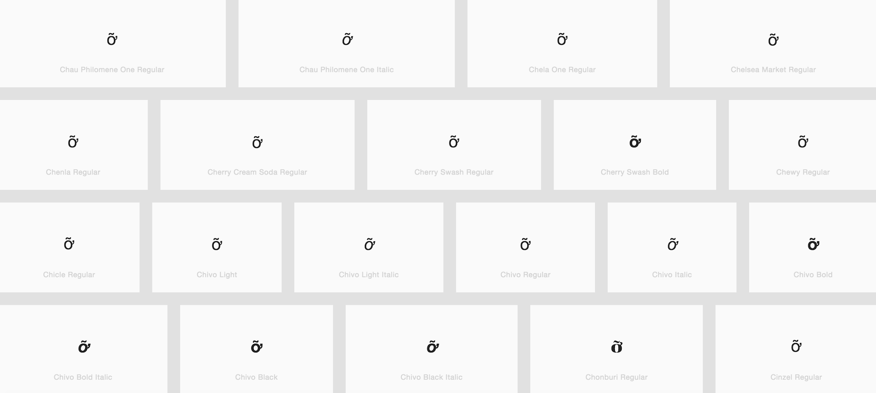

Finding: diacritics (tilde and horn) are always in place

Code Point: U+1EEF (ữ) Letter U with Horn and Tilde

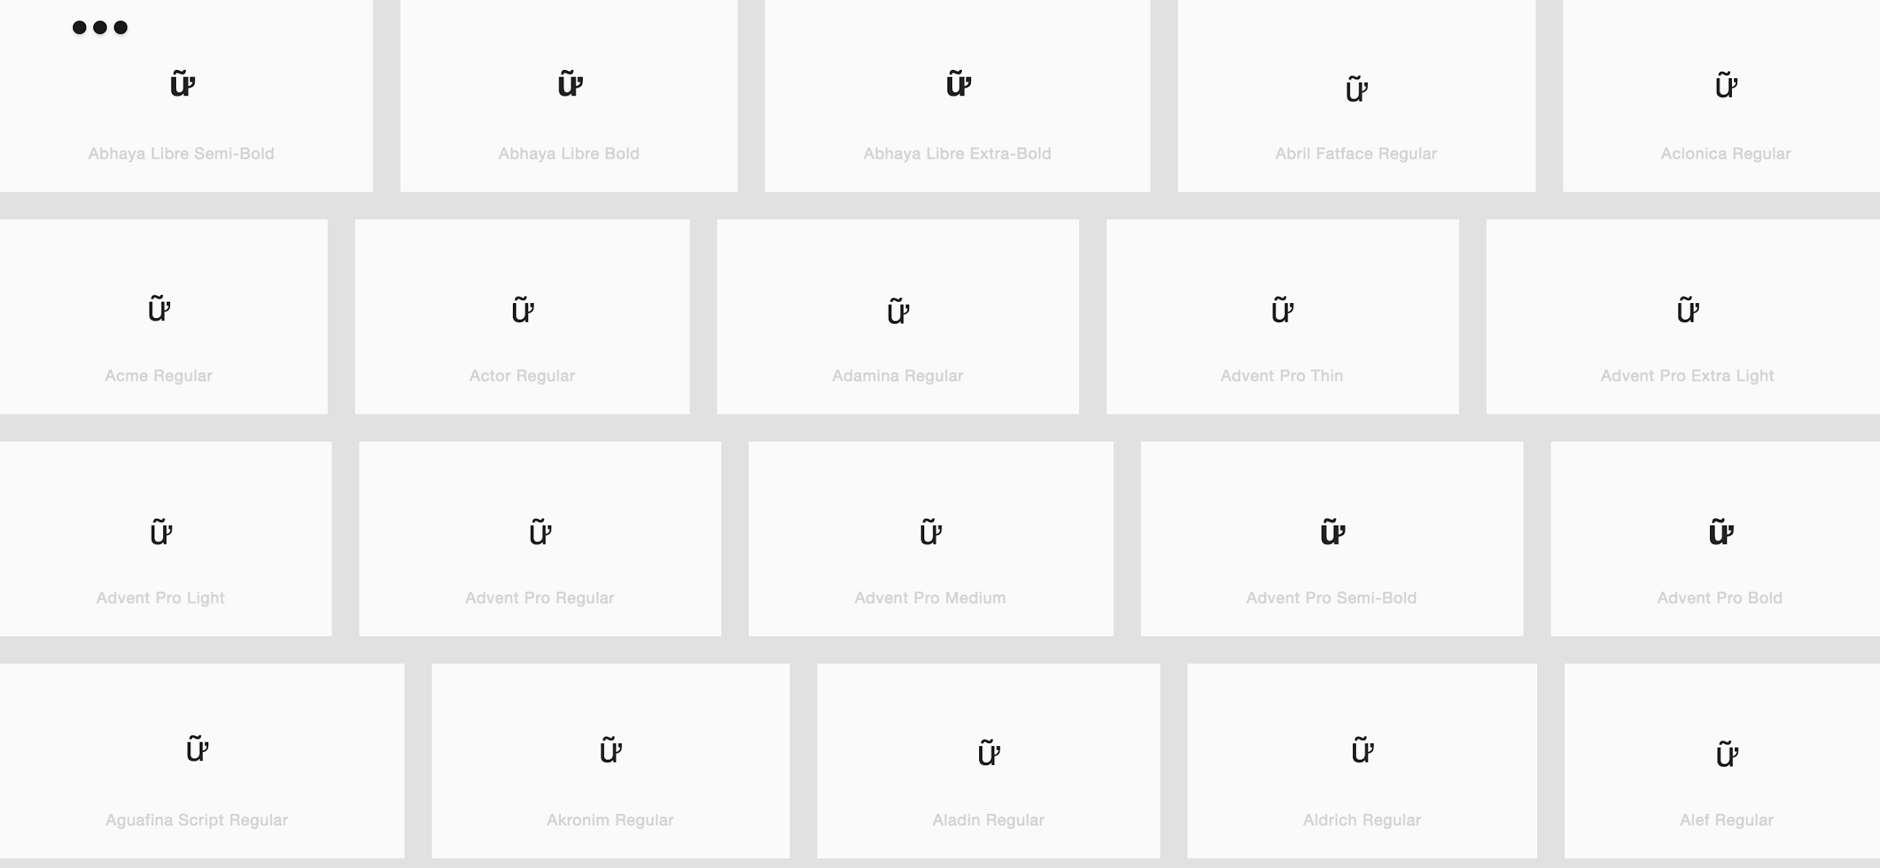
Finding: diacritics (tilde and horn) are always in place

