Android (9.1.0), Huawei EMUI(9.1), Huawei Mail (9.1.0.345)
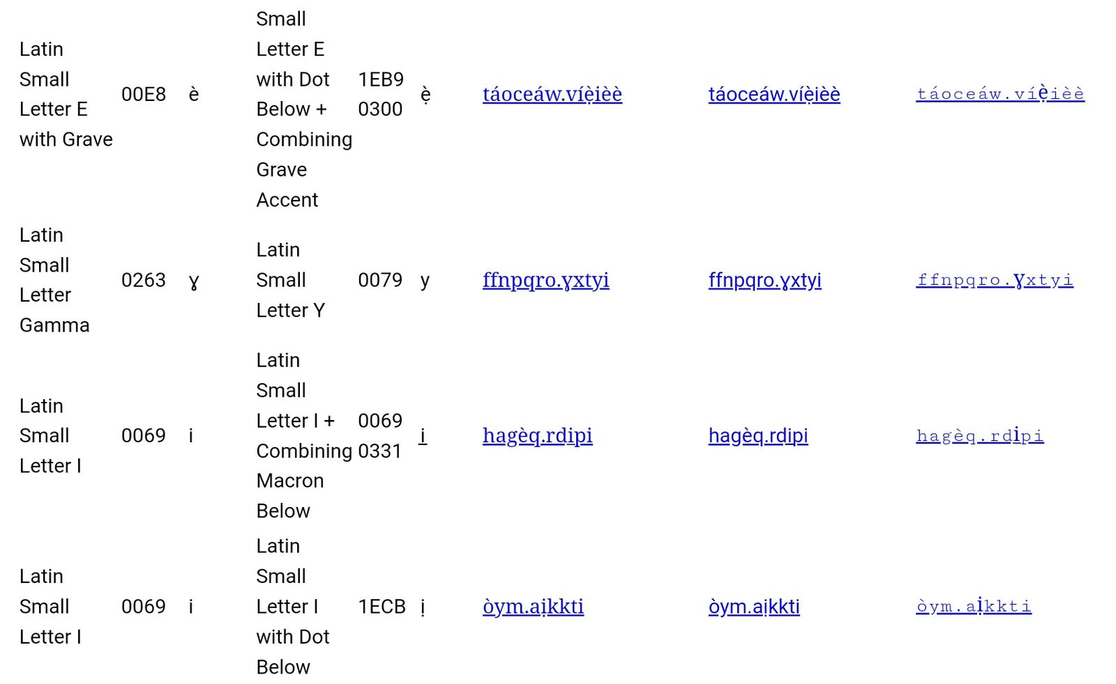

(i with Macron below) has a cut in the underline in Arial, but macron not recognizable.
Many Glyphs are bolded and clearly visible in Courier

Windows 10, Firefox 74.0, Gmail Web
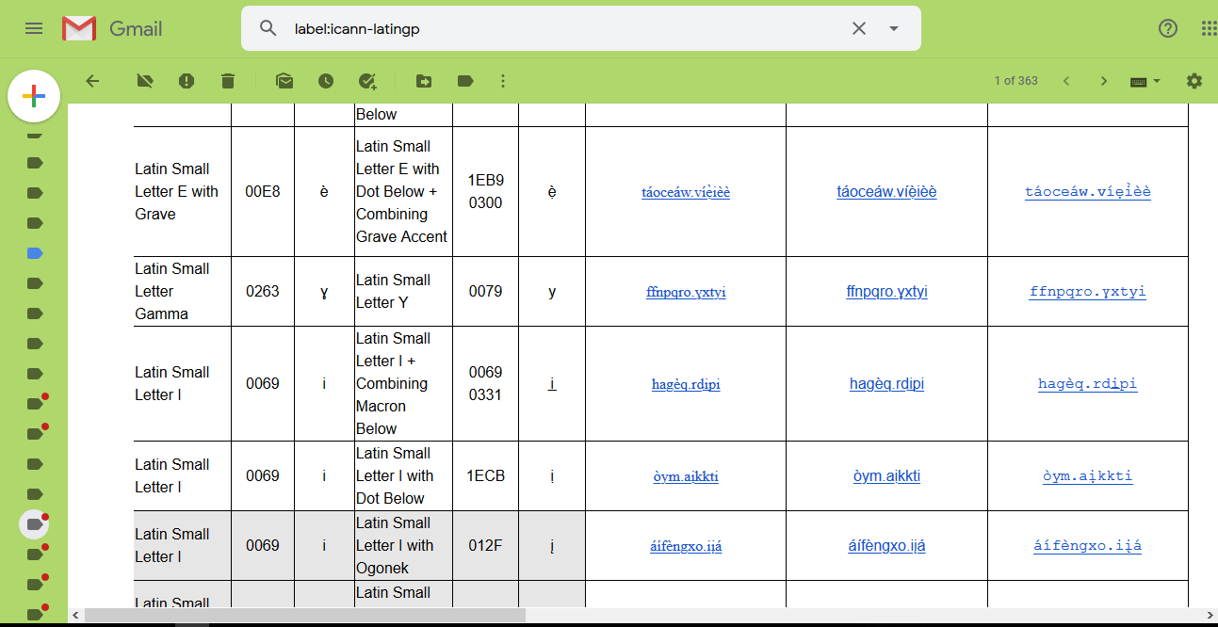

All glyphs are recognizable in all fonts, but Courier in the old fashioned underlining.

Windows 10, Firefox 74.0, Outlook OWA 14.3.487
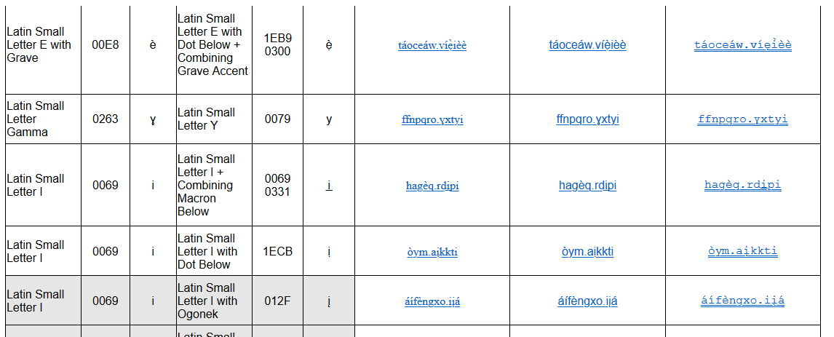

All glyphs are recognizable, Courier having a double underline.

Windows 10, Chrome 80.0.3987, Outlook OWA 14.3.487
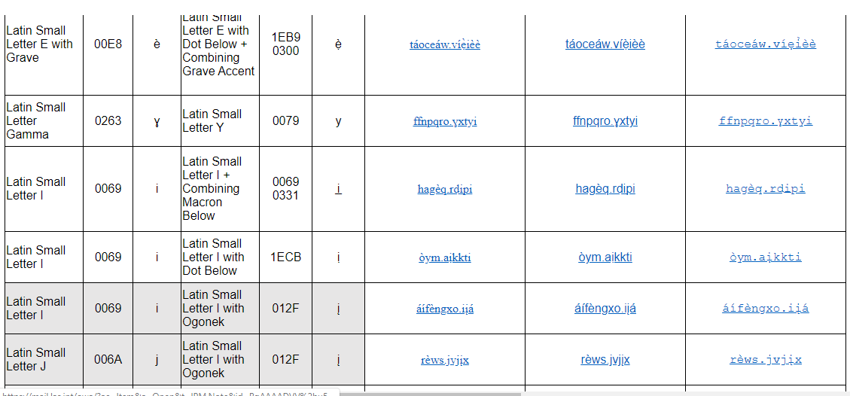

All glyphs are recognizable

Windows 10, Outlook 2016
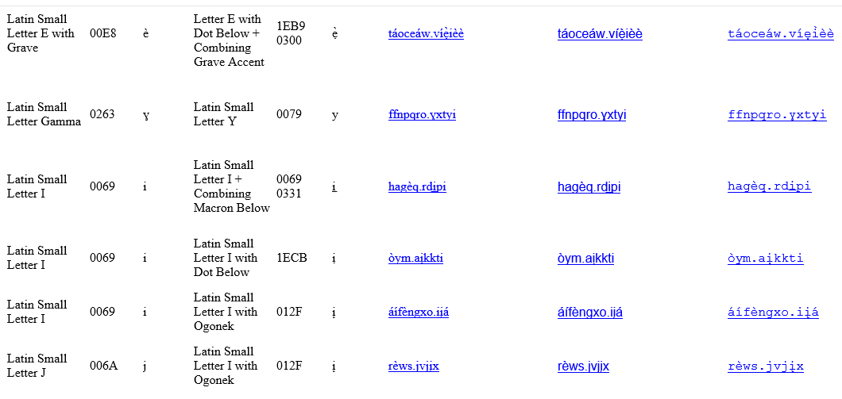

All glyphs are recognizable, but old underline style (probably because of outdated Outlook)

