Proposal for a Latin Script Root Zone LGR
LGR Version 4.0
Date: 2020-01-08
Document version: 6.3
Authors: Latin Generation Panel

Table of Content

Table of Content 2
1. General Information 7
2. Script for Which the LGR is Proposed 7
3. Background on Script and Principal Languages Using It 8
3.1 Principal Languages Using Latin Script 8
3.2 Geographic Territories or Countries with Significant Latin Script User Communities 9
3.3 Related Scripts 9
4. Overall Development Process and Methodology 9
5. Repertoire 10
5.1 Definitions 10
5.2 Principles for Developing Repertoire 11
5.2.1 Inclusion Principles 11
5.2.2 Exclusion Principles 12
5.3 Code Points Included 12
5.3.1 Combining Marks 31
5.4 Code Points Excluded 32
5.4.1 Other Excluded Letters 34
6. Variants 34
6.1 Principles for Developing Variants 35
6.1.1 Distinguishing Visual From Non-Visual Variants 36
6.1.2 Visual Variants 36
6.1.3 Non-Visual Variants 38
6.1.3.1 Shape of Base Characters 38
6.1.3.2 Spacing of Base Characters 38
6.1.3.3 IDNA 2003 Compatibility 38
6.1.3.4 Diacritics 39
6.1.3.4.1 Shape of Diacritics 39
6.1.3.4.2 Stacking of Diacritics 40
6.2 Methodology for Developing Cross-Script Variants 40
6.3 Cross-Script Variants 41
6.3.1 Armenian Script 41
6.3.2 Cyrillic Script 42
6.3.3 Greek Script 45
6.3.4 Generic Glyphs 47
6.4 Methodology for Developing In-Script Variants 49
6.5 In-Script Latin Variants 51
6.5.1 Breve and Caron 52
6.5.2 Tilde and Macron 52
6.5.3 Grave and Hook Above 53
6.5.4 Acute and Dot Above 54
6.5.5 Dot Above and Hook Above 54
6.5.6 Diaeresis and Double Acute 55
6.5.7 Acute and Grave 55
6.5.8 Acute and Hook Above 56
6.5.9 Misc 56
6.6 Other Considerations for Variant Analysis 57
6.6.1 URL Underlining 57
6.7 Variants Due to Transitivity 66
6.7.1 Latin In-script Variants due to Transitivity 66
6.7.2 Latin – Armenian Cross-script Variants due to Transitivity 66
6.7.3 Latin – Cyrillic Cross-script Variants due to Transitivity 66
6.7.4 Latin – Greek Cross-script Variants due to Transitivity 66
7 Whole Label Evaluation Rules (WLE) and contextual rules 66
8. Contributors 67
9 References 67
9.1 References used in developing Repertoire 67
9.2 Other references 73
Appendix A: Updated MSR during Latin GP work 74
Appendix B: Table of Languages Used to Develop Latin Script Repertoire 75
Appendix C: Repertoire Table Grouped by Glyph 85
Appendix D: Variants Analysis [Not completed yet, contains placeholders for additional analysis] 103
D.1 Shape of Base Characters 104
D.1.1 Latin Small Letter F vs. Latin Small Letter F with Hook 104
D.1.2 Latin Small Letter A vs. Latin Small Letter Alpha 105
D.1.3 Latin Small Letter Z vs. Latin Small Letter Ezh 105
D.1.4 Latin Small Letter V with Hook vs. Latin Small Letter V 105
D.1.5 Latin Small Letter I vs. Latin Small Letter Dotless I vs. Latin Small Letter Iota 106
D.1.6 Latin Small Letter E vs. Latin Small Letter Open E 108
D.1.7 Latin Small Letter K vs. Latin Small Letter K with Hook 109
D.1.8 Latin Small Letter Y vs. Latin Small Letter Y with Hook 110
D.1.9 Latin Small Letter D with Caron vs. Latin Small Letter D with Hook 111
D.1.10 Latin Small Letter T vs. Latin Small Letter L with Stroke 114
D.1.11 Latin Small Letter J vs. Latin Small Letter I with Ogonek 116
D.1.12 Latin Small Letter B vs. Latin Small Letter Thorn vs. Latin Small Letter P 116
D.1.13 Latin Small Letter B vs. Latin Small Letter Thorn vs. Latin Small Letter P 118
D.1.14 Letter Eth Versus Letter D with Stroke 120
D.1.15 Latin Small Letter Schwa vs. Latin Small Letter Turned E 121
D.2 Spacing of Base Characters 122
D.2.1 Latin Small Ligature Æ vs. Sequence AE 122
D.2.2 Latin Small Ligature Œ vs. Sequence OE 124
D.2.3 Sequence of Two Letter V with Hook vs. Latin Small Letter W 125
D.3 Shape of Diacritics 126
D.3.1 Caron (Above) vs. Breve 126
Code Points Considered: 126
D.3.2 Tilde vs. Macron (Above) 128
D.3.3 Combining Cedilla (Below), Ogonek and Comma Below 132
D.3.4 Ring Above vs. Dot Above 133
D.3.5 Acute vs. Dot Above 134
D.3.6 Grave vs. Dot Above 136
D.3.7 Double Acute vs. Diaeresis 137
D.3.8 Dot Below vs. Comma Below 138
D.3.9 Hook vs. Dot Above 140
D.3.10 Caron vs. Hook 142
D.3.11 Caron vs. Horn 144
D.3.12 Ring Above vs. Hook Above 148
D.4 Stacking of Diacritics 148
D.4.1 Circumflex and Tilde 148
D.4.2 Circumflex and Hook Above 152
D.4.3 Breve + Grave above 155
D.4.4 Breve and Hook Above 157
D.4.5 Breve and Tilde 158
D.4.6 Horn and Acute 159
D.4.7 Horn and Hook Above 160
D.4.8 Diacritic Grave 162
D.4.9 Diacritics Horn And Grave 163
D.4.10 Circumflex and Hook Above 164
D.4.11 Circumflex + Dot Below 165
D.4.12 Breve + Dot Below 171
D.4.13 Dot below and combining acute accent 171
D.4.14 Circumflex + Acute Above 174
D.4.15 Acute (vs. Non-Acute) 176
D.4.16 Circumflex Above + Grave Above 179
D.4.17 Breve and Acute Above 187
D.4.18 Tilde and Horn (Above) 187
D.4.19 Dot Below + Combining Grave Accent 189
D.4.20 Horn and Dot Below 191
D.4.21 Stacking in Courier New (And Perhaps Other Fonts) 195
D.4.22 Visual Variant Analysis 197
D.4.22.1 Consonants 197
D.4.22.2 Vowel ‘a’ 199
D.4.22.3 Vowel ‘e’ 200
D.4.22.4 Vowel ‘i’ 201
D.4.22.5 Vowel ‘o’ 202
D.4.22.6 Vowel ‘u’ 203
D.5 IDNA 2003 Compatibility 204
D.5.1 Latin Small Letter Sharp S (ß) 00DF 204
D.5.2 Latin Small Letter Dotless I (ı) 0131 211
D.6 Underlining Evaluation Process 214
D.7 Generic Glyphs 222
D.8 Caron Above 224
D.9 Cross-script Variants 225
D.9.1. Cyrillic Script 225
D.9.1.1 Cyrillic Small Letter Straight U 04A4 225
D.9.1.2 Cyrillic Small Letter Dzhe 045F 225
D.9.2. Greek Script 226
D.9.2.1. GREEK SMALL LETTER ALPHA 03B1 226
D.9.2.2. Greek Small Letter Rho 03C1 227
D.9.2.3.Greek Small Letter Upsilon G03C5 227
D.9.2.4. Greek Letter Beta 03B2 228
D.9.2.4. Greek Small Letter Sigma 03C3 229
Appendix E: Variant Relationship Mapping for “ss” and “s” 230
Appendix F: Confusables ( Working tables - Not discussed yet by the GP) 238
F.1 Latin – Armenian Confusables 238
F.2 Latin - Cyrillic Confusables 240
F.3 Latin - Greek Confusables 242
F.4 Latin In-Script Confusables 243

General Information

The purpose of this document is to give an overview of the proposed LGR in the XML format and the rationale behind the design decisions taken. It includes a discussion of relevant features of the script, the communities or languages using it, the process and methodology used, and information on the contributors. The formal specification of the LGR can be found in the accompanying XML document:
proposal-lgr-latin-20180910.xml
The test labels of the LGR can be found in the accompanying file:
TO BE DEVELOPED

Script for Which the LGR is Proposed

The Latin script has the following specifications:
- ISO 15924 code: Latn
- ISO 15924 no.: 215
- ISO 15924 English Name: Latin
Native name of the script:
- It is written differently in different languages.
A partial list of script names in different languages is given below:
- Latin (English, French),
- Latein (German),
- Latino (Italian, Portuguese),
- Latín (Spanish)
- Latinica (Croatian, Serbian)
- Kịch bản latin (Vietnamese)
- Umbhalo we-latin (Zulu)
Maximal Starting Repertoire (MSR) version: MSR-4
As per the Procedure to Develop and Maintain the Label Generation Rules for the DNS Root Zone in Respect of IDNA Labels (referred to simply as [Procedure] in the following), only code points included in the latest version of the Maximal Starting Repertoire (currently version 4 and referred to simply as [MSR] in the following) were considered.

The set of code points in the Latin script, as specified by [MSR], contains 346 selected code points, i.e. 326 letters and 20 Combining Diacritical Marks. Code points are from the following Unicode ranges as listed in table 1 below. [MSR] excludes the Unicode ranges listed in table 2 below.

Table 1. Unicode ranges included in [MSR].

Latin Script | Range of Unicode code points
Controls and Basic Latin | U+0061 – U+007A
Controls and Latin-1 Supplement | U+00DF - U+00F6  U+00F8 - U+00FF
Latin Extended-A | U+0101 – U+017F
Latin Extended-B | U+0180 – U+024F
IPA Extensions | U+0250 – U+02AF
Combining Diacritical Marks | U+0300 – U+036F
Combining Diacritical Marks Supplement | U+1DC0 – U+1DFF
Latin Extended Additional | U+1E00 – U+1EFF
Latin Extended-C | U+2C60 – U+2C7F

Table 2. Unicode ranges excluded from [MSR].

Latin Script | Range of Unicode code points
Latin Extended-D; technical use (phonetic)/obsolete/punctuation | U+A720 – U+A7FF
Latin Ligatures; compatibility characters not PVALID in IDNA 2008 | U+FB00 – U+FB0F
Full-width Latin Letters; compatibility characters not PVALID in IDNA 2008 | U+FF00 – U+FF5E

When a single, precomposed code point is equivalent to the combination of letter code point and a diacritic mark code point, only the precomposed code point may be used, per [IDNA 2008]. Furthermore, only lower case letters are considered in creating the repertoire, as upper case ones may not be used in IDNs, per [IDNA 2008].

Background on Script and Principal Languages Using It

The Latin script is a major writing system of the world today. It is the most widely used in terms of number of languages and number of speakers, with circa 70% of the world’s readers and writers making use of this script [Wikipedia-Latin script].

3.1 Principal Languages Using Latin Script

The list of languages taken into consideration contains relevant data for 455 languages using Latin script. The table with languages using Latin script was derived using data from

http://www.omniglot.com/writing/langalph.htm
and
https://www.ethnologue.com/browse/names .

Table with 455 considered languages is in APPENDIX B of this document.

3.2 Geographic Territories or Countries with Significant Latin Script User Communities

Per Wikipedia the distribution of the Latin script on the world map is:
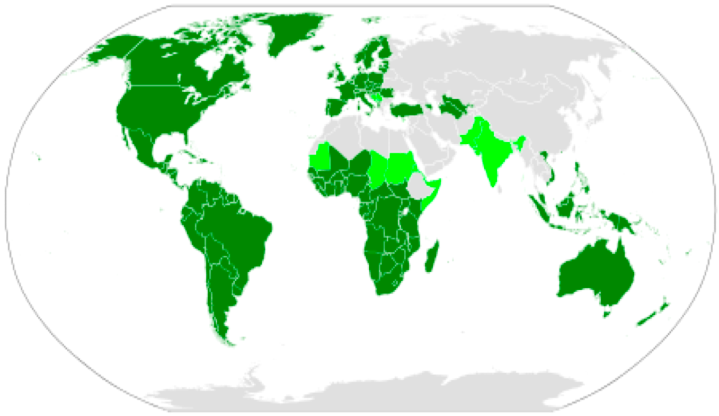
Dark green marks countries where the Latin script is the sole main script.
Light green marks countries where Latin co-exists with other scripts.
Grey marks areas, in which Latin script is not used or used only unofficially for second language.

3.3 Related Scripts

Latin GP considers the following scripts directly related to Latin script, as all are ultimately derived from Old Phoenician:
- Cyrillic
- Greek
- Armenian

Overall Development Process and Methodology

The work has been done according to the work plan given in “Proposal for the Generation Panel (GP) for the Latin Script Label Generation Ruleset (LGR) for the Root Zone”.
The panel formed two working groups:
- Repertoire WG
- Variant WG
which worked in parallel.

The first task for each group was to define the Principles for developing Repertoire and the Principles for developing Variants. The principles were sent to Integration panel for comments and suggestions and were also offered for public unofficial comment. Comments from the Integration panel were encompassed in final version of the Principles.

During the Repertoire definition phase, the Panel reviewed and processed 181 languages with EGIDS level 1 through 4, and 29 languages with EGIDS Level 5 which have more than 1, 000, 000 speakers. The processed languages are listed in Appendix B.

The Latin Generation Panel used [MSR] as the starting point and after processing 210 languages the Latin GP found:
- 193 MSR Unicode code points verified
- 22 Code Point Sequences (defined below) detected
- 6 New code points added to MSR
The panel also found that some languages use letters matching code points outside [MSR]. In some cases, these code points were rejected. In other cases the panel made successful requests for inclusion in [MSR]. This is described in more detail in Appendix A.

The second phase of Latin GP work was mainly devoted to defining in-script and cross-script Variants.

Repertoire

Based on the discussions within the GP, the principles for inclusion and exclusion of code points in the Repertoire are as follows.

5.1 Definitions

Language: The present document and its principles deal with any language making use of Latin script today. Languages are restricted to natural human languages in active use. Both the socio-political situation (such as the political or legal status of a language in a country or community) and the socio-linguistic roles of languages in society (such as the absolute or relative frequency of use) are explicitly not considered for the current purposes. Super- or sub-units of languages, such as dialect, regiolect (a dialect spoken in a particular geographical region), or language clusters, are all considered equivalent to language. However, notions such as official language, national language, standard language and vernacular, are not considered at all in determining whether something is a language.

Letter Code Point is a Unicode code point with General Category property value of Lx (Lu, Ll, Lt, Lm, Lo), as defined in the Unicode Character Database.

Mark Code Point is a Unicode code point with General Category property value of Mx (Mn, Mc, Me), as defined in the Unicode Character Database.

Code Point Sequence is a sequence of two or more Code Points (e.g. Letter Code Point followed by one or more Mark Code Point(s)).

Established contemporary use of a letter means it is in active use by a community today. Such use may be demonstrated by, for example, educational resources, published material, media, or other materials and sources. This does not depend on their material or non-material form, such as handwritten or typed manuscripts or digitally produced text. There may be multiple sources for acquiring such evidence, including (but not limited to) the following:
- Members of Language communities,
- Members of the Latin GP,
- Other experts
- Language tables submitted by ccTLD in the context of IDNA 2008 in the IANA repository, and
- Published standards (e.g. by a language authority or any other national or international body).

5.2 Principles for Developing Repertoire

5.2.1 Inclusion Principles

If a Code Point is included as part of a label, the Code Point cannot be retracted in future revisions of the LGR. All applicable criteria must be met to include a Code Point.
- Only languages which have a rating of levels of 0-4 under the Expanded Graded Intergenerational Disruption Scale (EGIDS) are considered as supporting the inclusion of a Code Point. Languages with EGIDS 5 may be included in special cases where there is additional evidence that it is in widespread use, notwithstanding its formal EGIDS rating. For these, 1 million native speakers was used as a threshold.
- Code Points may only be included if they have established contemporary use in one or more of the languages considered.
- If the Code Point in question is a Mark Code Point, then it can only be included in its context. That is, a Mark Code Point is included as part of a sequence consisting of a Lower Letter (Ll) or Other Letter (Lo) and the subsequent mark or marks. (See Section 5.3.1)
- Any combination of Code Points is defined by its sequence. To be included, a sequence must be supported by some included language in the same way as a separate Code Point of type Ll or Lo.
- If a character can be represented by multiple Code Point Sequences, each Code Point Sequence must be separately justified to be included.
- A Code Point Sequence can only be included if there is no pre-composed alternative available, unless there is specific evidence that a language eligible for inclusion under Criterion 1 makes alternate use of such a sequence.
- If the Code Point in question is a Modifier letter (Lm), then it can only be included together with its context. That is a sequence of Lm plus Ll or Lo (or the other way around), unless there is strong evidence that the Lm can be used in any context, or that such a sequence or order cannot be defined.

5.2.2 Exclusion Principles

A Code Point is excluded if at least one of these exclusion principles is met. (If a Code Point can neither be included nor excluded on the basis of these principles, the Code Point is automatically excluded from the proposed LGR for Latin Script, per RFC 6912.)
- The Code Point is DISALLOWED or UNASSIGNED by IDNA 2008 protocol.
- The Code Point presents a security or stability issue which cannot be resolved at any other stage of the analysis (e.g., stage of determining Code Points, variants, Contextual Rules or Whole Label Evaluation Rules).
- The Code Point is either deprecated or not recommended for use in Unicode Standard -- unless it meets all of the applicable inclusion criteria, with no alternative Code Point or Code Point sequence.
- The Code Point is used exclusively in a subset of textual genres, such as technical or religious texts, and is not otherwise used as described in Section 2 above.
- The Code Point is predominantly used in one of the following functions, apart from any other uses in orthography:
  - Formatting character or mark
  - Numerical digit
  - Punctuation mark
  - Honorific mark or symbol
  - Mathematical symbol
- The Code Point is difficult to distinguish from a Code Point which fit the criteria in #5. See Section 5.4.

5.3 Code Points Included

The table below lists the code points proposed for inclusion in the root zone LGR for the Latin script. The table also lists examples of languages using the code point and their EGIDS rating. All references for specific code points found during language processing are included. This table is sorted by Unicode column. (A table with the same data, sorted by glyph, can be found in Appendix C.) The list of references supporting inclusion of code point is in Section 9.1

Table 3. Code Points Included in the Repertoire of Latin Script LGR.

# | Unicode | Glyph | Unicode name | Languages using the code point (EGIDS) | Reference supporting inclusion (URL etc.)
 | 0061 | a | Latin Small Letter A | Basic Latin | [99]
 | 0061 + 0331 | a̱ | Latin Small Letter A + Combining Macron Below | Nuer (4) | [146], [129]
 | 0062 | b | Latin Small Letter B | Basic Latin | [99]
 | 0063 | c | Latin Small Letter C | Basic Latin | [99]
 | 0064 | d | Latin Small Letter D | Basic Latin | [99]
 | 0065 | e | Latin Small Letter E | Basic Latin | [99]
 | 0065 + 0331 | e̱ | Latin Small Letter E + Combining Macron Below | Nuer (4) | [146]
 | 0066 | f | Latin Small Letter F | Basic Latin | [99]
 | 0067 | g | Latin Small Letter G | Basic Latin | [99]
 | 0067 + 0303 | g̃ | Latin Small Letter G + Combining Tilde | Guarani (1) | [142], [143]
 | 0068 | h | Latin Small Letter H | Basic Latin | [99]
 | 0069 | i | Latin Small Letter I | Basic Latin | [99]
 | 0069 + 0331 | i̲ | Latin Small Letter I + Combining Macron Below | Nuer (4) | [146]
 | 006A | j | Latin Small Letter J | Basic Latin | [99]
 | 006B | k | Latin Small Letter K | Basic Latin | [99]
 | 006C | l | Latin Small Letter L | Basic Latin | [99]
 | 006D | m | Latin Small Letter M | Basic Latin | [99]
 | 006D + 0327 | m̦ | Latin Small Letter M + Combining Cedilla | Marshallese (1) | [213], [136], [214]
 | 006E | n | Latin Small Letter N | Basic Latin | [99]
 | 006E + 0304 | n̄ | Latin Small Letter N + Combining Macron | Raga (Hano) (3)  Marshallese (1) | [200], [213], [136]
 | 006E + 0308 | n̈ | Latin Small Letter N + Combining Diaeresis | Malagasy (1) | [230]
 | 006F | o | Latin Small Letter O | Basic Latin | [99]
 | 006F + 0327 | o̧ | Latin Small Letter O + Combining Cedilla | Marshallese (1) | [136]
 | 006F + 0331 | o̱ | Latin Small Letter O + Combining Macron Below | Nuer (4) | [146], [129]
 | 0070 | p | Latin Small Letter P | Basic Latin | [99]
 | 0071 | q | Latin Small Letter Q | Basic Latin | [99]
 | 0072 | r | Latin Small Letter R | Basic Latin | [99]
 | 0072 + 0303 | r̃ | Latin Small Letter R with Combining Cedilla | Hausa (2) | [147]
 | 0073 | s | Latin Small Letter S | Basic Latin | [99]
 | 0074 | t | Latin Small Letter T | Basic Latin | [99]
 | 0075 | u | Latin Small Letter U | Basic Latin | [99]
 | 0076 | v | Latin Small Letter V | Basic Latin | [99]
 | 0077 | w | Latin Small Letter W | Basic Latin | [99]
 | 0078 | x | Latin Small Letter X | Basic Latin | [99]
 | 0079 | y | Latin Small Letter Y | Basic Latin | [99]
 | 007A | z | Latin Small Letter Z | Basic Latin | [99]
 | 00DF | ß | Latin Small Letter Sharp S | German (1) | [119]
 | 00E0 | à | Latin Small Letter A with Grave | Italian (1)  French (1)  Galician (2)  Wolof (4) | [114]. [130], [131], [106], [132]
 | 00E1 | á | Latin Small Letter A with Acute | Spanish (1)  French (1)  Czech (1)  Icelandic (1)  Faroese (2)  Kirundi (1)  Chuukese (2)  Galician (2)  Lule Sámi (2)  Northern Sámi (2) | [100], [101], [102], [103], [104], [105], [106], [107], [108], [114]
 | 00E2 | â | Latin Small Letter A with Circumflex | Vietnamese (1)  Romanian (1)  Skolt Sami (2)  Kirundi (1)  French (1)  Galician (2)  West Frisian (2)  Friulian (4)  Xavante (4) | [109], [110], [113], [104], [114], [106], [115], [116], [117]
 | 00E3 | ã | Latin Small Letter A with Tilde | Umbundu (3)  Guarani (1)  Nauruan (3)  Khoekhoe (4) | [141], [142], [143], [144], [145]
 | 00E4 | ä | Latin Small Letter A with Diaeresis | German (1)  Finnish (1)  Turkmen (1)  Estonian (1)  Swedish (1)  Lule Sámi (2)  Yapese (2)  Dinka (4)  Kaqchikel (4)  Bashkir (4)  Alsatian (5)  Nuer (4) | [119], [120], [121], [122], [123], [107], [124], [125], [126], [127], [128], [129]
 | 00E5 | å | Latin Small Letter A with Ring Above | Danish (1)  Finnish (1)  Chamorro (1)  Swedish (1)  Lule Sámi (2) | [139], [120], [140], [123], [107]
 | 00E6 | æ | Latin Small Letter AE | Danish (1)  Icelandic (1)  Faroese (2) | [139], [102], [103]
 | 00E7 | ç | Latin Small Letter C with Cedilla | Turkish (1)  Turkmen (1)  Kurdish (2)  French (1)  Azerbaijani (1)  Basque (1)  Galician (2)  Friulian (4)  Bashkir (4) | [157], [121], [158], [114], [159], [160], [161], [106], [116], [127]
 | 00E8 | è | Latin Small Letter E with Grave | French (1)  Italian (1)  Afrikaans (1)  Kirundi (1)  Haitian Creole (1)  French (1) | [114], [130], [175], [104], [182], [183]
 | 00E9 | é | Latin Small Letter E with Acute | French (1)  Italian (1)  Spanish (1)  Czech (1)  Icelandic (1)  Kirundi (1)  Chuukese (2)  Galician (2)  Wolof (4)  XAVANTE (4)  West Frisian (2) | [114], [130], [100], [101], [102], [104], [105], [106], [132], [117], [115]
 | 00EA | ê | Latin Small Letter E with Circumflex | French (1)  Tswana (1)  Afrikaans (1)  Vietnamese (1)  Kurdish (2)  Kirundi (1)  West Frisian (2)  Friulian (4) | [114], [173], [174], [175], [109], [158], [104], [115], [116]
 | 00EB | ë | Latin Small Letter E with Diaeresis | Afrikaans (1)  Kirundi (1)  Albanian (1)  French (1)  Chuukese (2)  Uyghur (2)  Yapese (2)  Wolof (4)  Drehu (4)  Kaqchikel (4)  West Frisian (2)  Nuer (4) | [175], [104],[176], [177], [114], [178], [179], [124], [132], [180], [126], [115], [129]
 | 00EC | ì | Latin Small Letter I with Grave | Italian (1)  Kirundi (1) | [130], [206], [208]
 | 00ED | í | Latin Small Letter I with Acute | Spanish (1)  Czech (1)  Icelandic (1)  Faroese (2)  Kirundi (1)  Galician (2)  Bashkir (4) | [100], [101], [102], [103], [104], [106], [127]
 | 00EE | î | Latin Small Letter I with Circumflex | Afrikaans (1)  Romanian (1)  Kurdish (2)  Kirundi (1)  French (1)  Friulian (4) | [175], [110], [158], [104], [114], [116]
 | 00EF | ï | Latin Small Letter I with Diaeresis | Afrikaans (1)  French (1)  Kaqchikel (4)  Dinka (4)  West Frisian (2) | [175], [114], [126], [125], [115]
 | 00F0 | ð | Latin Small Letter Eth | Faroese (2)  Icelandic (1) | [103], [102]
 | 00F1 | ñ | Latin Small Letter N with Tilde | Spanish (1)  Fula (3)  Chamorro (1)  Filipino (1)  Guarani (1)  Chavacano (4)  Basque (1)  Galician (2)  Iloco (3)  Quechua (3)  Cape Verdean Creole (4)  Waray-Waray (3)  Wolof (4)  Nauruan (3)  Lozi (4)  Bashkir (4)  Marshallese (1)  Mandinka (5)  Igbo (2) | [221], [250],[222], [142], [143], [223], [160], [106], [224], [225], [226], [227], [228], [132], [144], [229], [127], [136], [197], [205]
 | 00F2 | ò | Latin Small Letter O with Tilde | Italian (1)  Haitian Creole (1) | [130], [182], [183]
 | 00F3 | ó | Latin Small Letter O Latin Small Letter | Spanish (1)  Polish (1)  Czech (1)  Icelandic (1)  Kirundi (1)  Chuukese (2)  Galician (2)  Wolof (4) | [100], [152], [101], [102], [104], [105], [106], [132]
 | 00F4 | ô | Latin Small Letter O with Circumflex | Tswana (1)  Afrikaans (1)  Vietnamese (1)  Kirundi (1)  French (1)  Northern Sotho (1)  West Frisian (2)  Galician (2)  Friulian (4)  Xavante (4) | [173], [174], [175], [109], [104], [114], [230], [115], [106], [116], [117]
 | 00F5 | õ | Latin Small Letter O with Tilde | Estonian (1)  Skolt Sami (2)  Umbundu (3)  Guarani (1)  Nauruan (3)  Xavante (4)  Khoekhoe (4) | [122], [113], [141], [142], [143], [144], [117], [145]
 | 00F6 | ö | Latin Small Letter O with Diaeresis | German (1)  Finnish (1)  Afrikaans (1)  Turkish (1)  Swedish (1)  Uygur (2)  Yapese (2)  Drehu (4)  Kaqchikel (4)  Dinka (4)  Bashkir (4)  Chechen (2) 1992 Version  West Frisian (2)  Nuer (4) | [119], [120], [175], [157], [123], [179], [124], [180], [126], [125], [127], [231], [232], [115], [129]
 | 00F8 | ø | Latin Small Letter O with Stroke | Danish (1)  Faroese (2) | [139], [103]
 | 00F9 | ù | Latin Small Letter U with Grave | Italian (1)  French (1)  Papiamento (1) | [130], [114],[206], [245], [246], [253]
 | 00FA | ú | Latin Small Letter U With Acute | Spanish (1)  Czech (1)  Icelandic (1)  Faroese (2)  Kirundi (1)  Chuukese (2)  West Frisian (2)  Galician (2) | [100], [101], [102], [103], [104], [105], [115], [106]
 | 00FB | û | Latin Small Letter U with Circumflex | Afrikaans (1)  Kurdish (2)  Kirundi (1)  French (1)  Miskito (2)  West Frisian (2)  Friulian (4)  Zazaki (4) | [175], [158], [104], [114], [243], [115], [116], [244]
 | 00FC | ü | Latin Small Letter U with Diaeresis | German (1)  Spanish (1)  Afrikaans (1)  Turkish (1)  Swedish (1)  French (1)  Azeri (1)  Basque (1)  Galician (2)  Uygur (2)  Kaqchikel (4)  Bashkir (4) | [119], [100], [175], [157], [123], [114], [159], [161], [106], [179], [126], [127], [231]
 | 00FD | ý | Latin Small Letter Y with Acute | Turkmen (1)  Czech (1)  Icelandic (1)  Faroese (2)  Guarani (1) | [121], [101], [102], [103], [142], [143]
 | 00FE | þ | Latin Small Letter Thorn | Icelandic (1) | [102]
 | 00FF | ÿ | Latin Small Letter Y with Diaeresis | French (1) | [114], [253], [257]
 | 0101 | ā | Latin Small Letter A with Macron | Latvian (1)  Tongan (1)  Hawaiian (2)  Marshallese (1) | [133], [134], [135], [136]
 | 0103 | ă | Latin Small Letter A with Breve | Vietnamese (1)  Romanian (1) | [109], [110]
 | 0105 | ą | Latin Small Letter A with Ogonek | Polish (1)  Lithuanian (1) | [137], [138]
 | 0107 | ć | Latin Small Letter C with Acute | Croatian (1)  Serbian (1)  Polish (1) | [150], [151], [152]
 | 0109 | ĉ | Latin Small Letter C with Circumflex | Esperanto (3) | [255]
 | 010B | ċ | Latin Small Letter C with Dot Above | Maltese (1) | [163]
 | 010D | č | Latin Small Letter C with Caron | Croatian (1)  Serbian (1)  Latvian (1)  Slovak (1)  Northern Sámi (2)  Lithuanian (1) | [150], [151], [133], [153], [108], [154]
 | 010F | ď | Latin Small Letter D with Caron | Czech (1)  Slovak (1) | [101], [153]
 | 0111 | đ | Latin Small Letter D with Stroke | Croatian (1)  Serbian (1)  Vietnamese (1)  Northern Sámi (2) | [150], [151], [109], [108], [168]
 | 0113 | ē | Latin Small Letter E with Macron | Latvian (1)  Hawaiian (2)  Tongan (1)  Minangkabau (5) | [133], [135], [134], [184]
 | 0117 | ė | Latin Small Letter E with Dot Above | Lithuanian (1) | [138], [154]
 | 0119 | ę | Latin Small Letter E with Ogonek | Polish (1)  Palauan (2)  Lithuanian (1) | [152], [185], [138], [154]
 | 011B | ě | Latin Small Letter E with Caron | Czech (1)  Kirundi (1)  Sorbian (4) | [101], [104], [172]
 | 011D | ĝ | Latin Small Letter G with Circumflex | Esperanto (3) | [255]
 | 011F | ğ | Latin Small Letter G with Breve | Turkish (1)  Tatar (2)  Azeri (1)  Bashkir (4)  Zaza (5) | [157], [201], [159], [127], [202]
 | 0121 | ġ | Latin Small Letter G with Dot Above | Maltese (1) | [163]
 | 0123 | ģ | Latin Small Letter G with Cedilla | Latvian (1)  Brahui (5) | [133], [168]
 | 0125 | ĥ | Latin Small Letter H with Circumflex | Esperanto (3) | [255]
 | 0127 | ħ | Latin Small Letter H with Stroke | Maltese (1) | [163]
 | 0129 | ĩ | Latin Small Letter I with Tilde | Guarani (1)  Cubeo (3)  Khoekhoe (4)  Kikuyu (5) | [142], [143], [186], [145], [209]
 | 012B | ī | Latin Small Letter I with Macron | Latvian (1)  Lithuanian (1)  Hawaiian (2)  Tongan (1) | [133], [138], [135], [134]
 | 012F | į | Latin Small Letter I with Ogonek | Lithuanian (1) | [154]
 | 0131 | ı | Latin Small Letter Dotless I | Turkish (1)  Tatar (2)  Azeri (1) | [157], [203], [201], [159]
 | 0135 | ĵ | Latin Small Letter J with Circumflex | Esperanto (3) | [255]
 | 0137 | ķ | Latin Small Letter K with Cedilla | Latvian (1) | [133]
 | 013A | ĺ | Latin Small Letter L with Acute | Slovak (1) | [153]
 | 013C | ļ | Latin Small Letter L with Cedilla | Latvian (1)  Marshallese (1)  Brahui (5) | [133], [213], [214], [168]
 | 013E | ľ | Latin Small Letter L with Caron | Slovak (1) | [153]
 | 0142 | ł | Latin Small Letter L with Stroke | Polish (1) | [152]
 | 0144 | ń | Latin Small Letter N with Acute | Polish (1)  Lule Sámi (2)  Sorbian (4)  Brahui (5) | [152], [107], [172], [168]
 | 0146 | ņ | Latin Small Letter N WITH CEDILLA | Latvian (1)  Marshallese (1) | [133], [136]
 | 0148 | ň | Lati Small Letter N with Caron | Turkmen (1)  Czech (1)  Slovak (1) | [121], [101], [153]
 | 014B | ŋ | Latin Small Letter Eng | Inari Sami (2)  Dagaare Burkina Faso (4)  Dagbani (Dagomba) (4)  Northern Sami (2)  Ewondo (3)  Luganda (3)  Wolof (4)  Adzera (4)  Nuer (4)  Ga (4)  Dinka (4)  Duala (3)  Ewe (3)  Soga (5)  Alur (5)  Mandinka (5)  Acholi (5)  Bambara (4)  Nuer (4) | [188], [148], [189], [108], [190], [191], [132], [192], [146], [193], [125], [194], [170], [195], [196], [197], [198], [199], [129]
 | 014D | ō | Latin Small Letter O with Macron | Hawaiian (2)  Marshallese (1)  Tongan (1) | [135], [136], [134]
 | 0151 | ő | Latin Small Letter O with Double Acute | Hungarian (1) | [233], [234]
 | 0153 | œ | Latin Small Ligature OE | French (1) | [114], [253]
 | 0155 | ŕ | Latin Small Letter R with Acute | Slovak (1)  Brahui (5) | [153], [168]
 | 0159 | ř | Latin Small Letter R with Caron | Czech (1)  Sorbian (4) | [101], [172]
 | 015B | ś | Latin Small Letter S with Acute | Polish (1)  Montenegrin (1) | [152], [258]
 | 015D | ŝ | Latin Small Letter S with Circumflex | Esperanto (3) | [255]
 | 015F | ş | Latin Small Letter S with Cedilla | Turkish (1)  Turkmen (1)  Kurdish (2)  Tatar (2)  Azeri (1)  Bashkir (4)  Brahui (5)  Zaza (5) | [157], [121], [158], [201], [159], [127], [168], [202]
 | 0161 | š | Latin Small Letter S with Caron | Tswana (1)  Croatian (1)  Serbian (1)  Latvian (1)  Northern Sotho (1)  Northern Sami (2)  Lithuanian (1) | [174], [150], [151], [133], [230], [108], [154]
 | 0165 | ť | Latin Small Letter T with Caron | Czech (1)  Slovak (1) | [101], [153]
 | 0167 | ŧ | Latin Small Letter T with Stroke | Northern Sami (2)  Brahui (5) | [108], [168]
 | 0169 | ũ | Latin Small Letter U with Tilde | Umbundu (3)  Guarani (1)  Nauruan (3)  Khoekhoe (4)  Kikuyu (5) | [141], [142], [143], [144], [145], [209]
 | 016B | ū | Latin Small Letter U with Macron | Latvian (1)  Hawaiian (2)  Lithuanian (1)  Marshallese (1)  Tongan (1) | [133], [135], [138], [154], [136], [134]
 | 016D | ŭ | Latin Small Letter U with Breve | Esperanto (3) | [255]
 | 016F | ů | Latin Small Letter U with Ring Above | Czech (1) | [101]
 | 0171 | ű | Latin Small Letter U with Double Acute | Hungarian (1) | [233], [234]
 | 0173 | ų | Latin Small Letter U with Ogonek | Lithuanian (1) | [154], [138]
 | 0175 | ŵ | Latin Small Letter W with Circumflex | Chichewa (3)  Welsh (2) | [247], [256]
 | 0177 | ŷ | Latin Small Letter Y with Circumflex | Welsh (2) | [256]
 | 017A | ź | Latin Small Letter Z with Acute | Polish (1)  Brahui (5)  Sorbian (4)  Montenegrin (1) | [152], [252], [168], [172], [258]
 | 017C | ż | Latin Small Letter Z with Dot Above | Polish (1)  Maltese (1) | [152], [163]
 | 017E | ž | Latin Small Letter Z with Caron | Lithuanian (1)  Croatian (1)  Serbian (1)  Turkmen (1)  Latvian (1)  Slovak (1)  Northern Sami (2)  Chechen (2) 1925 Version | [154], [150], [151], [121], [133], [153], [108], [232]
 | 0192 | ƒ | Latin Small Letter F with Hook | Ewe (3) | [170]
 | 0199 | ƙ | Latin Small Letter K with Hook | Hausa (2) | [147]
 | 01A1 | ơ | Latin Small Letter O with Horn | Vietnamese (1) | [109]
 | 01B0 | ư | Latin Small Letter U with Horn | Vietnamese (1) | [109]
 | 01B4 | ƴ | Latin Small Letter Y with Hook | Dagaare-Burkina Faso (4)  Fula (3) | [148], [251], [149]
 | 01CE | ǎ | Latin Small Letter A with Caron | Kirundi (1) | [104], [260]
 | 01D0 | ǐ | Latin Small Letter I with Caron | Kirundi (1) | [104]
 | 01D2 | ǒ | Latin Small Letter O with Caron | Kirundi (1) | [104]
 | 01D4 | ǔ | Latin Small Letter U with Caron | Kirundi (1) | [104]
 | 01DD | ǝ | Latin Small Letter Turned E | Kanuri (3) | [240]
 | 01E7 | ǧ | Latin Small Letter G with Caron | Skolt Sami (2) | [113]
 | 01E9 | ǩ | Latin Small Letter K with Caron | Skolt Sami (2) | [113]
 | 01EF | ǯ | Latin Small Letter Ezh with Caron | Skolt Sami (2) | [113]
 | 0219 | ș | Latin Small Letter S with Comma Below | Romanian (1) | [110]
 | 021B | ț | Latin Small Letter T with Comma Below | Romanian (1) | [110]
 | 024D | ɍ | Latin Small Letter R with Stroke | Kanuri (3) | [240]
 | 0253 | ɓ | Latin Small Letter B with Hook | Hausa (2)  Dagaare-Burkina Faso (4)  Fula (3) | [147], [148], [250]
 | 0254 | ɔ | Latin Small Letter Open O | Dagaare - Burkina Faso (4)  Dagbani (Dagomba) (4)  Lingala (2)  Akan (3)  Ewondo (3)  Fon (3)  Nuer (4)  Ga (4)  Duala (3)  Ewe (3)  Nuer (4) | [148], [189], [236], [237], [190], [169], [146], [193], [194], [170], [129]
 | 0254 + 0308 | ɔ̈ | Latin Small Letter Open O + Combining Diaeresis | Dinka (4) | [125]
 | 0254 + 0331 | ɔ̱ | Latin Small Letter Open O + Combining Macron Below | Nuer (4) | [129], [146]
 | 0256 | ɖ | Latin Small Letter D with Tail | Fon (3)  Ewe (3) | [169], [170]
 | 0257 | ɗ | Latin Small Letter D with Hook | Hausa (2)  Fula (3) | [147], [149], [250]
 | 0259 | ə | Latin Small letter Schwa | Azeri, Azerbaijani (1)  Ewondo (3)  Ewe (3)  Bugis (3) | [159], [190], [170], [241]
 | 025B | ɛ | Latin Small Letter Open E | Dagaare - Burkina Faso (4)  Lingala (2)  Akan (3)  Ewondo (3)  Dagbani (Dagomba) (4)  Fon (3)  Mossi (3)  Ga (4)  Ewe (3)  Duala (3)  Bambara (4)  Nuer (4) | [148], [236], [237], [190], [189], [169], [212], [238], [193], [170], [194], [199], [129]
 | 025B + 0308 | ɛ̈ | Latin Small Letter Open E + Combining Diaeresis | Nuer (4)  Dinka (4) | [129], [146], [239], [125]
 | 025B + 0331 | ɛ̱ | Latin Small Letter Open E + Combining Macron Below | Nuer (4) | [129], [146], [239]
 | 025B + 0331 + 0308 | ɛ̱̈ | Latin Small Letter Open E + Combining Macron Below + Combining Diaeresis | Nuer (4) | [146], [239]
 | 0263 | ɣ | Latin Small Letter Gamma | Dagbani (Dagomba) (4)  Nuer (4)  Dinka (4)  Ewe (3)  Nuer (4) | [189], [146], [125], [170], [129]
 | 0268 | ɨ | Latin Small Letter I with Stroke | Cubeo (3)  Dagbani (Dagomba) (4)  HIxkaryána (4)  Maasai (5) | [186], [189], [210], [211]
 | 0268 + 0303 | ɨ̃ | Latin Small Letter I with Stroke + Combining Tilde | Cubeo (3) | [186]
 | 0269 | ɩ | Latin Small Letter Iota | Dagaare - Burkina Faso (4)  Mossi (3) | [148], [212]
 | 0272 | ɲ | Latin Small Letter N with Left Hook | Susu (4)  Zarma (4)  Bambara (4) | [218], [219], [199]
 | 0289 | ʉ | Latin Small Letter U Bar | Cubeo (3)  Maasai (5) | [186], [187], [211]
 | 0289 + 0303 | ʉ̃ | Latin Small Letter U Bar + Combining Tilde | Cubeo (3) | [186], [187]
 | 028B | ʋ | Latin Small Letter V with Hook | Dagaare - Burkina Faso (4)  Mossi (3)  Ewe (3) | [148], [212], [238], [170]
 | 0292 | ʒ | Latin Small Letter Ezh | Skolt Sami (2)  Dagbani (Dagomba) (4) | [113], [189]
 | 1E13 | ḓ | Latin Small Letter D with Circumflex Below | Venda (1) | [164], [257]
 | 1E21 | ḡ | Latin Small Letter G + Macron | Raga (Hano) (3) | [200]
 | 1E37 | ḷ | Latin Small Letter L with Dot Below | Marshallese (1) | [213], [214], [215], [216]
 | 1E3D | ḽ | Latin Small Letter L with Circumflex Below | Venda (1) | [164], [257]
 | 1E43 | ṃ | Latin Small Letter M with Dot Below | Marshallese (1) | [213], [136], [215], [216]
 | 1E45 | ṅ | Latin Small Letter N wit Dot Above | Venda (1) | [164], [257]
 | 1E47 | ṇ | Latin Small Letter N with Dot Above | Marshallese (1) | [136], [215], [216]
 | 1E49 | ṉ | Latin Small Letter N with Line Below | Pitjantjatjara (4) | [220]
 | 1E4B | ṋ | Latin Small Letter N with Circumflex Below | Venda (1) | [164], [257]
 | 1E63 | ṣ | Latin Small Letter S with Dot Below | Yoruba (2) | [181]
 | 1E6D | ṭ | Latin Small Letter T with Dot Below | Mizo (4) | [242]
 | 1E71 | ṱ | Latin Small Letter T with Circumflex | Venda (1) | [164], [257]
 | 1E8D | ẍ | Latin Small Letter X with Diaeresis | Mam (4) | [248], [249]
 | 1EA1 | ạ | Latin Small Letter A with Dot Below | Vietnamese (1) | [109]
 | 1EA3 | ả | Latin Small Letter A with Hook Above | Vietnamese (1) | [109]
 | 1EA5 | ấ | Latin Small Letter A with Circumflex and Acute | Vietnamese (1) | [109]
 | 1EA7 | ầ | Latin Small Letter A with Circumflex and Grave | Vietnamese (1) | [109]
 | 1EA9 | ẩ | Latin Small Letter A with Circumflex and Hook Above | Vietnamese (1) | [109]
 | 1EAB | ẫ | Latin Small Letter A with Circumflex and Tilde | Vietnamese (1) | [109]
 | 1EAD | ậ | Latin Small Letter A with Circumflex and Dot Below | Vietnamese (1) | [109]
 | 1EAF | ắ | Latin Small Letter A with Breve and Acute | Vietnamese (1) | [109]
 | 1EB1 | ằ | Latin Small Letter A with Breve and Grave | Vietnamese (1) | [109]
 | 1EB3 | ẳ | Latin Small Letter A with Breve and Hook Above | Vietnamese (1) | [109]
 | 1EB5 | ẵ | Latin Small Letter A with Breve and Tilde | Vietnamese (1) | [109]
 | 1EB7 | ặ | Latin Small Letter A with Breve and Dot Above | Vietnamese (1) | [109]
 | 1EB9 | ẹ | Latin Small Letter E with Dot Below | Yoruba (2) | [181]
 | 1EB9 + 0300 | ẹ̀ | Latin Small Letter E with Dot Below + Combining grave Accent | Yoruba (2) | [254]
 | 1EB9 + 0301 | ẹ́ | Latin Small Letter E with Dot Below + Combining Acute Accent | Yoruba (2) | [254]
 | 1EBB | ẻ | Latin Small Letter E with Hook Above | Vietnamese (1) | [109]
 | 1EBD | ẽ | Latin Small Letter E with Tilde | Umbundu (3)  Guarani (1)  Cubeo (3)  Xavante (4) | [141], [142], [143], [186], [187], [117]
 | 1EBF | ế | Latin Small Letter E with Circumflex and Acute | Vietnamese (1) | [109]
 | 1EC1 | ề | Latin Small Letter E with Circumflex and Grave | Vietnamese (1) | [109]
 | 1EC3 | ể | Latin Small Letter E with Circumflex and Hook Above | Vietnamese (1) | [109]
 | 1EC5 | ễ | Latin Small Letter E with Circumflex and Tilde | Vietnamese (1) | [109]
 | 1EC7 | ệ | Latin Small Letter E with Circumflex and Dot Below | Vietnamese (1) | [109]
 | 1EC9 | ỉ | Latin Small Letter I with Hook Above | Vietnamese (1) | [109]
 | 1ECB | ị | Latin Small Letter I with Dot Below | Igbo (2) | [205]
 | 1ECD | ọ | Latin Small Letter O with Dot Below | Igbo (2)  Yoruba (2)  Marshallese (1) | [204], [205], [181], [136], [215], [216]
 | 1ECD + 0300 | ọ̀ | Latin Small Letter O wit Dot Below + Combining Grave Accent | Yoruba (2) | [254]
 | 1ECD + 0301 | ọ́ | Latin Small Letter O with Dot Below + Combining Acute Accent | Yoruba (2) | [254]
 | 1ECF | ỏ | Latin Small Letter O with Hook Above | Vietnamese (1) | [109]
 | 1ED1 | ố | Latin Small Letter O with Circumflex and Acute | Vietnamese (1) | [109]
 | 1ED3 | ồ | Latin Small Letter O with Circumflex and Grave | Vietnamese (1) | [109]
 | 1ED5 | ổ | Latin Small Letter O with Circumflex and Hook Above | Vietnamese (1) | [109]
 | 1ED7 | ỗ | Latin Small Letter O with Circumflex and Tilde | Vietnamese (1) | [109]
 | 1ED9 | ộ | Latin Small Letter O with Circumflex and Dot Below | Vietnamese (1) | [109]
 | 1EDB | ớ | Latin Small Letter O with Horn and Acute | Vietnamese (1) | [109]
 | 1EDD | ờ | Latin Small Letter O with Horn and Grave | Vietnamese (1) | [109]
 | 1EDF | ở | Latin Small Letter O with Horn and Hook Above | Vietnamese (1) | [109]
 | 1EE1 | ỡ | Latin Small Letter O with Horn and Tilde | Vietnamese (1) | [109]
 | 1EE3 | ợ | Latin Small Letter O with Horn and Dot Below | Vietnamese (1) | [109]
 | 1EE5 | ụ | Latin Small Letter U with Dot Above | Vietnamese (1]  Igbo (2) | [109], [204], [205]
 | 1EE7 | ủ | Latin Small Letter U with Hook Above | Vietnamese (1) | [109]
 | 1EE9 | ứ | Latin Small Letter U with Horn and Acute | Vietnamese (1) | [109]
 | 1EEB | ừ | Latin Small Letter U with Horn and Grave | Vietnamese (1) | [109]
 | 1EED | ử | Latin Small Letter U with Horn and Hook Above | Vietnamese (1) | [109]
 | 1EEF | ữ | Latin Small Letter U with Horn and Tilde | Vietnamese (1) | [109]
 | 1EF1 | ự | Latin Small Letter U with Horn and Dot Below | Vietnamese (1) | [109]
 | 1EF3 | ỳ | Latin Small Letter Y with Grave | Vietnamese (1) | [109]
 | 1EF5 | ỵ | Latin Small Letter Y with Dot Below | Vietnamese (1) | [109]
 | 1EF7 | ỷ | Latin Small Letter Y with Hook Above | Vietnamese (1) | [109]
 | 1EF9 | ỹ | Latin Small Letter Y with Tilde | Vietnamese (1)  Guarani (1) | [109] [142]

5.3.1 Combining Marks

There are six Unicode code points included in the Latin repertoire which are non-spacing combining marks and which are presented below in Table 4. They are not listed individually in the repertoire, since they cannot be used independently. Also, they cannot be arbitrarily combined with just any other code points from the repertoire. They are used only in specific combinations that are included as sequences in the repertoire above. (See Section 5.2.1, Inclusion Principle #3.)

Table 4. Combining Marks Included in the Repertoire of Latin Script LGR.

Unicode | Glyph | Unicode name
0300 | ̀ | Combining Grave Accent
0301 | ́ | Combining Acute Accent
0303 | ̃ | Combining Tilde
0304 | ̄ | Combining Macron
0308 | ̈ | Combining Diaeresis
0327 | ̧ | Combining Cedilla

5.4 Code Points Excluded

The Internet Architecture Board (IAB) has mandated that punctuation marks cannot be used in domain names. This includes punctuation marks themselves, code points that look like punctuation marks, and letters which, although they are single letters in a particular language’s alphabet, look like punctuation marks. It also includes cases where a diacritic is placed so that it looks like a separate punctuation mark. Accordingly, the following letters from various languages using the Latin script have been excluded from the repertoire.

Table 5. Punctuation Marks or Punctuation Mark Look-Alikes

Unicode | Glyph | Unicode Name | Language | Reference
02BB | ʻ | Modifier Letter Turned Comma | Hawaiian (2) | [135]
02BC | ’ | Modifier Letter Apostrophe | Chamorro - (1)  Dagaare-Burkina Faso (4)  Dagbani (Dagomba) (4)  Dholuo (5)  Garo (2)  Hausa (2)  Mossi (3)  Tartar (2)  Tausūg (3)  Tongan (1)  Uzbek (1) | [140],  [148[,  [189],  [261],  [262],  [147],  [212],  [201],  [264],  [134],  [265]
A78C | ꞌ | Latin Small Letter Saltillo | Central Sinama (4)  Guarani (1)  Kaqchikel (4)  Oromo (Afaan) (5)  Pangasinan (3) | [267], [268]. [142], [143], [126], [269],  [270]
01C3 | ! | Latin Letter Retroflex Click | Khoekhoe (4) | [235],  [271],  [145],[274]

Table 6. Letters Combined with Punctuation Marks or Punctuation Mark Look-Alikes.

Unicode | Glyph | Unicode Name | Language | Reference
0063 + 0068 + A78C | chꞌ | Latin Small Letter C + Latin Small Letter H + Latin Small Letter Saltillo | Quechua (3) | [225]
0067 + 02BC | g’ | Latin Small Letter G + Modifier Letter Apostrophe | Uzbek (1) | [266]
02BC + 0068 | ʼh | Latin Modifier Letter Apostrophe with Latin Small Letter H | Dagaare - Burkina Faso (4) | [148]
006B + A78C | kꞌ | Latin Small Letter K + Latin Small Letter Saltillo | Quechua (3) | [225]
02BC + 006C | ʼl | Latin Modifier Letter Apostrophe with Latin Small Letter L | Dagaare - Burkina Faso (4) | [148]
006C + 02BC | l’ | Latin Small Letter L + Modifier Letter Apostrophe | Garo (2) | [262], [263]
006D + 02BC | m’ | Latin Small Letter M + Modifier Letter Apostrophe | Garo (2) | [262]. [263]
006E + 02BC | n’ | Latin Small Letter N + Modifier Letter Apostrophe | Garo (2) | [262], [263]
006E + 0067 + 02BC | ng’ | Latin Small Letter N + Latin Small Letter G + Modifier Letter Apostrophe | Garo (2) | [262], [263]
014B + 02BC | ŋʼ | Latin Small letter Eng with Modifier Letter Apostrophe | Adzera (4) | [192]
006F + 02BC | o’ | Latin Small Letter O + Modifier Letter Apostrophe | Uzbek (1) | [266]
0070 + A78C | pꞌ | Latin Small Letter O + Latin Small Letter Saltillo | Quechua (3) | [225]
0071 + A78C | qꞌ | Latin Small Letter Q + Latin Small Letter Saltillo | Quechua (3) | [225]
0074 + A78C | tꞌ | Latin Small Letter T + Latin Small Letter Saltillo | Quechua (3) | [225]
02BC + 0077 | ʼw | Latin Modifier Letter Apostrophe with Latin Small Letter W | Dagaare - Burkina Faso (4) | [148]
[TBD: arguably, the letters d and l with caron (for which the caron is typically rendered in a way that looks like an apostrophe might be added to this list.]
[BJ: also need to consider adding o and u with tilde and horn above. In these, the horn is similarly displaced to look like an apostrophe.]
[MT:This should be discussed by Latin GP, cannot be resolved this time]

Other Excluded Letters

Complete explanation for exclusion could be found in https://www.icann.org/en/system/files/files/msr-3-overview-28mar18-en.pdf - Section 5.7.5 (pg. 24).

This is a quote from https://www.icann.org/en/system/files/files/msr-3-overview-28mar18-en.pdf - Section 5.7.5 (pg. 24).
“The Integration Panel recognizes that several of these code points, in particular the following six, are widely used and prominently occur in their respective writing systems. Nevertheless, the Integration Panel concludes that security concerns outweigh an interest in more naturally mnemonic TLDs, and has removed the code points from the MSR.”

Table 7. Homoglyphs of Punctuation Marks Excluded from the Repertoire of Latin Script LGR.

Unicode | Glyph | Unicode Name | Language | Reference
01C0 | ǀ | Latin Letter Dental Click | Khoekhoe( 4) | [235], [271],[145] ,[274]
01C1 | ǁ | Latin Letter Lateral Click | Khoekhoe (4) | [235], [271], [145] ,[274]
01C2 | ǂ | Latin Letter Alveolar Click | Khoekhoe (4) | [235], [271],[145] ,[274]

In MSR-4, it is noted that 01C0 resembles a vertical line. There are a variety of other glyphs which are included in the MSR represented essentially a vertical line (007C) -- see Section 6.3.4. Nonetheless, since it is not in the MSR it is excluded from the repertoire.

A fourth letter that the Latin GP proposed for inclusion is the Middle Dot (00B7). This character is an integral part of the Catalan language. Because the status of this code point under IDNA 2008 is CONTEXTO and “code points permitted by IDNA2008 under the CONTEXTO and CONTEXTJ rules are automatically excluded” according to the RZ-LGR Procedure Section B.3.4.2, this request could not be accommodated.

Table 8. CONTEXTO and CONTEXTJ Code Points Excluded from the Repertoire of Latin Script LGR.

Unicode | Glyph | Unicode Name | Language | Reference
00B7 | · | Middle Dot | Catalan (2) | [272],[273]

Variants

This section discusses the definition of variants for the Latin script, the discovery methodology, and the proposed candidates.

[TBD: Under separate cover, the IP has communicated a review of the set of proposed variants (limited to those variants listed in the XML document for the LGR proposal. This review is not repeated here. Instead the IP requests the GP to review the submitted variant review in light of the discussions at ICANN66 and make the necessary changes. Please be sure that the variants listed XML matche the variants listed in this document.]
[MT: Cannot be done in this version of the report ]

In accordance with the Procedure, an IDN variant for the Latin Root Zone LGR is an alternate code point (or sequence of code points) that could be substituted for a code point (or sequence of code points) in a candidate label to create a variant label that is considered the “same”.

6.1 Principles for Developing Variants

For the Latin Root Zone LGR the meaning of “same” will vary slightly. Latin GP determined that there are two dimensions for sameness for the Latin script:
- visual
- non-visual
In addition to the above, Latin GP has reviewed other cases which may or may not fall under those categories, such as IDNA2003 compatibility and HTML underlining.

For the normative specification of the LGR, a matrix has been developed, which will indicate for any codepoint, why it is considered a variant. The following matrix is an example but it is still under discussion and has not found consensus as of yet.

Table 9. Variants Principles Matrix.

Index # | Principle | Reason | Disposition | Example
1 | Visual variant (homoglyph) | Security | Blocked
2 | Visual variant (glyph nearly identical) | Security | Blocked
3 | Visual variant (generally acceptable font design) | Security | Blocked
4 | Non-visual variant | Security | Blocked
5 | Symmetry property {a:b} | Security | Blocked
6 | Transitivity property {a:b; b:c} | Security | Blocked
7 | URL underlining | Security | Blocked
8 | IDNA2003 Compatibility | Security | Blocked
9 | Function (alternate orthography) | Usability | Allocatable

6.1.1 Distinguishing Visual From Non-Visual Variants

Latin GP has analyzed variants on the basis of both visual and non-visual aspects. While the criteria for visual variants are fairly consistent across both in-script and cross-script variants, the non-visual variation was less clear-cut.

With non-visual variants the issue is essentially two-fold:
- Either readers (of domain name labels) may consider two glyphs conceptually identical, despite being able to visually tell them apart, or
- readers may identify glyphs wrongly with other letters or sequences of letters in certain contexts.

Both issues relate to the psycholinguistic process of reading and writing. These are based not only on graphic aspects, but also on other aspects such as linguistic, contextual and cognitive factors. However, the second issue also overlaps strongly with visual equivalence. While such capacities are generally individual to single readers, Latin GP had to identify certain key areas where such non-visual equivalence may be confusable across significant parts of the script-using community and across individual readers. GP has identified several aspects, which may play into why two or more code points may be considered “same”, as summarized in the following diagram:

Diagram 1: The Sub-Types of “Same” in Latin Script
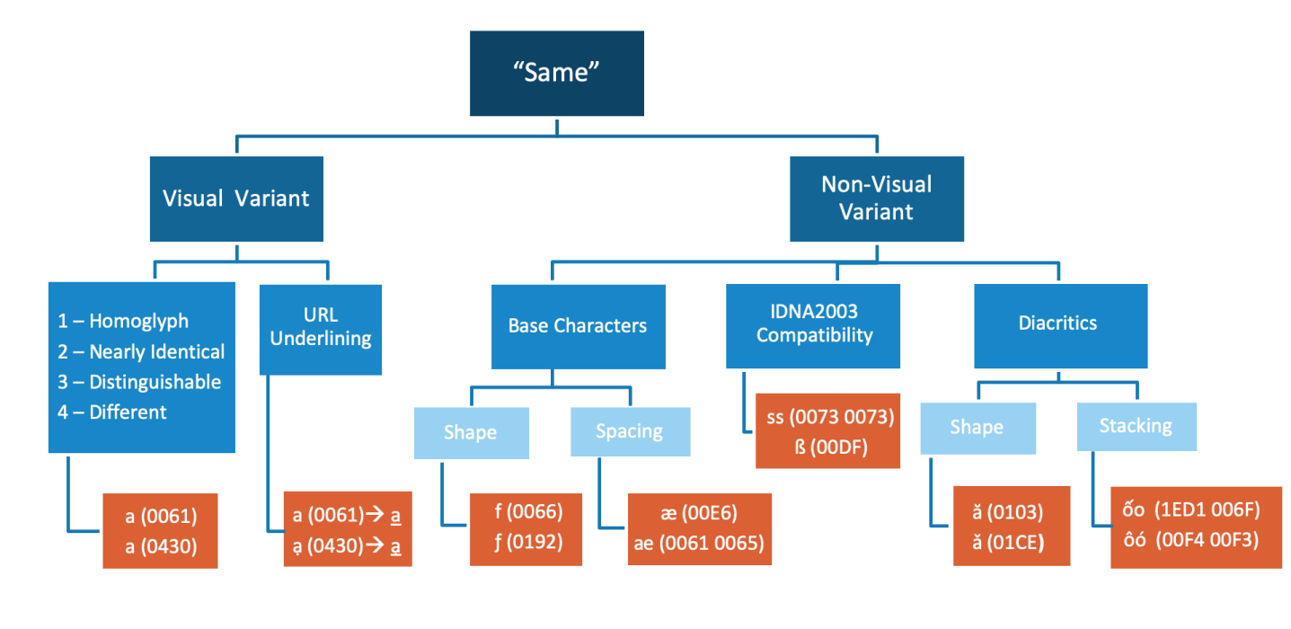
Section 6.1.2 below discusses first the types of visual similarity (on the left-hand branch of the diagram).

6.1.2 Visual Variants

Per [MSR], “the kinds of variants to be defined in the Root Zone LGR are limited to homoglyphs, which are characters essentially identical appearance by design, instead of merely similar appearance” (22 March 2017, IP Feedback to Latin GP Proposal, Document Version 1).

However, based on discussions within the Latin GP and by the GP with Integration Panel, the panel concluded that homoglyphs are not a categorial but a gradual distinction. Accordingly, Latin GP devised a four-point scale to determine whether a given pair of candidate characters tended to fall into the “essentially identical appearance by design” group, i.e. between a clear-cut case of a homoglyph and the a “merely similar appearance” group.

This scale was found to be useful by the GP, because it places similar interpretations next to one another: While both categories Homoglyphs and Distinct vis-a-vis one another are not only self-explanatory but were also judged very coherently across different members of the GP, the debates usually revolved around the difference between a Homoglyph and Nearly Identical case, a Nearly Identical Case versus a Distinguishable case, and - to a lesser degree - a Distinguishable case versus a Distinct case. The scale thus allowed the GP to express such gradual distinctions. The levels of that scale are presented together with a concise definition below in Table 10:

Table 10. Scale for Classifying Degree of Visual Identity

Score | Category
1 | Homoglyphs  A pair of code points in this category have essentially identical appearance by design.
2 | Nearly Identical  A pair of code points is considered Nearly Identical when the visual confusion can be attributed to font design.
3 | Distinguishable  A pair of code points is considered Distinguishable when any of the code point’s glyphs have recognizably different features from the other code point.
4 | Distinct  When the two glyphs in the pair are sufficiently different to be distinct.

Over time, a rough consensus evolved as summarized by the concise definitions of the items in Table 10. The GP decided that a Latin code point is deemed a visual variant with another code point when the two code points or sequence of code points are either
- homoglyphs (i.e. visual score = 1), or
- nearly identical (i.e. visual score = 2).

Nonetheless, numerous debates took place about the precise rating between different pairs of variant candidates according to this scale. These were eventually were resolved only by means of explicit rating by each active member, to establish majority decisions. However, during this very long process the GP came to the understanding, that visual appearance was not the only aspect which could lead to users considering code points as variants. For pragmatic reasons, this other category, which found no explicit mention in MSR, but which by consensus of the Panel was understood to be included under “characters essentially having identical appearance by design”, was simply termed ‘Non-Visual Variant’, as rendered on the right-hand branch of in Diagram 1 above, and as discussed in the following sections.

6.1.3 Non-Visual Variants

6.1.3.1 Shape of Base Characters

Historically, the classical Latin or Roman alphabet consisted of only 23 letters. Most new letters developed since are based on already existing letters and are therefore derived letters, or they were inspired by or adopted from other scripts, that is, they are borrowed letters. Derived letters were usually modified by extending certain lines (e.g. k vs. ƙ or f vs. ƒ) or by dropping elements (e.g. i vs. ı). In handwriting practices, a cursive writing style dominates connecting most letters to the right in order to speed up handwriting. The same kinds of changes to letters are made in order to make those connections; that is lines are extended and elements are dropped. Accordingly, Latin GP hypothesized that some hand-written forms may end up taking similar or the same shapes as some derived letters, and that readers may consider such unknown derived letters as hand-written variations of familiar letters, such as e.g. v vs. ʋ.

Also, some letters have traditionally different shapes in hand-written and printed forms such as a vs. ɑ. (The latter shape is the traditional form encountered in handwriting. However it is also found in some fonts. In particular, it is routinely see when fonts are italicized -- see the title of this sub-section.) Many such differences also overlap with the difference between upper and lower case, such as e.g. e vs. ɛ, with the latter glyph being a common upper-case form in handwriting to the former glyph and letter.

6.1.3.2 Spacing of Base Characters

Several letters have been derived by putting more closely together sequences of two or more letters, and the result of such modifications of spacing in between letters are called ligatures. This strategy to develop new letters was already employed in antiquity. For example, the letter w was derived out of a sequence of two instances of the letter v, i.e. vv (https://en.wikipedia.org/wiki/History_of_the_Latin_script).

While the origins are still somewhat recognizable in the case of w, in other cases the ligatures are not recognizable anymore as combinations of their original letters, such as ß which was formed on the hand-written basis of s and z (https://en.wikipedia.org/wiki/%C3%9F). In such cases, where letters are recognizable as being composed of two or more letters, confusion could arise among readers and depending on the spacing in between those glyphs in a font (which depends on typographic factors such as e.g. kerning), ligatures may become indistinguishable from a sequence of letters of which the same ligature was originally composed.

6.1.3.3 IDNA 2003 Compatibility

In Section 5.5 of Maximal Starting Repertoire — MSR-4 Overview and Rationale, the Integration Panel highlighted risks due to IDNA compatibility issues:
“In IDNA2003, case folding is applied, which creates compatibility issues between IDNA2008 and IDNA2003 for several code points. This arguably makes the affected code points candidates for summary exclusion from the MSR on grounds of Longevity (§2.1).”

Of those code points, two belong to the Latin-script repertoire, namely 00DF Latin Small Letter Sharp S and 0131 Latin Small Letter Dotless I. The solutions based on an understanding of IDNA compatibility are presented in sections 6.6.2 and 6.6.3. The considerations involving those code points and leading to those solutions are discussed in further detail in Appendix D.5.

Those two code points were also considered under other aspects, including cross-script variants between Latin and Greek script (cf. section 6.3.3), Generic Glyphs across scripts (cf. section 6.3.4) and in-script Variants based on the shape of base characters (cf. Appendix D.1).

6.1.3.4 Diacritics

6.1.3.4.1 Shape of Diacritics

Diacritics are modifiers surrounding basic letter shapes. In some cases diacritics are considered part and parcel of a letter shape, such as the dot on top of i. However they are generally recognized as distinct graphic elements of the script employed to form new letters, such as é based on e featuring an acute accent on top. The majority of derived letters of Latin script were developed using this strategy.

Over time, however, novel diacritics became employed which were based on other diacritics. For example ű, which features a base character u with a double acute (˝), a diacritic which is in turn based on the single acute (´). Many novel diacritics are very limited in use and occur in only a few languages. Typically they were developed to express less common distinctive linguistic features of languages written in Latin script, such as Tone, and often such are only familiar to users of such languages. Essentially there are three types of potential issues with such modifiers:

Firstly, certain diacritics may be considered conceptually the same as others by significant parts of the user community, such as dot below or a comma below.

Secondly, in some cases certain diacritics are not distinct from one another in handwriting traditions, such as e.g. a caron often being written in the same way as a breve, or a dot above being written in the same way as an acute. Furthermore, in cursive hand-writing writers make use of particular strategies to write letters more quickly, modifying them in ways in which the diacritics become visually identical or confusable with others, such as a diaeresis being replaced by two vertical strokes, which could be mistaken for a double acute in italic fonts, or a tilde being written ‘simply’ as a simple horizontal stroke above, i.e. a macron. Users thus perceive the two as interchangable.

Lastly, any given language uses only a small subset of the available diacritics. Especially with those diacritics used only in a very limited part of the script-using community, this may lead to confusion with significant parts of the script-using community or even the majority. For example, the horn (as used in combination with the basic letter shape “o” on 01A1 “ơ” Latin Small Letter O with Horn) could be conceptually mistaken by some readers for a misplaced acute (´). Or even an apostrophe (‘) -- for those users unaware that punctuation marks are excluded from use in IDN-labels because of the LDH principle.
In consequence, diacritics considered conceptually different in both print and Unicode may be considered as being interchangeable or even the same, or may become visually confusable or identical to other diacritics for readers.

6.1.3.4.2 Stacking of Diacritics

Diacritics are also combined with one another, such as “ấ” featuring both a circumflex and an acute. Such combinations are for the most part comparatively recent innovations, which again were often developed for linguistically distinctive features absent from European languages and therefore not traditionally represented in Latin script, such as tone. Such novel elements of the script were often encoded in later revisions of Unicode and glyphs have been developed only for a very limited number of fonts.

In consequence, many fonts use fallback rendering, replacing missing glyphs by taking them from any other font featuring the missing glyph and available to the user’s client. In other fonts, such glyphs may be represented with overlapping or misplacement of diacritics occurring frequently. Therefore, glyphs featuring base characters with several diacritics may become visually identical or confusable to readers with sequences of glyphs featuring the same diacritics on two separate code points or may even become effectively invisible in context by crossing over into adjacent glyphs.

6.1.4 Variants Due to Transitivity

Transitivity is a mathematical property of relations, defined as follows: if two mathematical expressions are in relation to a third expression then both are in the same relation to each other. The equal relation is a good example having the transitivity property (if A = B and C = B, then A = B).

Human perceptions do not work like mathematics, so this sometimes leads to odd results. That is, two glyphs end up being variants of each other due to transitivity which, if compared directly, would not not be variants.

Another problem arises, especially when cross-script variants are involved, when transitivity produces variants which are unacceptable. For example, the work of the Latin, Cyrillic, and Greek GPs resulted in a chain of variants involving multiple glyphs. Transitivity then resulted in the Latin Small Letter V (v) as an in-script variant of the Latin Small Letter Y (y). But these are both ASCII characters which, by rule, cannot be variants of each other. Accordingly the Latin, Greek, and Cyrillic GPs had to sit down and negotiate which link in the chain would be broken. That is, which variant relationship would be reduced to “merely Confusable”.

We have identified some transitivity cases manually. Others were identified using an XML tool.

6.2 Methodology for Developing Cross-Script Variants

Latin GP has analyzed variant relationships across related scripts, such as Cyrillic, Armenian and Greek. In addition, cases where a character shape is so generic that it occurs in multiple unrelated languages were examined. Example of such generic shapes include a straight vertical line (Latin Small Letter L), a circle (Latin Small Letter O), and a crescent (Latin Small Letter C and Latin Small Letter Open O).

The shapes of glyphs can differ among fonts. Accordingly, Latin GP selected three fonts to represent Latin script, which it deemed to be widespread enough to be representative: Arial, Courier New, and Times New Roman. In the case of Armenian script, it was noted that there were varying glyph shapes, depending on the application used for rendering strings, which made the initial analysis much more difficult. The GP consulted the Armenian Proposal to identify which glyphs the Armenian GP had chosen for representation in its Proposal [ARMENIAN] and considered those as standard for purposes of comparison with Latin script. To demonstrate the glyphs as seen and considered by Latin GP, we use screenshots in parts of this document to ensure that the reader sees the same shapes that we looked at during our analysis.

6.3 Cross-Script Variants

6.3.1 Armenian Script

Latin GP proposes the following cross-script variants with the Armenian script. (The two tables below display the same information; the second table, however, is a screenshot taken from Microsoft Excel to demonstrate the glyph shapes as seen by the GP during the cross-script variant analysis.)

Table 11. Armenian Cross-Script Variants

Source Unicode Name | Source Code Point | Source Glyph | Variant Relationship | Target Glyph | Target Code Point | Target Unicode Name | Disposition | Rationale
Latin Small Letter G | 0067 | g | ↔ | ց | 0581 | Armenian Small Letter Co | Blocked | Glyphs nearly identical due to font design
Latin Small Letter H | 0068 | h | ↔ | հ | 0570 | Armenian Small Letter Ho | Blocked | Glyphs nearly identical due to font design
Latin Small Letter N | 006E | n | ↔ | ո | 0578 | Armenian Small Letter Vo | Blocked | Glyphs nearly identical due to font design
Latin Small Letter O | 006F | o | ↔ | օ | 0585 | Armenian Small Letter Oh | Blocked | Homoglyph
Latin Small Letter Q | 0071 | q | ↔ | զ | 0566 | Armenian Small Letter Za | Blocked | Glyphs nearly identical due to font design
Latin Small Letter U | 0075 | u | ↔ | ս | 057D | Armenian Small Letter Seh | Blocked | Glyphs nearly identical due to font design
Latin Small Letter Iota | 0269 | ɩ | ↔ | ւ | 0582 | Armenian Small Letter Yiwn | Blocked | Glyphs nearly identical due to font design

Screenshot taken from Microsoft Excel. The three glyphs for each code point are set in Times New Roman, Arial, and Courier, respectively:

Cyrillic Script

The Latin GP proposes the following cross-script variants with the Cyrillic script:

Table 12: Cyrillic Cross-Script Variants

Source Unicode Name | Source Code Point | Source Glyph | Variant Relationship | Target Glyph | Target Code Point | Target Unicode Name | Disposition | Rationale
Latin Small Letter R | 0072 | r | ↔ | г | 0433 | Cyrillic Small Letter Ghe | Blocked | Glyphs nearly identical due to font design
Latin Small Letter Y | 0079 | y | ↔ | ү | 04AF | Cyrillic Small Letter Straight U | Blocked | Glyphs nearly identical due to font design. (Cf. Appendix D.9.1.1)
Latin Small Letter C with Cedilla | 00E7 | ç | ↔ | ҫ | 04AB | Cyrillic Small Letter Es with Descender | Blocked | Glyphs nearly identical due to font design
Latin Small Letter Y with Diaeresis | 00FF | ÿ | ↔ | Ӱ | 04F1 | Cyrillic Small Letter U with Diaeresis | Blocked | Glyphs nearly identical due to font design
Latin Small Letter R with Acute | 0155 | ŕ | ↔ | ѓ | 0453 | Cyrillic Small Letter Gje | Blocked | Glyphs nearly identical due to font design
Latin Small Letter R with Stroke | 024D | ɍ | ↔ | ғ | 0493 | Cyrillic Small Letter Ghe with Stroke | Blocked | Glyphs nearly identical due to font design
Latin Small Letter U with Dot Below | 1EE5 | ụ | ↔ | џ | 045F | Cyrillic Small Letter Dzhe | Blocked | Glyphs nearly identical due to font design. . (Cf. Appendix D.9.1.2.).
Latin Small Letter A | 0061 | a | ↔ | а | 0430 | Cyrillic Small Letter A | Blocked | Homoglyph
Latin Small Letter C | 0063 | c | ↔ | с | 0441 | Cyrillic Small Letter Es | Blocked | Homoglyph
Latin Small Letter E | 0065 | e | ↔ | е | 0435 | Cyrillic Small Letter Ie | Blocked | Homoglyph
Latin Small Letter H | 0068 | h | ↔ | һ | 04BB | Cyrillic Small Letter Shha | Blocked | Homoglyph
Latin Small Letter I | 0069 | i | ↔ | і | 0456 | Cyrillic Small Letter Belarusian-Ukrainian I | Blocked | Homoglyph
Latin Small Letter J | 006A | j | ↔ | ј | 0458 | Cyrillic Small Letter Je | Blocked | Homoglyph
Latin Small Letter L | 006C | l | ↔ | ӏ | 04CF | Cyrillic Small Letter Palochka | Blocked | Homoglyph
Latin Small Letter O | 006F | o | ↔ | о | 043E | Cyrillic Small Letter O | Blocked | Homoglyph
Latin Small Letter P | 0070 | p | ↔ | р | 0440 | Cyrillic Small Letter Er | Blocked | Homoglyph
Latin Small Letter S | 0073 | s | ↔ | ѕ | 0455 | Cyrillic Small Letter Dze | Blocked | Homoglyph
Latin Small Letter X | 0078 | x | ↔ | х | 0445 | Cyrillic Small Letter Ha | Blocked | Homoglyph
Latin Small Letter Y | 0079 | y | ↔ | у | 0443 | Cyrillic Small Letter U | Blocked | Homoglyph(Cf. Appendix D.9.1.1.).
Latin Small Letter A with Diaeresis | 00E4 | ä | ↔ | ӓ | 04D3 | Cyrillic Small Letter A with Diaeresis | Blocked | Homoglyph
Latin Small Letter Ae | 00E6 | æ | ↔ | ӕ | 04D5 | Cyrillic Small Ligature a Ie | Blocked | Homoglyph
Latin Small Letter E with Diaeresis | 00EB | ë | ↔ | ё | 0451 | Cyrillic Small Letter Io | Blocked | Homoglyph
Latin Small Letter I with Diaeresis | 00EF | ï | ↔ | ї | 0457 | Cyrillic Small Letter Yi | Blocked | Homoglyph
Latin Small Letter O with Diaeresis | 00F6 | ö | ↔ | ӧ | 04E7 | Cyrillic Small Letter O with Diaeresis | Blocked | Homoglyph
Latin Small Letter A with Breve | 0103 | ă | ↔ | ӑ | 04D1 | Cyrillic Small Letter A with Breve | Blocked | Homoglyph
Latin Small Letter H with Stroke | 0127 | ħ | ↔ | ћ | 045B | Cyrillic Small Letter Tshe | Blocked | Homoglyph
Latin Small Letter Turned E | 01DD | ǝ | ↔ | ә | 04D9 | Cyrillic Small Letter Schwa | Blocked | Homoglyph
Latin Small Letter Schwa | 0259 | ə | ↔ | ә | 04D9 | Cyrillic Small Letter Schwa | Blocked | Homoglyph
Latin Small Letter Ezh | 0292 | ʒ | ↔ | ӡ | 04E1 | Cyrillic Small Letter Abkhasian Dze | Blocked | Homoglyph

Greek Script

The Latin GP proposes the following cross-script variants with Greek script:

Table 13: Greek Cross-Script Variants

Source Unicode Name | Source Code Point | Source Glyph | Variant Relationship | Target Glyph | Target Code Point | Target Unicode Name | Disposition | Rationale
Latin Small Letter O | 006F | o | ↔ | ο | 03BF | Greek Small Letter Omicron | Blocked | Homoglyph
Latin Small Letter I with Acute | 00ED | Í | ↔ | ί | 03AF | Greek Small Letter Iota with Tonos | Blocked | Homoglyph
Latin Small Letter I with Diaeresis | 00EF | ï | ↔ | ϊ | 03CA | Greek Small Letter Iota with Dialytika | Blocked | Homoglyph
Latin Small Letter O with Acute | 00F3 | ó | ↔ | ό | 03CC | Greek Small Letter Omicron with Tonos | Blocked | Homoglyph
Latin Small Letter Dotless I | 0131 | ı | ↔ | ι | 03B9 | Greek Small Letter Iota | Blocked | Homoglyph
Latin Small Letter Open E | 025B | ɛ | ↔ | ε | 03B5 | Greek Small Letter Epsilon | Blocked | Homoglyph
Latin Small Letter Iota | 0269 | ɩ | ↔ | ι | 03B9 | Greek Small Letter Iota | Blocked | Homoglyph
Latin Small Letter V | 0076 | v | ↔ | ν | 03BD | Greek Small Letter Nu | Blocked | Glyphs nearly identical due to font design.
Latin Small Letter A | 0061 | a | ↔ | α | 03B1 | Greek Small Letter Alpha | Blocked | Glyphs nearly identical due to font design. See (Cf. Appendix D.9.2.1.).
Latin Small Letter P | 0070 | p | ↔ | ρ | 03C1 | Greek Small Letter Rho | Blocked | Glyphs nearly identical due to font design. (Cf. Appendix D.9.2.2.)
Latin Small Letter U | 0075 | u | ↔ | υ | 03C5 | Greek Small Letter Upsilon | Blocked | Glyphs nearly identical due to font design. (Cf. Appendix D.9.2.3.)
Latin Small Letter Y | 0079 | y | ↔ | γ | 03B3 | Greek Small Letter Gamma | Blocked | Glyphs nearly identical due to font design
Latin Small Letter Sharp S | 00DF | ß | ↔ | β | 03B2 | Greek Small Letter Beta | Blocked | Glyphs nearly identical due to font design. (Cf. Appendix D.9.2.4.).
Latin Small Letter A with Acute | 00E1 | á | ↔ | ά | 03AC | Greek Small Letter Alpha With Tonos | Blocked | Glyphs nearly identical due to font design
Latin Small Letter U with Acute | 00FA | ú | ↔ | ύ | 03CD | Greek Small Letter Upsilon with Tonos | Blocked | Glyphs nearly identical due to font design. (Cf. Appendix D.9.2.3.).
Latin Small Letter U with Diaeresis | 00FC | ü | ↔ | ϋ | 03CB | Greek Small Letter Upsilon with Dialytika | Blocked | Glyphs nearly identical due to font design
Latin Small Letter O with Horn | 01A1 | ơ | ↔ | σ | 03C3 | Greek Small Letter Sigma | Blocked | Glyphs nearly identical due to font design. (Cf. Appendix D.9.2.5.)
Latin Small Letter V with Hook | 028B | ʋ | ↔ | υ | 03C5 | Greek Small Letter Upsilon | Blocked | Glyphs nearly identical due to font design. (Cf. Appendix D.9.2.5.)

6.3.4 Generic Glyphs

In MSR, the Integration Panel highlights the risk of “a number of homoglyphs of code points that cross scripts”, providing examples of “circle glyph” from seven scripts:

“Because simple glyph shapes like this give effectively no hint of script identity, the IP encourages the Generation Panels to consider cross-script variants in such cases even for otherwise unrelated scripts. Among related scripts, there may be pairs of code points that are identical or nearly identical despite having more complex shapes. Where these can be used to form a label that is a homograph of a label in another script, they should be investigated for variant status.” [MSR, page 22-23]

Most scripts have used similar graphic elements to distinguish basic letter shapes. Accordingly, there are a few shapes which are sufficiently generic that they occur in both related and unrelated scripts, such as the “circle glyph” referenced by IP. For Latin script, in addition to a circle shape (Latin Small Letter O 006F) this includes a single straight line (Latin Small Letter L 006C and Latin Small Letter Dotless I 0131) or a crescent (Latin Small Letter C 0053 and Latin Small Letter Open O 0254). While these examples are independent code points in Latin script, in other scripts they may occur as combining mark code points.

Latin GP has identified the following variant relationships based on an analysis of generic glyphs of scripts included in [MSR], while all shortlisted variant candidates are presented in Appendix F.

Source Unicode Name | Source Code Point | Source Glyph | Variant Relation-ship | Target Glyph | Target Code Point | Target Unicode Name | Disposition | Rationale
Latin Small Letter L | 006C | l | ↔ | ӏ | 04CF | Cyrillic Small Letter Palochka | Blocked | Glyphs nearly identical due to font design
Latin Small Letter L | 006C | l | ↔ | ا | 0627 | Arabic Letter Alef | Blocked | Glyphs nearly identical due to font design
Latin Small Letter L | 006C | l | ↔ | ା | 0B3E | Oriya Vowel Sign Aa | Blocked | Glyphs nearly identical due to font design
Latin Small Letter Dotless I | 0131 | ı | ↔ | ו | 05D5 | Hebrew Letter Vav | Blocked | Glyphs nearly identical due to font design
Latin Small Letter Dotless I | 0131 | ı | ↔ | ၢ | 1062 | Myanmar Vowel Sign Sgaw Karen Eu | Blocked | Glyphs nearly identical due to font design
Latin Small Letter O | 006F | o | ↔ | ο | 0B6F | Greek Small Letter Omicron | Blocked | Glyphs nearly identical due to font design
Latin Small Letter O | 006F | o | ↔ | о | 043F | Cyrillic Small Letter O | Blocked | Glyphs nearly identical due to font design
Latin Small Letter O | 006F | o | ↔ | օ | 0585 | Armenian Small Letter Oh | Blocked | Glyphs nearly identical due to font design
Latin Small Letter O | 006F | o | ↔ | ס | 05E1 | Hebrew Letter Samekh | Blocked | Glyphs nearly identical due to font design
Latin Small Letter O | 006F | o | ↔ | ଠ | 0B20 | Oriya Letter Ttha | Blocked | Glyphs nearly identical due to font design
Latin Small Letter O | 006F | o | ↔ | ഠ | 0D20 | Malayalam Letter Ttha | Blocked | Glyphs nearly identical due to font design
Latin Small Letter O | 006F | o | ↔ | ဝ | 101D | Myanmar Letter Wa | Blocked | Glyphs nearly identical due to font design
Latin Small Letter O | 006F | o | ↔ | ዐ | 12D0 | Ethiopic Syllable Pharyngeal A | Blocked | Glyphs nearly identical due to font design
Latin Small Letter C | 0053 | c | ↔ | С | 0441 | Cyrillic Small Letter ES | Blocked | Glyphs nearly identical due to font design
Latin Small Letter C | 0053 | c | ↔ | ເ | 0EC0 | Lao Vowel Sign E | Blocked | Glyphs nearly identical due to font design
Latin Small Letter C | 0053 | c | ↔ | င | 1004 | Myanmar Letter Nga | Blocked | Glyphs nearly identical due to font design
Latin Small Letter Open O | 0254 | ɔ | ↔ | ວ | 0EA7 | Lao Letter Wo | Blocked | Glyphs nearly identical due to font design
Latin Small Letter Open O | 0254 | ɔ | ↔ | ာ | 102C | Myanmar Vowel Sign Aa | Blocked | Glyphs nearly identical due to font design

6.4 Methodology for Developing In-Script Variants

In the case of visual variants, the following cases will be proposed as in-script variant:
- Homoglyphs (i.e. visual score = 1): when any given pair of code points or code point sequences are visually identical as represented in a common use font (e.g., Arial, Times New Roman or Courier New) by Internet applications, such as internet browsers.
In the case of non-visual variants, the methodology is different, and depends on the type of suspected variance:

To test the hypotheses regarding the influence of handwriting on font design and the conception of readers, Latin GP looked at both handwriting samples as well as font design. The Latin GP looked comprehensively at font design when evaluating possible variants. In addition, in some cases, we looked at how handwriting typically renders letters in order to understand other ways that users might be accustomed to visualizing particular cases. This was not done systematically, just an aid to guide our review in particular cases. In the case of glyph shape for base characters and diacritics, it was assumed that if such handwriting practices would cross-over into the printed forms, there should be fonts in which such potential variant pairs would turn out to be identical or nearly identical in appearance by a significant number of fonts.

In the case of cross-script variants, the GP initially examined glyphs only in three widely used fonts, namely Arial, Courier New, and Times New Roman. However, in the case of in-script variants the GP choose to also compare glyphs across a wide number of fonts to see if a significant minority of fonts indicated a possible variant relationship between code points. This approach was chosen because there is no stability for the fonts employed by software. Not only are different fonts used across different types of software as well as across different platforms, but most clients offer the option to change the fonts, and some protocols also allow the server to freely specify a different font.

Therefore, the only way to predict what will be a plausible case for a variant relationship, is to look for trends in the rendering of certain glyphs, and to see if a significant minority of fonts renders the same glyph in a distinctly different manner. Since fonts designers are free to play with shapes and graphic elements comprising the glyphs recognizable by most users for a specific letter, there will always be ‘extreme’ cases, which may not be representative of the typical rendering of a character. However, if several fonts make use of the same graphical features in rendering of a glyph, such a shared feature may lead to a perceived similarity, which can pose a risk to stability and which may have to be dealt with at LGR-level.

In some potential variants the panel identified, a significant minority of glyphs shared some features, which suggested a variant relationship to other code points, however it was decided that it did not rise to the level of variant status based on a discussion among members actively participating in that discussion. In such cases the GP decided that such cases should be listed as Latin In-Script Confusables (see Appendix F). This should highlight these potential risks for any party looking to implement the LGR.

The GP used the website https://wordmark.it/ to compare strings across such a large number of different fonts. In order to attain results which were less dependent on pre-installed fonts on specific platforms and user interfaces, renderings were compared using Google Fonts, a font library employed by many APIs, instead of system fonts as rendered by that website.

Where the shape of base characters or diacritics was assumed to lead to variant candidates, strings containing the two code points, such as fƒ or vice versa, i.e. 0066 + 0192, or strings containing code points featuring the two diacritics, such as ăǎ or vice versa, i.e. 0103 + 01CE, were compared.

Sometimes spacing of base characters or stacking of diacritics were assumed to lead to variant candidates. In these cases, strings containing the ligature plus the separate elements of the ligature, such as œoe or vice versa (i.e. 0153 + 006F + 0065) were compared. In other cases, strings containing code points featuring the stacked diacritics followed by the base character which the stacked diacritics modifies as well as sequences of code points featuring those diacritics separately (where available), such as e.g. ốoôó, i.e. 1ED1 + 006F + 00F4 + 00F3.

This analysis was conducted for all code points featured in the suggested repertoire, as well as relevant candidates from other scripts.

Variance based on compatibility to with old revisions of IDNA is discussed separately below in section 6.6.2.

6.5 In-Script Latin Variants

In the following, the variant sets confirmed by Latin GP are presented together with the relevant data and rationale. The full list of potential variant candidates shortlisted and analyzed by the GP, including such cases which were not confirmed, is presented in Appendix D.

Table 14. In-Script Latin Variants - (Not finalized yet)

Source Unicode Name | Source Code Point | Source Glyph |  | Target Glyph | Target Code Point | Target Unicode Name | Disposition | Rationale
Latin Small Letter Turned E | 01DD | ǝ | ↔ | ə | 0259 | Latin Small Letter Schwa | Blocked | In-script variant due to transitivity relationship of 04D9 Cyrillic Small Letter Schwa
Latin Small Letter Dotless I | 0131 | ı | ↔ | ɩ | 0269 | Latin Small Letter Iota | Blocked | In-script variant due to transitivity relationship of 03B9 Greek Small Letter Iota  [BJ – move to Transitivity Section 6.7]
Latin Small Letter U | 0075 | u | ↔ | ʋ | 028B | Latin Small Letter V with Hook | Blocked | In-script variant due to transitivity relationship of 03C5 Greek Small Letter Upsilon  [BJ – move to Transitivity Section 6.7]
Latin Small Letter F | 0066 | f | ↔ | ƒ | 0192 | Latin Small Letter F with Hook | Blocked

6.5.1 Breve and Caron

The Breve diacritic consists of a smooth curve, whereas the Caron diacritic consists of two straight lines meeting at a shallow angle. When the underlying letter is large enough, these are readily distinguishable (see Appendix D.3.1). But at a normal font size (e.g, 12 point type) they are indistinguishable. Accordingly we have the following set of variants.

Breve |  |  |  | Caron
Source Unicode Name | Source Code Point | Source Glyph |  | Target Glyph | Target Code Point | Target Unicode Name | Disposition
Latin Small Letter A with Breve | 0103 | ă | ↔ | ǎ | 01CE | Latin Small Letter A with Caron | Blocked
Latin Small Letter E with Breve | 0115 | ĕ | ↔ | ě | 011B | Latin Small Letter E with Caron | Blocked
Latin Small Letter G with Breve | 011F | ğ | ↔ | ǧ | 01E7 | Latin Small Letter G with Caron | Blocked
Latin Small Letter U with Breve | 016D | ŭ | ↔ | ǔ | 01D4 | Latin Small Letter U with Caron | Blocked

6.5.2 Tilde and Macron

The Tilde diacritic consists of a wavy horizontal line whereas the Macron diacritic consists of a straight horizontal line. When the underlying letter is large enough, these are readily distinguishable (see Appendix D.3.2). But at a normal font size (e.g, 12 point type) they are indistinguishable. Accordingly we have the following set of variants.

Tilde |  |  |  | Macron
Source Unicode Name | Source Code Point | Source Glyph | Variant Relationship | Target Glyph | Target Code Point | Target Unicode Name | Disposition
Latin Small Letter A with Tilde | 00E3 | ã | ↔ | ā | 0101 | Latin Small Letter A with Macron | Blocked
Latin Small Letter E with Tilde | 1EBD | ẽ | ↔ | ē | 0113 | Latin Small Letter E with Macron | Blocked
Latin Small Letter G with Combining Tilde | 0067 + 0303 | g̃ | ↔ | ḡ | 1E21 | Latin Small Letter G with Combining Macron | Blocked
Latin Small Letter I with Tilde | 0129 | ĩ | ↔ | ī | 012B | Latin Small Letter I with Macron | Blocked
Latin Small Letter N with Tilde | 00F1 | ñ | ↔ | n̄ | 006E + 0304 | Latin Small Letter N with Combining Macron | Blocked
Latin Small Letter O with Tilde | 006F | õ | ↔ | ō | 014D | Latin Small Letter O with Macron | Blocked
Latin Small Letter R with Combining Tilde | 0072 + 0303 | r̃ | ↔ | ř | 0159 | Latin Small Letter R with Macron | Blocked
Latin Small Letter U with Tilde | 0169 | ũ | ↔ | ū | 016B | Latin Small Letter U with Macron | Blocked

6.5.3 Grave and Hook Above
Grave |  |  |  | Hook Above
Source Unicode Name | Source Code Point | Source Glyph |  | Target Glyph | Target Code Point | Target Unicode Name | Disposition
Latin Small Letter A with Grave | 00E0 | à | ↔ | ả | 1EA3 | Latin Small Letter A with Hook Above | Blocked
Latin Small Letter A with Breve and Grave | 1EB1 | ắ | ↔ | ẳ | 1EB3 | Latin Small Letter A with Breve and Hook Above | Blocked
Latin Small Letter A with Circumflex and Grave | 1EA7 | ầ | ↔ | ẩ | 1EA9 | Latin Small Letter A with Circumflex and Hook Above | Blocked
Latin Small Letter E with Grave | 00E8 | è | ↔ | ẻ | 1EBB | Latin Small Letter E with Hook Above | Blocked
Latin Small Letter E with Circumflex and Grave | 1EC1 | ề | ↔ | ẻ | 1EC3 | Latin Small Letter E with Circumflex and Hook Above | Blocked
Latin Small Letter I with Grave | 0069 | ì | ↔ | ỉ | 1EC9 | Latin Small Letter I with Hook Above | Blocked
Latin Small Letter O with Grave | 00F2 | ò | ↔ | ỏ | 1ECF | Latin Small Letter O with Hook Above | Blocked
Latin Small Letter O with Horn and Grave | 1EDD | ờ | ↔ | ở | 1EDF | Latin Small Letter O with Horn and Hook Above | Blocked
Latin Small Letter O with Circumflex and Grave | 1ED3 | ồ | ↔ | ổ | 1ED5 | Latin Small Letter O with Circumflex and Hook Above | Blocked
Latin Small Letter U with Grave | 00F9 | ù | ↔ | ủ | 1EE7 | Latin Small Letter U with Hook Above | Blocked
Latin Small Letter U with Horn and Grave | 1EEB | ừ | ↔ | ử | 1EED | Latin Small Letter U with Horn and Hook Above | Blocked
Latin Small Letter Y with Grave | 1EF3 | ỳ | ↔ | ỷ | 1EF7 | Latin Small Letter Y with Hook Above | Blocked

6.5.4 Acute and Dot Above

Acute |  |  |  | Dot Above
Source Unicode Name | Source Code Point | Source Glyph |  | Target Glyph | Target Code Point | Target Unicode Name | Disposition
Latin Small Letter C with Acute | 0107 | ć | ↔ | ċ | 010B | Latin Small Letter C with Dot Above | Blocked
Latin Small Letter N with Acute | 0144 | ń | ↔ | ṅ | 1E45 | Latin Small Letter N with Dot Above | Blocked
Latin Small Letter Z with Acute | 017A | ź | ↔ | ż | 017C | Latin Small Letter Z with Dot Above | Blocked

6.5.5 Dot Above and Hook Above

Dot Above |  |  |  | Hook Above
Source Unicode Name | Source Code Point | Source Glyph |  | Target Glyph | Target Code Point | Target Unicode Name | Disposition
Latin Small Letter E with Dot Above | 0117 | ė | ↔ | ẻ | 1EBB | Latin Small Letter E with Hook Above | Blocked
Latin Small Letter I | 0117 | i | ↔ | ỉ | 1EC9 | Latin Small Letter I with Hook Above | Blocked

6.5.6 Diaeresis and Double Acute

Diaeresis |  |  |  | Double Acute
Source Unicode Name | Source Code Point | Source Glyph |  | Target Glyph | Target Code Point | Target Unicode Name | Disposition
Latin Small Letter O with Diaeresis | 00F6 | ö | ↔ | ő | 0151 | Latin Small Letter O with Double Acute | Blocked
Latin Small Letter U with Diaeresis | 00FC | ü | ↔ | ű | 0171 | Latin Small Letter U with Double Acute | Blocked

6.5.7 Acute and Grave

Acute |  |  |  | Grave
Source Unicode Name | Source Code Point | Source Glyph |  | Target Glyph | Target Code Point | Target Unicode Name | Disposition
Latin Small Letter A with Circumflex and Acute | 1EA5 | ấ | ↔ | ầ | 1EA7 | Latin Small Letter A with Circumflex and Grave | Blocked
Latin Small Letter A with Breve and Acute | 1EAF | ắ | ↔ | ằ | 1EB1 | Latin Small Letter A with Breve and Grave | Blocked
Latin Small Letter O with Circumflex and Acute | 1ED1 | ố | ↔ | ồ | 1ED3 | Latin Small Letter O with Circumflex and Grave | Blocked

6.5.8 Acute and Hook Above

Acute |  |  |  | Hook Above
Source Unicode Name | Source Code Point | Source Glyph |  | Target Glyph | Target Code Point | Target Unicode Name | Disposition
Latin Small Letter A with Circumflex and Acute | 1EA5 | ấ | ↔ | ẩ | 1EA9 | Latin Small Letter A with Circumflex and Hook Above | Blocked
Latin Small Letter A with Breve and Acute | 1EAF | ắ | ↔ | ẳ | 1EB3 | Latin Small Letter A with Breve and Hook Above | Blocked
Latin Small Letter E with Circumflex and Acute | 1EBF | ế | ↔ | ể | 1EC3 | Latin Small Letter E with Circumflex and Hook Above | Blocked
Latin Small Letter O with Horn and Acute | 1ED1 | ớ | ↔ | ở | 1EDF | Latin Small Letter O with Horn and Hook Above | Blocked
Latin Small Letter O with Circumflex and Acute | 1EDB | ố | ↔ | ổ | 1ED5 | Latin Small Letter O with Circumflex and Hook Above | Blocked
Latin Small Letter Y with Acute | 1EF3 | ỳ | ↔ | ỷ | 1EF9 | Latin Small Letter Y with Hook Above | Blocked

6.5.9 Misc

Source Unicode Name | Source Code Point | Source Glyph |  | Target Glyph | Target Code Point | Target Unicode Name | Disposition
Latin Small Letter G with Dot Above | 0121 | ġ | ↔ | ģ | 0123 | Latin Small Letter G with Cedilla | Blocked
Latin Small Letter Dotless I | 0131 | ı | ↔ | ɩ | 0269 | Latin Small Letter Iota | Blocked
Latin Small Letter O with Circumflex and Acute | 1ED1 | ố | ↔ | ồ | 1ED3 | Latin Small Letter O with Circumflex and Grave | Blocked
Latin Small Letter U with Ring Above | 016F | ů | ↔ | ģ | 1EE7 | Latin Small Letter U with Hook Above | Blocked

6.6 Other Considerations for Variant Analysis

Apart from cross-script variants and in-script variants, Latin GP has also considered three other potential security risks, which could affect the safety and stability of the root zone, namely the effect of URL underlining, full compliance with IDNA 2003 but not IDNA 2008, and generic shapes of glyphs across related and unrelated scripts in [MSR]. The results of that analysis are summarized in this section, with details of the analysis presented in Appendix D.

6.6.1 URL Underlining

In many user interfaces and software clients for different protocols making use of IDNs, IDN labels are linked by converting them into protocol-specific hyperlinks. These are usually highlighted by underlining the URL. In their communique by email from August 29, 2018, the Integration Panel highlighted recent security risks based on the underlining of labels in URLs. Underlining may obscure modifiers below or near the baseline. The IP asked the GP to take such risks into particular consideration:

“There are recent and widely published examples of phishing attacks using Latin IDNs in which the key features involved were diacritics below the letter. […] Of all diacritics, diacritics below can be difficult to distinguish or be prone to clipping -- there is less space below the baseline than between the typical lowercase glyph and the top of the line. […] The IP would like to encourage the Latin GP (and any other GP facing cases like this) to explicitly examine this example and other cases like it, where code points can become indistinguishable in common usage scenarios for IDNs, and formally conclude whether and how to take these into account when designing their LGR.“

The GP used the same methodology and framework used for analysis of cross-script variants (see section 6.2 above).

Identifying relevant code points (the glyphs of which crossed into or below the baseline) was relatively comparatively straightforward. However, it wasn’t always clear which code points to compare them to. . For example, should Letter I with Ogonek be compared to Letter I or to Letter J? In several cases, new or extended potential variant sets evolved after the data had been prepared and initially analyzed, since the obscuring of certain ‘extensions’ of the letters led to a wider than expected similarity (which relates to the fact that most letters were developed based on others as discussed above in section 6.1.3). Generally, any code point included in the repertoire and represented by a glyph which features a modifier below the baseline was compared with the code point representing the same glyph without any modifier below the baseline, such as e.g. ą, a̱, or ạ vs a. In the end, this analysis proved to be even more difficult than the cross-script variant analysis. Any set of code points positively identified as variants was automatically assigned the disposition of Blocked.

The tables below present the variant candidate sets positively confirmed by the GP after such an analysis. All the candidate sets analyzed, including those which could not be confirmed, are presented together with the data in Appendix D.6.

Table 15. In-Script Variants Due to Underlining

Group | Underlining
Target |  |  | Source |  |  | Variant Candidate [Yes/No] | Disposition Allocatable /Blocked] | Rationale
Code Point | Glyph | Name | Code Point | Glyph | Name | Variant Candidate [Yes/No] |  | Rationale
0061 | a | Latin Small Letter A | 0105 | ą | Latin Small Letter A with Ogonek | YES | Blocked | Glyphs nearly identical due to underlining
0061 | a | Latin Small Letter A | 0061 + 0331 | a̱ | Latin Small Letter A + Combining Macron Below | YES | Blocked | Glyphs nearly identical due to underlining
0061 | a | Latin Small Letter A | 1EA1 | ạ | Latin Small Letter A with Dot Below | YES | Blocked | Glyphs nearly identical due to underlining
0103 | ă | Latin Small Letter A with Breve | 1EA7 | ặ | Latin Small Letter A with Breve and Dot Below | YES | Blocked | Glyphs nearly identical due to underlining
00E2 | â | Latin Small Letter A with Circumflex | 1EAD | ậ | Latin Small Letter A with Circumflex and Dot Below | YES | Blocked | Glyphs nearly identical due to underlining
0062 | b | Latin Small Letter B | 00FE | þ | Latin Small Letter Thorn | YES | Blocked | Glyphs nearly identical due to underlining
0064 | d | Latin Small Letter D | 1E13 | ḓ | Latin Small Letter D with Circumflex Below | YES | Blocked | Glyphs nearly identical due to underlining
0065 | e | Latin Small Letter E | 1EB9 | ẹ | Latin Small Letter E with Dot Below | YES | Blocked | Glyphs nearly identical due to underlining
0065 | e | Latin Small Letter E | 0065 + 0331 | e̱ | Latin Small Letter E + Combining Macron Below | YES | Blocked | Glyphs nearly identical due to underlining
0065 | e | Latin Small Letter E | 0119 | ê | Latin Small Letter E with Ogonek | YES | Blocked | Glyphs nearly identical due to underlining
0065 | e | Latin Small Letter E | 0019 |  | Latin Small Letter E with Ogonek | YES | Blocked | Glyphs nearly identical due to underlining
00E9 | é | Latin Small Letter E with Acute | 1EB9 + 0301 | ẹ́ | Latin Small Letter E with Dot Below + Combining Acute Accent | YES | Blocked | Glyphs nearly identical due to underlining
00EA | ê | Latin Small Letter E with Circumflex | 1EC7 | ệ | Latin Small Letter E with Circumflex and Dot Below | YES | Blocked | Glyphs nearly identical due to underlining
00E8 | è | Latin Small Letter E with Grave | 1EB9 + 0300 | ẹ̀ | Latin Small Letter E with Dot Below + Combining Grave Accent | YES | Blocked | Glyphs nearly identical due to underlining
025B | ɛ | Latin Small Letter Open E | 025B + 0331 | ɛ̱ | Latin Small Letter Open E with Combining Macron Below | YES | Blocked | Glyphs nearly identical due to underlining
025B + 0308 | ɛ̈ | Latin Small Letter Open E + Combining Diaeresis | 025B + 0331 + 0308 | ɛ̱̈ | Latin Small Letter Open E + Combining Macron Below + Combining Diaeresis | YES | Blocked | Glyphs nearly identical due to underlining
0069 | i | Latin Small Letter I | 0069 + 0331 | i̲ | Latin Small Letter I + Combining Macron Below | YES | Blocked | Glyphs nearly identical due to underlining
0069 | i | Latin Small Letter I | 1ECB | ị | Latin Small Letter I with Dot Below | YES | Blocked | Glyphs nearly identical due to underlining
006A | j | Latin Small Letter J | 012F | į | Latin Small Letter I with Ogonek | YES | Blocked | Glyphs nearly identical due to underlining
006B | k | Latin Small Letter K | 0137 | ķ | Latin Small Letter K with Cedilla | YES | Blocked | Glyphs nearly identical due to underlining
006C | l | Latin Small Letter L | 013C | ļ | Latin Small Letter L with Cedilla | YES | Blocked | Glyphs nearly identical due to underlining
006C | l | Latin Small Letter L | 1E37 | ḷ | Latin Small Letter L with Dot Below | YES | Blocked | Glyphs nearly identical due to underlining
006C | l | Latin Small Letter L | 1E3D | ḽ | Latin Small Letter L with Circumflex Below | YES | Blocked | Glyphs nearly identical due to underlining
006D | m | Latin Small Letter M | 1E43 | ṃ | Latin Small Letter M with Dot Below | YES | Blocked | Glyphs nearly identical due to underlining
006E | n | Latin Small Letter N | 1E47 | ṇ | Latin Small Letter N with Dot Below | YES | Blocked | Glyphs nearly identical due to underlining
006E | n | Latin Small Letter N | 1E49 | ṉ | Latin Small Letter N with Line Below | YES | Blocked | Glyphs nearly identical due to underlining
006E | n | Latin Small Letter N | 014B | ŋ | Latin Small Letter Eng | YES | Blocked | Glyphs nearly identical due to underlining
0146 | ņ | Latin Small Letter N with Cedilla | 1E4B | ṋ | Latin Small Letter N with Circumflex Below | YES | Blocked | Glyphs nearly identical due to underlining
006F | o | Latin Small Letter O | 006F + 0331 | o̱ | Latin Small Letter O + Combining Macron Below | YES | Blocked | Glyphs nearly identical due to underlining
00F3 | ó | Latin Small Letter O with Acute | 1ECD + 0301 | ọ́ | Latin Small Letter O with Dot Below + Combining Acute Accent | YES | Blocked | Glyphs nearly identical due to underlining
00F4 | ô | Latin Small Letter O with Circumflex Below | 1ED9 | ộ | Latin Small Letter O with Circumflex and Dot Below | YES | Blocked | Glyphs nearly identical due to underlining
00F2 | ò | Latin Small Letter O with Grave | 1ECD + 0300 | ọ̀ | Latin Small Letter O with Dot Below + Combining Grave Accent | YES | Blocked | Glyphs nearly identical due to underlining
01A1 | ơ | Latin Small Letter O with Horn | 1EE3 | ợ | Latin Small Letter O with Horn and Dot Below | YES | Blocked | Glyphs nearly identical due to underlining
00F4 | ô | Latin Small Letter Open O with Circumflex | 1ED9 | ộ | Latin Small Letter Open O with Circumflex and Dot Below | YES | Blocked | Glyphs nearly identical due to underlining
0073 | s | Latin Small Letter S | 015F | ş | Latin Small Letter S with Cedilla | YES | Blocked | Glyphs nearly identical due to underlining
015F | ş | Latin Small Letter S with Cedilla | 0219 | ș | Latin Small Letter S with Comma Below | YES | Blocked | Glyphs nearly identical due to underlining
0074 | t | Latin Small Letter T | 021B | ț | Latin Small Letter T with Cedilla | YES | Blocked | Glyphs nearly identical due to underlining
0074 | t | Latin Small Letter T | 1E71 | ṱ | Latin Small Letter T with Circumflex Below | YES | Blocked | Glyphs nearly identical due to underlining
0074 | t | Latin Small Letter T | 1E6D | ṭ | Latin Small Letter T with Dot Below | YES | Blocked | Glyphs nearly identical due to underlining
021B | t | Latin Small T with Comma Below | 1E71 | ṱ | Latin Small Letter T with Circumflex Below | YES | Blocked | Glyphs nearly identical due to underlining
0075 | u | Latin Small Letter U | 1EE5 | ụ | Latin Small Letter U with Dot Below | YES | Blocked | Glyphs nearly identical due to underlining
0079 | y | Latin Small Letter Y | 1EF5 | ỵ | Latin Small Letter Y with Dot Below | YES | Blocked | Glyphs nearly identical due to underlining
1E3D | ḽ | Latin Small Letter L with Circumflex Below | 013C | ļ | Latin Small Letter L with Cedilla | YES | Blocked | Glyphs nearly identical due to underlining
006E | n | Latin Small Letter N | 0146 | ņ | Latin Small Letter N with Cedilla | YES | Blocked | Glyphs nearly identical due to underlining
006F | o | Latin Small Letter O | 1ECD | ọ | Latin Small Letter O with Dot Below | YES | Blocked | Glyphs nearly identical due to underlining
0254 | ɔ | Latin Small Letter Open O | 0254 + 0331 | ɔ̱ | Latin Small Letter Open O + Combining Macron Below | YES | Blocked | Glyphs nearly identical due to underlining
0073 | s | Latin Small Letter S | 1E63 | ṣ | Latin Small Letter S with Dot Below | YES | Blocked | Glyphs nearly identical due to underlining |  |  |  | YES | Blocked | Glyphs nearly identical due to underlining
0075 | u | Latin Small Letter U | 0173 | ų | Latin Small Letter U with Ogonek | YES | Blocked | Glyphs nearly identical due to underlining
01B0 | ư | Latin Small Letter U with Horn | 1EF1 | ự | Latin Small Letter U with Horn and Dot Below | YES | Blocked | Glyphs nearly identical due to underlining

6.6.2 IDNA2003 Compatibility

[TBD: make each case a sub-sub-sub section, e.g. 6.2.7.1 etc.]
[MT:This wiill be done for the next revision]

The Latin GP has analyzed and discussed the pros and cons of different solutions for mitigating risks arising from IDNA 2003 compatibility issues, as discussed in detail in Appendix D.5.

[TBD: while 00DF is implicated in the transition from IDNA 2003, there is independent rationale for the proposed variant treatment. It might be better to focus on that aspect and mention IDNA2003 only in passing.]
[MT:This wiill be done for the next revision]

In the case of Latin Small Letter Sharp S (00DF), the LGR proposes a solution which includes the code point together with a variant relationship with the sequence of letters ‘ss’ (0073 0073), as follows:

Table 16. In-Script Variants for Latin Small Letter Sharp S (00DF)

Source Code Point | Variant Relationship | Target Code Point | Disposition
00DF  Latin Small Letter Sharp S | → | 0073 0073  Latin Small Letter S + Latin Small Letter S | Allocatable
0073 0073  Latin Small Letter S + Latin Small Letter S | → | 00DF  Latin Small Letter Sharp S | Blocked

Since “ss” and “s” coexist in the repertoire and that “s” has variant relationships on its own there is a need to explicitly determine all variant relationships to ensure the entire variant set is a well-behaved one. The resulting table is shown in Appendix E.

Additionally, Latin GP seeks to limit the number of allocatable variants from this large variant set. Accordingly, it considers the following guidelines to limit the number of allocatable variants:

      - “ß” and “ss” can coexist in German ortography, therefore it is plausible for a label to contain the two sequences;
      - Germans would prefer a label with “ß”, while
      - Swiss would prefer a label with “ss”.

Therefore;

The type “r-german” is assigned to the reflexive variant “ß””ß”, while a type “swiss” is assigned to variant relationship “ß””ss”. Then, the following actions are added to the LGR:

<action disp=”allocatable” all-variants=”swiss” comment=”Swiss Preferred”/>

<action disp=”allocatable” all-variants=”r-german” comment=”German Preferred”/>

The GP has not yet reached final consensus on a solution to the case of Latin Small Letter Dotless I (0131). The preliminary detailed analysis is presented in Appendix D.5.2.

6.7 Variants Due to Transitivity

In this section, we give the variant relationships which are not otherwise listed, but which are produced by transitivity. As noted in Section 6.1.4

6.7.1 Latin In-script Variants due to Transitivity

6.7.2 Latin – Armenian Cross-script Variants due to Transitivity

6.7.3 Latin – Cyrillic Cross-script Variants due to Transitivity

6.7.4 Latin – Greek Cross-script Variants due to Transitivity

7 Whole Label Evaluation Rules (WLE) and contextual rules

In LGR contextual rules or restrictions can be defined in several ways. One technique is called Whole Label Evaluation Rules (WLE).

For Latin LGR no WLEs are planned, but the analysis is yet to be conducted. The only code points that need contextual restrictions are the non-space marks (see section 5.3.1). The restriction of those is that they are only allowed, in the Latin LGR, after specific letter code points. That restriction is achieved by not listing the marks as individual code points in the LGR, but only as part of the permitted sequence of a letter code point and the non-space mark (in one instance, the sequence of a letter code point plus two ordered non-space marks).

[TBD: if the scheme to reduce allocatable variant labels that involves definitions of <action> elements is adopted, those should be summarized here. Suggest: 7.1 for context rules and 7.2 for “Dispositions based on variant type”.]

8. Contributors

Michael Bauland
Chris Dillon (Chair of Latin GP until 2016 chair)
Mats Dufberg
Hazem Hezzah
Bill Jouris
Meikal Mumin
Jean Paul Nkurunziza
Dennis Tan Tanaka
Mirjana Tasić (Chair of Latin GP from 2016)

9 References

9.1 References used in developing Repertoire

[99] The Unicode Consortium, Unicode® 11.0.0, http://www.unicode.org/versions/Unicode11.0.0/, 5 September 2018
[100], ICANN, Second Level Reference Label Generation Rules for Spanish, https://www.icann.org/sites/default/files/packages/lgr/lgr-second-level-spanish-30aug16-en.html, 31 August 2018
[101], Omniglot, Czech (čeština), http://www.omniglot.com/writing/czech.htm , 31 August 2018
[102], Omniglot, Icelandic (Íslenska), http://www.omniglot.com/writing/icelandic.htm , 31 August 2018
[103], Omniglot, Faroese (føroyskt mál), http://www.omniglot.com/writing/faroese.htm , 31 August 2018
[104], Wikipedia, Burundi Bwacu, https://en.wikipedia.org/wiki/Burundi_Bwacu#Kirundi_.28with_tonal_diacritics_.E2.80.94_utw.C3.A2tuzo.29 , 31 August 2018
[105], Omniglot, Chuukese (Chuuk), http://www.omniglot.com/writing/chuukese.htm , 31 August 2018
[106], SCRIPTSOURCE, Galician written with Latin script, http://www.webcitation.org/6siTI8ieQ , 31 August 2018
[107], Omniglot, Lule Sámi (julevsámegiella), http://www.omniglot.com/writing/lulesami.htm , 31 August 2018
[108], Wikipedia, Northern Sami, https://en.wikipedia.org/wiki/Northern_Sami , 4 September 2018
[109], Omniglot, Vietnamese (tiếng việt / 㗂越), http://www.omniglot.com/writing/vietnamese.htm , 4 September 2018
[110], Omniglot, Romanian (limba română), http://www.omniglot.com/writing/romanian.htm , 4 September 2018
[113], Omniglot, Skolt Sámi (Sääˊmǩiõll / Nuõrttsää’m), http://www.omniglot.com/writing/skoltsami.htm , 4 September 2018
[114], Omniglot, French (français), http://omniglot.com/writing/french.htm , 4 September 2018
[115], Omniglot, West Frisian (Frysk), http://www.omniglot.com/writing/westfrisian.htm , 4 September 2018
[116], Omniglot, Friulian (furlan/marilenghe), http://www.omniglot.com/writing/friulian.htm , 4 September 2018
[117], Anteriormente Summer Institute of Linguistics, Pequeno dicionário: Xavante-Português, Português-Xavante, http://www.silbrasil.org.br/resources/archives/17019 , 4 September 2018
[119], Omniglot, German (Deutsch), http://www.omniglot.com/writing/german.htm , 4 September 2018
[120], Omniglot, Finnish (suomi), http://www.omniglot.com/writing/finnish.htm , 4 September 2018
[121], Omniglot, Turkmen (Türkmen dili / Түркмен дили), http://www.omniglot.com/writing/turkmen.htm , 4 September 2018
[122], Omniglot, Estonian (eesti keel), http://www.omniglot.com/writing/estonian.htm , 4 September 2018
[123], Omniglot, Swedish (svenska), http://www.omniglot.com/writing/swedish.htm , 4 September 2018
[124], Omniglot, Yapese (Waab), http://www.omniglot.com/writing/yapese.htm , 4 September 2018
[125], Omniglot, Dinka (Thuɔŋjäŋ), https://www.omniglot.com/writing/dinka.php , 4 September 2018
[126], Omniglot, Kaqchikel (Kaqchikel Ch'ab'äl), http://www.omniglot.com/writing/kaqchikel.htm , 4 September 2018
[127], Omniglot, Bashkir/Bashkort (Башҡорт теле / Başqort tele), http://www.omniglot.com/writing/bashkir.htm , 4 September 2018
[128], Omniglot, Alsatian (Ëlsässisch), https://www.omniglot.com/writing/alsatian.htm , 4 September 2018
[129], Wikipedia, Nuer language, https://en.wikipedia.org/wiki/Nuer_language , 4 September 2018
[130], Omniglot, Italian (italiano), http://www.omniglot.com/writing/italian.htm , 4 September 2018
[131], Wikipedia, Italian orthography, https://en.wikipedia.org/wiki/Italian_orthography , 4 September 2018
[132], Omniglot, Wolof (Wollof), http://www.omniglot.com/writing/wolof.htm , 4 September 2018
[133], Omniglot, Latvian (latviešu valoda), http://www.omniglot.com/writing/latvian.htm , 4 September 2018
[134], Omniglot, Tongan (Faka-Tonga), http://www.omniglot.com/writing/tongan.htm , 4 September 2018
[135], Omniglot, Hawaiian (ʻŌlelo Hawaiʻi), http://www.omniglot.com/writing/hawaiian.htm , 4 September 2018
[136], Omniglot, Marshallese (kajin m̧ajeļ), http://www.omniglot.com/writing/marshallese.php , 4 September 2018
[137], Omniglot, Polish (polski), http://www.omniglot.com/writing/polish.htm , 4 September 2018
[138], Omniglot, Lithuanian (lietuvių kalba), http://www.omniglot.com/writing/lithuanian.htm , 4 September 2018
[139], Omniglot, Danish (dansk), http://www.omniglot.com/writing/danish.htm , 4 September 2018
[140], Omniglot, Chamorro (chamoru), http://www.omniglot.com/writing/chamorro.htm , 4 September 2018
[141], Omniglot, Umbundu (Úmbúndú), http://www.omniglot.com/writing/umbundu.htm , 4 September 2018
[142], Omniglot, Guaraní (Avañe'ẽ), http://www.omniglot.com/writing/guarani.htm , 4 September 2018
[143], Wikipedia, Guarani alphabet, https://en.wikipedia.org/wiki/Guarani_alphabet , 4 September 2018
[144], Omniglot, Nauruan (Ekaiairũ Naoero), http://www.omniglot.com/writing/nauruan.htm , 4 September 2018
[145], Omniglot, Khoekhoe (Khoekhoegowab), https://www.omniglot.com/writing/khoekhoe.htm , 4 September 2018
[146], Omniglot, Nuer (Naath), https://www.omniglot.com/writing/nuer.htm , 4 September 2018
[147], Omniglot, Hausa (Harshen Hausa / هَرْشَن هَوْسَ), http://www.omniglot.com/writing/hausa.htm , 4 September 2018
[148], Omniglot, Dagaare, http://www.omniglot.com/writing/dagaare.htm , 4 September 2018
[149], Omniglot, Fula (Fulfulde, Pulaar, Pular'Fulaare), http://www.omniglot.com/writing/fula.htm , 4 September 2018
[150], Omniglot, Croatian (Hrvatski), http://www.omniglot.com/writing/croatian.htm , 4 September 2018
[151], Omniglot, Serbian (српски / srpski), http://www.omniglot.com/writing/serbian.htm , 4 September 2018
[152], Wikipedia, Polish language, https://en.wikipedia.org/wiki/Polish_language , 4 September 2018
[153], Omniglot, Slovak (slovenčina), http://www.omniglot.com/writing/slovak.htm , 4 September 2018
[154], Evertype Publishing, Lithuanian lietuvių kalba Version 1.1, http://www.evertype.com/alphabets/lithuanian.pdf , 4 September 2018
[157], Omniglot, Turkish (Türkçe), http://www.omniglot.com/writing/turkish.htm , 4 September 2018
[158], Omniglot, Kurdish (Kurdî / کوردی), http://www.omniglot.com/writing/kurdish.htm , 4 September 2018
[159], Omniglot, Azerbaijani (آذربايجانجا ديلي / Азәрбајҹан дили / Azərbaycan dili), http://www.omniglot.com/writing/azeri.htm , 4 September 2018
[160], Omniglot, Basque (euskara), http://www.omniglot.com/writing/basque.htm , 4 September 2018
[161], Wikipedia, Basque language, https://en.wikipedia.org/wiki/Basque_language#Writing_system , 4 September 2018
[163], Omniglot, Maltese (Malti), http://www.omniglot.com/writing/maltese.htm , 4 September 2018
[164], Omniglot, Venda (Tshivenḓa / Luvenḓa), http://www.omniglot.com/writing/venda.htm , 4 September 2018
[166], Wikipedia, Hausa language, https://en.wikipedia.org/wiki/Hausa_language , 4 September 2018
[167], Christian Chanard and Rhonda L. Hartell. 2014 , Pulaar sound inventory (AA), http://phoible.org/inventories/view/809#tsource , 4 December 2019
[168], Omniglot, Brahui (Bráhuí / براوی), https://www.omniglot.com/writing/brahui.htm , 4 September 2018
[169], Wikipedia, Fon language, https://en.wikipedia.org/wiki/Fon_language , 4 September 2018
[170], Omniglot, Ewe (Eʋegbe), http://www.omniglot.com/writing/ewe.htm , 4 September 2018
[172], Omniglot, Sorbian (hornjoserbsce/dolnoserbski), https://www.omniglot.com/writing/sorbian.htm , 4 September 2018
[173], Peace corps, Botswana, An Introduction to Setswana Language, http://files.peacecorps.gov/multimedia/audio/languagelessons/botswana/Bw_Setswana_Language_Lessons.pdf , 4 September 2018
[174], Omniglot, Tswana (Setswana), http://omniglot.com/writing/tswana.php , 4 September 2018
[175], Wikipedia, Afrikaans, https://en.wikipedia.org/wiki/Afrikaans , 4 September 2018
[176], Omniglot, Albanian (shqip / gjuha shqipe), http://www.omniglot.com/writing/albanian.htm , 4 September 2018
[177], Wikipedia, Albanian alphabet, https://en.wikipedia.org/wiki/Albanian_alphabet , 4 September 2018
[178], Compiled by Jay Hinner, So you want to learn chuukese?, http://www.jesuitvolunteers.org/wp-content/uploads/2015/08/So_you_want_to_learn_chuukese_-_only_for_Chuuk_JVs.pdf , 4 September 2018
[179], Wikipedia, Uyghur Latin alphabet, https://en.wikipedia.org/wiki/Uyghur_Latin_alphabet , 4 September 2018
[180], Omniglot, Drehu (Deʼu), http://www.omniglot.com/writing/drehu.php , 4 September 2018
[181], Omniglot, Yoruba (Èdè Yorùbá), http://www.omniglot.com/writing/yoruba.htm , 4 September 2018
[182], Omniglot, Haitian Creole (Kreyòl ayisyen), http://www.omniglot.com/writing/haitiancreole.htm , 4 September 2018
[183], Wikipedia, Haitian Creole, https://en.wikipedia.org/wiki/Haitian_Creole#Orthography , 4 September 2018
[184], Omniglot, Minangkabau (Baso Minangkabau / باسو مينڠكاباو), http://www.omniglot.com/writing/minangkabau.htm , 4 September 2018
[185], Omniglot, Palauan (a tekoi er a Belau), http://www.omniglot.com/writing/palauan.htm , 4 September 2018
[186], Omniglot, Cubeo (pãmié), http://www.omniglot.com/writing/cubeo.htm , 4 September 2018
[187], Editorial Alberto Lleras Camargo, Diccionario Ilustrado Bilingüe cubeo-español español-cubeo, https://www.sil.org/system/files/reapdata/10/58/27/10582785843693992331766506069073895620/40337_01.pdf , 4 September 2018
[188], Omniglot, Inari Saami (Anarâškielâ), http://www.omniglot.com/writing/inarisami.htm , 4 September 2018
[189], Omniglot, Compiled by Wolfram Siegel, DAGBANI, http://www.omniglot.com/charts/dagbani.pdf , 4 September 2018
[190], Omniglot, Ewondo, http://www.omniglot.com/writing/ewondo.php , 4 September 2018
[191], Omniglot, Luganda (Oluganda), http://www.omniglot.com/writing/ganda.php , 4 September 2018
[192], Omniglot, Adzera, http://www.omniglot.com/writing/adzera.htm , 4 September 2018
[193], Omniglot, Ga (Gã), http://www.omniglot.com/writing/ga.htm , 4 September 2018
[194], Omniglot, Duala (Duálá), http://www.omniglot.com/writing/duala.php , 4 September 2018
[195], Omniglot, Soga (Lusoga), http://www.omniglot.com/writing/soga.htm , 4 September 2018
[196], Omniglot, Alur (Lur), http://www.omniglot.com/writing/alur.htm , 4 September 2018
[197], Omniglot, Mandinka (Mandi'nka kango / لغة مندنكا), http://www.omniglot.com/writing/mandinka.htm , 4 September 2018
[198], Omniglot, Acholi (Lwo), https://www.omniglot.com/writing/acholi.htm , 4 September 2018
[199], Omniglot, Bambara (Bamanankan), http://www.omniglot.com/writing/bambara.htm , 4 September 2018
[200], Omniglot, Raga (Hano), http://www.omniglot.com/writing/raga.htm , 4 September 2018
[201], Omniglot, Tatar (tatarça / татарча / تاتارچا), http://www.omniglot.com/writing/tatar.htm , 4 September 2018
[202], Omniglot, Zaza (Zazaki / زازاکی), https://www.omniglot.com/writing/zazaki.htm , 4 September 2018
[203], Wikipedia, Turkish alphabet, https://en.wikipedia.org/wiki/Turkish_alphabet , 4 September 2018
[204], School of English, Adam Michiewicz University, Poznań, Poland, Poznań Studies in Contemporary Linguistics 43(1),2007, pp. 169-180, A Demographic Igbo Orthography, https://www.degruyter.com/downloadpdf/j/psicl.2007.43.issue-1/v10010-007-0009-0/v10010-007-0009-0.pdf , 4 September 2018
[205], Omniglot, Igbo (Asụsụ Igbo), http://www.omniglot.com/writing/igbo.htm , 4 September 2018
[206], ItalianPod101, Italian Accents and Proper Italian Pronunciation, https://www.italianpod101.com/italian-accents , 4 September 2018
[208], Reverso Dictionary, venerdì translation | Italian-English dictionary, http://dictionary.reverso.net/italian-english/venerd%C3%AC , 4 September 2018
[209], Omniglot, Kikuyu (Gĩkũyũ), http://www.omniglot.com/writing/kikuyu.htm , 4 September 2018
[210], Omniglot, Hixkaryána, http://www.omniglot.com/writing/hixkaryana.htm , 4 September 2018
[211], Omniglot, Maasai (ɔl Maa), http://www.omniglot.com/writing/maasai.htm , 4 September 2018
[212], Omniglot, Mossi (Mòoré), http://www.omniglot.com/writing/mossi.htm , 4 September 2018
[213], Omniglot, Jenesis. The Bible in Marshallese, 2009., Contributed by Wolfgang Kuhl, http://www.omniglot.com/babel/marshallese.htm , 4 September 2018
[214], Wikipedia, Cedilla, https://en.wikipedia.org/wiki/Cedilla#Marshallese , 4 September 2018
[215], Wikipedia, Marshallese language, https://en.wikipedia.org/wiki/Marshallese_language#Display_issues , 4 September 2018
[216], Trussel, Marshallese-English Online Dictionary, http://www.trussel2.com/MOD/ , 4 September 2018
[218], Omniglot, Susu (Sosoxi), https://www.omniglot.com/writing/susu.htm , 4 September 2018
[219], Omniglot, Zarma (Zarmaciine), https://www.omniglot.com/writing/zarma.htm , 4 September 2018
[220], Omniglot, Pitjantjatjara, https://www.omniglot.com/writing/pitjantjatjara.htm , 4 September 2018
[221], Omniglot, Spanish (español/castellano), http://www.omniglot.com/writing/spanish.htm , 4 September 2018
[222], Omniglot, Filipino (wikang Filipino), http://www.omniglot.com/writing/filipino.htm , 4 September 2018
[223], Omniglot, Chavacano, http://www.omniglot.com/writing/chavacano.php , 4 September 2018
[224], Wikipedia, Ilocano language, https://en.wikipedia.org/wiki/Ilocano_language#Modern_alphabet , 4 September 2018
[225], Omniglot, Quechua (Runasimi), http://www.omniglot.com/writing/quechua.htm , 4 September 2018
[226], Wikipedia, Quechua alphabet, https://en.wikipedia.org/wiki/Quechua_alphabet , 4 September 2018
[227], Omniglot, Cape Verdean Creole (Kriolu), http://www.omniglot.com/writing/kriol.php , 4 September 2018
[228], Omniglot, Waray-Waray, http://www.omniglot.com/writing/waray.php , 4 September 2018
[229], Omniglot, Lozi (siLozi), http://www.omniglot.com/writing/lozi.htm , 4 September 2018
[230], africanlanguages.com, Sesotho sa Leboa (Northern Sotho), http://africanlanguages.com/northern_sotho/ , 4 September 2018
[231], Omniglot, Low German (Plattdüütsch / Nedderdüütsch), https://www.omniglot.com/writing/lowgerman.htm , 4 September 2018
[232], Wikipedia, Chechen language, https://en.wikipedia.org/wiki/Chechen_language , 4 September 2018
[233], Omniglot, Hungarian (magyar), http://www.omniglot.com/writing/hungarian.htm , 4 September 2018
[234], Wikipedia, Hungarian alphabet, https://en.wikipedia.org/wiki/Hungarian_alphabet , 4 September 2018
[235], Encyclopedia Britanica,Khoisan Languages, https://www.britannica.com/topic/Khoisan-languages
[236], Omniglot, Lingala, http://www.omniglot.com/writing/lingala.htm , 4 September 2018
[237], Omniglot, Akan, https://www.omniglot.com/writing/akan.htm , 4 September 2018
[238], Wikipedia, Mossi language, https://en.wikipedia.org/wiki/Mossi_language , 4 September 2018
[239], SIL-Sudan, OCCASIONAL PAPERS in the study of SUDANESE LANGUAGES No. 9, https://www.sil.org/system/files/reapdata/10/06/46/100646256099282892829790816212446104791/OPSL_9.pdf (p. 75), 4 September 2018
[240], Omniglot, Kanuri, http://www.omniglot.com/writing/kanuri.htm , 4 September 2018
[241], Omniglot, Bugis (Basa Ugi ), http://www.omniglot.com/writing/bugis.htm , 4 September 2018
[242], Omniglot, Mizo (Mizo ṭawng), http://www.omniglot.com/writing/mizo.htm , 4 September 2018
[243], Omniglot, Miskito (Mískitu), http://www.omniglot.com/writing/miskito.htm , 4 September 2018
[244], Omniglot, Zaza (Zazaki / زازاکی), http://www.omniglot.com/writing/zazaki.htm , 4 September 2018
[245], Wikipedia, Papiamento, https://en.wikipedia.org/wiki/Papiamento , 4 September 2018
[246], Omniglot, Papiamento (Papiamentu), http://www.omniglot.com/writing/papiamento.php , 4 September 2018
[247], Omniglot, Chichewa (Chicheŵa), http://www.omniglot.com/writing/chichewa.php , 4 September 2018
[248], Native Languages of the Americas website, Vocabulary in Native American Languages: Mam Words, http://www.native-languages.org/mam_words.htm , 4 September 2018
[249], Omniglot, Mam (Qyol Mam), http://www.omniglot.com/writing/mam.htm , 4 September 2018
[250], Wikipedia, Pulaar language, https://en.wikipedia.org/wiki/Pulaar_language , 4 September 2018
[251], Wikipedia, Fula language, https://en.wikipedia.org/wiki/Fula_language#Writing_systems , 4 September 2018
[252], Wikipedia, Polish alphabet, https://en.wikipedia.org/wiki/Polish_alphabet , 4 September 2018
[253], Wikipedia, French orthography, https://en.wikipedia.org/wiki/French_orthography , 4 September 2018
[254], Omniglot, Yoruba (Èdè Yorùbá), https://www.omniglot.com/writing/yoruba.htm , 4 September 2018
[255], Omniglot, Esperanto, http://www.omniglot.com/writing/esperanto.htm , 4 September 2018
[256], Omniglot, Welsh (Cymraeg), http://www.omniglot.com/writing/welsh.htm , 4 September 2018
[257], Wikipedia, List of Latin-script letters,
https://en.wikipedia.org/wiki/List_of_Latin-script_letters , 4 September 2018
[258], Omniglot, Montenegrin, https://www.omniglot.com/writing/montenegrin.htm, 20 March 2019
[259], Wikipedia, Rho, https://en.wikipedia.org/wiki/Rho, 24 September 2019
[260], Jean Paul Nkurunziza (personal communication) https://www.dropbox.com/s/ptfclojxkmbceyf/Kirundi%20and%20its%20tonal%20diacritics.docx, 9 April 2017
[261], Omniglot, Dholuo, https://www.omniglot.com/writing/dholuo.php, 4 December 2019
[262], Omniglot, Garo, https://www.omniglot.com/writing/garo.htm , 4 December 2019
[263], The Language of the Modhupur Mandi (Garo), Volume 1, http://www.webcitation.org/6sl20cbZO , 4 December 2019
[264], Omniglot, Tausug, https://www.omniglot.com/writing/tausug.htm , 4 December 2019
[265], Omniglot, Uzbek, http://www.omniglot.com/writing/uzbek.htm , 4 December 2019
[266], Wikipedia, Uzbek language, https://en.wikipedia.org/wiki/Uzbek_alphabet#Distinct_characters , 4 December 2019
[267], Omniglot, Central Sinama, https://www.omniglot.com/writing/centralsinama.htm , 4 December 2019
[268], The Central Sinama Alphabet, http://sinama.org/bahasa-sinama/sama-alphabet/ , 4 December 2019
[269], Omniglot, Oromo, https://www.omniglot.com/writing/oromo.htm , 4 December 2019
[270], Omniglot, Pangasinan, https://www.omniglot.com/writing/pangasinan.htm , 4 December 2019
[271], Wikipedia, Khoe Languages, https://en.wikipedia.org/wiki/Khoe_languages , 4 December 2019
[272], Omniglot, Catalan, http://www.omniglot.com/writing/catalan.htm , 4 December 2019
[273], Wikipedia, Interpunct, Catalan, https://en.wikipedia.org/wiki/Interpunct#Catalan , 4 December 2019
[274], Khoikhoi Language Nation https://khoekhoegowab.wordpress.com/weekly-photo-journal/text/,4 December 2019

9.2 Other references

[Procedure] Internet Corporation for Assigned Names and Numbers, "Procedure to Develop and Maintain the Label Generation Rules for the Root Zone in Respect of IDNA Labels." (Los Angeles, California: ICANN, March 2013). https://www.icann.org/en/system/files/files/lgr-procedure-20mar13-en.pdf

[Requirements] Integration Panel “Requirements for LGR Proposals from Generation Panels”. https://www.icann.org/en/system/files/files/Requirements-for-LGR-Proposals- 20150424.pdf

[Considerations] VIP Study Group “Considerations in the use of the Latin script in
variant internationalized top-level domains” (Los Angeles, California: ICANN, October 2011).
https://archive.icann.org/en/topics/new-gtlds/latin-vip-issues-report-07oct11-en.pdf

[UCD] The Unicode Consortium, Unicode Character Database. http://www.unicode.org/Public/UCD/latest/

[Katz & Frost 1992] Katz, Leonard & Ram Frost. 1992. “The Reading Process is Different for Different Orthographies: The Orthographic Depth Hypothesis”. Haskins Laboratories Status Report on Speech Research 111/112. 147–160.

[Wikipedia-Latin script] Latin script. Cached version retrieved 2017-02-14. http://www.webcitation.org/6oGZwoNUu

[Wikipedia-Capital ẞ] Capital ẞ. Cached version retrieved 2018-01-17. http://www.webcitation.org/6wXlGtfqc

[Wikipedia - Ejectives] Ejectives. Cached version retrieved 2018-01-19. http://www.webcitation.org/6waqfVtj3

[Wikipedia - ASCII] ASCII. Cached version retrieved 2018-01-20. http://www.webcitation.org/6waqfVtj3

[Rogers] Rogers, Henry. 2005. Writing systems: A linguistic approach. Malden, Massachusetts: Blackwell Publishing.

[MSR] Maximal Starting Repertoire https://www.icann.org/resources/pages/msr-2015-06-21-en

[ARMENIAN] Armenian Generation Panel, “Proposal for an Armenian Script Root Zone LGR. Version 3." (Los Angeles, California: ICANN, June 2015. https://www.icann.org/public-comments/proposal-armenian-lgr-2015-07-22-en

[CYRILLIC] Cyrillic Generation Panel, “Proposal for Cyrillic Script Root Zone Label Generation Rules. Version 1.4." (Los Angeles, California: ICANN, October 2017. https://www.icann.org/public-comments/cyrillic-lgr-2017-10-17-en

[DANIELS] Daniels, Peter T. 1992. “The syllabic origin of writing and the segmental origin of the alphabet.” The Linguistics of Literacy in Downing, Pamela A., Lima, Susan D., & Noonan, Michael (Eds.), 83-110. John Benjamins, Amsterdam.

[HUSSAIN] Sarmad Hussain, Ahmed Bakhat, Nabil Benamar, Meikal Mumin & Inam Ullah (2016) Enabling multilingual domain names: adfd.1.5
dressing the challenges of the Arabic script top-level domains, Journal of Cyber Policy, 1:1, 107-129, DOI: 10.1080/23738871.2016.1157618

Appendix A: Updated MSR during Latin GP work

When the work of Latin Generation Panel started the Maximal Starting Repertoire (MSR) version was 2 (MSR-2). As a result of the investigation and analysis of the languages, the Panel requested an extension of MSR with the six code points in table A1 below. Three of those were accepted by the Integration Panel (IP) and could therefore be included in the repertoire. The other three were rejected and could not be included.

Table A1. Code points not found in MSR-2 and requested to be included in updated MSR.

Unicode | Glyph | Unicode name | Languages | Reference supporting inclusion | MSR-3 status
0268 | ɨ | Latin Small Letter I with Stroke | Cubeo (3)  Dagbani (4)  HIxkaryána (4) | [186],[187],  [189],  [210] | INCLUDED
0272 | ɲ | Latin Small Letter N with Left Hook | Susu (4)  Zarma (4) | [217]  [219] | INCLUDED
01C0 | ǀ | Latin Letter Dental Click | Khoekhoe (4) | [235],  [271[, [274]  [145] | EXCLUDED
01C1 | ǁ | Latin Letter Lateral Click | Khoekhoe (4) | [235],  [271], [274]  [145] | EXCLUDED
01C2 | ǂ | Latin Letter Alveolar Click | Khoekhoe (4) | [235],  [271],  [274]  [145] | EXCLUDED
1E3D | ḽ | Latin Small Letter L with Circumflex Below | Venda (1) | [164] | INCLUDED

MSR was upgraded to version MSR-3 on January 17, 2018, with three additional Latin script code points as in table A1. A description of changes to MSR-3 can be found in https://www.icann.org/en/system/files/files/msr-3-overview-28mar18-en.pdf.

In October 2018, the Panel discovered three further code points needed for Venda language, but not included in MSR (MSR-3). The Panel then requested the inclusion of the three code points in table A2 below to the IP on 2018-10-10.

Table A2. Code points not found in MSR-3 and requested to be included in updated MSR-4.

Unicode | Glyph | Unicode name | Languages | Reference supporting inclusion | MSR-4 status
1E13 | ḓ | Latin Small Letter D with Circumflex Below | Venda (1) | [164] | INCLUDED
1E4B | ṋ | Latin Small Letter N with Circumflex below | Venda (1) | [164] | INCLUDED
1E71 | ṱ | Latin Small Letter T with Circumflex Below | Venda (1) | [164] | INCLUDED

All three were included in the updated [MSR] (MSR-4 https://www.icann.org/en/system/files/files/msr-4-overview-25jan19-en.pdf).

Appendix B: Table of Languages Used to Develop Latin Script Repertoire

Table B.1. Languages Used to Develop Latin Script Repertoire

 | Language | ISO 639-3 | EGIDS
 | Afrikaans, | afr | 1
 | Albanian, Arbëreshë Albanian [aae] (Italy) Arvanitika Albanian [aat] (Greece) Gheg Albanian [aln] (Serbia) Tosk Albanian [als] | sqi | 1
 | Azeri, Azerbaijani | azj | 1
 | Chamorro, Chamorru Tjamoro | cha | 1
 | Croatian, Hrvatski | hrv | 1
 | Czech Bohemian Cestina | ces | 1
 | Danish, Dansk Rigsdansk | dan | 1
 | Dutch, Hollands Nederlands | nld | 1
 | English | eng | 1
 | Estonian Eesti keel | ekk | 1
 | Filipino | fil | 1
 | Finnish, Suomi | fin | 1
 | French, Français | fra | 1
 | German Deutsch Tedesco | deu | 1
 | Greenlandic Kalaallisut, Inuktitut, | kal | 1
 | Guarani Avañe’e Paraguayan | grn | 1
 | Haitian Creole, Creole, Haitian Creole Western Caribbean Creole | hat | 1
 | Hungarian Magyar | hun | 1
 | Icelandic Íslenska | isl | 1
 | Indonesian | ind | 1
 | Irish Erse Gaeilge Gaelic Irish | gle | 1
 | Italian Italiano | ita | 1
 | Kazakh, Kaisak, Kazak, Kosach, Qazaq | kaz | 1
 | Kinyarwanda, Ikinyarwanda, Orunyarwanda, Ruanda, Rwandan, Urunyaruanda | kin | 1
 | Kiribati, Gilbertese, Ikiribati, I-Kiribati, Kiribatese | gil | 1
 | Kirundi, Rundi Urundi, | run | 1
 | Latvian, “Lettisch” (pej.), “Lettish” (pej.) | lav | 1
 | Lithuanian, Lietuvi, Lietuviskai, Litauische, Litewski, Litovskiy | lit | 1
 | Malagasy, Plateau, Malagasy, Malgache, Official Malagasy, Standard Malagasy | plt | 1
 | Malay, | msa | 1
 | Maltese, Malti | mlt | 1
 | Marshallese, Ebon, Montenegrin (mne) | mah | 1
 | Ndebele, Isikhethu, IsiNdebele, Ndzundza, Nrebele, Southern Ndebele, Transvaal Ndebele | nbl | 1
 | Niuean, Niue, “Niuefekai” (pej.) | niu | 1
 | Northern Sotho, Pedi, Sepedi, Sesotho sa Leboa, Transvaal Sotho | nso | 1
 | Norwegian, Norsk | nor | 1
 | Papiamento, Papiamentu, Curaçoleño, Curassese, Papiamen, Papiamentoe | pap | 1
 | Polish, Polnisch, Polski | pol | 1
 | Portuguese, | por | 1
 | Romanian, Daco-Rumanian, Moldavian, Rumanian | ron | 1
 | Samoan, | smo | 1
 | Sango, Sangho | sag | 1
 | Serbian, srpski, српски, | srp | 1
 | Seychelles Creole, Seselwa Creole, Creole, Ilois, Kreol, Kreol Seselwa, Seselwa, Seychelles Creole French, Seychellois Creole | crs | 1
 | Slovak, Slovakian, Slovencina | slk | 1
 | Slovenian, Slovenscina, Slovene | slv | 1
 | Somali, Af-Maxaad Tiri, Af-Soomaali, Common Somali, Soomaaliga, Standard Somali | som | 1
 | Southern Sotho, Sesotho, Sisutho, Souto, Suthu, Suto | sot | 1
 | Spanish, Castellano, Castilian, Español | spa | 1
 | Swahili, Kisuaheli, Kiswahili | swh | 1
 | Swati/Swazi, Isiswazi, Ngwane, Phuthi, Siswati, Swazi, Tekela, Tekeza | ssw | 1
 | Swedish, Ruotsi, Svenska | swe | 1
 | Tahitian, | tah | 1
 | Tok Pisin, Melanesian English, Neomelanesian, New Guinea Pidgin English, Pidgin, Pisin | tpi | 1
 | Tongan, Tonga | ton | 1
 | Tsonga, Shangaan, Shangana, Shitsonga, Thonga, Tonga, Xitsonga | tso | 1
 | Tswana, Beetjuans, Chuana, Coana, Cuana, Sechuana, Setswana | tsn | 1
 | Turkish, Anatolian, Türkçe, Türkisch | tur | 1
 | Turkmen, Trukhmen, Trukhmeny, Turkmani, Turkmanian, Turkmenler, Turkomans | tuk | 1
 | Uzbek, Özbek, Usbeki, Uzbak, Uzbeki | uzb | 1
 | Venda, Chivenda, Tshivenda | ven | 1
 | Vietnamese, Annamese, Ching, Gin, Jing, Kinh, Viet | vie | 1
 | Xhosa, “Cauzuh” (pej.), Isixhosa, Koosa, Xosa | xho | 1
 | Zulu, Isizulu, Zunda | zul | 1
 | Basque, Euskara Euskera Vascuense | eus | 2
 | Catalan, Català Catalán Catalan-Valencian-Balear Catalonian Valencian | cat | 2
 | Chechen, Galancho Nokchiin Muott Nokhchiin | che | 2
 | Chuukese Chuuk Lagoon Chuukese Ruk Truk Trukese | chk | 2
 | Faroese Føroyskt | fao | 2
 | Frisian Fries Frysk | fry | 2
 | Galician Galego Gallego | glg | 2
 | Garo Garrow Mande Mandi | grt | 2
 | Hausa Abakwariga Habe Haoussa Hausawa Kado Mgbakpa | hau | 2
 | Hawaiian Olelo Hawai’i ’Olelo Hawai’i Makuahine | haw | 2
 | Igbo | ibo | 2
 | Inari Sámi Anarâškielâ Anar “Finnish Lapp” (pej.) “Inari Lappish” (pej.) “Lapp” (pej.) Saami Saame Sámi Samic | smn | 2
 | Konkani, Bankoti, Central Konkan, Concorinum, Cugani, Kathodi, Katvadi, Konkan Standard, Konkanese, Konkani Mangalorean, Kunabi, North Konkan | knn | 2
 | Kurdish, | kur | 2
 | Lingala, Ngala | lin | 2
 | Lule Sámi, “Lapp” (pej.), Lule, Saami | smj | 2
 | Mirandese, Mirandês | mwl | 2
 | Miskito, Marquito, Mískitu, Miskuto, Mísquito, Mosquito | miq | 2
 | Northern Sámi, Saami North, “Lapp” (pej.), North Sámi, “Northern Lappish” (pej.), Northern Saami, “Norwegian Lapp” (pej.), Saami, Same, Sámegiella, Samic | sme | 2
 | Palauan, Belauan, Palau | pau | 2
 | Pohnpeian, Ponapean | pon | 2
 | Skolt Sámi, “Lapp” (pej.), Southern Lapp | sma | 2
 | Tatar, Tartar | tat | 2
 | Tshiluba, Luba-Kasai, Bena-Lulua, Ciluba, Luba-Lulua, Luva, Tshiluba, Western Luba | lua | 2
 | Uyghur, Uighuir, Uighur, Uiguir, Uigur, Uygur, Weiwu’er, Wiga | uig | 2
 | Wa, Paruk, Baraog, Phalok, Praok, Standard Wa, Wa | prk | 2
 | Welsh, Cymraeg | cym | 2
 | West Frisian, Fries, Frysk | fry | 2
 | Yapese, | yap | 2
 | Yoruba, Yariba, Yooba | yor | 2
 | Akan, Twi, Ajan Twi | aka | 3
 | Bislama, Bichelamar | bis | 3
 | Bugis Basa Ugi Boegineesche Boeginezen Bugi Buginese De’ Rappang Buginese Ugi | bug | 3
 | Cebuano, Binisaya Bisayan Sebuano Sugbuanon Sugbuhanon Visayan | ceb | 3
 | Chichewa Chewa Chinyanja Nyanja Nyanja-Chewa | nya | 3
 | Cubeo Cuveo Hehenawa Hipnwa Kobeua Kobewa Kubwa Pamiwa | cub | 3
 | Duala Diwala Douala Dualla Dwala Dwela Sawa | dua | 3
 | Esperanto | epo | 3
 | Ewe Ebwe Efe Eibe Eue Eve Gbe Krepe Krepi Popo Vhe Eʋegbe | ewe | 3
 | Ewondo Ewundu Jaunde Yaounde Yaunde | ewo | 3
 | Fanagalo Fanakalo Pidgin Zulu Fanekolo Isikula Lololo or Isilololo Piki or Isipiki Silunguboi, Chilapalapa Cikabanga | fng | 3
 | Fon Dahomeen Fongbe | fon | 3
 | Fula(ni), Fulfulde Pulaar Pular' Fulaare | fuv | 3
 | Ganda Luganda | lug | 3
 | Hiligaynon Hiligainon Illogo Ilonggo | hil | 3
 | Iban Dayak | iba | 3
 | IlokoIlokano Ilocano | ilo | 3
 | Kanuri, | kau | 3
 | Kapampangan, Pampangan, Pampango, Pampangueño, Capampangan, Amanung Sisuan | pam | 3
 | Latin, Latina | let | 3
 | Manado Malay, Manadonese, Manadonese Malay, Minahasan Malay | xmm | 3
 | Masbateño, Masbatenyo, Minasbate | msb | 3
 | Mossi, Mole, Moose, More, Moshi, Mossi | mos | 3
 | Nagamese, Bodo, Kachari Bengali, Naga Creole Assamese, Naga-Assamese, Naga Pidgin | nag | 3
 | Nauruan | nau | 3
 | OshiWambo, Cuanhama, Humba, Kuanjama, Kwancama, Kwanjama, Kwanyama, Ochikwanyama, Oshikuanjama, Oshikwanyama, Ovambo, Oxikuanyama, Wambo | kua | 3
 | Pangasinan | pag | 3
 | Pijin, Neo-Solomonic, Solomons Pidgin | pis | 3
 | Quechua, Runasimi , Qhichwa simi | que | 3
 | Raga, Hano, Bwatvenua, Lamalanga, North Raga, Qatvenua, Raga, Vunmarama | lml | 3
 | Roviana, Robiana, Rubiana, Ruviana | rug | 3
 | Shona, Chishona, “Swina” (pej.), Zezuru | sna | 3
 | Sranan, Sranan Tongo, Surinaams, Suriname Creole English, Surinamese, Taki-Taki | srn | 3
 | Tagalog, | tgl | 3
 | Tausūg, Bahasa Sug, Moro Joloano, Sinug, Sulu, Suluk, Tausog, Taw Sug | tsg | 3
 | Torres-Strait Creole, Ap-Ne-Ap, Blaik, Broken, Cape York Creole, Creole, Torres Strait Broken, Torres Strait Pidgin English, West Torres, Yumplatok | tcs | 3
 | Tuvaluan, Ellice, Ellicean, Tuvalu | tvl | 3
 | Umbundu, Kimbari, Mbali, Mbari, M’bundo, Mbundu, Mbundu Benguella, Nano, Olumbali, Ovimbundu, South Mbundu, Umbundo | umb | 3
 | Waray-Waray, Binisaya, Samaran, Samareño, Samarenyo, Samar-Leyte, Waray | war | 3
 | Wolaytta, Borodda, Ometo, Ualamo, Uba, Uollamo, “Walamo” (pej.), Wallamo, Welamo, Wellamo, Wolaita, Wolaitta, Wolataita, Wolayta, Wollamo | wal | 3
 | Zhuang, Nong | zha | 3
 | Adzera, Atzera, Azera, Atsera or Acira, | adz | 4
 | Aklan, Aklan, Aklanon or AkeanonInakeanon (native) | akl | 4
 | Arrernte, Arunta, Eastern Aranda, Upper Aranda | aer | 4
 | Bambara, Bamanankan | bam | 4
 | BashkirBashkir Bashqort Basquort | bak | 4
 | Cape Verdean Creole, Creole, Kriol, “Badiu” (pej.), Caboverdiano, Criol, Crioulo, Kriol, Krioulo, Krioulu, “Sampadjudu” (pej.), Kabuverdianu | kea | 4
 | Central Sinama, “Bajaw” (pej.) Central Sinama Orang Laut Sama Dilaut Samal Siasi Sama Sinama | sml | 4
 | Chavacano, Chabacano Chabakano Zamboangueño | cbk | 4
 | CorsicanCorse Corsi Corso Corsu | cos | 4
 | DagaareDagaare Dagara Dagare Dagari Dagati Degati Dogaari Southern Dagari | dga | 4
 | DagbaniDagbamba Dagbane Dagomba | dag | 4
 | Dinka, Padang White Nile Dinka Agar Central Dinka Bor Cam Dinka Bor Eastern Dinka Rek Western Dinka | din | 4
 | DrehuDehu De’u Lifou Lifu Qene Drehu | dhv | 4
 | FijianBoumaa Fijian Eastern Fijian Fiji Standard Fijian | fij | 4
 | Friulian, Frioulan Frioulian Friulano Furlan Priulian | fur | 4
 | Ga Accra Acra Amina Gain | gaa | 4
 | HixkaryanaChawiyana Faruaru Hichkaryana Hishkariana Hishkaryana Hixkariana Hyxkaryana Kumiyana Parucutu Parukoto-Charuma Sherewyana Sokaka Wabui Xereu Xerewyana | hix | 4
 | Ifugao, Ifugaw, Mayaoyaw, Mayoyao | ifu | 4
 | Ixil | ixl | 4
 | JavaneseDjawa Jawa | jav | 4
 | Kagayanen, Cagayano, Kagay-anen, Kinagayanen | cgc | 4
 | Kaqchikel, Cakchiquel, Kaqchikel, Kaqchiquel | cak | 4
 | Khoekhoe, Bergdamara, “Hottentot” (pej.), Khoekhoegowab, Khoekhoegowap, Maqua, Nama, Namakwa, Naman, Namaqua, Tama, Tamakwa, Tamma | naq | 4
 | Ki'che', Central K’iche’, Central Quiché, Chiquel, Qach’abel, Quiché | quc | 4
 | Lozi, Kololo, Kolololo, Rotse, Rozi, Rutse, Silozi, Tozvi | loz | 4
 | Luxembourgish, Frankish, Letzburgisch, Lëtzebuergesch, Luxembourgeois, Luxemburgian, Luxemburgish, Moselle Franconian | ltz | 4
 | Mam, Huehuetenango Mam | mam | 4
 | Maranao, Maranaw, Ranao | mrw | 4
 | Mbula, Kaimanga, Mangaaba, Mangaava, Mangaawa, Mangap, Mangap-Mbula | mna | 4
 | Mizo, Duhlian Twang, Dulien, Hualngo, Lukhai, Lusago, Lusai, Lusei, Lushai, Lushai-Mizo, Lushei, Sailau, Whelngo | lus | 4
 | Nuer, Naadh, Naath | nus | 4
 | Nuosu (Yi), Black Yi, Liangshan Yi, Northern Yi, Nosu Yi, Sichuan Yi | iii | 4
 | Pitjantjatjara, Pitjantjara | pjt | 4
 | Q'eqchi', Cacche’, Kekchi’, Kekchí, Ketchi’, Quecchi’ | kek | 4
 | Romansh, Rhaeto-Romance, Rheto-Romance, Romanche, Romansh, Rumantsch | roh | 4
 | Scottish Gaelic, Gaelic-Scotish | gla | 4
 | Shavante, Xavante, Akuên, Akwen, A’uwe Uptabi, A’we, Chavante, Crisca, Pusciti, Shavante, Tapacua | xav | 4
 | Sorbian, Haut Sorabe, Hornjoserbski, Hornoserbski, Obersorbisch, Upper Lusatian, Wendish | hsb | 4
 | Susu, Sose, Soso, Soussou, Susoo | sus | 4
 | Tagabawà, Tagabawa Bagobo, Tagabawa Manobo | bgs | 4
 | Talysh, Talesh, Talish, Talyshi | tly | 4
 | Tumbuka, Chitumbuka, Citumbuka, Tamboka, Tambuka, Timbuka, Tombucas, Tumboka | tum | 4
 | Tuvan, Tuva, Diba, Kök Mungak, Soyod, Soyon, Soyot, Tannu-Tuva, Tofa, Tokha, Tuba, Tuvan, Tuvia, Tuvin, Tuvinian, Tyva, Uriankhai, Uriankhai-Monchak, Uryankhai | tyv | 4
 | Wolof, Ouolof, Volof, Walaf, Waro-Waro, Yallof | wol | 4
 | Zarma, Adzerma, Djerma, Dyabarma, Dyarma, Dyerma, Zabarma, Zarbarma, Zarmaci | dje | 4
 | Zazaki, Northern, Alevica, Dersimki, Dimilki, Kirmanjki, Northern Zaza, So-Bê, Zaza, Zonê Ma | kiu | 4
 | Acehnese, Achehnese AchineseAceh | ace | 5
 | Acholi, Acoli Acooli Akoli Atscholi Dok Acoli Gang Lëbacoli Log Acoli Lwo Lwoo Shuli | ach | 5
 | Afaan Oromooromo Oromiffa “Galla” (pej.) “Galligna” (pej.) “Gallinya” (pej.) Southern Oromo | orm | 5
 | Afar, Adal, ’Afar Af, Afaraf, “Danakil” (pej.), “Denkel” (pej.), Qafar | aar | 5
 | Alsatian, Elsässerdeutsche Alsacien Alemanic Alemannisch Schwyzerdütsch | gsw | 5
 | Alur, Aloro, Alua, Alulu, Dho Alur, Jo Alur, Lur, Luri | alz | 5
 | Bavarian, Bairisch Bavarian Austrian Bayerisch Ost-Oberdeutsch | bar | 5
 | Brahui, Birahui Brahuidi Brahuigi Kur Galli | brh | 5
 | Dholuo Kavirondo Luo Luo Nilotic Kavirondo | luo | 5
 | JamaicanBongo Talk Jamiekan Limon Creole English Patois Patwa Quashie Talk Western Caribbean Creole | jam | 5
 | Kabyle, Amazigh, Kabyl, Kabylia, Tamazight, Taqbaylit | kbp | 5
 | Kikuyu, Gĩkũyũ, Gekoyo, Gigikuyu, | kik | 5
 | Low Saxon, Low German, Nedderdütsch, Neddersassisch, Nedersaksisch, Niederdeutsch, Niedersaechsisch, Plattdeutsch, Plattdüütsch | nds | 5
 | Maasai, Maa, Masai | mas | 5
 | Madurese, Madura, Basa Mathura | mad | 5
 | Makhuwa, Central Makhuwa, Emakhuwa, Emakua, Macua, Makhuwa-Makhuwana, Makhuwwa of Nampula, Makoane, Makua, Maquoua | vmw | 5
 | Mandinka, Mande, Manding, Mandingo, Mandingue, Mandinque, Socé | mnk | 5
 | Minangkabau, Minang, Padang | min | 5
 | Mundari, Colh, Horo, Mandari, Mondari, Munari | unr | 5
 | Neapolitan, Napoletano, Neapolitan-Calabrese | nap | 5
 | Piedmontese, Piemontese, Piemontèis | pms | 5
 | Romany, | rom | 5
 | Sasak, Lombok | sas | 5
 | Sicilian, Calabro-Sicilian, Sicilianu, Siculu | scn | 5
 | Soga, Lusoga, Olusoga | xog | 5
 | Soninke, Aswanek, Aswanik, Azer, Ceddo, Cheddo, Gangara, Genger, Kwara, Maraka, Marka, Markaajo, Markakan, Sarakole, Sarakolle, Sarakule, Sarakulle, Sarangkole, Sarangkolle, Saraxuli, Sebbe, Serahule, Serecole, Soninkanxanne, Sooninke, Wakkore, Wankara | snk | 5
 | Tswa, Kitshwa, Sheetshwa, Shitshwa, Tshwa, Xitshwa, Xitswa | tsc | 5
 | Venetian, Talian, Venet | vec | 5
 | Zazaki, Southern, Dimili, Dimli, Southern Zaza, Zaza, Zazaca | diq | 5

Appendix C: Repertoire Table Grouped by Glyph

The data in this table is the same as in Table 3 in Section 5.3, except for the ordering of entries. Entries are ordered here by the underlying letter. That is, all variations of Latin Small Letter A (i.e A plus diacritic mark), followed by all variations of Latin Small Letter B, etc.

Table C.1. Repertoire Table Grouped by Glyph

# | Unicode | Glyph | Unicode name | Languages using the code point (EGIDS) | Reference supporting inclusion (URL etc.)
 | 0061 | a | Latin Small Letter A | Basic Latin | [99]
 | 0061 + 0331 | a̱ | Latin Small Letter A + Combining Macron Below | Nuer (4) | [146], [129]
 | 00E0 | à | Latin Small Letter A with Grave | Italian (1)  French (1)  Galician (2)  Wolof (4) | [130], [114], [131], [106], [132]
 | 00E1 | á | Latin Small Letter A with Acute | Spanish (1)  Czech (1)  Icelandic (1)  Faroese (2)  Kirundi (1)  Chuukese (2)  Galician (2)  Lule Sámi (2)  Northern Sámi (2)  French (2) | [100], [101], [102], [103], [104], [105], [106], [107], [108], [114]
 | 00E2 | â | Latin Small Letter A with Circumflex | Vietnamese (1)  Romanian (1)  Skolt Sami (2)  Kirundi (1)  French (1)  Galician (2)  West Frisian (2)  Friulian (4)  Xavante (4) | [109], [110], [113], [104], [114], [106], [115], [116], [117]
 | 00E3 | ã | Latin Small Letter A with Tilde | Umbundu (3)  Guarani (1)  Nauruan (3)  Khoekhoe (4) | [141], [142], [143], [144], [145]
 | 00E4 | ä | Latin Small Letter A with Diaeresis | German (1)  Finnish (1)  Turkmen (1)  Estonian (1)  Swedish (1)  Lule Sámi (2)  Yapese (2)  Dinka (4)  Kaqchikel (4)  Bashkir (4)  Alsatian (5)  Nuer (4) | [119], [120], [121], [122], [123], [107], [124], [125], [126], [127], [128], [129]
 | 00E5 | å | Latin Small Letter A with Ring Above | Danish (1)  Finnish (1)  Chamorro (1)  Swedish (1)  Lule Sámi (2) | [139], [120], [140], [123], [107]
 | 00E6 | æ | Latin Small Letter Ae | Danish (1)  Icelandic (1)  Faroese (2) | [139], [102], [103]
 | 0101 | ā | Latin Small Letter A with Macron | Latvian (1)  Tongan (1)  Hawaiian (2)  Marshallese (1) | [133], [134], [135], [136]
 | 0103 | ă | Latin Small Letter A with Breve | Vietnamese (1)  Romanian (1) | [109], [110]
 | 0105 | ą | Latin Small Letter A with Ogonek | Polish (1)  Lithuanian (1) | [137], [138]
 | 01CE | ǎ | Latin Small Letter A with Caron | Kirundi (1) | [104], [260]
 | 1EA1 | ạ | Latin Small Letter A with Dot Below | Vietnamese (1) | [109]
 | 1EA3 | ả | Latin Small Letter A with Hook Above | Vietnamese (1) | [109]
 | 1EA5 | ấ | Latin Small Letter A with Circumflex and Acute | Vietnamese (1) | [109]
 | 1EA7 | ầ | Latin Small Letter A with Circumflex and Grave | Vietnamese (1) | [109]
 | 1EA9 | ẩ | Latin Small Letter A with Circumflex and Hook Above | Vietnamese (1) | [109]
 | 1EAB | ẫ | Latin Small Letter A with Circumflex and Tilde | Vietnamese (1) | [109]
 | 1EAD | ậ | Latin Small Letter A with Circumflex and Dot Below | Vietnamese (1) | [109]
 | 1EAF | ắ | Latin Small Letter A with Breve and Acute | Vietnamese (1) | [109]
 | 1EB1 | ằ | Latin Small Letter A with Breve and Grave | Vietnamese (1) | [109]
 | 1EB3 | ẳ | Latin Small Letter A with Breve and Hook Above | Vietnamese (1) | [109]
 | 1EB5 | ẵ | Latin Small Letter A with Breve and Tilde | Vietnamese (1) | [109]
 | 1EB7 | ặ | Latin Small Letter A with Breve and Dot Below | Vietnamese (1) | [109]
 | 0062 | b | Latin Small Letter B | Basic Latin | [99]
 | 0253 | ɓ | Latin Small Letter B with Hook | Hausa (2)  Dagaare - Burkina Faso (4)  Fula (3) | [147], [148], [250]
 | 0063 | c | Latin Small Letter C | Basic Latin | [99]
 | 00E7 | ç | Latin Small Letter C with Cedilla | Turkish (1)  Turkmen (1)  Kurdish (2)  French (1)  Azerbaijani (1)  Basque (1)  Galician (2)  Friulian (4)  Bashkir (4) | [157], [121], [158], [114], [159], [160], [161], [106], [116], [127]
 | 0107 | ć | Latin Small Letter C with Acute | Croatian (1)  Serbian (1)  Polish (1) | [150], [151], [152]
 | 0109 | ĉ | Latin Small Letter C with Circumflex | Esperanto (3) | [255]
 | 010B | ċ | Latin Small Letter C with Dot Above | Maltese (1) | [163]
 | 010D | č | Latin Small Letter C with Caron | Croatian (1)  Serbian (1)  Latvian (1)  Slovak (1)  Northern Sámi (2)  Lithuanian (1) | [150], [151], [133], [153], [108], [154]
 | 0064 | d | Latin Small Letter D | Basic Latin | [99]
 | 00F0 | ð | Latin Small Letter Eth | Faroese (2)  Icelandic (1) | [103], [102]
 | 010F | ď | Latin Small Letter D with Caron | Czech (1)  Slovak (1) | [101], [153]
 | 0111 | đ | Latin Small Letter D with Stroke | Croatian (1)  Serbian (1)  Vietnamese (1)  Northern Sámi  Brahui (5) | [150], [151], [109], [108], [168]
 | 0256 | ɖ | Latin Small Letter D with Tail | Fon (3)  Ewe (3) | [169], [170]
 | 0257 | ɗ | Latin Small Letter D with Hook | Hausa (2)  Fula (3) | [147], [166], [250]
 | 1E13 | ḓ | Latin Small Letter D with Circumflex below | Venda (1) | [164], [257]
 | 0065 | e | Latin Small Letter E | Basic Latin | [99]
 | 0065 + 0331 | e̱ | Latin Small Letter E + Combining Macron Below | Nuer (4) | [146]
 | 00E8 | è | Latin Small Letter E with Grave | French (1)  Italian (1)  Afrikaans (1)  Kirundi (1)  Haitian Creole (1) | [114], [130], [175], [104], [182], [183]
 | 00E9 | é | Latin Small Letter E with Acute | French (1)  Italian (1)  Spanish (1)  Czech (1)  Icelandic (1)  Kirundi (1)  Chuukese (2)  Galician (2)  Wolof (4)  XAVANTE (4)  West Frisian (2) | [114], [130], [100], [101], [102], [104], [105], [106], [132], [117], [115]
 | 00EA | ê | Latin Small Letter E with Circumflex | French (1)  Tswana (1)  Afrikaans (1)  Vietnamese (1)  Kurdish (2)  Kirundi (1)  West Frisian (2)  Friulian (4) | [114], [173], [174], [175], [109], [158], [104], [115], [116]
 | 00EB | ë | Latin Small Letter E with Diaeresis | Afrikaans (1)  Kirundi (1)  Albanian (1)  French (1)  Chuukese (2)  Uyghur (2)  Yapese (2)  Wolof (4)  Drehu (4)  Kaqchikel (4)  West Frisian (2)  Nuer (4) | [175], [104], [176], [177], [114], [176], [177], [114], [178], [179], [124], [132], [180], [126], [115], [129]
 | 0113 | ē | Latin Small Letter E with Macron | Latvian (1)  Hawaiian (2)  Tongan (1)  Minangkabau (5) | [133], [135], [134], [184]
 | 0117 | ė | Latin Small Letter E with Dot Above | Lithuanian (1) | [138], [154]
 | 0119 | ę | Latin Small Letter E with Ogonek | Polish (1)  Palauan (2)  Lithuanian (1) | [152], [185], [138], [154]
 | 011B | ě | Latin Small Letter E with Caron | Czech (1)  Kirundi (1)  Sorbian (4) | [101], [104], [172]
 | 01DD | ǝ | Latin Small Letter Turned E | Kanuri (3) | [240]
 | 0259 | ə | Latin Small Letter Schwa | Azeri, Azerbaijani (1)  Ewondo (3)  Ewe (3)  Bugis (3) | [159], [190], [170], [241]
 | 025B | ɛ | Latin Small Letter Open E | Dagaare - Burkina Faso (4)  Lingala (2)  Akan (3)  Ewondo (3)  Dagbani (Dagomba) (4)  Fon (3)  Mossi (3)  Ga (4)  Ewe (3)  Duala (3)  Bambara (4)  Nuer (4) | [148], [236], [237], [190], [189], [169], [212], [238], [193], [170], [194], [199], [129]
 | 025B + 0308 | ɛ̈ | Latin Small Letter Open E + Combining Diaeresis | Nuer (4)  Dinka (4) | [129], [146], [239], [125]
 | 025B + 0331 | ɛ̱ | Latin Small Letter Open E + Combining Macron Below | Nuer (4) | [129], [146], [239]
 | 025B + 0331 + 0308 | ɛ̱̈ | Latin Small Letter Open E + Combining Macron Below + Combining Diaeresis | Nuer (4) | [146], [239]
 | 1EB9 | ẹ | Latin Small Letter E with Dot Below | Yoruba (2) | [181]
 | 1EB9 + 0300 | ẹ̀ | Latin Small Letter E with Dot Below + Combining Grave Accent | Yoruba (2) | [254]
 | 1EB9 + 0301 | ẹ́ | Latin Small Letter E with Dot Below + Combining Acute Accent | Yoruba (2) | [254]
 | 1EBB | ẻ | Latin Small Letter E with Hook Above | Vietnamese (1) | [109]
 | 1EBD | ẽ | Latin Small Letter E with Tilde | Umbundu (3)  Guarani (1)  Cubeo (3)  Xavante (4) | [141], [142], [143], [186], [187], [117]
 | 1EBF | ế | Latin Small Letter E with Circumflex and Acute | Vietnamese (1) | [109]
 | 1EC1 | ề | Latin Small Letter E with Circumflex and Grave | Vietnamese (1) | [109]
 | 1EC3 | ể | Latin Small Letter E with Circumflex and Hook Above | Vietnamese (1) | [109]
 | 1EC5 | ễ | Latin Small Letter E with Circumflex and Tilde | Vietnamese (1) | [109]
 | 1EC7 | ệ | Latin Small Letter E with Circumflex and Dot below | Vietnamese (1) | [109]
 | 0066 | f | Latin Small Letter F | Basic Latin | [99]
 | 0192 | ƒ | Latin Small Letter F with Hook | Ewe (3) | [170]
 | 0067 | g | Latin Small Letter G | Basic Latin | [99]
 | 0067 + 0303 | g̃ | Latin Small Letter G + Combining Tilde | Guarani (1) | [142], [143]
 | 0067 + 0304 | ḡ | Latin Small Letter G + Combining Macron | Raga (Hano) (3) | [200]
 | 011D | ĝ | Latin Small Letter G with Circumflex | Esperanto (3) | [255]
 | 011F | ğ | Latin Small Letter G with Breve | Turkish (1)  Tatar (2)  Azeri (1)  Bashkir (4)  Zaza (5) | [157], [201], [159], [127], [202]
 | 0121 | ġ | Latin Small Letter G with Dot Above | Maltese (1) | [163]
 | 0123 | ģ | Latin Small Letter G with Cedilla | Latvian (1)  Brahui (5) | [133], [168]
 | 01E7 | ǧ | Latin Small Letter G with Caron | Skolt Sami (2) | [113]
 | 0263 | ɣ | Latin Small Letter Gamma | Dagbani (Dagomba) (4)  Nuer (4)  Dinka (4)  Ewe (3)  Nuer (4) | [189], [146], [125], [170], [129]
 | 0068 | h | Latin Small Letter H | Basic Latin | [99]
 | 0125 | ĥ | Latin Small Letter H with Circumflex | Esperanto (3) | [255]
 | 0127 | ħ | Latin Small Letter H with Stroke | Maltese (1) | [163]
 | 0069 | i | Latin Small Letter I | Basic Latin | [99]
 | 0069 + 0331 | i̲ | Latin Small Letter I + Combining Macron below | Nuer (4) | [146]
 | 00EC | ì | Latin Small Letter I with Grave | Italian (1)  Kirundi (1) | [130], [206], [208]
 | 00ED | í | Latin Small Letter I with Acute | Spanish (1)  Czech (1)  Icelandic (1)  Faroese (2)  Kirundi (1)  Galician (2)  Bashkir (4) | [100], [101], [102], [103], [104], [106], [127]
 | 00EE | î | Latin Small Letter I with Circumflex | Afrikaans (1)  Romanian (1)  Kurdish (2)  Kirundi (1)  French (1)  Friulian (4) | [175], [110], [158], [104], [114], [116]
 | 00EF | ï | Latin Small Letter I with Diaeresis | Afrikaans (1)  French (1)  Kaqchikel (4)  Dinka (4)  West Frisian (2) | [175], [114], [126], [125], [115]
 | 0129 | ĩ | Latin Small Letter I with Tilde | Guarani (1)  Cubeo (3)  Khoekhoe (4)  Kikuyu (5) | [142], [143], [186], [145], [209]
 | 012B | ī | Latin Small Letter I with Macron | Latvian (1)  Lithuanian (1)  Hawaiian (2)  Tongan (1) | [133], [138], [135], [134]
 | 012F | į | Latin Small Letter I with Ogonek | Lithuanian (1) | [154]
 | 0131 | ı | Latin Small Letter Dotless I | Turkish (1)  Tatar (2)  Azeri (1) | [157], [203], [201], [159]
 | 01D0 | ǐ | Latin Small Letter I with Caron | Kirundi (1) | [104]
 | 0268 | ɨ | Latin Small Letter I with Stroke | Cubeo (3)  Dagbani (Dagomba) (4)  HIxkaryána (4)  Maasai (5) | [186], [189], [210], [211]
 | 0268 + 0303 | ɨ̃ | Latin Small Letter I with Stroke + Combining Tilde | Cubeo (3) | [186]
 | 1EC9 | ỉ | Latin Small Letter I with Hook Above | Vietnamese (1) | [109]
 | 1ECB | ị | Latin Small Letter I with Dot Below | Igbo (2) | [205]
 | 0269 | ɩ | Latin Small Letter Iota | Dagaare - Burkina Faso (4)  Mossi (3) | [148], [212]
 | 0135 | ĵ | Latin Small Letter J with Cedilla | Esperanto (3) | [255]
 | 006B | k | Latin Small Letter K | Basic Latin | [99]
 | 0137 | ķ | Latin Small Letter K with Cedilla | Latvian (1) | [133]
 | 0199 | ƙ | Latin Small Letter K with Hook | Hausa (2) | [147]
 | 01E9 | ǩ | Latin Small Letter K with Caron | Skolt Sami (2) | [113]
 | 006C | l | Latin Small Letter L | Basic Latin | [99]
 | 013A | ĺ | Latin Small Letter L with Acute | Slovak (1) | [153]
 | 013C | ļ | Latin Small Letter L with Cedilla | Latvian (1)  Marshallese (1)  Brahui (5) | [133], [213], [214], [168]
 | 013E | ľ | Latin Small Letter L with Caron | Slovak (1) | [153]
 | 0142 | ł | Latin Small Letter L with Stroke | Polish (1) | [152]
 | 1E37 | ḷ | Latin Small Letter L with Dot Below | Marshallese (1) | [213], [214], [215], [216]
 | 1E3D | ḽ | Latin Small Letter L with Circumflex Below | Venda (1) | [164], [257]
 | 006D | m | Latin Small Letter M | Basic Latin | [99]
 | 006D + 0327 | m̦ | Latin Small Letter M + Combining Cedilla | Marshallese (1) | [213], [136], [214]
 | 1E43 | ṃ | Latin Small Letter M with Dot Below | Marshallese (1) | [213], [136], [215], [216]
 | 006E | n | Latin Small Letter N | Basic Latin | [99]
 | 006E + 0304 | n̄ | Latin Small Letter N + Combining Macron | Raga (Hano) (3)  Marshallese (1) | [200], [213], [136]
 | 006E + 0308 | n̈ | Latin Small Letter N + Combining Diaerersis | Malagasy (1) | [230]
 | 00F1 | ñ | Latin Small Letter N with Tilde | Spanish (1)  Fula (3)  Chamorro (1)  Filipino (1)  Guarani (1)  Chavacano (4)  Basque (1)  Galician (2)  Iloco (3)  Quechua (3)  Cape Verdean Creole (4)  Waray-Waray (3)  Wolof (4)  Nauruan (3)  Lozi (4)  Bashkir (4)  Marshallese (1)  Mandinka (5)  Igbo (2) | [221], [250] [222], [142], [143], [223], [160], [106], [224], [225], [226], [227], [228], [132], [144], [229], [127], [136], [197], [205]
 | 0144 | ń | Latin Small Letter N with Acute | Polish (1)  Lule Sámi (2)  Sorbian (4)  Brahui (5) | [152], [107], [172], [168]
 | 0146 | ņ | Latin Small Letter N with Cedilla | Latvian (1)  Marshallese (1) | [133], [136]
 | 0148 | ň | Latin Small Letter N with Caron | Turkmen (1)  Czech (1)  Slovak (1) | [121], [101], [153]
 | 014B | ŋ | Latin Small Letter Eng | Inari Sami (2)  Dagaare - Burkina Faso (4)  Dagbani (Dagomba) (4)  Northern Sami (2)  Ewondo (3)  Luganda (3)  Wolof (4)  Adzera (4)  Nuer (4)  Ga (4)  Dinka (4)  Duala (3)  Ewe (3)  Soga (5)  Alur (5)  Mandinka (5)  Acholi (5)  Bambara (4)  Nuer (4) | [188], [148], [189], [108], [190], [191], [132], [192], [146], [193], [125], [194], [170], [195], [196], [197], [198], [199], [129]
 | 0272 | ɲ | Latin Small Letter N with Left Hook | Susu (4)  Zarma (4)  Bambara (4) | [218], [219], [199]
 | 1E45 | ṅ | Latin Small Letter N with Dot Above | Venda (1) | [164], [257]
 | 1E47 | ṇ | Latin Small Letter N with Dot Below | Marshallese (1) | [136], [215], [216]
 | 1E49 | ṉ | Latin Small Letter N with Line Below | Pitjantjatjara (4) | [220]
 | 1E4B | ṋ | Latin Small Letter N with Circumflex Below | Venda (1) | [164], [257]
 | 006F | o | Latin Small Letter O | Basic Latin | [99]
 | 006F + 0327 | o̧ | Latin Small Letter O + Combining Cedilla | Marshallese (1) | [136]
 | 006F + 0331 | o̱ | Latin Small Letter O + Combining Macron Below | Nuer (4) | [146], [129]
 | 00F2 | ò | Latin Small Letter O with Grave | Italian (1)  Haitian Creole (1) | [130], [182], [183]
 | 00F3 | ó | Latin Small Letter O with Acute | Spanish (1)  Polish (1)  Czech (1)  Icelandic (1)  Kirundi (1)  Chuukese (2)  Galician (2)  Wolof (4) | [100], [152], [101], [102], [104], [105], [106], [132]
 | 00F4 | ô | Latin Small Letter O with Circumflex | Tswana (1)  Afrikaans (1)  Vietnamese (1)  Kirundi (1)  French (1)  Northern Sotho (1)  West Frisian (2)  Galician (2)  Friulian (4)  Xavante (4) | [173], [174], [175], [109], [104], [114], [230], [115], [106], [116], [117]
 | 00F5 | õ | Latin Small Letter O with Tilde | Estonian (1)  Skolt Sami (2)  Umbundu (3)  Guarani (1)  Nauruan (3)  Xavante (4)  Khoekhoe (4) | [122], [113], [141], [142], [143], [144], [145], [117]
 | 00F6 | ö | Latin Small Letter O with Diaeresis | German (1)  Finnish (1)  Afrikaans (1)  Turkish (1)  Swedish (1)  Uygur (2)  Yapese (2)  Drehu (4)  Kaqchikel (4)  Dinka (4)  Bashkir (4)  Low German (5)  Chechen (2) 1992 Version  West Frisian (2)  Nuer (4) | [119], [120], [175], [157], [123], [179], [124], [180], [126], [125], [127], [231], [232], [115], [129]
 | 00F8 | ø | Latin Small Letter O with Stroke | Danish (1)  Faroese (2) | [139], [103]
 | 014D | ō | LATIN SMALL LETTER O with Macron | Hawaiian (2)  Marshallese (1)  Tongan (1) | [135], [136], [134]
 | 0151 | ő | Latin Small Letter O with Double Acute | Hungarian (1) | [233], [234]
 | 0153 | œ | Latin Small Ligature Oe | French (1) | [114], [253]
 | 01A1 | ơ | Latin Small Letter O with Horn | Vietnamese (1) | [109]
 | 01D2 | ǒ | Latin Small Letter O with Caron | Kirundi (1) | [104]
 | 0254 | ɔ | Latin Small Letter Open O | Dagaare - Burkina Faso (4)  Dagbani (Dagomba) (4)  Lingala (2)  Akan (3)  Ewondo (3)  Fon (3)  Nuer (4)  Ga (4)  Duala (3)  Ewe (3)  Nuer (4) | [148], [189], [236], [237], [190], [169], [146], [193], [194], [170], [129]
 | 0254 + 0308 | ɔ̈ | Latin Small Letter Open O + Combining Diaeresis | Dinka (4) | [125]
 | 0254 + 0331 | ɔ̱ | Latin Small Letter Open O + Combining Macron Below | Nuer (4) | [129], [146]
 | 1ECD | ọ | Latin Small Letter O with Dot Below | Igbo (2)  Yoruba (2)  Marshallese (1) | [204], [205], [181], [136], [215], [216]
 | 1ECD + 0300 | ọ̀ | Latin Small Letter O with Dot Below + Combining Grave Accent | Yoruba (2) | [254]
 | 1ECD + 0301 | ọ́ | Latin Small Letter O with Dot Below + Combining Acute Accent | Yoruba (2) | [254]
 | 1ECF | ỏ | Latin Small Letter O with Hook Above | Vietnamese (1) | [109]
 | 1ED1 | ố | Latin Small Letter O with Circumflex and Acute | Vietnamese (1) | [109]
 | 1ED3 | ồ | Latin Small Letter O with Circumflex and Grave | Vietnamese (1) | [109]
 | 1ED5 | ổ | Latin Small Letter O with Circumflex and Hook Above | Vietnamese (1) | [109]
 | 1ED7 | ỗ | Latin Small Letter O with Circumflex and Tilde | Vietnamese (1) | [109]
 | 1ED9 | ộ | Latin Small Letter O with Circumflex and Dot Below | Vietnamese (1) | [109]
 | 1EDB | ớ | Latin Small Letter O with Horn and Acute | Vietnamese (1) | [109]
 | 1EDD | ờ | Latin Small Letter O with Horn and Grave | Vietnamese (1) | [109]
 | 1EDF | ở | Latin Small Letter O with Horn and Hook Above | Vietnamese (1) | [109]
 | 1EE1 | ỡ | Latin Small Letter O with Horn and Tilde | Vietnamese (1) | [109]
 | 1EE3 | ợ | Latin Small Letter O with Horn and Dot Below | Vietnamese (1) | [109]
 | 0070 | p | Latin Small Letter P | Basic Latin | [99]
 | 00FE | þ | Latin Small Letter Thorn | Icelandic (1) | [102]
 | 0071 | q | Latin Small Letter Q | Basic Latin | [99]
 | 0072 | r | Latin Small Letter R | Basic Latin | [99]
 | 0072 + 0303 | r̃ | Latin Small Letter R + Combining Tilde | Hausa (2) | [147]
 | 0155 | ŕ | Latin Small Letter R with Acute | Slovak (1)  Brahui (5) | [153], [168]
 | 0159 | ř | Latin Small Letter R with Caron | Czech (1)  Sorbian (4) | [101], [172]
 | 024D | ɍ | Latin Small Letter R with Stroke | Kanuri (3) | [240]
 | 0073 | s | Latin Small Letter S | Basic Latin | [99]
 | 00DF | ß | Latin Small Letter Sharp S | German (1) | [119]
 | 015B | ś | Latin Small Letter S with Acute | Polish (1)  Montenegrin (1) | [152], [258]
 | 015D | ŝ | Latin Small Letter S with Circumflex | Esperanto (3) | [255]
 | 015F | ş | Latin Small Letter S with Cedilla | Turkish (1)  Turkmen (1)  Kurdish (2)  Tatar (2)  Azeri (1)  Bashkir (4)  Brahui (5)  Zaza (5) | [157], [121], [158], [201], [159], [127], [168], [202]
 | 0161 | š | Latin Small Letter S with Caron | Tswana (1)  Croatian (1)  Serbian (1)  Latvian (1)  Northern Sotho (1)  Northern Sami (2)  Lithuanian (1) | [174], [150], [151], [133], [230], [108], [154]
 | 0219 | ș | Latin Small Letter S with Comma Below | Romanian (1) | [110]
 | 1E63 | ṣ | Latin Small Letter S with Dot Below | Yoruba (2) | [181]
 | 0074 | t | Latin Small Letter T | Basic Latin | [99]
 | 0165 | ť | Latin Small Letter T with Caron | Czech (1)  Slovak (1) | [101], [153]
 | 0167 | ŧ | Latin Small Letter T with Stroke | Northern Sami (2)  Brahui (5) | [108], [168]
 | 021B | ț | Latin Small Letter T with Comma Below | Romanian (1) | [110]
 | 1E6D | ṭ | Latin Small Letter T with Dot Below | Mizo (4) | [242]
 | 1E71 | ṱ | Latin Small Letter T with Circumflex Below | Venda (1) | [164], [257]
 | 0075 | u | Latin Small Letter U | Basic Latin | [99]
 | 00F9 | ù | Latin Small Letter U with Grave | Italian (1)  French (1)  Papiamento (1) | [130], [114],[206], [245], [246]
 | 00FA | ú | Latin Small Letter U with Acute | Spanish (1)  Czech (1)  Icelandic (1)  Faroese (2)  Kirundi (1)  Chuukese (2)  West Frisian (2)  Galician (2) | [100], [101], [102], [103], [104], [105], [115], [106]
 | 00FB | û | Latin Small Letter U with Circumflex | Afrikaans (1)  Kurdish (2)  Kirundi (1)  French (1)  Miskito (2)  West Frisian (2)  Friulian (4)  Zazaki (4) | [175], [158], [104], [114], [243], [115], [116], [244]
 | 00FC | ü | Latin Small Letter U with Diaeresis | German (1)  Spanish (1)  Afrikaans (1)  Turkish (1)  Swedish (1)  French (1)  Azeri (1)  Basque (1)  Galician (2)  Uygur (2)  Kaqchikel (4)  Bashkir (4) | [119], [100], [175], [157], [123], [114], [159], [161], [106], [179], [126], [127], [231]
 | 0169 | ũ | Latin Small Letter U with Tilde | Umbundu (3)  Guarani (1)  Nauruan (3)  Khoekhoe (4)  Kikuyu (5) | [141], [142], [143], [144], [145], [209]
 | 016B | ū | Latin Small Letter U with Macron | Latvian (1)  Hawaiian (2)  Lithuanian (1)  Marshallese (1)  Tongan (1) | [133], [135], [138], [154], [136], [134]
 | 016D | ŭ | Latin Small Letter U with Breve | Esperanto (3) | [255]
 | 016F | ů | Latin Small Letter U with Ring Above | Czech (1) | [101]
 | 0171 | ű | Latin Small Letter U with Double Acute | Hungarian (1) | [233], [234]
 | 0173 | ų | Latin Small Letter U with Ogonek | Lithuanian (1) | [154], [138]
 | 01B0 | ư | Latin Small Letter U with Horn | Vietnamese (1) | [109]
 | 01D4 | ǔ | Latin Small Letter U with Caron | Kirundi (1) | [104]
 | 0289 | ʉ | Latin Small letter U Bar | Cubeo (3)  Maasai (5) | [186], [187], [211]
 | 0289 + 0303 | ʉ̃ | Latin Small Letter U Bar + Combining Tilde | Cubeo (3) | [186], [187]
 | 1EE5 | ụ | Latin Small Letter U with Dot Below | Vietnamese (1)  Igbo (2) | [109],[204], [205]
 | 1EE7 | ủ | Latin Small Letter U with Hook Above | Vietnamese (1) | [109]
 | 1EE9 | ứ | Latin Small Letter U with Horn and Acute | Vietnamese (1) | [109]
 | 1EEB | ừ | Latin Small Letter U with Horn and Grave | Vietnamese (1) | [109]
 | 1EED | ử | Latin Small Letter U with Horn and Hook Above | Vietnamese (1) | [109]
 | 1EEF | ữ | Latin Small Letter U with Horn and Tilde | Vietnamese (1) | [109]
 | 1EF1 | ự | Latin Small Letter U with Horn and Dot Below | Vietnamese (1) | [109]
 | 0076 | v | Latin Small Letter V | Basic Latin | [99]
 | 028B | ʋ | Latin Small Letter V with Hook | Dagaare - Burkina Faso (4)  Mossi (3)  Ewe (3) | [148], [212], [238], [170]
 | 0077 | w | Latin Small Letter W | Basic Latin | [99]
 | 0175 | ŵ | Latin Small Letter W with Circumflex | Chichewa (3) | [247]
 | 0078 | x | Latin Small Letter X | Basic Latin | [99]
 | 1E8D | ẍ | Latin Small Letter X with Dieaeresis | Mam (4) | [248], [249]
 | 0079 | y | Latin Small Letter Y | Basic Latin | [99]
 | 00FD | ý | Latin Small Letter Y with Acute | Turkmen (1)  Czech (1)  Icelandic (1)  Faroese (2)  Guarani (1) | [121], [101], [102], [103], [142], [143]
 | 00FF | ÿ | Latin Small Letter Y with Diaeresis | French (1) | [114], [253], [257]
 | 0177 | ŷ | Latin Small Letter Y with Circumflex | Welsh (2) | [256]
 | 01B4 | ƴ | Latin Small Letter Y with Hook | Dagaare - Burkina Faso (4) | [148], [251], [149]
 | 1EF3 | ỳ | Latin Small Letter Y with Grave | Vietnamese (1) | [109]
 | 1EF5 | ỵ | Latin Small Letter Y with Dot Above | Vietnamese (1) | [109]
 | 1EF7 | ỷ | Latin Small Letter Y with Hook Above | Vietnamese (1) | [109]
 | 1EF9 | ỹ | Latin Small Letter Y with Tilde | Vietnamese (1)  Guarani (1) | [109] [142]
 | 007A | z | Latin Small Letter Z | Basic Latin | [99]
 | 017A | ź | Latin Small Letter Z with Acute | Polish (1)  Brahui (5)  Sorbian (4)  Montenegrin (1) | [152], [252], [168], [172], [258]
 | 017C | ż | Latin Small Letter Z with Dot Above | Polish (1)  Maltese (1) | [152], [163]
 | 017E | ž | Latin Small Letter Z with Caron | Lithuanian (1)  Croatian (1)  Serbian (1)  Turkmen (1)  Latvian (1)  Slovak (1)  Northern Sami (2)  Chechen (2) 1925 Version | [154], [150], [151], [121], [133], [153], [108], [232]
 | 0292 | ʒ | Latin Small Letter Ezh | Skolt Sami (2)  Dagbani (Dagomba) (4) | [113], [189]
 | 01EF | ǯ | Latin Small Letter EZH with Caron | Skolt Sami (2) | [113]

Appendix D: Variants Analysis [Not completed yet, contains placeholders for additional analysis]

Below all shortlisted variant candidates are presented. Effectively these tables are a superset of all variant candidates summarized above in section 6.5. Below these are given in different categories based on the main criteria used for comparison following the principles for variant analysis established above in section 6.1. These categories however served only as initial motivation for consideration as variant candidates, and in several cases further variant candidates evolved out of the original set of candidates. There were also cases where the rationale for analysis was changed, based on the data gathered (the final rationale for inclusion in the variant sets is given above for each pair in section 6.5).
As an aid to the reader, the lines have been color coded, where by yellow indicates that a potential variant pair was identified, and green indicates that a potential variant pair was confirmed.

D.1 Shape of Base Characters

D.1.1 Latin Small Letter F vs. Latin Small Letter F with Hook

Code Points Considered:

Code Points | Glyph | Name
0066 | f | Latin Small Letter F
0192 | ƒ | Latin Small Letter F with Hook

Example from a Swedish Newspaper:
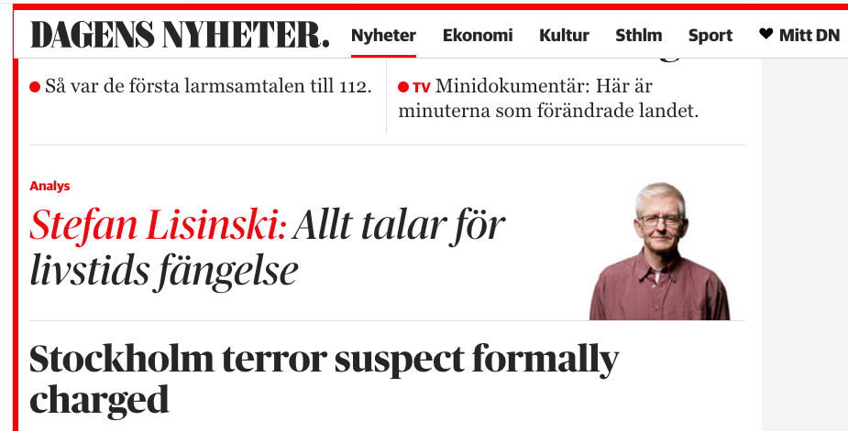

Findings:
The example uses a shape of “Latin Small Letter F” (0066) that is identical to “Latin Small Letter F with Hook” (0192) in italic style. Example from a large, daily newspaper, in which all instances of “ƒ” are just italic variants of “f”.

Conclusions:
These two Code Points should be treated as variants

[TBD: this “conclusion” does not agree with the formal specificaiton. The variant relation is not carried out in the XML (and perhaps not in all tables in this document? Not in Table 14 in Section 6.5) Make sure that either this statement is withdrawn or the variant definition is actually added.]
[MT: to be addresed in the next version of the report]

D.1.2 Latin Small Letter A vs. Latin Small Letter Alpha

Code Points Considered:

Code Points | Glyph |  | Name
0061 |  | a |  | Latin Small Letter A
0251 |  | ɑ |  | Latin Small Letter Alpha

Findings:
Latin Small Letter Alpha is not in the Repertoire

D.1.3 Latin Small Letter Z vs. Latin Small Letter Ezh

Code Points Considered:

Code Points | Glyph | Name
007A | Z | Latin Small Letter Z
0292 | ʒ | Latin Small Letter Ezh

Sequence zʒ (007A 0292) compared using Google Fonts in https://wordmark.it/:
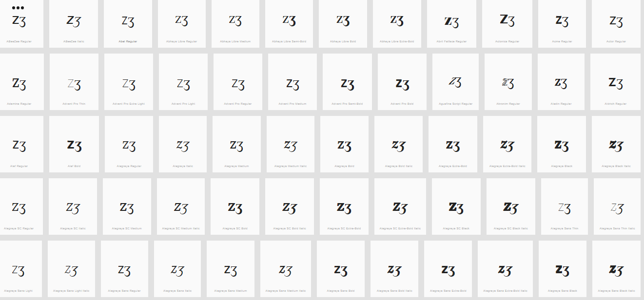

Findings:
Glyphs are distinguishable. In a large number of fonts, the two letters are consistently different.

D.1.4 Latin Small Letter V with Hook vs. Latin Small Letter V

Code Points Considered:

Code Points | Glyph | Name
028B | ʋ | Latin Small Letter V with Hook
0076 | v | Latin Small Letter V

Sequence ʋv (028B 0067) compared using Google Fonts in https://wordmark.it/ :

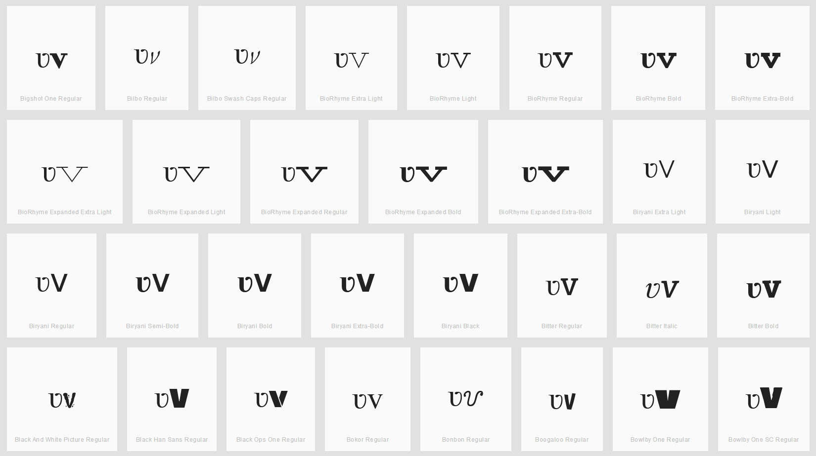

Findings:
All cases I viewed on wordmark.it looked more or less similar to the above screenshot. In particular the ʋ looks more like a u than a v at the bottom in the sense that it never has a sharp angle, but always a curve (whereas v has almost always a sharp angle). Furthermore, the top right corner of the ʋ is always turned visibly to the left. Even in cases where the v has some serif this is distinguishable from the ʋ hook as the serif is always in both directions (left and right).

D.1.5 Latin Small Letter I vs. Latin Small Letter Dotless I vs. Latin Small Letter Iota

Hypothesis:
Latin Small Letters I, Dotless I and Iota may be considered equivalent by readers and writers, since the dot of the I is frequently omitted in hand-writing, and since the shape of Iota is a typical style of writing the shape of the I.

Code Points Considered:

Code Points | Glyph | Name
0069 | i | Latin Small Letter I
0131 | ı | Latin Small Letter Dotless I
0269 | ɩ | Latin Small Letter Iota

Sequence iıɩ ( 0069 0131 0269) compared using Google Fonts in https://wordmark.it/ :

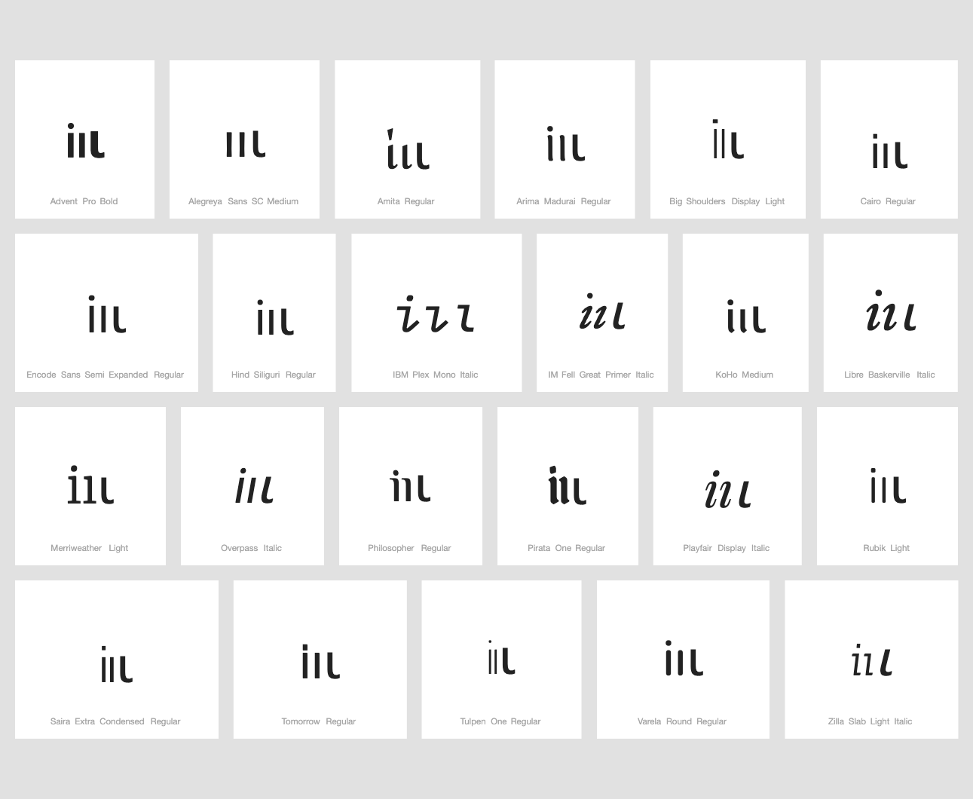

Findings:
Glyphs are distinguishable when written in lower case.

Sequence ıɩ (0131 0269) compared using Google Fonts in https://wordmark.it/

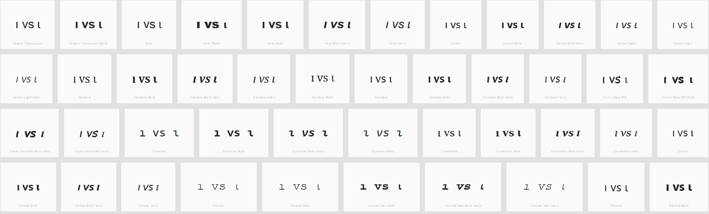

Findings:
In the italic versions of any of the serif fonts (e.g. Times New Roman or Consolas) these are identical.

D.1.6 Latin Small Letter E vs. Latin Small Letter Open E

Hypothesis:
Latin Small Letter E and Latin Small Letter Open E may be considered equivalent by readers and writers, since Open E is a typical shape in writing e in word-initial positions.

Code Points Considered:

Code Points | Glyph | Name
0065 | e | Latin Small Letter E
025B | ɛ | Latin Small Letter Open E

Glyph Representations per https://wordmark.it/:
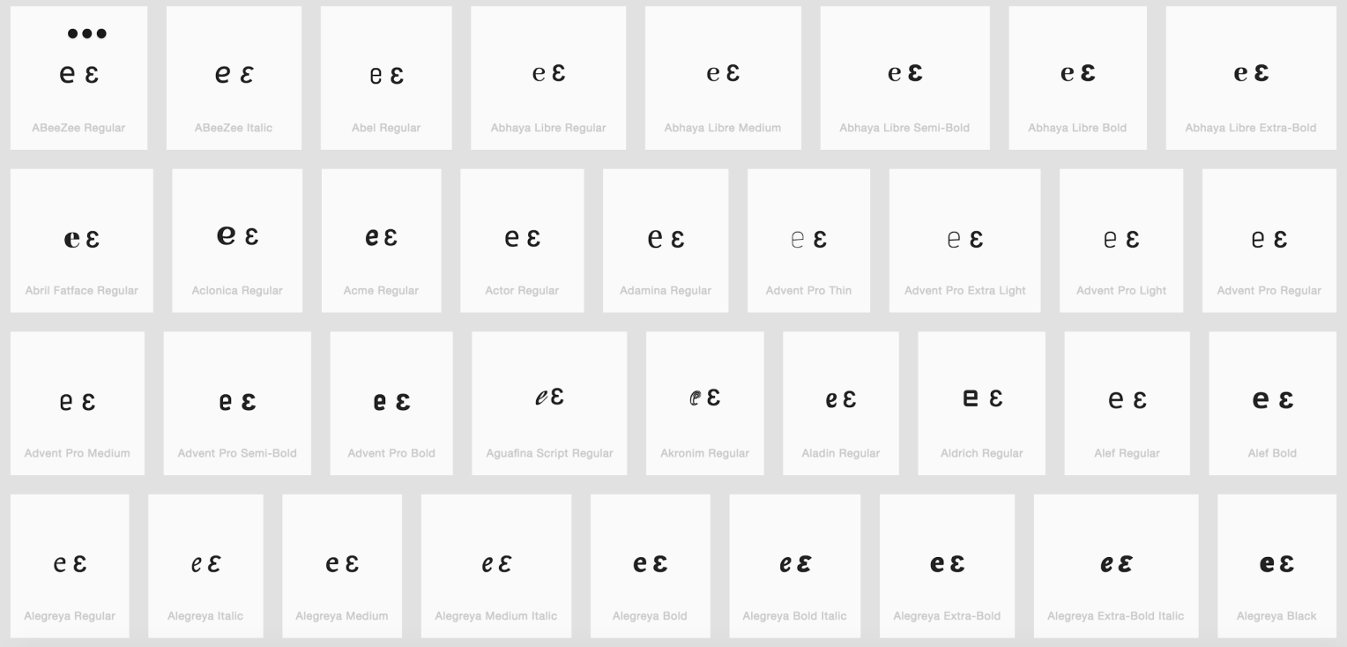

Findings:
Glyphs are distinguishable. In a large number of fonts, the two letters are consistently different.

D.1.7 Latin Small Letter K vs. Latin Small Letter K with Hook

Hypothesis:
Latin Small Letter K and Latin Small Letter K with Hook may be considered equivalent by readers and writers, since the extended hook is a frequent variation encountered in hand-writing.

Code Points Considered:

Code Points | Glyph | Name
006B | k | Letter K
0199 | ƙ | Letter K with Hook

Sequence K (006B) and K with Hook: ƙ (0199) compared using Google Fonts in https://wordmark.it/:
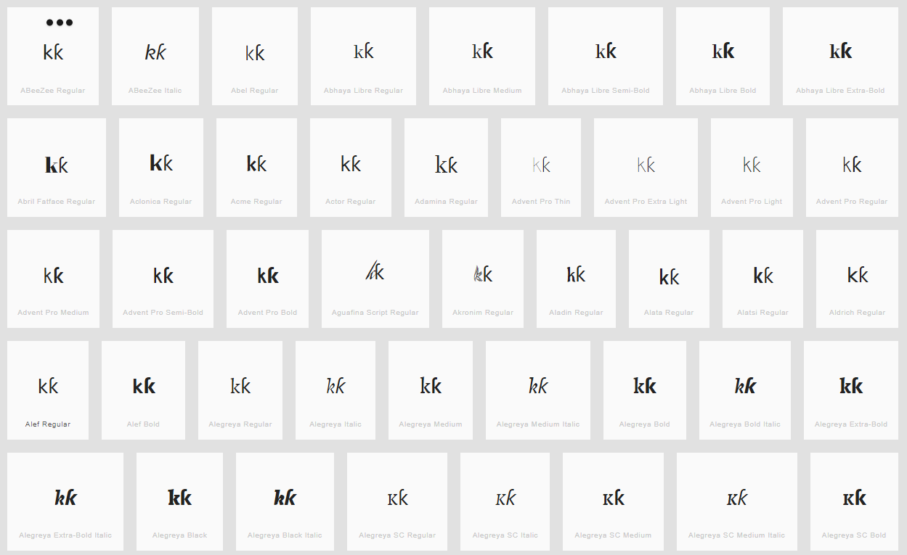

Findings:
Variant – indistinguishable in some fonts

D.1.8 Latin Small Letter Y vs. Latin Small Letter Y with Hook

Hypothesis:
Latin Small Letter Y and Latin Small Letter Y with Hook may be considered equivalent by readers and writers, since the extended hook is a frequent variation encountered in hand-writing.

Code Points Considered:

Code Points | Glyph | Name
01B4 | ƴ | Latin Small Letter Y with Hook
0079 | y | Latin Small Letter Y

Sequence yyƴy (0079 + 0079 + 01B4 + 0079) compared using Google Fonts in https://wordmark.it/:

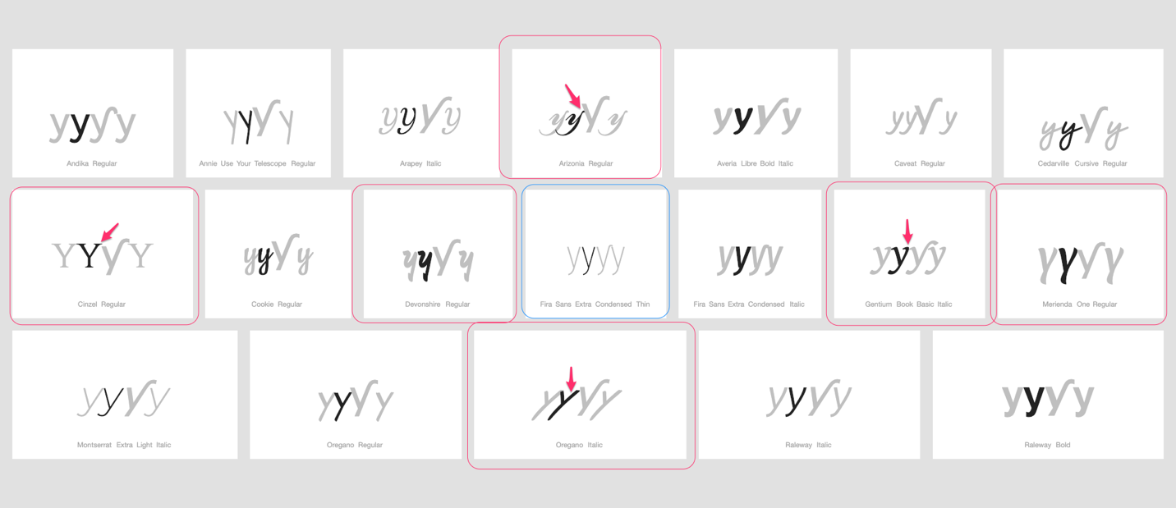

Findings:
As expected, there is a large degree in variation in the rendering of the glyphs of 0079.
Two essential differences between 01B4 and 0079 are recognized. 01B4 tends to be tilted or italicized and the key difference is the extended diagonal line turning into a right hand side hook.
As demonstrated by the examples, a number of fonts show a similar tilting, not only in italic fonts, as well as an extension of lines.

However, no example was found where the right hand-side line is extended right-wards (but only left-wards - generally also in cursive handwriting the letter doesn’t connect right-wards at the top to following letter), and only one font (highlighted in blue) was shown where the two renderings are visually (nearly) identical.

Conclusions:
Since the two code-points are different in a large number of fonts (albeit inconsistently) no variant pair is warranted in this case.

D.1.9 Latin Small Letter D with Caron vs. Latin Small Letter D with Hook

Hypothesis:
Latin Small Letter D and Latin Small Letter D with Hook may be considered equivalent by readers and writers, since the extended hook may be another style of writing the Caron in cursive hand-writing. Additionally, the Caron may become indistinguishable from an apostrophe.

Code Points Considered:

Code Points | Glyph | Name
010F | ď | Letter D with Caron
0257 | ɗ | Letter D with Hook
02BC | ʼ | Modifier Letter Apostrophe
0064 | d | Latin Small Letter D
006C | l | Latin Small Letter L
013E | ľ | Latin Small Letter L With Caron

Sequence (ɗďdʼ) (0257 010F 0064 02BC) compared using Google Fonts in https://wordmark.it/:
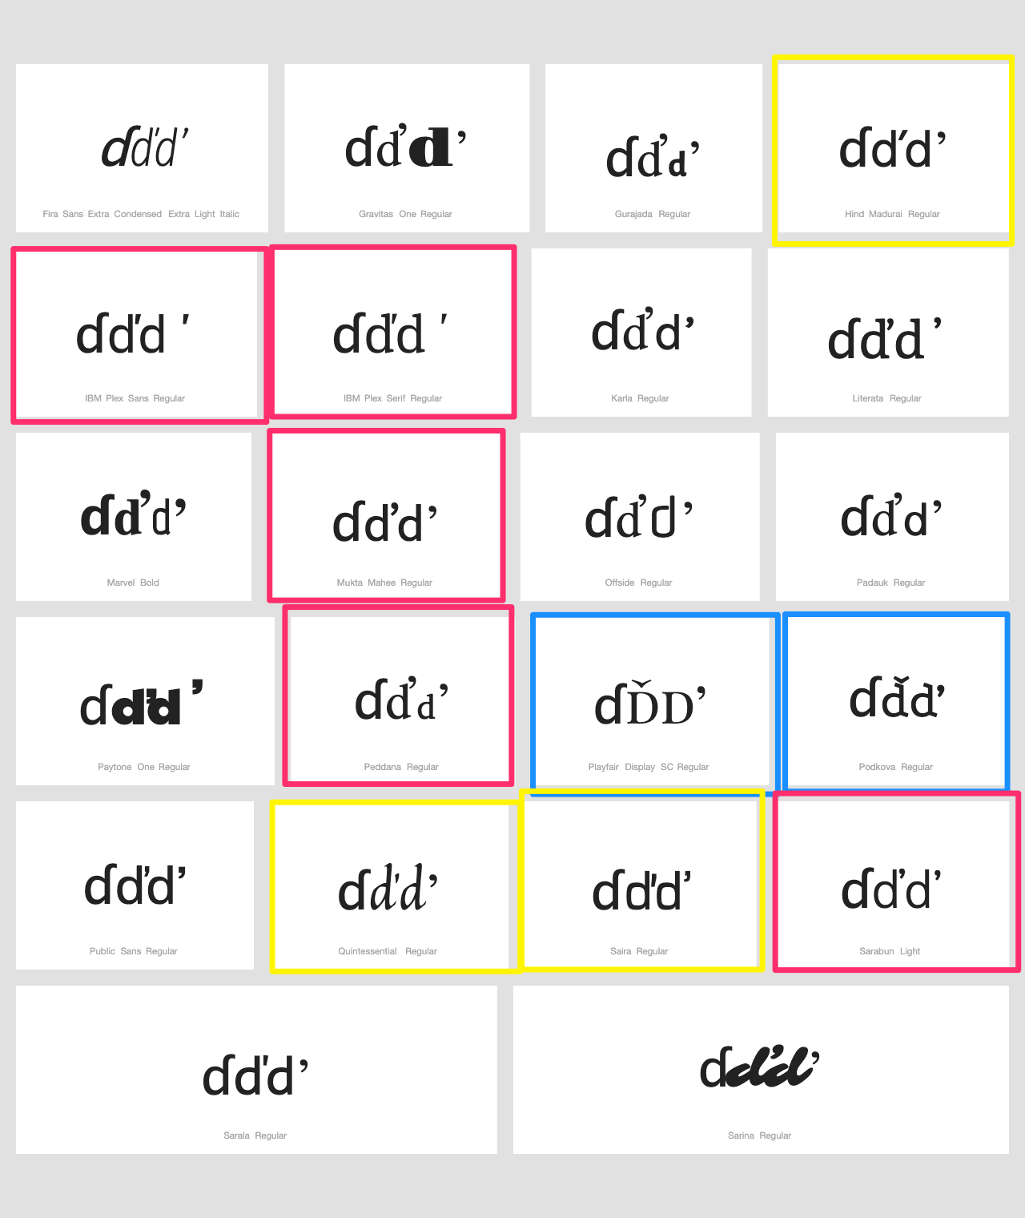

Sequence (l'ľ) (006C 02BC 013E) compared using Google Fonts in https://wordmark.it/:
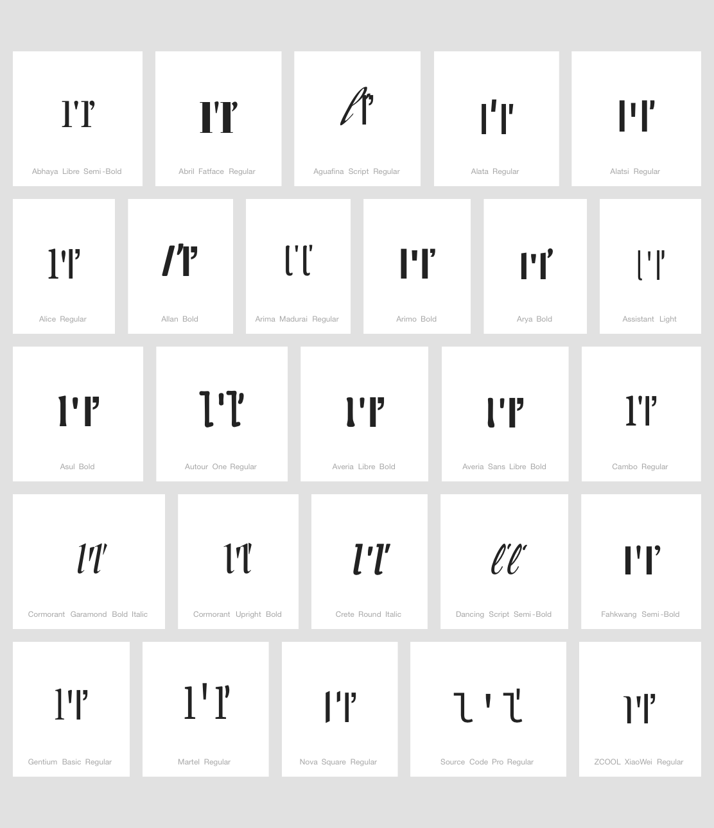
Findings:
While the differences between 0257 and 010F seem rather stable, this is not the case for 010F vs 0064 + 02BC as well as 006C + 02BC vs 013E. While a number of fonts (highlighted in yellow) do retain a difference in the shape of the modifier in between the caron and the apostrophe, however these differences are commonly considered inter-changeable in handwriting, which may impact the way readers perceive these. In very few fonts the caron retains the shape of a modifier above the letter (highlighted in blue), however in a significant number of fonts (red) the shape of the two modifiers is identical, sometimes with slight differences in spacing, but sometimes not. Accordingly, 010F vs 0064 + 02BC as well as 006C + 02BC vs 013E are indistinguishable in a significant number of fonts and homogylphs in a minority of fonts.

Conclusions:
010F vs 0064 + 02BC as well as 006C + 02BC vs 013E should be in a variant relationship since they are indistinguishable in a number of fonts. Since punctuation marks and look-alikes must be excluded from the zone however, 010F as well as should be excluded.

D.1.10 Latin Small Letter T vs. Latin Small Letter L with Stroke

Hypothesis:
Latin Small Letter T and Latin Small Letter L with Stroke may become confusable in casual hand-writing, italic fonts or fonts which do not slant the stroke of the l.

Code Points Considered:

Code Points | Glyph | Name
0074 | t | Latin Small Letter T
0142 | ł | Latin Small Letter L with Stroke

Sequence (t ł) (0074 0142) compared using Google Fonts in https://wordmark.it/:

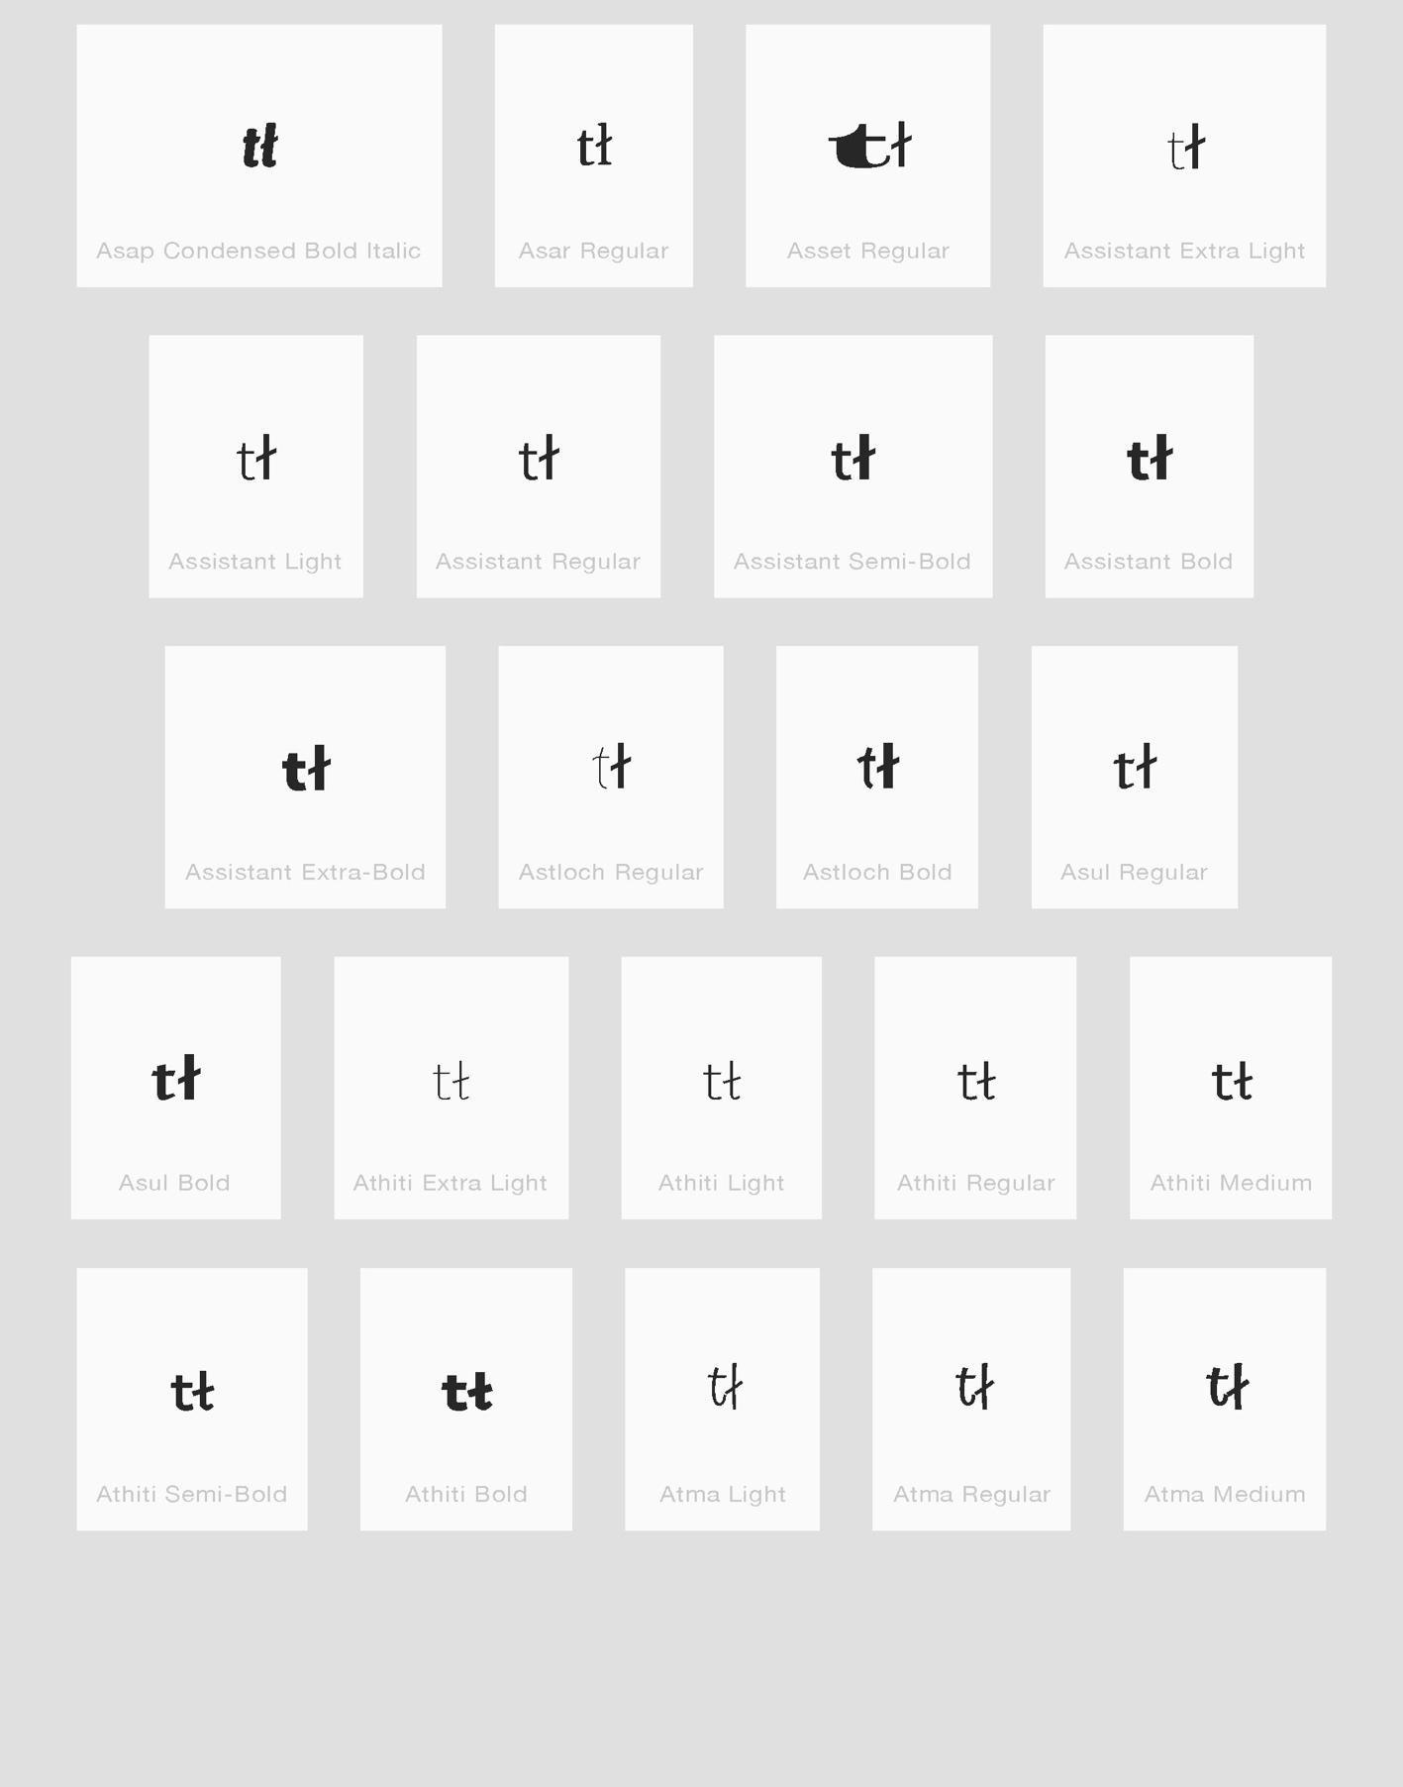

Findings:
Glyphs are distinguishable

D.1.11 Latin Small Letter J vs. Latin Small Letter I with Ogonek

Hypothesis:
Latin Small Letter J and Latin Small Letter I with Ogonek may become confusable in some font designs, since the ogonek may be mistaken for the extension of the j-shape below the baseline for less careful readers.

Code Points Considered:

Code Points | Glyph | Name
006A | j | Latin Small Letter J
012F | į | Latin Small Letter I with Ogonek

Sequence jį (006A 012F) compared using Google Fonts in https://wordmark.it/:
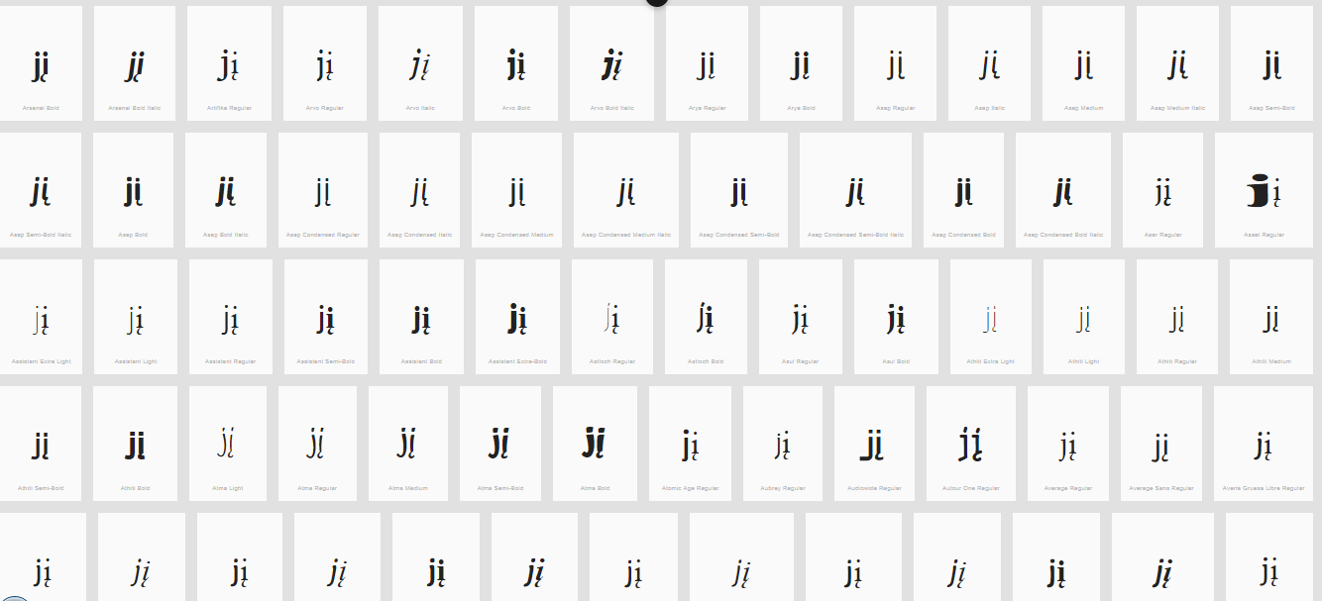

Findings:
Glyphs are distinguishable
In a large number of fonts, the two letters are consistently different.

D.1.12 Latin Small Letter B vs. Latin Small Letter Thorn vs. Latin Small Letter P

Hypothesis:
Latin Small Letter Thorn may become nearly identical to either Latin Small Letter B or Latin Small Letter P depending on font designs, context, and reader since the former is essentially an overlay of the latter two shapes and serifs may appear in either of the extensions of the round shape above and below the baseline.

Code Points Considered:

Code Points | Glyph | Name
025B00FE | ɛþ | Latin Small Letter Open E Thorn
00620065 | eb | Latin Small Letter EB
0070 | p | Latin Small Letter P

Sequence þb (00FE 0062) compared using Google Fonts in https://wordmark.it/ :
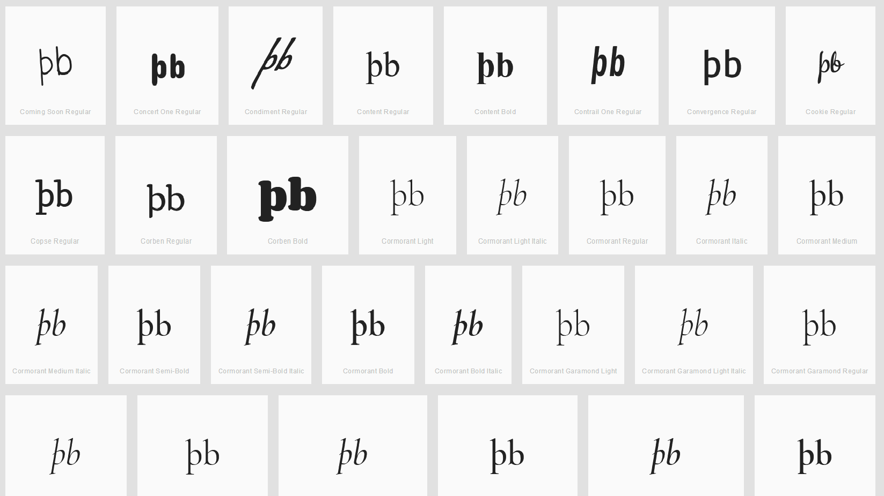

Findings:
All cases on wordmark.it looked similar to the above screenshot. The þ and b always appear quite distinguishable as the þ always has a stroke below the base line and the b never crosses the baseline.

Sequence (p þ) (0070 00FE) compared using Google Fonts in https://wordmark.it/:
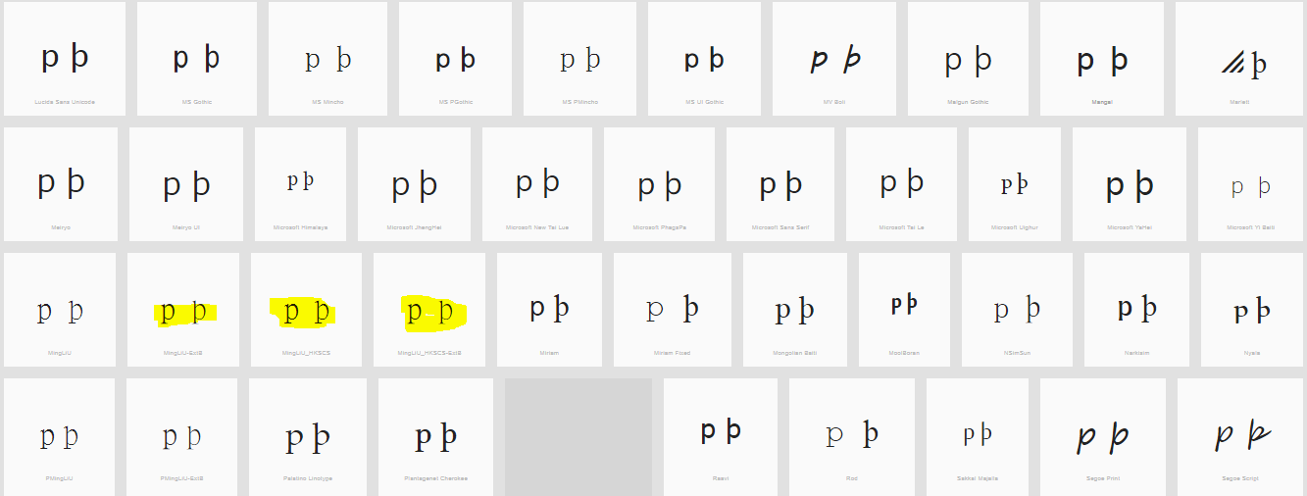
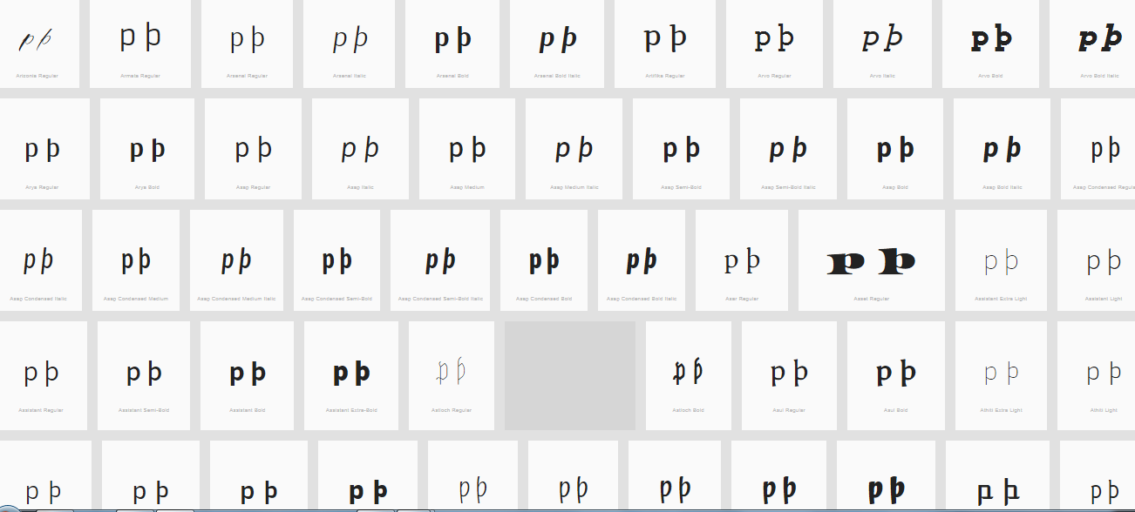

Findings:
The upper leg of the Thorn is visible in most fonts (except those highlighted) can be somewhat unclear.

D.1.13 Latin Small Letter B vs. Latin Small Letter Thorn vs. Latin Small Letter P

Code Points Considered:

Code Points | Glyph | Name
00FE | þ | Latin Small Letter Thorn
0062 | b | Latin Small Letter B
0070 | p | Latin Small Letter P

Sequence þb (00FE 0062) compared using Google Fonts in https://wordmark.it/ :

Findings:
All cases I viewed on wordmark.it looked similar to the above screenshot. The þ and b always appear quite distinguishable as the þ always has a stroke below the base line and the b never crosses the base line.

Sequence (p þ) (0070 00FE) compared using Google Fonts in https://wordmark.it/:

Findings:
The upper leg of the Thorn is visible in most fonts (except those highlighted) can be somewhat unclear.

D.1.14 Letter Eth Versus Letter D with Stroke

Hypothesis:
Letter Eth and Letter D with Stroke may become nearly identical depending on font designs, context, and reader since the former is essentially the same shape as the latter in a cursive or italic style.

Code Points Considered:

Code Points | Glyph | Name
00F0 | ð | Latin Small Letter Eth
0111 | đ | Latin Small Letter D with Stroke

Sequence (ðđ) (00F0 0111) compared using Google Fonts in https://wordmark.it/:

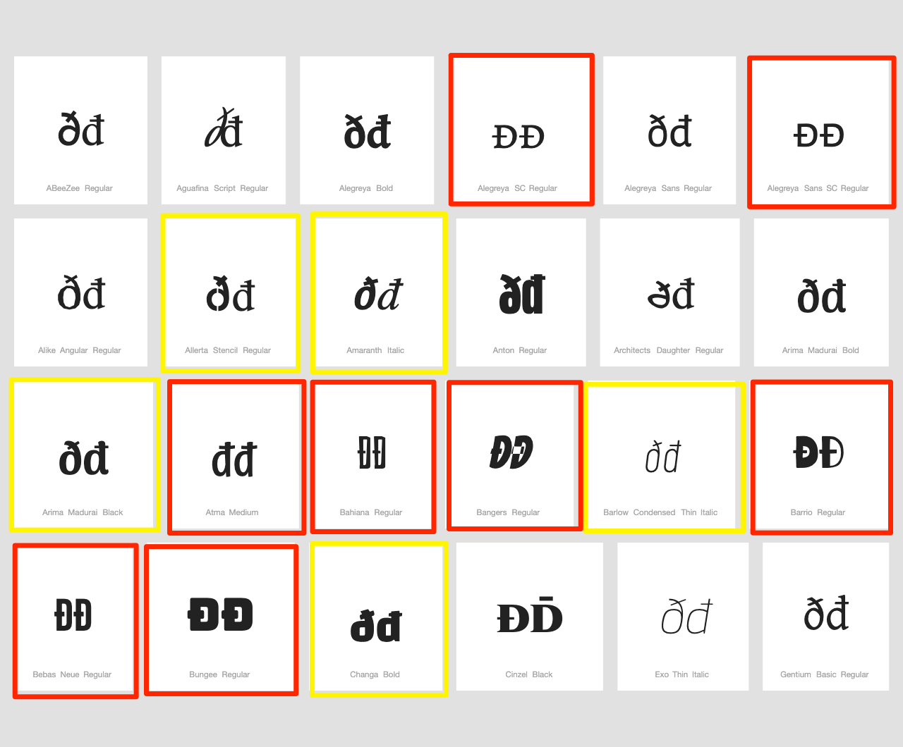

Findings:
The two letters are distinguishable in a majority of fonts. In italic or bold fonts, they may become difficult to distinguish (highlighted in yellow), while in few fonts they are represented identically (highlighted in red). A minority of fonts represents both codepoints in uppercase forms, in which they are homoglyphs (highlighted in red).

Conclusions:
The characters should be suggested to be highlighted in the string-similarity check, since they may be confusingly similar or even homoglyphs in a minority of fonts.

D.1.15 Latin Small Letter Schwa vs. Latin Small Letter Turned E

Hypothesis:

Code Points Considered:
Code Points | Glyph | Name
0259 | ə | Latin Small Letter Schwa
01DD | ǝ | Latin Small Letter Turned E

Sequence əǝ (0259 01DD) compared using Google Fonts in https://wordmark.it/:
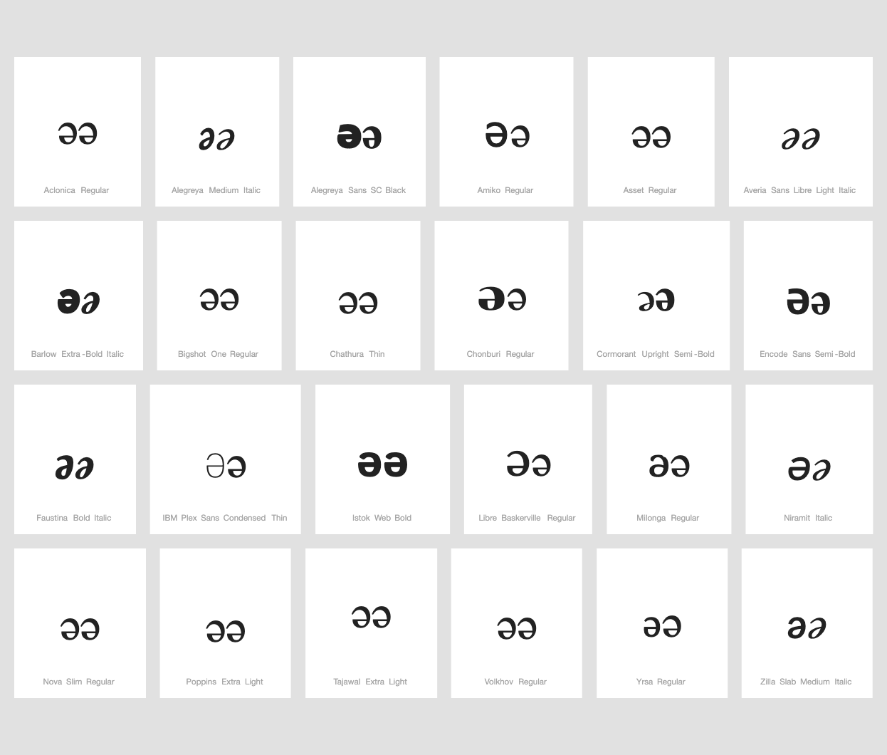

Findings: Shapes of code points are mostly identical. In some font shapes of code points are different in size but there is no possibility to now which shape corresponds to which code point.

Conclusions: These two code points are variants

D.2 Spacing of Base Characters

D.2.1 Latin Small Ligature Æ vs. Sequence AE

Code Points Considered:

Code Points | Glyph | Name
00E6 | æ | Latin Small Letter Æ
0061 | a | Latin Small Letter A
0065 | e | Latin Small Letter E
0153 | œ | Latin Small Ligature Œ
0251 | ɑ | Latin Small Letter Alpha

Sequence æae (00E6 + 0061 + 0065) compared using Google Fonts in https://wordmark.it/:
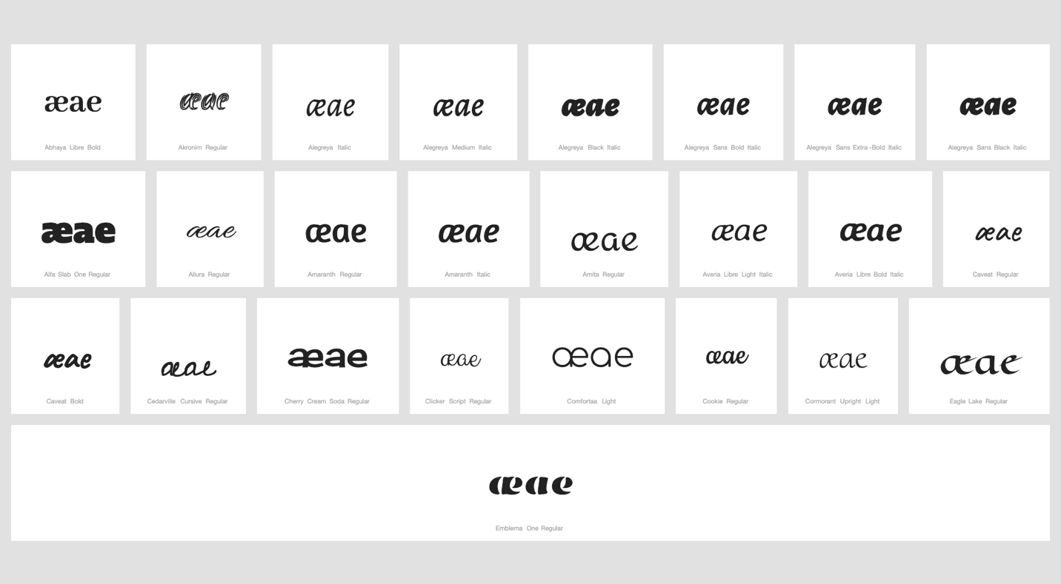

Findings:
In some fonts, in which the a-glyph takes a shape similar to that of 0251 ɑ Latin Small Letter Alpha, the ligature and the sequence bare some similarity but are distinguishable.
In a large number of fonts, the ligature and the sequence are consistently different.

Additional Findings:
In fonts, in which the a-glyph takes a shape similar to that of 0251 ɑ Latin Small Letter Alpha, the ligature 00E6 becomes nearly visually identical with the o-e ligature (0153 œ Latin Small Ligature Oe) as demonstrated below.

Sequence æaeœoe (00E6+0061+0065+0153+006F+0065) compared using Google Fonts in https://wordmark.it/: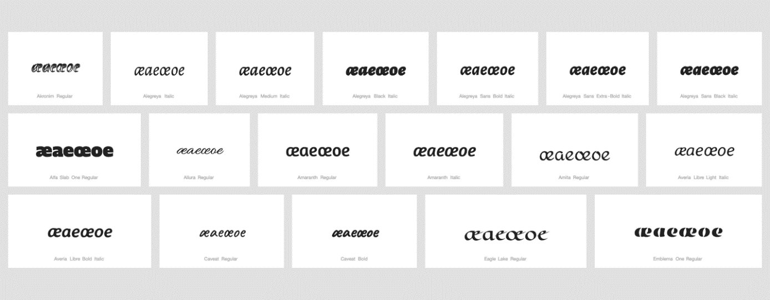
Conclusion:
Suggestion to consider 00E6 Latin Small Letter Æ and 0153 Latin Small Ligature Œ as variant pair or add to the string similarity list on the grounds of them being visually nearly identical and being similar on non-visual grounds because of conceptional identity of 0251 Latin Small Letter Alpha (“ɑ“) and 0061 Latin Small Letter A (“a“) in a significant number of fonts.

D.2.2 Latin Small Ligature Œ vs. Sequence OE

Code Points Considered:

Code Point | Glyph | Name
0065 | e | Latin Small Letter E
006F | o | Latin Small Letter O
0153 | œ | Latin Small Ligature Œ

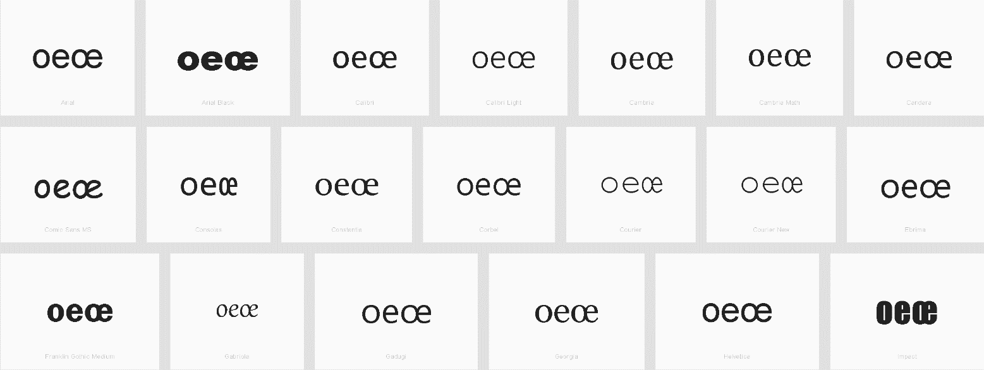

Findings:

In a large number of fonts, the sequence and the ligature are consistently different.

D.2.3 Sequence of Two Letter V with Hook vs. Latin Small Letter W
Code Points Considered:
Code Points | Glyph | Name
028B 028B | ʋʋ | Latin Small Letter V with Hook (x2)
0077 | w | Latin Small Letter W

Sequence ʋʋ w (028B028B 0077) compared using Google Fonts in https://wordmark.it/:
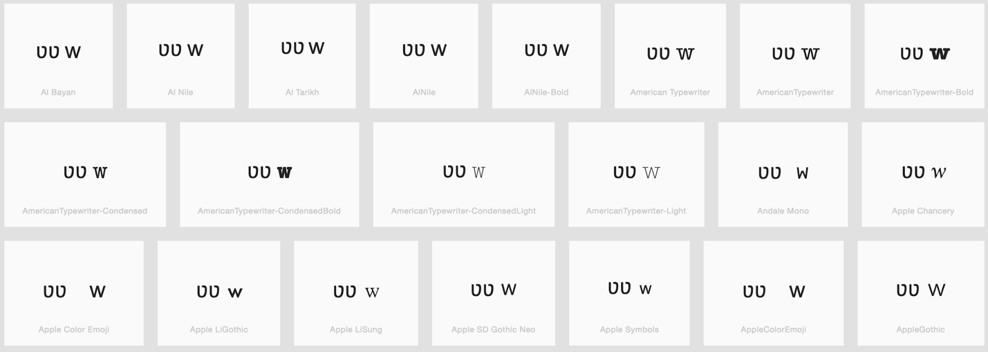
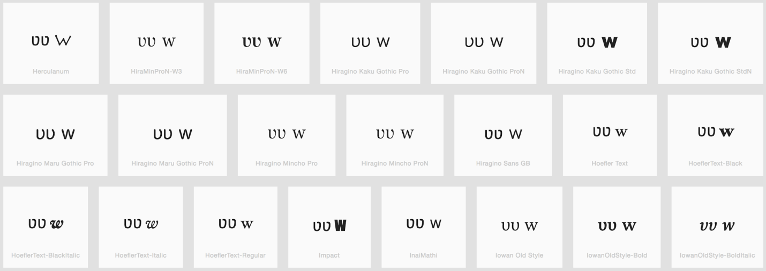
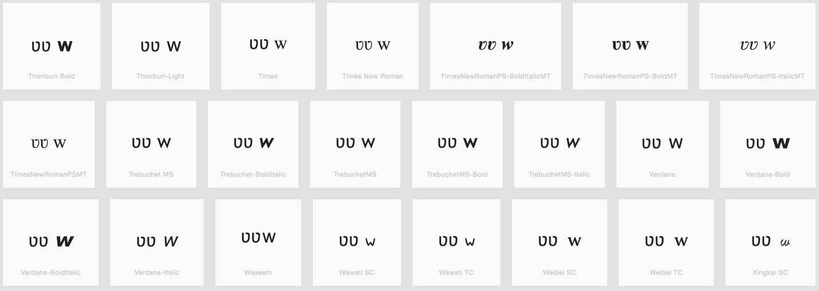

Findings:
Sequence of two Letters V with Hook is different than Letter W

D.3 Shape of Diacritics

D.3.1 Caron (Above) vs. Breve

Code Points Considered:

Code Points | Glyph | Name
0103 | ă | Latin Small Letter A with Breve
011F | ğ | Latin Small Letter G with Breve
016D | ŭ | Latin Small Letter U with Breve
010D | č | Latin Small Letter C with Caron
011B | ě | Latin Small Letter E with Caron
0148 | ň | Latin Small Letter N with Caron
0159 | ř | Latin Small Letter R with Caron
0161 | š | Latin Small Letter S with Caron
017E | ž | Latin Small Letter Z with Caron
01CE | ǎ | Latin Small Letter A with Caron
01D0 | ǐ | Latin Small Letter I with Caron
01D2 | ǒ | Latin Small Letter O with Caron
01D4 | ǔ | Latin Small Letter U with Caron
01E7 | ǧ | Latin Small Letter G with Caron
01E9 | ǩ | Latin Small Letter K with Caron
01EF | ǯ | Latin Small Letter Ezh with Caron

Sequence ăǎ (0103 01CE) compared using Google Fonts in https://wordmark.it/:
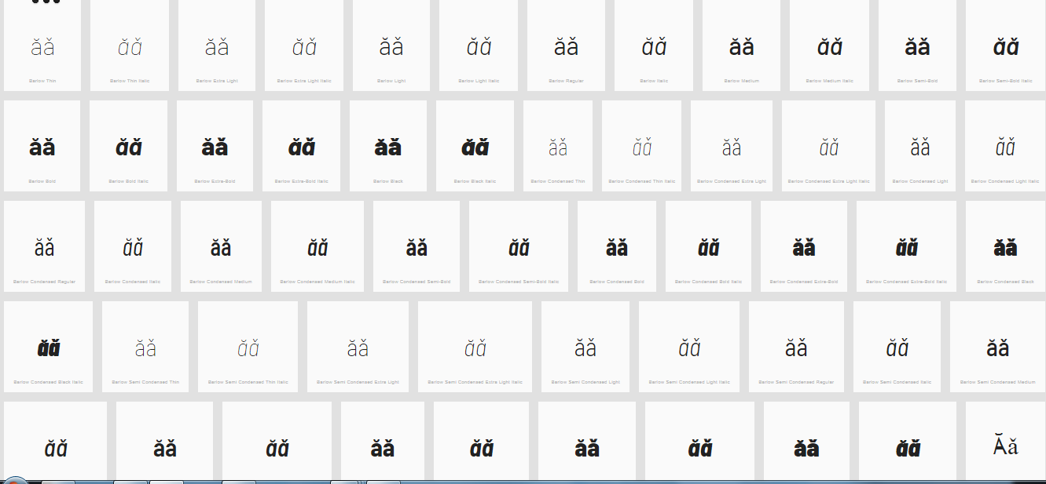
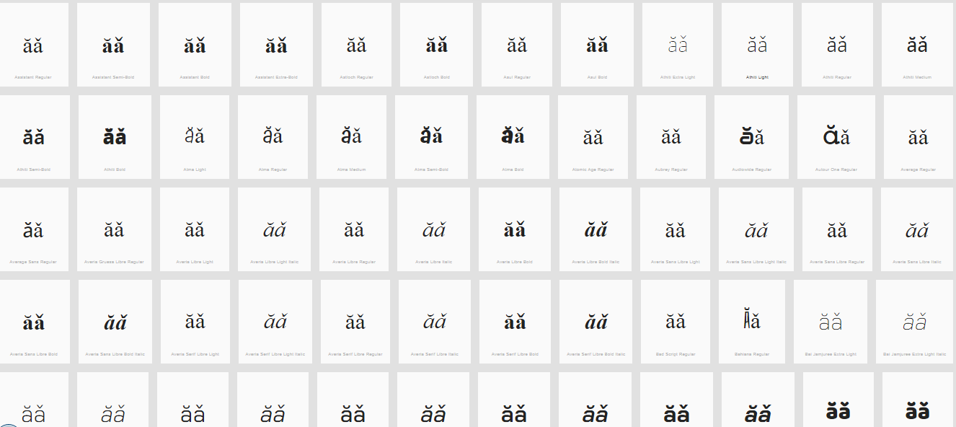

Sequence ğǧ (011F 01E7) compared using Google Fonts in https://wordmark.it/:
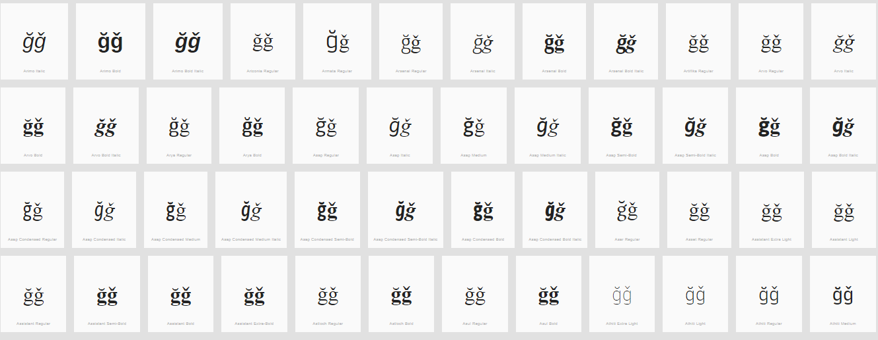
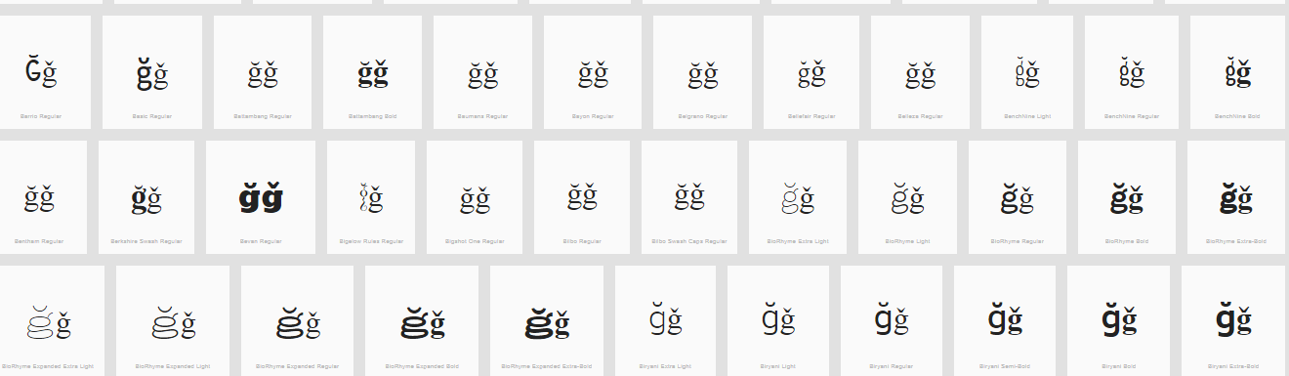

Sequence ŭ ǔ (016D 01D4) compared using Google Fonts in https://wordmark.it/:
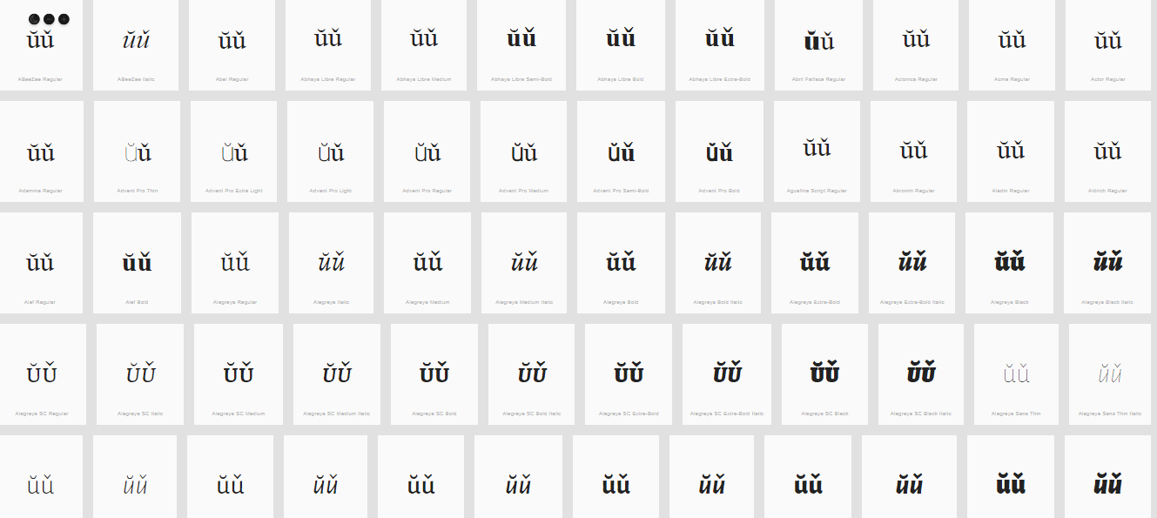
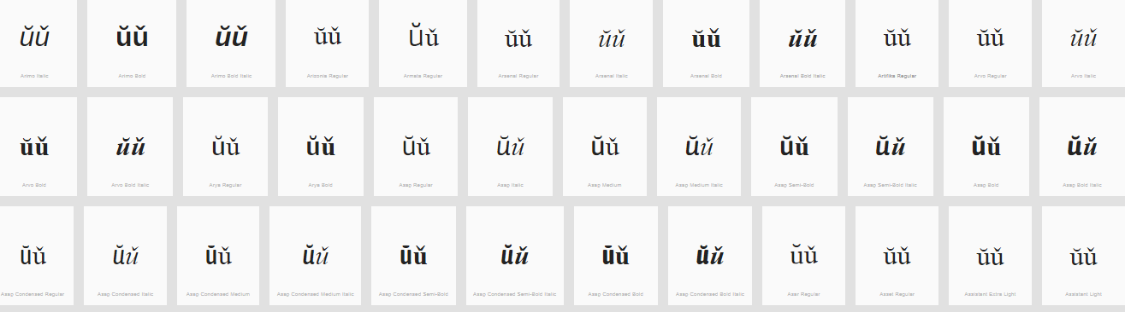

Findings:
The representations of the Breve and the Caron in Letters A, G and U are distinguishable and undistinguishable in a number of fonts (see pictures above); depending on the font and size.

D.3.2 Tilde vs. Macron (Above)

Code Points Considered:

Code Points | Glyph | Name
0067 + 0303 | g̃ | Latin Small Letter G + Combining Tilde
006E + 0304 | n̄ | Latin Small Letter N + Combining Macron
0072 + 0303 | r̃ | Latin Small Letter R with Tilde
00E3 | ã | Latin Small Letter A with Tilde
00F1 | ñ | Latin Small Letter N with Tilde
00F5 | õ | Latin Small Letter O with Tilde
0101 | ā | Latin Small Letter A with Macron
0113 | ē | Latin Small Letter E with Macron
0129 | ĩ | Latin Small Letter I with Tilde
012B | ī | Latin Small Letter I with Macron
014D | ō | Latin Small Letter O with Macron
0169 | ũ | Latin Small Letter U with Tilde
016B | ū | Latin Small Letter U with Macron
1E21 | ḡ | Latin Small Letter G + Macron
1EBD | ẽ | Latin Small Letter E with Tilde
1EF9 | ỹ | Latin Small Letter Y with Tilde

Sequence ãā (00E3 0101) compared using Google Fonts in https://wordmark.it/:
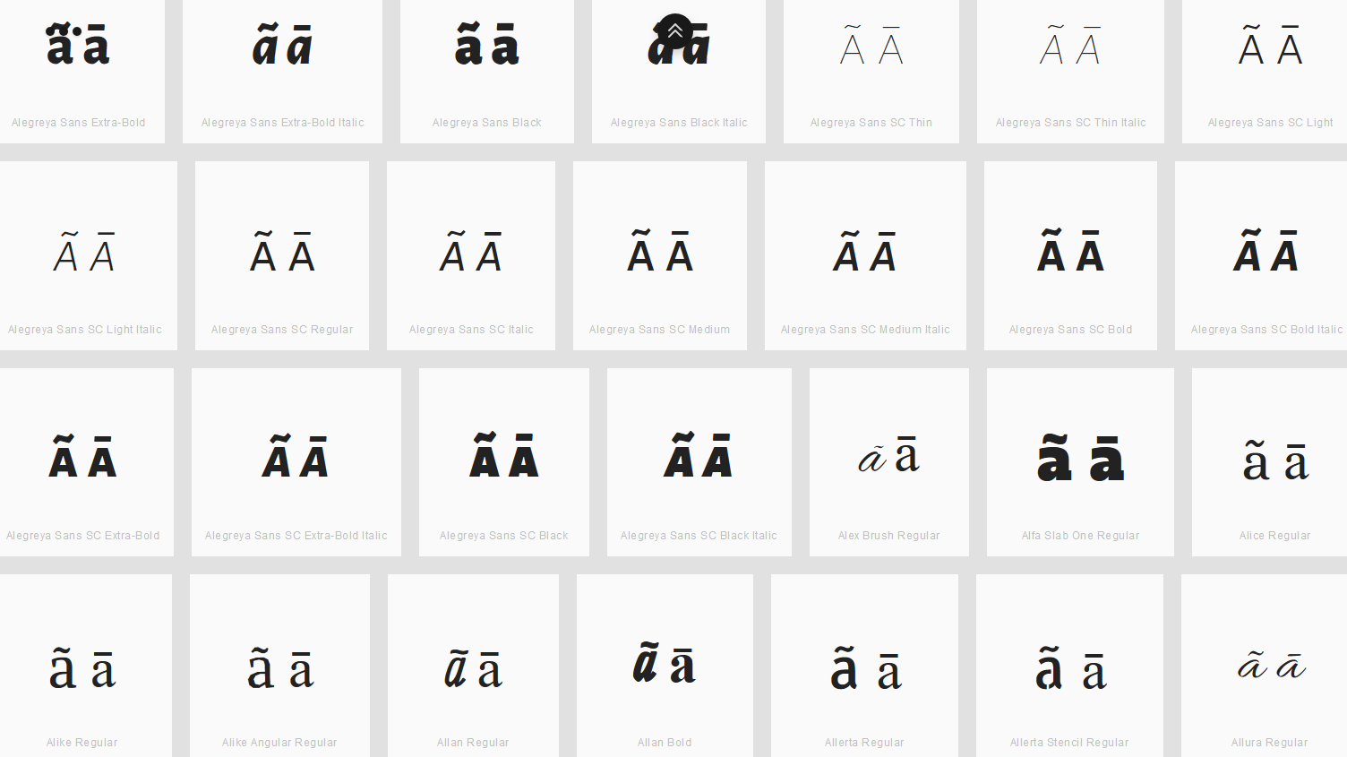

Findings:
Macron and Tilde are distinguishable for the viewed fonts.

Sequence ēẽ (0113 1EBD) compared using Google Fonts in https://wordmark.it/:
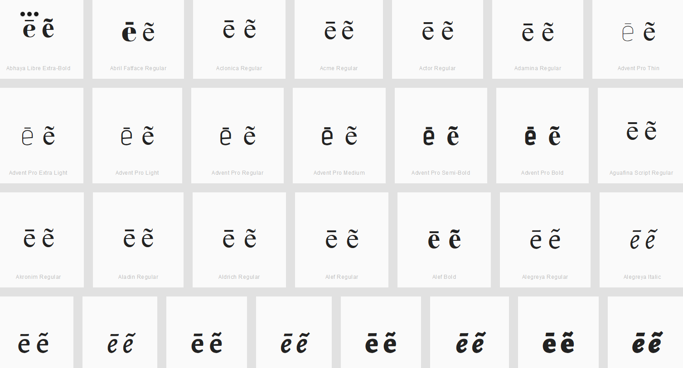

Findings:
Macron and Tilde are distinguishable for the viewed fonts.

Sequence g̃ḡ (0067+0303 1E21) compared using Google Fonts in https://wordmark.it/:
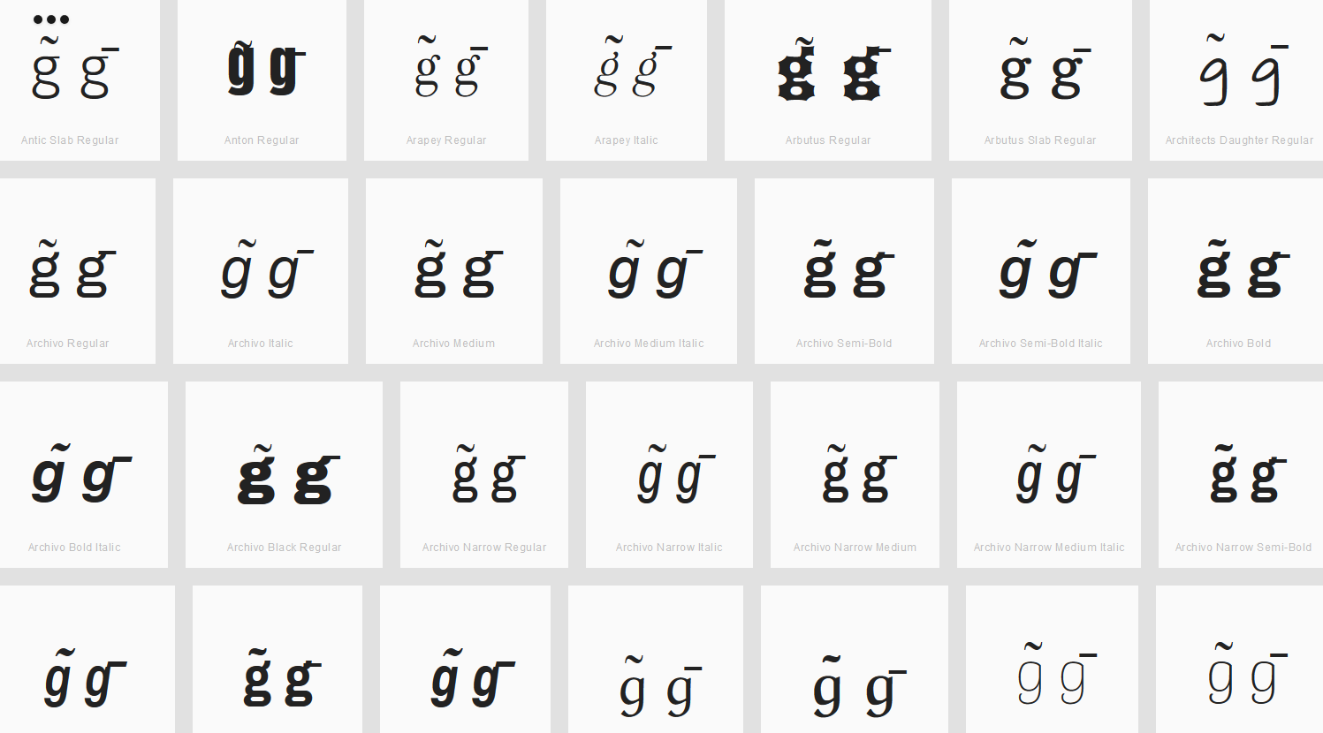

Findings:
Macron and Tilde are distinguishable for the viewed fonts.

Sequence ĩī (0129 012B) compared using Google Fonts in https://wordmark.it/:
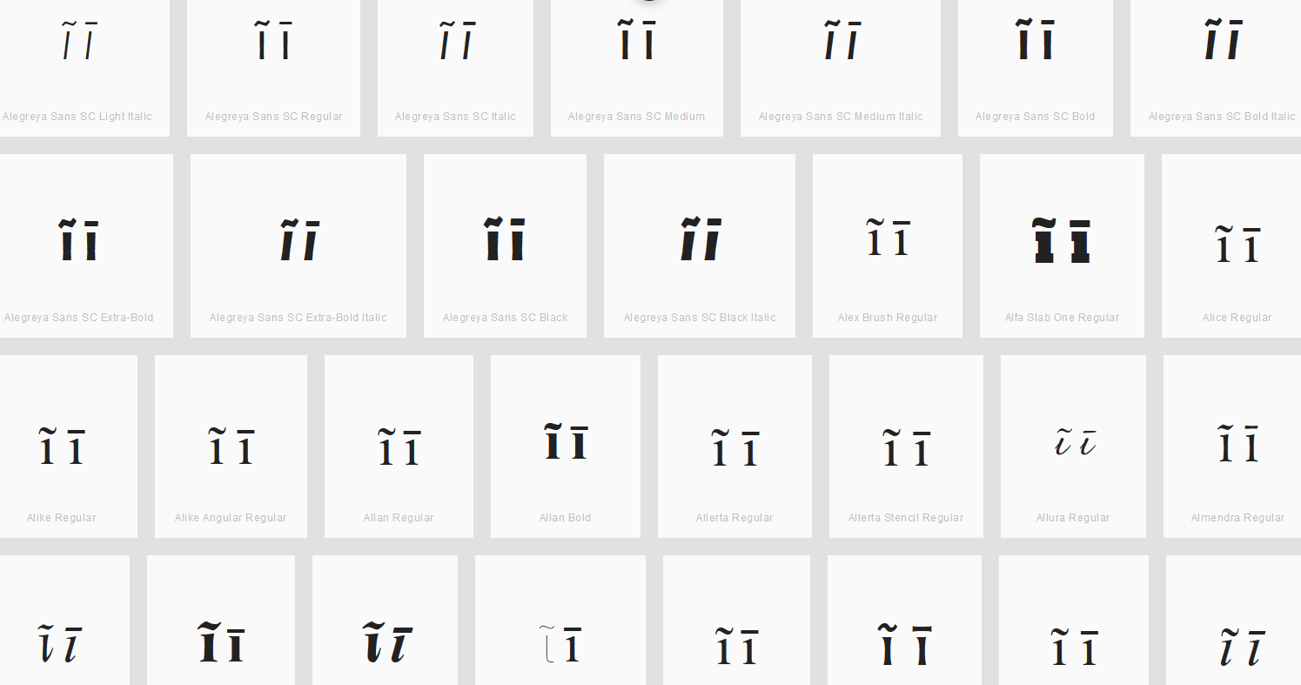

Findings:
Macron and Tilde are distinguishable for the viewed fonts.

Sequence n̄ñ (006E+0304 00F1) compared using Google Fonts in https://wordmark.it/:
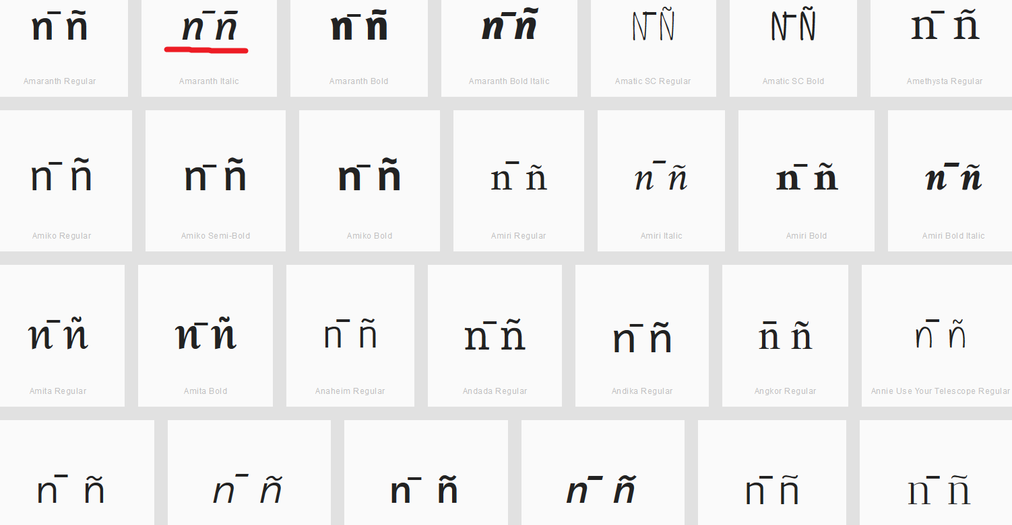

Findings:
Macron and Tilde are distinguishable for almost all viewed fonts. There are few examples where they are not. In the example below the second pair (marked red) is distinguishable, but only because the macron above is moved to the right.

Sequence õō (00F5 014D) compared using Google Fonts in https://wordmark.it/:
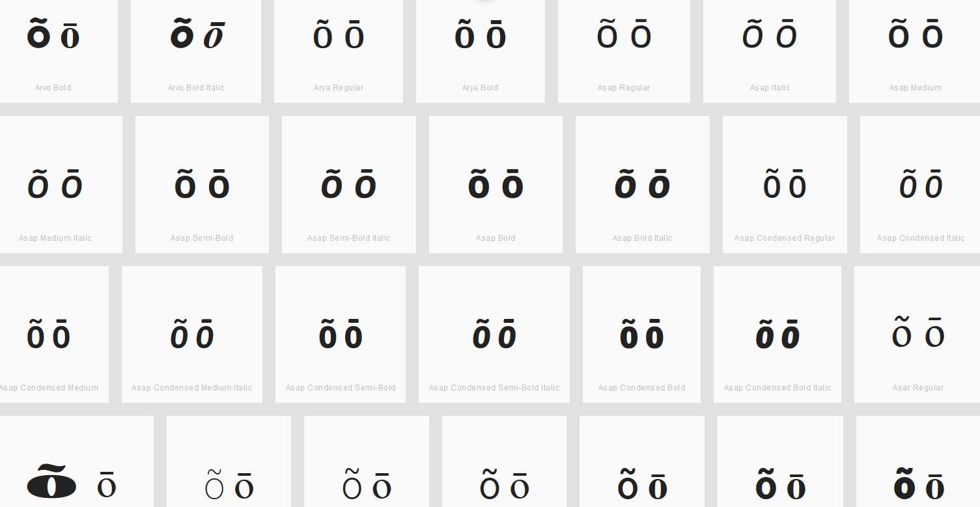

Findings:
Macron and Tilde are distinguishable for the viewed fonts.

Sequence ũū (0169 016B) compared using Google Fonts in https://wordmark.it/:
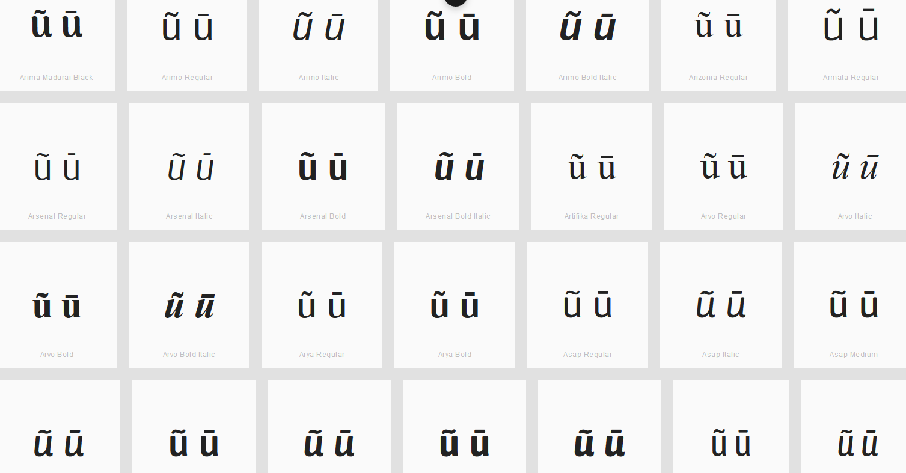

Findings:
Macron and Tilde are distinguishable for the viewed fonts.

D.3.3 Combining Cedilla (Below), Ogonek and Comma Below

Code Points Considered:

Code Points | Glyph | Name
006D 0327 | m̧ | Latin Small Letter M with Combining Cedilla
006F 0327 | o̧ | Latin Small Letter O with Combining Cedilla
00E7 | ç | Latin Small Letter C with Cedilla
0105 | ą | Latin Small Letter A with Ogonek
0119 | ę | Latin Small Letter E with Ogonek
012F | į | Latin Small Letter I with Ogonek
0137 | ķ | Latin Small Letter K with Cedilla
013C | ļ | Latin Small Letter L with Cedilla
0146 | ņ | Latin Small Letter N with Cedilla
015F | ş | Latin Small Letter S with Cedilla
0173 | ų | Latin Small Letter U with Ogonek
0219 | ș | Latin Small Letter S with Comma Below
021B | ț | Latin Small Letter T with Comma Below

Sequence şș (015F 0219) compared using Google Fonts in https://wordmark.it/:
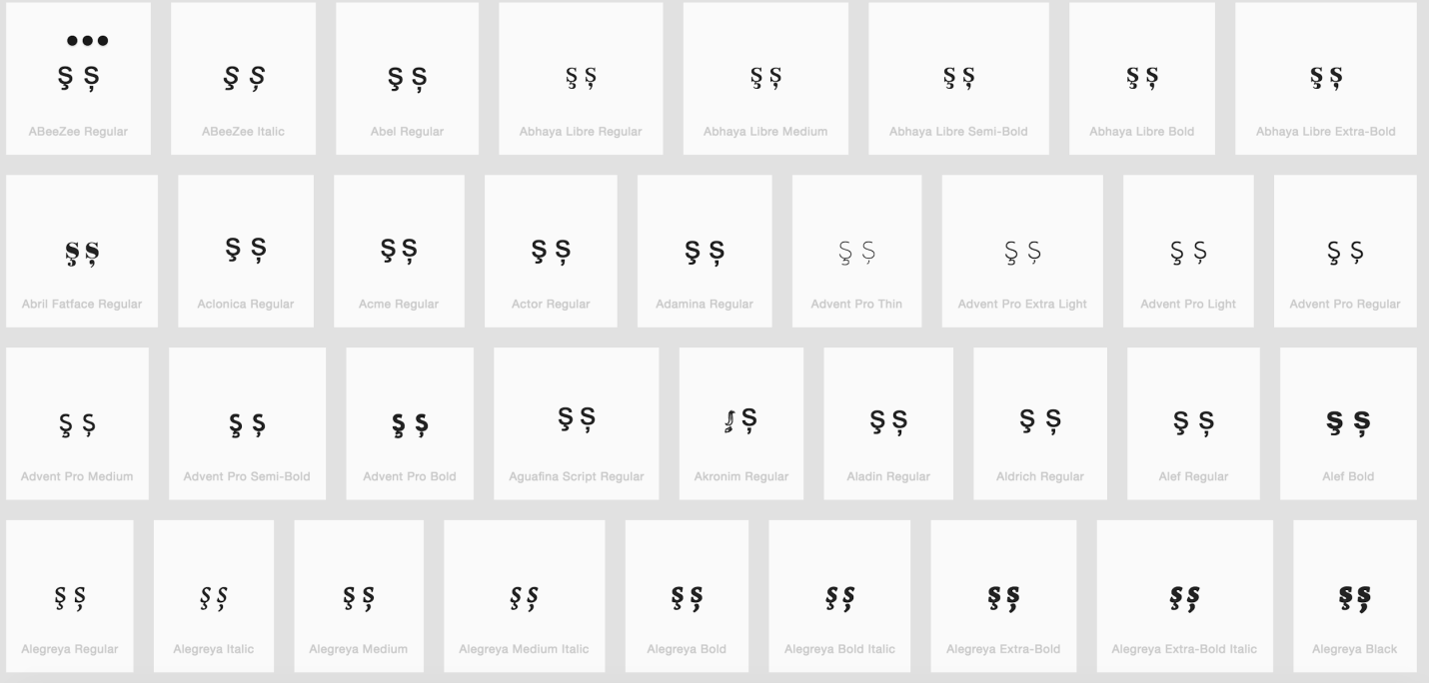
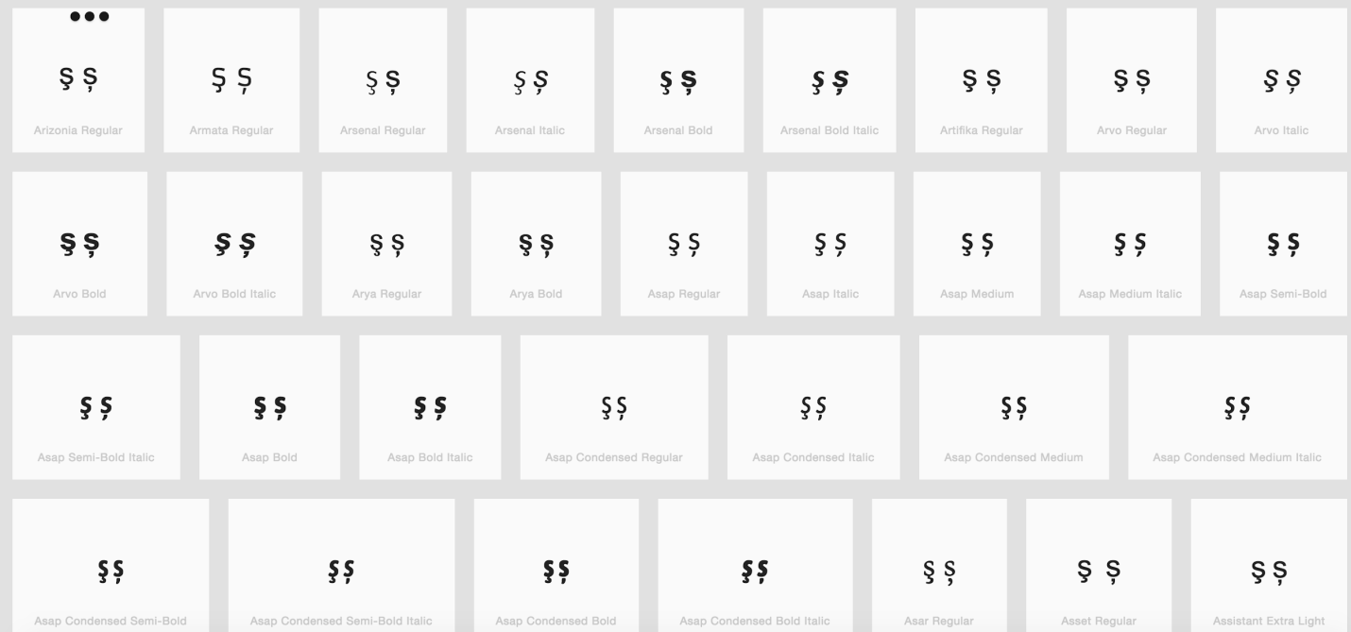

Findings:
The representations of the Cedilla and the Comma Below in Letter S are distinguishable in a number of fonts (see pictures above); in a large number of fonts, the two diacritics are consistently different. No other point base character (except for Letter S) uses two different diacritics (i.e., Letter M only exists with a Combining Cedilla, but not with Ogonek or Comma Below).

D.3.4 Ring Above vs. Dot Above

Hypothesis:
Ring above and Dot above may be considered the same by readers and writers since they are in free variation in handwriting.

Code Points Considered:

Code Points | Glyph | Name
00E5 | å | Latin Small Letter A with Ring Above
016F | ů | Latin Small Letter U with Ring Above
017C | ż | Latin Small Letter Z with Dot Above
010B | ċ | Latin Small Letter C with Dot Above
0117 | ė | Latin Small Letter E with Dot Above
0121 | ġ | Latin Small Letter G with Dot Above
1E45 | ṅ | Latin Small Letter N with Dot Above

Findings:
No eligible candidates.

D.3.5 Acute vs. Dot Above

Code Points Considered:

Code Points | Glyph | Name
0069 | I | Latin Small Letter I
00E1 | á | Latin Small Letter A with Acute
00E9 | é | Latin Small Letter E with Acute
00ED | í | Latin Small Letter I with Acute
00F3 | ó | Latin Small Letter O with Acute
00FA | ú | Latin Small Letter U with Acute
00FD | ý | Latin Small Letter Y with Acute
0107 | ć | Latin Small Letter C with Acute
013A | ĺ | Latin Small Letter L with Acute
0144 | ń | Latin Small Letter Latin Small Letter N with Acute
0155 | ŕ | Latin Small Letter R with Acute
015B | ś | Latin Small Letter S with Acute
017A | ź | Latin Small Letter Z with Acute
010B | ċ | Latin Small Letter C with Dot Above
0117 | ė | Latin Small Letter E with Dot Above
0121 | ġ | Latin Small Letter G with Dot Above
017C | ż | Latin Small Letter Z with Dot Above
1E45 | ṅ | Latin Small Letter N with Dot Above

Sequence ċć (010B+ 0107) compared using Google Fonts in https://wordmark.it/:
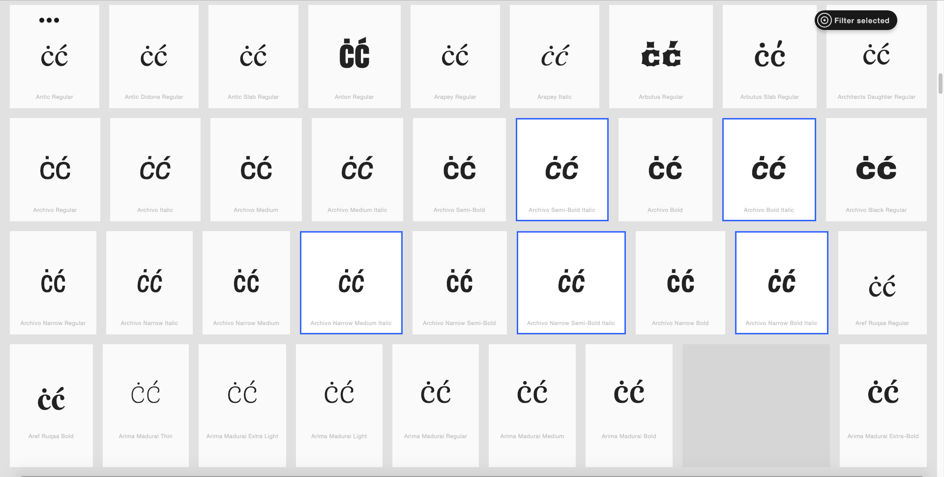

Sequence ėé (0117 + 00E9) compared using Google Fonts in https://wordmark.it/:
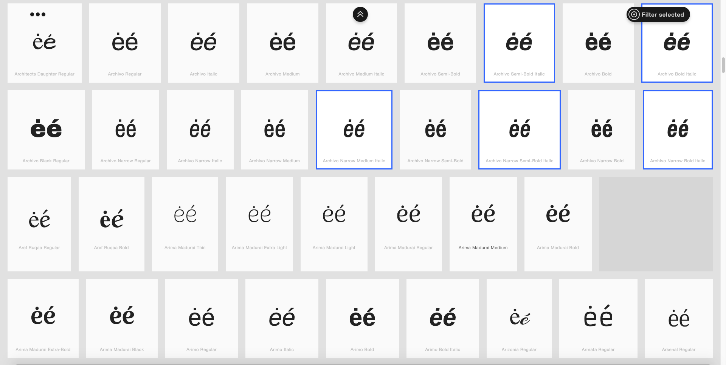

Sequence ṅń (1E45+ 0144) compared using Google Fonts in https://wordmark.it/:
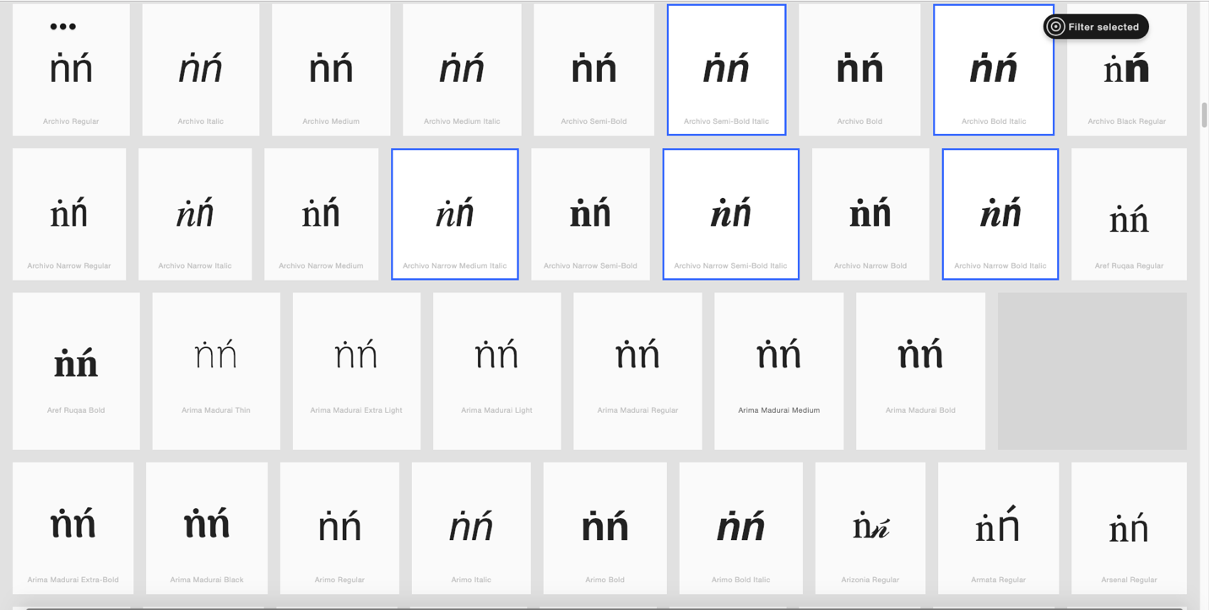

Sequence żź (017C+ 017A) compared using Google Fonts in https://wordmark.it/:
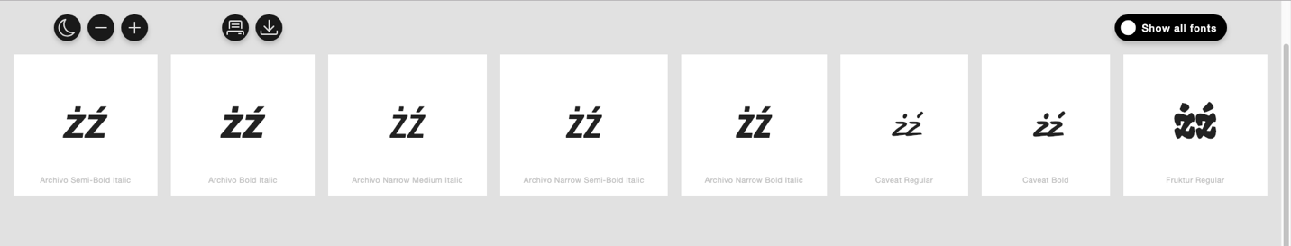

Findings:
ċć, ėé, ṅń, and żź were considered as potential variant pairs
The representations of the acute and the dot above in these pairs are distinguishable in a number of fonts. In a large number of fonts, the two diacritics are consistently different.

Conclusion:
No variant pairs are warranted.

D.3.6 Grave vs. Dot Above

Code Points Considered:

Code Points | Glyph | Name
00E8 | è | Latin Small Letter E with Grave
00EC | ì | Latin Small Letter Latin Small Letter I WITH GRAVE
00F2 | ò | Latin Small Letter O with Grave
00F9 | ù | Latin Small Letter U with Grave
1EF3 | ỳ | Latin Small Letter Y with Grave
010B | ċ | Latin Small Letter C with Dot Above
0117 | ė | Latin Small Letter E with Dot Above
0121 | ġ | Latin Small Letter G with Dot Above
017C | ż | Latin Small Letter Z with Dot Above
1E45 | ṅ | Latin Small Letter N with Dot Above

Sequence èė (00E8 + 0117) compared using Google Fonts in https://wordmark.it/ :
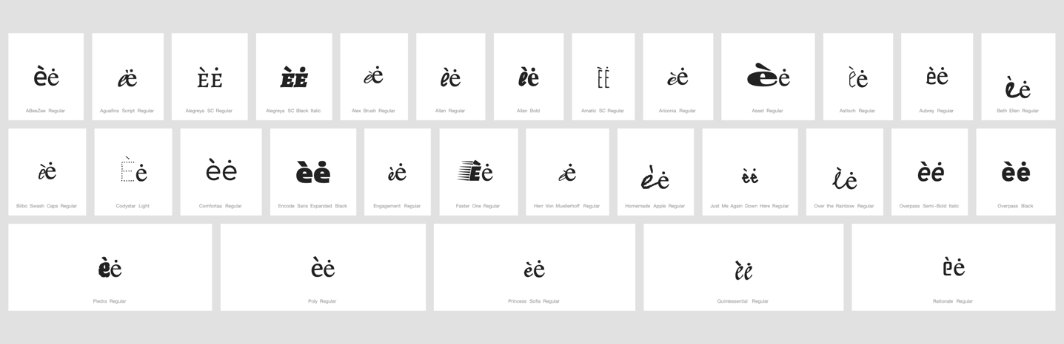

Findings:
Despite variation in the glyph shape of e, as well as occasional clippings, the representations of the grave and the dot remain distinguishable.
In a large number of fonts, the two diacritics are consistently different.

Conclusion:
No variant pairs are warranted.

D.3.7 Double Acute vs. Diaeresis

Code Points Considered:

Code Points | Glyph | Name
006E + 0308 | n̈ | Latin Small Letter N + Combining Diaeresis
00E4 | ä | Latin Small Letter A with Diaeresis
00EB | ë | Latin Small Letter E with Diaeresis
00EF | ï | Latin Small Letter I with Diaeresis
00F6 | ö | Latin Small Letter O with Diaeresis
00FC | ü | Latin Small Letter U with Diaeresis
00FF | ÿ | Latin Small Letter Y with Diaeresis
0151 | ő | Latin Small Letter O with Double Acute
0171 | ű | Latin Small Letter U with Double Acute
0254 + 0308 | ɔ̈ | Latin Small Letter Open O + Combining Diaeresis
025B + 0308 | ɛ̈ | Latin Small Letter Open E + Combining Diaeresis
025B + 0331 + 0308 | ɛ̱̈ | Latin Small Letter Open E + Combining Macron Below + Combining Diaeresis
1E8D | ẍ | Latin Small Letter X with Diaeresis

Sequence őö and üű (00F6 0151 and 00FC 0171) compared using Google Fonts in https://wordmark.it/:
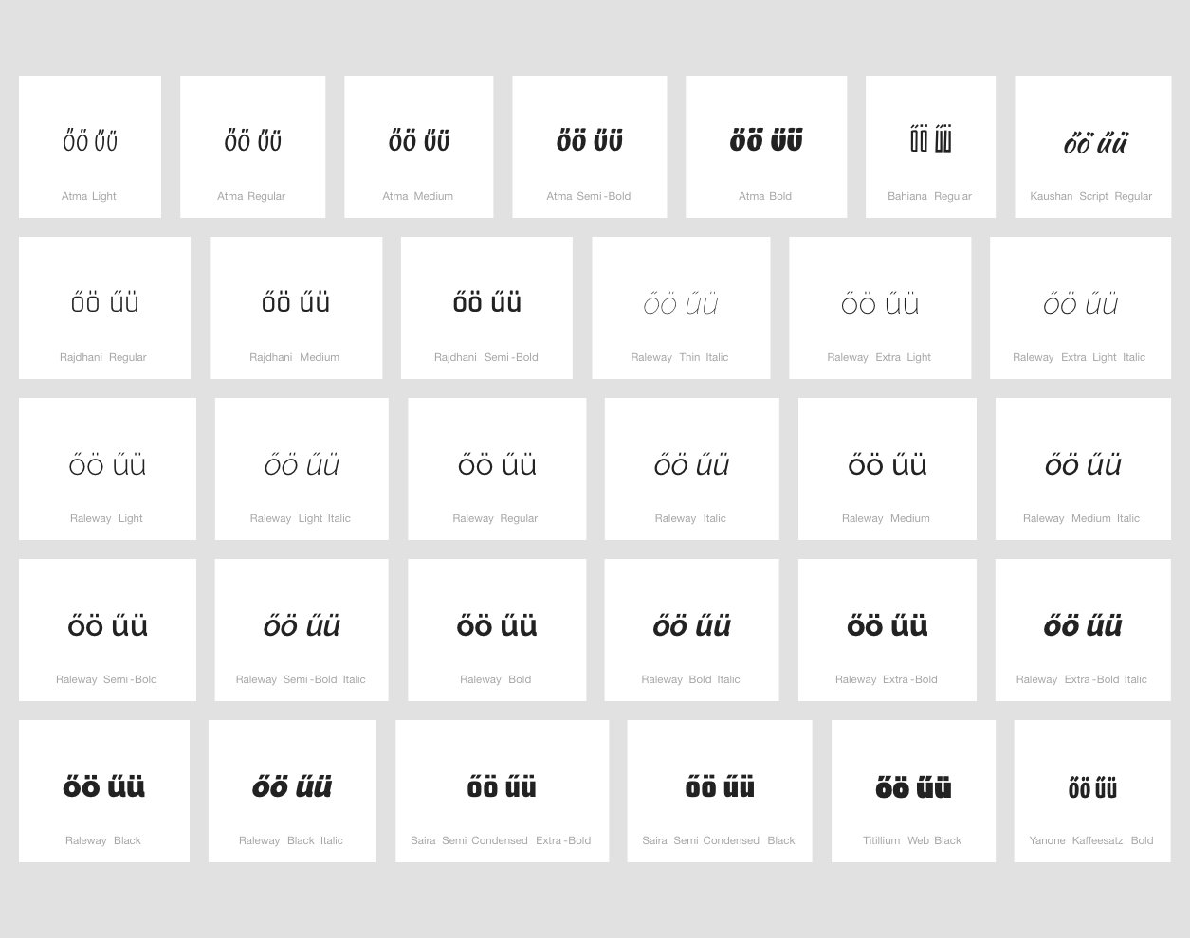

Findings:
The representations of the Double Acute vs Diaeresis in these pairs are distinguishable in a number of fonts. In some fonts, the two diacritics look similar.

Conclusion:
Code points őö and üű should be investigated for visual similarity

D.3.8 Dot Below vs. Comma Below

Code Points Considered:

Code Points | Glyph | Name
1E37 | ḷ | Latin Small Letter L with Dot Below
1E43 | ṃ | Latin Small Letter M with Dot Below
1E47 | ṇ | Latin Small Letter N with Dot Below
1E63 | ṣ | Latin Small Letter S with Dot Below
1E6D | ṭ | Latin Small Letter T with Dot Below
1EA1 | ạ | Latin Small Letter A with Dot Below
1EB9 | ẹ | Latin Small Letter E with Dot Below
1ECB | ị | Latin Small Letter I with Dot Below
1ECD | ọ | Latin Small Letter O with Dot Below
1EE5 | ụ | Latin Small Letter U with Dot Below
1EF5 | ỵ | Latin Small Letter Y with Dot Below
0219 | ș | Latin Small Letter S with Comma Below
021B | ț | Latin Small Letter T with Comma Below

Sequence ṣș (1E63 0219) compared using Google Fonts in https://wordmark.it/:
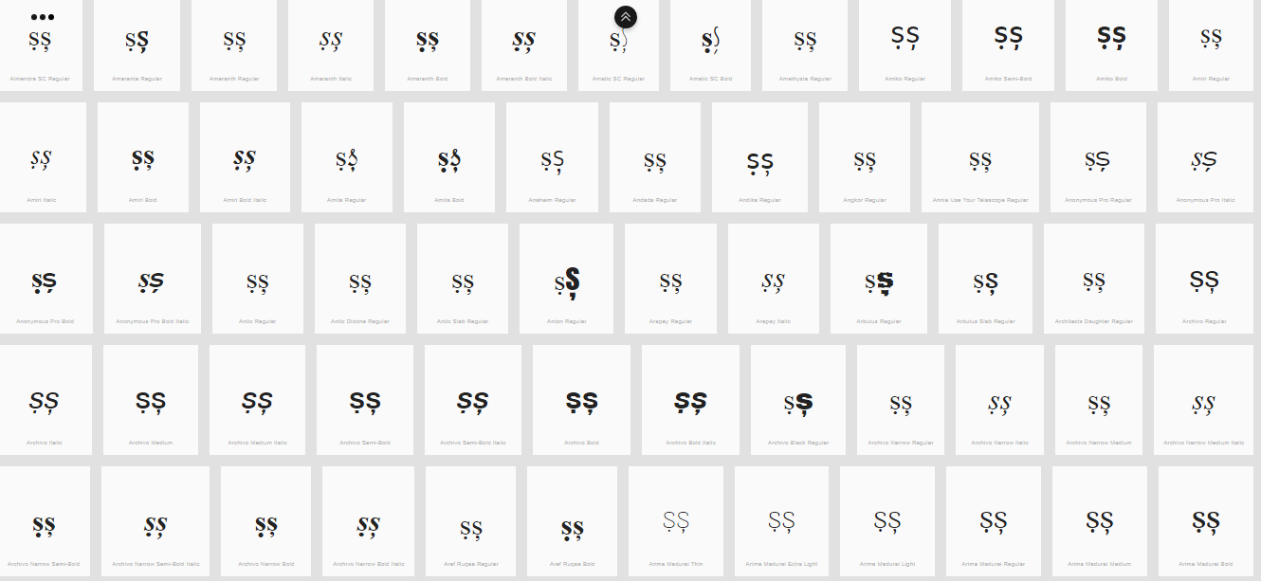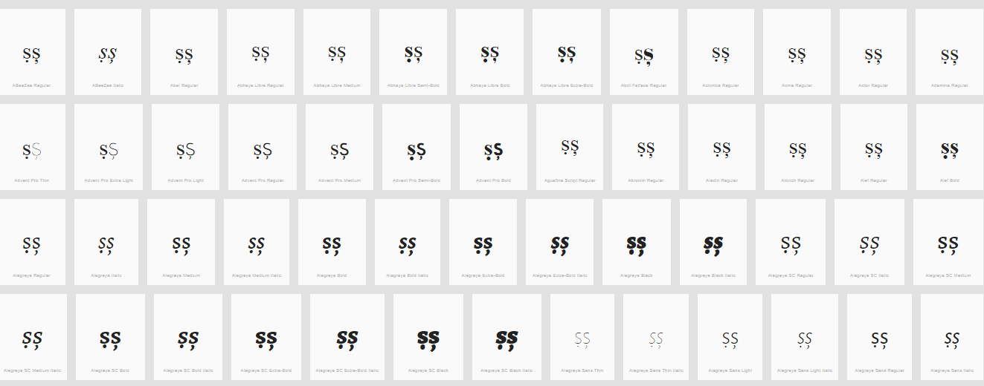

Sequence ṭț (1E6D 021B) compared using Google Fonts in https://wordmark.it/:
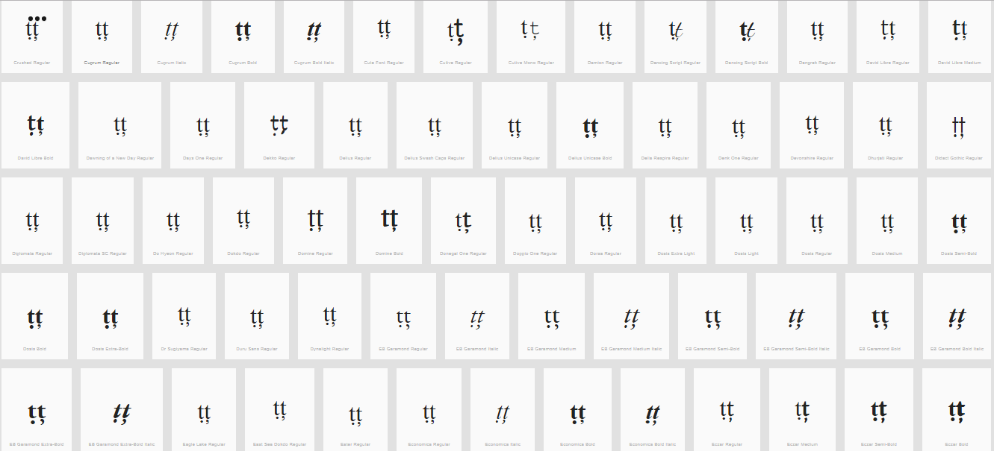
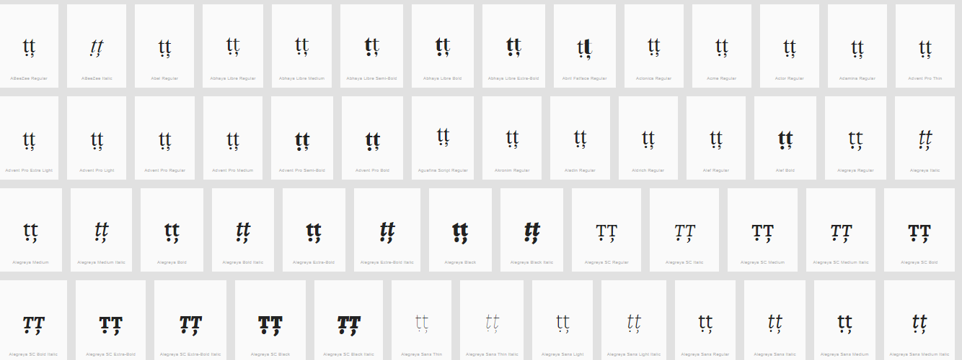

Findings:
The representations of the Dot below and Comma below in Letters S and T are distinguishable in a number of fonts (see pictures above); in a large number of fonts, the two diacritics are consistently different.

D.3.9 Hook vs. Dot Above

Code Points Considered:

Code Points | Glyph | Name
0069 | i | Latin Small Letter I
010B | ċ | Latin Small Letter C with Dot Above
0117 | ė | Latin Small Letter E with Dot Above
0121 | ġ | Latin Small Letter Latin Small Letter G with Dot Above
017C | ż | Latin Small Letter Z with Dot Above
0199 | ƙ | Latin Small Letter K with Hook
01B4 | ƴ | Latin Small Letter Y with Hook
0253 | ɓ | Latin Small Letter B with Hook
0257 | ɗ | Latin Small Letter D with Hook
1E45 | ṅ | Latin Small Letter N with Dot Above
1EA3 | ả | Latin Small Letter A with Hook Above
1EBB | ẻ | Latin Small Letter E with Hook Above
1EC9 | ỉ | Latin Small Letter I with Hook Above
1ECF | ỏ | Latin Small Letter O with Hook Above
1EE7 | ủ | Latin Small Letter U with Hook Above
1EF7 | ỷ | Latin Small Letter Y with Hook Above

Sequence ẻė (1EBB 0117) compared using Google Fonts in https://wordmark.it/:
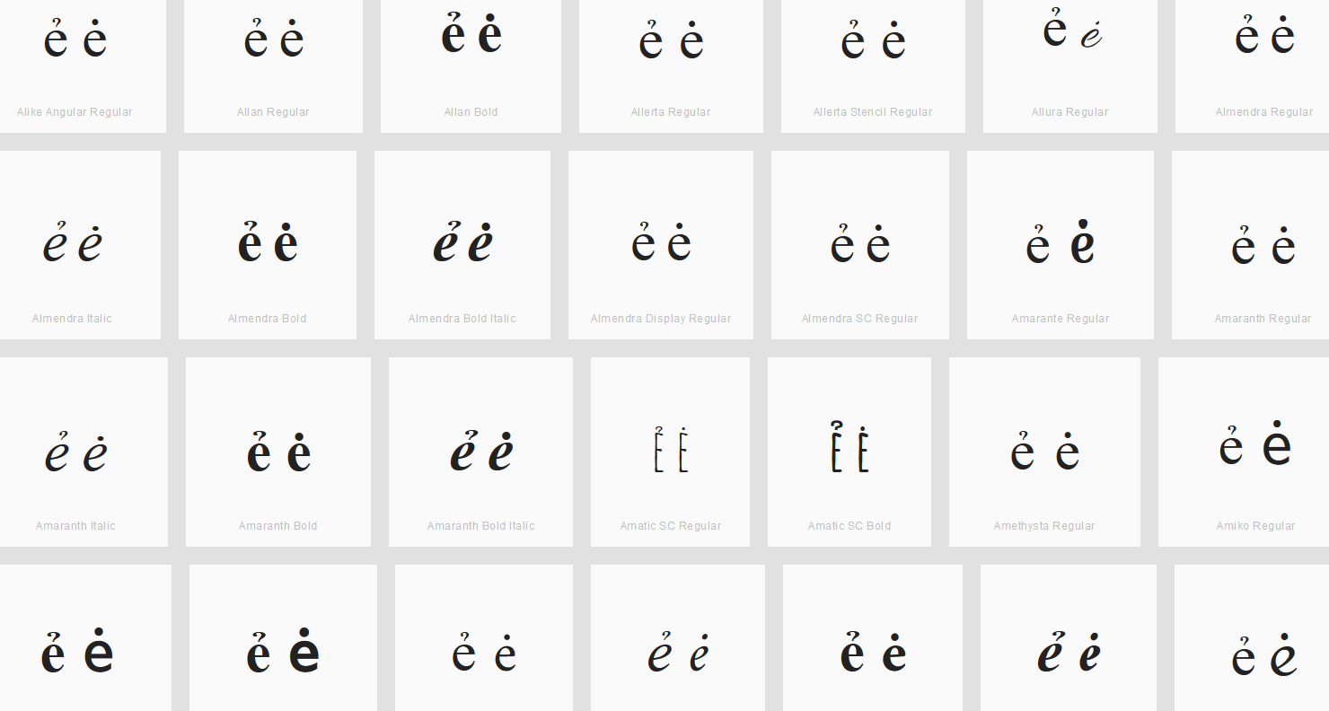

Findings:
Dot and Hook are distinguishable for the viewed fonts.

Sequence iỉ (0069 1EC9) compared using Google Fonts in https://wordmark.it/:
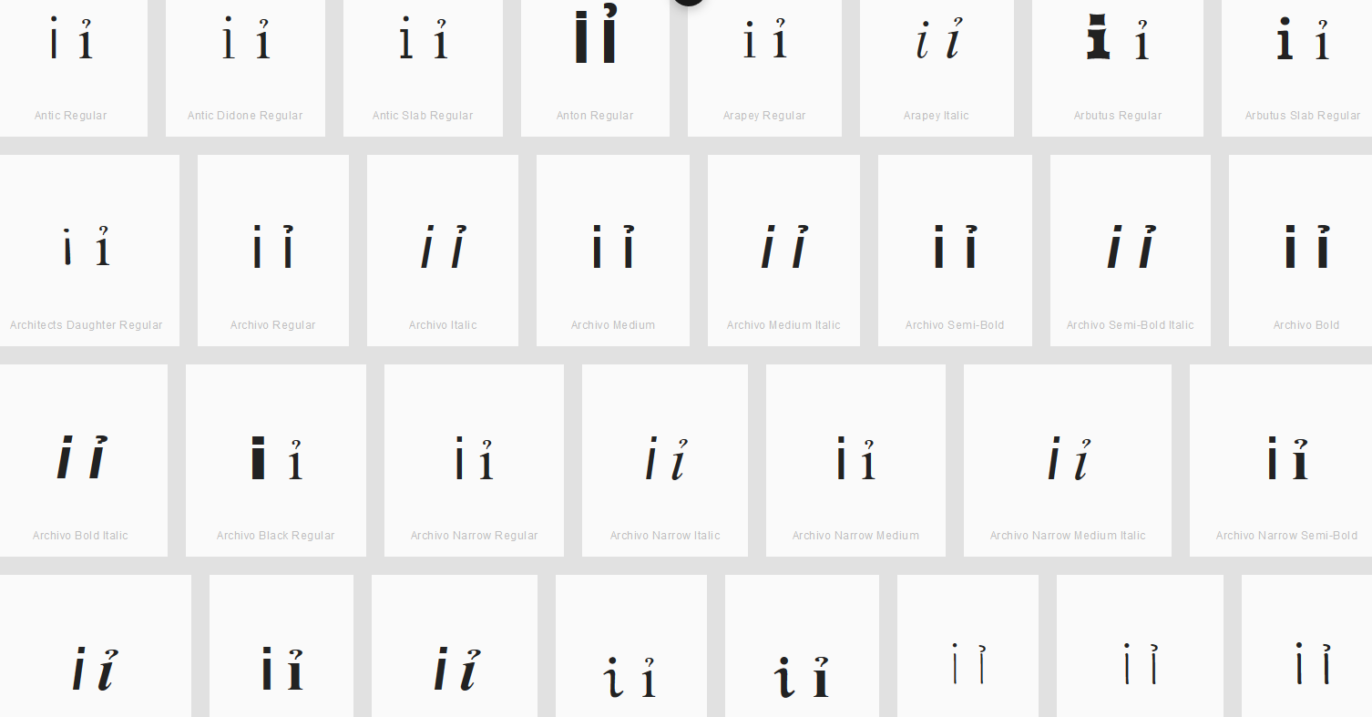
Findings:
Dot and Hook are distinguishable for the viewed fonts.

Sequence ƴỷ (01B4 1EF7) compared using Google Fonts in https://wordmark.it/:
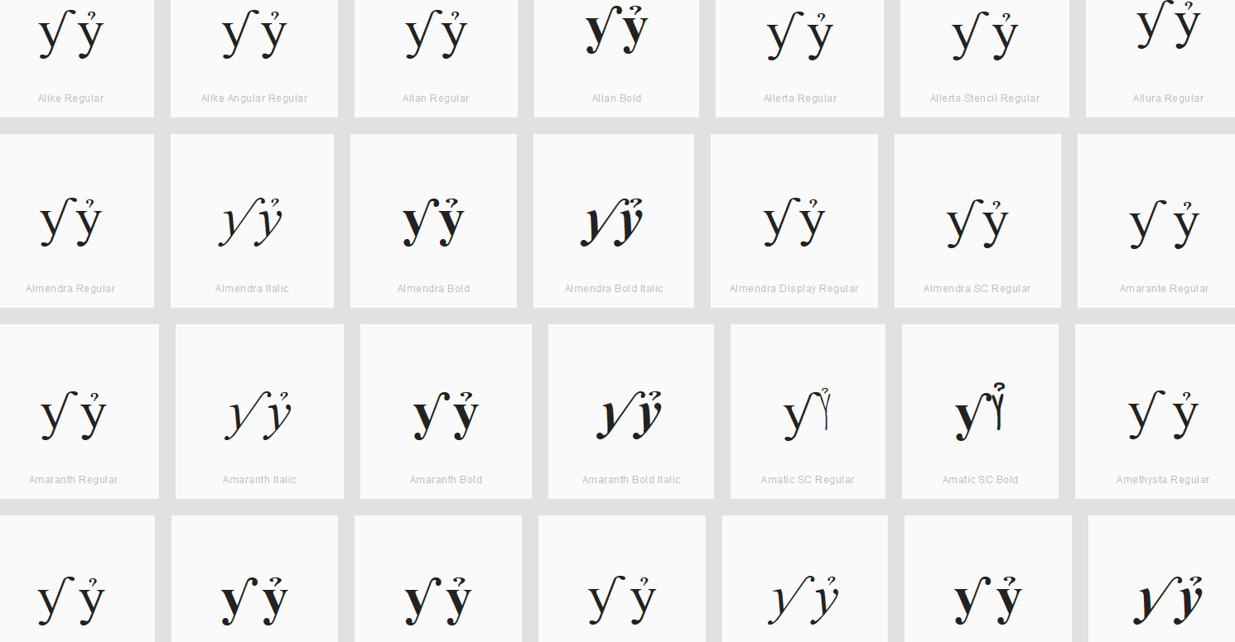
Findings:
Hook and Hook Above are distinguishable for the viewed fonts.

D.3.10 Caron vs. Hook

Code Points Considered:

 | Code Points | Glyph |  | Name
010F |  | ď | Latin Small Letter D with Caron
0257 |  | ɗ | Latin Small Letter D with Hook
Sequence ďɗ (010F 0257) compared using Google Fonts in https://wordmark.it/:
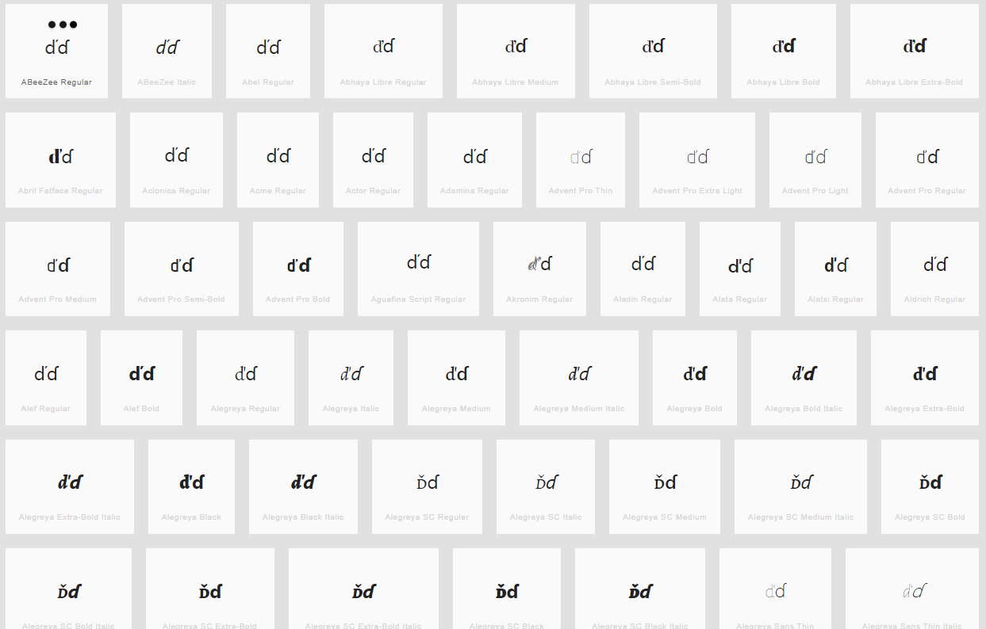
Findings: Caron and Hook are distinguishable in most fonts viewed

Sequence åả (00E5 1EA3) compared using Google Fonts in https://wordmark.it/:
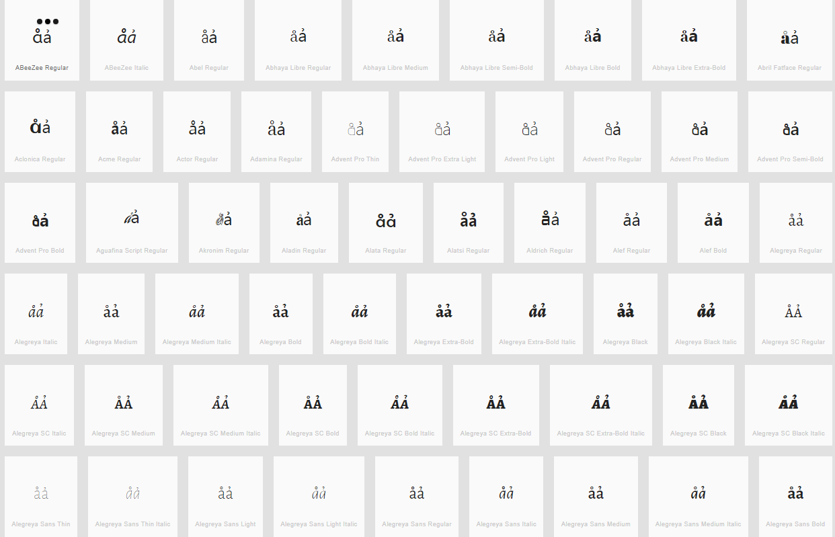
Sequence ůủ (016F 1EE7) compared using Google Fonts in https://wordmark.it/:
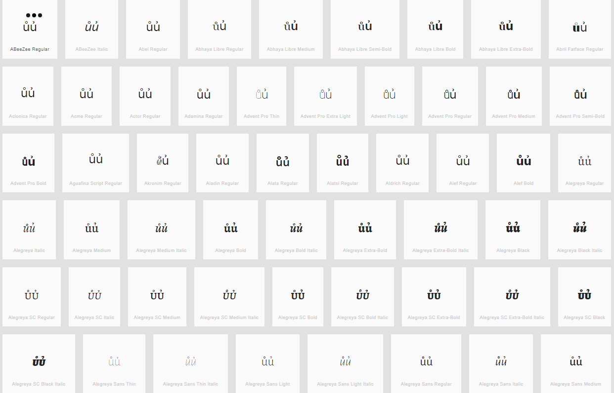

Findings: Ring above and Hook above are distinguishable in all fonts viewed

Conclusions:

D.3.11 Caron vs. Horn

Hypothesis:
Caron and Horn may become nearly identical depending on font, context and reader, and they may be used interchangeably in handwriting.

Code Points Considered:

Code Points | Glyph | Name
01CE | ǎ | Latin Small Letter A with Caron
010D | č | Latin Small Letter C with Caron
010F | ď | Latin Small Letter Latin Small Letter D with Caron
011B | ě | Latin Small Letter E with Caron
01E7 | ǧ | Latin Small Letter G with Caron
01D0 | ǐ | Latin Small Letter I with Caron
01E9 | ǩ | Latin Small Letter K with Caron
013E | ľ | Latin Small Letter L with Caron
0148 | ň | Latin Small Letter N with Caron
01D2 | ǒ | Latin Small Letter O with Caron
01A1 | ơ | Latin Small Letter O with Horn
1EDB | ớ | Latin Small Letter O with Horn and Acute
1EDD | ờ | Latin Small Letter O with Horn and Grave
1EE1 | ỡ | Latin Small Letter O with Horn and Tilde
1EDF | ở | Latin Small Letter O with Horn and Hook Above
1EE3 | ợ | Latin Small Letter O with Horn and Dot Below
0159 | ř | Latin Small Letter R with Caron
0161 | š | Latin Small Letter S with Caron
0165 | ť | Latin Small Letter T with Caron
01D4 | ǔ | Latin Small Letter U with Caron
01B0 | ǔ | Latin Small Letter U with Horn
1EE9 | ứ | Latin Small Letter U with Horn and Acute
1EEB | ừ | Latin Small Letter U with Horn and Grave
1EEF | ữ | Latin Small Letter U with Horn and Tilde
1EED | ử | Latin Small Letter U with Horn and Hook Above
1EF1 | ự | Latin Small Letter U with Horn and Dot Below
017E | ž | Latin Small Letter Z with Caron
01EF | ǯ | Latin Small Letter Ezh with Caron

String (oǒo oơo oớo oờo oỡo oởo oợo) compared using Google Fonts in https://wordmark.it/

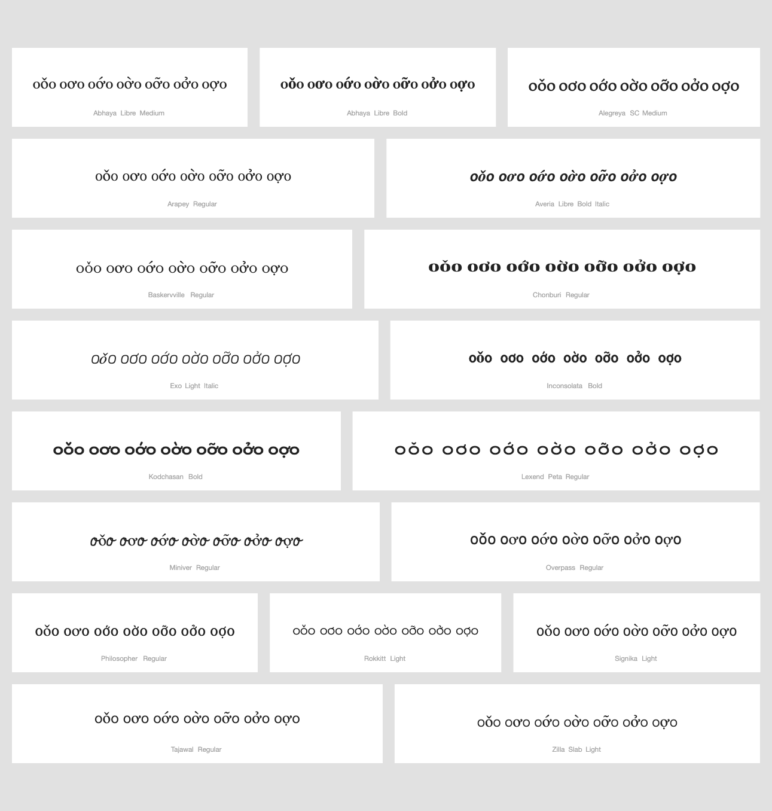

Findings: Caron and horn are always in place and distinguishable

Conclusions: No variants candidates found

String (uǔu uưu uứu uừu uữu uửu uựu) compared using Google Fonts in https://wordmark.it/
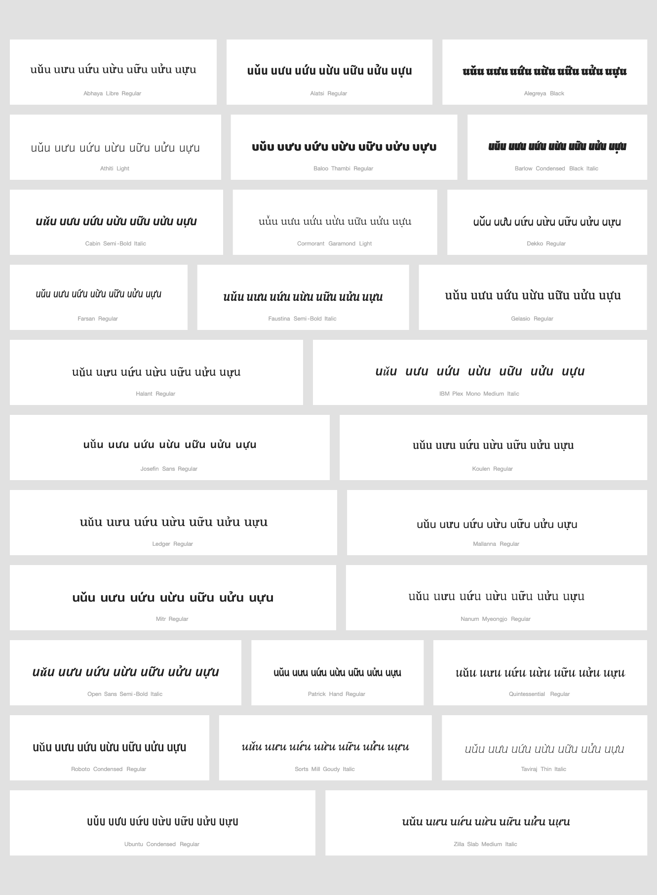
Findings: Caron and horn are always in place and distinguishable

Conclusions: No variants candidates found

D.3.12 Ring Above vs. Hook Above

Code Points Considered:

Code Point | Glyph | Name
1EA3 | ả | Latin Small Letter A with Hook Above
00E5 | å | Latin Small Letter A with Ring Above
1EE7 | ủ | Latin Small Letter U with Hook Above
016F | ů | Latin Small Letter U with Ring Above

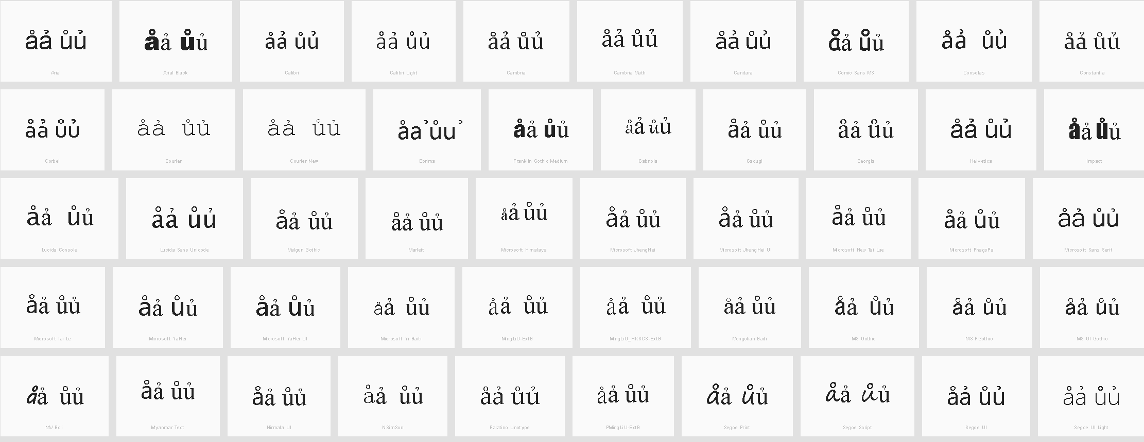

Findings

In some fonts, at normal sizes, the two diacritics can be difficult to distinguish.

D.4 Stacking of Diacritics

D.4.1 Circumflex and Tilde

Code Points Considered:

Code Points | Glyph | Name
00E2 | â | Latin Small Letter A with Circumflex
00E3 | ã | Latin Small Letter A with Tilde
00EA | ê | Latin Small Letter E with Circumflex
00EE | î | Latin Small Letter I with Circumflex
1EAB | ẫ | Latin Small Letter A WITH CIRCUMFLEX AND TILDE
00F1 | ñ | Latin Small Letter N with Tilde
00F4 | ô | Latin Small Letter O with Circumflex
00F5 | õ | Latin Small Letter O with Tilde
00FB | û | Latin Small Letter U with Circumflex
1EC5 | ễ | Latin Small Letter E with Circumflex and Tilde
006F | o | Latin Small Letter O
1ED7 | ỗ | Latin Small Letter O with Circumflex and Tilde
1EF9 | ỹ | Latin Small Letter Y with Tilde
011D | ĝ | Latin Small Letter G with Circumflex
015D | ŝ | Latin Small Letter S with Circumflex
0061 | a | Latin Small Letter A
0065 | e | Latin Small Letter E
0109 | ĉ | Latin Small Letter C with Circumflex
0125 | ĥ | Latin Small Letter H with Circumflex
0129 | ĩ | Latin Small Letter I WITH TILDE
0135 | ĵ | Latin Small Letter J with Circumflex
0169 | ũ | Latin Small Letter U with Tilde
0175 | ŵ | Latin Small Letter W with Circumflex
0177 | ŷ | Latin Small Letter Y with Circumflex
0067 + 0303 | g̃ | Latin Small Letter G + Combining Tilde
0072 + 0303 | r̃ | Latin Small Letter R with Combining Tilde
0268 + 0303 | ɨ̃ | Latin Small Letter I with Stoke + Combining Tilde
0289 + 0303 | ʉ̃ | Latin Small Letter U Bar + Combining Tilde

Sequence aẫa (0061 1EAB 0061) compared using Google Fonts in https://wordmark.it/:
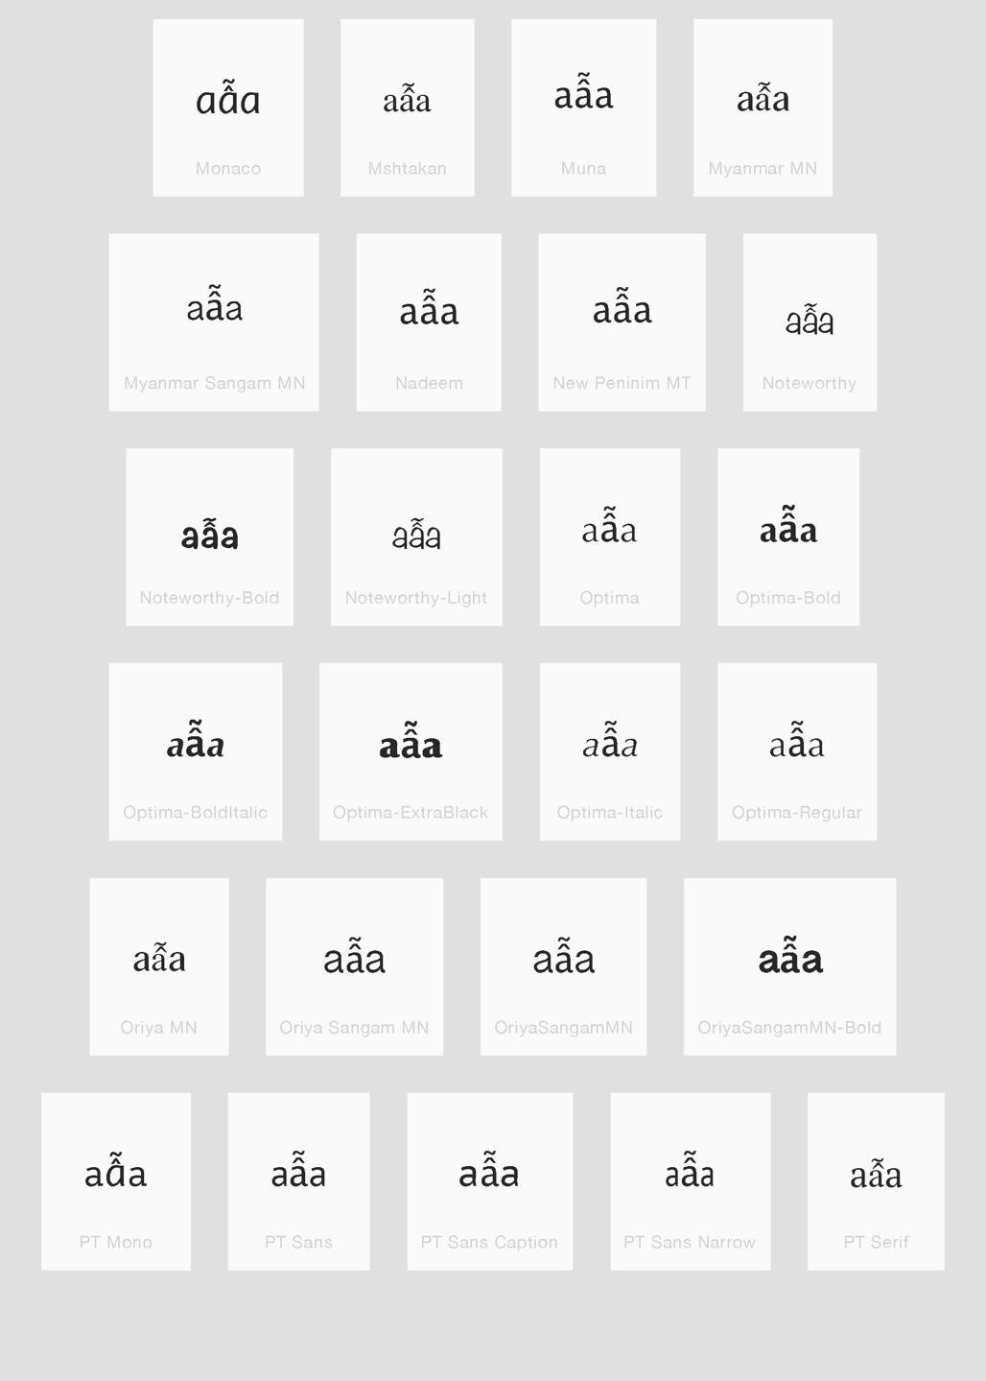

Findings:
Stacking diacritics are always in place

Sequence eễe (0065 1EC5 0065) compared using Google Fonts in https://wordmark.it/:
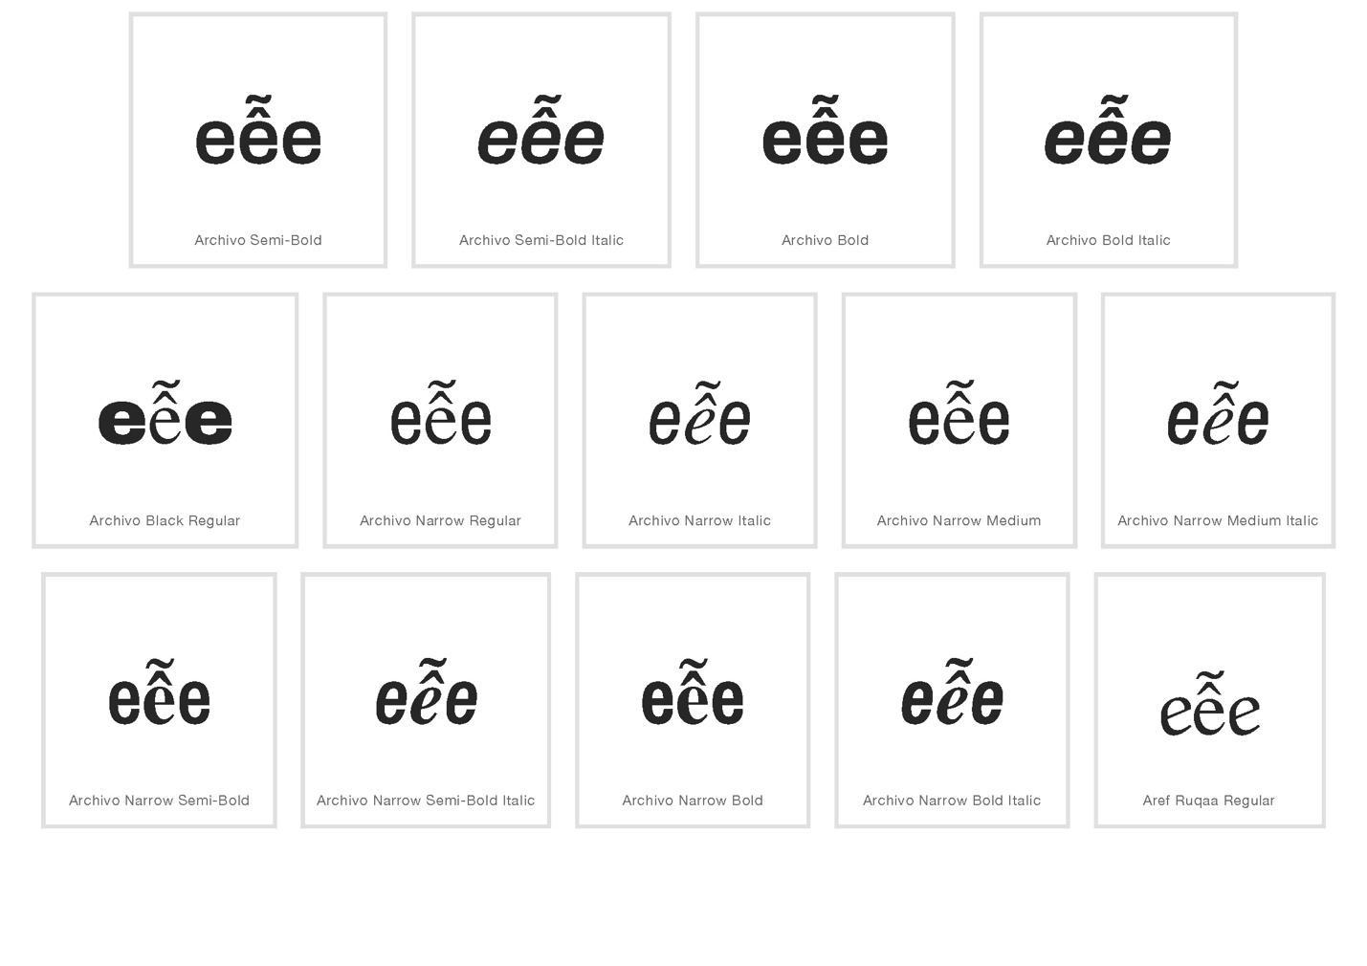
Findings:
Stacking diacritics are always in place

Sequence oỗo (006F 1EC5 006F) compared using Google Fonts in https://wordmark.it/:
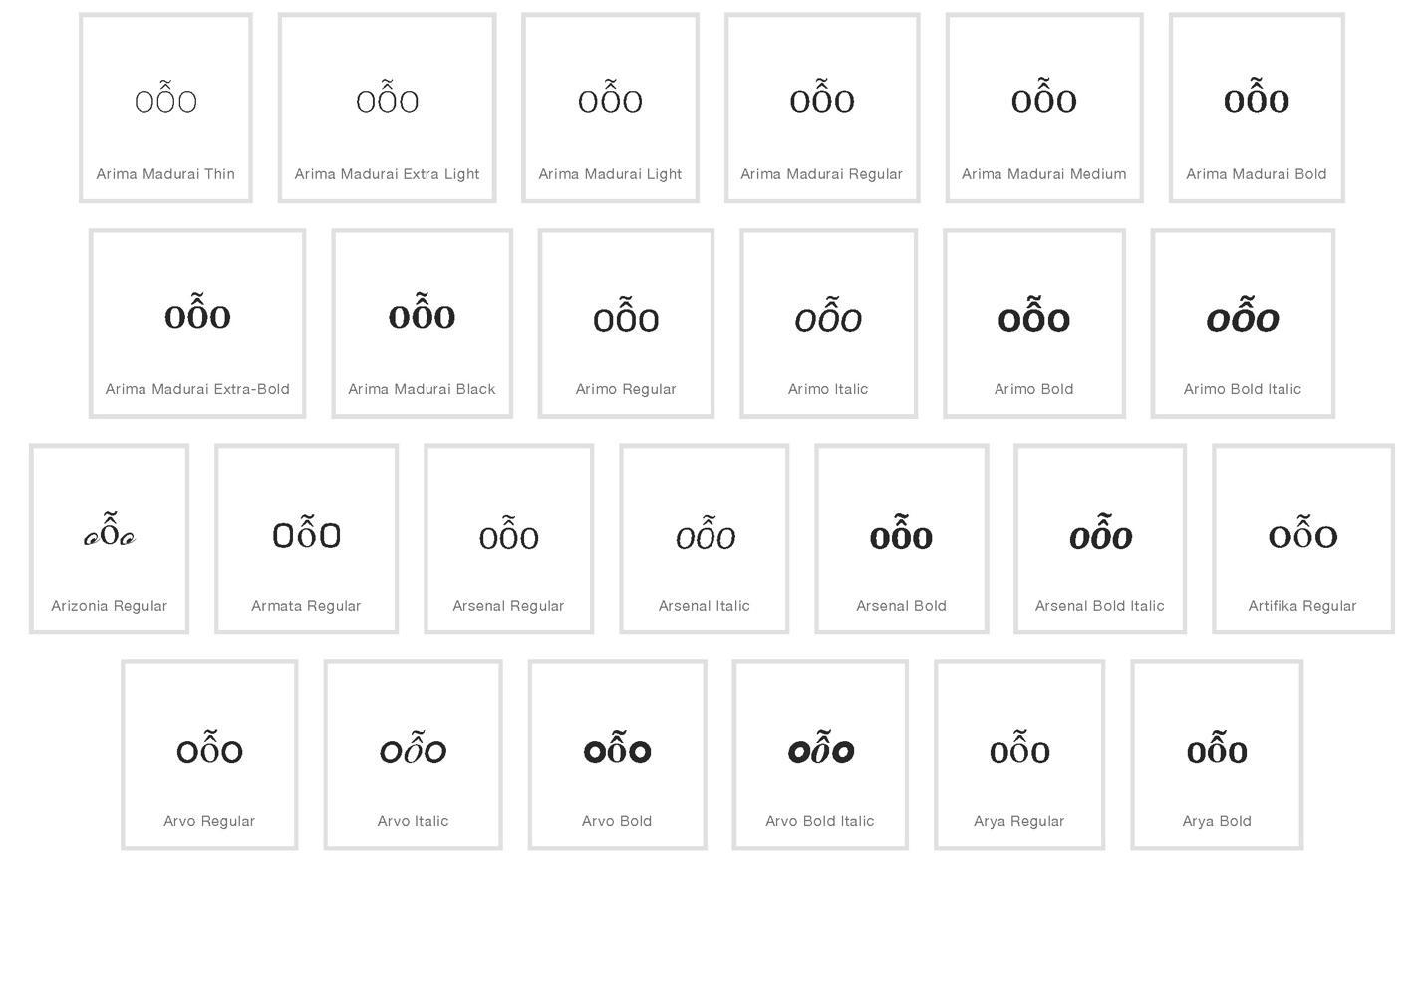

Findings:
Stacking diacritics are always in place

D.4.2 Circumflex and Hook Above
Code Points Considered:
Code Points | Glyph | Name
1EA9 | ẩ | Latin Small Letter A with Circumflex and Hook Above
00E2 | â | Latin Small Letter A with Circumflex
1EA3 | ả | Latin Small Letter A with Hook Above
1EC3 | ể | Latin Small Letter E with Circumflex and Hook Above
00EA | ê | Latin Small Letter E with Circumflex
1EBB | ẻ | Latin Small Letter E with Hook Above
1ED5 | ổ | Latin Small Letter O with Circumflex and Hook Above
00F4 | ô | Latin Small Letter O with Circumflex
1ECF | ỏ | Latin Small Letter O with Hook Above

Sequence ẩaâả (1EA9 + 0061 + 00E2 + 1EA3) compared using Google Fonts in https://wordmark.it/:
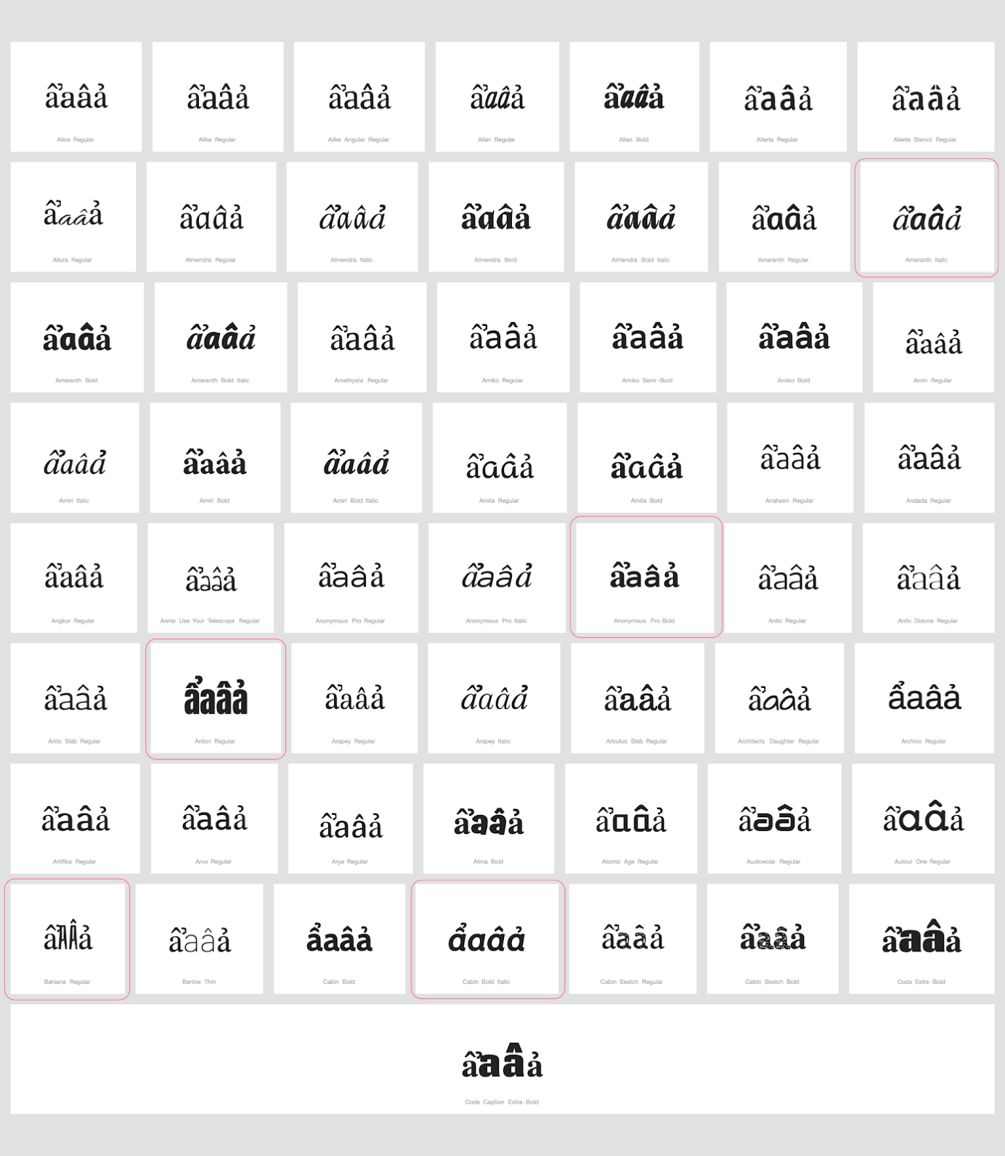

Sequence ểeêẻ (1EC3 + 0065 + 00EA + 1EBB) compared using Google Fonts in https://wordmark.it/:
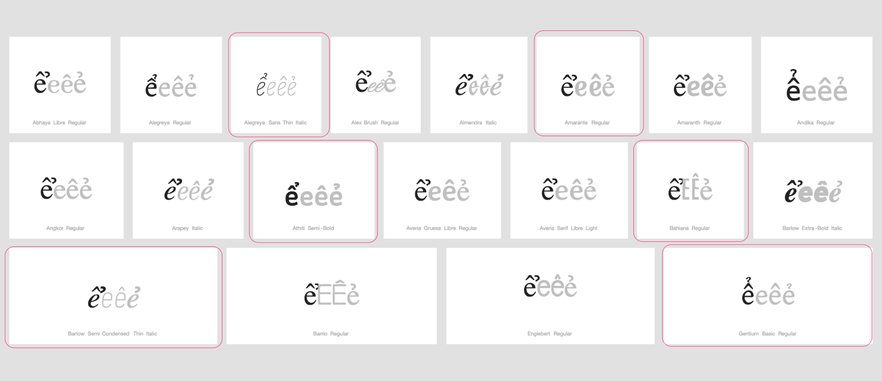

Sequence ổoôỏ (1ED5 + 006F + 00F4 + 1ECF) compared using Google Fonts in https://wordmark.it/:
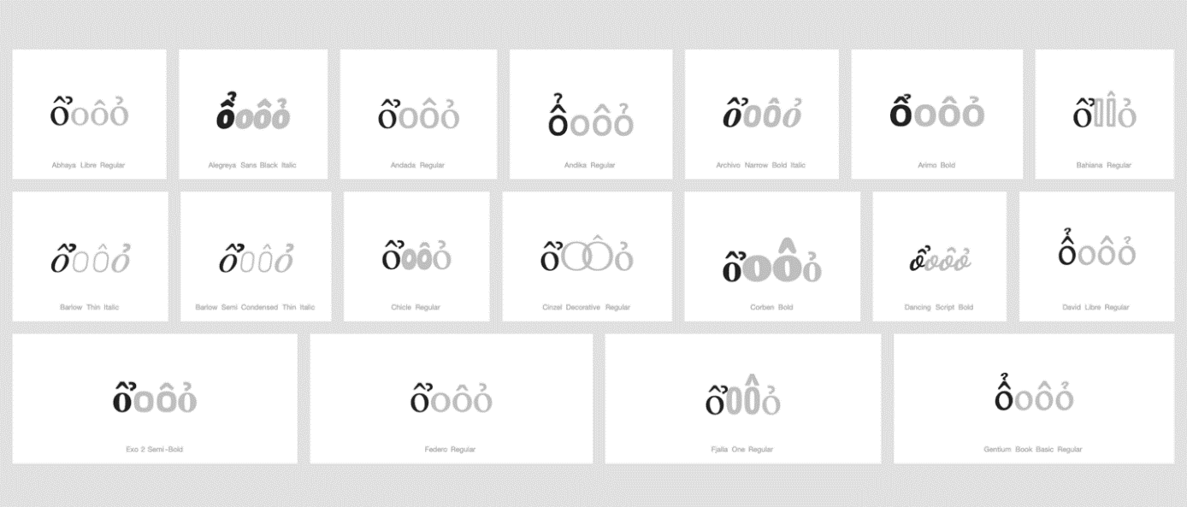

Findings:
In a large number of fonts, the two letters are consistently different. However, in a significant number of fonts, renderings are very diverse. In some case the hook as secondary modifier is placed vertically above, in others it is set horizontally next to the circumflex as primary modifier, in some fonts it is spaced so far horizontally to the right that it becomes unclear if it is a modifier belonging to the first or the second code point, and yet in other cases it even overlaps with the glyph of the following code point.

Conclusion:
Suggestion to add to shortlist for the string similarity list or create three variant pairs on the ground of them being visually similar to the level of being nearly identical or confusable.
ẩ 1EA9 and âả 00E2 + 1EA3
ể 1EC3 and êẻ 00EA + 1EBB
ổ 1ED5 and ôỏ 00F4 + 1ECF

D.4.3 Breve + Grave above

Code Points Considered:

1EB1 | ằ | Latin Small Letter A with Breve and Grave

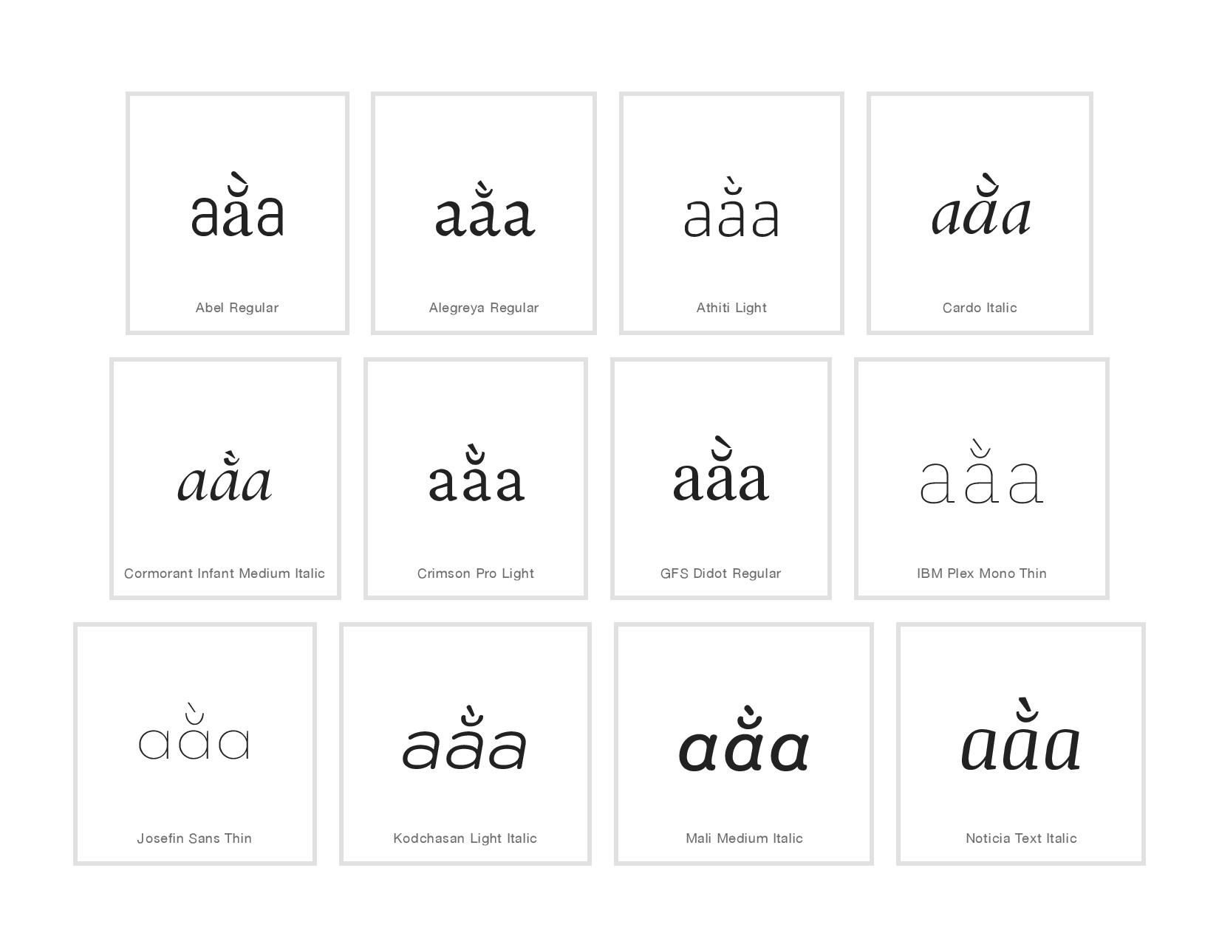Sequence aằa (0061 1EB1 0061) compared using Google Fonts in https://wordmark.it/ :
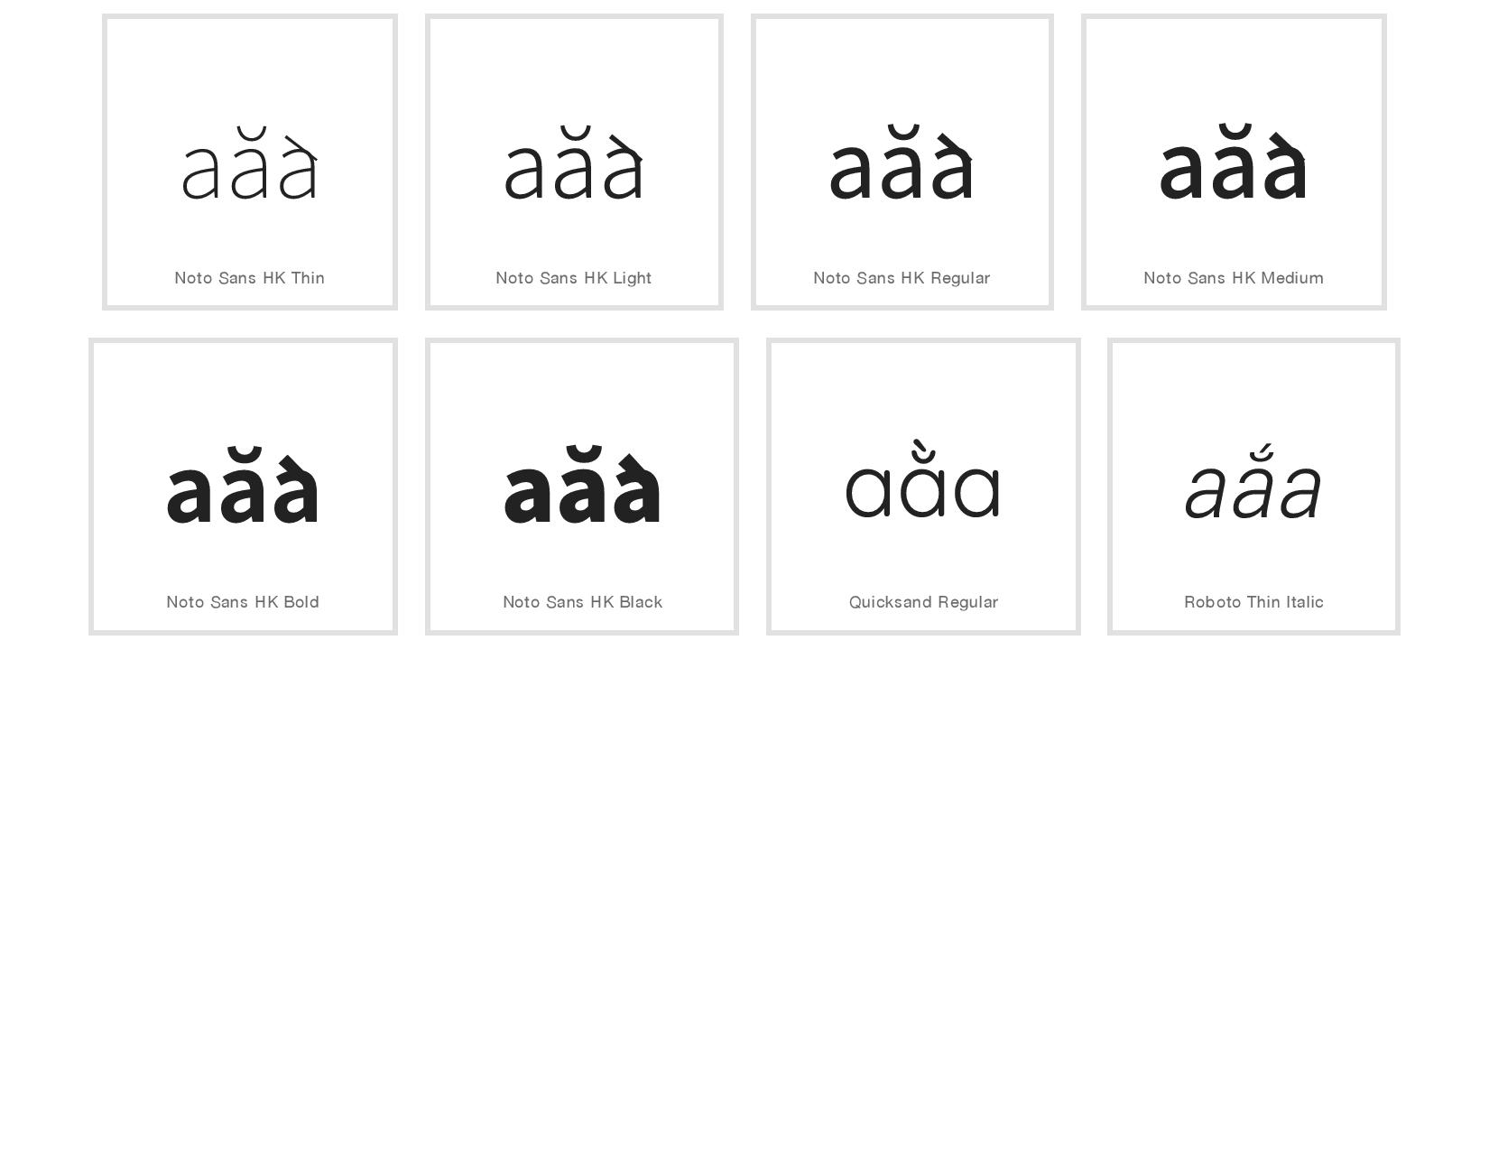
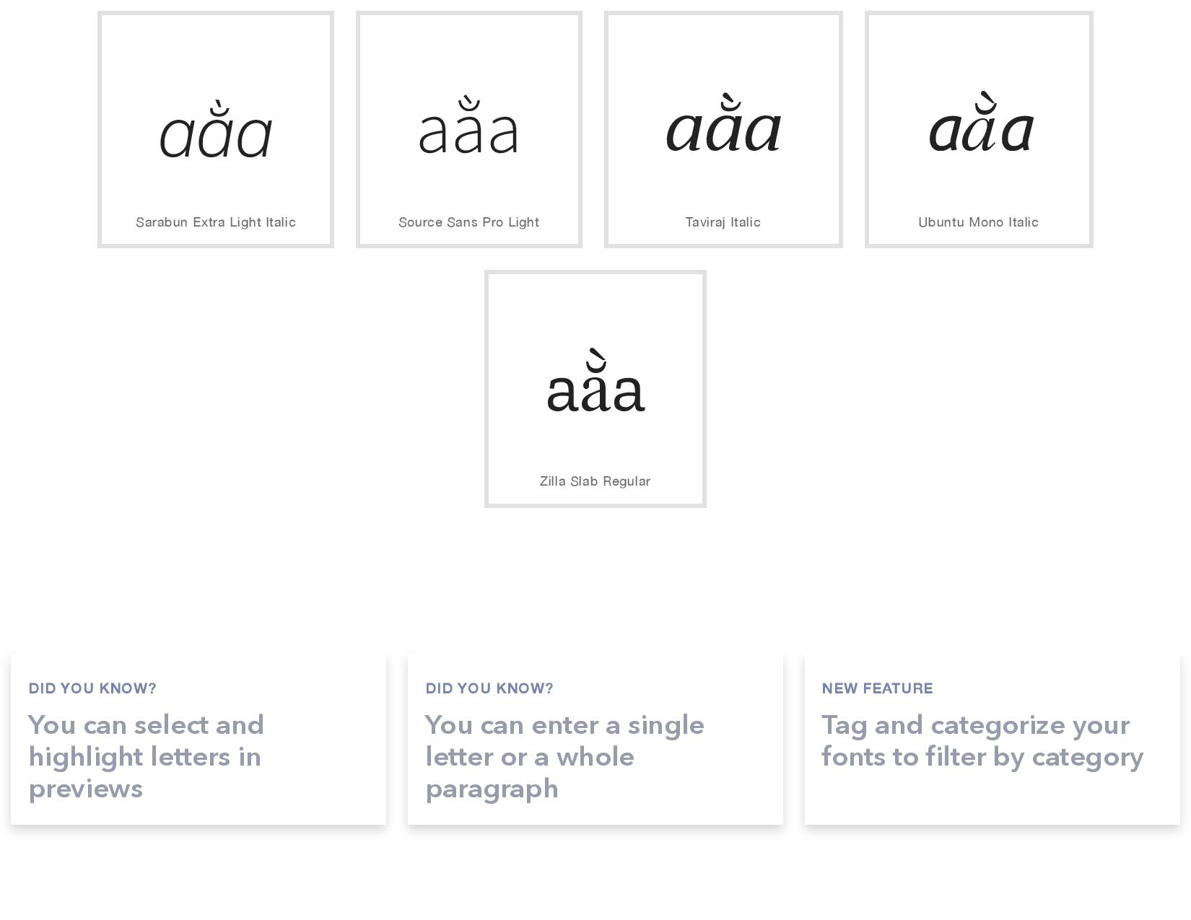
Findings:
Stacking diacritics are in place in most cases
One font namely Noto Sans HK has an error in design, or there are some errors in wordmark.it software: on the screen diacritics are not positioned properly, in .png downloaded from wordmark.it diacritics are positioned properly, in .pdf presentation of the same web page diacritics are not positioned properly

Conclusion:
Stacking diacritics are almost always in place

D.4.4 Breve and Hook Above

Code Points Considered:
Code Points | Glyph | Name
1EA3 | ả | Latin Small Letter A With Hook Above
1EB3 | ẳ | Latin Small Letter A With Breve And Hook Above
0061 | a | Latin Small Letter A
0103 | ă | Latin Small Letter A With Breve

Sequence (aẳaăả) (0061 1EB3 0061 0103 1EA3) compared using Google Fonts in https://wordmark.it/:
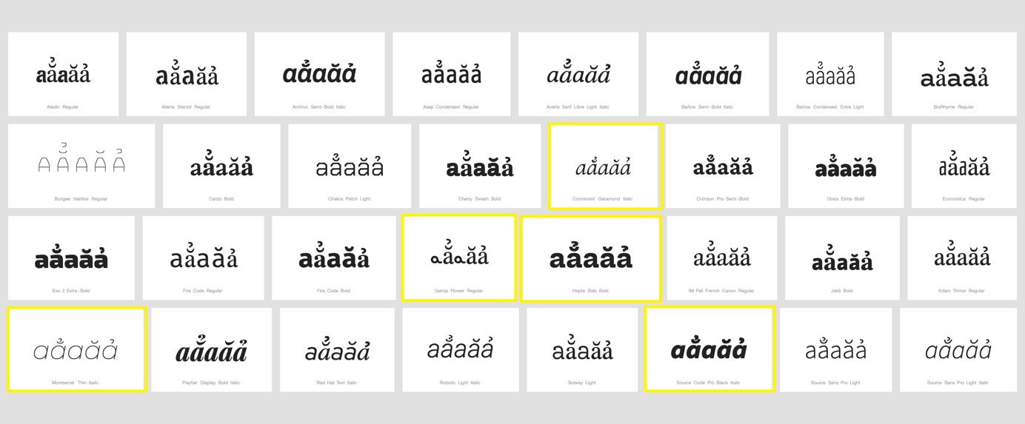

Findings:
Stacking diacritics are always in place.

Conclusions:
No variant relationship is warranted.

D.4.5 Breve and Tilde

Code Points Considered:

Code Points | Glyph | Name
1EB5 | ẵ | Latin Small Letter A with Breve and Tilde

Sequence ẵ (1EB5) compared using Google Fonts in https://wordmark.it/:
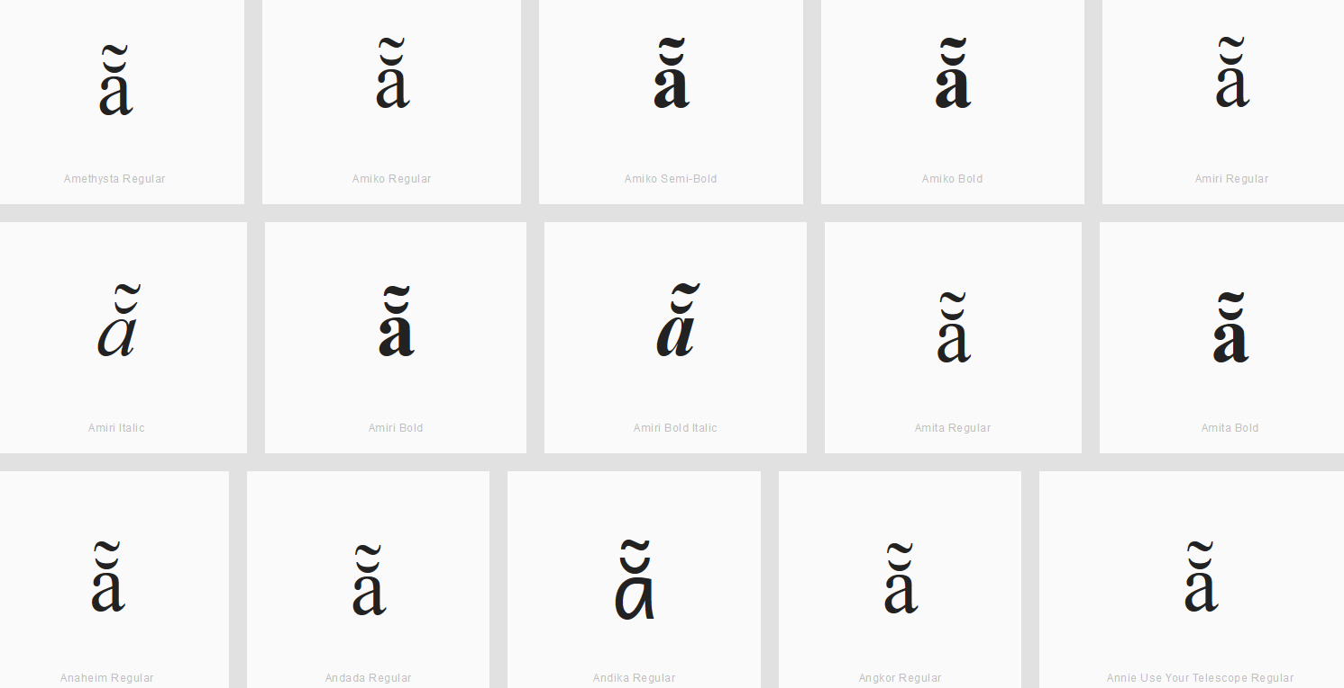

Findings:
The double diacritics stay at the base character and thus will not be confused with characters next to it having just one of the diacritics.

D.4.6 Horn and Acute

Code Points Considered:

1EDB | ớ | Latin Small Letter O with Horn and Acute
1EE9 | ứ | Latin Small Letter U with Horn and Acute

Sequence ớ (1EDB) compared using Google Fonts in https://wordmark.it/:
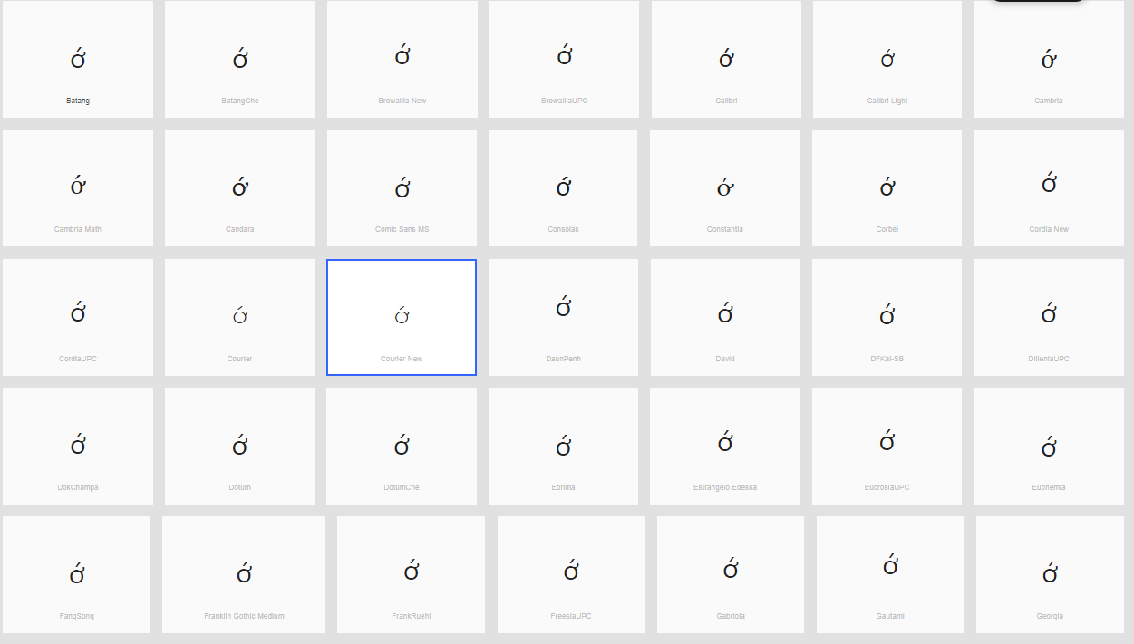

Sequence ứ (1EE9) compared using Google Fonts in https://wordmark.it/:
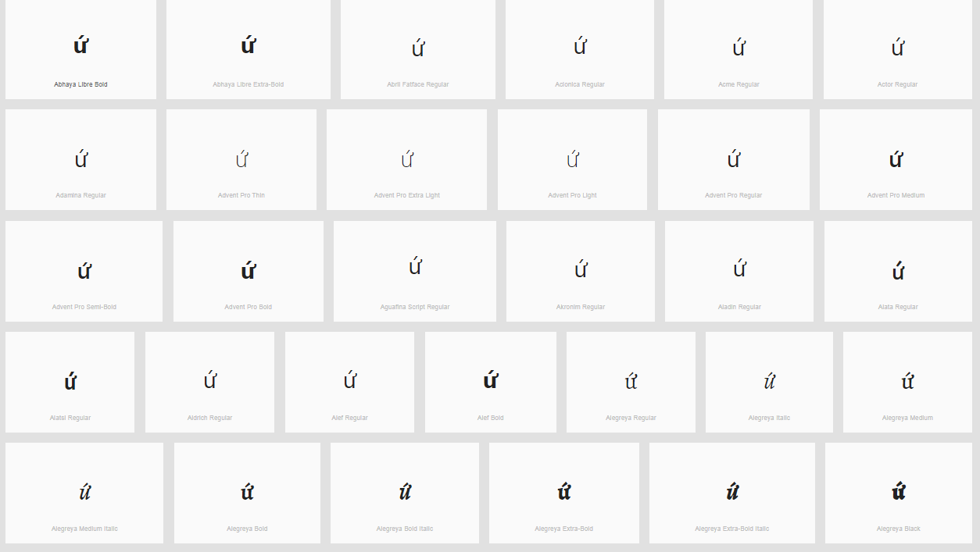

Finding: Diacritics are rendered in a consistent manner

D.4.7 Horn and Hook Above

Code Points Considered:

Code Points | Glyph | Name
1EDF | ở | Latin Small Letter O with Horn and Hook Above
1ECF | ỏ | Latin Small Letter O with Hook Above
01A1 | ơ | Latin Small Letter O with Horn
1EED | ử | Latin Small Letter U with Horn and Hook Above
1EE7 | ủ | Latin Small Letter U with Hook Above
01B0 | ư | Latin Small Letter U with Horn

Sequence ởoỏơ (1EDF + 006F + 1ECF + 01A1) compared using Google Fonts in https://wordmark.it/:
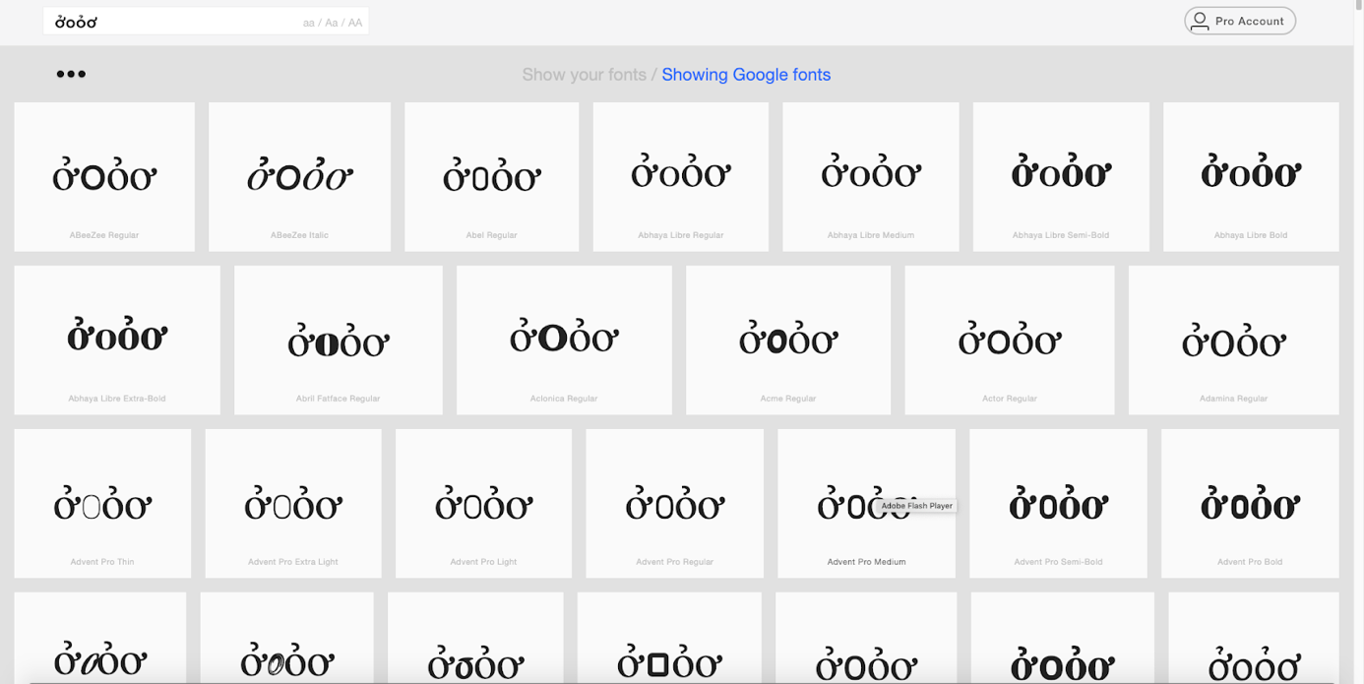

Sequence ửuủư (1EED + 0075+ 1EE7+ 01B0) compared using Google Fonts in https://wordmark.it/:
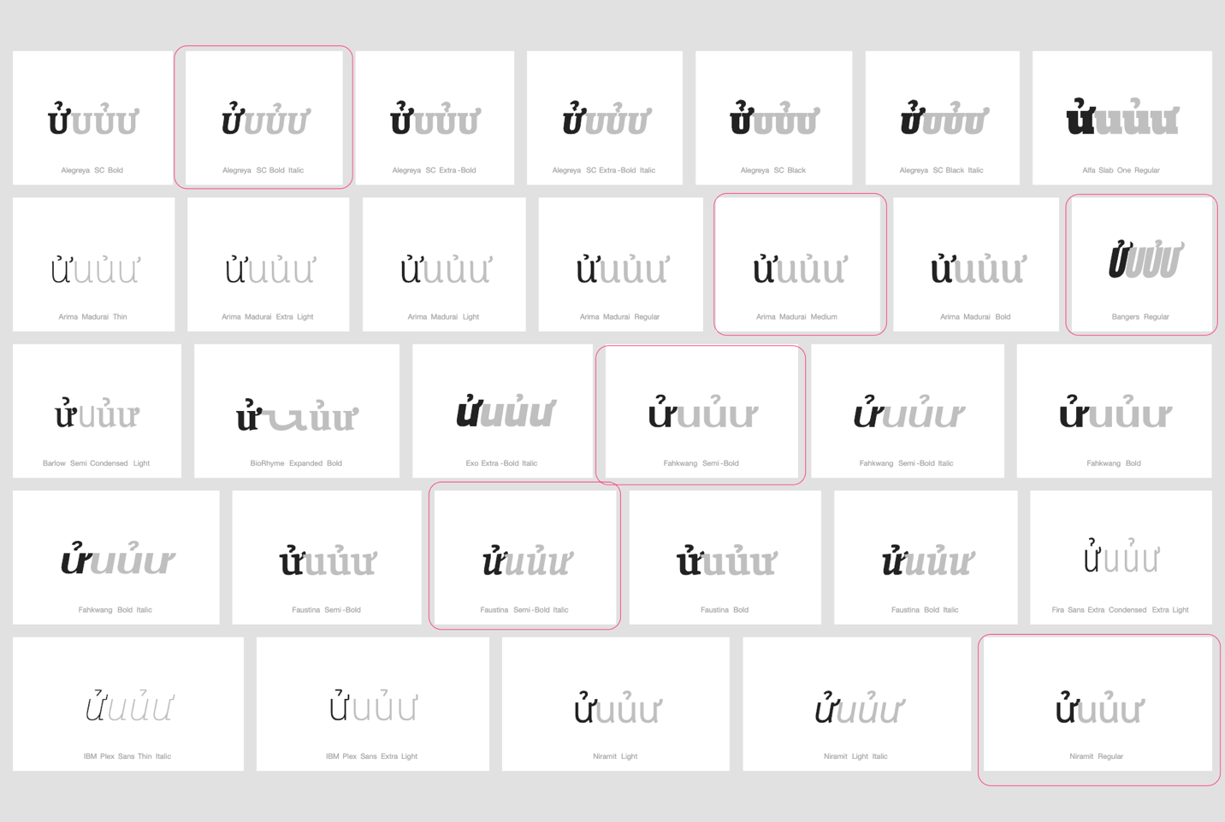

Findings:
In the case of 1EDF, renderings are considerably homogenous and clearly discernible from adjacent glyphs.

In the case of 1EED however, renderings are rather heterogeneous and there is a significant number of fonts in which it is not clear whether the modifying hook is a modifier of 1EED, a ligature between 1EED and the following code point, or a left hand-side modifier of a subsequently following code point to the right.

Therefore, additional analysis is warranted of a sequence of 1EED followed by u-shape based Code Points featuring a left-hand side modifier, i.e. 00F9 (ù Latin Small Letter U with Grave) and 1EEB (ừ Latin Small Letter U with Horn and Grave), which was conducted as demonstrated below:

Sequence ửuửùửừ (1EED + 0075 + 1EED + 00F9 + 1EED + 1EEB ) compared using Google Fonts in https://wordmark.it/:
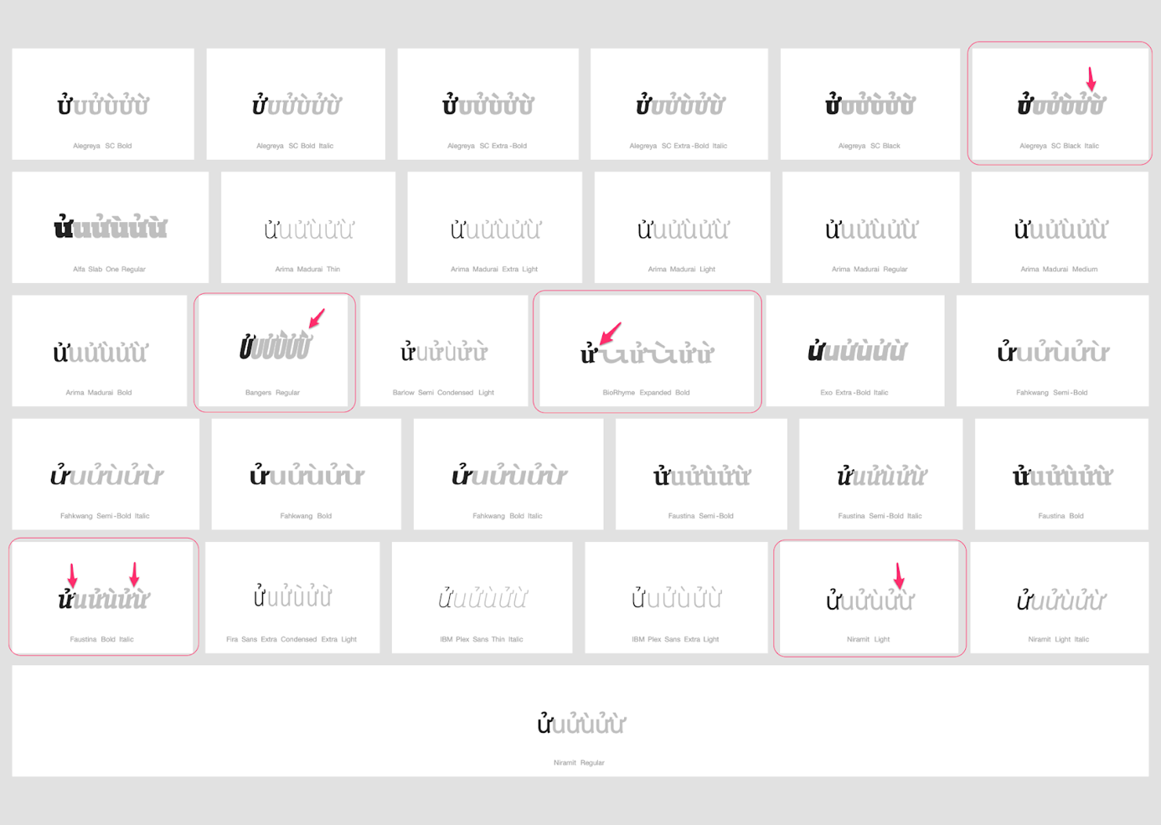

Additional Findings:
In some fonts, it remains unclear whether the right-hand side hook of 1EED belongs to that glyph or the code point following to the right. Given however two facts, namely that no code point exists in with a left-hand modifier similar enough, and that these Code Points are used only in a minority of language communities, the readers of which should be attuned to such differences, this would not seem to cross the threshold to constitute a variant. It may however be advisable to pay attention to these inconsistencies in a string-similarity review before admission to the root zone.

Conclusion:
Highlight the inconsistencies of the rendering of 1EED in the string-similarity shortlist.
If a u-based shape with a left-hand side modifier is suggested for a future revision of the LGR, particular attention needs to be paid to that code point in sequence with 1EED.

D.4.8 Diacritic Grave

Code Points Considered:
Code Points | Glyph | Name
0061 | a | Latin Small Letter A
0065 | e | Latin Small Letter E
0069 | i | Latin Small Letter I
006F | o | Latin Small Letter E
0075 | u | Latin Small Letter U
0079 | y | Latin Small Letter Y
00E0 | à | Latin Small Letter A with Grave
00E8 | è | Latin Small Letter E with Grave
00EC | ì | Latin Small Letter I with Grave
00F2 | ò | Latin Small Letter O with Grave
00F9 | ù | Latin Small Letter U with Grave
1EF3 | ỳ | Latin Small Letter Y with Grave

Sequence aàa, eèe, iìi, oòo, uùu, and yỳy (0061 00E0 0061, 0065 00E8 0065, 0069 00EC 0069, 006F 00F2 006F, 0075 00F9 0075, and 0079 1EF3 0079 ) compared using Google Fonts in https://wordmark.it/:
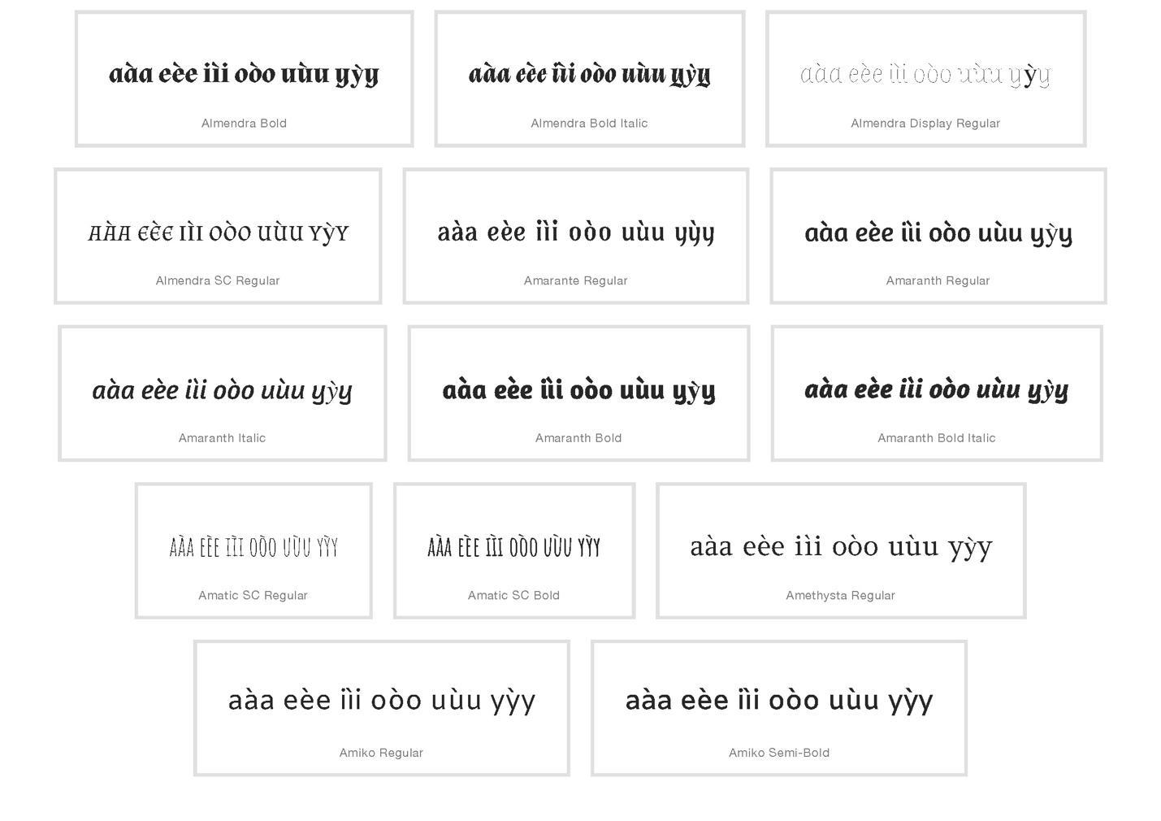
Findings:
Diacritics are always in place

D.4.9 Diacritics Horn And Grave

Code Points Considered:

Code Points | Glyph |  | Name
006F |  | o | Latin Small Letter E
0075 |  | u | Latin Small Letter U
00F2 |  | ò | Latin Small Letter O with Grave
00F9 |  | ù | Latin Small Letter U with Grave
01A1 |  | ơ | Latin Small Letter O with Horn
01B0 |  | ư | Latin Small Letter U with Horn
1EDD |  | ờ | Latin Small Letter O with Horn and Grave
1EEB |  | ừ | Latin Small Letter U with Horn and Grave

Sequence ờoơò and ừuưù (1EDD 006F 01A1 00F2 and 1EEB 0075 01B0 00F9) compared using Google Fonts in https://wordmark.it/:
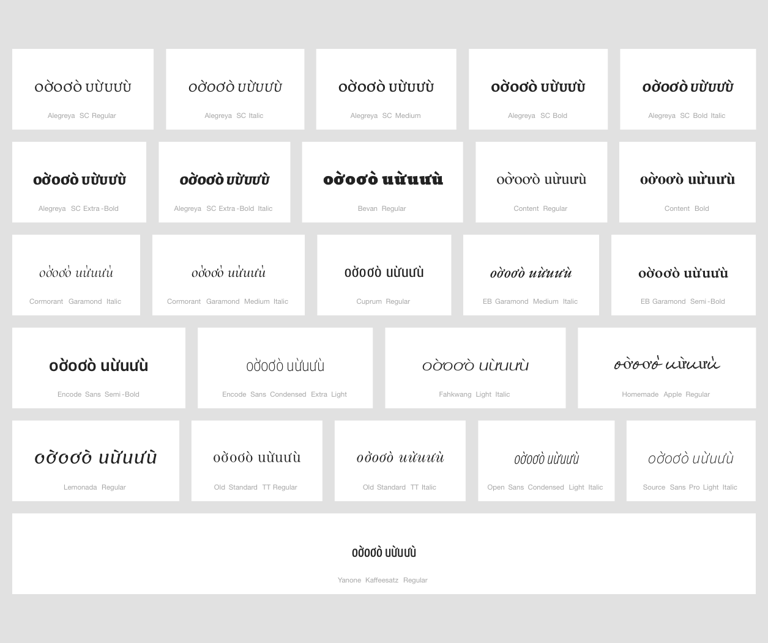

Findings:
Diacritics are always in place
Additional Findings:
In some fonts, especially in letter "u" case, it seems that horn belongs to the next character. There is no character with horn to the left in Repertoire.

D.4.10 Circumflex and Hook Above

Code Points Considered:

Code Points | Glyph | Name
1EA9 | ẩ | Latin Small Letter A with Circumflex and Hook Above
1EC3 | ể | Latin Small Letter E with Circumflex and Hook Above
1ED5 | ổ | Latin Small Letter O with Hook Above

String (aẩa eểe oổo) compared using Google Fonts in https://wordmark.it/:

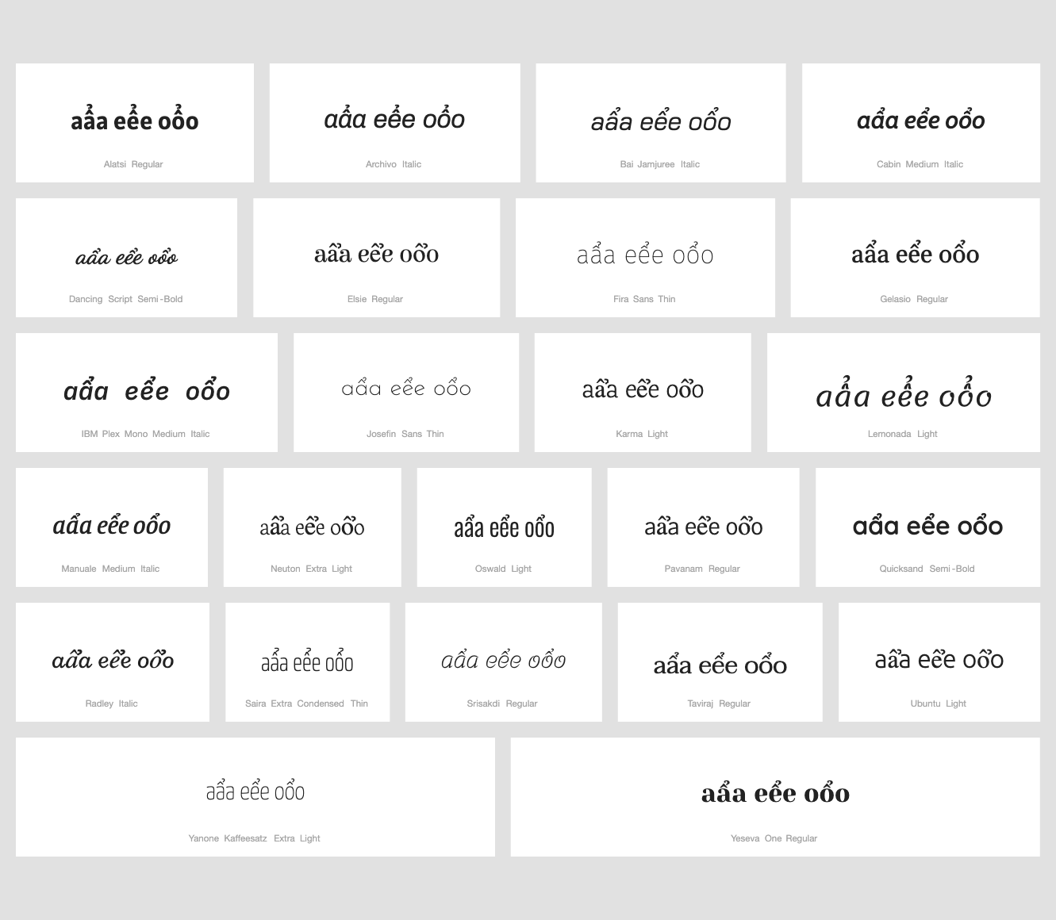
Findings:
The double diacritics stay at the base character and thus will not be confused with characters next to it having just one of the diacritics.

D.4.11 Circumflex + Dot Below

Code Points Considered:

Code Points | Glyph | Name
0061 | a | Latin Small Letter A
006F | o | Latin Small Letter O
00E2 | â | Latin Small Letter A with Circumflex
00F4 | ô | Latin Small Letter O with Circumflex
1EA1 | ạ | Latin Small Letter A with Dot Below
1EAD | ậ | Latin Small Letter A with Circumflex
1ECD | ọ | Latin Small Letter O with Dot Below
1ED9 | ộ | Latin Small Letter O with Circumflex and Dot Below

Sequence aậaâạ (0061 1EAD 0061 00E2 1EA1) compared using Google Fonts in https://wordmark.it/:
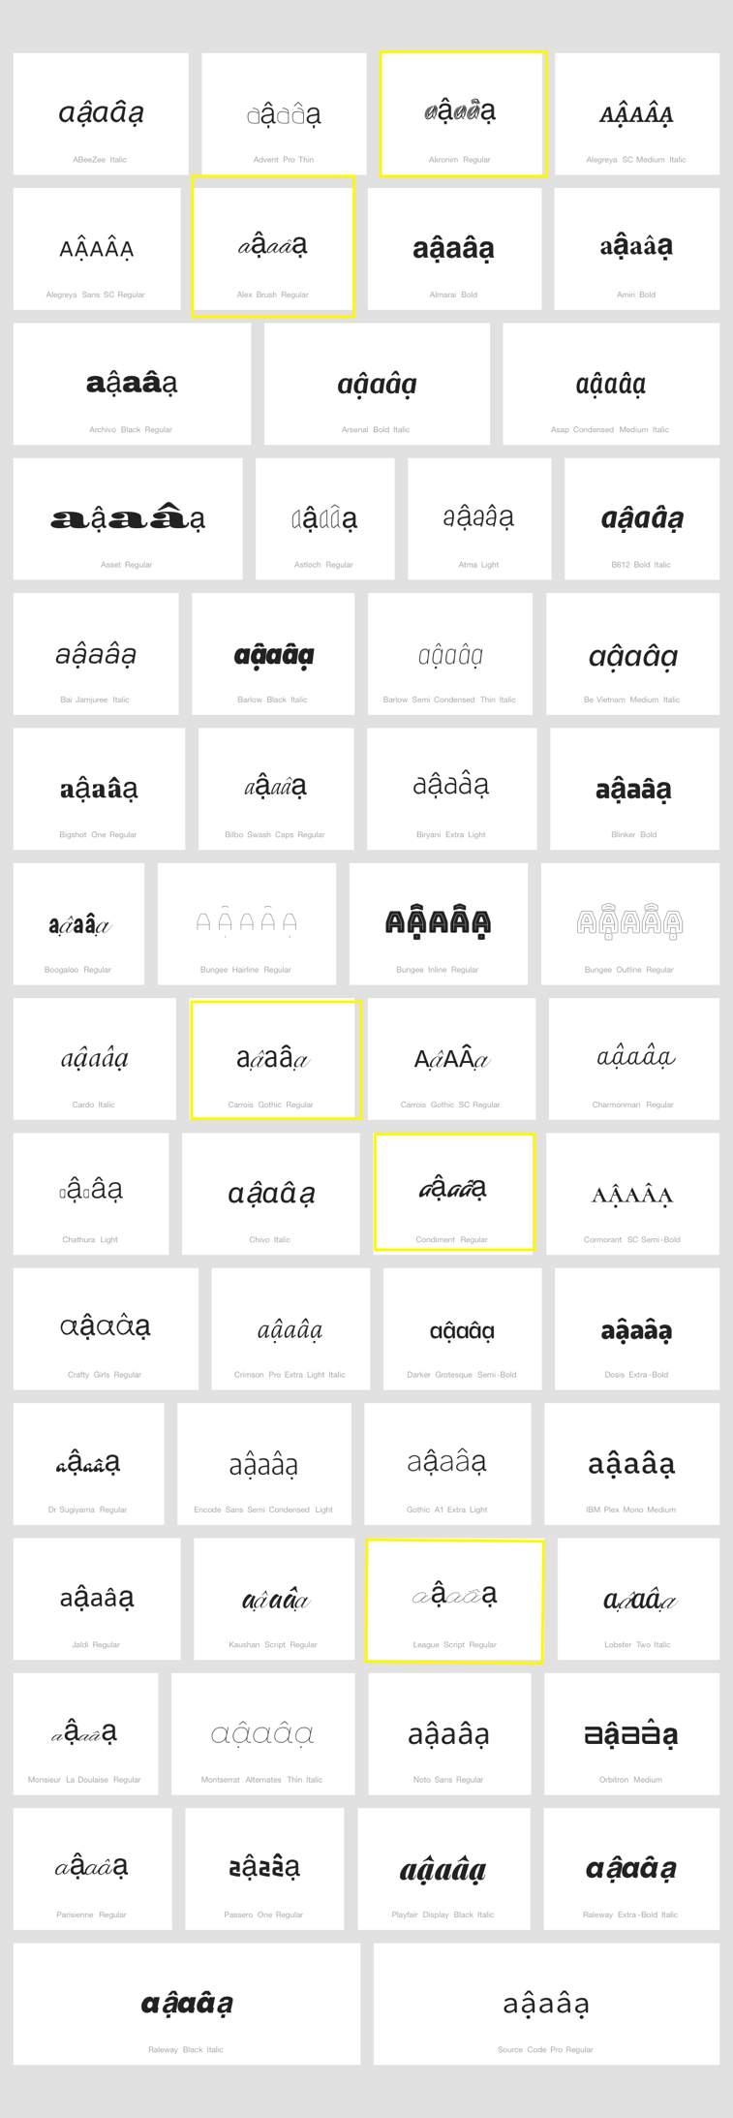

Sequence oộoôọ (006F 1ED9 006F 00F4 1ECD) compared using Google Fonts in https://wordmark.it/:
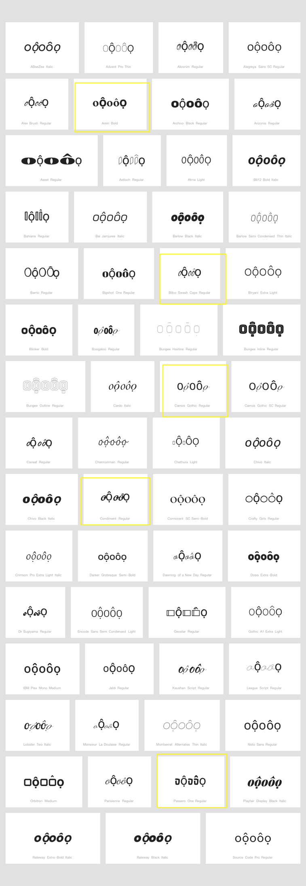
Findings:
The modifiers stay in place even in fonts with strong deviation from standard shapes or where font substitution takes place.

Conclusions:

No variant relationship is warranted.

D.4.12 Breve + Dot Below

Code Points Considered:

Code Points | Glyph | Name
0061 | a | Latin Small Letter A
0103 | ă | Latin Small Letter A with Breve
1EA1 | ạ | Latin Small Letter A with Dot Below
1EB7 | ặ | Latin Small Letter A with Breve and Dot Below

Sequence aặaăạ (0061 1EB7 0061 0103 1EA1) compared using Google Fonts in https://wordmark.it/:

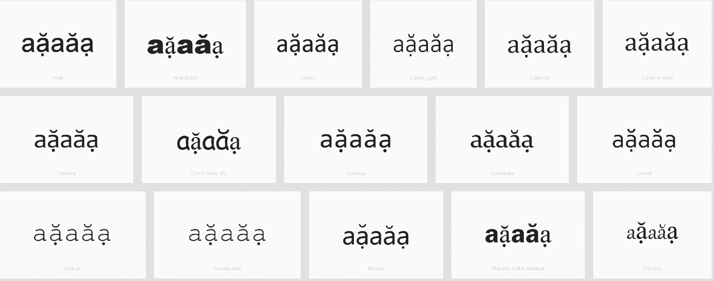

Findings:

The double diacritics stay at the base character and thus will not be confused with characters next to it having just one of the diacritics.

D.4.13 Dot below and combining acute accent

Code Points Considered:

Code Points | Glyph | Name
0065 | e | Latin Small Letter E
006F | o | Latin Small Letter O
00E9 | é | Latin Small Letter E with Acute
00F3 | ó | Latin Small Letter O with Acute
1EB9 | ẹ | Latin Small Letter E with Dot Below
1EB9 + 0301 | ẹ́ | Latin Small Letter E with Dot Below + Combining Acute Accent
1ECD | ọ | Latin Small Letter O with Dot Below
1ECD + 0301 | ọ́ | Latin Small Letter O with Dot Below + Combining Acute Accent

Sequence (eẹ́e and oọ́o) (U+0065 U+1EAB+0301 U+0065 and U+006F U+1ECD+0301 U+006f) compared using Google Fonts in https://wordmark.it/ :

Findings:
Downloading picture from wordmark.it does not give the right picture of the screen:
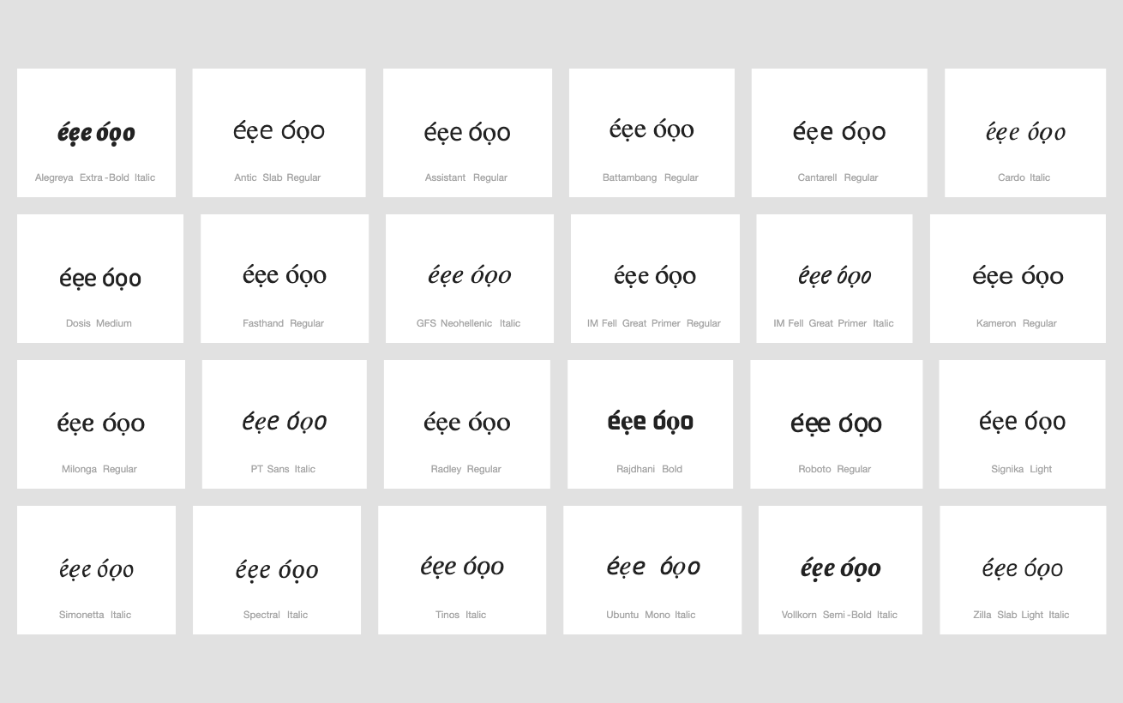

Printing web page as .pdf, then converting it to .jpg gives right picture of the screen
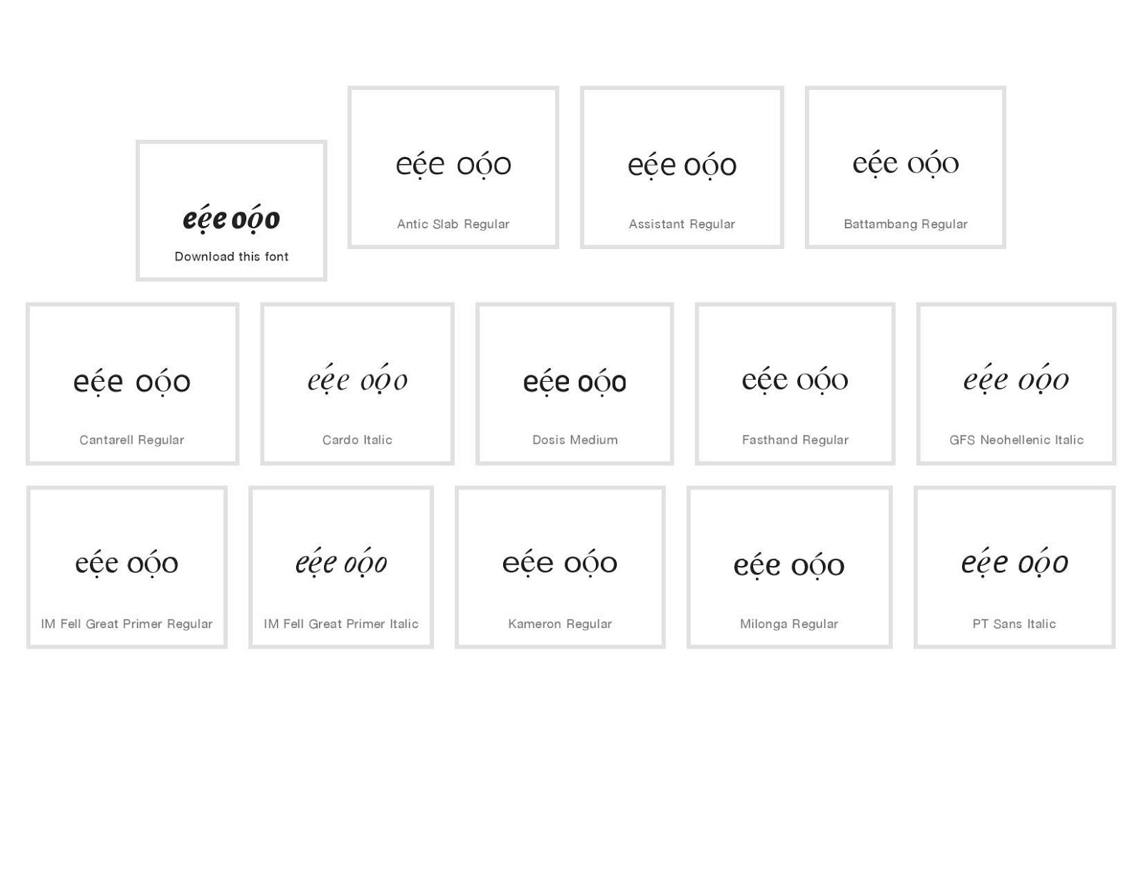
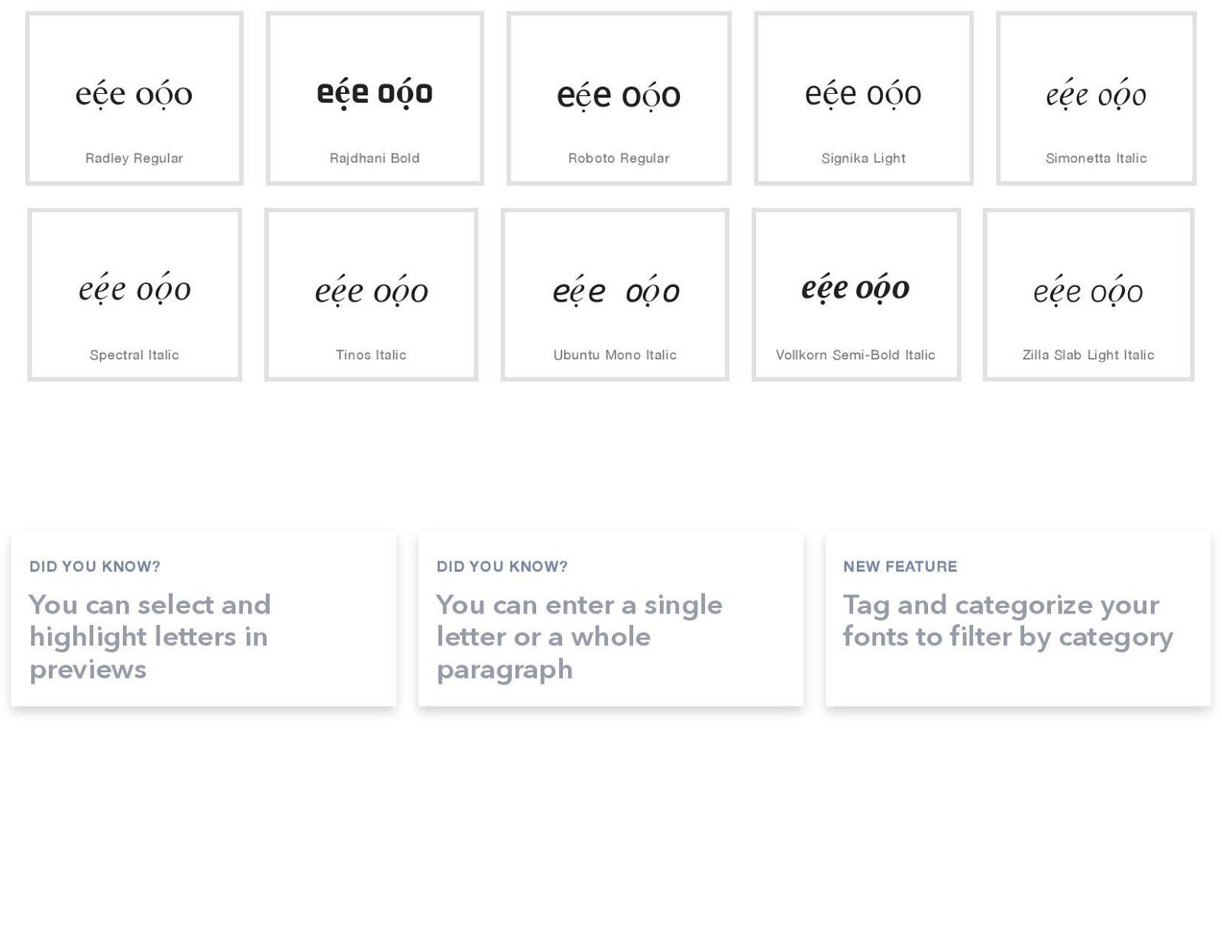

Conclusions:
Stacking diacritics are always in place

D.4.14 Circumflex + Acute Above

Code Points Considered:

Code Points | Glyph | Name
0061 | a | Latin Small Letter A
0065 | e | Latin Small Letter E
006F | o | Latin Small Letter O
00E1 | á | Latin Small Letter A with Acute
00E2 | â | Latin Small Letter A with Circumflex
00E9 | é | Latin Small Letter E with Acute
00EA | ê | Latin Small Letter E with Circumflex
00F3 | ó | Latin Small Letter O with Acute
00F4 | ô | Latin Small Letter O with Circumflex
1EA5 | ấ | Latin Small Letter A with Circumflex and Acute
1EBF | ế | Latin Small Letter E with Circumflex and Acute
1ED1 | ố | Latin Small Letter O with Circumflex and Acute
Sequence ấaâá (1EA5 0061 00E2 00E1) compared using Google Fonts in https://wordmark.it/:
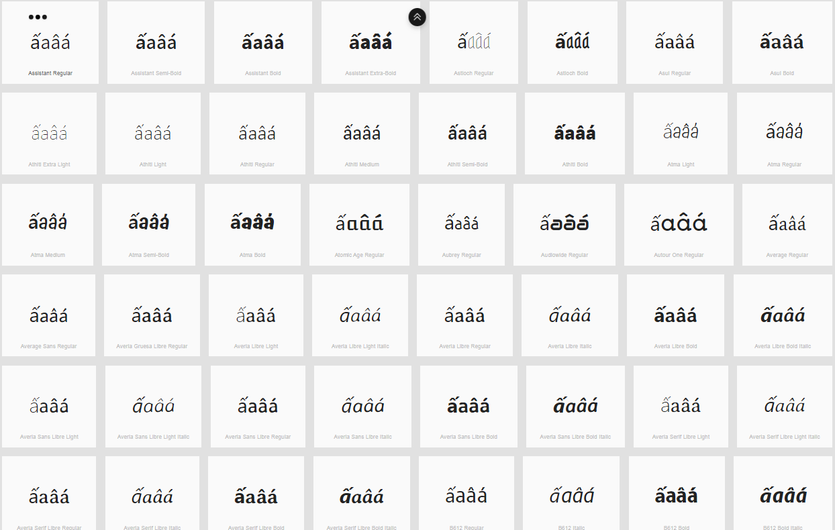
Sequence ếeêé (1EBF 0065 00EA 00E9) compared using Google Fonts in https://wordmark.it/:
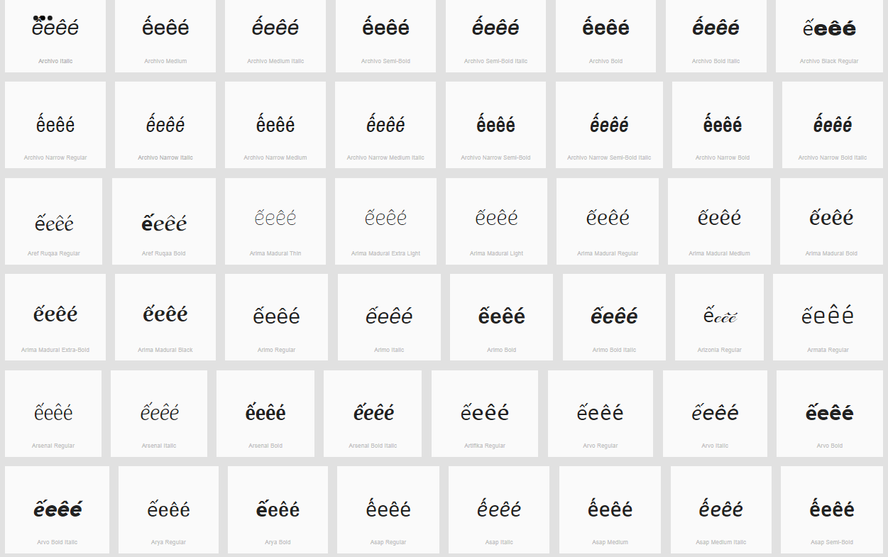
Sequence ốoôó (1ED1 006F 00F4 00F3) compared using Google Fonts in https://wordmark.it/:
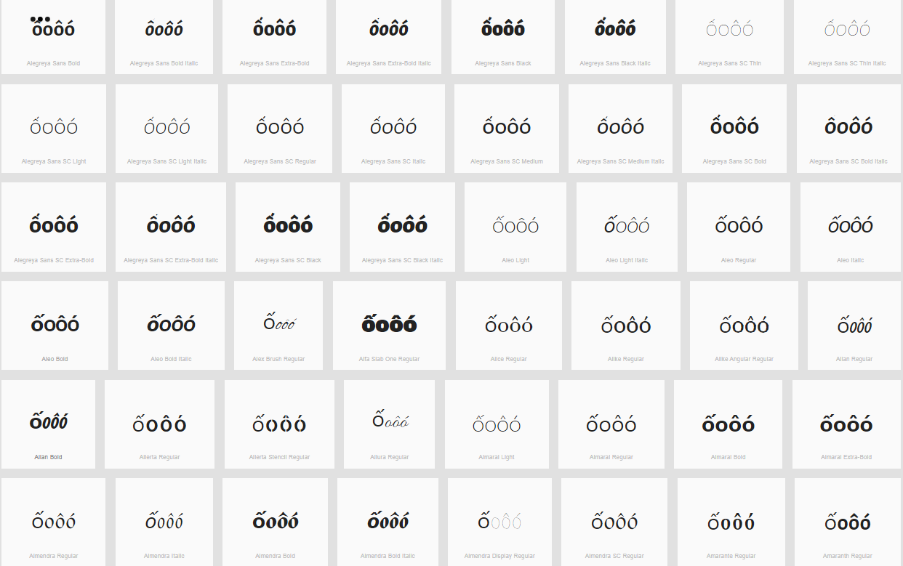

Findings: Diacritics are rendered in a consistent manner, but in some fonts circumflex and acute together can be confused with a Tilde

Conclusions:

D.4.15 Acute (vs. Non-Acute)

Code Points Considered:

Code Points | Glyph | Name
00E1 | á | Latin Small Letter A with Acute
00E9 | é | Latin Small Letter E with Acute
00ED | í | Latin Small Letter I with Acute
00F3 | ó | Latin Small Letter O with Acute
00FA | ú | Latin Small Letter U with Acute
00FD | ý | Latin Small Letter Y with Acute
0107 | ć | Latin Small Letter C with Acute
013A | ĺ | Latin Small Letter L with Acute
0144 | ń | Latin Small Letter N with Acute
0155 | ŕ | Latin Small Letter R with Acute
015B | ś | Latin Small Letter S with Acute
017A | ź | Latin Small Letter Z with Acute
0061 | a | Latin Small Letter A
0065 | e | Latin Small Letter E
0069 | i | Latin Small Letter I
006F | o | Latin Small Letter O
0075 | u | Latin Small Letter U
0079 | y | Latin Small Letter Y
0063 | c | Latin Small Letter C
006C | l | Latin Small Letter L
006E | n | Latin Small Letter N
0072 | r | Latin Small Letter R
0073 | s | Latin Small Letter S
007A | z | Latin Small Letter Z

Sequence (aácćeéiílĺnń) (0061 00E1 0063 0107 0065 00E9 0069 00ED 006C 013A) compared using Google Fonts in https://wordmark.it/:

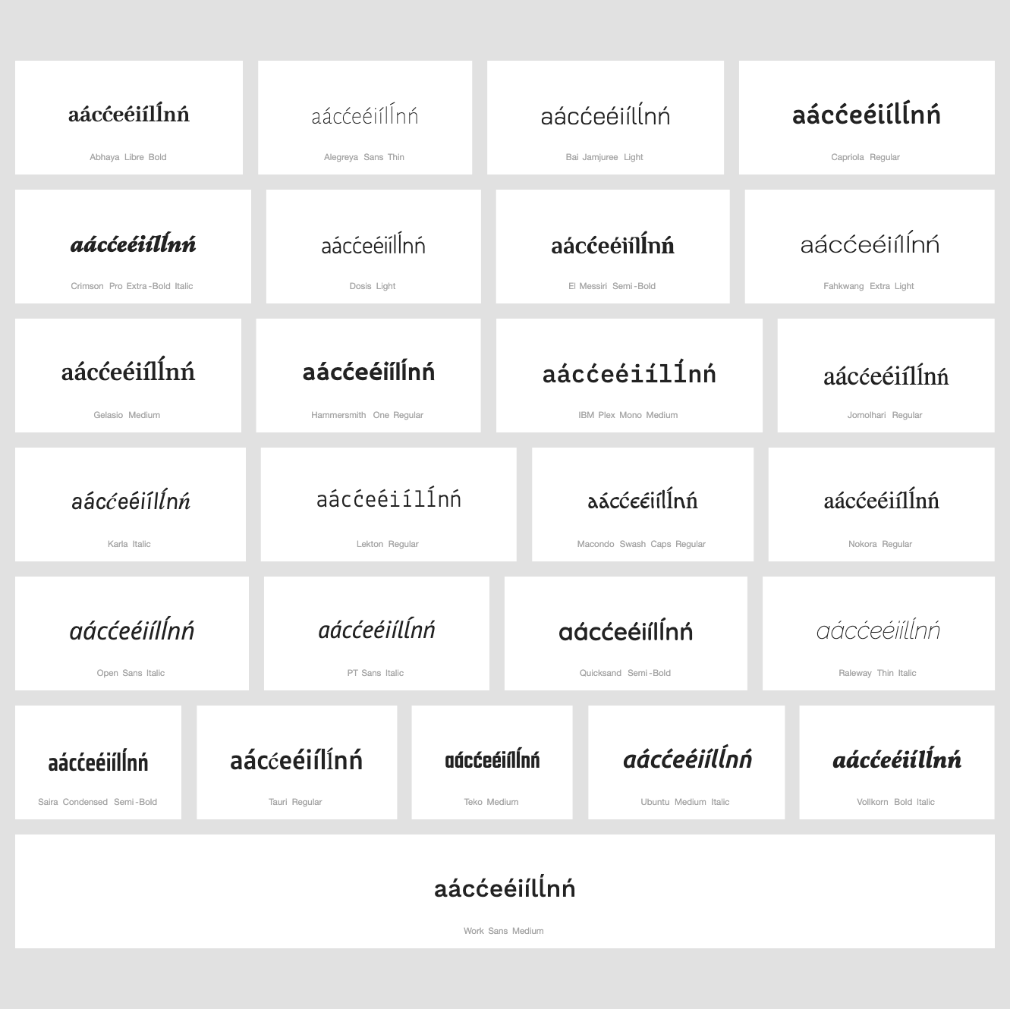

String (nńoórŕsśuùyýzź) compared using Google Fonts in https://wordmark.it/:

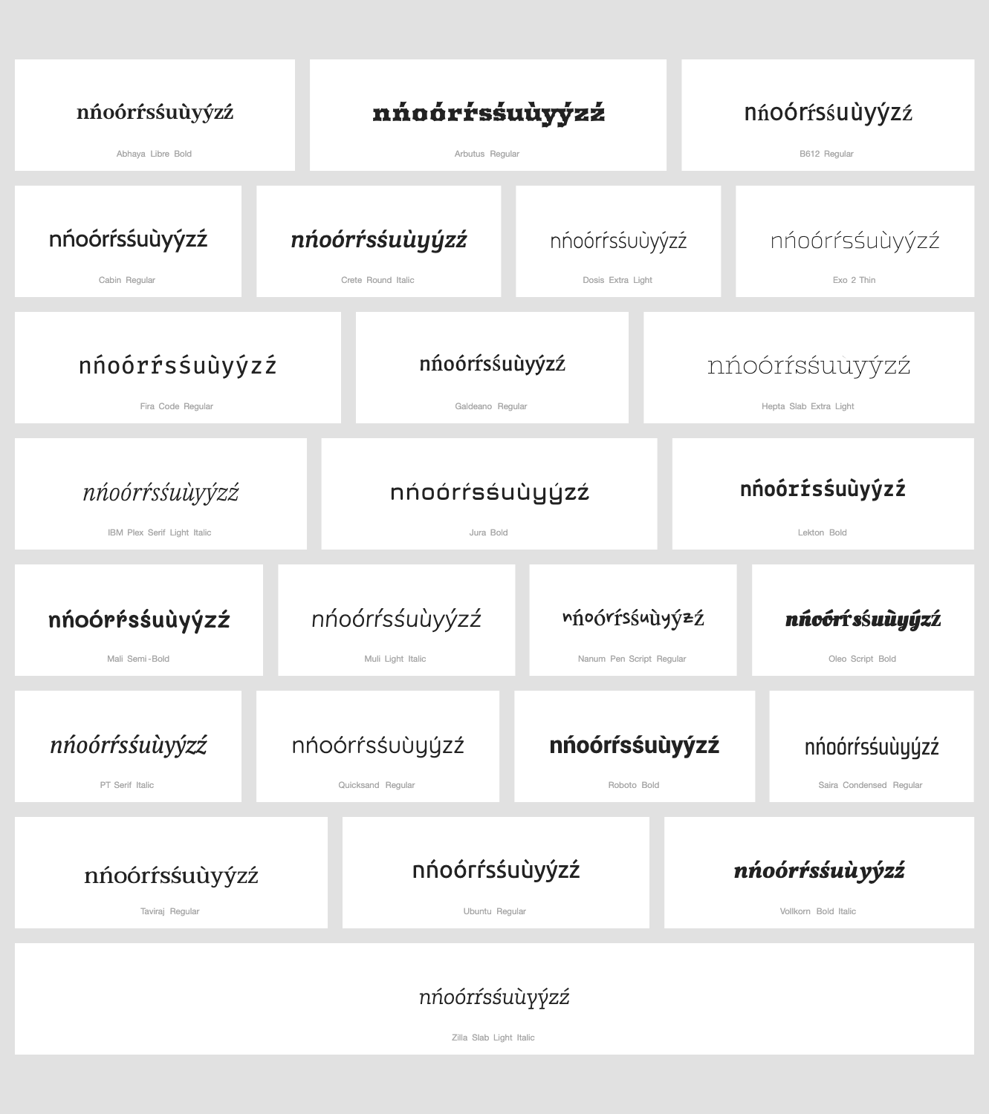

Findings: Acute is always in place

Conclusions: No variants candidates found

D.4.16 Circumflex Above + Grave Above

Code Points Considered:

Code Points | Glyph | Name
00E2 | â | Latin Small Letter A with Circumflex
00EA | ê | Latin Small Letter E with Circumflex
00E0 | à | Latin Small Letter A with Grave
00E8 | è | Latin Small Letter E with Grave
00F4 | ô | Latin Small Letter O with Circumflex
00F2 | ò | Latin Small Letter O with Grave
1EC1 | ề | Latin Small Letter E with Circumflex and Grave
1ED3 | ồ | Latin Small Letter O with Circumflex and Grave
006F | o | Latin Small Letter O
1EA7 | ầ | Latin Small Letter A with Circumflex and Grave
0061 | a | Latin Small Letter A
0065 | e | Latin Small Letter E
Sequence aầaàâ (0061 1EA7 0061 00E0 00E2) compared using Google Fonts in https://wordmark.it/:
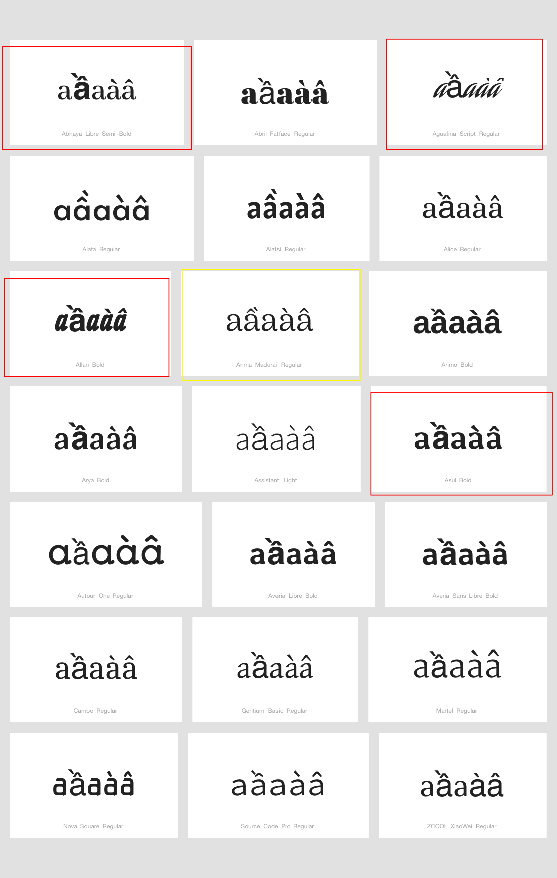

Sequence eềeèê (0065 1EC1 0065 00EA 00E8) compared using Google Fonts in https://wordmark.it/:
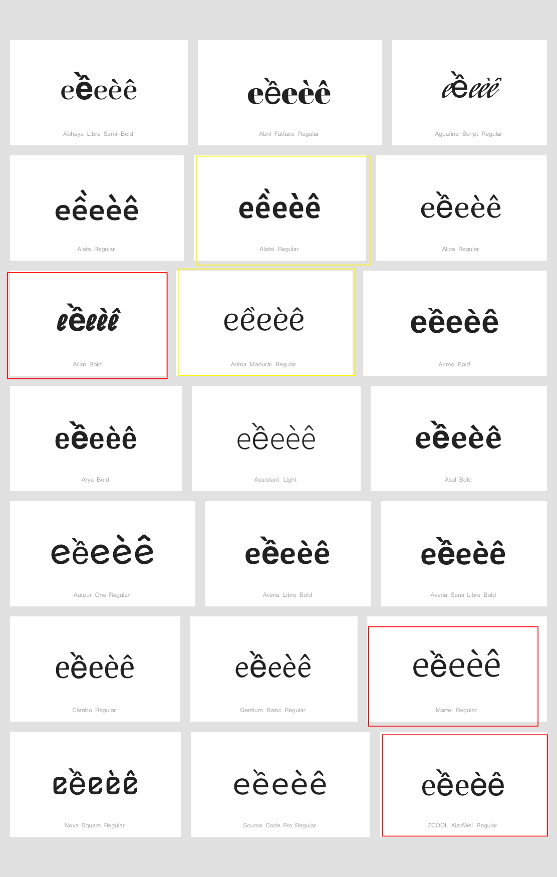

Sequence oồoòô (006F 1ED3 006F 00F4 00F2) compared using Google Fonts in https://wordmark.it/:
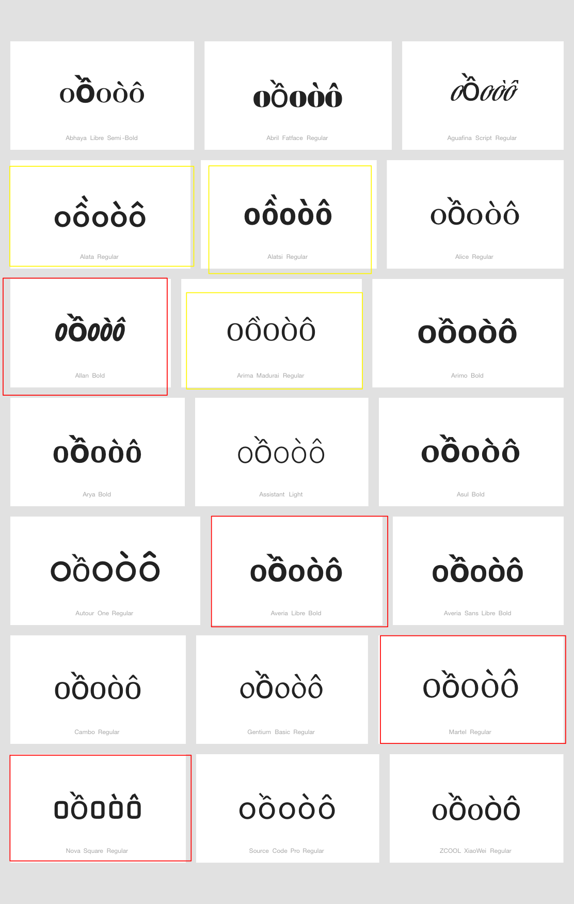

Findings:
There is no stability in the way the grave is positioned. In few fonts it occurs above the circumflex, in a minority of fonts it occurs displaced to the right, here highlighted in yellow. In a significant minority of fonts the grave occurs instead misplaced to the left of the basic letter shape, and in all such cases presented here (but particularly in the case of a with circumflex and grave) the unmodified basic letter shape followed by the the same with circumflex and grave may appear to carry the grave. Accordingly there is a specific risk for confusion by latin script users of a, e, or o followed by the same with circumflex and grave with a sequence of the same, first with a grave then with circumflex on top.

Conclusions:
To ensure safety and stability of the zone, and given the misleading placement of the grave in the cases discussed, it seems warranted to create three variant pairs:
àâ should be in a variant relationship with aầ
èê should be in a variant relationship with eề
òô should be in a variant relationship with oồ

D.4.17 Breve and Acute Above

Code Points Considered:

Code Points | Glyph | Name
1EAF | ắ | Latin Small Letter A with Breve and Acute
00E1 | á | Latin Small Letter A with Acute
0103 | ă | Latin Small Letter A with Breve
0061 | a | Latin Small Letter A

Sequence ắaăá (1EAF 0061 0103 00E1) compared using Google Fonts in https://wordmark.it/:

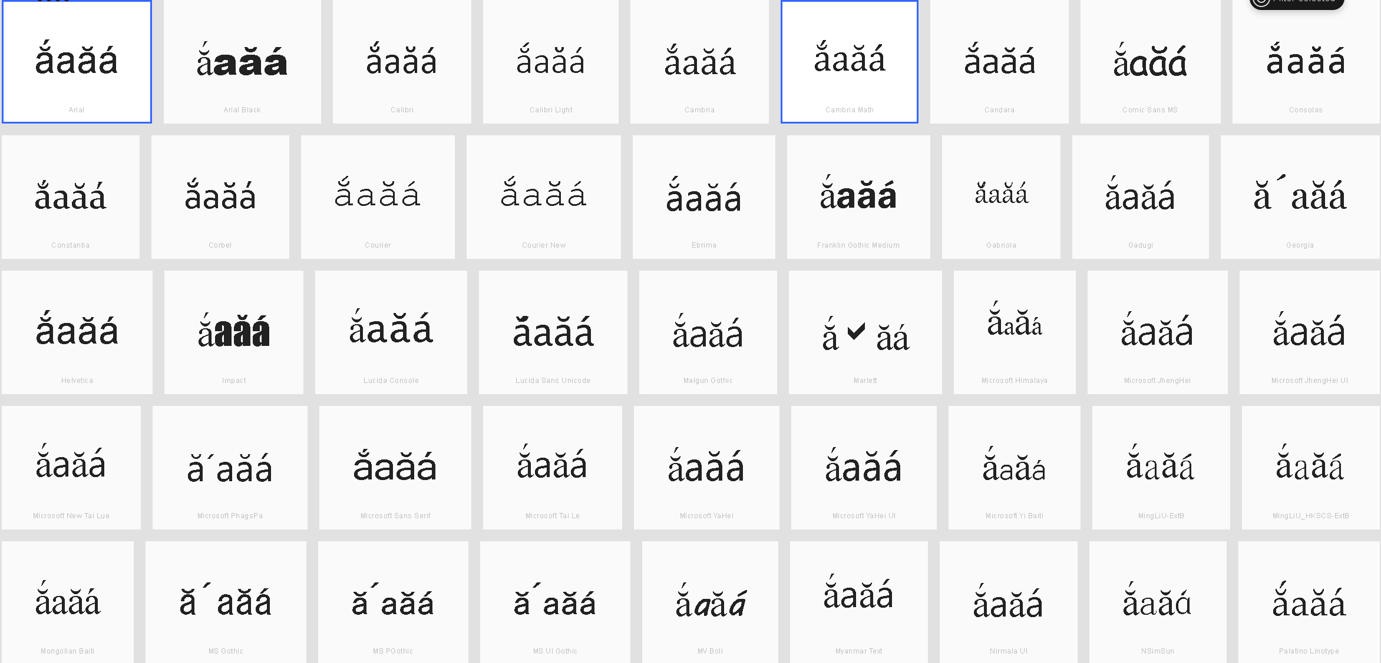
Findings:
In some fonts, the Acute diacritic is displaced to the right. However it does not appear to be above the following glyph, but standing alone.

Conclusions:
There should not be significant confusion with other glyphs.

D.4.18 Tilde and Horn (Above)

Code Points Considered:

Code Points | Glyph | Name
1EEF | ữ | Latin Small Letter U with Horn and Tilde
00F5 | õ | Latin Small Letter O with Tilde
01A1 | ơ | Latin Small Letter O with Horn
01B0 | ư | Latin Small Letter U with Horn
1EE1 | ỡ | Latin Small Letter O with Horn and Tilde
006F | o | Latin Small Letter O
0075 | u | Latin Small Letter U
0169 | ũ | Latin Small Letter U with Tilde

Sequence ỡoõơ (1EE1 006F 00F5 01A1) compared using Google Fonts in https://wordmark.it/:
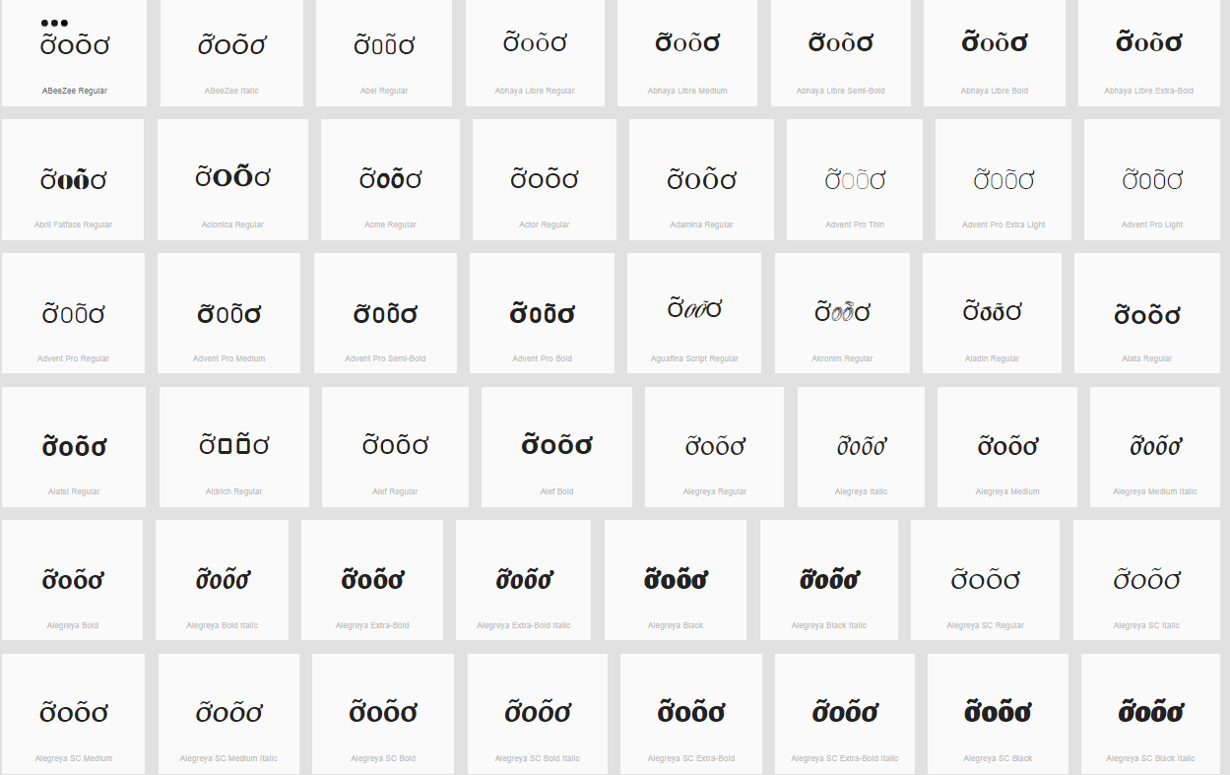
Sequence ữuũư (1EEF 0075 0169 01B0) compared using Google Fonts in https://wordmark.it/:
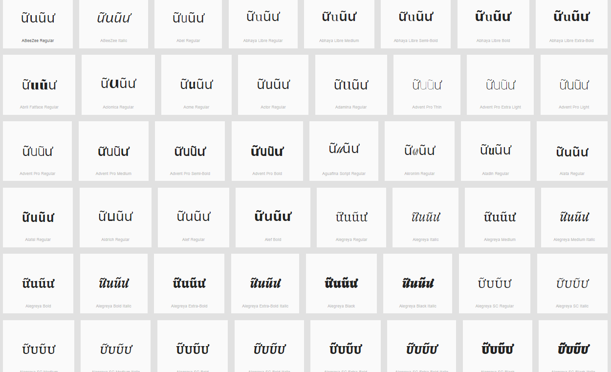
Findings: Diacritics are rendered in a consistent manner

Conclusions:

D.4.19 Dot Below + Combining Grave Accent

Code Points Considered:

Code Points | Glyph | Name
1EB9 + 0300 0065 00E8 1EB9 | e | Latin Small Letter E
1ECD + 0300 006F 00F2 1ECD | o | Latin Small Letter O
00E8 | è | Latin Small Letter E with Grave
00F2 | ò | Latin Small Letter O with Grave
1EB9 | ẹ | Latin Small Letter E with Dot Below
1EB9 + 0300 | ẹ̀ | Latin Small Letter E with Dot Above + Combining Grave Accent
1ECD | ọ | Latin Small Letter O with Dot Below
1ECD + 0300 | ọ̀ | Latin Small Letter O with Dot Below + Combining Grave Accent

Sequence ọ̀oòọ (1ECD + 0300 006F 00F2 1ECD) compared using Google Fonts in https://wordmark.it/:
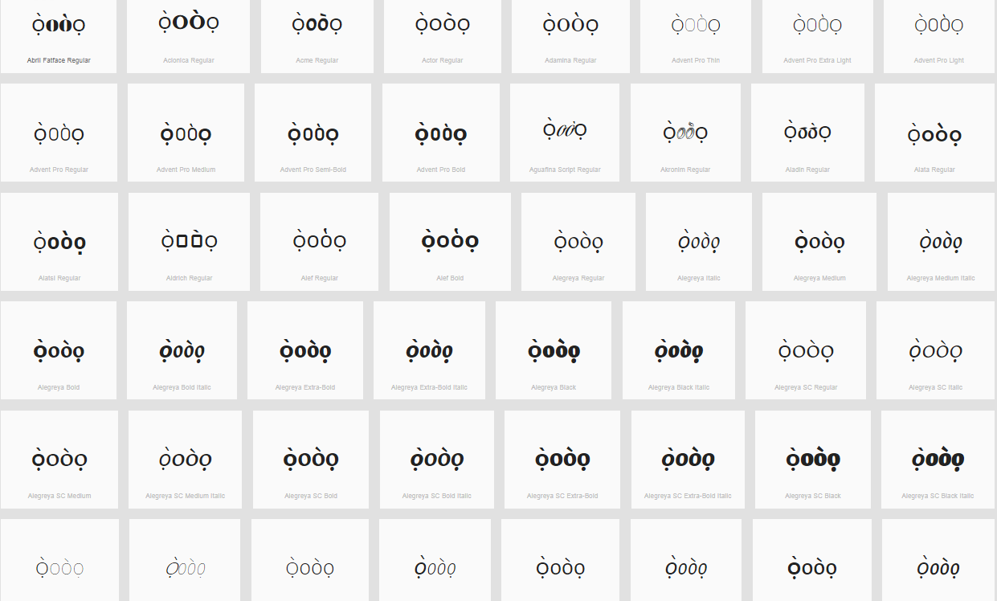
Sequence ẹ̀eèẹ (1EB9 + 0300 0065 00E8 1EB9) compared using Google Fonts in https://wordmark.it/:
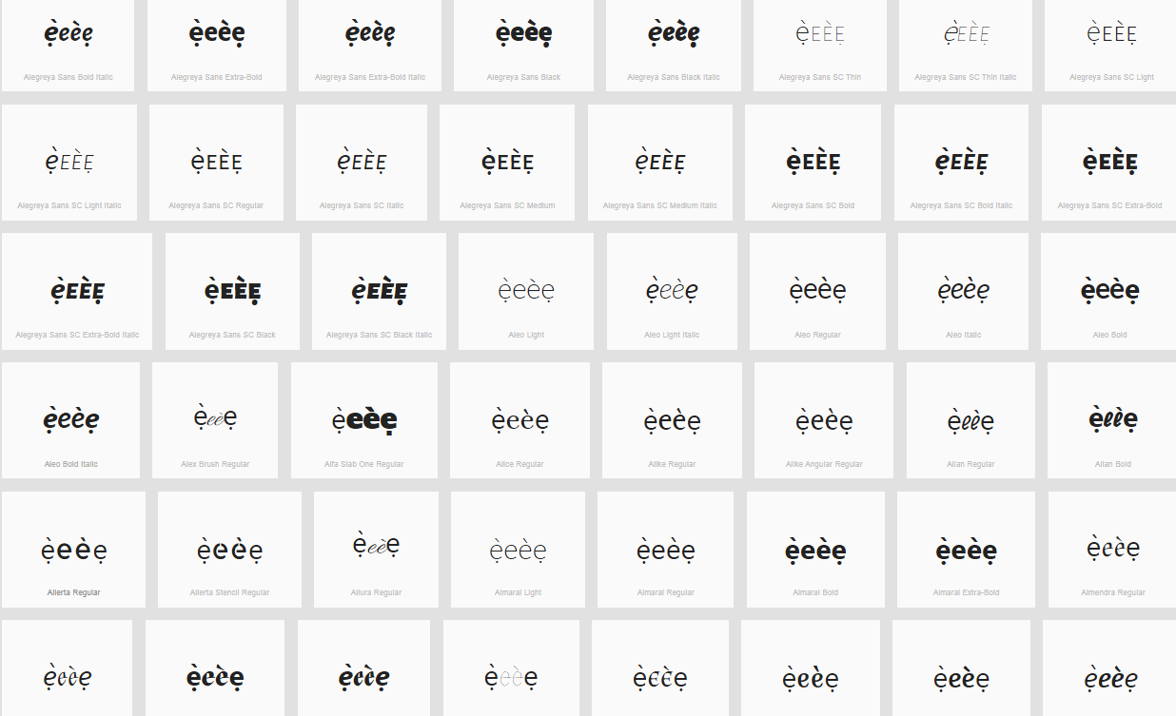

Findings: Diacritics are rendered in a consistent manner

Conclusions:

D.4.20 Horn and Dot Below

Code Points Considered:

Code Points | Glyph | Name
006F | o | Latin Small Letter O
0075 | u | Latin Small Letter U
01A1 | ơ | Latin Small Letter O with Horn
01B0 | ư | Latin Small Letter U with Horn
1ECD | ọ | Latin Small Letter O with Dot Below
1EE3 | ợ | Latin Small Letter O with Horn and Dot Below
1EE5 | ụ | Latin Small Letter U with Dot Below
1EF1 | ự | Latin Small Letter U with Horn and Dot Below

Sequence oợoọơ (006F 1EE3 006F 1ECD 01A1) compared using Google Fonts in https://wordmark.it/:
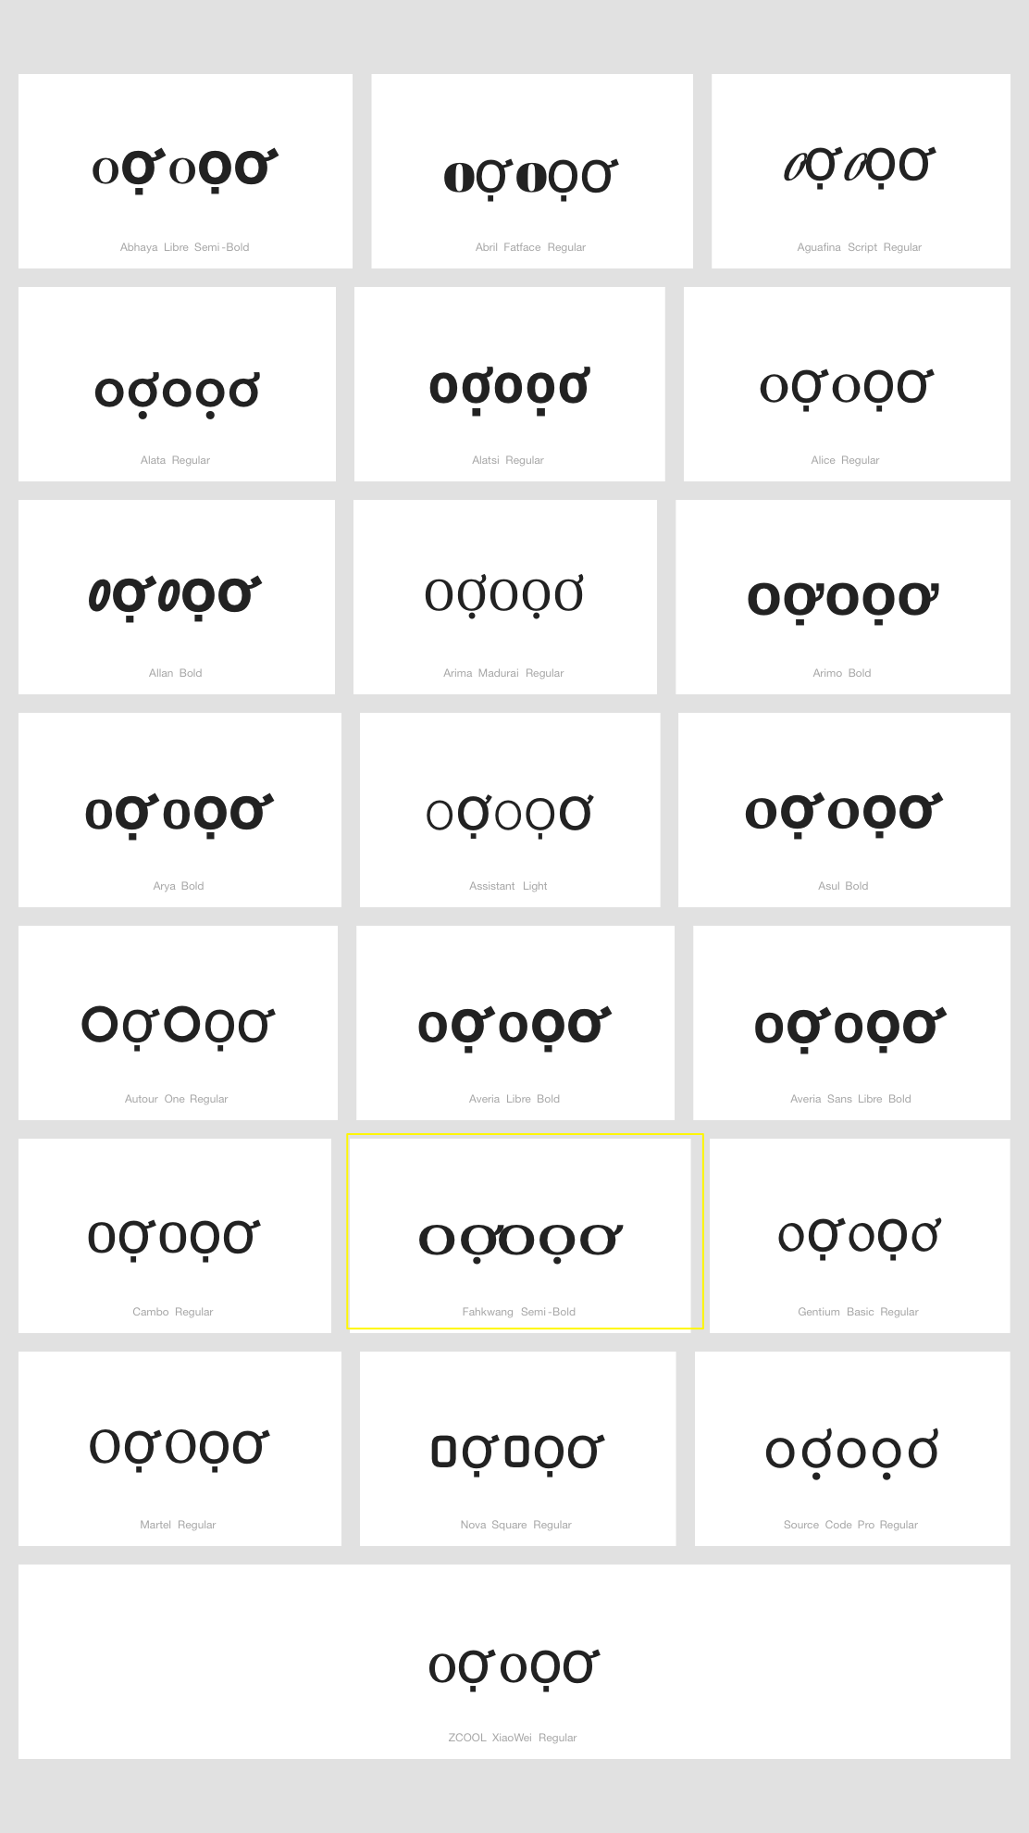

Sequence uựuụư (0075 1EF1 0075 1EE5 01B0) compared using Google Fonts in https://wordmark.it/:
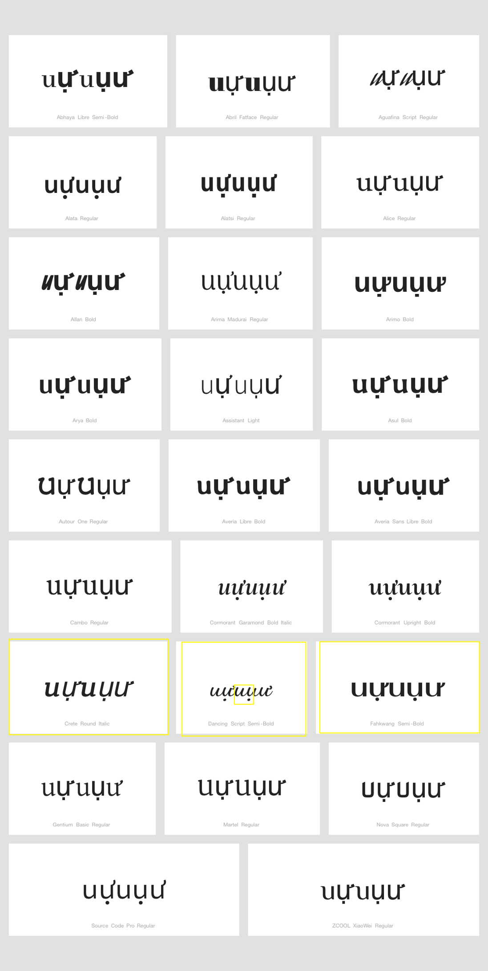

Findings:
In rare cases, it is not clear if the horn is a righthand-side modifier of the second character or a lefthand-side modifier of the third character. However there is no character with a lefthand-side modifier in the repertoire, which is why this does not pose a security risk.

Conclusions:
No variant relationship is warranted.

D.4.21 Stacking in Courier New (And Perhaps Other Fonts)

We have seen that, with precomposed Code Points, there is no stacking problem. However, when we have not had a precomposed Code Points available, we have necessarily used combining diacritics. Then, the situation changes. In particular, when using the Courier New font (which is one of our three standard fonts for analysis), there is sometimes a problem. Sometimes, the combining mark simply gets its own space, with the following letter shifter right to make room – which is irritating, but not confusing. However in other cases the combining mark appears to be associated with the following letter.

Code Points Considered:

1EB9 + 0301 | ẹ́ | Latin Small Letter E with Dot Below + Combining Acute Accent
1EB9 + 0300 | ẹ̀ | Latin Small Letter E with Dot Below + Combining Grave Accent
0067 + 0303 | g̃ | Latin Small Letter G + Combining Tilde
0268 + 0303 | ɨ̃ | Latin Small Letter I with Stroke + Combining Tilde
1ECD + 0300 | ọ̀ | Latin Small Letter O with Dot Below + Combining Grave Accent
1ECD + 0301 | ọ́ | Latin Small Letter O with Dot Below + Combining Acute Accent
025B + 0331 + 0308 | ɛ̱̈ | Latin Small Letter Open E + Combining Diaeresis + Combining Macron Below
025B + 0331 | ɛ̱ | Latin Small Letter Open E + Combining Macron Below
0254 + 0331 | ɔ̱ | Latin Small Letter Open O + Combining Macron Below
0072 + 0303 | r̃ | Latin Small Letter R + Combining Tilde
0289 + 0303 | ʉ̃ | Latin Small Letter U with Bar + Combining Tilde

In each case below, the letter is followed by another letter (or two, in the case of two combining marks. (In each case shown, the letters were simply copied, then the font changed.)
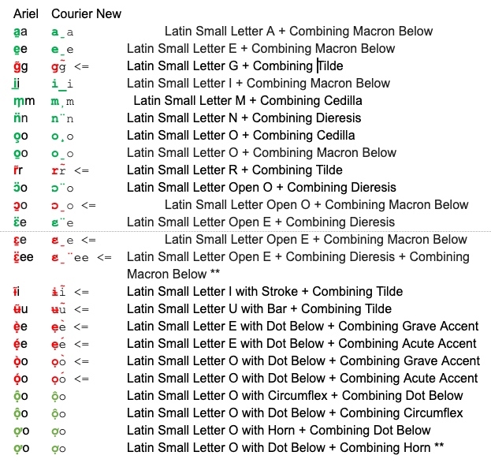

Findings:
With each of these cases, error is a certainty. The ideal solution, of course, would be for the Unicode Consortium to create new pre-composed Code Points for these problem cases. But the Unicode Consortium does not plan on creating any new codepoints.

D.4.22 Visual Variant Analysis

D.4.22.1 Consonants

D.4.22.2 Vowel ‘a’

D.4.22.3 Vowel ‘e’

D.4.22.4 Vowel ‘i’

D.4.22.5 Vowel ‘o’

D.4.22.6 Vowel ‘u’

D.5 IDNA 2003 Compatibility

D.5.1 Latin Small Letter Sharp S (ß) 00DF

IDNA2003 Versus IDNA2008
One of the differences between IDNA2008 and IDNA2003 is the treatment of four characters, one of which is relevant to the Latin Script LGR, the Latin Small Letter Sharp S or 00DF. Despite the fact IDNA2008 superseded IDNA2003, some applications continued to apply the character mapping from IDNA2003 resulting in DNS lookup queries that look like the following:

Table D.1. DNS resolution comparison for Sharp S (00DF)
Char | Example | IDNA2003 Result | IDNA2008 Result
ß  00DF | href="http://faß.de" | http://faß.de →  http://fass.de | http://faß.de →  http://xn--fa-hia.de
Source: https://unicode.org/reports/tr46/#Transition_Considerations

The difference in application behavior relative to DNS labels containing the code point 00DF causes two types of problems:

- Failure of service. The user intends to navigate to “example.faß” but the application sends the user to “example.fass” which doesn’t exist, because the domain name is not registered or is blocked or withheld.
- Misconnection. The user intends to navigate to “example.faß” but the browser returns “example.fass” which is controlled by a different registrant.

The situation is summarized in Diagram D.1 below:

Diagram D.1: Resolution of Latin Small Letter Sharp S (ß) 00DF in Different Enviroments
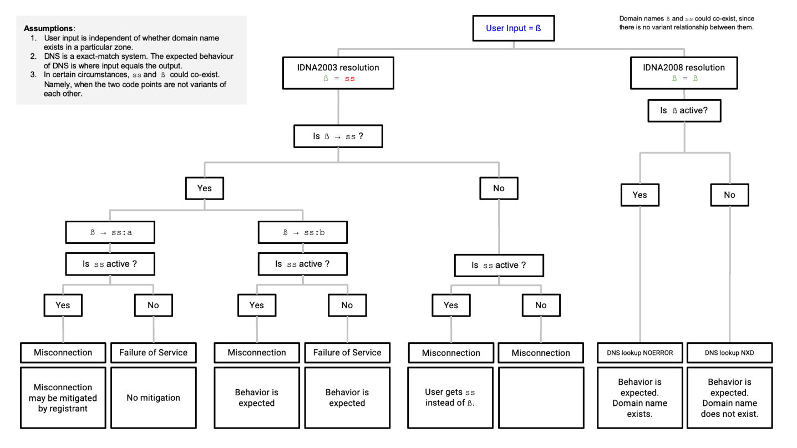

Internet Browser Support
As of the writing of this proposal, certain Internet browsers process 00DF using the IDNA2003 mapping mechanism instead of doing the IDNA2008 conversion. A test with the four major Internet browsers shows that Google Chrome and Microsoft Edge have not fully implemented IDNA2008; they still are in what is called “transitional mode”. For more information about IDNA2008 transitional mode, see Unicode Technical Standard #46 at https://unicode.org/reports/tr46/.

Table D.2. Resolution of http://faß.de by Different Internet Browsers
Internet Browser | http://faß.de resolves to
Microsoft Edge/Explorer | http://fass.de
Apple Safari | http://xn--fa-hia.de
Firefox | http://xn--fa-hia.de
Google Chrome | http://fass.de

The trend of browser implementation seems to be towards full IDNA2008 compliance (given that Apple Safari and Firefox did migrate from IDNA2003 to IDNA2008). However, it is not clear how soon or late Google Chrome or Microsoft Edge will fully transition to IDNA2008. See for example, https://bugs.chromium.org/p/chromium/issues/detail?id=941691

As of March 2019, Chrome has the largest browser market share in Germany, which suggests an important part of the end-user population is exposed to the problem with DNS lookups when utilizing the non-IDNA2008-conforming browsers when the label contains code point 00DF.

Diagram D.2: Market Share of the Most Used Browser Versions in Germany in March 2019

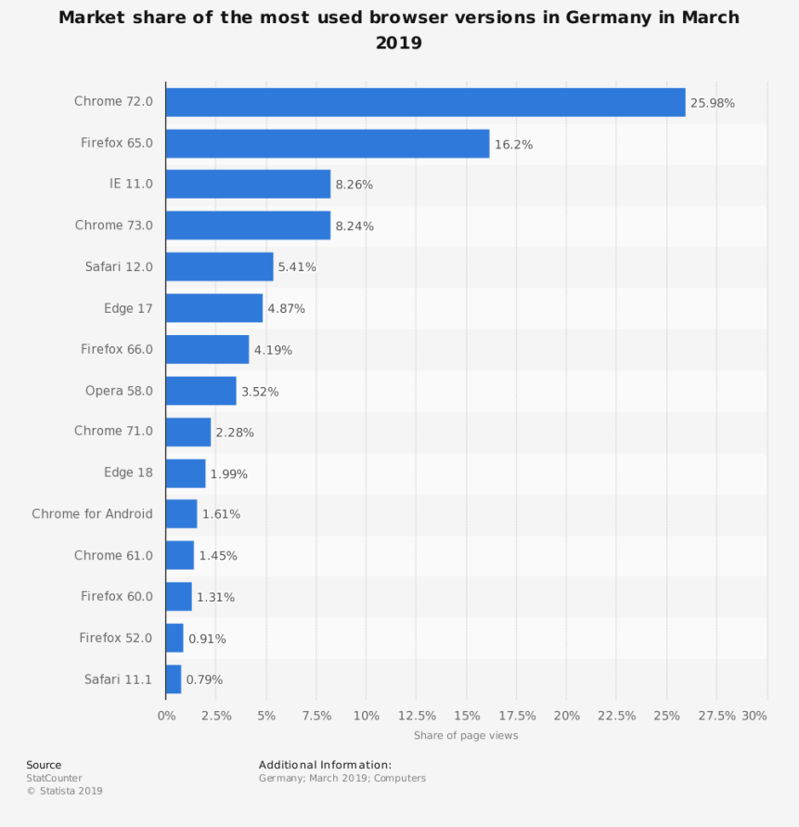

Registry Implementation at the Second Level
Latin GP sought the input of TLD registries serving the German-speaking communities, namely DENIC (www.denic.de), NIC.AT (www.nic.at), and SWITCH (www.nic.ch) to inform Latin GP’s solution regarding the IDNA2003 compatibility issue.

At the second level, the .DE registry (DENIC) offers 00DF as a separate, stand-alone code point; in consequence these hypothetical domain names “straße.de" and "strasse.de" would be offered for registration as two separate domains. The .CH registry (SWITCH) and the .AT registry (nic.at) do not offer 00DF in their repertoires for the second level per their published policies .

Input from the German User Community
The GP has sought input from experts of the three major German-speaking ccTLDs (namely Denic, nic.at, and switch, for Germany, Austria, and Switzerland, respectively) on the topic of whether ß and ss should be considered variants. After some discussions, these experts found the following consensus solution, which they suggested to the GP for use at LGR level:

Table D.3 Solution Suggested by the German User Community

Group | ß vs ss
Target |  |  | Source |  |  | Variant Candidate [Yes/No] | Disposition [Allocatable/  Blocked] | Rationale
Code Point | Glyph | Name | Code Point | Glyph | Name | Variant Candidate [Yes/No] | Disposition [Allocatable/  Blocked] | Rationale
00DF | ß | Latin Small Letter Sharp S | 0073  +  0073 | ss | Latin Small Letter S +  Latin Small Letter S | YES | Blocked | See Section 6.6.2
0073  +  0073 | ss | Latin Small Letter S +  Latin Small Letter S | 00DF | ß | Latin Small Letter Sharp S | YES | Allocatable | See Section 6.6.2

The experts from the German-speaking ccTLD of German users suggested two main reasons for creating this variant relation:
- There are still browsers (e.g. Chrome) that apply IDNA2003 at the time of writing. Users of such browsers have each ß automatically replaced by a sequence of two s.
- Swiss users do not use ß and consider it as equivalent to ss, even where they are able to recognize and point out the differences, when pressed to do so. In consequence, a Swiss user would e.g. very likely rewrite an IDN as .strasse even where it had been presented to the same user .straße before. Therefore, a variant relationship is warranted on non-visual grounds.
For the variant disposition, the same experts were of the opinion that ß needs to be allocatable towards ss, since the same transformation is done by IDNA2003 and since the same is a long-standing and widely-applied orthographic solution by the German-language community also outside of IDNs, considered valid by all users, especially in the context of domain names. For the other direction, however, the experts were of the opinion ,that the disposition should be blocked since there are many non-German words having a double ss (e.g., cross, process, discussion) for which the same label with ß makes no sense (e.g., croß, proceß, discußion), which would lead to the generation of too many invalid variants otherwise.

Possible Solutions to Address the IDNA2003 Compatibility Issue for Latin Small Letter Sharp S (ß) 00DF: Pros and Cons
Based on the evidence presented, the GP tried to weigh different solutions to address the IDNA 2003 Compatibility issues, which are summarized in Diagram D.3:

Diagram D.3: General Factors to Resolving the IDNA2003 Compatibility Issue in the Case of Latin Small Letter Sharp S (ß) 00DF
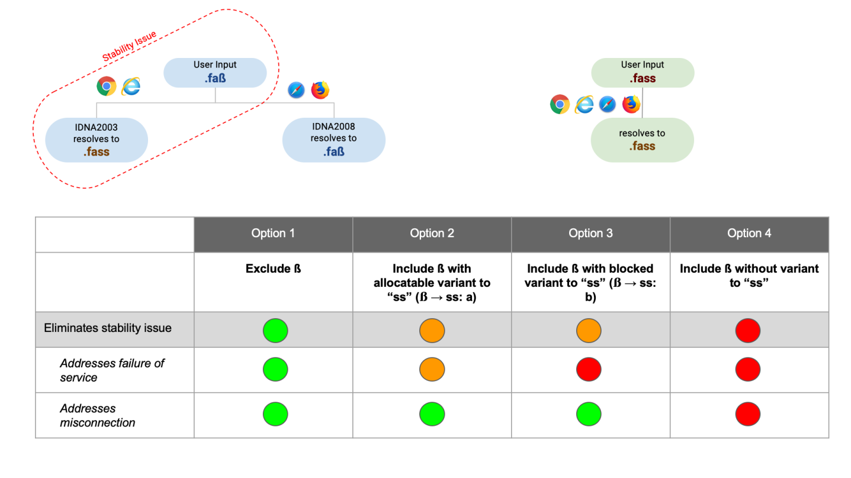

The pros and cons for each solution are presented in more detail in the following tables:

Table D.3. Solution excluding 00DF from the Latin script repertoire
Pros | Cons
- Most conservative option; removes the option of DNS labels with code point 00DF. The possibility of landing at the “wrong” website is greatly diminished because there would be only one version of the website (i.e. the one using ‘ss’ (0073 0073)). | - Misconnection or failure of service is still possible when using Chrome or Edge (albeit only one domain name would actually exist) because user input is independent of whether a domain name exists or not.  - Code point 00DF is used in the orthography of German as written in Germany and Austria (but not in Switzerland). German is an EGIDS level 1 language.  - For the German and Austrian part of the user community it would force a fallback for all names and words ordinarily spelled with 00DF. In many such cases, the spelling with “ss” actually identifies a different name or word (minimal pair), which effectively would restrict the linguistic freedom of these communities.
Table D.3. Solution including 00DF with variant relationship with ‘ss’ (ß → ss)

Pros | Cons
- The possibility of landing at the “wrong” website is diminished provided the two versions of domain names are controlled by the same entity.  - Enables labels that match the actual spelling for certain words and names in the German and Austrian part of the user community; code point  00DF is used in the orthography of German as written in Germany and Austria (but not in Switzerland). German is an EGIDS level 1 language. | - Limits registration choices.  - Due to transitivity there will be a variant relationship ß (Latin Sharp S, 00DF) → ‘ss’ → β (Greek Beta, 03B2), therefore imposing a cross-script variant on the Greek script LGR.  - Failure of service or misconnection may occur depending on application’s implementation (IDNA2003 or IDNA2008 + TR46).  - Due to overlap of “ss” with ‘s’, there will be additional variants consisting of pairs of all variants of ‘s’ to ensure that variant label sets are well-behaved. See RFC 8228.

Table D.4. Solution for Disposition: Allocatable versus Blocked ß → ss
2.1 ß → ss: Allocatable | 2.2 ß → ss: Blocked
- It would be possible for a registry operator to apply for the variant label. Per the latest IDN variant TLD Management Framework recommendation, each TLD variant should be evaluated and processed as a standalone TLD (i.e. separate application fee, evaluation process, etc.)  - If registry operator does not apply for the variant label, the label will remain reserved for said registry operator.  - Misconnection cannot occur but failure of service can.  - Because there are words that contain multiple instances of 00DF, measures must be implemented to prevent more than two allocatable variants, i.e. one for the German/Austrian spelling and one for the Swiss. | - With a “blocked” disposition, the variant label would remain withheld from registration by any registry operator.  - Misconnection cannot occur but failure of service can.

Table D.5. Solution for Disposition: Allocatable versus Blocked ss → ß

2.3 ss → ß: Allocatable | 2.4 ss → ß: Blocked
- Simpler solution for TLD applicant; the TLD applicant does not need to be concerned about asymmetrical relationship. Can apply for the ‘ss’ version first and apply for the 00DF version at a later point in time.  - German-language users do not expect that all labels spelled with double ‘ss’ can also be represented with a label with letter Sharp S (00DF); Swiss users expect a label with Sharp S (00DF) to always be represented with a label with double ‘ss’, while German and Austrian users may accept that as a fallback. | - Alignment with LGR procedure (i.e. minimize allocatable variants)  - No linguistic expectations on the side of the users.  Most conservative option according to the LGR Procedure  - Denies the opportunity to apply for the 00DF version, if ‘ss’ is registered first.

Table D.6. Solution to Include 00DF without variant relationship with ‘ss’
Pros | Cons
- Option is consistent with implementation by DENIC (German registry); German users have been conditioned to this behavior.  [NOTE; this solution may have been adopted because the use of an alternative using variants may not have been considered.]  [MT: I suppose that GP need not to discuss this note] | - Failure of service or misconnection may occur depending on the application's implementation (IDNA2003 or IDNA2008 + TR46) with respect to ß.  - Forces applicants to register all label combinations to defend against spoofing (unless this is robustly excluded as part of the TLD process). In some cases, there are more than two possible combinations.  - Confusing for Swiss people as they generally use ‘ss’ in all cases for Sharp S (00DF).  - Need for defensive registration

Conclusion: Inclusion of 00DF with Variant Mechanism
The Latin GP proposes a solution that balances the needs of certain parts of the Latin script community while minimizing security and stability issues introduced by applications outside the DNS. The solution is to include Latin Small Letter Sharp S (00DF) with a variant relationship with the sequence of letters ‘ss’ (0073 0073), as follows:

Table D.7. Final Variant Solution for Latin Small Letter Sharp S (00DF)

Source Code Point | Variant Relationship | Target Code Point | Disposition
00DF  Latin Small Letter Sharp S | → | 0073 0073  Latin Small Letter S + Latin Small Letter S | Allocatable
0073 0073  Latin Small Letter S + Latin Small Letter S | → | 00DF  Latin Small Letter Sharp S | Blocked

This LGR solution along with the appropriate policies (i.e. TLD variant labels managed by the same entity, and second level variant labels managed by the same registrant) would not solve the failure of service problems but would mitigate the issues of misconnection.

[TBD: describe the additional variants needed because of overlap between the variant definitions for “ss” and “s”. Describe the additional methods needed to prevent more than two allocatable labels (variant subtyping) – see separate document. The IP will gladly provide assistance with formulating the proper LGR syntax, if requested.]
[MT: sould be done in some of the next versions of the report]

D.5.2 Latin Small Letter Dotless I (ı) 0131

There are four Latin code points that have special case (upper case/lower case) relationship:
- U+0069 Latin Small Letter I ("i")
- U+0049 Latin Capital Letter I ("I")
- U+0131 Latin Small Letter Dotless I ("ı")
- U+0130 Latin Capital Letter I with Dot Above ("İ")

In most locales Latin Small Letter I is lower case of Latin Capital Letter I, and reverse Latin Capital Letter I (U+0069) is upper case of Latin Small Letter I (U+0069). In those locales, Latin Capital Letter I (U+0049) is also upper case of Latin Small Letter Dotless I. It could be described as in the following chart:

Table D.8. Case Relationships for 0069, 0049, 0130, and 0131
Character | Process | Resulting Character | Process | Resulting Character
Latin Small Letter I  U+0069 | up case → | Latin Capital Letter I  U+0049 | down case → | Latin Small Letter I  U+0069
Latin Small Letter Dotless I  U+0131 | up case → | LatinCapital Letter I  U+0049 | down case → | Latin Small Letter I  U+0069
Latin Capital Letter I with Dot Above  U+0130 | down case → | Latin Small Letter I  U+0069 | up case → | Latin Capital Letter I  U+0049

In two locales, Turkish and Azeri, respectively, the case relationship is different. In those two, Latin Small Letter I and Latin Capital Letter I with Dot Above are in mutual upcase/downcase relationship to each other, as well as Latin Small Letter Dotless I and Latin Capital Letter I, which could be described as in the following chart:

Table D.9. Case Relationships in Turkish and Azeri Locales
Character | Process | Resulting Character | Process | Resulting Character
Latin Small Letter I | up case → | Latin Capital Letter I with Dot Above | down case → | Latin Small Letter I
Latin Small Leter Dotless I | up case → | Latin Capital Letter I | down case → | Latin Small Letter Dotless I

If we look at the repertoire of Latin code points for the root zone, as proposed by the Latin Generation Panel, Latin Small Letter I and Latin Small Letter Dotless I are included, whereas the capital letters are excluded. Capital letters are not even valid in IDNA2008, so the question is, is the case relationship described here a problem or even relevant?

Before IDNA2008, there was IDNA2003. Even though IDNA2003 has been replaced by IDNA2008 it is still implemented. For example, the web browser Google Chrome to date remains IDNA2003 compliant but not fully IDNA 2008 compliant. In IDNA2003 there is a pre-process, normalization, of domain names before conversion to punycode. That normalization includes down casing of Latin characters. For ASCII labels there is already an equivalence between upper case and lower case letters. And this is what users, based on decades of experience, expect to happen.

In an IDNA2003-compliant web browser it is expected that "EXÄMPEL" and "EXAMPLE" are equivalent to "exämpel" and "example", respectively. In an IDNA2008 browser "EXAMPLE" must be accepted, but "EXÄMPLE" could be rejected since "Ä" is not valid, but that is not how e.g. Mozilla Firefox and Apple Safari have been designed to handle the problem. They also do down case before the formal IDNA2008 process.

Even though down casing is not part of the formal IDNA2008 process, one of the IDNA2008 documents, RFC 5894, states that the user interface of an application, before IDNA2008 processing, can do normalization. The down casing in IDNA2008 browsers should probably be seen in that light.

While "TÄT" will probably be down cased to "tät" in the browser, what should the browser do with "TIT"? Depending on the locale that the browser is running in, it may be down cased to either "tit" or "tıt" (with or without the dot).

The casing, in an application, is expected to go in one direction, from upper case to lower case. When domain names are presented in text, however, it is common that domain names are presented in upper or mixed case. So "ice" might become "Ice" or "İce".

It is quite obvious from the text above that case shift of dotted or dotless I could create erroneous lookup, but the question is how large threat it would be to the users. Since the applications are expected to go from upper case to lower case, when they handle domain names, we should consider a situation where down casing could result in different lower case letters, i.e. when CAPITAL LETTER I is down cased.

With a non-Turkish and non-Azeri locale, a Latin CAPITAL LETTER I in a domain name is either down cased to Latin Small Letter I (IDN label) or equivalent to Latin Small Letter I (ASCII label).

With a Turkish or Azeri locale, a Latin Capital Letter I is expected to be down cased to Latin Small Letter Dotless I, but in an ASCII label in a domain name, it is still expected to be equivalent with Latin Small Letter I, because that is what the DNS standards says.

There is an obvious risk that, in a Turkish or Azeri locale that the two letters are confused or mistreated due to the case folding, and this confusion could be misused. To be on the safe side Latin Small Letter I and Latin Small Letter Dotless I should be variants. Accordingly, the following variant set could be the optimal solution:

Table D.10. Possible Variant Relationships for 0069 and 0131

Group | Dotless i vs. i
Target |  |  | Source |  |  | Variant Candidate [Yes/No] | Disposition [Allocatable/  Blocked] | Rationale
Code Point | Glyph | Name | Code Point | Glyph | Name | Variant Candidate [Yes/No] | Disposition [Allocatable/  Blocked] | Rationale
0069 | i | Latin Small Letter I | 0131 | ı | Latin Small Letter Dotless I | YES | Blocked | Risk of confusion due to inconsistent case folding
0131 | ı | Latin Small Letter Dotless I | 0069 | i | Latin Small Letter I | YES | Blocked | Risk of confusion due to inconsistent case folding

D.6 Underlining Evaluation Process

Because it is common for domain names to be presented as underlined by applications making use or representing IDNs, we evaluated those code points which include diacritics below the line and those which extend below the line. Code points were again displayed in the same three common fonts used for cross-script variants analysis, i.e. Arial, Courier New, and Times New Roman. Each pair was then evaluated by two members of the GP; if they agreed that the pair were variants, in any of the fonts, that finding was adopted. When there was disagreement, the pairs were evaluated by each of the members of the GP, and the median finding was adopted.

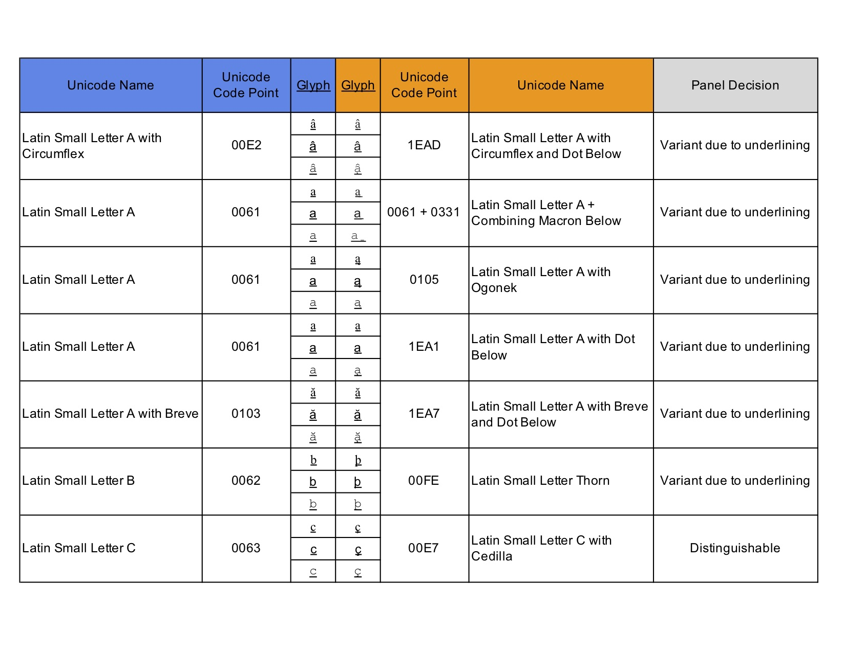

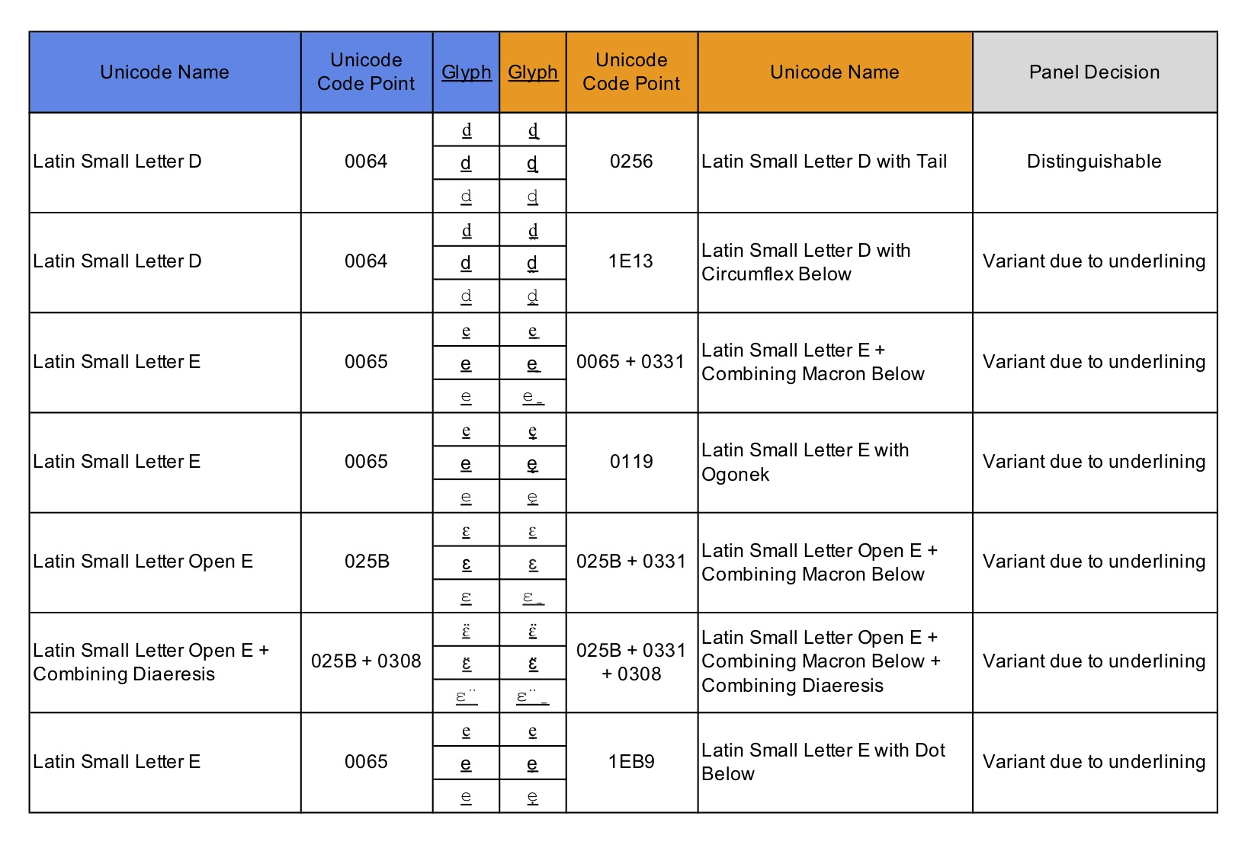

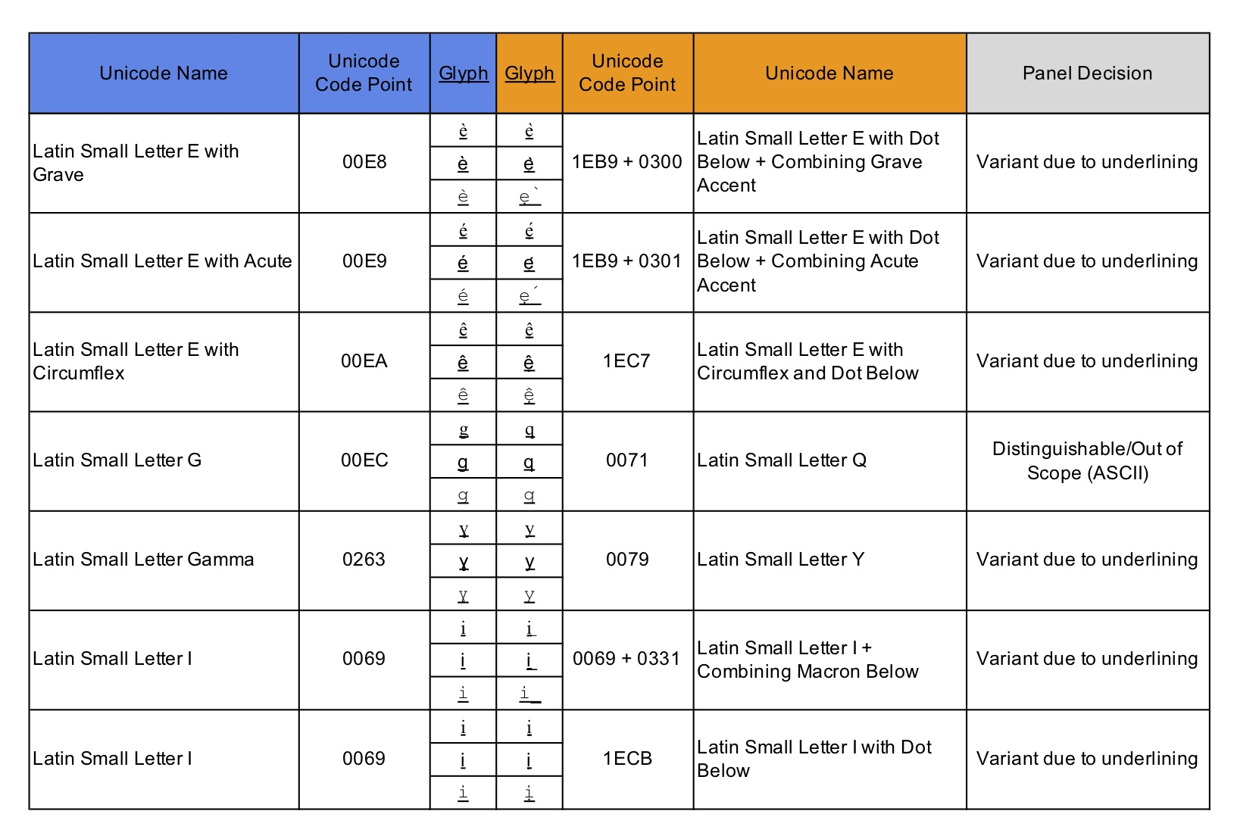
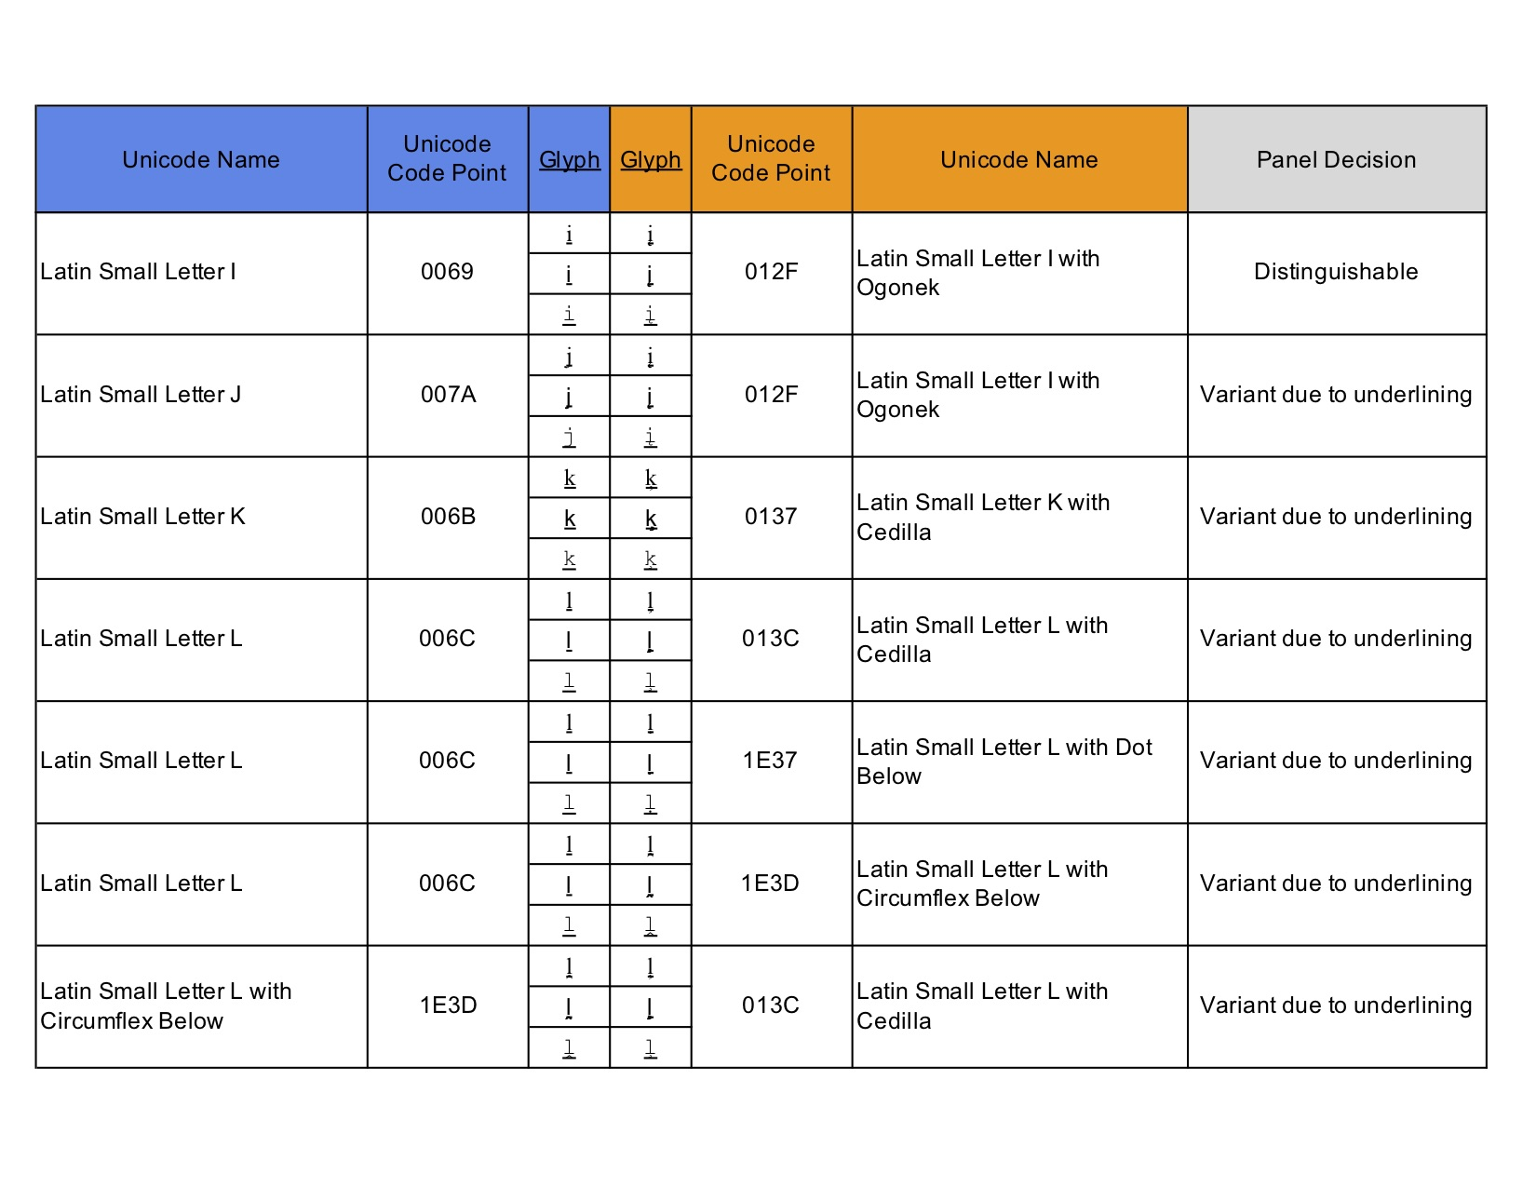
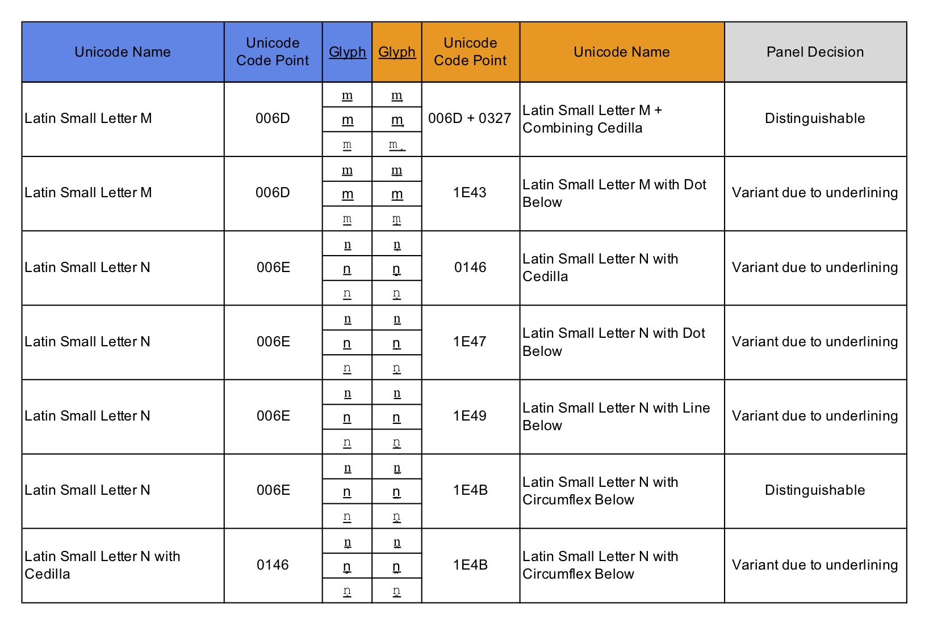
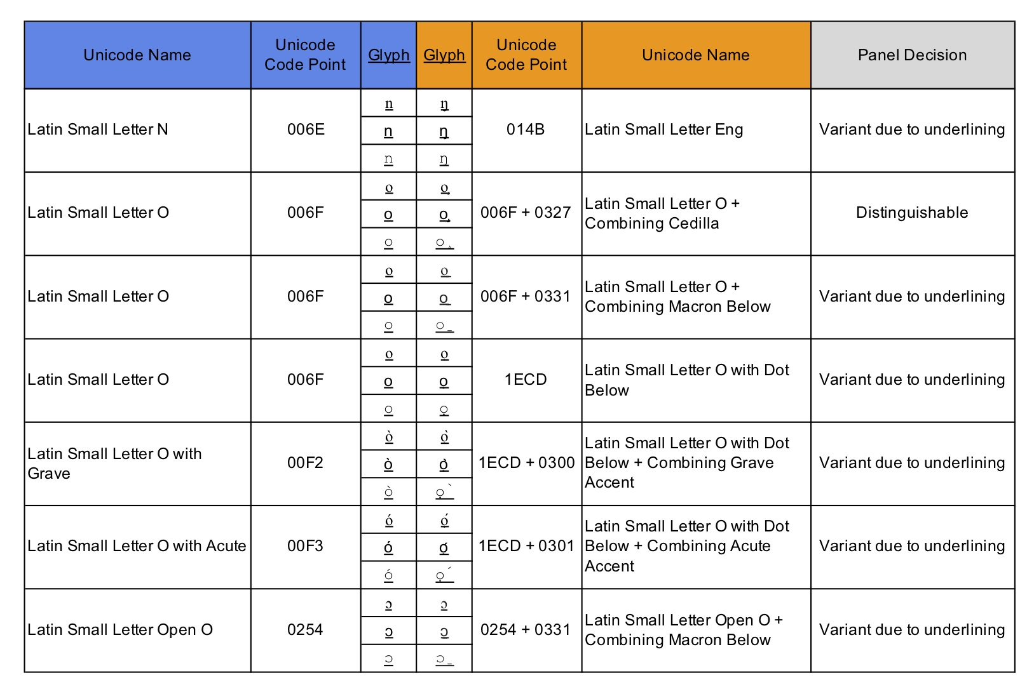
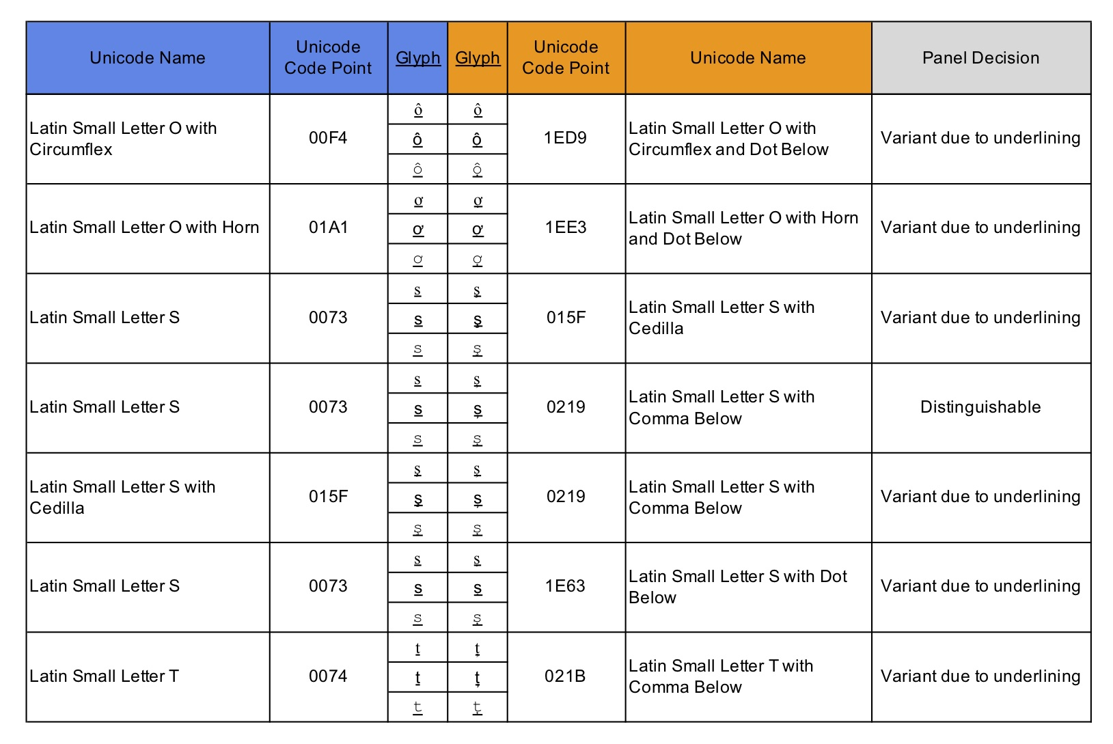
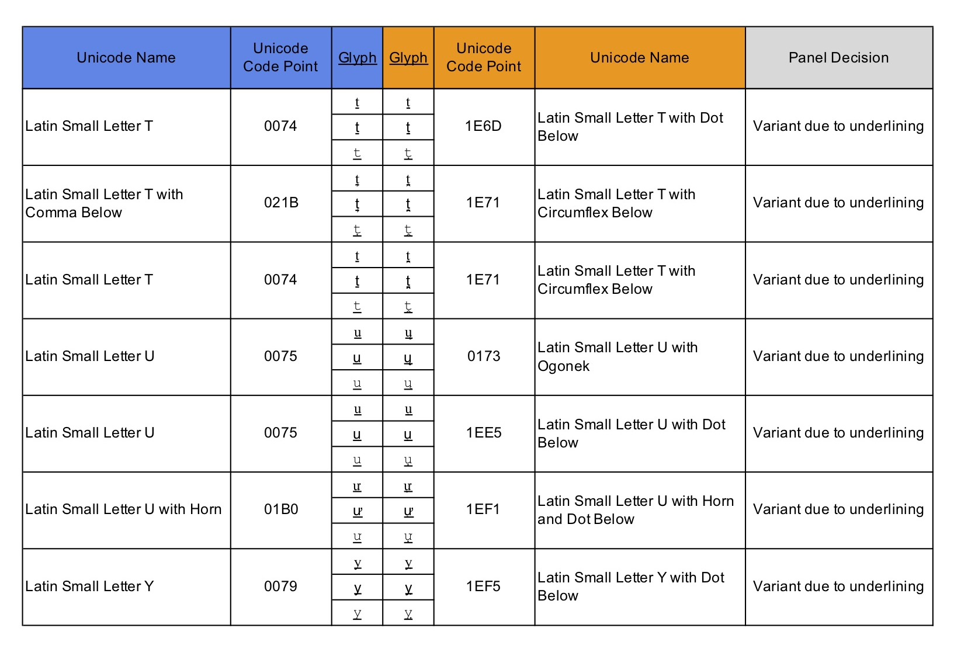

D.7 Generic Glyphs

Latin GP has tentatively identified the following variant sets for future analysis based on generic glyph shapes. Combining mark code points are indicated in the tables below by a dotted circle to the left of the glyph.

Table D.12. Generic Glyphs - Straight vertical line, full length

Glyph | Unicode | Name
l | 006C | Latin Small Letter L
ӏ | 04CF | Cyrillic Small Letter Palochka
ا | 0627 | Arabic Letter Alef

Table D.13. Generic Glyphs - Straight vertical line, half length

Glyph | Unicode | Name
ı | 0131 | Latin Small Letter Dotless I
ו | 05D5 | Hebrew Letter Vav
ၢ | 1062 | Myanmar Vowel Sign Sgaw Karen Eu

Table D.14. Generic Glyphs - Circle

Glyph | Unicode | Unicode Name
o | 006F | Latin Small Letter O
ο | 03BF | Greek Small Letter Omicron
о | 043E | Cyrillic Small Letter O
օ | 0585 | Armenian Small Letter Oh
ס | 05E1 | Hebrew Letter Samekh
ଠ | 0B20 | Oriya Letter Ttha
ഠ | 0D20 | Malayalam Letter Tta
ဝ | 101D | Myanmar Letter Wa
ዐ | 12D0 | Ethiopic Syllable Pharyngeal A

Note that the Latin script only includes crescents with openings to the left and right, not to the top and bottom. So only those are included here.

Table D.15. Generic Glyphs - Crescent - Open to right

Glyph | Unicode | Name
c | 0053 | Latin Small Letter C
с | 0441 | Cyrillic Small Letter ES
ເ | 0EC0 | Lao Vowel Sign E
င | 1004 | Myanmar Letter Nga

Table D.16. Generic Glyphs - Crescent - Open to left

Glyph | Unicode | Name
ɔ | 0254 | Latin Small Letter Open O
ວ | 0EA7 | Lao Letter Wo
ာ | 102C | Myanmar Vowel Sign Aa

D.8 Caron Above
The term Caron is used for a modifier above (also widely known as Háček), which can either occur above a letter in a wedge-shape or next to it in a shape resembling an apostrophe, depending on which basic letter shape it is combined with. Figure XXX below demonstrates renderings of all 16 codepoints featuring Caron which are suggested for inclusion in the repertoire. Out of these 16, three codepoints feature the basic letter shapes t, l, and d (highlighted in Figure XXX), on which the modifier does not occur on top, but as a modifier to the right of the basic letter shape – note however, that for example the fonts Advent Pro or Alegreya render the Caron in it’s wedge-form also on top of t and l.

Figure XXX: Screenshot of an Arbitrary Selection of Google Fonts Rendering the String ǎǐǒǔǧǩǯžšřňěčťľď on Wordmark.it

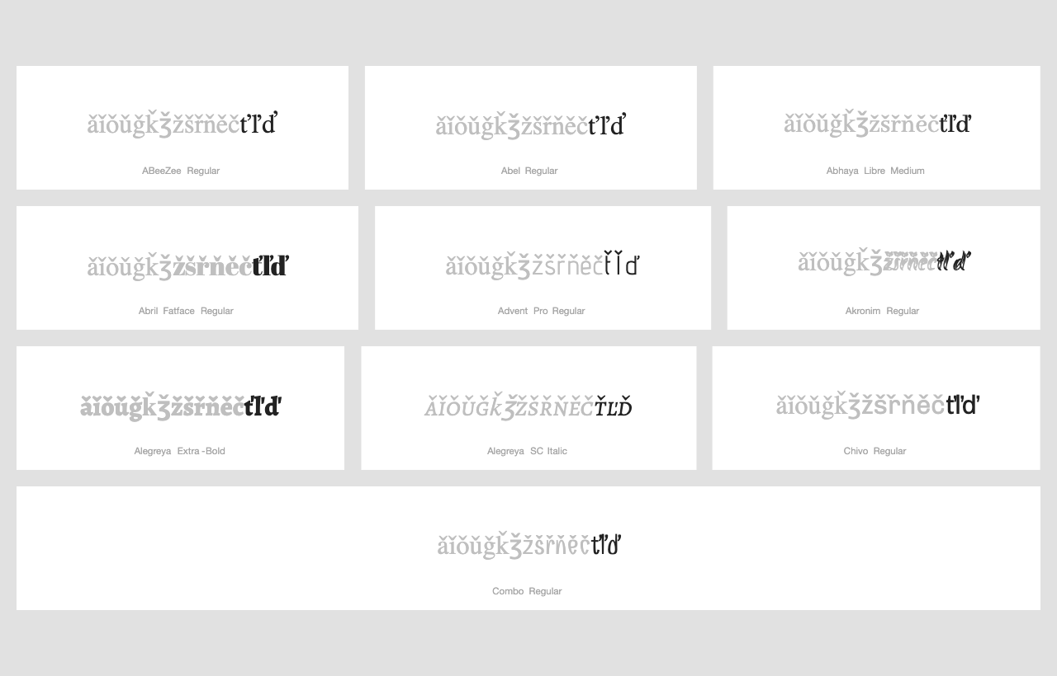

In it’s review of a draft of the present proposal dated XXX, Integration Panel pointed out that ‘arguably, the letters d and l with caron (for which the caron is typically rendered in a way that looks like an apostrophe might be added to this list.’, referring to the list of excluded code points. Accordingly, the GP decided to exclude those two codepoints mentioned by IP as well as t, which betrays the same rendering in most fonts.

D.9 Cross-script Variants

D.9.1. Cyrillic Script

D.9.1.1 Cyrillic Small Letter Straight U 04A4

Cyrillic GP has already classified 0079 and 0443 as variants [CYRILLIC]. In addition to that, Latin GP considers 04AF to be sufficiently similar to 0079 to warrant a variant relationship between the two characters. By consequence, this finding leads towards an in-script variant in Cyrillic script between 04AF and 0443, due to the requirement of transitivity.

D.9.1.2 Cyrillic Small Letter Dzhe 045F
In Arial and Courier New, the glyphs of 1EE5 and 045F look nearly identical. The screenshot below presents the glyphs in those two fonts in the second and third rows, respectively (The first row presents the glyphs in Times New Roman).

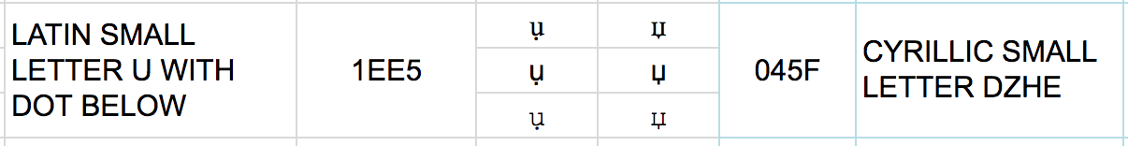

D.9.2. Greek Script

D.9.2.1. GREEK SMALL LETTER ALPHA 03B1
Latin-script users consider 0061 Latin Small Letter A and Greek Small Letter Alpha 03B1 as variants on non-visual grounds:

0061 is regularly represented using a glyph (nearly) identical with 03B1 in italic, which is why significant parts of the Latin script-using community may consider them equivalent, despite being able to visually tell the difference between the two glyphs. For example, 0061 is considered the block- or print-letter shape to the hand-written shape of 03B1 in large parts of the script-using community, and a shape similar to 03B1 is used in standard primers and repertoire of handwriting as taught to school children, such as e.g. the Grundschrift (https://en.wikipedia.org/wiki/Grundschrift) demonstrated in Figure G02:

Figure G02. Repertoire of Standard Handwriting repertoire as official in the German state Hamburg, taken from https://en.wikipedia.org/wiki/Grundschrift#/media/File:Hamburger_Druckschrift_ab_2011.jpg
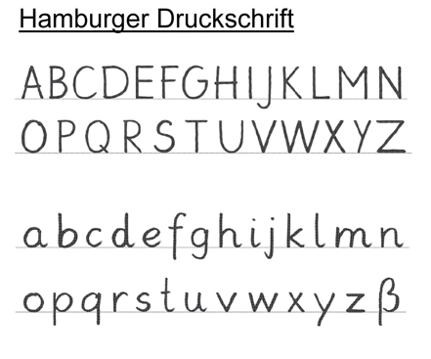
This variation between glyphs is however not limited to the German speaking user community or didactic hand-writing repertoires: Similar shapes to both 0061 and 03B1 are featured prominently in the graphic design of logos of international brand names in, which constantly reiterates the inter-changeability to the minds of readers:
- US TV-station ABC (http://logos.wikia.com/wiki/ABC_(United_States)?file=Abc_2013_logo_dark_grey.svg),
- Beats by Dr. Dre (https://cdn.dealspotr.com/zc-images/merchants/beats-by-dre.jpg),
- Macys (https://en.wikipedia.org/wiki/Macy%27s),
- Adidas (https://en.wikipedia.org/wiki/Adidas)
- German TV station ARD-Alpha (https://de.wikipedia.org/wiki/ARD-alpha),
- Former US airline AirTran (http://logos.wikia.com/wiki/AirTran_Airways?file=AirTran_A.svg)
The variation in between the two character shapes occurs also within the same logos
- e.g. http://logos.wikia.com/wiki/Save-A-Lot)
This inter-changeability is also historically established and has been used for decades in the typography employed in movies (cf. the initial “a” Paramount movie openers (http://logos.wikia.comwiki/Paramount_Cartoon_Studios).

While IP has noted that logos should not be used as evidence since they use ad-hoc font styles (as noted during the conference call with IP in October 2018), the large number of well-known logos across language communities together with the independent evidence from font renderings constitutes sufficient evidence for Latin GP to be considered as valid evidence in favor of a variant relationship.

In summary, Latin GP concluded that users of Latin script may not be able to differentiate 03B1 from 0061 based on non-visual grounds, and therefore 03B1 should be in a variant relationship with 0061.

D.9.2.2. Greek Small Letter Rho 03C1
LATIN SMALL LETTER P (0070) and GREEK SMALL LETTER RHO (03C1) are visually nearly identical in isolation in several widespread fonts (such as Times New Roman and Courier New, presented in the first and third row, respectively, of the screenshot below).

Figure G02: 0070 vs. 03C1
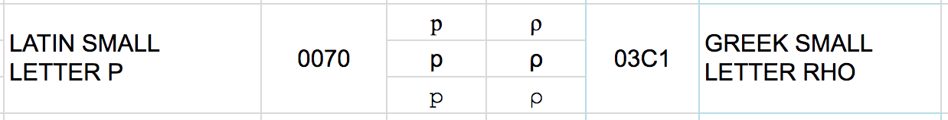

In such cases, the two code-points are visually only distinguishable in context because of their relative positioning towards the baseline, since 0070 crosses below the baseline but 03C1 does not. Given that there are several variant candidates among the cross-script variants, numerous plausible labels could be made up, such as .ρορ vs .pop or .ραγ vs .pay,which most Latin-script users would be hard-pressed to distinguish in context.

Furthermore, designers from the Latin-script using community have exploited the visual similarity between these two code-points and have created logos for globally used brand-names, which employ glyphs baring more resemblance to Greek 03C1 rather than Latin 0070, such as Pepsi (cf. https://perma.cc/6GTA-98C9?type=image). Again, this use in logo designs is neither limited to the Pepsi-brand logo nor the English-using community - cf.
- http://logos.wikia.com/wiki/Logopedia:Theme/Logos_with_the_letter_P?file=Publix_logo.png,
- http://logos.wikia.com/wiki/File:150px-Android_P_logo.png
- http://logos.wikia.com/wiki/File:Vpf.png,
- http://logos.wikia.com/wiki/Category:Red_PAT -

,and it is featured in historically established logos – cf.
- http://logos.wikia.com/wiki/File:Pba_83_on_city_2_Vintage_Sports.jpg.

By consequence, Latin-script users tend to recognize glyphs resembling Greek 03C1 as non-visual variants of 0070, even where they are able to visually distinguish the two shapes and irrespective of the fact, that for Greek users, 03C1 is clearly distinctive from Latin 0070, therefore constituting a variant on non-visual grounds.

D.9.2.3.Greek Small Letter Upsilon G03C5
0075-03C5: The two glyphs look “nearly identical” in Arial font (as shown in the second row in the image below).

Figure G03.1: 0075 vs. 03C5
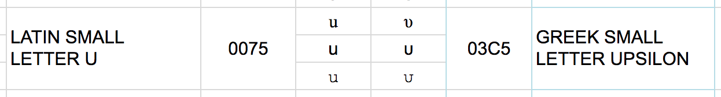

028B-03C5: Also these two glyphs look “nearly identical” in Times New Roman font (as shown in the first row in the image below).

Figure G03.2: 028B vs. 03C5
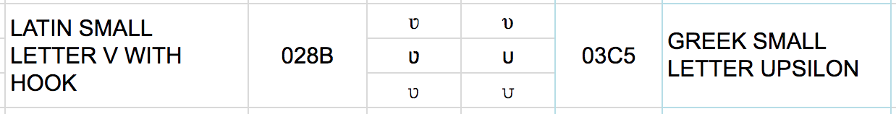

The same analysis applies to 00FA and 03CD, which are essentially the same characters with the addition of a modifying diacritic on top (an Acute in the case of Latin and a Tonos in the case of Greek script).

Since the former two variant sets feature one and the same code point from Greek script but two different code points from Latin script, this therefore imposes an in-script variant relationship between 0075 and 028B due to transitivity. The two code points Latin U (0075) and Latin V with Hook (028B) are however both used in a distinguishing manner in the orthography of Mossi – a language of Burkina Faso. Latin GP foresees no issues and accepts the imposed variant relationship between the two code points, given that the variant relationship between U and V with Hook will still permit users from the Mossi community to employ both code points in labels, and since there won’t be any particular security risk for the Mossi community, such as spoofing, as the variant set will have a the disposition of “blocked”.

D.9.2.4. Greek Letter Beta 03B2
The Greek script code point 03B2 β (Letter Beta) is visually nearly identical due to font design to Latin script code point 00DF ß (Letter Sharp S). While those differences may be argued to be sufficiently different from a point of view of Greek script users, particularly the German users from the German language community may consider these code points confusable, since the typical rendering of the Greek variant is one of the forms taught to elementary school pupils as a hand-written form of the Latin-script code point 00DF ß across the German-speaking part of the script-using community, as demonstrated by Figure G04 below.

Figure G04: A handwritten form of the German Lexeme Grüße ‘greetings’, taken from
https://de.wikipedia.org/wiki/%C3%9F#/media/File:Gruesse-Schneidler-Legende.png (Cf. e.g. https://de.wikipedia.org/wiki/%C3%9F#/media/File:Gruesse-Schneidler-Legende.png,
where the German lexeme Grüße is spelled with such a hand-written form).
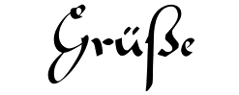

Therefore, adult script-users may also consider them in their minds to be the same, despite them being able to see the visual differences between the glyphs. Given that there are several Greek code points in a variant relationship to Latin code points, which are used by the German orthography, there are numerous plausible labels which could be made up, such as Greek. νοβ, which may be identified with the German surname Voß. Additionally, German orthography commonly replaces 00DF ß by a sequence of two ss, and the same variation is also encountered in personal names, i.e. both Voß and Voss are used, which gives further scope to this potential confusion among readers (This issue is further complicated by the issue of IDNA compatibility – c.f. section 6.7.2). Accordingly, there is a concrete risk for the safety and stability of the zone, which should be dealt with at the level of the LGR definition by a variant relationship between those two code points (and others), despite them not being homoglyphs in a strict sense in a number of fonts.

D.9.2.4. Greek Small Letter Sigma 03C3
In Courier New (represented by the third row in the screenshot of Figure G04 below) the glyphs are deemed nearly identical due to font design:

Figure G05: 01A1 vs. 03C3
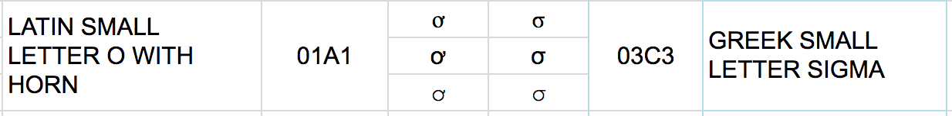

Appendix E: Variant Relationship Mapping for “ss” and “s”

Since “ss” and “s” coexist in the repertoire and that “s” has variant relationships on its own there is a need to explicitly determine all variant relationships to ensure the entire variant set is a well-behaved one.

# | Source | Glyph | Target | Glyph |  | Type(s)
1 | U+0073 U+0073 | s s [ss] | U+0073 U+015F | s ş [sş] | ↔ | blocked
2 | U+0073 U+0073 | s s [ss] | U+0073 U+0219 | s ș [sș] | ↔ | blocked
3 | U+0073 U+0073 | s s [ss] | U+0073 U+0455 | s ѕ [sѕ] | ↔ | blocked
4 | U+0073 U+0073 | s s [ss] | U+0073 U+1E63 | s ṣ [sṣ] | ↔ | blocked
5 | U+0073 U+0073 | s s [ss] | U+00DF | ß | → | blocked
 |  |  |  |  | ← | swiss
6 | U+0073 U+0073 | s s [ss] | U+015F U+0073 | ş s [şs] | ↔ | blocked
7 | U+0073 U+0073 | s s [ss] | U+015F U+015F | ş ş [şş] | ↔ | blocked
8 | U+0073 U+0073 | s s [ss] | U+015F U+0219 | ş ș [şș] | ↔ | blocked
9 | U+0073 U+0073 | s s [ss] | U+015F U+0455 | ş ѕ [şѕ] | ↔ | blocked
10 | U+0073 U+0073 | s s [ss] | U+015F U+1E63 | ş ṣ [şṣ] | ↔ | blocked
11 | U+0073 U+0073 | s s [ss] | U+0219 U+0073 | ș s [șs] | ↔ | blocked
12 | U+0073 U+0073 | s s [ss] | U+0219 U+015F | ș ş [șş] | ↔ | blocked
13 | U+0073 U+0073 | s s [ss] | U+0219 U+0219 | ș ș [șș] | ↔ | blocked
14 | U+0073 U+0073 | s s [ss] | U+0219 U+0455 | ș ѕ [șѕ] | ↔ | blocked
15 | U+0073 U+0073 | s s [ss] | U+0219 U+1E63 | ș ṣ [șṣ] | ↔ | blocked
16 | U+0073 U+0073 | s s [ss] | U+03B2 | β | ↔ | blocked
17 | U+0073 U+0073 | s s [ss] | U+0455 U+0073 | ѕ s [ѕs] | ↔ | blocked
18 | U+0073 U+0073 | s s [ss] | U+0455 U+015F | ѕ ş [ѕş] | ↔ | blocked
19 | U+0073 U+0073 | s s [ss] | U+0455 U+0219 | ѕ ș [ѕș] | ↔ | blocked
20 | U+0073 U+0073 | s s [ss] | U+0455 U+0455 | ѕ ѕ [ѕѕ] | ↔ | blocked
21 | U+0073 U+0073 | s s [ss] | U+0455 U+1E63 | ѕ ṣ [ѕṣ] | ↔ | blocked
22 | U+0073 U+0073 | s s [ss] | U+1E63 U+0073 | ṣ s [ṣs] | ↔ | blocked
23 | U+0073 U+0073 | s s [ss] | U+1E63 U+015F | ṣ ş [ṣş] | ↔ | blocked
24 | U+0073 U+0073 | s s [ss] | U+1E63 U+0219 | ṣ ș [ṣș] | ↔ | blocked
25 | U+0073 U+0073 | s s [ss] | U+1E63 U+0455 | ṣ ѕ [ṣѕ] | ↔ | blocked
26 | U+0073 U+0073 | s s [ss] | U+1E63 U+1E63 | ṣ ṣ [ṣṣ] | ↔ | blocked
27 | U+0073 U+015F | s ş [sş] | U+0073 U+015F | s ş [sş] | ≡ | out-of-repertoire-var
28 | U+0073 U+015F | s ş [sş] | U+0073 U+0219 | s ș [sș] | ↔ | blocked
29 | U+0073 U+015F | s ş [sş] | U+0073 U+0455 | s ѕ [sѕ] | ↔ | blocked
30 | U+0073 U+015F | s ş [sş] | U+0073 U+1E63 | s ṣ [sṣ] | ↔ | blocked
31 | U+0073 U+015F | s ş [sş] | U+00DF | ß | ↔ | blocked
32 | U+0073 U+015F | s ş [sş] | U+015F U+0073 | ş s [şs] | ↔ | blocked
33 | U+0073 U+015F | s ş [sş] | U+015F U+015F | ş ş [şş] | ↔ | blocked
34 | U+0073 U+015F | s ş [sş] | U+015F U+0219 | ş ș [şș] | ↔ | blocked
35 | U+0073 U+015F | s ş [sş] | U+015F U+0455 | ş ѕ [şѕ] | ↔ | blocked
36 | U+0073 U+015F | s ş [sş] | U+015F U+1E63 | ş ṣ [şṣ] | ↔ | blocked
37 | U+0073 U+015F | s ş [sş] | U+0219 U+0073 | ș s [șs] | ↔ | blocked
38 | U+0073 U+015F | s ş [sş] | U+0219 U+015F | ș ş [șş] | ↔ | blocked
39 | U+0073 U+015F | s ş [sş] | U+0219 U+0219 | ș ș [șș] | ↔ | blocked
40 | U+0073 U+015F | s ş [sş] | U+0219 U+0455 | ș ѕ [șѕ] | ↔ | blocked
41 | U+0073 U+015F | s ş [sş] | U+0219 U+1E63 | ș ṣ [șṣ] | ↔ | blocked
42 | U+0073 U+015F | s ş [sş] | U+03B2 | β | ↔ | blocked
43 | U+0073 U+015F | s ş [sş] | U+0455 U+0073 | ѕ s [ѕs] | ↔ | blocked
44 | U+0073 U+015F | s ş [sş] | U+0455 U+015F | ѕ ş [ѕş] | ↔ | blocked
45 | U+0073 U+015F | s ş [sş] | U+0455 U+0219 | ѕ ș [ѕș] | ↔ | blocked
46 | U+0073 U+015F | s ş [sş] | U+0455 U+0455 | ѕ ѕ [ѕѕ] | ↔ | blocked
47 | U+0073 U+015F | s ş [sş] | U+0455 U+1E63 | ѕ ṣ [ѕṣ] | ↔ | blocked
48 | U+0073 U+015F | s ş [sş] | U+1E63 U+0073 | ṣ s [ṣs] | ↔ | blocked
49 | U+0073 U+015F | s ş [sş] | U+1E63 U+015F | ṣ ş [ṣş] | ↔ | blocked
50 | U+0073 U+015F | s ş [sş] | U+1E63 U+0219 | ṣ ș [ṣș] | ↔ | blocked
51 | U+0073 U+015F | s ş [sş] | U+1E63 U+0455 | ṣ ѕ [ṣѕ] | ↔ | blocked
52 | U+0073 U+015F | s ş [sş] | U+1E63 U+1E63 | ṣ ṣ [ṣṣ] | ↔ | blocked
53 | U+0073 U+0219 | s ș [sș] | U+0073 U+0219 | s ș [sș] | ≡ | out-of-repertoire-var
54 | U+0073 U+0219 | s ș [sș] | U+0073 U+0455 | s ѕ [sѕ] | ↔ | blocked
55 | U+0073 U+0219 | s ș [sș] | U+0073 U+1E63 | s ṣ [sṣ] | ↔ | blocked
56 | U+0073 U+0219 | s ș [sș] | U+00DF | ß | ↔ | blocked
57 | U+0073 U+0219 | s ș [sș] | U+015F U+0073 | ş s [şs] | ↔ | blocked
58 | U+0073 U+0219 | s ș [sș] | U+015F U+015F | ş ş [şş] | ↔ | blocked
59 | U+0073 U+0219 | s ș [sș] | U+015F U+0219 | ş ș [şș] | ↔ | blocked
60 | U+0073 U+0219 | s ș [sș] | U+015F U+0455 | ş ѕ [şѕ] | ↔ | blocked
61 | U+0073 U+0219 | s ș [sș] | U+015F U+1E63 | ş ṣ [şṣ] | ↔ | blocked
62 | U+0073 U+0219 | s ș [sș] | U+0219 U+0073 | ș s [șs] | ↔ | blocked
63 | U+0073 U+0219 | s ș [sș] | U+0219 U+015F | ș ş [șş] | ↔ | blocked
64 | U+0073 U+0219 | s ș [sș] | U+0219 U+0219 | ș ș [șș] | ↔ | blocked
65 | U+0073 U+0219 | s ș [sș] | U+0219 U+0455 | ș ѕ [șѕ] | ↔ | blocked
66 | U+0073 U+0219 | s ș [sș] | U+0219 U+1E63 | ș ṣ [șṣ] | ↔ | blocked
67 | U+0073 U+0219 | s ș [sș] | U+03B2 | β | ↔ | blocked
68 | U+0073 U+0219 | s ș [sș] | U+0455 U+0073 | ѕ s [ѕs] | ↔ | blocked
69 | U+0073 U+0219 | s ș [sș] | U+0455 U+015F | ѕ ş [ѕş] | ↔ | blocked
70 | U+0073 U+0219 | s ș [sș] | U+0455 U+0219 | ѕ ș [ѕș] | ↔ | blocked
71 | U+0073 U+0219 | s ș [sș] | U+0455 U+0455 | ѕ ѕ [ѕѕ] | ↔ | blocked
72 | U+0073 U+0219 | s ș [sș] | U+0455 U+1E63 | ѕ ṣ [ѕṣ] | ↔ | blocked
73 | U+0073 U+0219 | s ș [sș] | U+1E63 U+0073 | ṣ s [ṣs] | ↔ | blocked
74 | U+0073 U+0219 | s ș [sș] | U+1E63 U+015F | ṣ ş [ṣş] | ↔ | blocked
75 | U+0073 U+0219 | s ș [sș] | U+1E63 U+0219 | ṣ ș [ṣș] | ↔ | blocked
76 | U+0073 U+0219 | s ș [sș] | U+1E63 U+0455 | ṣ ѕ [ṣѕ] | ↔ | blocked
77 | U+0073 U+0219 | s ș [sș] | U+1E63 U+1E63 | ṣ ṣ [ṣṣ] | ↔ | blocked
78 | U+0073 U+0455 | s ѕ [sѕ] | U+0073 U+0455 | s ѕ [sѕ] | ≡ | out-of-repertoire-var
79 | U+0073 U+0455 | s ѕ [sѕ] | U+0073 U+1E63 | s ṣ [sṣ] | ↔ | blocked
80 | U+0073 U+0455 | s ѕ [sѕ] | U+00DF | ß | ↔ | blocked
81 | U+0073 U+0455 | s ѕ [sѕ] | U+015F U+0073 | ş s [şs] | ↔ | blocked
82 | U+0073 U+0455 | s ѕ [sѕ] | U+015F U+015F | ş ş [şş] | ↔ | blocked
83 | U+0073 U+0455 | s ѕ [sѕ] | U+015F U+0219 | ş ș [şș] | ↔ | blocked
84 | U+0073 U+0455 | s ѕ [sѕ] | U+015F U+0455 | ş ѕ [şѕ] | ↔ | blocked
85 | U+0073 U+0455 | s ѕ [sѕ] | U+015F U+1E63 | ş ṣ [şṣ] | ↔ | blocked
86 | U+0073 U+0455 | s ѕ [sѕ] | U+0219 U+0073 | ș s [șs] | ↔ | blocked
87 | U+0073 U+0455 | s ѕ [sѕ] | U+0219 U+015F | ș ş [șş] | ↔ | blocked
88 | U+0073 U+0455 | s ѕ [sѕ] | U+0219 U+0219 | ș ș [șș] | ↔ | blocked
89 | U+0073 U+0455 | s ѕ [sѕ] | U+0219 U+0455 | ș ѕ [șѕ] | ↔ | blocked
90 | U+0073 U+0455 | s ѕ [sѕ] | U+0219 U+1E63 | ș ṣ [șṣ] | ↔ | blocked
91 | U+0073 U+0455 | s ѕ [sѕ] | U+03B2 | β | ↔ | blocked
92 | U+0073 U+0455 | s ѕ [sѕ] | U+0455 U+0073 | ѕ s [ѕs] | ↔ | blocked
93 | U+0073 U+0455 | s ѕ [sѕ] | U+0455 U+015F | ѕ ş [ѕş] | ↔ | blocked
94 | U+0073 U+0455 | s ѕ [sѕ] | U+0455 U+0219 | ѕ ș [ѕș] | ↔ | blocked
95 | U+0073 U+0455 | s ѕ [sѕ] | U+0455 U+0455 | ѕ ѕ [ѕѕ] | ↔ | blocked
96 | U+0073 U+0455 | s ѕ [sѕ] | U+0455 U+1E63 | ѕ ṣ [ѕṣ] | ↔ | blocked
97 | U+0073 U+0455 | s ѕ [sѕ] | U+1E63 U+0073 | ṣ s [ṣs] | ↔ | blocked
98 | U+0073 U+0455 | s ѕ [sѕ] | U+1E63 U+015F | ṣ ş [ṣş] | ↔ | blocked
99 | U+0073 U+0455 | s ѕ [sѕ] | U+1E63 U+0219 | ṣ ș [ṣș] | ↔ | blocked
100 | U+0073 U+0455 | s ѕ [sѕ] | U+1E63 U+0455 | ṣ ѕ [ṣѕ] | ↔ | blocked
101 | U+0073 U+0455 | s ѕ [sѕ] | U+1E63 U+1E63 | ṣ ṣ [ṣṣ] | ↔ | blocked
102 | U+0073 U+1E63 | s ṣ [sṣ] | U+0073 U+1E63 | s ṣ [sṣ] | ≡ | out-of-repertoire-var
103 | U+0073 U+1E63 | s ṣ [sṣ] | U+00DF | ß | ↔ | blocked
104 | U+0073 U+1E63 | s ṣ [sṣ] | U+015F U+0073 | ş s [şs] | ↔ | blocked
105 | U+0073 U+1E63 | s ṣ [sṣ] | U+015F U+015F | ş ş [şş] | ↔ | blocked
106 | U+0073 U+1E63 | s ṣ [sṣ] | U+015F U+0219 | ş ș [şș] | ↔ | blocked
107 | U+0073 U+1E63 | s ṣ [sṣ] | U+015F U+0455 | ş ѕ [şѕ] | ↔ | blocked
108 | U+0073 U+1E63 | s ṣ [sṣ] | U+015F U+1E63 | ş ṣ [şṣ] | ↔ | blocked
109 | U+0073 U+1E63 | s ṣ [sṣ] | U+0219 U+0073 | ș s [șs] | ↔ | blocked
110 | U+0073 U+1E63 | s ṣ [sṣ] | U+0219 U+015F | ș ş [șş] | ↔ | blocked
111 | U+0073 U+1E63 | s ṣ [sṣ] | U+0219 U+0219 | ș ș [șș] | ↔ | blocked
112 | U+0073 U+1E63 | s ṣ [sṣ] | U+0219 U+0455 | ș ѕ [șѕ] | ↔ | blocked
113 | U+0073 U+1E63 | s ṣ [sṣ] | U+0219 U+1E63 | ș ṣ [șṣ] | ↔ | blocked
114 | U+0073 U+1E63 | s ṣ [sṣ] | U+03B2 | β | ↔ | blocked
115 | U+0073 U+1E63 | s ṣ [sṣ] | U+0455 U+0073 | ѕ s [ѕs] | ↔ | blocked
116 | U+0073 U+1E63 | s ṣ [sṣ] | U+0455 U+015F | ѕ ş [ѕş] | ↔ | blocked
117 | U+0073 U+1E63 | s ṣ [sṣ] | U+0455 U+0219 | ѕ ș [ѕș] | ↔ | blocked
118 | U+0073 U+1E63 | s ṣ [sṣ] | U+0455 U+0455 | ѕ ѕ [ѕѕ] | ↔ | blocked
119 | U+0073 U+1E63 | s ṣ [sṣ] | U+0455 U+1E63 | ѕ ṣ [ѕṣ] | ↔ | blocked
120 | U+0073 U+1E63 | s ṣ [sṣ] | U+1E63 U+0073 | ṣ s [ṣs] | ↔ | blocked
121 | U+0073 U+1E63 | s ṣ [sṣ] | U+1E63 U+015F | ṣ ş [ṣş] | ↔ | blocked
122 | U+0073 U+1E63 | s ṣ [sṣ] | U+1E63 U+0219 | ṣ ș [ṣș] | ↔ | blocked
123 | U+0073 U+1E63 | s ṣ [sṣ] | U+1E63 U+0455 | ṣ ѕ [ṣѕ] | ↔ | blocked
124 | U+0073 U+1E63 | s ṣ [sṣ] | U+1E63 U+1E63 | ṣ ṣ [ṣṣ] | ↔ | blocked
125 | U+00DF | ß | U+00DF | ß | ≡ | r-german
126 | U+00DF | ß | U+015F U+0073 | ş s [şs] | ↔ | blocked
127 | U+00DF | ß | U+015F U+015F | ş ş [şş] | ↔ | blocked
128 | U+00DF | ß | U+015F U+0219 | ş ș [şș] | ↔ | blocked
129 | U+00DF | ß | U+015F U+0455 | ş ѕ [şѕ] | ↔ | blocked
130 | U+00DF | ß | U+015F U+1E63 | ş ṣ [şṣ] | ↔ | blocked
131 | U+00DF | ß | U+0219 U+0073 | ș s [șs] | ↔ | blocked
132 | U+00DF | ß | U+0219 U+015F | ș ş [șş] | ↔ | blocked
133 | U+00DF | ß | U+0219 U+0219 | ș ș [șș] | ↔ | blocked
134 | U+00DF | ß | U+0219 U+0455 | ș ѕ [șѕ] | ↔ | blocked
135 | U+00DF | ß | U+0219 U+1E63 | ș ṣ [șṣ] | ↔ | blocked
136 | U+00DF | ß | U+03B2 | β | ↔ | blocked
137 | U+00DF | ß | U+0455 U+0073 | ѕ s [ѕs] | ↔ | blocked
138 | U+00DF | ß | U+0455 U+015F | ѕ ş [ѕş] | ↔ | blocked
139 | U+00DF | ß | U+0455 U+0219 | ѕ ș [ѕș] | ↔ | blocked
140 | U+00DF | ß | U+0455 U+0455 | ѕ ѕ [ѕѕ] | ↔ | blocked
141 | U+00DF | ß | U+0455 U+1E63 | ѕ ṣ [ѕṣ] | ↔ | blocked
142 | U+00DF | ß | U+1E63 U+0073 | ṣ s [ṣs] | ↔ | blocked
143 | U+00DF | ß | U+1E63 U+015F | ṣ ş [ṣş] | ↔ | blocked
144 | U+00DF | ß | U+1E63 U+0219 | ṣ ș [ṣș] | ↔ | blocked
145 | U+00DF | ß | U+1E63 U+0455 | ṣ ѕ [ṣѕ] | ↔ | blocked
146 | U+00DF | ß | U+1E63 U+1E63 | ṣ ṣ [ṣṣ] | ↔ | blocked
147 | U+015F U+0073 | ş s [şs] | U+015F U+0073 | ş s [şs] | ≡ | out-of-repertoire-var
148 | U+015F U+0073 | ş s [şs] | U+015F U+015F | ş ş [şş] | ↔ | blocked
149 | U+015F U+0073 | ş s [şs] | U+015F U+0219 | ş ș [şș] | ↔ | blocked
150 | U+015F U+0073 | ş s [şs] | U+015F U+0455 | ş ѕ [şѕ] | ↔ | blocked
151 | U+015F U+0073 | ş s [şs] | U+015F U+1E63 | ş ṣ [şṣ] | ↔ | blocked
152 | U+015F U+0073 | ş s [şs] | U+0219 U+0073 | ș s [șs] | ↔ | blocked
153 | U+015F U+0073 | ş s [şs] | U+0219 U+015F | ș ş [șş] | ↔ | blocked
154 | U+015F U+0073 | ş s [şs] | U+0219 U+0219 | ș ș [șș] | ↔ | blocked
155 | U+015F U+0073 | ş s [şs] | U+0219 U+0455 | ș ѕ [șѕ] | ↔ | blocked
156 | U+015F U+0073 | ş s [şs] | U+0219 U+1E63 | ș ṣ [șṣ] | ↔ | blocked
157 | U+015F U+0073 | ş s [şs] | U+03B2 | β | ↔ | blocked
158 | U+015F U+0073 | ş s [şs] | U+0455 U+0073 | ѕ s [ѕs] | ↔ | blocked
159 | U+015F U+0073 | ş s [şs] | U+0455 U+015F | ѕ ş [ѕş] | ↔ | blocked
160 | U+015F U+0073 | ş s [şs] | U+0455 U+0219 | ѕ ș [ѕș] | ↔ | blocked
161 | U+015F U+0073 | ş s [şs] | U+0455 U+0455 | ѕ ѕ [ѕѕ] | ↔ | blocked
162 | U+015F U+0073 | ş s [şs] | U+0455 U+1E63 | ѕ ṣ [ѕṣ] | ↔ | blocked
163 | U+015F U+0073 | ş s [şs] | U+1E63 U+0073 | ṣ s [ṣs] | ↔ | blocked
164 | U+015F U+0073 | ş s [şs] | U+1E63 U+015F | ṣ ş [ṣş] | ↔ | blocked
165 | U+015F U+0073 | ş s [şs] | U+1E63 U+0219 | ṣ ș [ṣș] | ↔ | blocked
166 | U+015F U+0073 | ş s [şs] | U+1E63 U+0455 | ṣ ѕ [ṣѕ] | ↔ | blocked
167 | U+015F U+0073 | ş s [şs] | U+1E63 U+1E63 | ṣ ṣ [ṣṣ] | ↔ | blocked
168 | U+015F U+015F | ş ş [şş] | U+015F U+015F | ş ş [şş] | ≡ | out-of-repertoire-var
169 | U+015F U+015F | ş ş [şş] | U+015F U+0219 | ş ș [şș] | ↔ | blocked
170 | U+015F U+015F | ş ş [şş] | U+015F U+0455 | ş ѕ [şѕ] | ↔ | blocked
171 | U+015F U+015F | ş ş [şş] | U+015F U+1E63 | ş ṣ [şṣ] | ↔ | blocked
172 | U+015F U+015F | ş ş [şş] | U+0219 U+0073 | ș s [șs] | ↔ | blocked
173 | U+015F U+015F | ş ş [şş] | U+0219 U+015F | ș ş [șş] | ↔ | blocked
174 | U+015F U+015F | ş ş [şş] | U+0219 U+0219 | ș ș [șș] | ↔ | blocked
175 | U+015F U+015F | ş ş [şş] | U+0219 U+0455 | ș ѕ [șѕ] | ↔ | blocked
176 | U+015F U+015F | ş ş [şş] | U+0219 U+1E63 | ș ṣ [șṣ] | ↔ | blocked
177 | U+015F U+015F | ş ş [şş] | U+03B2 | β | ↔ | blocked
178 | U+015F U+015F | ş ş [şş] | U+0455 U+0073 | ѕ s [ѕs] | ↔ | blocked
179 | U+015F U+015F | ş ş [şş] | U+0455 U+015F | ѕ ş [ѕş] | ↔ | blocked
180 | U+015F U+015F | ş ş [şş] | U+0455 U+0219 | ѕ ș [ѕș] | ↔ | blocked
181 | U+015F U+015F | ş ş [şş] | U+0455 U+0455 | ѕ ѕ [ѕѕ] | ↔ | blocked
182 | U+015F U+015F | ş ş [şş] | U+0455 U+1E63 | ѕ ṣ [ѕṣ] | ↔ | blocked
183 | U+015F U+015F | ş ş [şş] | U+1E63 U+0073 | ṣ s [ṣs] | ↔ | blocked
184 | U+015F U+015F | ş ş [şş] | U+1E63 U+015F | ṣ ş [ṣş] | ↔ | blocked
185 | U+015F U+015F | ş ş [şş] | U+1E63 U+0219 | ṣ ș [ṣș] | ↔ | blocked
186 | U+015F U+015F | ş ş [şş] | U+1E63 U+0455 | ṣ ѕ [ṣѕ] | ↔ | blocked
187 | U+015F U+015F | ş ş [şş] | U+1E63 U+1E63 | ṣ ṣ [ṣṣ] | ↔ | blocked
188 | U+015F U+0219 | ş ș [şș] | U+015F U+0219 | ş ș [şș] | ≡ | out-of-repertoire-var
189 | U+015F U+0219 | ş ș [şș] | U+015F U+0455 | ş ѕ [şѕ] | ↔ | blocked
190 | U+015F U+0219 | ş ș [şș] | U+015F U+1E63 | ş ṣ [şṣ] | ↔ | blocked
191 | U+015F U+0219 | ş ș [şș] | U+0219 U+0073 | ș s [șs] | ↔ | blocked
192 | U+015F U+0219 | ş ș [şș] | U+0219 U+015F | ș ş [șş] | ↔ | blocked
193 | U+015F U+0219 | ş ș [şș] | U+0219 U+0219 | ș ș [șș] | ↔ | blocked
194 | U+015F U+0219 | ş ș [şș] | U+0219 U+0455 | ș ѕ [șѕ] | ↔ | blocked
195 | U+015F U+0219 | ş ș [şș] | U+0219 U+1E63 | ș ṣ [șṣ] | ↔ | blocked
196 | U+015F U+0219 | ş ș [şș] | U+03B2 | β | ↔ | blocked
197 | U+015F U+0219 | ş ș [şș] | U+0455 U+0073 | ѕ s [ѕs] | ↔ | blocked
198 | U+015F U+0219 | ş ș [şș] | U+0455 U+015F | ѕ ş [ѕş] | ↔ | blocked
199 | U+015F U+0219 | ş ș [şș] | U+0455 U+0219 | ѕ ș [ѕș] | ↔ | blocked
200 | U+015F U+0219 | ş ș [şș] | U+0455 U+0455 | ѕ ѕ [ѕѕ] | ↔ | blocked
201 | U+015F U+0219 | ş ș [şș] | U+0455 U+1E63 | ѕ ṣ [ѕṣ] | ↔ | blocked
202 | U+015F U+0219 | ş ș [şș] | U+1E63 U+0073 | ṣ s [ṣs] | ↔ | blocked
203 | U+015F U+0219 | ş ș [şș] | U+1E63 U+015F | ṣ ş [ṣş] | ↔ | blocked
204 | U+015F U+0219 | ş ș [şș] | U+1E63 U+0219 | ṣ ș [ṣș] | ↔ | blocked
205 | U+015F U+0219 | ş ș [şș] | U+1E63 U+0455 | ṣ ѕ [ṣѕ] | ↔ | blocked
206 | U+015F U+0219 | ş ș [şș] | U+1E63 U+1E63 | ṣ ṣ [ṣṣ] | ↔ | blocked
207 | U+015F U+0455 | ş ѕ [şѕ] | U+015F U+0455 | ş ѕ [şѕ] | ≡ | out-of-repertoire-var
208 | U+015F U+0455 | ş ѕ [şѕ] | U+015F U+1E63 | ş ṣ [şṣ] | ↔ | blocked
209 | U+015F U+0455 | ş ѕ [şѕ] | U+0219 U+0073 | ș s [șs] | ↔ | blocked
210 | U+015F U+0455 | ş ѕ [şѕ] | U+0219 U+015F | ș ş [șş] | ↔ | blocked
211 | U+015F U+0455 | ş ѕ [şѕ] | U+0219 U+0219 | ș ș [șș] | ↔ | blocked
212 | U+015F U+0455 | ş ѕ [şѕ] | U+0219 U+0455 | ș ѕ [șѕ] | ↔ | blocked
213 | U+015F U+0455 | ş ѕ [şѕ] | U+0219 U+1E63 | ș ṣ [șṣ] | ↔ | blocked
214 | U+015F U+0455 | ş ѕ [şѕ] | U+03B2 | β | ↔ | blocked
215 | U+015F U+0455 | ş ѕ [şѕ] | U+0455 U+0073 | ѕ s [ѕs] | ↔ | blocked
216 | U+015F U+0455 | ş ѕ [şѕ] | U+0455 U+015F | ѕ ş [ѕş] | ↔ | blocked
217 | U+015F U+0455 | ş ѕ [şѕ] | U+0455 U+0219 | ѕ ș [ѕș] | ↔ | blocked
218 | U+015F U+0455 | ş ѕ [şѕ] | U+0455 U+0455 | ѕ ѕ [ѕѕ] | ↔ | blocked
219 | U+015F U+0455 | ş ѕ [şѕ] | U+0455 U+1E63 | ѕ ṣ [ѕṣ] | ↔ | blocked
220 | U+015F U+0455 | ş ѕ [şѕ] | U+1E63 U+0073 | ṣ s [ṣs] | ↔ | blocked
221 | U+015F U+0455 | ş ѕ [şѕ] | U+1E63 U+015F | ṣ ş [ṣş] | ↔ | blocked
222 | U+015F U+0455 | ş ѕ [şѕ] | U+1E63 U+0219 | ṣ ș [ṣș] | ↔ | blocked
223 | U+015F U+0455 | ş ѕ [şѕ] | U+1E63 U+0455 | ṣ ѕ [ṣѕ] | ↔ | blocked
224 | U+015F U+0455 | ş ѕ [şѕ] | U+1E63 U+1E63 | ṣ ṣ [ṣṣ] | ↔ | blocked
225 | U+015F U+1E63 | ş ṣ [şṣ] | U+015F U+1E63 | ş ṣ [şṣ] | ≡ | out-of-repertoire-var
226 | U+015F U+1E63 | ş ṣ [şṣ] | U+0219 U+0073 | ș s [șs] | ↔ | blocked
227 | U+015F U+1E63 | ş ṣ [şṣ] | U+0219 U+015F | ș ş [șş] | ↔ | blocked
228 | U+015F U+1E63 | ş ṣ [şṣ] | U+0219 U+0219 | ș ș [șș] | ↔ | blocked
229 | U+015F U+1E63 | ş ṣ [şṣ] | U+0219 U+0455 | ș ѕ [șѕ] | ↔ | blocked
230 | U+015F U+1E63 | ş ṣ [şṣ] | U+0219 U+1E63 | ș ṣ [șṣ] | ↔ | blocked
231 | U+015F U+1E63 | ş ṣ [şṣ] | U+03B2 | β | ↔ | blocked
232 | U+015F U+1E63 | ş ṣ [şṣ] | U+0455 U+0073 | ѕ s [ѕs] | ↔ | blocked
233 | U+015F U+1E63 | ş ṣ [şṣ] | U+0455 U+015F | ѕ ş [ѕş] | ↔ | blocked
234 | U+015F U+1E63 | ş ṣ [şṣ] | U+0455 U+0219 | ѕ ș [ѕș] | ↔ | blocked
235 | U+015F U+1E63 | ş ṣ [şṣ] | U+0455 U+0455 | ѕ ѕ [ѕѕ] | ↔ | blocked
236 | U+015F U+1E63 | ş ṣ [şṣ] | U+0455 U+1E63 | ѕ ṣ [ѕṣ] | ↔ | blocked
237 | U+015F U+1E63 | ş ṣ [şṣ] | U+1E63 U+0073 | ṣ s [ṣs] | ↔ | blocked
238 | U+015F U+1E63 | ş ṣ [şṣ] | U+1E63 U+015F | ṣ ş [ṣş] | ↔ | blocked
239 | U+015F U+1E63 | ş ṣ [şṣ] | U+1E63 U+0219 | ṣ ș [ṣș] | ↔ | blocked
240 | U+015F U+1E63 | ş ṣ [şṣ] | U+1E63 U+0455 | ṣ ѕ [ṣѕ] | ↔ | blocked
241 | U+015F U+1E63 | ş ṣ [şṣ] | U+1E63 U+1E63 | ṣ ṣ [ṣṣ] | ↔ | blocked
242 | U+0219 U+0073 | ș s [șs] | U+0219 U+0073 | ș s [șs] | ≡ | out-of-repertoire-var
243 | U+0219 U+0073 | ș s [șs] | U+0219 U+015F | ș ş [șş] | ↔ | blocked
244 | U+0219 U+0073 | ș s [șs] | U+0219 U+0219 | ș ș [șș] | ↔ | blocked
245 | U+0219 U+0073 | ș s [șs] | U+0219 U+0455 | ș ѕ [șѕ] | ↔ | blocked
246 | U+0219 U+0073 | ș s [șs] | U+0219 U+1E63 | ș ṣ [șṣ] | ↔ | blocked
247 | U+0219 U+0073 | ș s [șs] | U+03B2 | β | ↔ | blocked
248 | U+0219 U+0073 | ș s [șs] | U+0455 U+0073 | ѕ s [ѕs] | ↔ | blocked
249 | U+0219 U+0073 | ș s [șs] | U+0455 U+015F | ѕ ş [ѕş] | ↔ | blocked
250 | U+0219 U+0073 | ș s [șs] | U+0455 U+0219 | ѕ ș [ѕș] | ↔ | blocked
251 | U+0219 U+0073 | ș s [șs] | U+0455 U+0455 | ѕ ѕ [ѕѕ] | ↔ | blocked
252 | U+0219 U+0073 | ș s [șs] | U+0455 U+1E63 | ѕ ṣ [ѕṣ] | ↔ | blocked
253 | U+0219 U+0073 | ș s [șs] | U+1E63 U+0073 | ṣ s [ṣs] | ↔ | blocked
254 | U+0219 U+0073 | ș s [șs] | U+1E63 U+015F | ṣ ş [ṣş] | ↔ | blocked
255 | U+0219 U+0073 | ș s [șs] | U+1E63 U+0219 | ṣ ș [ṣș] | ↔ | blocked
256 | U+0219 U+0073 | ș s [șs] | U+1E63 U+0455 | ṣ ѕ [ṣѕ] | ↔ | blocked
257 | U+0219 U+0073 | ș s [șs] | U+1E63 U+1E63 | ṣ ṣ [ṣṣ] | ↔ | blocked
258 | U+0219 U+015F | ș ş [șş] | U+0219 U+015F | ș ş [șş] | ≡ | out-of-repertoire-var
259 | U+0219 U+015F | ș ş [șş] | U+0219 U+0219 | ș ș [șș] | ↔ | blocked
260 | U+0219 U+015F | ș ş [șş] | U+0219 U+0455 | ș ѕ [șѕ] | ↔ | blocked
261 | U+0219 U+015F | ș ş [șş] | U+0219 U+1E63 | ș ṣ [șṣ] | ↔ | blocked
262 | U+0219 U+015F | ș ş [șş] | U+03B2 | β | ↔ | blocked
263 | U+0219 U+015F | ș ş [șş] | U+0455 U+0073 | ѕ s [ѕs] | ↔ | blocked
264 | U+0219 U+015F | ș ş [șş] | U+0455 U+015F | ѕ ş [ѕş] | ↔ | blocked
265 | U+0219 U+015F | ș ş [șş] | U+0455 U+0219 | ѕ ș [ѕș] | ↔ | blocked
266 | U+0219 U+015F | ș ş [șş] | U+0455 U+0455 | ѕ ѕ [ѕѕ] | ↔ | blocked
267 | U+0219 U+015F | ș ş [șş] | U+0455 U+1E63 | ѕ ṣ [ѕṣ] | ↔ | blocked
268 | U+0219 U+015F | ș ş [șş] | U+1E63 U+0073 | ṣ s [ṣs] | ↔ | blocked
269 | U+0219 U+015F | ș ş [șş] | U+1E63 U+015F | ṣ ş [ṣş] | ↔ | blocked
270 | U+0219 U+015F | ș ş [șş] | U+1E63 U+0219 | ṣ ș [ṣș] | ↔ | blocked
271 | U+0219 U+015F | ș ş [șş] | U+1E63 U+0455 | ṣ ѕ [ṣѕ] | ↔ | blocked
272 | U+0219 U+015F | ș ş [șş] | U+1E63 U+1E63 | ṣ ṣ [ṣṣ] | ↔ | blocked
273 | U+0219 U+0219 | ș ș [șș] | U+0219 U+0219 | ș ș [șș] | ≡ | out-of-repertoire-var
274 | U+0219 U+0219 | ș ș [șș] | U+0219 U+0455 | ș ѕ [șѕ] | ↔ | blocked
275 | U+0219 U+0219 | ș ș [șș] | U+0219 U+1E63 | ș ṣ [șṣ] | ↔ | blocked
276 | U+0219 U+0219 | ș ș [șș] | U+03B2 | β | ↔ | blocked
277 | U+0219 U+0219 | ș ș [șș] | U+0455 U+0073 | ѕ s [ѕs] | ↔ | blocked
278 | U+0219 U+0219 | ș ș [șș] | U+0455 U+015F | ѕ ş [ѕş] | ↔ | blocked
279 | U+0219 U+0219 | ș ș [șș] | U+0455 U+0219 | ѕ ș [ѕș] | ↔ | blocked
280 | U+0219 U+0219 | ș ș [șș] | U+0455 U+0455 | ѕ ѕ [ѕѕ] | ↔ | blocked
281 | U+0219 U+0219 | ș ș [șș] | U+0455 U+1E63 | ѕ ṣ [ѕṣ] | ↔ | blocked
282 | U+0219 U+0219 | ș ș [șș] | U+1E63 U+0073 | ṣ s [ṣs] | ↔ | blocked
283 | U+0219 U+0219 | ș ș [șș] | U+1E63 U+015F | ṣ ş [ṣş] | ↔ | blocked
284 | U+0219 U+0219 | ș ș [șș] | U+1E63 U+0219 | ṣ ș [ṣș] | ↔ | blocked
285 | U+0219 U+0219 | ș ș [șș] | U+1E63 U+0455 | ṣ ѕ [ṣѕ] | ↔ | blocked
286 | U+0219 U+0219 | ș ș [șș] | U+1E63 U+1E63 | ṣ ṣ [ṣṣ] | ↔ | blocked
287 | U+0219 U+0455 | ș ѕ [șѕ] | U+0219 U+0455 | ș ѕ [șѕ] | ≡ | out-of-repertoire-var
288 | U+0219 U+0455 | ș ѕ [șѕ] | U+0219 U+1E63 | ș ṣ [șṣ] | ↔ | blocked
289 | U+0219 U+0455 | ș ѕ [șѕ] | U+03B2 | β | ↔ | blocked
290 | U+0219 U+0455 | ș ѕ [șѕ] | U+0455 U+0073 | ѕ s [ѕs] | ↔ | blocked
291 | U+0219 U+0455 | ș ѕ [șѕ] | U+0455 U+015F | ѕ ş [ѕş] | ↔ | blocked
292 | U+0219 U+0455 | ș ѕ [șѕ] | U+0455 U+0219 | ѕ ș [ѕș] | ↔ | blocked
293 | U+0219 U+0455 | ș ѕ [șѕ] | U+0455 U+0455 | ѕ ѕ [ѕѕ] | ↔ | blocked
294 | U+0219 U+0455 | ș ѕ [șѕ] | U+0455 U+1E63 | ѕ ṣ [ѕṣ] | ↔ | blocked
295 | U+0219 U+0455 | ș ѕ [șѕ] | U+1E63 U+0073 | ṣ s [ṣs] | ↔ | blocked
296 | U+0219 U+0455 | ș ѕ [șѕ] | U+1E63 U+015F | ṣ ş [ṣş] | ↔ | blocked
297 | U+0219 U+0455 | ș ѕ [șѕ] | U+1E63 U+0219 | ṣ ș [ṣș] | ↔ | blocked
298 | U+0219 U+0455 | ș ѕ [șѕ] | U+1E63 U+0455 | ṣ ѕ [ṣѕ] | ↔ | blocked
299 | U+0219 U+0455 | ș ѕ [șѕ] | U+1E63 U+1E63 | ṣ ṣ [ṣṣ] | ↔ | blocked
300 | U+0219 U+1E63 | ș ṣ [șṣ] | U+0219 U+1E63 | ș ṣ [șṣ] | ≡ | out-of-repertoire-var
301 | U+0219 U+1E63 | ș ṣ [șṣ] | U+03B2 | β | ↔ | blocked
302 | U+0219 U+1E63 | ș ṣ [șṣ] | U+0455 U+0073 | ѕ s [ѕs] | ↔ | blocked
303 | U+0219 U+1E63 | ș ṣ [șṣ] | U+0455 U+015F | ѕ ş [ѕş] | ↔ | blocked
304 | U+0219 U+1E63 | ș ṣ [șṣ] | U+0455 U+0219 | ѕ ș [ѕș] | ↔ | blocked
305 | U+0219 U+1E63 | ș ṣ [șṣ] | U+0455 U+0455 | ѕ ѕ [ѕѕ] | ↔ | blocked
306 | U+0219 U+1E63 | ș ṣ [șṣ] | U+0455 U+1E63 | ѕ ṣ [ѕṣ] | ↔ | blocked
307 | U+0219 U+1E63 | ș ṣ [șṣ] | U+1E63 U+0073 | ṣ s [ṣs] | ↔ | blocked
308 | U+0219 U+1E63 | ș ṣ [șṣ] | U+1E63 U+015F | ṣ ş [ṣş] | ↔ | blocked
309 | U+0219 U+1E63 | ș ṣ [șṣ] | U+1E63 U+0219 | ṣ ș [ṣș] | ↔ | blocked
310 | U+0219 U+1E63 | ș ṣ [șṣ] | U+1E63 U+0455 | ṣ ѕ [ṣѕ] | ↔ | blocked
311 | U+0219 U+1E63 | ș ṣ [șṣ] | U+1E63 U+1E63 | ṣ ṣ [ṣṣ] | ↔ | blocked
312 | U+03B2 | β | U+03B2 | β | ≡ | out-of-repertoire-var
313 | U+03B2 | β | U+0455 U+0073 | ѕ s [ѕs] | ↔ | blocked
314 | U+03B2 | β | U+0455 U+015F | ѕ ş [ѕş] | ↔ | blocked
315 | U+03B2 | β | U+0455 U+0219 | ѕ ș [ѕș] | ↔ | blocked
316 | U+03B2 | β | U+0455 U+0455 | ѕ ѕ [ѕѕ] | ↔ | blocked
317 | U+03B2 | β | U+0455 U+1E63 | ѕ ṣ [ѕṣ] | ↔ | blocked
318 | U+03B2 | β | U+1E63 U+0073 | ṣ s [ṣs] | ↔ | blocked
319 | U+03B2 | β | U+1E63 U+015F | ṣ ş [ṣş] | ↔ | blocked
320 | U+03B2 | β | U+1E63 U+0219 | ṣ ș [ṣș] | ↔ | blocked
321 | U+03B2 | β | U+1E63 U+0455 | ṣ ѕ [ṣѕ] | ↔ | blocked
322 | U+03B2 | β | U+1E63 U+1E63 | ṣ ṣ [ṣṣ] | ↔ | blocked
323 | U+0455 U+0073 | ѕ s [ѕs] | U+0455 U+0073 | ѕ s [ѕs] | ≡ | out-of-repertoire-var
324 | U+0455 U+0073 | ѕ s [ѕs] | U+0455 U+015F | ѕ ş [ѕş] | ↔ | blocked
325 | U+0455 U+0073 | ѕ s [ѕs] | U+0455 U+0219 | ѕ ș [ѕș] | ↔ | blocked
326 | U+0455 U+0073 | ѕ s [ѕs] | U+0455 U+0455 | ѕ ѕ [ѕѕ] | ↔ | blocked
327 | U+0455 U+0073 | ѕ s [ѕs] | U+0455 U+1E63 | ѕ ṣ [ѕṣ] | ↔ | blocked
328 | U+0455 U+0073 | ѕ s [ѕs] | U+1E63 U+0073 | ṣ s [ṣs] | ↔ | blocked
329 | U+0455 U+0073 | ѕ s [ѕs] | U+1E63 U+015F | ṣ ş [ṣş] | ↔ | blocked
330 | U+0455 U+0073 | ѕ s [ѕs] | U+1E63 U+0219 | ṣ ș [ṣș] | ↔ | blocked
331 | U+0455 U+0073 | ѕ s [ѕs] | U+1E63 U+0455 | ṣ ѕ [ṣѕ] | ↔ | blocked
332 | U+0455 U+0073 | ѕ s [ѕs] | U+1E63 U+1E63 | ṣ ṣ [ṣṣ] | ↔ | blocked
333 | U+0455 U+015F | ѕ ş [ѕş] | U+0455 U+015F | ѕ ş [ѕş] | ≡ | out-of-repertoire-var
334 | U+0455 U+015F | ѕ ş [ѕş] | U+0455 U+0219 | ѕ ș [ѕș] | ↔ | blocked
335 | U+0455 U+015F | ѕ ş [ѕş] | U+0455 U+0455 | ѕ ѕ [ѕѕ] | ↔ | blocked
336 | U+0455 U+015F | ѕ ş [ѕş] | U+0455 U+1E63 | ѕ ṣ [ѕṣ] | ↔ | blocked
337 | U+0455 U+015F | ѕ ş [ѕş] | U+1E63 U+0073 | ṣ s [ṣs] | ↔ | blocked
338 | U+0455 U+015F | ѕ ş [ѕş] | U+1E63 U+015F | ṣ ş [ṣş] | ↔ | blocked
339 | U+0455 U+015F | ѕ ş [ѕş] | U+1E63 U+0219 | ṣ ș [ṣș] | ↔ | blocked
340 | U+0455 U+015F | ѕ ş [ѕş] | U+1E63 U+0455 | ṣ ѕ [ṣѕ] | ↔ | blocked
341 | U+0455 U+015F | ѕ ş [ѕş] | U+1E63 U+1E63 | ṣ ṣ [ṣṣ] | ↔ | blocked
342 | U+0455 U+0219 | ѕ ș [ѕș] | U+0455 U+0219 | ѕ ș [ѕș] | ≡ | out-of-repertoire-var
343 | U+0455 U+0219 | ѕ ș [ѕș] | U+0455 U+0455 | ѕ ѕ [ѕѕ] | ↔ | blocked
344 | U+0455 U+0219 | ѕ ș [ѕș] | U+0455 U+1E63 | ѕ ṣ [ѕṣ] | ↔ | blocked
345 | U+0455 U+0219 | ѕ ș [ѕș] | U+1E63 U+0073 | ṣ s [ṣs] | ↔ | blocked
346 | U+0455 U+0219 | ѕ ș [ѕș] | U+1E63 U+015F | ṣ ş [ṣş] | ↔ | blocked
347 | U+0455 U+0219 | ѕ ș [ѕș] | U+1E63 U+0219 | ṣ ș [ṣș] | ↔ | blocked
348 | U+0455 U+0219 | ѕ ș [ѕș] | U+1E63 U+0455 | ṣ ѕ [ṣѕ] | ↔ | blocked
349 | U+0455 U+0219 | ѕ ș [ѕș] | U+1E63 U+1E63 | ṣ ṣ [ṣṣ] | ↔ | blocked
350 | U+0455 U+0455 | ѕ ѕ [ѕѕ] | U+0455 U+0455 | ѕ ѕ [ѕѕ] | ≡ | out-of-repertoire-var
351 | U+0455 U+0455 | ѕ ѕ [ѕѕ] | U+0455 U+1E63 | ѕ ṣ [ѕṣ] | ↔ | blocked
352 | U+0455 U+0455 | ѕ ѕ [ѕѕ] | U+1E63 U+0073 | ṣ s [ṣs] | ↔ | blocked
353 | U+0455 U+0455 | ѕ ѕ [ѕѕ] | U+1E63 U+015F | ṣ ş [ṣş] | ↔ | blocked
354 | U+0455 U+0455 | ѕ ѕ [ѕѕ] | U+1E63 U+0219 | ṣ ș [ṣș] | ↔ | blocked
355 | U+0455 U+0455 | ѕ ѕ [ѕѕ] | U+1E63 U+0455 | ṣ ѕ [ṣѕ] | ↔ | blocked
356 | U+0455 U+0455 | ѕ ѕ [ѕѕ] | U+1E63 U+1E63 | ṣ ṣ [ṣṣ] | ↔ | blocked
357 | U+0455 U+1E63 | ѕ ṣ [ѕṣ] | U+0455 U+1E63 | ѕ ṣ [ѕṣ] | ≡ | out-of-repertoire-var
358 | U+0455 U+1E63 | ѕ ṣ [ѕṣ] | U+1E63 U+0073 | ṣ s [ṣs] | ↔ | blocked
359 | U+0455 U+1E63 | ѕ ṣ [ѕṣ] | U+1E63 U+015F | ṣ ş [ṣş] | ↔ | blocked
360 | U+0455 U+1E63 | ѕ ṣ [ѕṣ] | U+1E63 U+0219 | ṣ ș [ṣș] | ↔ | blocked
361 | U+0455 U+1E63 | ѕ ṣ [ѕṣ] | U+1E63 U+0455 | ṣ ѕ [ṣѕ] | ↔ | blocked
362 | U+0455 U+1E63 | ѕ ṣ [ѕṣ] | U+1E63 U+1E63 | ṣ ṣ [ṣṣ] | ↔ | blocked
363 | U+1E63 U+0073 | ṣ s [ṣs] | U+1E63 U+0073 | ṣ s [ṣs] | ≡ | out-of-repertoire-var
364 | U+1E63 U+0073 | ṣ s [ṣs] | U+1E63 U+015F | ṣ ş [ṣş] | ↔ | blocked
365 | U+1E63 U+0073 | ṣ s [ṣs] | U+1E63 U+0219 | ṣ ș [ṣș] | ↔ | blocked
366 | U+1E63 U+0073 | ṣ s [ṣs] | U+1E63 U+0455 | ṣ ѕ [ṣѕ] | ↔ | blocked
367 | U+1E63 U+0073 | ṣ s [ṣs] | U+1E63 U+1E63 | ṣ ṣ [ṣṣ] | ↔ | blocked
368 | U+1E63 U+015F | ṣ ş [ṣş] | U+1E63 U+015F | ṣ ş [ṣş] | ≡ | out-of-repertoire-var
369 | U+1E63 U+015F | ṣ ş [ṣş] | U+1E63 U+0219 | ṣ ș [ṣș] | ↔ | blocked
370 | U+1E63 U+015F | ṣ ş [ṣş] | U+1E63 U+0455 | ṣ ѕ [ṣѕ] | ↔ | blocked
371 | U+1E63 U+015F | ṣ ş [ṣş] | U+1E63 U+1E63 | ṣ ṣ [ṣṣ] | ↔ | blocked
372 | U+1E63 U+0219 | ṣ ș [ṣș] | U+1E63 U+0219 | ṣ ș [ṣș] | ≡ | out-of-repertoire-var
373 | U+1E63 U+0219 | ṣ ș [ṣș] | U+1E63 U+0455 | ṣ ѕ [ṣѕ] | ↔ | blocked
374 | U+1E63 U+0219 | ṣ ș [ṣș] | U+1E63 U+1E63 | ṣ ṣ [ṣṣ] | ↔ | blocked
375 | U+1E63 U+0455 | ṣ ѕ [ṣѕ] | U+1E63 U+0455 | ṣ ѕ [ṣѕ] | ≡ | out-of-repertoire-var
376 | U+1E63 U+0455 | ṣ ѕ [ṣѕ] | U+1E63 U+1E63 | ṣ ṣ [ṣṣ] | ↔ | blocked
377 | U+1E63 U+1E63 | ṣ ṣ [ṣṣ] | U+1E63 U+1E63 | ṣ ṣ [ṣṣ] | ≡ | out-of-repertoire-var

Appendix F: Confusables ( Working tables - Not discussed yet by the GP)

The Latin GP is clear that identification of Confusables is not part of our mandate. However, in the course of evaluating potential Variants we identified a number of cases which were not quite close enough to be designated as variants, but still close enough to cause confusion. (We have taken a relatively broad view of Confusables. Basically, if one of our members found them to be confusable, the pair has been included.)
These are provided in this Appendix. Note however that this list is neither comprehensive nor definitive.

F.1 Latin – Armenian Confusables

Table E.1. Latin – Armenian Confusables

Unicode name | Unicode | Glyph | Glyph | Unicode | Unicode Name
Latin Small Letter A with Breve | 0103 | ă | ձ | 0571 | Armenian Small Letter Ja
Latin Small Letter B with Hook | 0253 | ɓ | ճ | 0573 | Armenian Small Letter Cheh
Latin Small Letter D | 0064 | d | ժ | 056A | Armenian Small Letter Zhe
Latin Small Letter D with Hook | 0257 | ɗ | ժ | 056A | Armenian Small Letter Zhe
Latin Small Letter D with Stroke | 0111 | đ | ժ | 056A | Armenian Small Letter Zhe
Latin Small Letter Eng | 014B | ŋ | դ | 0564 | Armenian Small Letter Da
Latin Small Letter Eng | 014B | ŋ | ղ | 0572 | Armenian Small Letter Ghad
Latin Small Letter Eth | 00F0 | ð | ծ | 056E | Armenian Small Letter Ca
Latin Small Letter H | 0068 | h | ի | 056B | Armenian Small Letter Ini
Latin Small Letter H + Latin Small Letter U | 0068 0075 | hu | խ | 056D | Armenian Small Letter Xeh
Latin Small Letter H + Latin Small Letter U with Grave | 0068 00F9 | hù | խ | 056D | Armenian Small Letter Xeh
Latin Small Letter H + Latin Small Letter U with Ogonek | 0068 0173 | hų | խ | 056D | Armenian Small Letter Xeh
Latin Small Letter H + Latin Small Letter V with Hook | 0068 028B | hʋ | խ | 056D | Armenian Small Letter Xeh
Latin Small Letter I + Combining Macron Below | 0069 0331 | i̱ | լ | 056C | Armenian Small Letter Liwn
Latin Small Letter Iota + Latin Small Letter H | 0269 0068 | ɩh | փ | 0583 | Armenian Small Letter Piwr
Latin Small Letter J | 006A | j | յ | 0575 | Armenian Small Letter Yi
Latin Small Letter L | 006C | l | լ | 056C | Armenian Small Letter Liwn
Latin Small Letter N with Left Hook | 0272 | ɲ | ը | 0568 | Armenian Small Letter Et
Latin Small Letter N with Left Hook | 0272 | ɲ | ր | 0580 | Armenian Small Letter Reh
Latin Small Letter O with Dot Below with Combining Grave Accent | 1ECD 0300 | ọ̀ | ծ | 056E | Armenian Small Letter Ca
Latin Small Letter O with Dot Below with Combining Grave Accent | 1ECD 0300 | ọ̀ | ձ | 0571 | Armenian Small Letter Ja
Latin Small Letter P | 0070 | p | բ | 0562 | Armenian Small Letter Ben
Latin Small Letter P | 0070 | p | թ | 0569 | Armenian Small Letter To
Latin Small Letter T | 0074 | t | է | 0567 | Armenian Small Letter Eh
Latin Small Letter T + Latin Small Letter Dotless I | 0074 0131 | tı | ե | 0565 | Armenian Small Letter Ech
Latin Small Letter T + Latin Small Letter Iota | 0074 0269 | tɩ | ե | 0565 | Armenian Small Letter Ech
Latin Small Letter Thorn | 00FE | þ | ի | 056B | Armenian Small Letter Ini
Latin Small Letter Thorn + Latin Small Letter U | 00FE 0075 | þu | խ | 056D | Armenian Small Letter Xeh
Latin Small Letter Thorn + Latin Small Letter U with Grave | 00FE 00F9 | þù | խ | 056D | Armenian Small Letter Xeh
Latin Small Letter U + Latin Small Letter N | 0075 006E | un | տ | 057F | Armenian Small Letter Tiwn
Latin Small Letter U with Horn | 01B0 | ư | մ | 0574 | Armenian Small Letter Men
Latin Small Letter U with Ogonek | 0173 | ų | կ | 056F | Armenian Small Letter Ken

In addition, we have this pair:

Latin Small Letter Q | 0071 | q | գ | 0563 | Armenian Small Letter Gim

There is substantial opinion within the Latin GP that these two should be considered variants. However, we have already identified the Armenian small letter Za (0566) as a variant of the Latin small letter Q. If we were to designate this pair as variants, transitivity would impose an in-script variant on Armenian, one which was not identified by the Armenian GP. Since the Armenian GP is no longer available to negotiate the issue, we restrict ourselves to including this pair among the Confusables.

F.2 Latin - Cyrillic Confusables

Table E.2 Latin – Cyrillic Confusables

Latin Small Letter B | 0062 | b | ь | 044C | Cyrillic Small Letter Soft Sign
Latin Small Letter B + Latin Small Letter L | 0062 006C | bl | ы | 044B | Cyrillic Small Letter Yeru
Latin Small Letter B with Stroke | 0253 | ɓ | ҕ | 0495 | Cyrillic Small Letter Ghe with Middle Hook
Latin Small Letter E | 0065 | e | ҽ | 04BD | Cyrillic Small Letter Abkhasian Che
Latin Small Letter E with Dot Below | 1EB9 | ẹ | ҿ | 04BF | Cyrillic Small Letter Abkhasian Che with Descender
Latin Small Letter E with Dot Below + Combining Grave Accent | 1EB9 + 0300 | ẹ̀ | ҿ | 04BF | Cyrillic Small Letter Abkhasian Che with Descender
Latin Small Letter H with Stroke | 0127 | ħ | ђ | 0452 | Cyrillic Small Letter Dje
Latin Small Letter Iota | 0269 | ɩ | ӏ | 04CF | Cyrillic Small Letter Palochka
Latin Small Letter N | 006E | n | ԥ | 0525 | Cyrillic Small Letter Pe with Descender
Latin Small Letter Open E | 025B | ɛ | є | 0454 | Cyrillic Small Letter Ukrainian Ie
Latin Small Letter U with Ogonek | 0173 | ų | ч | 0447 | Cyrillic Small Letter Che
Latin Small Letter X | 0078 | x | ҳ | 04B3 | Cyrillic Small Letter Ha with Descender
Latin Small Letter Y with Tilde | 1EF9 | ỹ | Ӯ | 04EF | Cyrillic Small Letter U with Macron
Latin Small Letter Y with Tilde | 1EF9 | ỹ | Ӱ | 04F1 | Cyrillic Small Letter U with Diaeresis
Latin Small Letter Y with Tilde | 1EF9 | ỹ | Ӳ | 04F3 | Cyrillic Small Letter U with Double Acute

In addition, we have these pairs where the Cyrillic lower case looks like the Latin upper case.

Table E.3. Latin - Cyrillic Lower Case

Latin Small Letter B | 0062 | b | в | 0432 | Cyrillic Small Letter Ve
Latin Small Letter H | 0068 | h | н | 043D | Cyrillic Small Letter En
Latin Small Letter K | 006B | k | к | 043A | Cyrillic Small Letter Ka
Latin Small Letter M | 006D | m | м | 043C | Cyrillic Small Letter Em
Latin Small Letter T | 0074 | t | т | 0442 | Cyrillic Small Letter Te

While domain name labels are, by definition, strictly lower case, general Internet users (with the exception or the technical community) have decades of experience that teaches them that Latin upper and lower case are interchangeable.

The potential for substantial confusion is obvious. For example, a user encountering a Cyrillic TLD of .сом for the first time would naturally assume that what he was seeing was the .com TLD, merely rendered in upper case as .COM. Accordingly it seems appropriate to treat these as Confusables.

F.3 Latin - Greek Confusables

Table E.4. Latin – Greek Confusables

Latin Small Letter C with Cedilla | 00E7 | ç | ς | 03C2 | Greek Small Letter Final Sigma
Latin Small Letter Eng | 014B | ŋ | η | 03B7 | Greek Small Letter Eta
Latin Small Letter Eth | 00F0 | ð | δ | 03B4 | Greek Small Letter Delta
Latin Small Letter I with Diaeresis | 00EF | ï | ΐ | 0390 | Greek Small Letter Iota with Dialytika and Tonos
Latin Small Letter L | 006C | l | ι | 03B9 | Greek Small Letter Iota
Latin Small Letter L with Acute | 013A | ĺ | ί | 03AF | Greek Small Letter Iota with Tonos
Latin Small Letter N with Acute | 0144 | ń | ή | 03AE | Greek Small Letter Iota with Tonos
Latin Small Letter Open E | 025B | ɛ | έ | 03AD | Greek Small Letter Epsilon with Tonos
Latin Small Letter T | 0074 | t | τ | 03C4 | Greek Small Letter Tau
Latin Small Letter T + Latin Small Letter T | 0074 0074 | tt | π | 03C0 | Greek Small Letter Pi
Latin Small Letter U | 0075 | u | μ | 03BC | Greek Small Letter Mu
Latin Small Letter U with Acute | 00FA | ú | ύ | 03CD | Greek Small Letter Upsilon with Tonos
Latin Small Letter U with Horn | 01B0 | ư | υ | 03C5 | Greek Small Letter Upsilon
Latin Small Letter U with Diaeresis | 00FC | ü | ϋ | 03CB | Greek Small Letter Upsilon with Dialytika
Latin Small Letter U with Diaeresis | 00FC | ü | ΰ | 03B0 | Greek Small Letter Upsilon with Dialytika and Tonos
Latin Small Letter V with Hook + Latin Small Letter V with Hook | 028B 028B | ʋʋ | ω | 03C9 | Greek Small Letter Omega
Latin Small Letter W | 0077 | w | ω | 03C9 | Greek Small Letter Omega
Latin Small Letter X | 0078 | x | χ | 03C7 | Greek Small Letter Chi
Latin Small Letter Y with Hook | 01B4 | ƴ | γ | 03B3 | Greek Small Letter Gamma

As with Cyrillic, we have cases where the Greek lower case looks like a Latin upper case:

Table E.5. Latin - Greek Lower Case

Latin Small Letter K | 006B | k | κ | 03BA | Greek Small Letter Kappa
Latin Small Letter K with Hook | 0199 | ƙ | κ | 03BA | Greek Small Letter Kappa

F.4 Latin In-Script Confusables

F.4.1 Latin Small Letter G vs Latin Small Letter Q

The Latin Small Letter G can have two very different forms, depending on the font used. In some fonts, it appears as g, in others it appears as g. When the latter form occurs, and we have underlining (as generally happens with domain names), the underlining obscures the difference. Consider, for example, .qov vs .gov. When rendered in the san serif fonts they can appear as .qov vs.gov. By rule, two ASCII letters cannot be variants. But the potential for massive confusion is obvious.

F.4.2 Latin Small Letter I vs Latin Small Letter J
In 2019 there was a series of frauds perpetrated against would-be customers of EasyJet, inc (domain name www.easyjet.com) using the domain name www.easyiet.com. We thus have a real-world example of just how easily the Latin Small Letter I and the Latin Small Letter J can be confused.

F.4.3 Latin Small Letter I vs Latin Small Letter L
Browsers are routinely coded so as to convert upper case letters into lower case before sending domain names to DNS. The Latin Capital Letter I is a homoglyph (in the san serif fonts) of the Latin Small Letter L. Thus, for example, a possible TLD of .mii would work equally well if rendered with the second I capitalized: .miI . . . which is indistinguishable from the long established TLD .mil.

F.4.4 Sequences
In the san-serif fonts, the Latin Small Letter M ( m ) and the sequence of Latin Small Letter R and Latin Small Letter N ( rn ) are readily confused.

In the san serif fonts, the Latin Small Letter N ( n ) and the sequence of Latin Small Letter R and Latin Small Letter Dotless I ( rı ) are readily confused.

F.4.5

Script is used here to indicate the whole writing system including basic letters, ligatures and diacritics. See also RFC 6365 and ISO 15924.
However, several orthographies on the basis of different scripts are frequently used simultaneously, both historically and contemporarily.
The Latin script is also known as Roman script in academic literature.
Google Sheets, the tool used for cross-script analysis, did not offer variety of font designs for Armenian letters, which made it difficult for the Latin GP to replicate Armenian GP’s results. Therefore we used an alternate application, Microsoft Excel, which did offer more variety of font styles as seen in the snapshot.
Only very few script creations occurred in complete isolation (cf. [DANIELS], inter alia), and most scripts have inspired one another through linguistic and cultural contact in terms of features expressed and graphic elements employed, irrespective of whether such scripts were related historically in a linguistic sense or not.
DENIC Domain Name Guidelines: https://www.denic.de/fileadmin/public/documents/DENIC_Domainrichtlinien_EN.pdf
https://www.denic.de/en/know-how/idn-domains/
SWITCH IDN Policy: https://www.nic.ch/faqs/idn/
NIC.AT Repertoire: https://www.nic.at/media/files/pdf/IDN-Zeichentabelle.pdf
Cf. also the discussion on pp. 115-117 of [HUSSAIN] summarizing how linguistic rights are recognized politically today as a form of freedom of expression.

