D.8 Caron Above

The term Caron is used in the Unicode standard for a diacritic otherwise known as Háček, that can either occur above a letter in a wedge-shape or next to it in a shape resembling an apostrophe, depending on which basic letter shape it is combined with. The figure below demonstrates renderings of all 16 codepoints featuring Caron which are suggested for inclusion in the repertoire. Out of these 16, three codepoints feature the basic letter shapes t, l, and d (highlighted in the figure), on which the modifier does not occur on top, but as a modifier to the right of the basic letter shape – note however, that for example the fonts Advent Pro or Alegreya render the Caron in its wedge-form also on top of t and l.

Screenshot of an Arbitrary Selection of Google Fonts Rendering the String ǎǐǒǔǧǩǯžšřňěčťľď on Wordmark.it

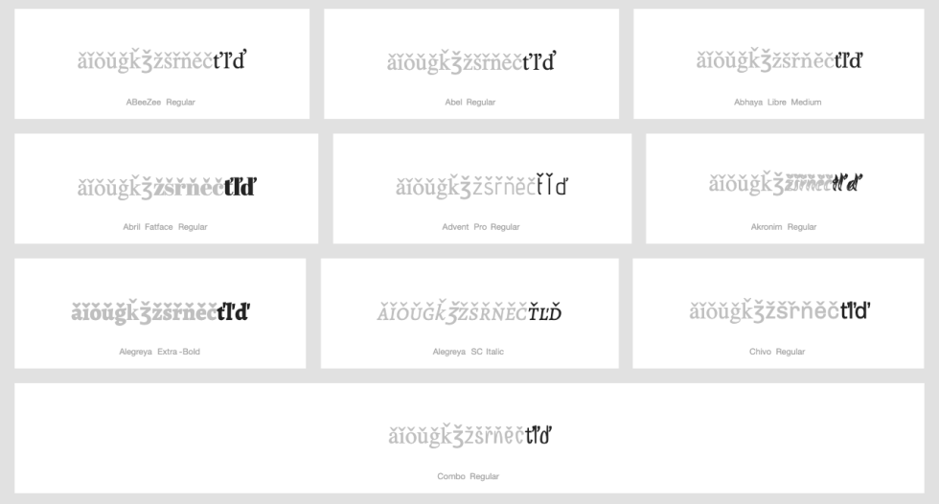

The three letters are included in the repertoire as these are used in Czech and Slovak. As the apostrophe (U+02BC) is not included in the repertoire, there is no possibility for the confusion between t, l, d with Caron and the combining t, l, d with apostrophe.

The Latin GP considered the case where the character with caron can be used to “spell” word with apostrophe, e.g. Small Letter D with Caron can be used to spell a French word like aujourďhui, and concluded that it does not raise security concern in the context of generating a label for the root-zone.

The GP also further concluded that the Latin Small Letter D with Caron, Latin Small Letter L with Caron, and Latin Small Letter T with Caron are not variant with each of its own base character.

