Mac OS Catalina 10.15.3, Apple Mail Version 13.0 (3608.60.0.2.5)

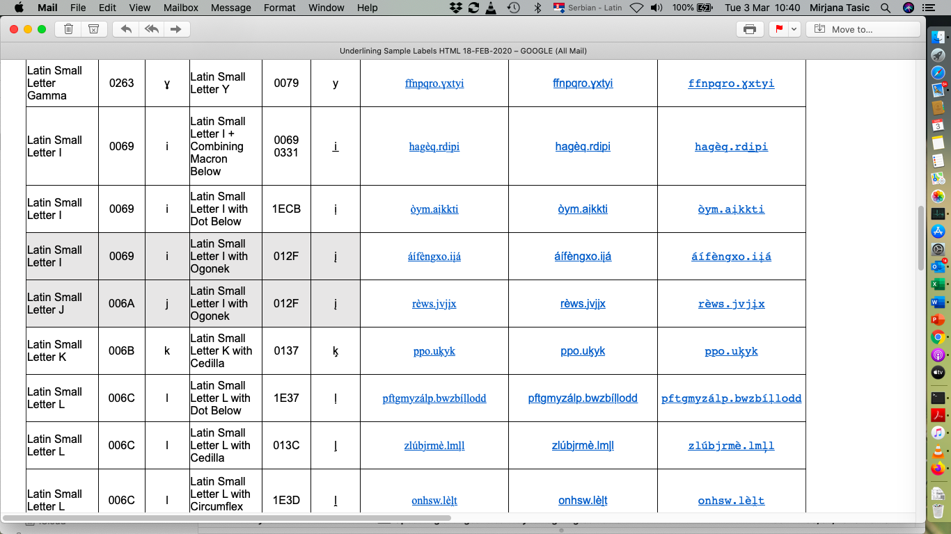
Remark: Latin Small Letter I + Combining Macron Below is not recognizable in Ariel font

Mac OS Catalina 10.15.3, Firefox 73.0.1(64bit), Webmail GMAIL

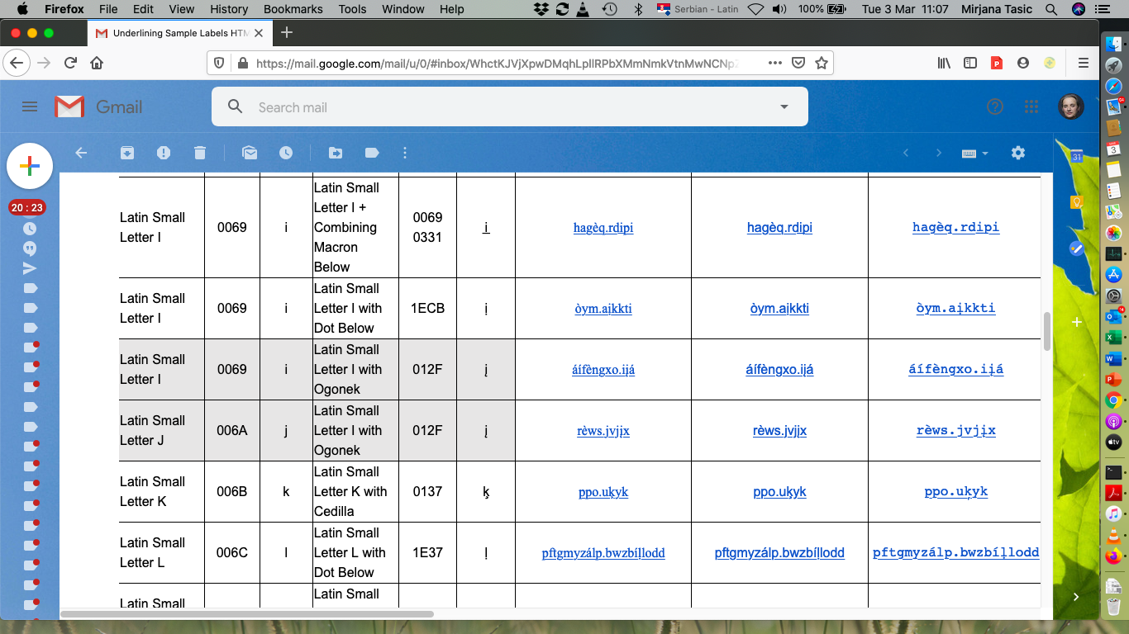
All glyphs are recognizable

Mac OS Catalina 10.15.3, Google Chrome Version 80.0.3987.122 (Official Build) (64-bit), Microsoft Outlook Web Application
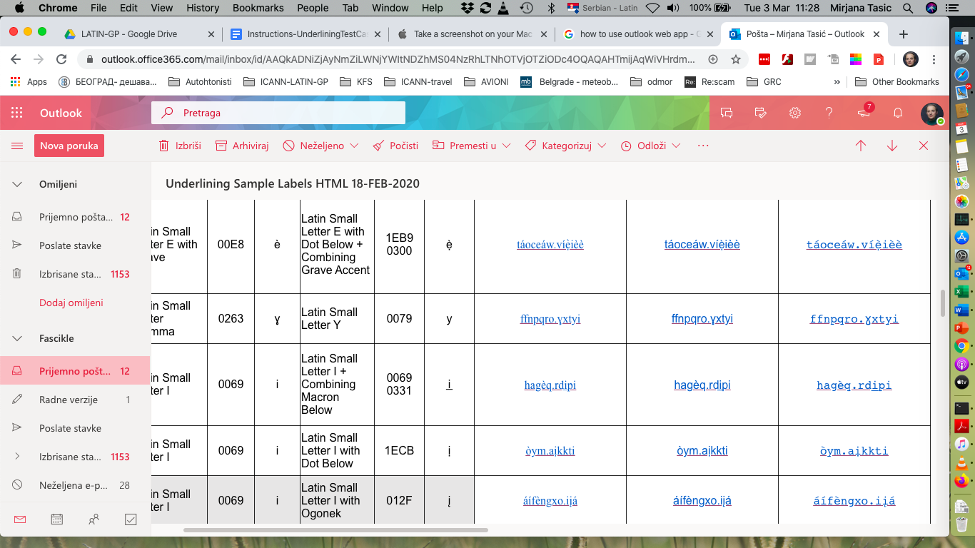
All glyphs are recognizable

Mac OS Catalina 10.15.3, Safari Version 13.0.5 (15608.5.11), Microsoft Outlook Web Application

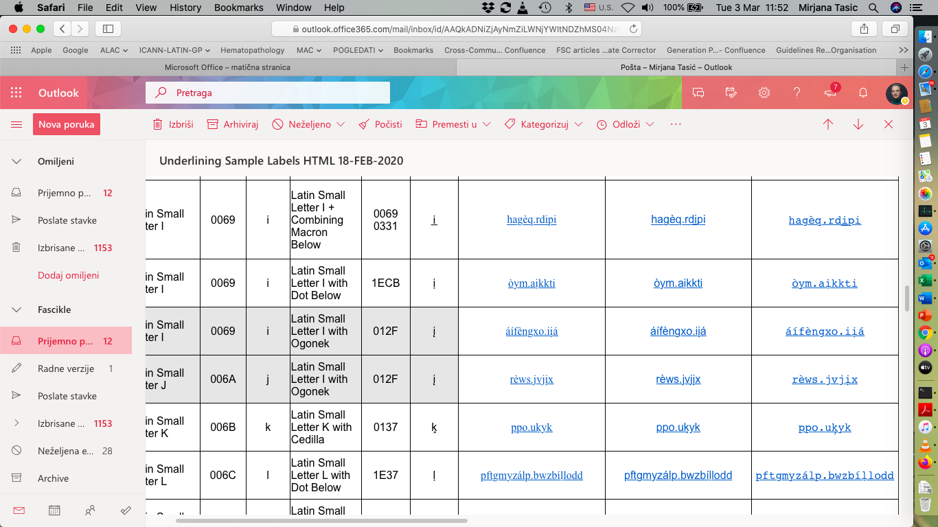

All glyphs are recognizable

Mac OS Catalina 10.15.3, Firefox 73.0.1(64bit), Microsoft Outlook Web Application

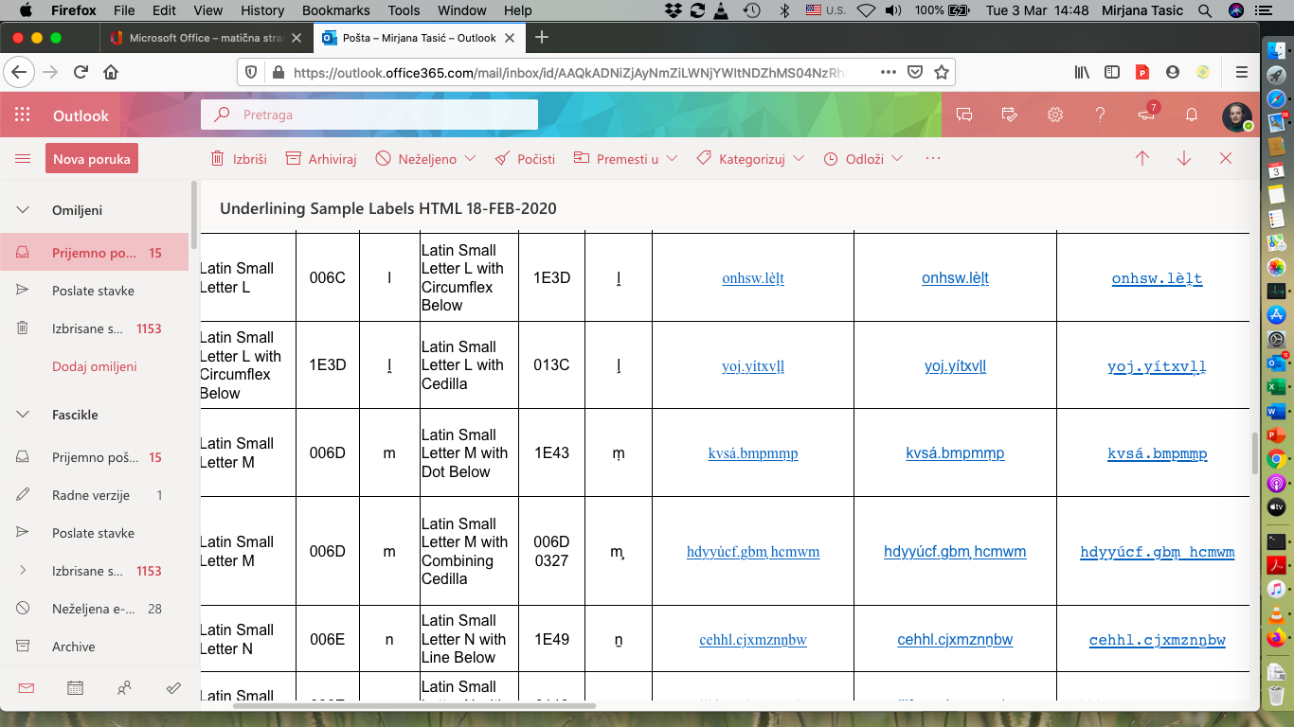
All glyphs are recognizable

