D.4 Stacking of Diacritics

D.4.1 Circumflex and Tilde

Code Points Considered:

Code Point | Glyph | Unicode Name
00E2 | â | LATIN SMALL LETTER A WITH CIRCUMFLEX
00E3 | ã | LATIN SMALL LETTER A WITH TILDE
00EA | ê | LATIN SMALL LETTER E WITH CIRCUMFLEX
00EE | î | LATIN SMALL LETTER I WITH CIRCUMFLEX
1EAB | ẫ | LATIN SMALL LETTER A WITH CIRCUMFLEX AND TILDE
00F1 | ñ | LATIN SMALL LETTER N WITH TILDE
00F4 | ô | LATIN SMALL LETTER O WITH CIRCUMFLEX
00F5 | õ | LATIN SMALL LETTER O WITH TILDE
00FB | û | LATIN SMALL LETTER U WITH CIRCUMFLEX
1EC5 | ễ | LATIN SMALL LETTER E WITH CIRCUMFLEX AND TILDE
006F | o | LATIN SMALL LETTER O
1ED7 | ỗ | LATIN SMALL LETTER O WITH CIRCUMFLEX AND TILDE
1EF9 | ỹ | LATIN SMALL LETTER Y WITH TILDE
011D | ĝ | LATIN SMALL LETTER G WITH CIRCUMFLEX
015D | ŝ | LATIN SMALL LETTER S WITH CIRCUMFLEX
0061 | a | LATIN SMALL LETTER A
0065 | e | LATIN SMALL LETTER E
0109 | ĉ | LATIN SMALL LETTER C WITH CIRCUMFLEX
0125 | ĥ | LATIN SMALL LETTER H WITH CIRCUMFLEX
0129 | ĩ | LATIN SMALL LETTER I WITH TILDE
0135 | ĵ | LATIN SMALL LETTER J WITH CIRCUMFLEX
0169 | ũ | LATIN SMALL LETTER U WITH TILDE
0175 | ŵ | LATIN SMALL LETTER W WITH CIRCUMFLEX
0177 | ŷ | LATIN SMALL LETTER Y WITH CIRCUMFLEX
0067 + 0303 | g̃ | LATIN SMALL LETTER G + COMBINING TILDE
0072 + 0303 | r̃ | LATIN SMALL LETTER R WITH COMBINING TILDE
0268 + 0303 | ɨ̃ | LATIN SMALL LETTER I WITH STOKE + COMBINING TILDE
0289 + 0303 | ʉ̃ | LATIN SMALL LETTER U BAR + COMBINING TILDE

Sequence aẫa (0061 1EAB 0061) compared using Google Fonts in https://wordmark.it/:
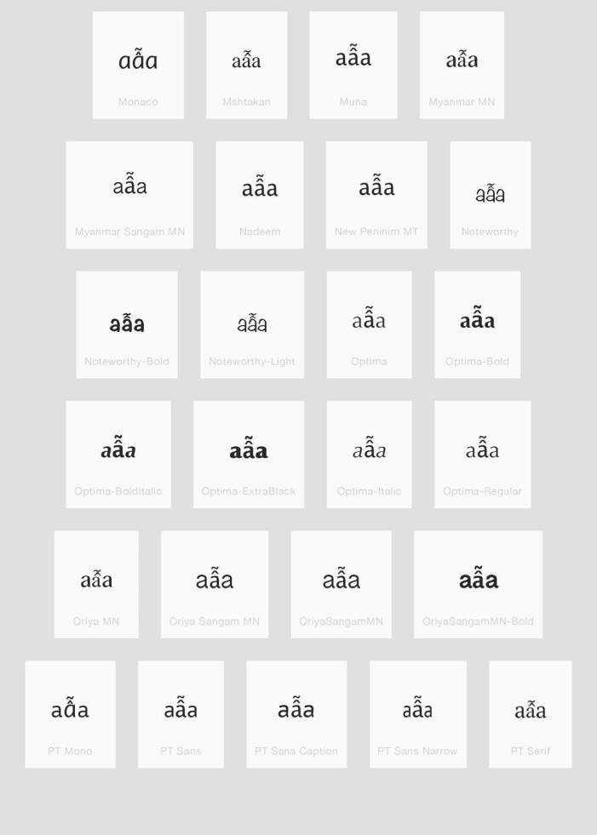

Findings:
Stacking diacritics are always in place. Sequence eễe (0065 1EC5 0065) compared using Google Fonts in https://wordmark.it/:
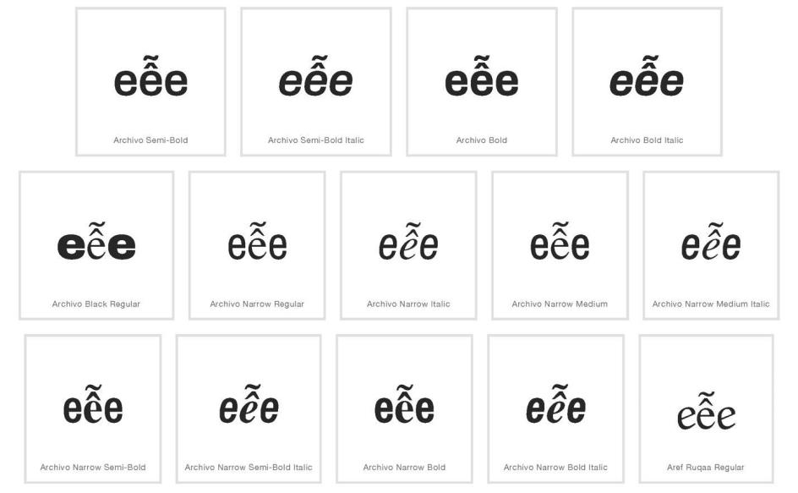
Findings:
Stacking diacritics are always in place.
Sequence oỗo (006F 1EC5 006F) compared using Google Fonts in https://wordmark.it/:
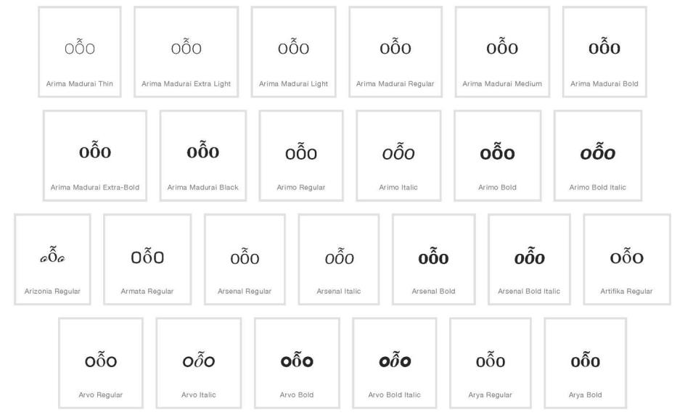

Findings:
Stacking diacritics are always in place

D.4.2 Circumflex and Hook Above

Code Points Considered:

Code Point | Glyph | Unicode Name
1EA9 | ẩ | LATIN SMALL LETTER A WITH CIRCUMFLEX AND HOOK ABOVE
00E2 | â | LATIN SMALL LETTER A WITH CIRCUMFLEX
1EA3 | ả | LATIN SMALL LETTER A WITH HOOK ABOVE
1EC3 | ể | LATIN SMALL LETTER E WITH CIRCUMFLEX AND HOOK ABOVE
00EA | ê | LATIN SMALL LETTER E WITH CIRCUMFLEX
1EBB | ẻ | LATIN SMALL LETTER E WITH HOOK ABOVE
1ED5 | ổ | LATIN SMALL LETTER O WITH CIRCUMFLEX AND HOOK ABOVE
00F4 | ô | LATIN SMALL LETTER O WITH CIRCUMFLEX
1ECF | ỏ | LATIN SMALL LETTER O WITH HOOK ABOVE

Sequence ẩaâả (1EA9 + 0061 + 00E2 + 1EA3) compared using Google Fonts in https://wordmark.it/:
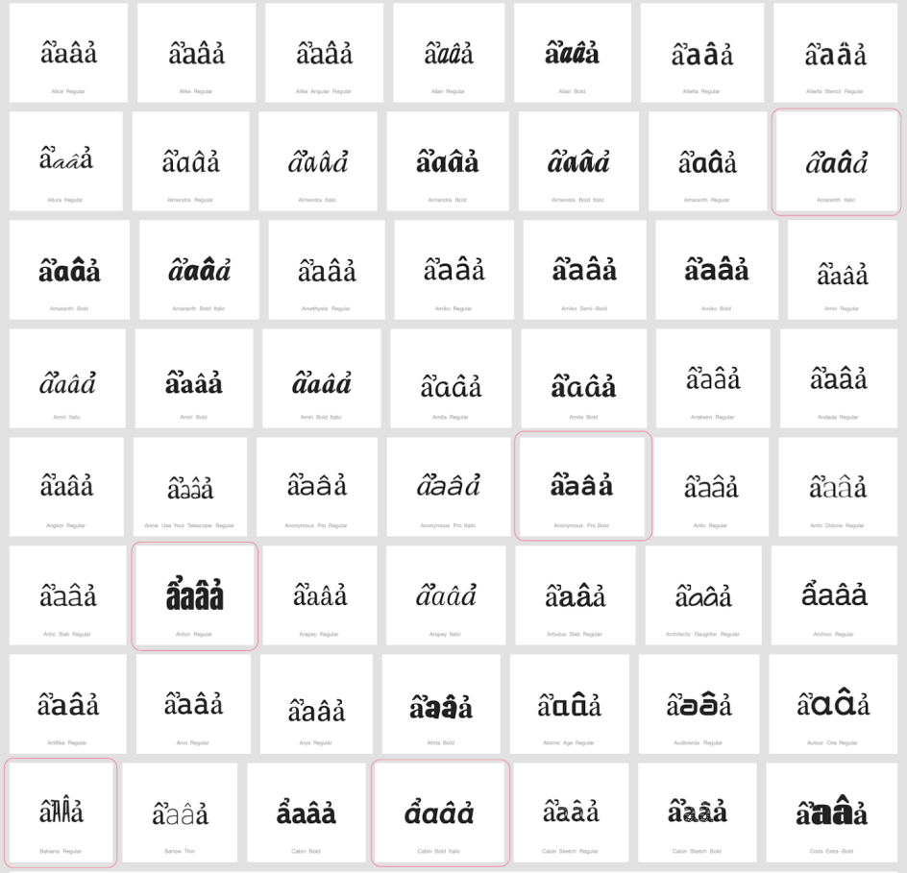

Sequence ểeêẻ (1EC3 + 0065 + 00EA + 1EBB) compared using Google Fonts in https://wordmark.it/:
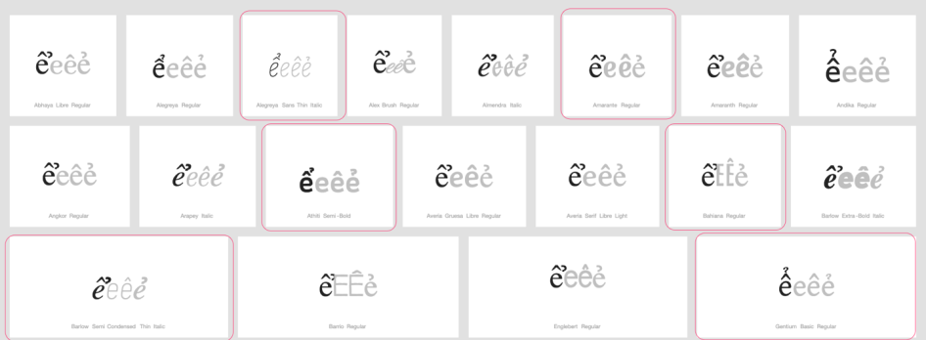

Sequence ổoôỏ (1ED5 + 006F + 00F4 + 1ECF) compared using Google Fonts in https://wordmark.it/:
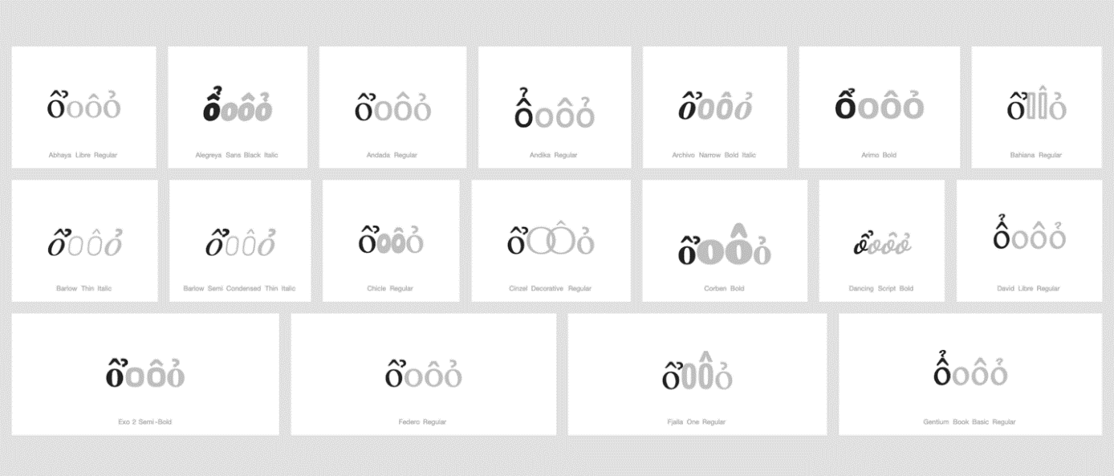

Findings:
In a large number of fonts, the two letters are consistently different. However, in a significant number of fonts, renderings are very diverse. In some case the hook as secondary modifier is placed vertically above, in others it is set horizontally next to the circumflex as primary modifier, in some fonts it is spaced so far horizontally to the right that it becomes unclear if it is a modifier belonging to the first or the second code point, and yet in other cases it even overlaps with the glyph of the following code point.

Conclusion:
Multiple diacritics were generally well-rendered and there was no case of the diacritic completely shifting to the following letter and creating confusion. In addition, these are used in Vietnamese language where the language users can distinguish these code points. Therefore, it was concluded that these code points are not variants.

D.4.3 Breve + Grave above

Code Points Considered:

Code Point | Glyph | Unicode Name
1EB1 | ằ | LATIN SMALL LETTER A WITH BREVE AND GRAVE
Sequence aằa (0061 1EB1 0061) compared using Google Fonts in https://wordmark.it/ :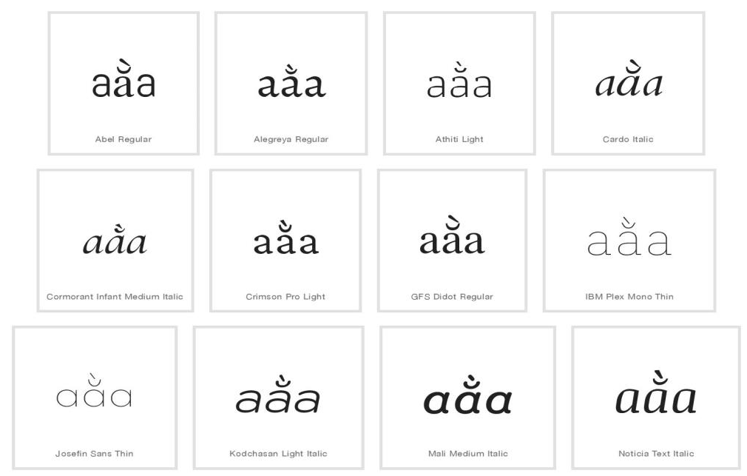
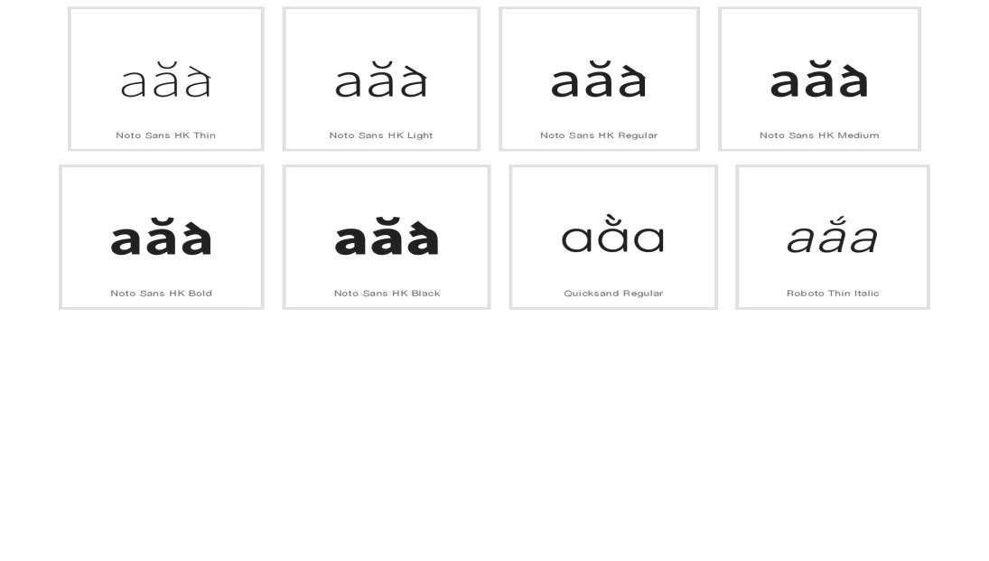
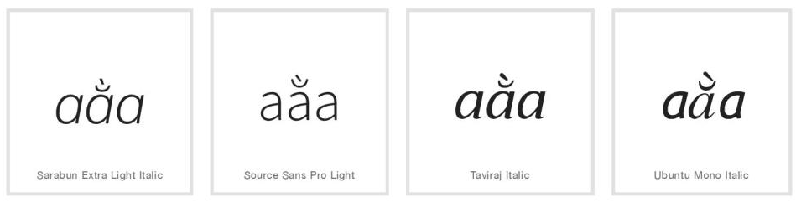
Findings:
Stacking diacritics are in place in most cases. One font namely Noto Sans HK has an error in design, or there are some errors in wordmark.it software: on the screen diacritics are not positioned properly, in .png downloaded from wordmark.it diacritics are positioned properly,
in .pdf presentation of the same web page diacritics are not positioned properly

Conclusion:
Stacking diacritics are almost always in place.

D.4.4 Breve and Hook Above

Code Points Considered:
Code Point | Glyph | Unicode Name
1EA3 | ả | LATIN SMALL LETTER A WITH HOOK ABOVE
1EB3 | ẳ | LATIN SMALL LETTER A WITH BREVE AND HOOK ABOVE
0061 | a | LATIN SMALL LETTER A
0103 | ă | LATIN SMALL LETTER A WITH BREVE
Sequence (aẳaăả) (0061 1EB3 0061 0103 1EA3) compared using Google Fonts in https://wordmark.it/:
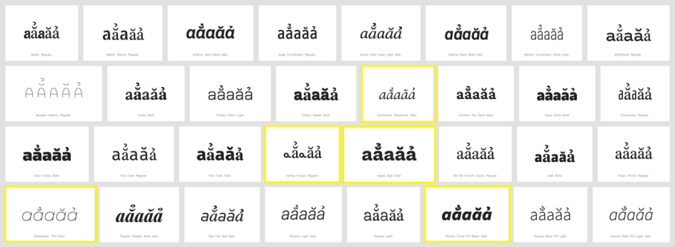

Findings:
Stacking diacritics are always in place.

Conclusions:
No variant relationship is warranted.

D.4.5 Breve and Tilde

Code Points Considered:

Code Point | Glyph | Unicode Name
1EB5 | ẵ | LATIN SMALL LETTER A WITH BREVE AND TILDE

Sequence ẵ (1EB5) compared using Google Fonts in https://wordmark.it/:
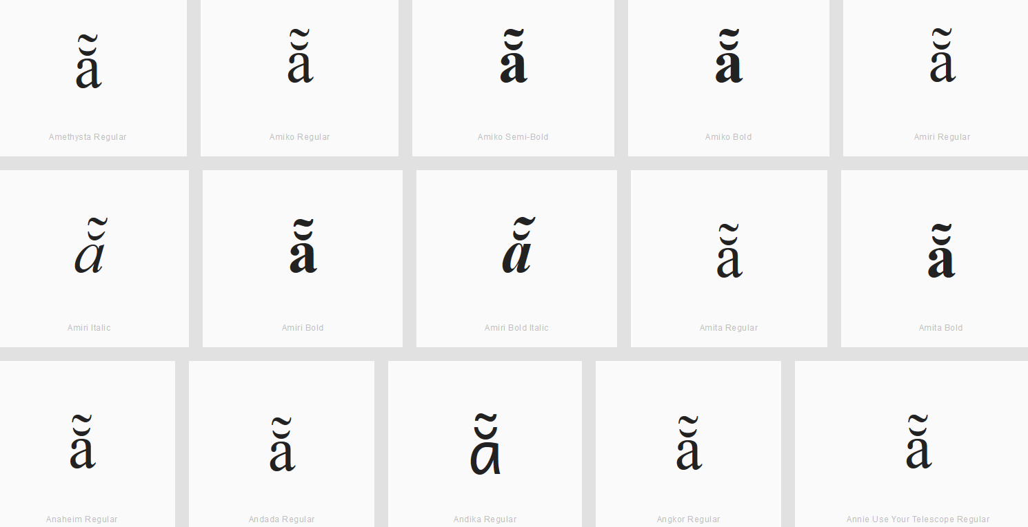

Findings:
The double diacritics stay at the base character and thus will not be confused with characters next to it having just one of the diacritics.

D.4.6 Horn and Acute

Code Points Considered:

Code Point | Glyph | Unicode Name
1EDB | ớ | LATIN SMALL LETTER O WITH HORN AND ACUTE
1EE9 | ứ | LATIN SMALL LETTER U WITH HORN AND ACUTE

Sequence ớ (1EDB) compared using Google Fonts in https://wordmark.it/:

Sequence ứ (1EE9) compared using Google Fonts in https://wordmark.it/:

Findings:
Diacritics are rendered in a consistent manner.

D.4.7 Horn and Hook Above

Code Points Considered:

Code Point | Glyph | Unicode Name
1EDF | ở | LATIN SMALL LETTER O WITH HORN AND HOOK ABOVE
1ECF | ỏ | LATIN SMALL LETTER O WITH HOOK ABOVE
01A1 | ơ | LATIN SMALL LETTER O WITH HORN
1EED | ử | LATIN SMALL LETTER U WITH HORN AND HOOK ABOVE
1EE7 | ủ | LATIN SMALL LETTER U WITH HOOK ABOVE
01B0 | ư | LATIN SMALL LETTER U WITH HORN

Sequence ởoỏơ (1EDF + 006F + 1ECF + 01A1) compared using Google Fonts in https://wordmark.it/:
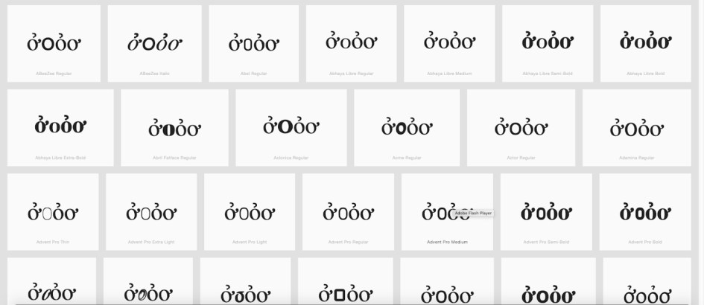

Sequence ửuủư (1EED + 0075+ 1EE7+ 01B0) compared using Google Fonts in https://wordmark.it/:
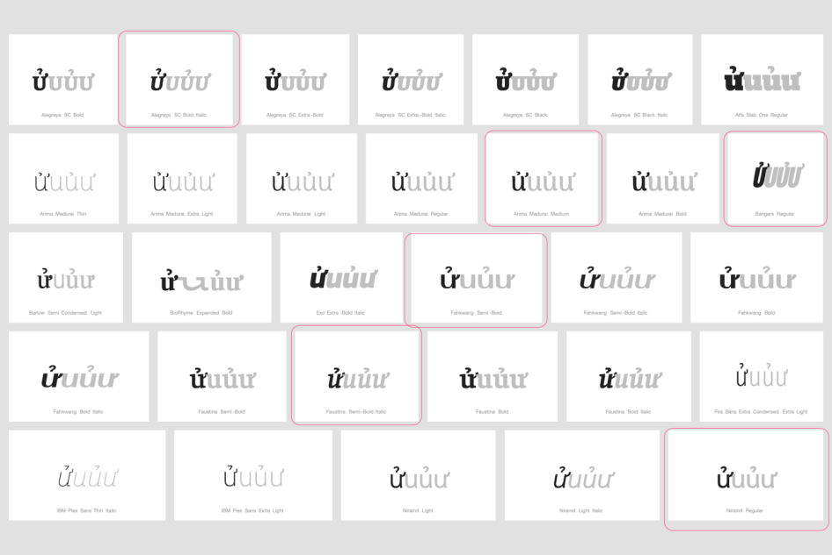

Findings:
In the case of 1EDF, renderings are considerably homogenous and clearly discernible from adjacent glyphs. In the case of 1EED however, renderings are rather heterogeneous and there are a significant number of fonts in which it is not clear whether the modifying hook is a modifier of 1EED, a ligature between 1EED and the following code point, or a left hand-side modifier of a subsequently following code point to the right.
Therefore, additional analysis is warranted of a sequence of 1EED followed by u-shape based Code Points featuring a left-hand side modifier, i.e. 00F9 (ù Latin Small Letter U with Grave) and 1EEB (ừ Latin Small Letter U with Horn and Grave), which was conducted as demonstrated below:

Sequence ửuửùửừ (1EED + 0075 + 1EED + 00F9 + 1EED + 1EEB ) compared using Google Fonts in https://wordmark.it/:
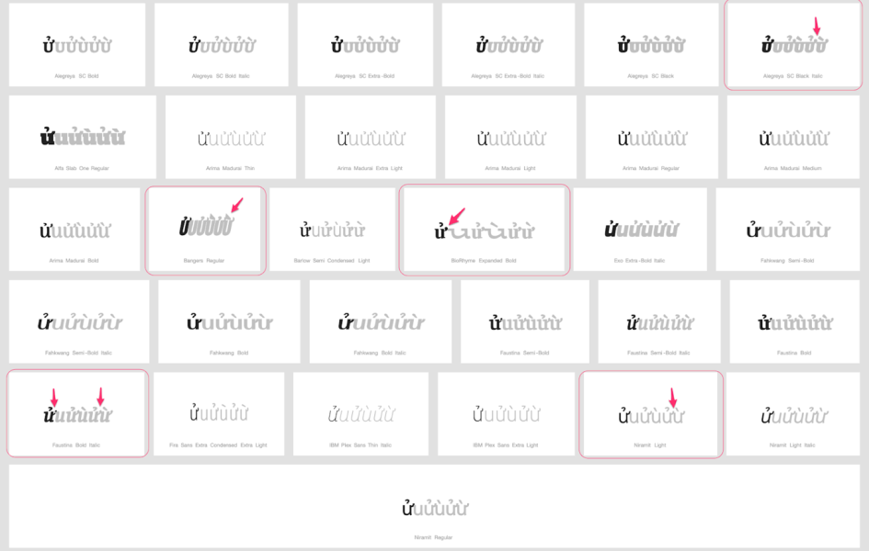
Additional Findings:
In some fonts, it remains unclear whether the right-hand side hook of 1EED belongs to that glyph or the code point following to the right. Given however two facts, namely that no code point exists in with a left-hand modifier similar enough, and that these Code Points are used only in a minority of language communities, the readers of which should be attuned to such differences, this would not seem to cross the threshold to constitute a variant. It may however be advisable to pay attention to these inconsistencies in a string-similarity review before admission to the root zone.

Conclusions:
These code points are not variants.

D.4.8 Diacritic Grave

Code Points Considered:
Code Point | Glyph | Unicode Name
0061 | a | LATIN SMALL LETTER A
0065 | e | LATIN SMALL LETTER E
0069 | i | LATIN SMALL LETTER I
006F | o | LATIN SMALL LETTER E
0075 | u | LATIN SMALL LETTER U
0079 | y | LATIN SMALL LETTER Y
00E0 | à | LATIN SMALL LETTER A WITH GRAVE
00E8 | è | LATIN SMALL LETTER E WITH GRAVE
00EC | ì | LATIN SMALL LETTER I WITH GRAVE
00F2 | ò | LATIN SMALL LETTER O WITH GRAVE
00F9 | ù | LATIN SMALL LETTER U WITH GRAVE
1EF3 | ỳ | LATIN SMALL LETTER Y WITH GRAVE

Sequence aàa, eèe, iìi, oòo, uùu, and yỳy (0061 00E0 0061, 0065 00E8 0065, 0069 00EC 0069, 006F 00F2 006F, 0075 00F9 0075, and 0079 1EF3 0079 ) compared using Google Fonts in https://wordmark.it/:
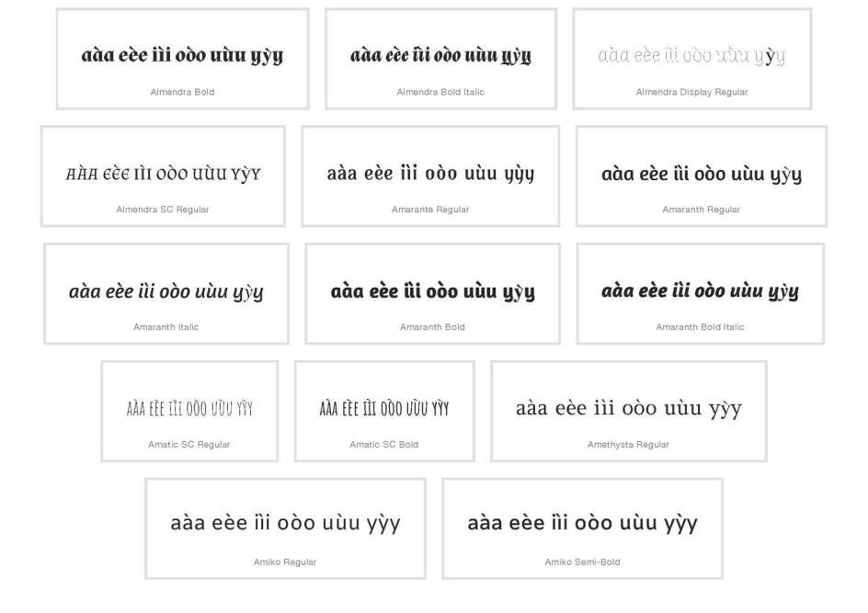
Findings:
Diacritics are always in place.

D.4.9 Diacritics Horn And Grave

Code Points Considered:

Code Point | Glyph |  | Unicode Name
006F |  | o | LATIN SMALL LETTER E
0075 |  | u | LATIN SMALL LETTER U
00F2 |  | ò | LATIN SMALL LETTER O WITH GRAVE
00F9 |  | ù | LATIN SMALL LETTER U WITH GRAVE
01A1 |  | ơ | LATIN SMALL LETTER O WITH HORN
01B0 |  | ư | LATIN SMALL LETTER U WITH HORN
1EDD |  | ờ | LATIN SMALL LETTER O WITH HORN AND GRAVE
1EEB |  | ừ | LATIN SMALL LETTER U WITH HORN AND GRAVE

Sequence ờoơò and ừuưù (1EDD 006F 01A1 00F2 and 1EEB 0075 01B0 00F9) compared using Google Fonts in https://wordmark.it/:
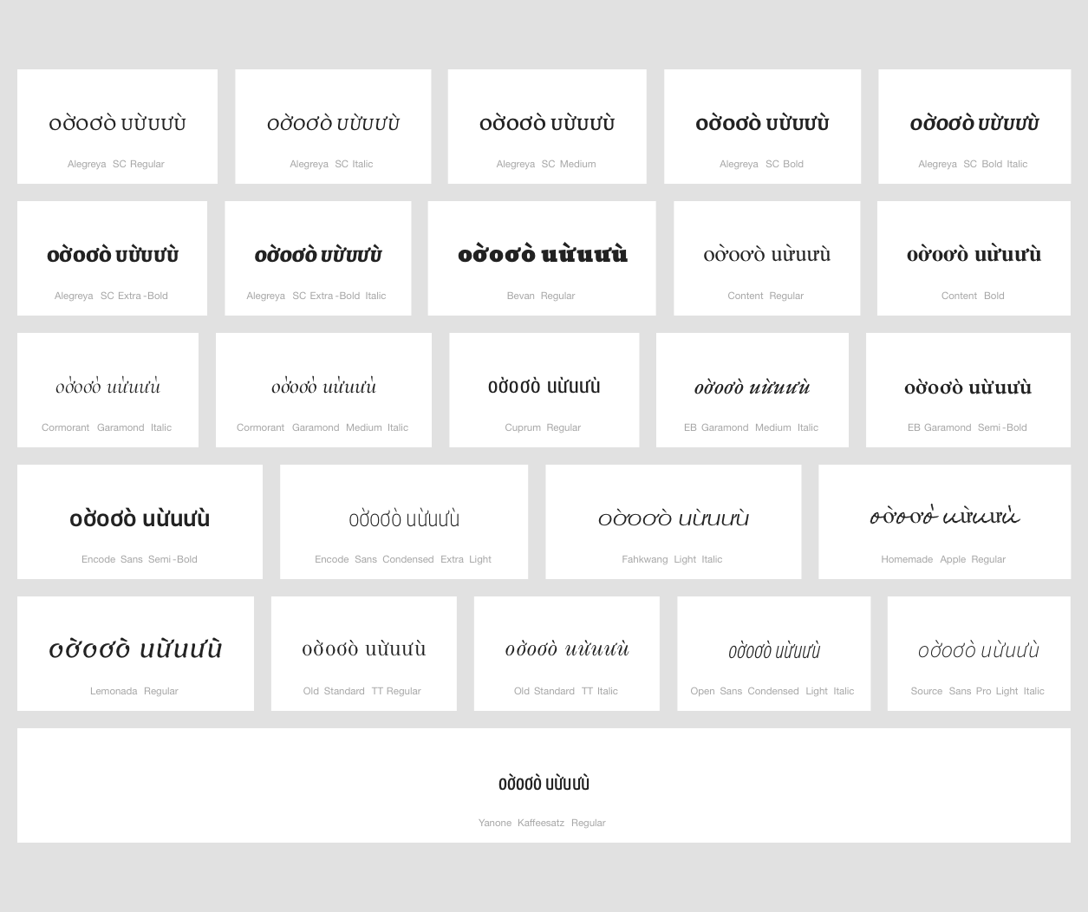

Findings:
Diacritics are always in place. In some fonts, especially in letter "u" case, it seems that horn belongs to the next character. There is no character with horn to the left in Repertoire.

D.4.10 Circumflex and Hook Above

Code Points Considered:

Code Point | Glyph | Unicode Name
1EA9 | ẩ | Latin Small Letter A with Circumflex and Hook Above
1EC3 | ể | Latin Small Letter E with Circumflex and Hook Above
1ED5 | ổ | Latin Small Letter O with Hook Above

String (aẩa eểe oổo) compared using Google Fonts in https://wordmark.it/:
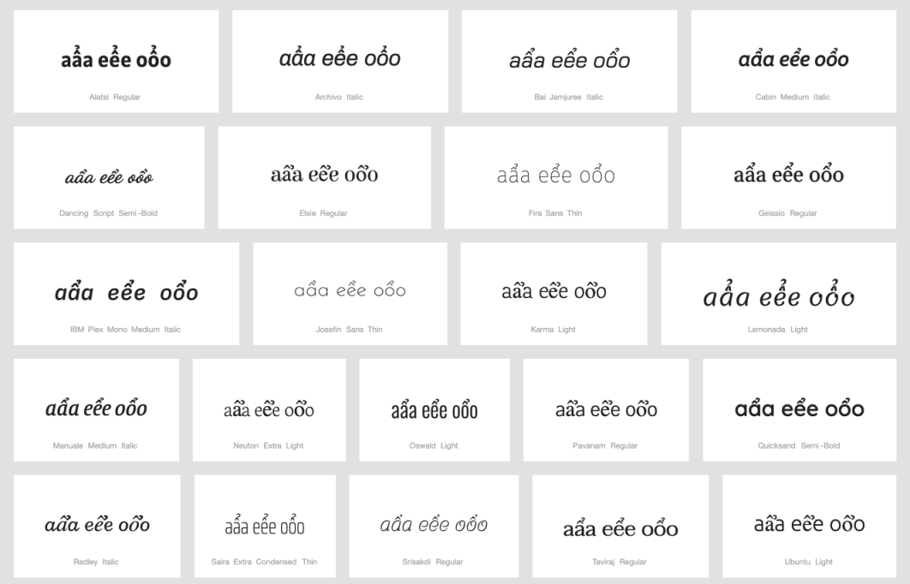

Findings:
The double diacritics stay at the base character and thus will not be confused with characters next to it having just one of the diacritics.

D.4.11 Circumflex + Dot Below

Code Points Considered:

Code Point | Glyph | Unicode Name
0061 | a | LATIN SMALL LETTER A
006F | o | LATIN SMALL LETTER O
00E2 | â | LATIN SMALL LETTER A WITH CIRCUMFLEX
00F4 | ô | LATIN SMALL LETTER O WITH CIRCUMFLEX
1EA1 | ạ | LATIN SMALL LETTER A WITH DOT BELOW
1EAD | ậ | LATIN SMALL LETTER A WITH CIRCUMFLEX
1ECD | ọ | LATIN SMALL LETTER O WITH DOT BELOW
1ED9 | ộ | LATIN SMALL LETTER O WITH CIRCUMFLEX AND DOT BELOW

Sequence aậaâạ (0061 1EAD 0061 00E2 1EA1) compared using Google Fonts in https://wordmark.it/:
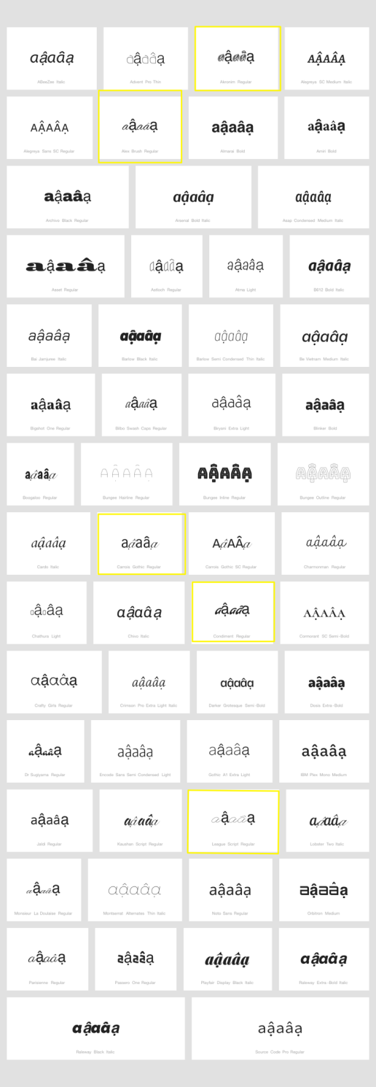

Sequence oộoôọ (006F 1ED9 006F 00F4 1ECD) compared using Google Fonts in https://wordmark.it/:
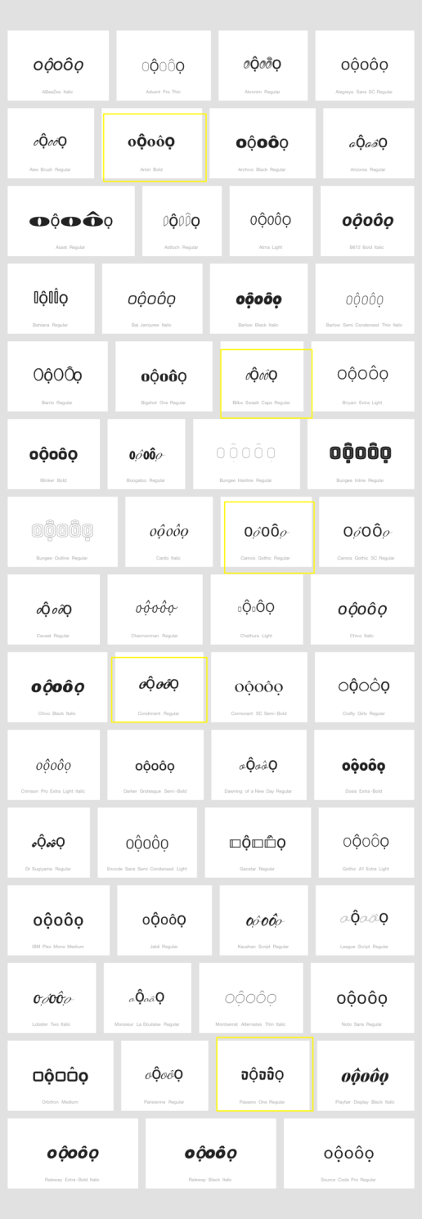

Findings:
The modifiers stay in place even in fonts with strong deviation from standard shapes or where font substitution takes place.

Conclusions:
No variant relationship is warranted.

D.4.12 Breve + Dot Below

Code Points Considered:

Code Point | Glyph | Unicode Name
0061 | a | LATIN SMALL LETTER A
0103 | ă | LATIN SMALL LETTER A WITH BREVE
1EA1 | ạ | LATIN SMALL LETTER A WITH DOT BELOW
1EB7 | ặ | LATIN SMALL LETTER A WITH BREVE AND DOT BELOW

Sequence aặaăạ (0061 1EB7 0061 0103 1EA1) compared using Google Fonts in https://wordmark.it/:

Findings:
The double diacritics stay at the base character and thus will not be confused with characters next to it having just one of the diacritics.

D.4.13 Dot below and combining acute accent

Code Points Considered:

Code Point | Glyph | Unicode Name
0065 | e | LATIN SMALL LETTER E
006F | o | LATIN SMALL LETTER O
00E9 | é | LATIN SMALL LETTER E WITH ACUTE
00F3 | ó | LATIN SMALL LETTER O WITH ACUTE
1EB9 | ẹ | LATIN SMALL LETTER E WITH DOT BELOW
1EB9 + 0301 | ẹ́ | LATIN SMALL LETTER E WITH DOT BELOW + COMBINING ACUTE ACCENT
1ECD | ọ | LATIN SMALL LETTER O WITH DOT BELOW
1ECD + 0301 | ọ́ | LATIN SMALL LETTER O WITH DOT BELOW + COMBINING ACUTE ACCENT

Sequence (eẹ́e and oọ́o) (U+0065 U+1EAB+0301 U+0065 and U+006F U+1ECD+0301 U+006f) compared using Google Fonts in https://wordmark.it/ :
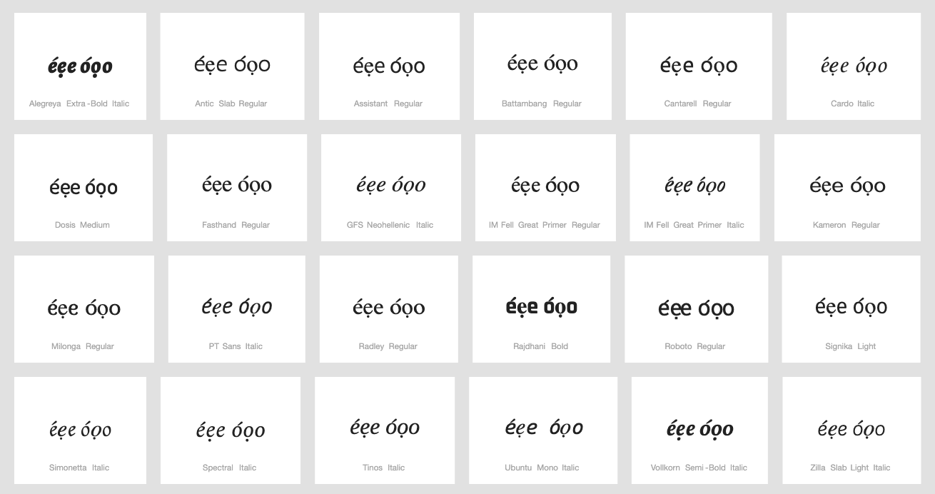

Conclusions:
Stacking diacritics are always in place.

D.4.14 Circumflex + Acute Above

Code Points Considered:

Code Point | Glyph | Unicode Name
0061 | a | LATIN SMALL LETTER A
0065 | e | LATIN SMALL LETTER E
006F | o | LATIN SMALL LETTER O
00E1 | á | LATIN SMALL LETTER A WITH ACUTE
00E2 | â | LATIN SMALL LETTER A WITH CIRCUMFLEX
00E9 | é | LATIN SMALL LETTER E WITH ACUTE
00EA | ê | LATIN SMALL LETTER E WITH CIRCUMFLEX
00F3 | ó | LATIN SMALL LETTER O WITH ACUTE
00F4 | ô | LATIN SMALL LETTER O WITH CIRCUMFLEX
1EA5 | ấ | LATIN SMALL LETTER A WITH CIRCUMFLEX AND ACUTE
1EBF | ế | LATIN SMALL LETTER E WITH CIRCUMFLEX AND ACUTE
1ED1 | ố | LATIN SMALL LETTER O WITH CIRCUMFLEX AND ACUTE

Sequence ấaâá (1EA5 0061 00E2 00E1) compared using Google Fonts in https://wordmark.it/:

Sequence ếeêé (1EBF 0065 00EA 00E9) compared using Google Fonts in https://wordmark.it/:
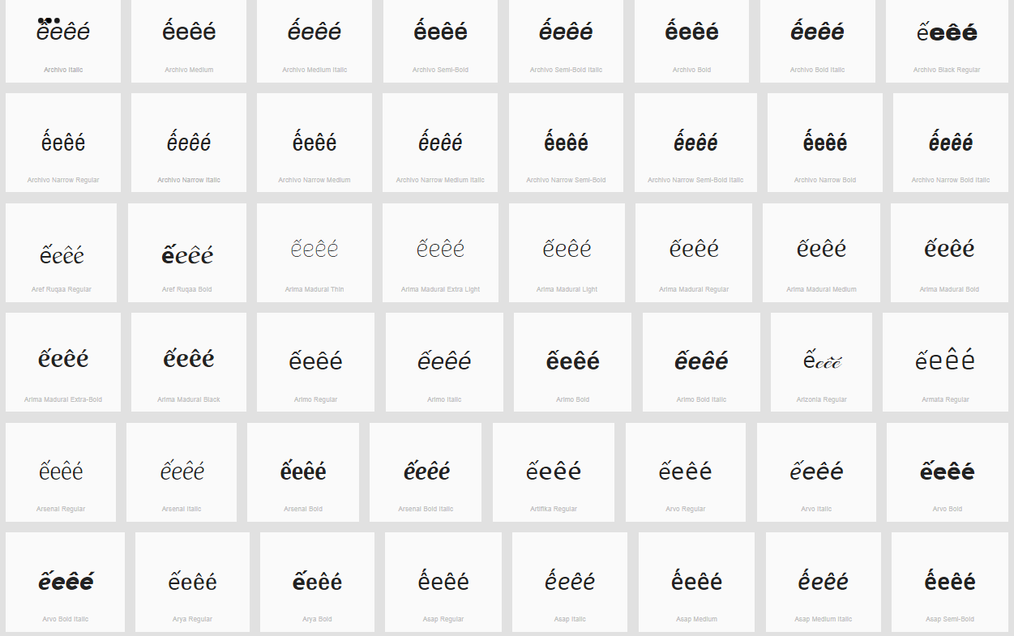

Sequence ốoôó (1ED1 006F 00F4 00F3) compared using Google Fonts in https://wordmark.it/:

Findings:
Diacritics are rendered in a consistent manner, but in some fonts circumflex and acute together can be confused with a Tilde.

Conclusions:
These code points are not variants.

D.4.15 Acute (vs. Non-Acute)

Code Points Considered:

Code Point | Glyph | Unicode Name
00E1 | á | LATIN SMALL LETTER A WITH ACUTE
00E9 | é | LATIN SMALL LETTER E WITH ACUTE
00ED | í | LATIN SMALL LETTER I WITH ACUTE
00F3 | ó | LATIN SMALL LETTER O WITH ACUTE
00FA | ú | LATIN SMALL LETTER U WITH ACUTE
00FD | ý | LATIN SMALL LETTER Y WITH ACUTE
0107 | ć | LATIN SMALL LETTER C WITH ACUTE
013A | ĺ | LATIN SMALL LETTER L WITH ACUTE
0144 | ń | LATIN SMALL LETTER N WITH ACUTE
0155 | ŕ | LATIN SMALL LETTER R WITH ACUTE
015B | ś | LATIN SMALL LETTER S WITH ACUTE
017A | ź | LATIN SMALL LETTER Z WITH ACUTE
0061 | a | LATIN SMALL LETTER A
0065 | e | LATIN SMALL LETTER E
0069 | i | LATIN SMALL LETTER I
006F | o | LATIN SMALL LETTER O
0075 | u | LATIN SMALL LETTER U
0079 | y | LATIN SMALL LETTER Y
0063 | c | LATIN SMALL LETTER C
006C | l | LATIN SMALL LETTER L
006E | n | LATIN SMALL LETTER N
0072 | r | LATIN SMALL LETTER R
0073 | s | LATIN SMALL LETTER S
007A | z | LATIN SMALL LETTER Z

Sequence (aácćeéiílĺnń) (0061 00E1 0063 0107 0065 00E9 0069 00ED 006C 013A) compared using Google Fonts in https://wordmark.it/:
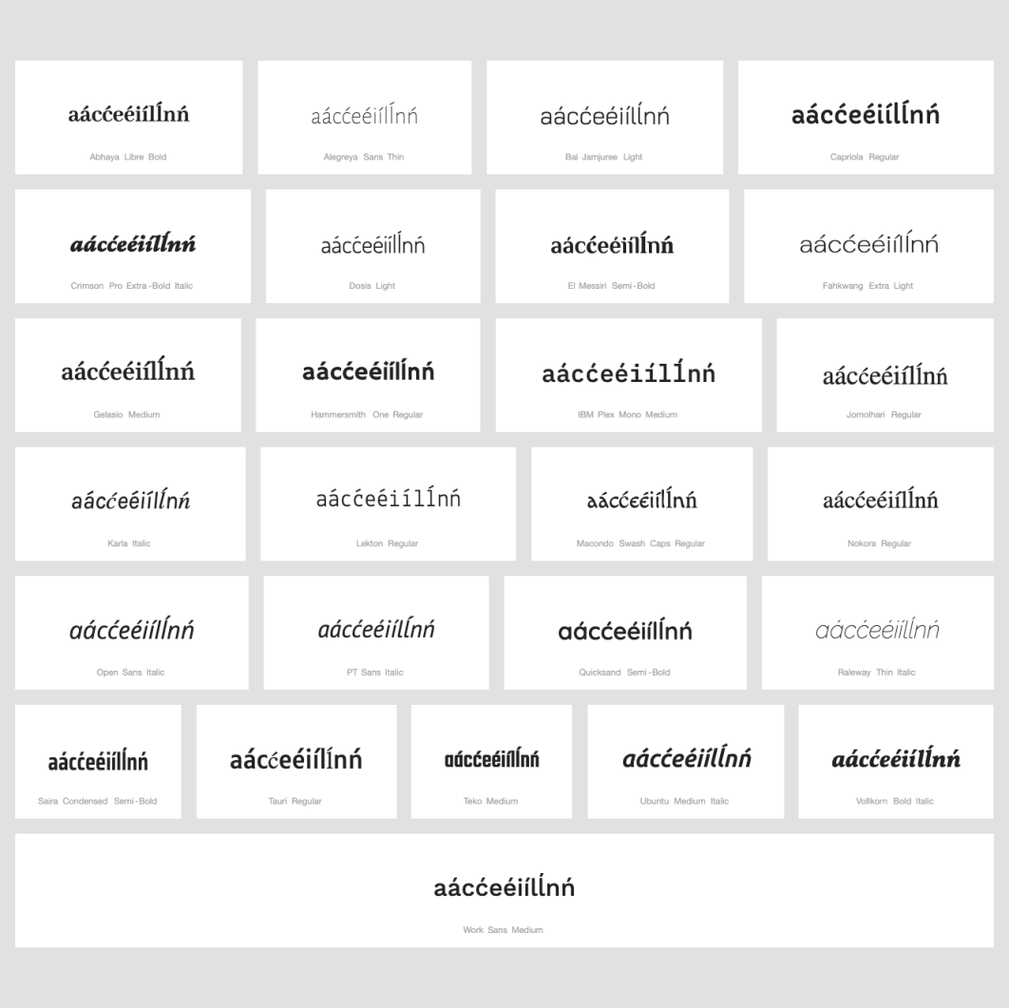

String (nńoórŕsśuùyýzź) compared using Google Fonts in https://wordmark.it/:
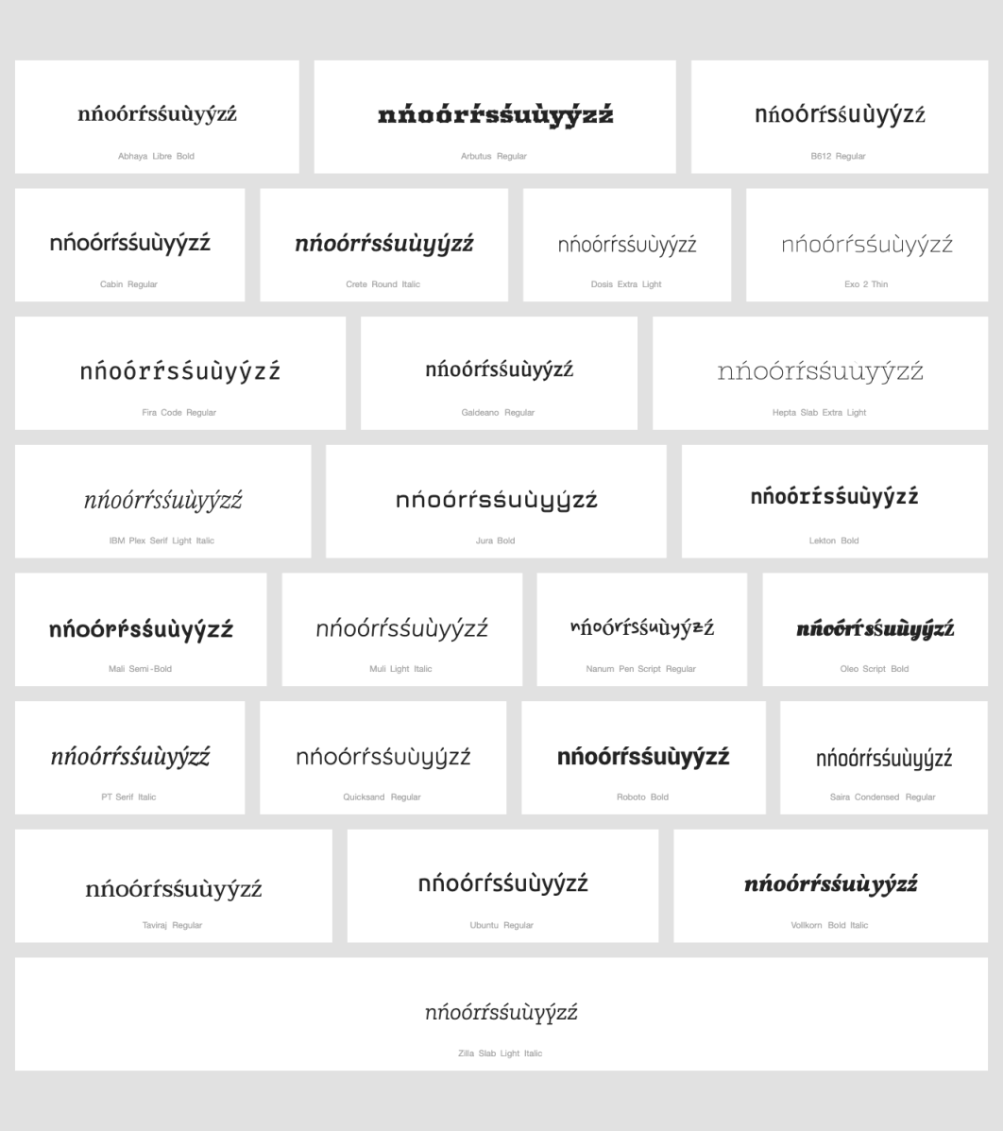

Findings:
Acute is always in place.

Conclusions:
No variants candidates found.

D.4.16 Circumflex Above + Grave Above

Code Points Considered:

Code Point | Glyph | Unicode Name
00E2 | â | LATIN SMALL LETTER A WITH CIRCUMFLEX
00EA | ê | LATIN SMALL LETTER E WITH CIRCUMFLEX
00E0 | à | LATIN SMALL LETTER A WITH GRAVE
00E8 | è | LATIN SMALL LETTER E WITH GRAVE
00F4 | ô | LATIN SMALL LETTER O WITH CIRCUMFLEX
00F2 | ò | LATIN SMALL LETTER O WITH GRAVE
1EC1 | ề | LATIN SMALL LETTER E WITH CIRCUMFLEX AND GRAVE
1ED3 | ồ | LATIN SMALL LETTER O WITH CIRCUMFLEX AND GRAVE
006F | o | LATIN SMALL LETTER O
1EA7 | ầ | LATIN SMALL LETTER A WITH CIRCUMFLEX AND GRAVE
0061 | a | LATIN SMALL LETTER A
0065 | e | LATIN SMALL LETTER E

Sequence aầaàâ (0061 1EA7 0061 00E0 00E2) compared using Google Fonts in https://wordmark.it/:
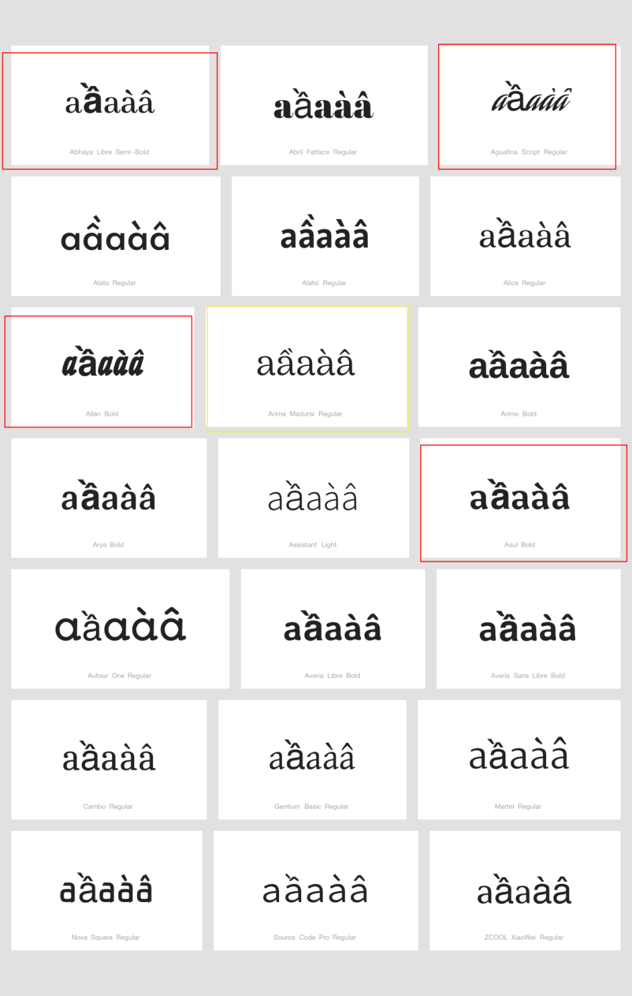

Sequence eềeèê (0065 1EC1 0065 00EA 00E8) compared using Google Fonts in https://wordmark.it/:
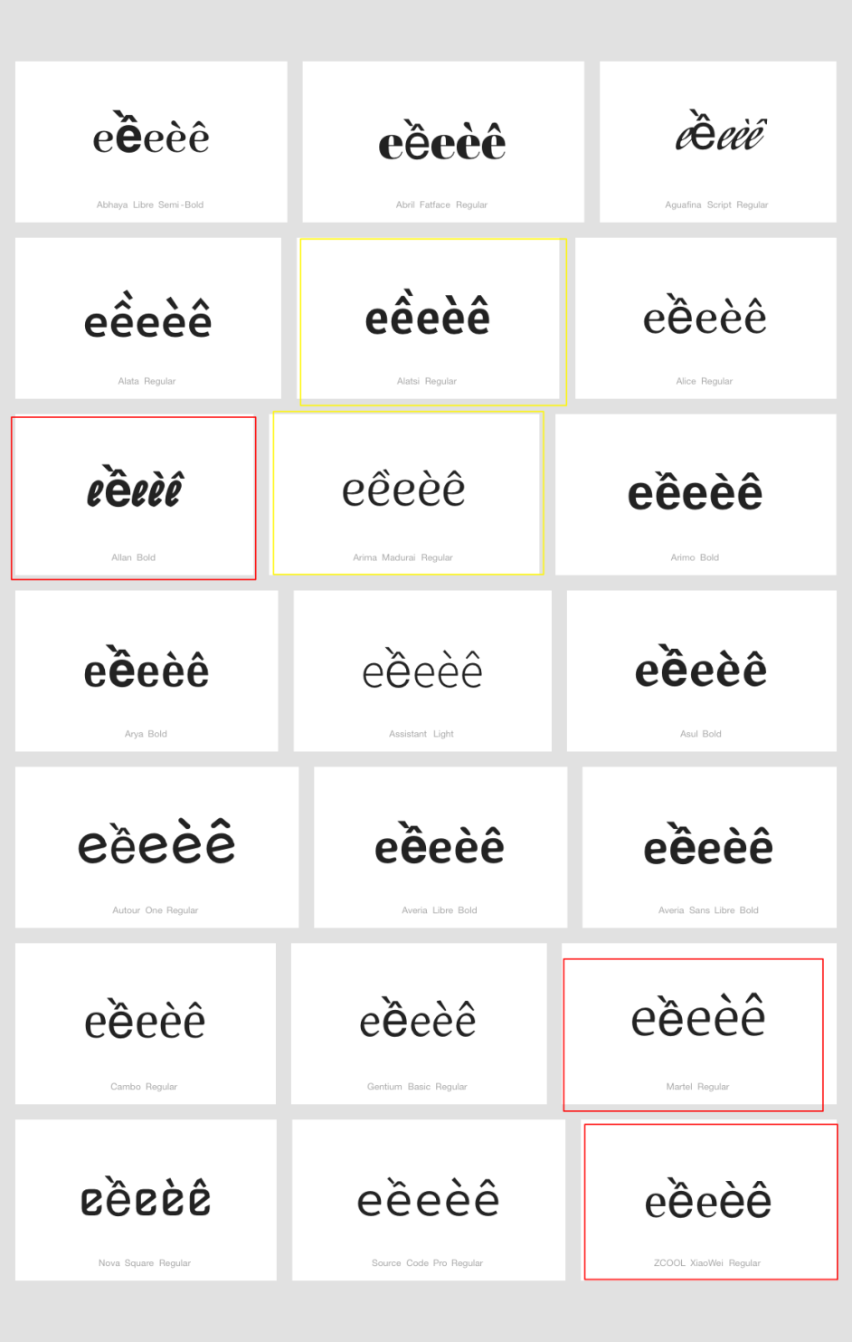

Sequence oồoòô (006F 1ED3 006F 00F4 00F2) compared using Google Fonts in https://wordmark.it/:
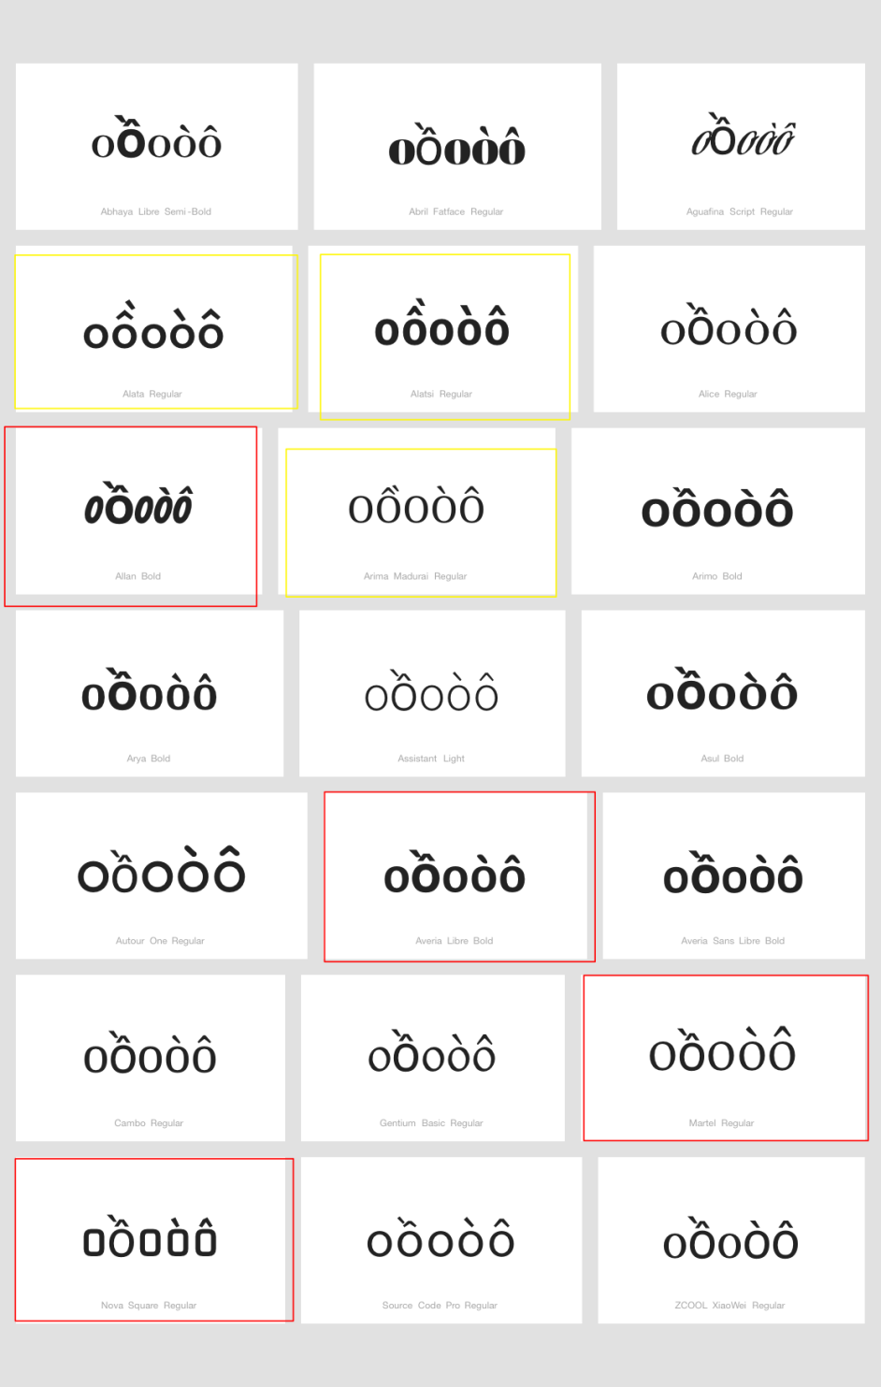

Findings:
There is no stability in the way the grave is positioned. In few fonts it occurs above the circumflex, in a minority of fonts it occurs displaced to the right, here highlighted in yellow. In a significant minority of fonts, the grave occurs instead misplaced to the left of the basic letter shape, and in all such cases presented here (but particularly in the case of a with circumflex and grave) the unmodified basic letter shape followed by the same with circumflex and grave may appear to carry the grave. Accordingly, there is a specific risk for confusion by Latin script users of a, e, or o followed by the same with circumflex and grave with a sequence of the same, first with a grave then with circumflex on top.

Conclusions:
Multiple diacritics were generally well-rendered and there was no case of the diacritic completely shifting to the following letter and creating confusion. In addition, these are used in Vietnamese language where the language users can distinguish these code points. Therefore, it was concluded that these code points are not variants.

D.4.17 Breve and Acute Above

Code Points Considered:

Code Point | Glyph | Unicode Name
1EAF | ắ | LATIN SMALL LETTER A WITH BREVE AND ACUTE
00E1 | á | LATIN SMALL LETTER A WITH ACUTE
0103 | ă | LATIN SMALL LETTER A WITH BREVE
0061 | a | LATIN SMALL LETTER A

Sequence ắaăá (1EAF 0061 0103 00E1) compared using Google Fonts in https://wordmark.it/:
Findings:
In some fonts, the Acute diacritic is displaced to the right. However, it does not appear to be above the following glyph, but standing alone.

Conclusions:
There should not be significant confusion with other glyphs.

D.4.18 Tilde and Horn (Above)

Code Points Considered:

Code Point | Glyph | Unicode Name
1EEF | ữ | LATIN SMALL LETTER U WITH HORN AND TILDE
00F5 | õ | LATIN SMALL LETTER O WITH TILDE
01A1 | ơ | LATIN SMALL LETTER O WITH HORN
01B0 | ư | LATIN SMALL LETTER U WITH HORN
1EE1 | ỡ | LATIN SMALL LETTER O WITH HORN AND TILDE
006F | o | LATIN SMALL LETTER O
0075 | u | LATIN SMALL LETTER U
0169 | ũ | LATIN SMALL LETTER U WITH TILDE

Sequence ỡoõơ (1EE1 006F 00F5 01A1) compared using Google Fonts in https://wordmark.it/:

Sequence ữuũư (1EEF 0075 0169 01B0) compared using Google Fonts in https://wordmark.it/:
Findings:
Diacritics are rendered in a consistent manner

Conclusions:
According to the findings, these code points are not variants.

D.4.19 Dot Below + Combining Grave Accent

Code Points Considered:

Code Point | Glyph | Unicode Name
0065 | e | LATIN SMALL LETTER E
006F | o | LATIN SMALL LETTER O
00E8 | è | LATIN SMALL LETTER E WITH GRAVE
00F2 | ò | LATIN SMALL LETTER O WITH GRAVE
1EB9 | ẹ | LATIN SMALL LETTER E WITH DOT BELOW
1EB9 + 0300 | ẹ̀ | LATIN SMALL LETTER E WITH DOT ABOVE + COMBINING GRAVE ACCENT
1ECD | ọ | LATIN SMALL LETTER O WITH DOT BELOW
1ECD + 0300 | ọ̀ | LATIN SMALL LETTER O WITH DOT BELOW + COMBINING GRAVE ACCENT

Sequence ọ̀oòọ (1ECD + 0300 006F 00F2 1ECD) compared using Google Fonts in https://wordmark.it/:
Sequence ẹ̀eèẹ (1EB9 + 0300 0065 00E8 1EB9) compared using Google Fonts in https://wordmark.it/:

Findings:
Diacritics are rendered in a consistent manner

Conclusions:
According to the findings, these code points are not variants.

D.4.20 Horn and Dot Below

Code Points Considered:

Code Point | Glyph | Unicode Name
006F | o | Latin Small Letter O
0075 | u | Latin Small Letter U
01A1 | ơ | Latin Small Letter O with Horn
01B0 | ư | Latin Small Letter U with Horn
1ECD | ọ | Latin Small Letter O with Dot Below
1EE3 | ợ | Latin Small Letter O with Horn and Dot Below
1EE5 | ụ | Latin Small Letter U with Dot Below
1EF1 | ự | Latin Small Letter U with Horn and Dot Below

Sequence oợoọơ (006F 1EE3 006F 1ECD 01A1) compared using Google Fonts in https://wordmark.it/:
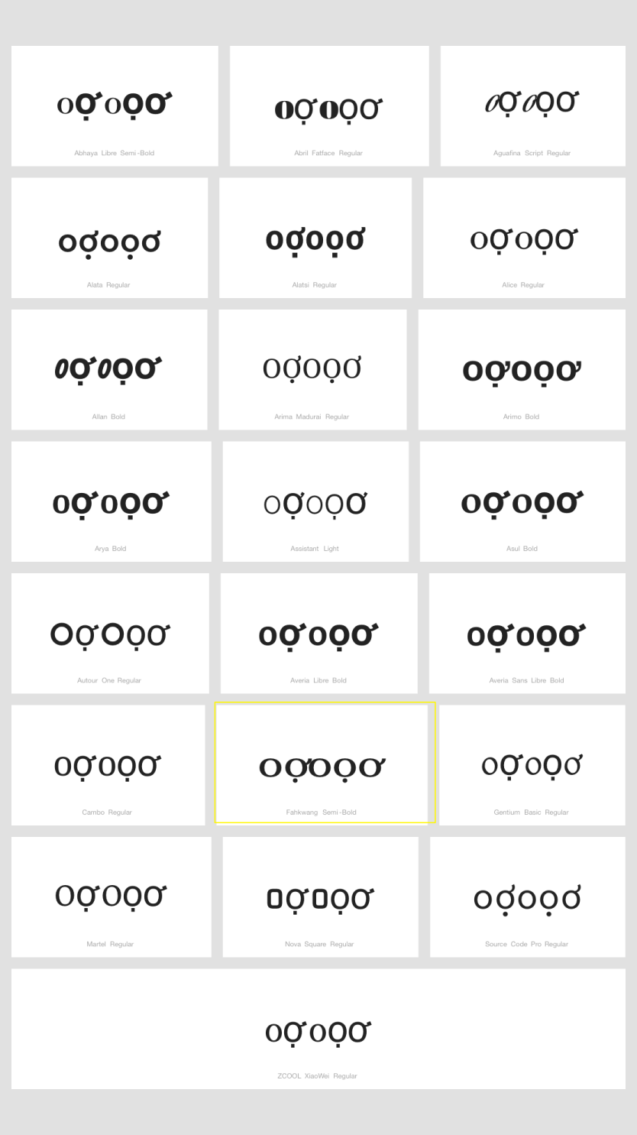

Sequence uựuụư (0075 1EF1 0075 1EE5 01B0) compared using Google Fonts in https://wordmark.it/:
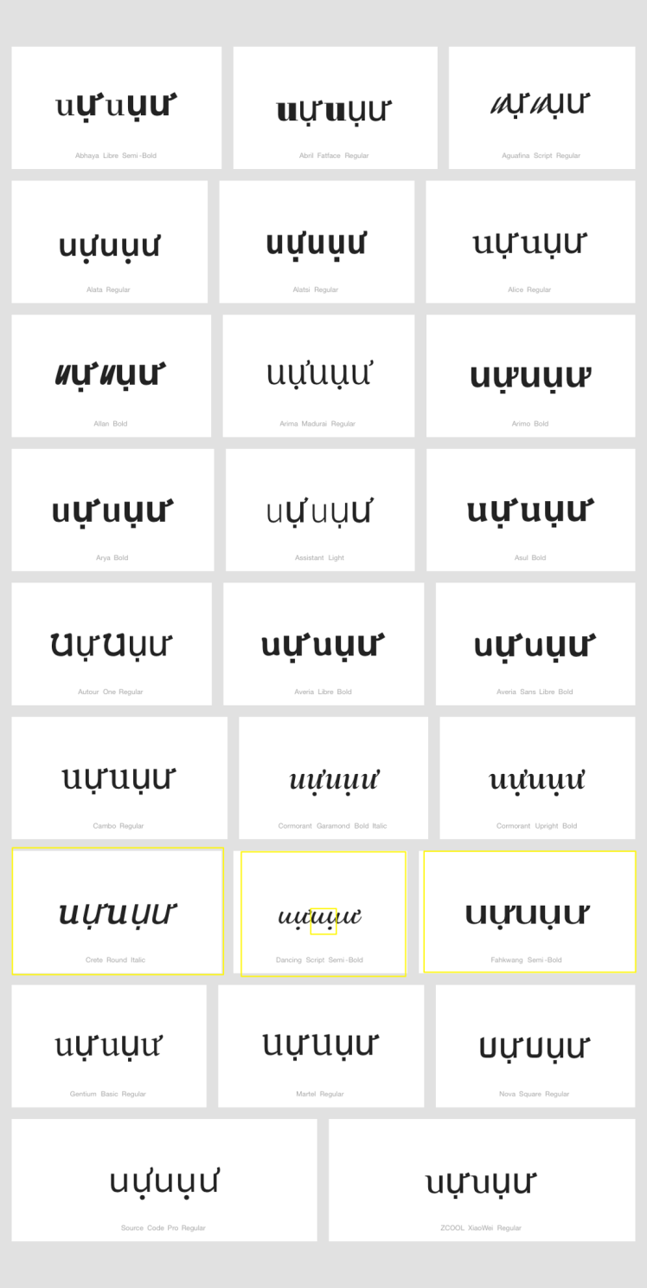

Findings:
In rare cases, it is not clear if the horn is a righthand-side modifier of the second character or a left-hand-side modifier of the third character. However, there is no character with a left-hand-side modifier in the repertoire. Therefore this does not pose a security risk.

Conclusions:
No variant relationship is warranted.

D.4.21 Stacking in Courier New (And Perhaps Other Fonts)

We have seen that, with precomposed Code Points, there is no stacking problem. However, when we have not had a precomposed Code Points available, we have necessarily used combining diacritics. Then, the situation changes. In particular, when using the Courier New font (which is one of our three standard fonts for analysis), there is sometimes a problem. Sometimes, the combining mark simply gets its own space, with the following letter shifter right to make room – which is irritating, but not confusing. However, in other cases the combining mark appears to be associated with the following letter.

Code Points Considered:

Code Point | Glyph | Unicode Name
1EB9 + 0301 | ẹ́ | Latin Small Letter E with Dot Below + Combining Acute Accent
1EB9 + 0300 | ẹ̀ | Latin Small Letter E with Dot Below + Combining Grave Accent
0067 + 0303 | g̃ | Latin Small Letter G + Combining Tilde
0268 + 0303 | ɨ̃ | Latin Small Letter I with Stroke + Combining Tilde
1ECD + 0300 | ọ̀ | Latin Small Letter O with Dot Below + Combining Grave Accent
1ECD + 0301 | ọ́ | Latin Small Letter O with Dot Below + Combining Acute Accent
025B + 0331 + 0308 | ɛ̱̈ | Latin Small Letter Open E + Combining Diaeresis + Combining Macron Below
025B + 0331 | ɛ̱ | Latin Small Letter Open E + Combining Macron Below
0254 + 0331 | ɔ̱ | Latin Small Letter Open O + Combining Macron Below
0072 + 0303 | r̃ | Latin Small Letter R + Combining Tilde
0289 + 0303 | ʉ̃ | Latin Small Letter U with Bar + Combining Tilde

In each case below, the letter is followed by another letter (or two, in the case of two combining marks. (In each case shown, the letters were simply copied, then the font changed.)

Findings:
With each of these cases, error is a certainty. The ideal solution, of course, would be for the Unicode Consortium to create new pre-composed Code Points for these problem cases. But the Unicode Consortium does not plan on creating any new codepoints.

Conclusions:
This problem exists as the bug in the font. They are not variants.

D.4.22 Circumflex and Acute vs Tilde

Code Points Considered:

Code Point | Glyph | Unicode Name
1EA5 | ấ | LATIN SMALL LETTER A WITH CIRCUMFLEX AND ACUTE
1EBF | ế | LATIN SMALL LETTER E WITH CIRCUMFLEX AND ACUTE
1ED1 | ố | LATIN SMALL LETTER O WITH CIRCUMFLEX AND ACUTE
00E3 | ã | LATIN SMALL LETTER A WITH TILDE
00F1 | ñ | LATIN SMALL LETTER N WITH TILDE
00F5 | õ | LATIN SMALL LETTER O WITH TILDE
0129 | ĩ | LATIN SMALL LETTER I WITH TILDE
0169 | ũ | LATIN SMALL LETTER U WITH TILDE
Comparing 1EA5 00E3 ấã
Comparing 1ED1 00F5 ốõ
Findings:
These are distinguishable.

Conclusions:
No variant relationship is warranted.

