D.2 Spacing of Base Characters

D.2.1 Latin Small Ligature Æ vs. Sequence AE

Code Points Considered:

Code Points | Glyph | Name
00E6 | æ | LATIN SMALL LIGATURE AE
0061 | a | LATIN SMALL LETTER A
0065 | e | LATIN SMALL LETTER E
0153 | œ | LATIN SMALL LIGATURE OE
0251 | ɑ | LATIN SMALL LETTER ALPHA

Sequence æae (00E6 + 0061 + 0065) compared using Google Fonts in https://wordmark.it/:
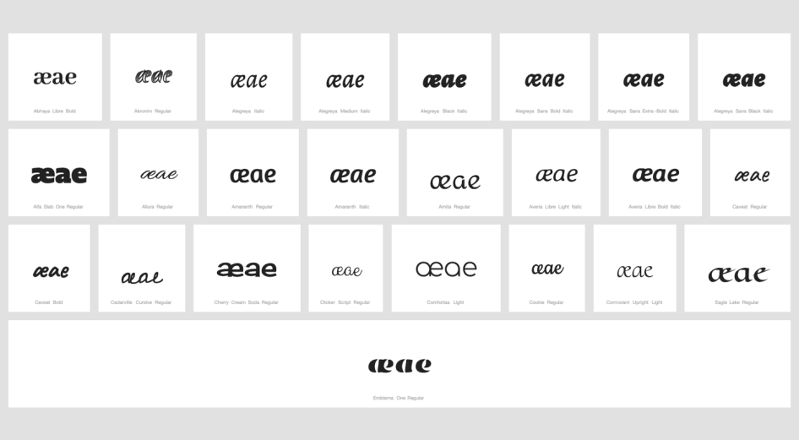

Findings:
In some fonts, in which the a-glyph takes a shape similar to that of 0251 ɑ LATIN SMALL LETTER ALPHA, the ligature and the sequence bare some similarity but are distinguishable.
In a large number of fonts, the ligature and the sequence are consistently different.

Additional Findings:
In fonts, in which the a-glyph takes a shape similar to that of 0251 ɑ Latin Small Letter Alpha, the ligature 00E6 becomes nearly visually identical with the o-e ligature (0153 œ LATIN SMALL LIGATURE OE) as demonstrated below.

Sequence æaeœoe (00E6+0061+0065+0153+006F+0065) compared using Google Fonts in https://wordmark.it/: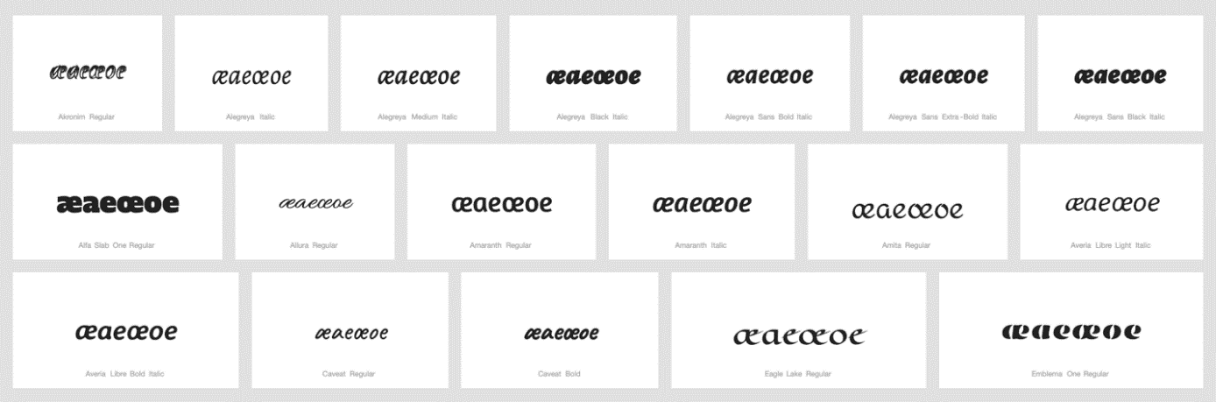

Conclusions:
The ligature of AE and the sequence of A and E are not variants. 00E6 Latin Small Letter Æ and 0153 Latin Small Ligature Œ should be added to string similarity table.

D.2.2 Latin Small Ligature Œ vs. Sequence OE

Code Points Considered:

Code Point | Glyph | Name
0065 | e | LATIN SMALL LETTER E
006F | o | LATIN SMALL LETTER O
0153 | œ | LATIN SMALL LIGATURE OE

Findings:
In a large number of fonts, the sequence and the ligature are consistently different.

Conclusions:
These are not variants.

D.2.3 Sequence of Two Letter V with Hook vs. Latin Small Letter W

Code Points Considered:
Code Points | Glyph | Name
028B 028B | ʋʋ | LATIN SMALL LETTER V WITH HOOK and LATIN SMALL LETTER V WITH HOOK
0077 | w | LATIN SMALL LETTER W

Sequence ʋʋ w (028B028B 0077) compared using Google Fonts in https://wordmark.it/:
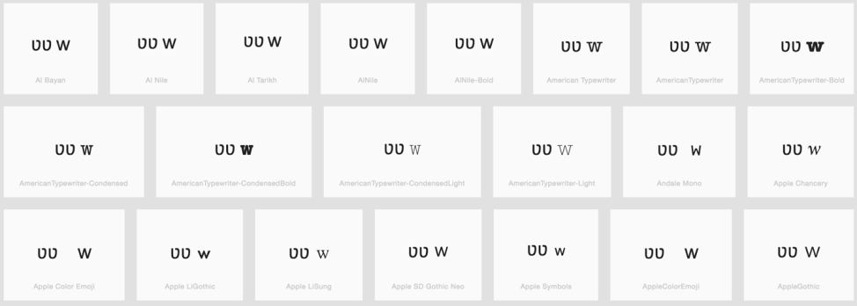
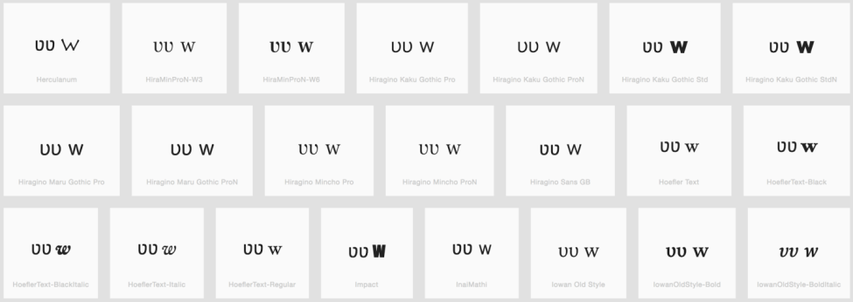
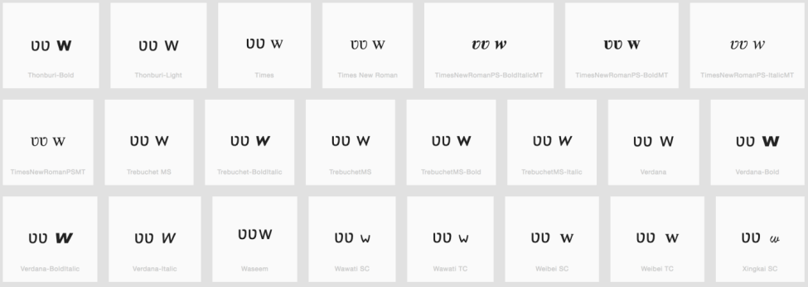

Findings:
Sequence of two Letters V with Hook is different than Letter W

Conclusions:
These are not variants.

