D.3 Shape of Diacritics

D.3.1 Caron (Above) vs. Breve

Code Points Considered:

Code Point | Glyph | Unicode Name
0103 | ă | LATIN SMALL LETTER A WITH BREVE
011F | ğ | LATIN SMALL LETTER G WITH BREVE
016D | ŭ | LATIN SMALL LETTER U WITH BREVE
010D | č | LATIN SMALL LETTER C WITH CARON
011B | ě | LATIN SMALL LETTER E WITH CARON
0115 | ĕ | LATIN SMALL LETTER E WITH BREVE
0148 | ň | LATIN SMALL LETTER N WITH CARON
0159 | ř | LATIN SMALL LETTER R WITH CARON
0161 | š | LATIN SMALL LETTER S WITH CARON
017E | ž | LATIN SMALL LETTER Z WITH CARON
01CE | ǎ | LATIN SMALL LETTER A WITH CARON
01D0 | ǐ | LATIN SMALL LETTER I WITH CARON
01D2 | ǒ | LATIN SMALL LETTER O WITH CARON
01D4 | ǔ | LATIN SMALL LETTER U WITH CARON
01E7 | ǧ | LATIN SMALL LETTER G WITH CARON
01E9 | ǩ | LATIN SMALL LETTER K WITH CARON
01EF | ǯ | LATIN SMALL LETTER EZH WITH CARON

Sequence ăǎ (0103 01CE) compared using Google Fonts in https://wordmark.it/:
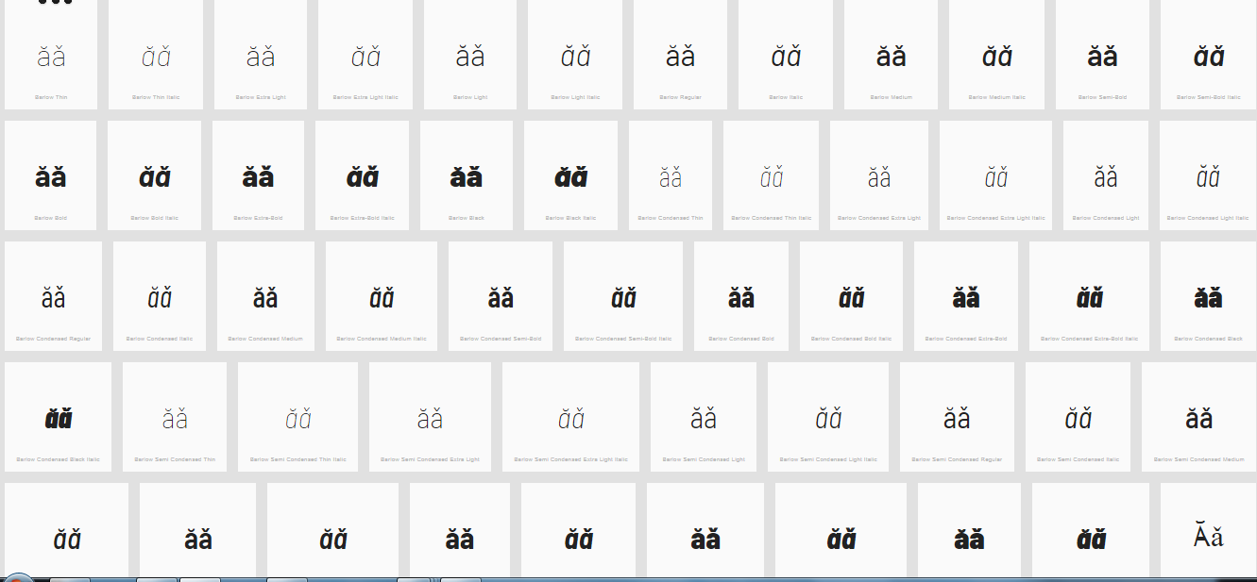
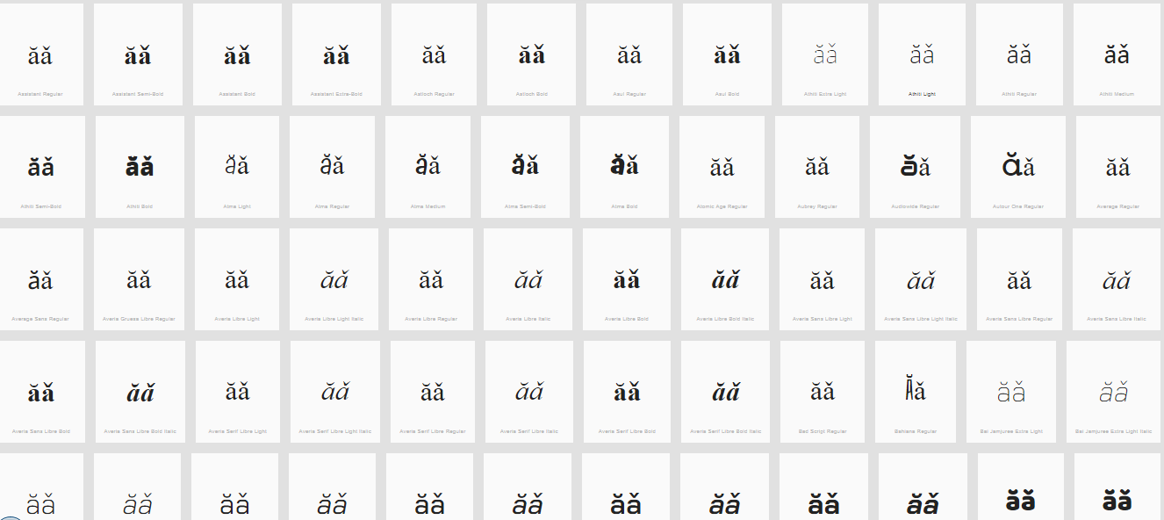

Sequence ğǧ (011F 01E7) compared using Google Fonts in https://wordmark.it/:
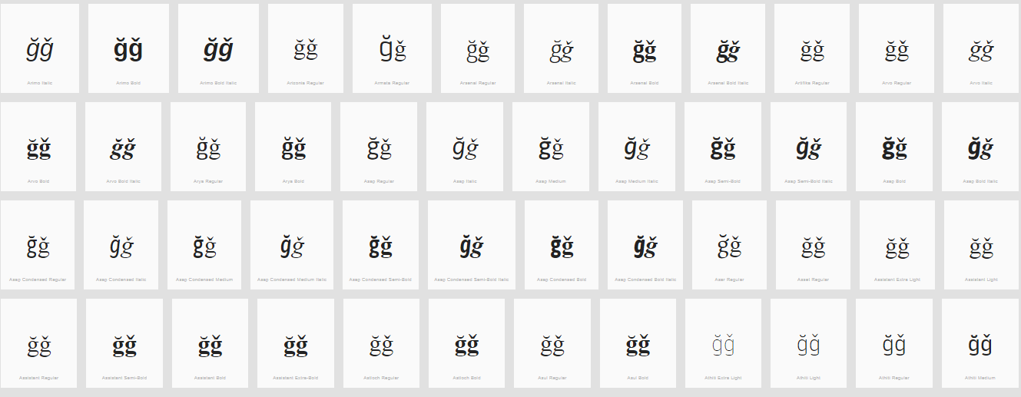
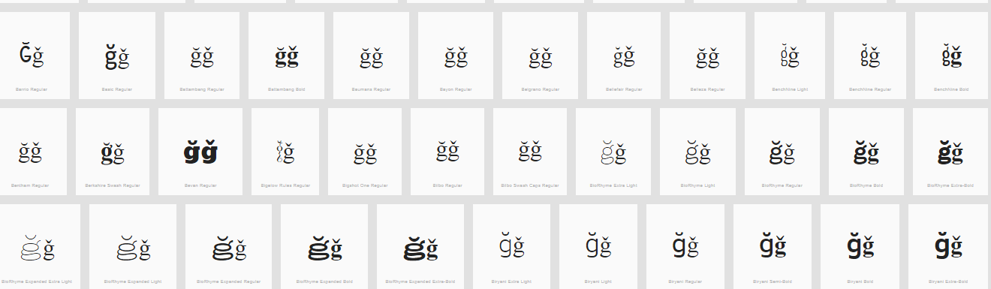

Sequence ŭ ǔ (016D 01D4) compared using Google Fonts in https://wordmark.it/:
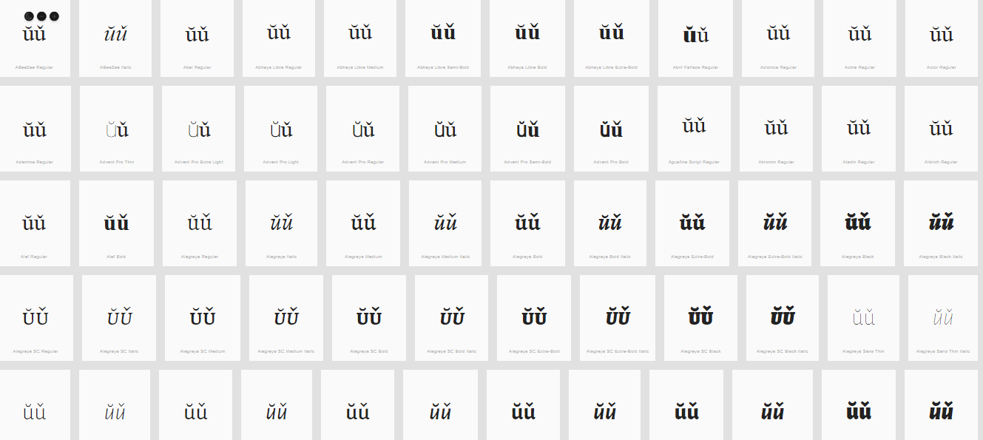
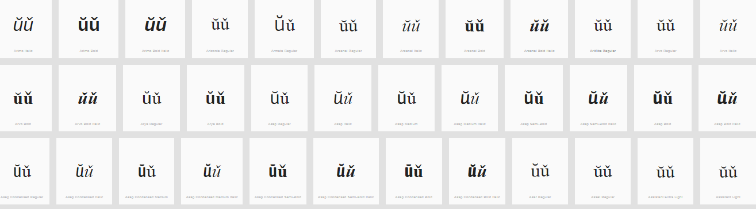

Findings:
The representations of the Breve and the Caron in Letters A, G and U are distinguishable and undistinguishable in a number of fonts (see pictures above); depending on the font and size.

The following are considered
ă 0103 A WITH BREVE <-> ǎ 01CE A WITH CARON
ĕ 0115 E WITH BREVE <-> ě 011B E WITH CARON
ŭ 016D U WITH BREVE <-> ǔ 01D4 U WITH CARON
ğ 011F G WITH BREVE <-> ǧ 01E7 G WITH CARON

However, the GP revised the repertoire and excluded the code point 01CE, 011B, 01D4 from the repertoire. Therefore, only ğ 011F G WITH BREVE <-> ǧ 01E7 G WITH CARON are variants.

Conclusions:
The following code points are variants:
ğ 011F G WITH BREVE <-> ǧ 01E7 G WITH CARON

D.3.2 Tilde vs. Macron (Above)

Code Points Considered:

Code Point | Glyph | Unicode Name
0067 + 0303 | g̃ | LATIN SMALL LETTER G + COMBINING TILDE
006E + 0304 | n̄ | LATIN SMALL LETTER N + COMBINING MACRON
0072 + 0303 | r̃ | LATIN SMALL LETTER R WITH TILDE
00E3 | ã | LATIN SMALL LETTER A WITH TILDE
00F1 | ñ | LATIN SMALL LETTER N WITH TILDE
00F5 | õ | LATIN SMALL LETTER O WITH TILDE
0101 | ā | LATIN SMALL LETTER A WITH MACRON
0113 | ē | LATIN SMALL LETTER E WITH MACRON
0129 | ĩ | LATIN SMALL LETTER I WITH TILDE
012B | ī | LATIN SMALL LETTER I WITH MACRON
014D | ō | LATIN SMALL LETTER O WITH MACRON
0169 | ũ | LATIN SMALL LETTER U WITH TILDE
016B | ū | LATIN SMALL LETTER U WITH MACRON
1E21 | ḡ | LATIN SMALL LETTER G WITH MACRON
1EBD | ẽ | LATIN SMALL LETTER E WITH TILDE
1EF9 | ỹ | LATIN SMALL LETTER Y WITH TILDE

Sequence ãā (00E3 0101) compared using Google Fonts in https://wordmark.it/:
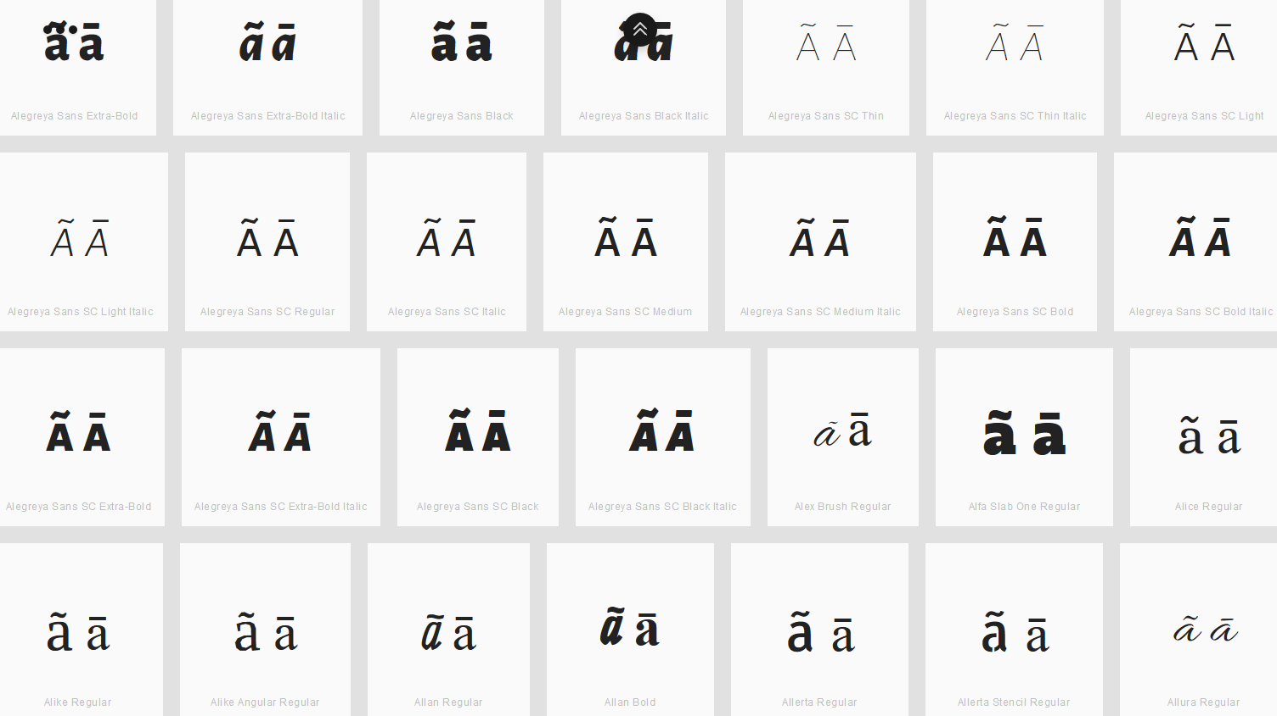

Findings:
Macron and Tilde are not distinguishable for the viewed fonts.

Sequence ēẽ (0113 1EBD) compared using Google Fonts in https://wordmark.it/:
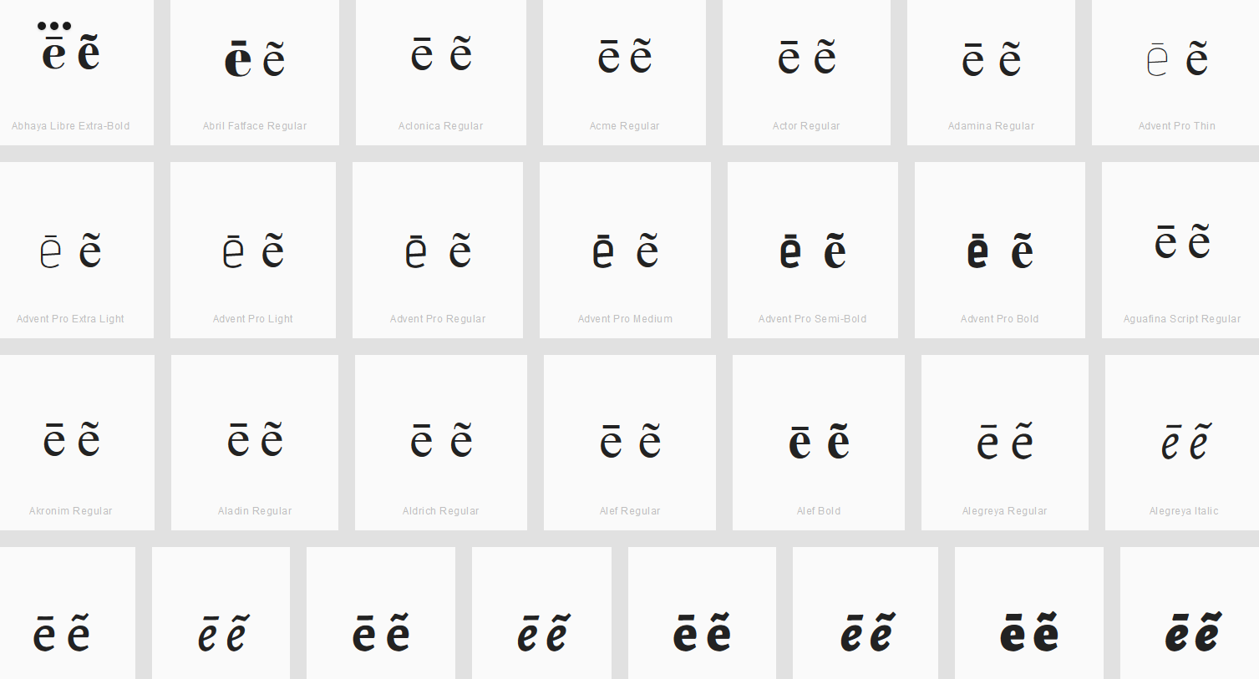

Findings:
Macron and Tilde are not distinguishable for the viewed fonts.

Sequence g̃ḡ (0067+0303 1E21) compared using Google Fonts in https://wordmark.it/:
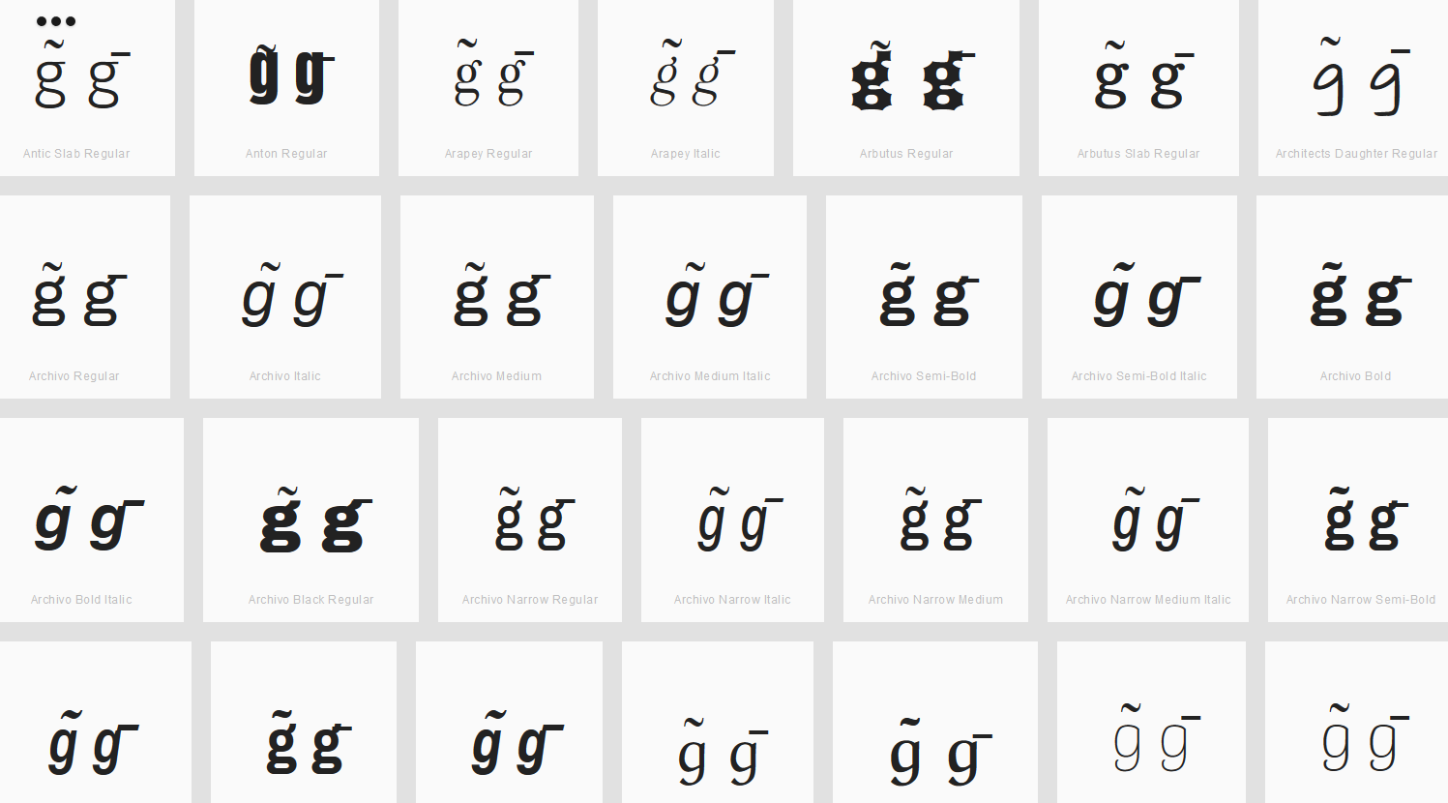

Findings:
Macron and Tilde are not distinguishable for the viewed fonts.
Sequence ĩī (0129 012B) compared using Google Fonts in https://wordmark.it/:
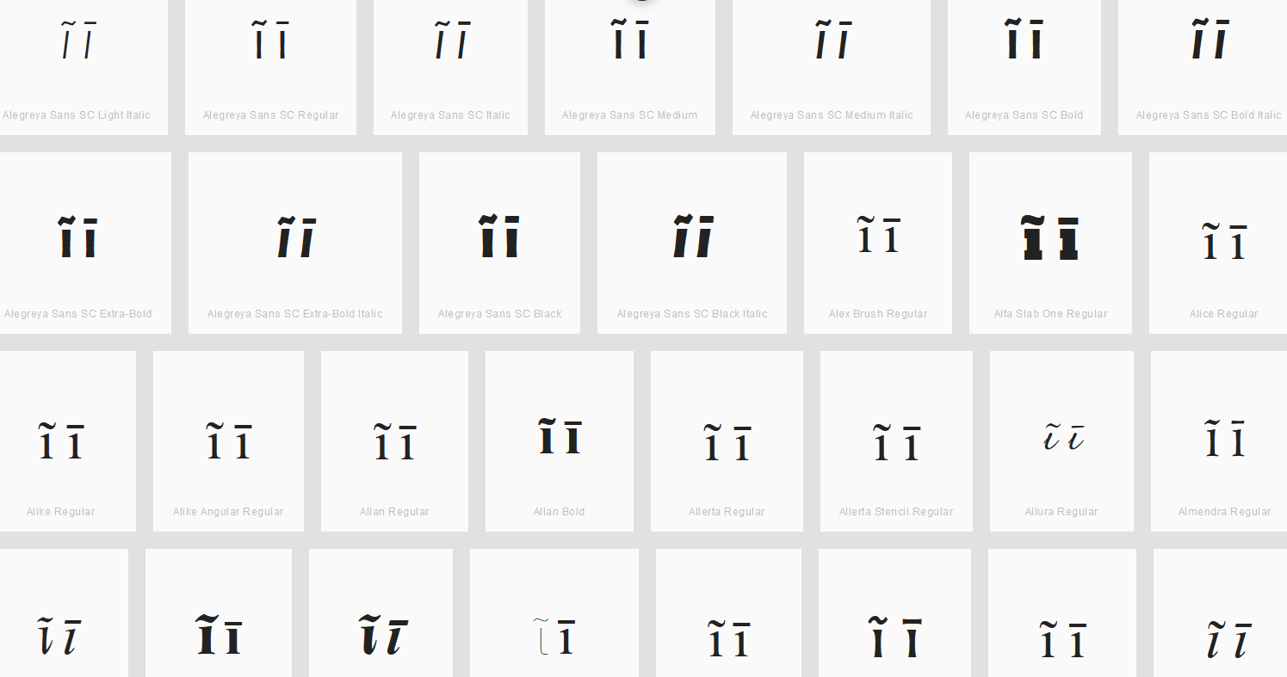

Findings:
Macron and Tilde are not distinguishable for the viewed fonts.

Sequence n̄ñ (006E+0304 00F1) compared using Google Fonts in https://wordmark.it/:
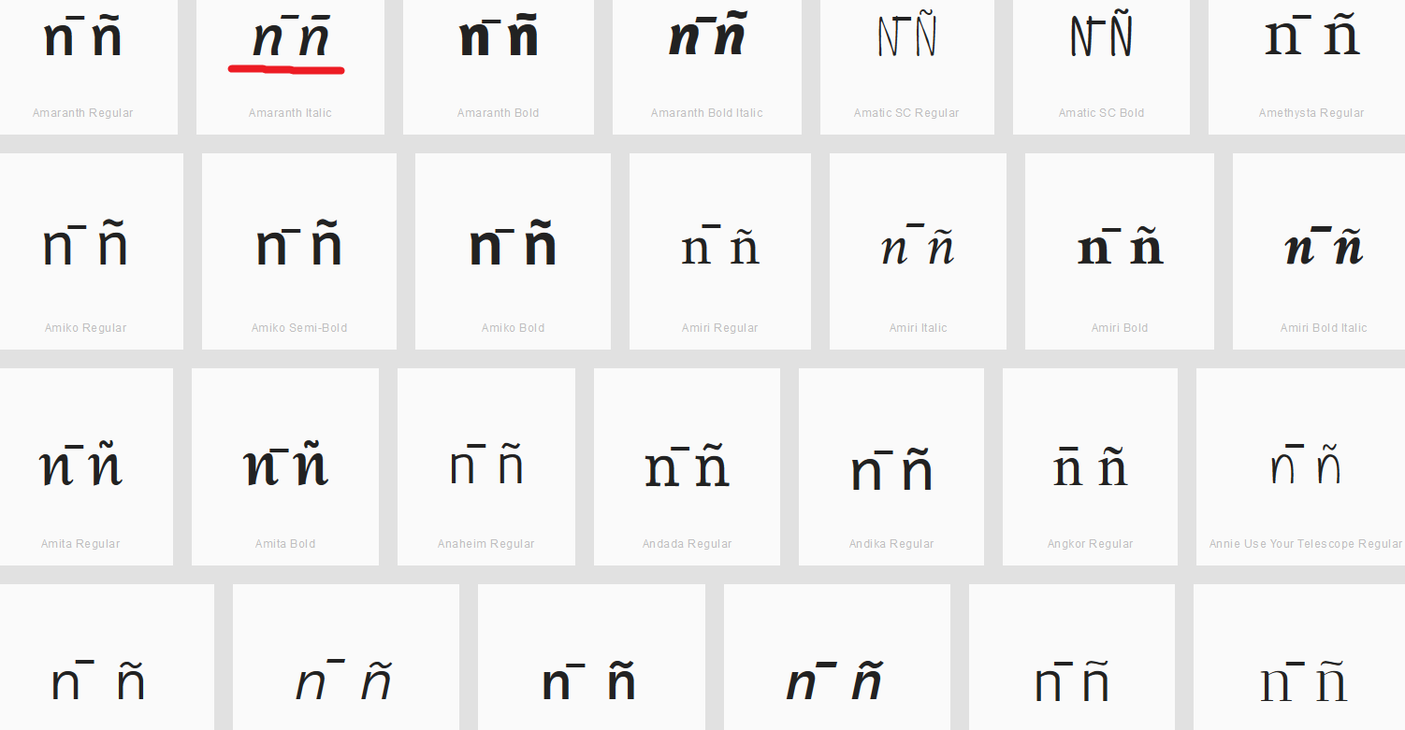

Findings:
Macron and Tilde are not distinguishable for the viewed fonts.

Sequence õō (00F5 014D) compared using Google Fonts in https://wordmark.it/:
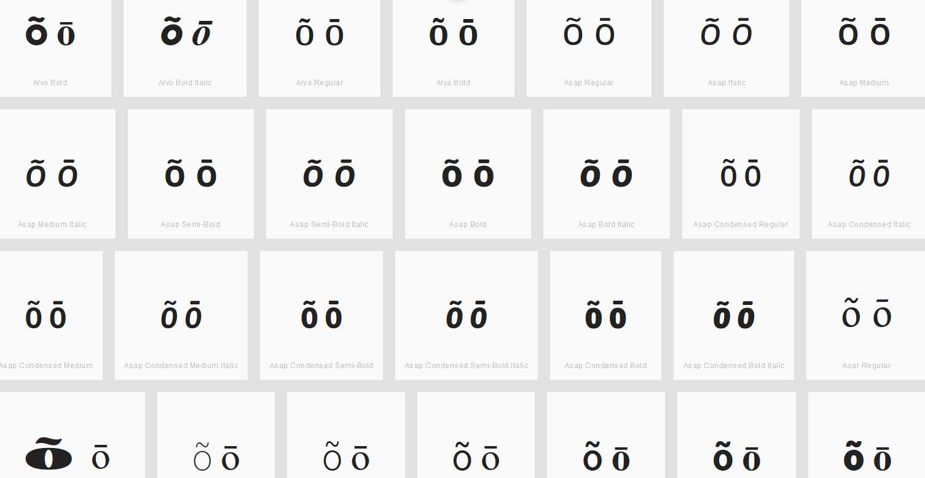

Findings:
Macron and Tilde are not distinguishable for the viewed fonts.

Sequence ũū (0169 016B) compared using Google Fonts in https://wordmark.it/:
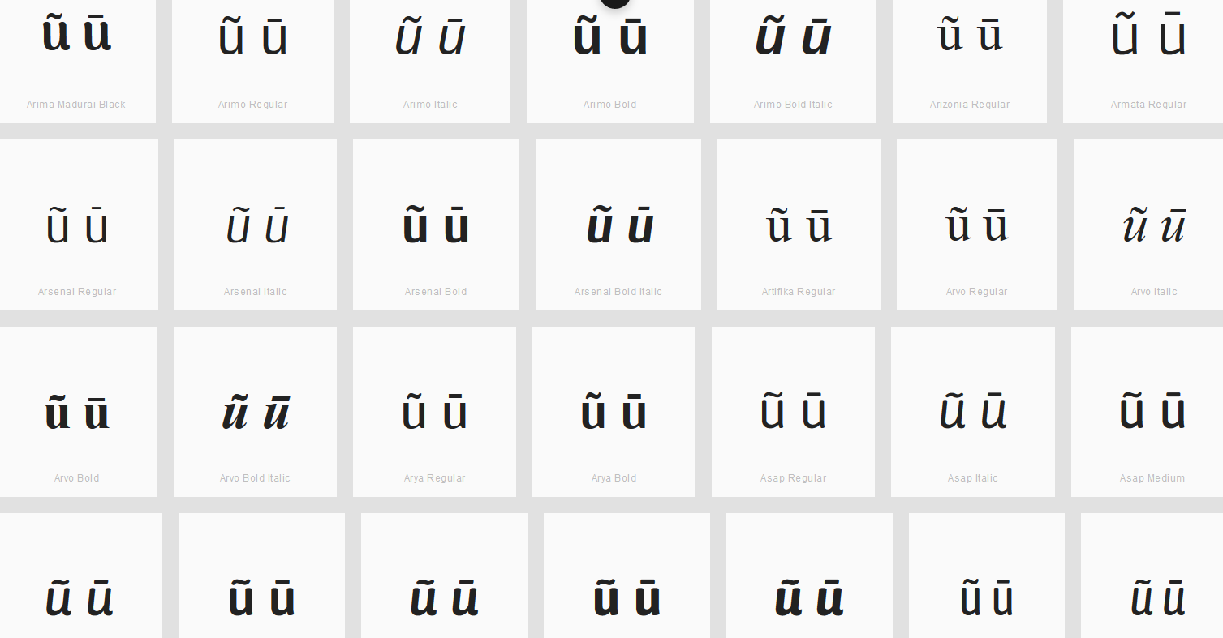

Findings:
Macron and Tilde are not distinguishable for the viewed fonts.

Conclusions:
Following letters with Tilde and Macron are variants: a, e, i, o, u, g, and n.

D.3.3 Combining Cedilla (Below), Ogonek and Comma Below

Code Points Considered:

Code Point | Glyph | Unicode Name
006D + 0327 | m̧ | LATIN SMALL LETTER M + COMBINING CEDILLA
006F + 0327 | o̧ | LATIN SMALL LETTER O + COMBINING CEDILLA
00E7 | ç | LATIN SMALL LETTER C WITH CEDILLA
0105 | ą | LATIN SMALL LETTER A WITH OGONEK
0119 | ę | LATIN SMALL LETTER E WITH OGONEK
012F | į | LATIN SMALL LETTER I WITH OGONEK
0137 | ķ | LATIN SMALL LETTER K WITH CEDILLA
013C | ļ | LATIN SMALL LETTER L WITH CEDILLA
0146 | ņ | LATIN SMALL LETTER N WITH CEDILLA
015F | ş | LATIN SMALL LETTER S WITH CEDILLA
0173 | ų | LATIN SMALL LETTER U WITH OGONEK
0219 | ș | LATIN SMALL LETTER S WITH COMMA BELOW
021B | ț | LATIN SMALL LETTER T WITH COMMA BELOW

Sequence şș (015F 0219) compared using Google Fonts in https://wordmark.it/:
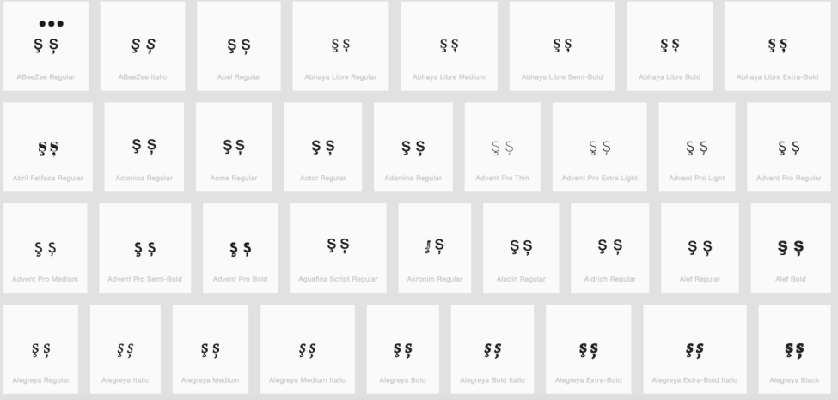
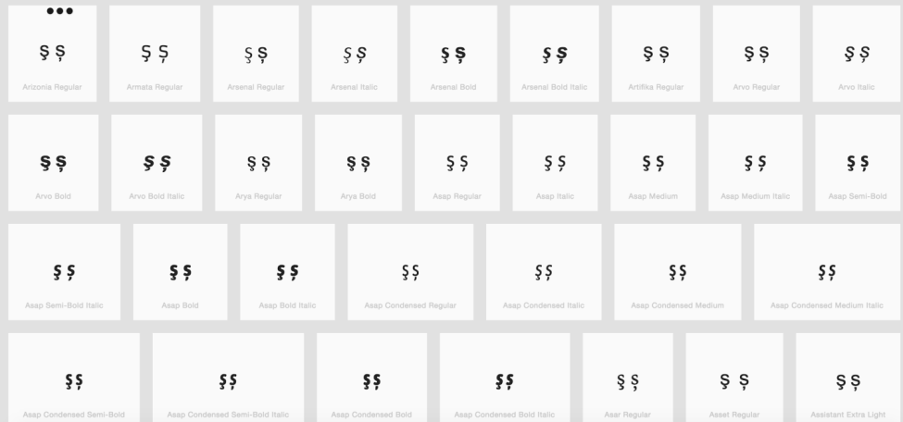

Findings:
The representations of the Cedilla and the Comma Below in Letter S are distinguishable in a number of fonts (see pictures above); in a large number of fonts, the two diacritics are consistently different. No other point base character (except for Letter S) uses two different diacritics (i.e., Letter M only exists with a Combining Cedilla, but not with Ogonek or Comma Below).

Conclusions:
These are not variants.

D.3.4 Ring Above vs. Dot Above

Ring above and Dot above may be considered the same by readers and writers since they are in free variation in handwriting.

Code Points Considered:

Code Point | Glyph | Unicode Name
00E5 | å | LATIN SMALL LETTER A WITH RING ABOVE
016F | ů | LATIN SMALL LETTER U WITH RING ABOVE
017C | ż | LATIN SMALL LETTER Z WITH DOT ABOVE
010B | ċ | LATIN SMALL LETTER C WITH DOT ABOVE
0117 | ė | LATIN SMALL LETTER E WITH DOT ABOVE
0121 | ġ | LATIN SMALL LETTER G WITH DOT ABOVE
1E45 | ṅ | LATIN SMALL LETTER N WITH DOT ABOVE

Findings:
No eligible candidates because of these two diacritics do not occur with the same base letters.

D.3.5 Acute vs. Dot Above

Code Points Considered:

Code Point | Glyph | Unicode Name
0069 | I | LATIN SMALL LETTER I
00E1 | á | LATIN SMALL LETTER A WITH ACUTE
00E9 | é | LATIN SMALL LETTER E WITH ACUTE
00ED | í | LATIN SMALL LETTER I WITH ACUTE
00F3 | ó | LATIN SMALL LETTER O WITH ACUTE
00FA | ú | LATIN SMALL LETTER U WITH ACUTE
00FD | ý | LATIN SMALL LETTER Y WITH ACUTE
0107 | ć | LATIN SMALL LETTER C WITH ACUTE
013A | ĺ | LATIN SMALL LETTER L WITH ACUTE
0144 | ń | LATIN SMALL LETTER LATIN SMALL LETTER N WITH ACUTE
0155 | ŕ | LATIN SMALL LETTER R WITH ACUTE
015B | ś | LATIN SMALL LETTER S WITH ACUTE
017A | ź | LATIN SMALL LETTER Z WITH ACUTE
010B | ċ | LATIN SMALL LETTER C WITH DOT ABOVE
0117 | ė | LATIN SMALL LETTER E WITH DOT ABOVE
0121 | ġ | LATIN SMALL LETTER G WITH DOT ABOVE
017C | ż | LATIN SMALL LETTER Z WITH DOT ABOVE
1E45 | ṅ | LATIN SMALL LETTER N WITH DOT ABOVE

Sequence ċć (010B+ 0107) compared using Google Fonts in https://wordmark.it/:
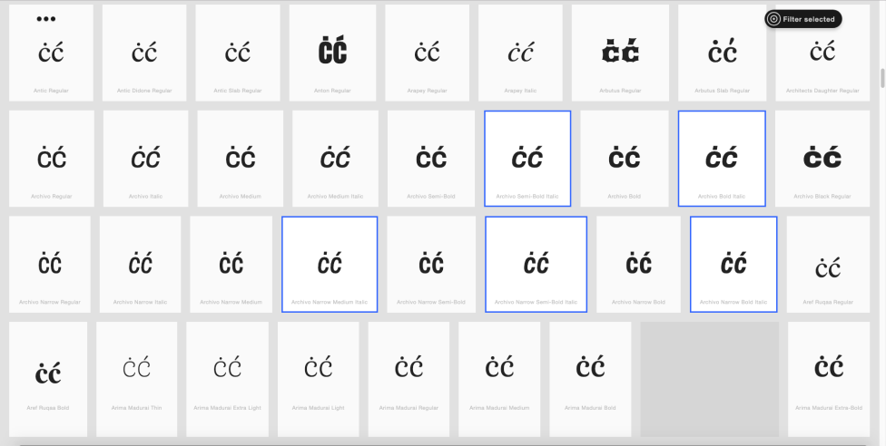

Sequence ėé (0117 + 00E9) compared using Google Fonts in https://wordmark.it/:
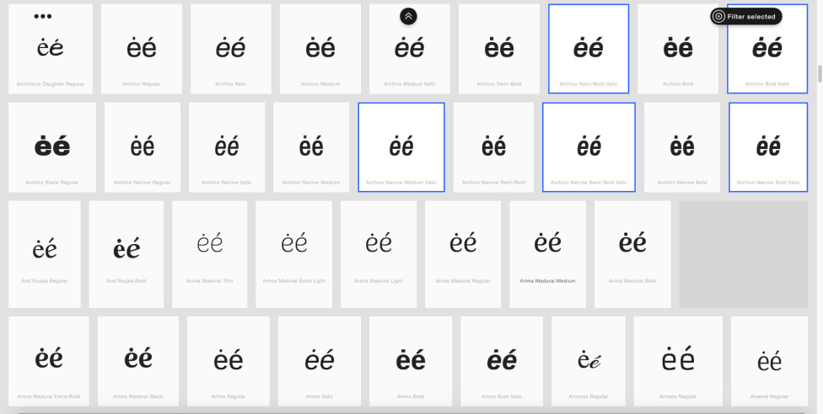

Sequence ṅń (1E45+ 0144) compared using Google Fonts in https://wordmark.it/:
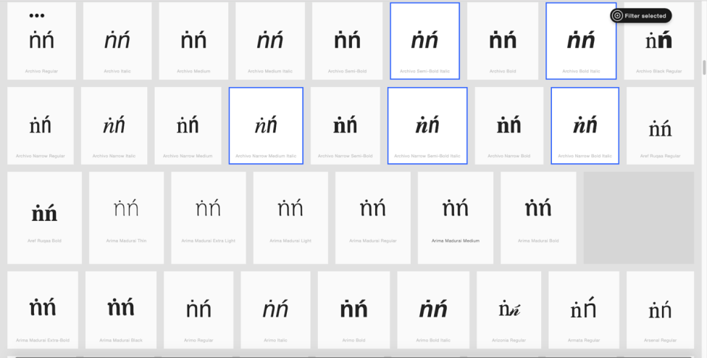

Sequence żź (017C+ 017A) compared using Google Fonts in https://wordmark.it/:
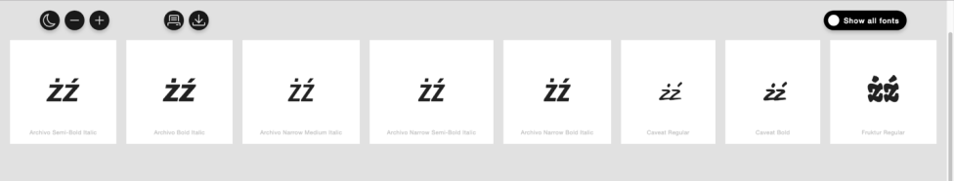

Findings:
ċć, ṅń, and żź were considered as variant pairs. The representations of the acute and the dot above in these pairs are not distinguishable in a number of fonts.

Conclusion:
These letter with Acute and Dot Above are variants: c, n, and z.

D.3.6 Grave vs. Dot Above

Code Points Considered:

Code Points | Glyph | Unicode Name
00E8 | è | LATIN SMALL LETTER E WITH GRAVE
00EC | ì | LATIN SMALL LETTER I WITH GRAVE
00F2 | ò | LATIN SMALL LETTER O WITH GRAVE
00F9 | ù | LATIN SMALL LETTER U WITH GRAVE
1EF3 | ỳ | LATIN SMALL LETTER Y WITH GRAVE
010B | ċ | LATIN SMALL LETTER C WITH DOT ABOVE
0117 | ė | LATIN SMALL LETTER E WITH DOT ABOVE
0121 | ġ | LATIN SMALL LETTER G WITH DOT ABOVE
017C | ż | LATIN SMALL LETTER Z WITH DOT ABOVE
1E45 | ṅ | LATIN SMALL LETTER N WITH DOT ABOVE

Sequence èė (00E8 + 0117) compared using Google Fonts in https://wordmark.it/ :
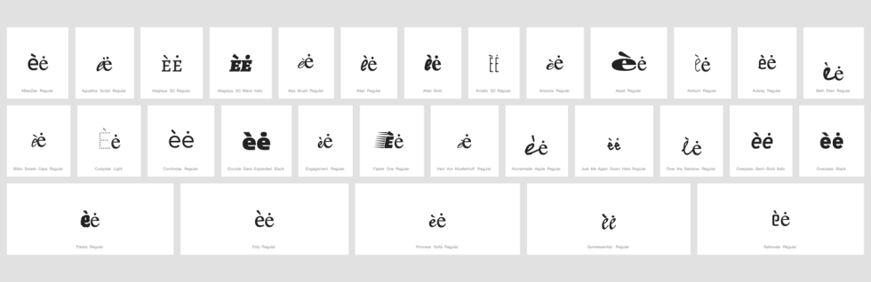

Findings:
Despite variation in the glyph shape of e, as well as occasional clippings, the representations of the grave and the dot above remain distinguishable. In a large number of fonts, the two diacritics are consistently different.

Conclusion:
No variant pairs are warranted.

D.3.7 Double Acute vs. Diaeresis

Code Points Considered:

Code Point | Glyph | Unicode Name
006E + 0308 | n̈ | LATIN SMALL LETTER N + COMBINING DIAERESIS
00E4 | ä | LATIN SMALL LETTER A WITH DIAERESIS
00EB | ë | LATIN SMALL LETTER E WITH DIAERESIS
00EF | ï | LATIN SMALL LETTER I WITH DIAERESIS
00F6 | ö | LATIN SMALL LETTER O WITH DIAERESIS
00FC | ü | LATIN SMALL LETTER U WITH DIAERESIS
00FF | ÿ | LATIN SMALL LETTER Y WITH DIAERESIS
0151 | ő | LATIN SMALL LETTER O WITH DOUBLE ACUTE
0171 | ű | LATIN SMALL LETTER U WITH DOUBLE ACUTE
0254 + 0308 | ɔ̈ | LATIN SMALL LETTER OPEN O + COMBINING DIAERESIS
025B + 0308 | ɛ̈ | LATIN SMALL LETTER OPEN E + COMBINING DIAERESIS
025B + 0331 + 0308 | ɛ̱̈ | LATIN SMALL LETTER OPEN E + COMBINING MACRON BELOW + COMBINING DIAERESIS
1E8D | ẍ | LATIN SMALL LETTER X WITH DIAERESIS

Sequence őö and üű (00F6 0151 and 00FC 0171) compared using Google Fonts in https://wordmark.it/:
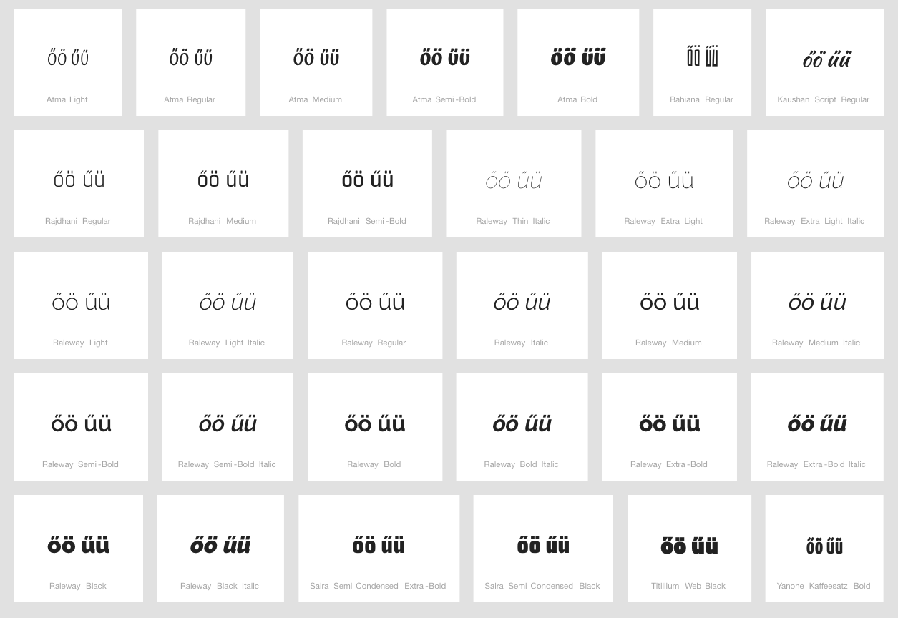

Findings:
The representations of the Double Acute vs Diaeresis in these pairs are distinguishable in a number of fonts. In some fonts, the two diacritics look similar.

Conclusion:
Code points őö and üű are not variants. They should be investigated for visual similarity.

D.3.8 Dot Below vs. Comma Below

Code Points Considered:

Code Point | Glyph | Unicode Name
1E37 | ḷ | LATIN SMALL LETTER L WITH DOT BELOW
1E43 | ṃ | LATIN SMALL LETTER M WITH DOT BELOW
1E47 | ṇ | LATIN SMALL LETTER N WITH DOT BELOW
1E63 | ṣ | LATIN SMALL LETTER S WITH DOT BELOW
1E6D | ṭ | LATIN SMALL LETTER T WITH DOT BELOW
1EA1 | ạ | LATIN SMALL LETTER A WITH DOT BELOW
1EB9 | ẹ | LATIN SMALL LETTER E WITH DOT BELOW
1ECB | ị | LATIN SMALL LETTER I WITH DOT BELOW
1ECD | ọ | LATIN SMALL LETTER O WITH DOT BELOW
1EE5 | ụ | LATIN SMALL LETTER U WITH DOT BELOW
1EF5 | ỵ | LATIN SMALL LETTER Y WITH DOT BELOW
0219 | ș | LATIN SMALL LETTER S WITH COMMA BELOW
021B | ț | LATIN SMALL LETTER T WITH COMMA BELOW

Sequence ṣș (1E63 0219) compared using Google Fonts in https://wordmark.it/:
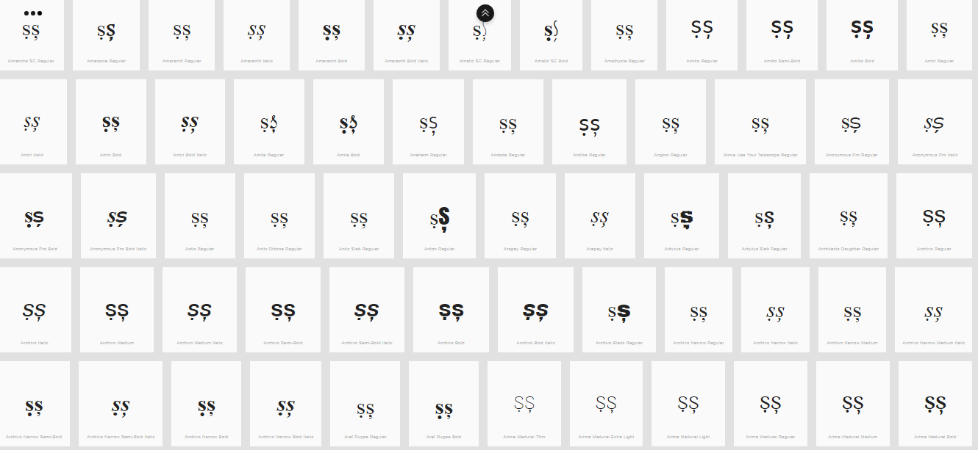
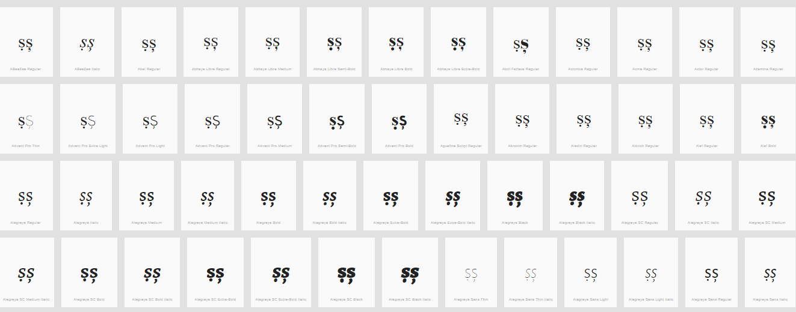

Sequence ṭț (1E6D 021B) compared using Google Fonts in https://wordmark.it/:
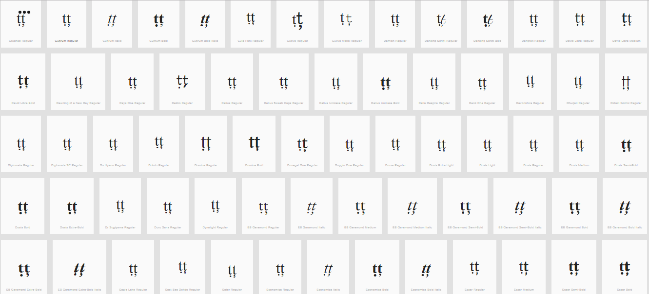
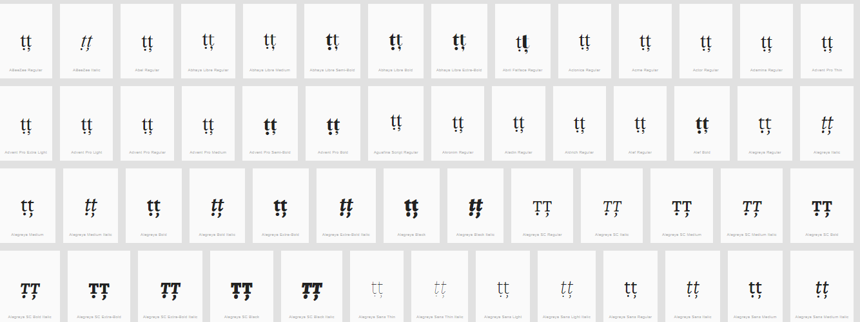

Findings:
The representations of the Dot below and Comma below in Letters S and T are distinguishable in a number of fonts (see pictures above); in a large number of fonts, the two diacritics are consistently different.

Conclusions:
These are not variants.

D.3.9 Hook vs. Dot Above

Code Points Considered:

Code Point | Glyph | Unicode Name
0069 | i | LATIN SMALL LETTER I
010B | ċ | LATIN SMALL LETTER C WITH DOT ABOVE
0117 | ė | LATIN SMALL LETTER E WITH DOT ABOVE
0121 | ġ | LATIN SMALL LETTER LATIN SMALL LETTER G WITH DOT ABOVE
017C | ż | LATIN SMALL LETTER Z WITH DOT ABOVE
0199 | ƙ | LATIN SMALL LETTER K WITH HOOK
01B4 | ƴ | LATIN SMALL LETTER Y WITH HOOK
0253 | ɓ | LATIN SMALL LETTER B WITH HOOK
0257 | ɗ | LATIN SMALL LETTER D WITH HOOK
1E45 | ṅ | LATIN SMALL LETTER N WITH DOT ABOVE
1EA3 | ả | LATIN SMALL LETTER A WITH HOOK ABOVE
1EBB | ẻ | LATIN SMALL LETTER E WITH HOOK ABOVE
1EC9 | ỉ | LATIN SMALL LETTER I WITH HOOK ABOVE
1ECF | ỏ | LATIN SMALL LETTER O WITH HOOK ABOVE
1EE7 | ủ | LATIN SMALL LETTER U WITH HOOK ABOVE
1EF7 | ỷ | LATIN SMALL LETTER Y WITH HOOK ABOVE

Sequence ẻė (1EBB 0117) compared using Google Fonts in https://wordmark.it/:
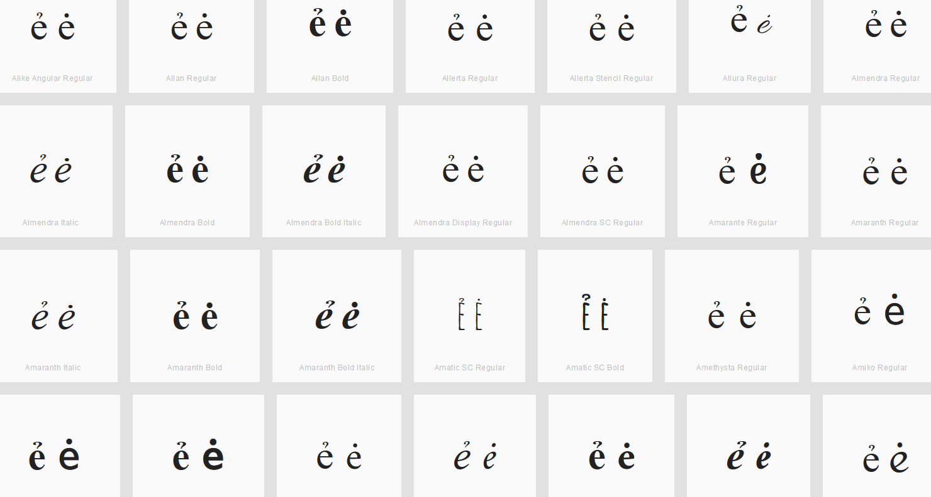

Findings:
Dot and Hook are distinguishable for the viewed fonts.
Sequence iỉ (0069 1EC9) compared using Google Fonts in https://wordmark.it/:
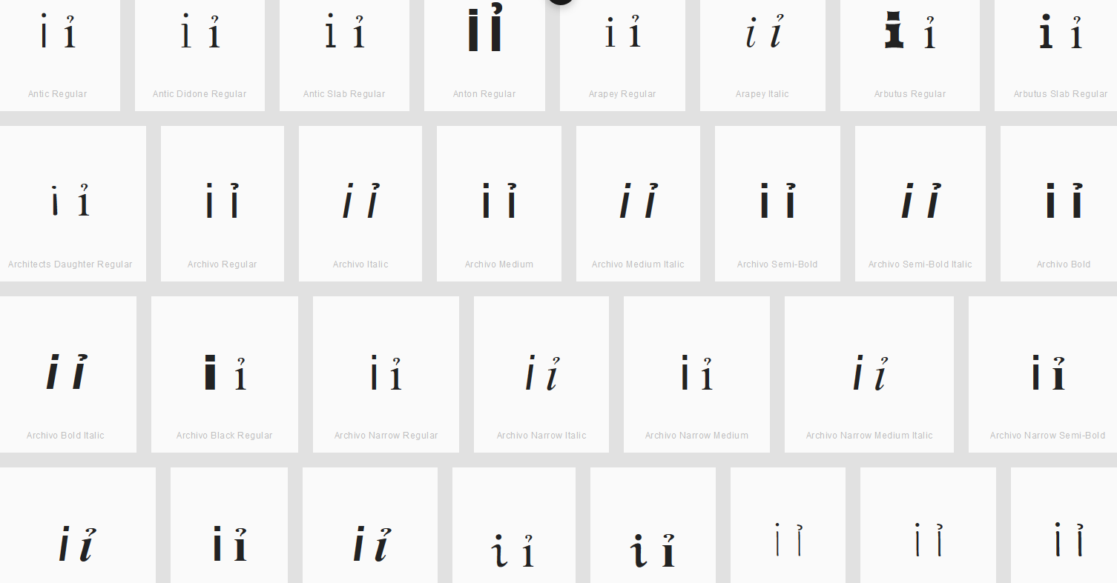
Findings:
Dot and Hook are not distinguishable for the viewed fonts.

Sequence ƴỷ (01B4 1EF7) compared using Google Fonts in https://wordmark.it/:
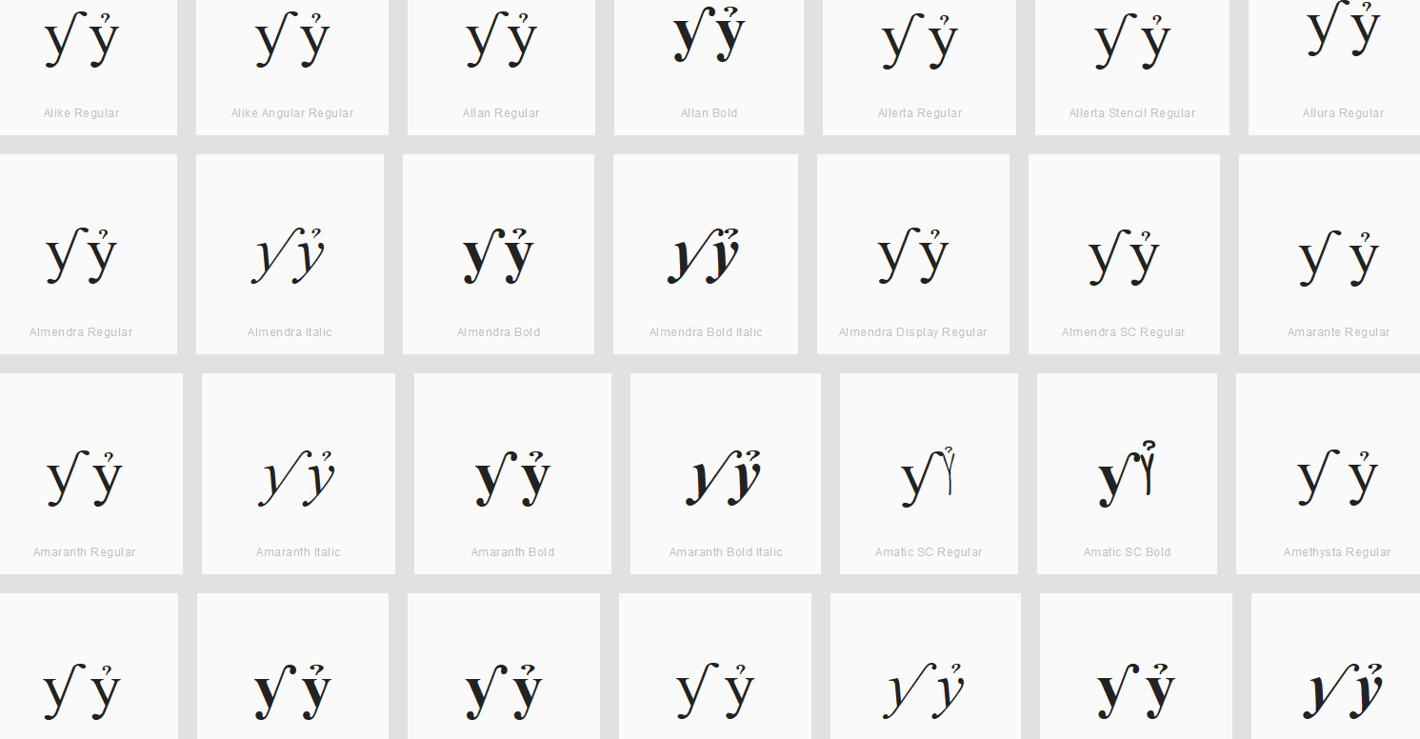
Findings:
Hook and Hook Above are distinguishable for the viewed fonts.

Conclusion:
These code points are variants: Latin Small Letter I (i , 0069) and Latin Small Letter I with Hook Above (ỉ , 1EC9)

D.3.10 Caron vs. Hook

Code Points Considered:

Code Point | Glyph | Unicode Name
010F | ď | LATIN SMALL LETTER D WITH CARON
0257 | ɗ | LATIN SMALL LETTER D WITH HOOK

Sequence ďɗ (010F 0257) compared using Google Fonts in https://wordmark.it/:
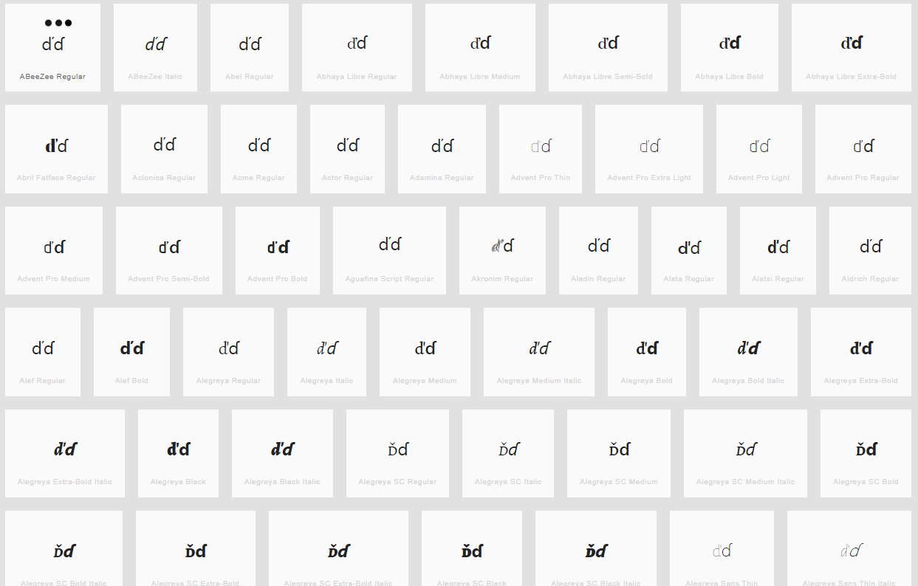

Findings:
Caron and Hook are distinguishable in most fonts viewed

Conclusion:
These code points are not variants.

D.3.11 Caron vs. Horn

Caron and Horn may become nearly identical depending on font, context and reader, and they may be used interchangeably in handwriting.

Code Points Considered:

Code Point | Glyph | Unicode Name
01CE | ǎ | LATIN SMALL LETTER A WITH CARON
010D | č | LATIN SMALL LETTER C WITH CARON
010F | ď | LATIN SMALL LETTER LATIN SMALL LETTER D WITH CARON
011B | ě | LATIN SMALL LETTER E WITH CARON
01E7 | ǧ | LATIN SMALL LETTER G WITH CARON
01D0 | ǐ | LATIN SMALL LETTER I WITH CARON
01E9 | ǩ | LATIN SMALL LETTER K WITH CARON
013E | ľ | LATIN SMALL LETTER L WITH CARON
0148 | ň | LATIN SMALL LETTER N WITH CARON
01D2 | ǒ | LATIN SMALL LETTER O WITH CARON
01A1 | ơ | LATIN SMALL LETTER O WITH HORN
1EDB | ớ | LATIN SMALL LETTER O WITH HORN AND ACUTE
1EDD | ờ | LATIN SMALL LETTER O WITH HORN AND GRAVE
1EE1 | ỡ | LATIN SMALL LETTER O WITH HORN AND TILDE
1EDF | ở | LATIN SMALL LETTER O WITH HORN AND HOOK ABOVE
1EE3 | ợ | LATIN SMALL LETTER O WITH HORN AND DOT BELOW
0159 | ř | LATIN SMALL LETTER R WITH CARON
0161 | š | LATIN SMALL LETTER S WITH CARON
0165 | ť | LATIN SMALL LETTER T WITH CARON
01D4 | ǔ | LATIN SMALL LETTER U WITH CARON
01B0 | ǔ | LATIN SMALL LETTER U WITH HORN
1EE9 | ứ | LATIN SMALL LETTER U WITH HORN AND ACUTE
1EEB | ừ | LATIN SMALL LETTER U WITH HORN AND GRAVE
1EEF | ữ | LATIN SMALL LETTER U WITH HORN AND TILDE
1EED | ử | LATIN SMALL LETTER U WITH HORN AND HOOK ABOVE
1EF1 | ự | LATIN SMALL LETTER U WITH HORN AND DOT BELOW
017E | ž | LATIN SMALL LETTER Z WITH CARON
01EF | ǯ | LATIN SMALL LETTER EZH WITH CARON

String (oǒo oơo oớo oờo oỡo oởo oợo) compared using Google Fonts in https://wordmark.it/

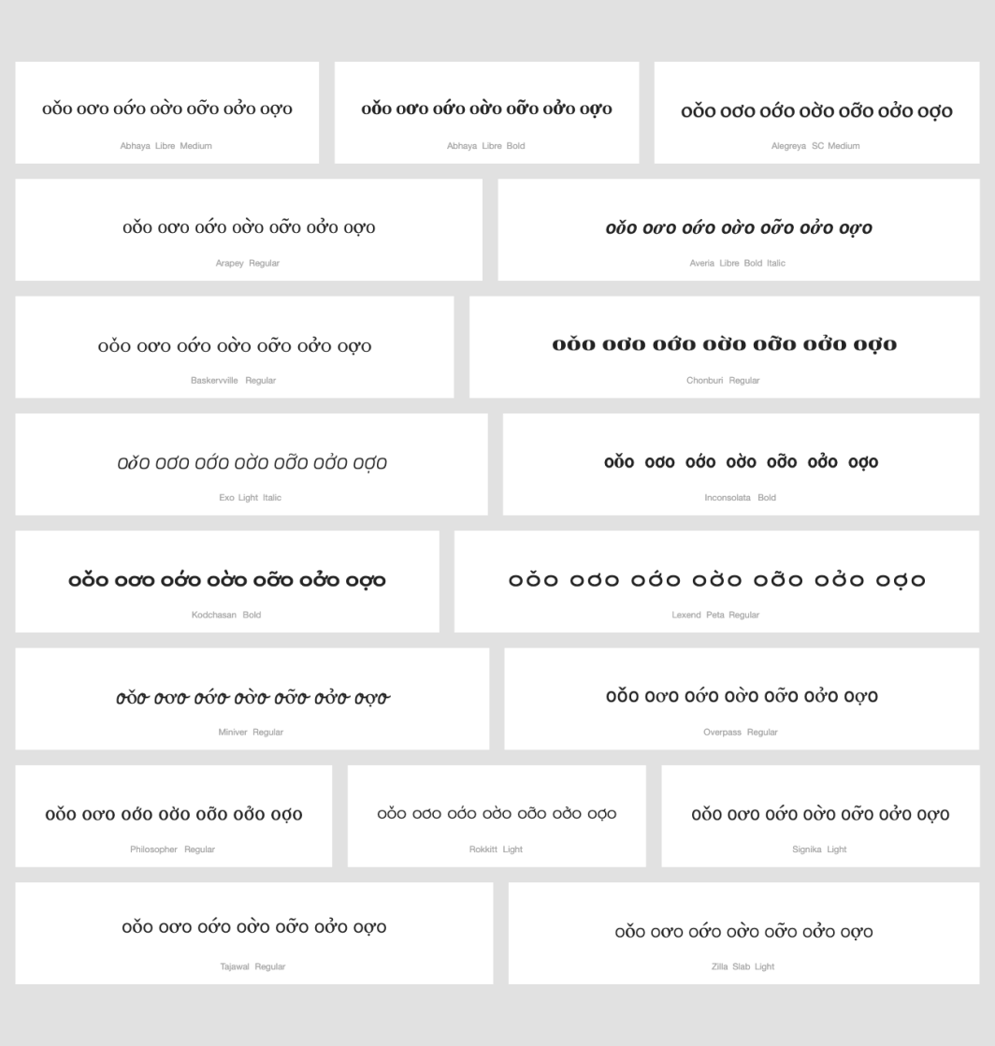
Findings:
Caron and horn are always in place and distinguishable.

Conclusions:
No variants candidates found.

String (uǔu uưu uứu uừu uữu uửu uựu) compared using Google Fonts in https://wordmark.it/
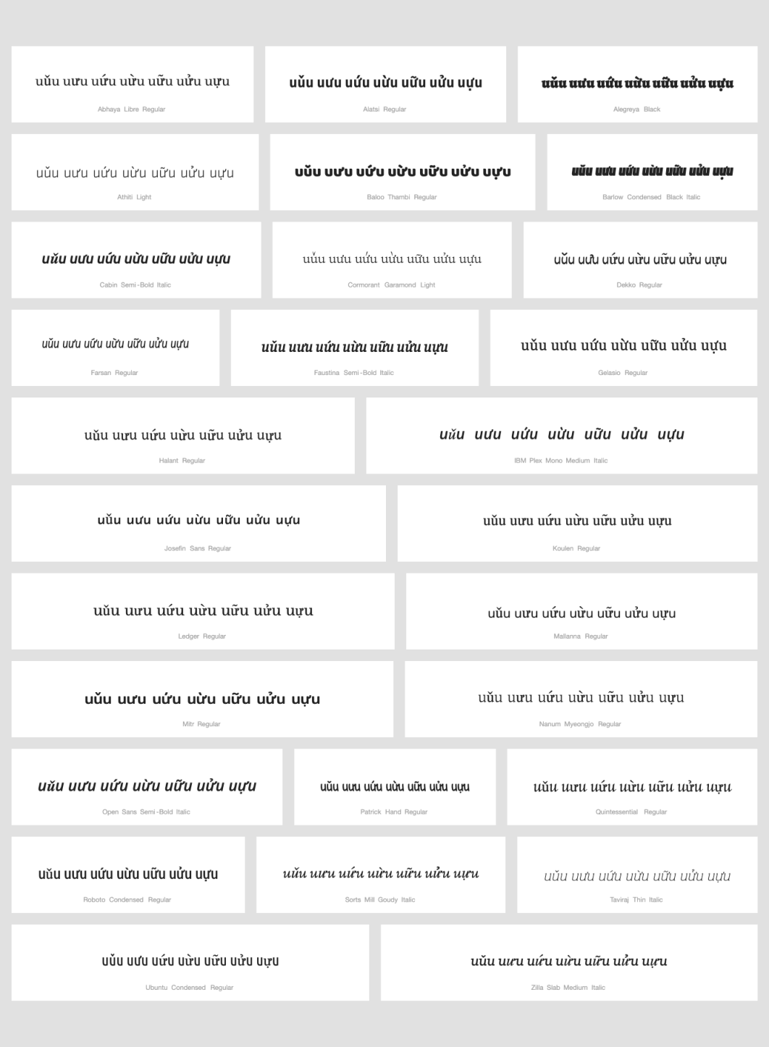

Findings:
Caron and horn are always in place and distinguishable.

Conclusions:
No variants candidates found.

D.3.12 Ring Above vs. Hook Above

Code Points Considered:

Code Point | Glyph | Unicode Name
1EA3 | ả | LATIN SMALL LETTER A WITH HOOK ABOVE
00E5 | å | LATIN SMALL LETTER A WITH RING ABOVE
1EE7 | ủ | LATIN SMALL LETTER U WITH HOOK ABOVE
016F | ů | LATIN SMALL LETTER U WITH RING ABOVE

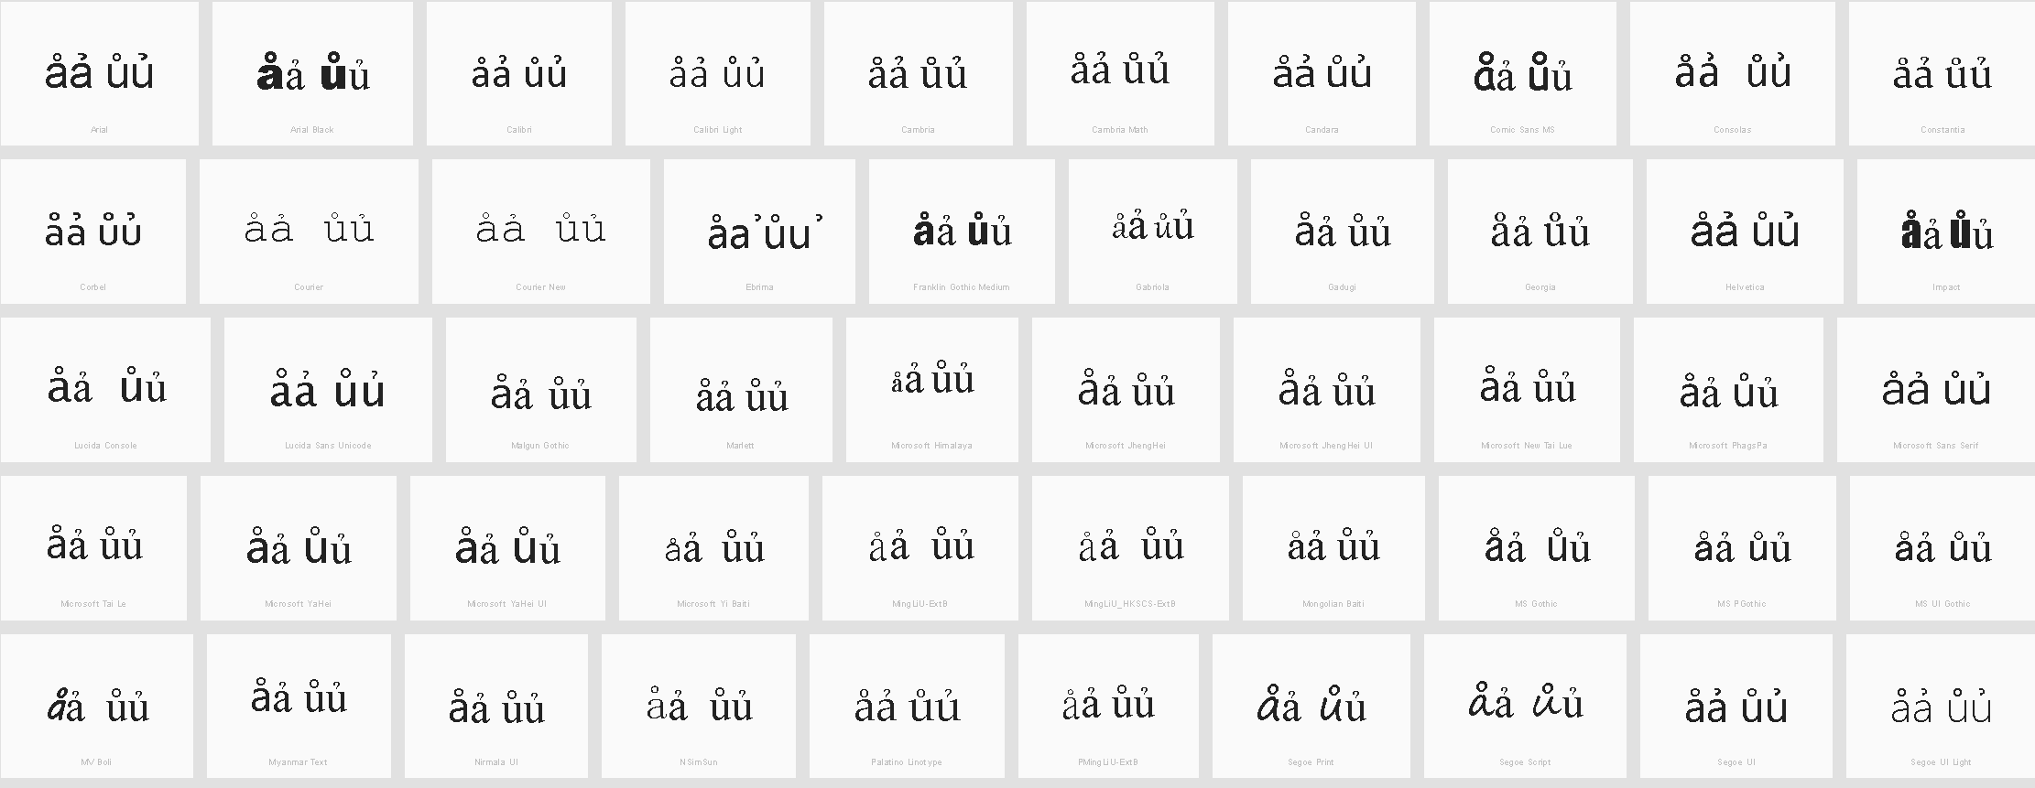

Findings
In some fonts, at normal sizes, the two diacritics can be difficult to distinguish.
Sequence åả (00E5 1EA3) compared using Google Fonts in https://wordmark.it/:
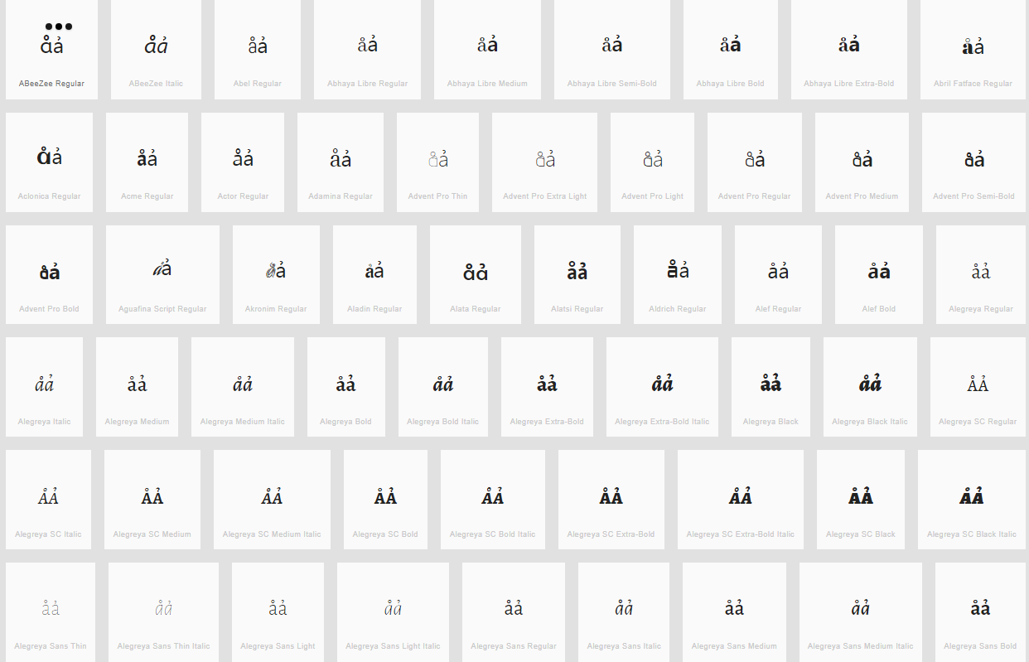

Sequence ůủ (016F 1EE7) compared using Google Fonts in https://wordmark.it/:
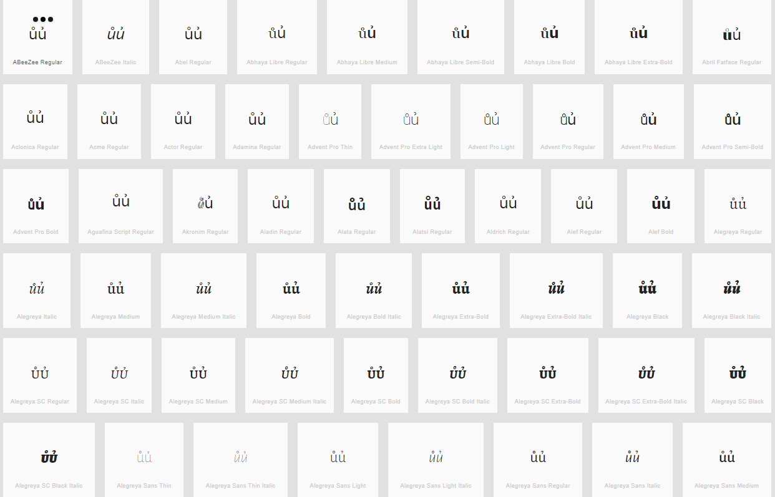

Findings:
Ring above and Hook above are distinguishable in all fonts viewed.

Conclusions:
This code points are not variants.

D.3.13 Visual Variant Analysis

D.3.13.1 Consonants

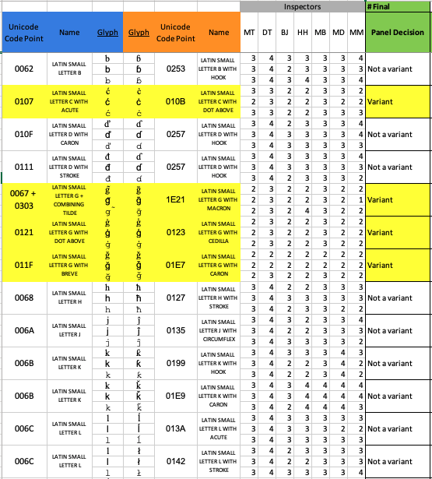

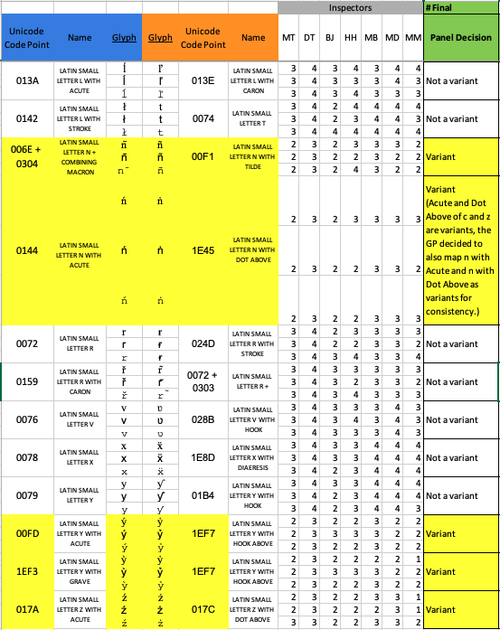

D.3.13.2 Vowel ‘a’

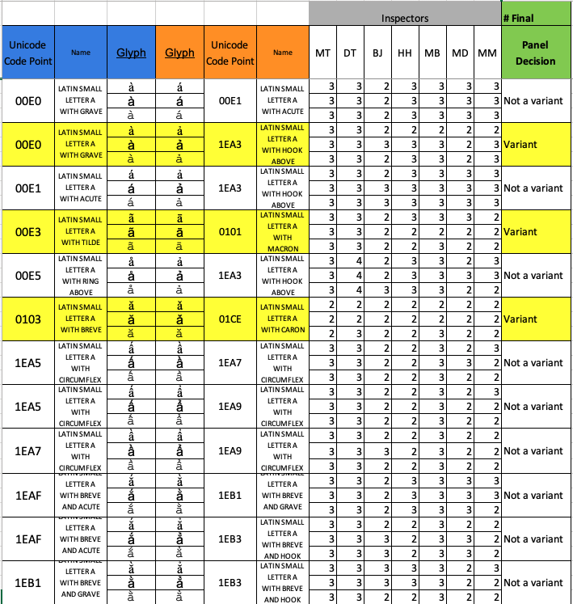

D.3.13.3 Vowel ‘e’

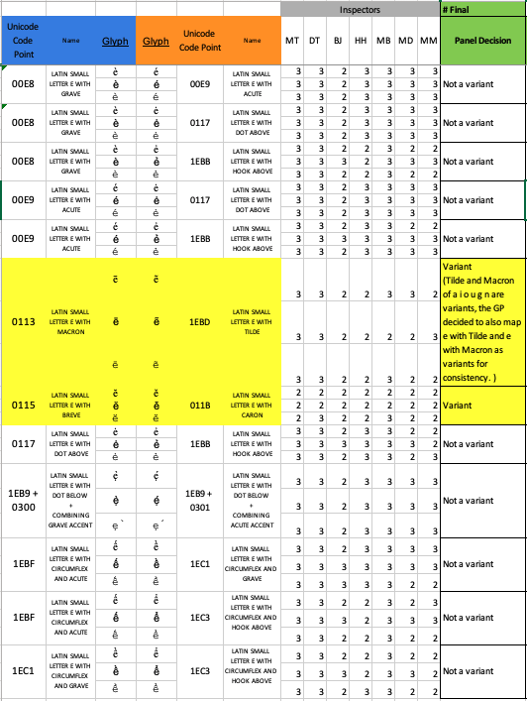

D.3.13.4 Vowel ‘i’

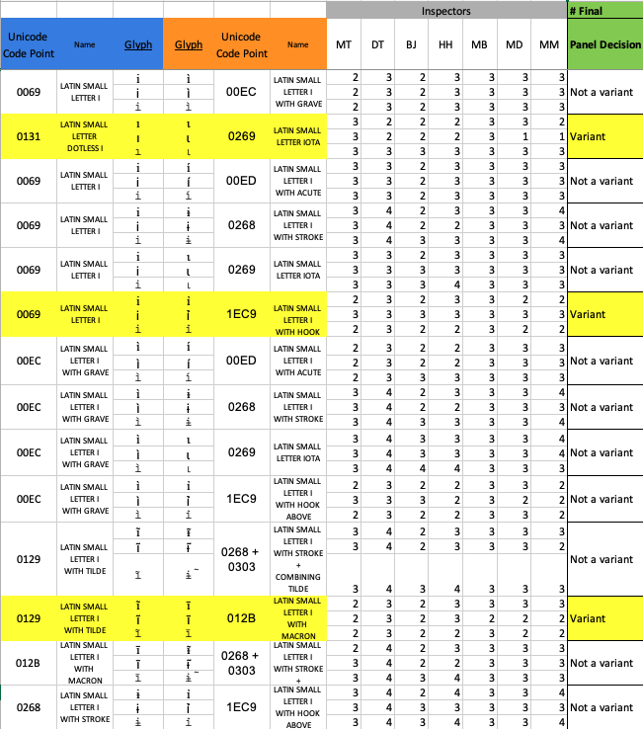

D.3.13.5 Vowel ‘o’

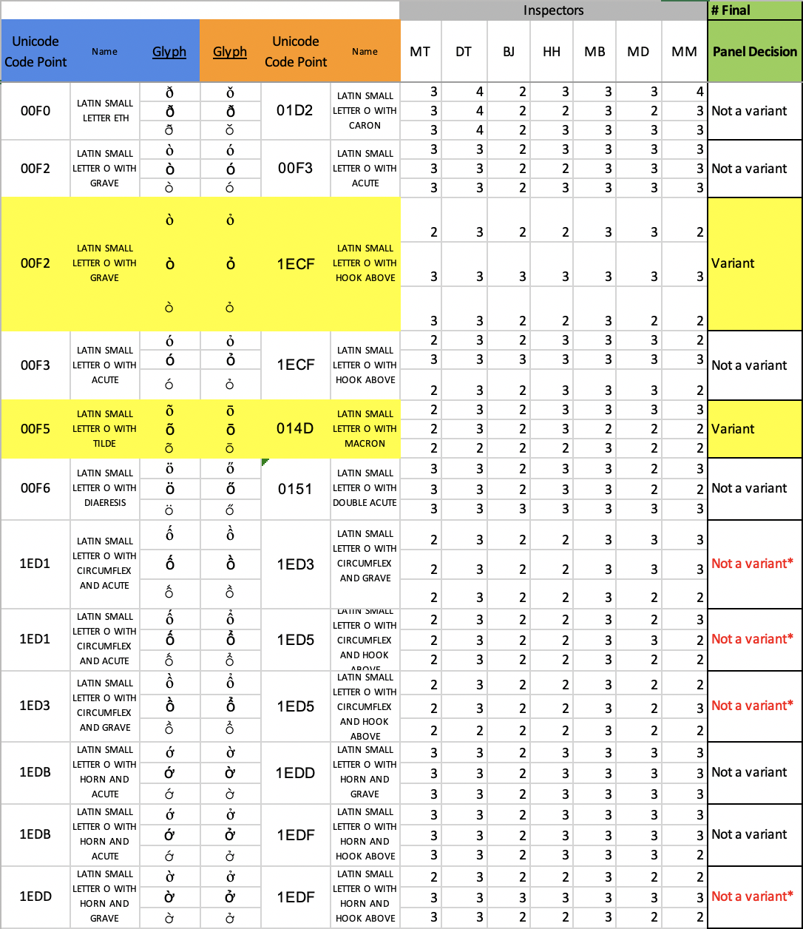

* These are used in Vietnamese and Vietnamese users can distinguish these code points

D.3.13.6 Vowel ‘u’

