D.9 Cross-script Variants

D.9.1. Cyrillic Script

D.9.1.1 Cyrillic Small Letter Straight U 04A4

Cyrillic GP has already classified 0079 and 0443 as variants [CYRILLIC]. In addition to that, Latin GP considers 04AF to be sufficiently similar to 0079 to warrant a variant relationship between the two characters. By consequence, this finding leads towards an in-script variant in Cyrillic script between 04AF and 0443, due to the requirement of transitivity.

D.9.1.2 Cyrillic Small Letter Dzhe 045F

In Arial and Courier New, the glyphs of 1EE5 and 045F look nearly identical. The screenshot below presents the glyphs in those two fonts in the second and third rows, respectively. (The first row presents the glyphs in Times New Roman).

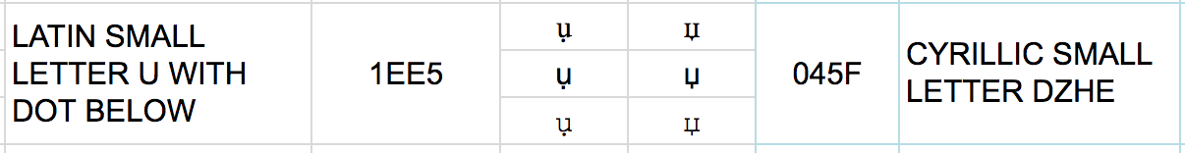

D.9.2. Greek Script

D.9.2.1. Greek Small Letter Alpha 03B1

Latin-script users consider 0061 Latin Small Letter A and Greek Small Letter Alpha 03B1 as variants on non-visual grounds:

0061 is regularly represented using a glyph (nearly) identical with 03B1 in italic: a. (See the title of this subsection.) Thus, significant parts of the Latin script-using community may consider them equivalent, despite being able to visually tell the difference between the two glyphs.

For example, 0061 is considered the block- or print-letter shape to the hand-written shape of 03B1 in large parts of the script-using community, and a shape similar to 03B1 is used in standard primers and repertoire of handwriting as taught to school children, such as e.g. the Grundschrift https://en.wikipedia.org/wiki/Grundschrift demonstrated in Figure G02:
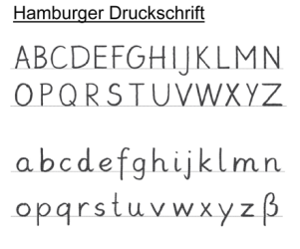
Figure G02. Repertoire of Standard Handwriting repertoire as official in the German state Hamburg, taken from https://en.wikipedia.org/wiki/Grundschrift#/media/File:Hamburger_Druckschrift_ab_2011.jpg

This variation between glyphs is however not limited to the German speaking user community or didactic hand-writing repertoires: Similar shapes to both 0061 and 03B1 are featured prominently in the graphic design of logos of international brand names in, which constantly reiterates the inter-changeability to the minds of readers:
- US TV-station ABC (http://logos.wikia.com/wiki/ABC_(United_States)?file=Abc_2013_logo_dark_grey.svg),
- Beats by Dr. Dre (https://cdn.dealspotr.com/zc-images/merchants/beats-by-dre.jpg),
- Macys (https://en.wikipedia.org/wiki/Macy%27s),
- Adidas (https://en.wikipedia.org/wiki/Adidas),
- German TV station ARD-Alpha (https://de.wikipedia.org/wiki/ARD-alpha),
- Former US airline AirTran (http://logos.wikia.com/wiki/AirTran_Airways?file=AirTran_A.svg),
- The variation in between the two character shapes occurs also within the same logos
e.g. http://logos.wikia.com/wiki/Save-A-Lot.

This inter-changeability is also historically established and has been used for decades in the typography employed in movies (cf. the initial “a” Paramount movie openers (http://logos.wikia.comwiki/Paramount_Cartoon_Studios).

While IP has noted that logos should not be used as evidence since they use ad-hoc font styles (as noted during the conference call with IP in October 2018), the large number of well-known logos across language communities together with the independent evidence from font renderings constitutes sufficient evidence for Latin GP to be considered as valid evidence in favor of a variant relationship.

In summary, Latin GP concluded that users of the Latin script may not be able to differentiate 03B1 from 0061 based on non-visual grounds, and therefore 03B1 should be in a variant relationship with 0061.

D.9.2.2. Greek Small Letter Rho 03C1

LATIN SMALL LETTER P (0070) and GREEK SMALL LETTER RHO (03C1) are visually nearly identical in isolation in several widespread fonts (such as Times New Roman and Courier New, presented in the first and third row, respectively, of the screenshot below).

Figure G02: 0070 vs. 03C1
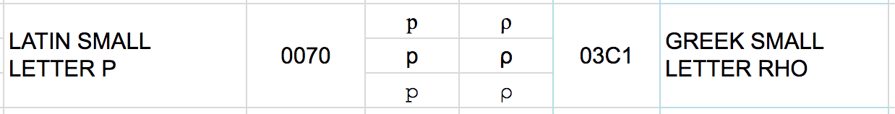

In such cases, the two code-points are visually only distinguishable in context because of their relative positioning towards the baseline, since 0070 crosses below the baseline but 03C1 does not. Given that there are several variant candidates among the cross-script variants, numerous plausible labels could be made up, such as .ρορ vs .pop or .ραγ vs .pay,which most Latin-script users would be hard-pressed to distinguish in context.

Furthermore, designers from the Latin-script using community have exploited the visual similarity between these two code-points and have created logos for globally used brand-names, which employ glyphs baring more resemblance to Greek 03C1 rather than Latin 0070, such as Pepsi (cf. https://perma.cc/6GTA-98C9?type=image). Again, this use in logo designs is neither limited to the Pepsi-brand logo nor the English-using community - cf.
- http://logos.wikia.com/wiki/Logopedia:Theme/Logos_with_the_letter_P?file=Publix_logo.png,
- http://logos.wikia.com/wiki/File:150px-Android_P_logo.png
- http://logos.wikia.com/wiki/File:Vpf.png,
- http://logos.wikia.com/wiki/Category:Red_PAT -

It is also featured in historically established logos – cf.
- http://logos.wikia.com/wiki/File:Pba_83_on_city_2_Vintage_Sports.jpg.

By consequence, Latin-script users tend to recognize glyphs resembling Greek 03C1 as non-visual variants of 0070, even where they are able to visually distinguish the two shapes and irrespective of the fact, that for Greek users, 03C1 is clearly distinctive from Latin 0070, therefore constituting a variant on non-visual grounds.

D.9.2.3. Greek Small Letter Upsilon G03C5

0075-03C5: The two glyphs look “nearly identical” in Arial font (as shown in the second row in the image below).

Figure G03.1: 0075 vs. 03C5
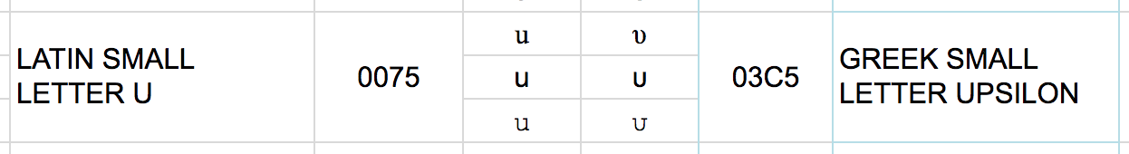

028B-03C5: Also, these two glyphs look “nearly identical” in Times New Roman font (as shown in the first row in the image below).

Figure G03.2: 028B vs. 03C5
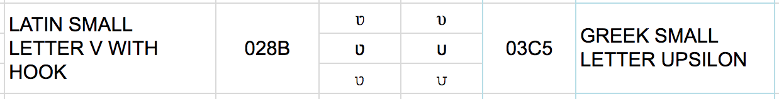

The same analysis applies to 00FA and 03CD, which are essentially the same characters with the addition of a modifying diacritic on top (an Acute in the case of Latin and a Tonos in the case of Greek script).

Since the former two variant sets feature one and the same code point from Greek script but two different code points from Latin script, this therefore imposes an in-script variant relationship between 0075 and 028B due to transitivity. The two code points Latin U (0075) and Latin V with Hook (028B) are however both used in a distinguishing manner in the orthography of Mossi – a language of Burkina Faso. Latin GP foresees no issues, and accepts the imposed variant relationship between the two code points, given that the variant relationship between U and V with Hook will still permit users from the Mossi community to employ both code points in labels, and since there won’t be any particular security risk for the Mossi community, such as spoofing, as the variant set will have a the disposition of “blocked”.

D.9.2.4. Greek Letter Beta 03B2

The Greek script code point 03B2 β (Letter Beta) is visually nearly identical due to font design to Latin script code point 00DF ß (Letter Sharp S). While those differences may be argued to be sufficiently different from a point of view of Greek script users, particularly the German users from the German language community may consider these code points confusable, since the typical rendering of the Greek variant is one of the forms taught to elementary school pupils as a hand-written form of the Latin-script code point 00DF ß across the German-speaking part of the script-using community, as demonstrated by Figure G04 below.

Figure G04: A handwritten form of the German Lexeme Grüße ‘greetings’, taken from
https://de.wikipedia.org/wiki/%C3%9F#/media/File:Gruesse-Schneidler-Legende.png (Cf. e.g. https://de.wikipedia.org/wiki/%C3%9F#/media/File:Gruesse-Schneidler-Legende.png,
where the German lexeme Grüße is spelled with such a hand-written form).
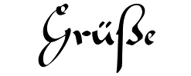

Therefore, adult script-users may also consider them in their minds to be the same, despite them being able to see the visual differences between the glyphs. Given that there are several Greek code points in a variant relationship to Latin code points, which are used by the German orthography, there are numerous plausible labels which could be made up, such as Greek. νοβ, which may be identified with the German surname Voß. Additionally, German orthography commonly replaces 00DF ß by a sequence of two ss, and the same variation is also encountered in personal names, i.e. both Voß and Voss are used, which gives further scope to this potential confusion among readers (This issue is further complicated by the issue of IDNA compatibility – c.f. section 6.7.2). Accordingly, there is a concrete risk for the safety and stability of the zone, which should be dealt with at the level of the LGR definition by a variant relationship between those two code points (and others), despite them not being homoglyphs in a strict sense in a number of fonts.

D.9.2.5. Greek Small Letter Sigma 03C3

In Courier New (represented by the third row in the screenshot of Figure G04 below) the glyphs are deemed nearly identical due to font design:

Figure G05: 01A1 vs. 03C3
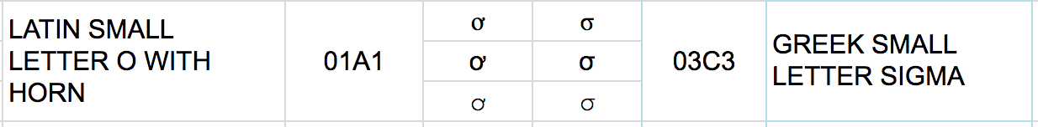

D.9.2.6. Greek Small Letter Gamma 0263

The distinction between the Latin Small Letter Gamma (ɣ U+0263) and Greek Small Letter Gamma (γ, U+03B3) is an arbitrary convention: the range of generally encountered shapes for Greek gamma encompasses also the form chosen for Latin gamma, even if user-interface fonts tend to keep these two distinct. Greek users may accept 0263 as an unusual font style, because of lack of awareness that a Latin clone of this letter even exists.

D.9.3. Armenian – Latin Cross-Script Variant Analysis

D.9.4. Cyrillic – Latin Cross-Script Variant Analysis

*Decided as 'similar' based on the additional GP's discussions and consultations with the IP.

*Decided as 'similar' based on the additional GP's discussions and consultations with the IP.

*Decided as 'similar' based on the additional GP's discussions and consultations with the IP.

**The code point is not in the repertoire

D.9.5. Greek – Latin Cross-Script Variant Analysis

*Decided as 'similar' based on the additional GP's discussions and consultations with the IP.

*Decided as 'similar' based on the additional GP's discussions and consultations with the IP.

*Decided as 'similar' based on the additional GP's discussions and consultations with the IP.

