D.1 Shape of Base Characters

D.1.1 Latin Small Letter F vs. Latin Small Letter F with Hook

Code Points Considered:

Code Points | Glyph | Name
0066 | f | LATIN SMALL LETTER F
0192 | ƒ | LATIN SMALL LETTER F WITH HOOK
01AD | ƭ | LATIN SMALL LETTER T WITH HOOK (See D.1.17)

Example from a Swedish Newspaper:

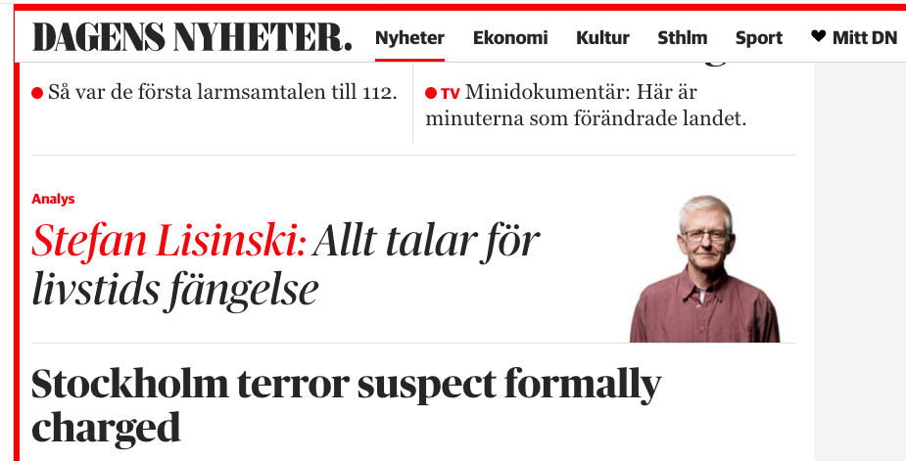

Findings:
The example uses a shape of “Latin Small Letter F” (0066) that is identical to “Latin Small Letter F with Hook” (0192) in italic style. Example from a large, daily newspaper, in which all instances of “ƒ” are just italic variants of “f”.

Conclusions:
These two code points should be treated as variants

D.1.2 Latin Small Letter A vs. Latin Small Letter Alpha

Code Points Considered:

Code Points | Glyph | Name
0061 | a | LATIN SMALL LETTER A
0251 | ɑ | LATIN SMALL LETTER ALPHA

Findings:
Latin Small Letter Alpha is not in the Repertoire

Conclusion:
These code points are not variants.

D.1.3 Latin Small Letter Z vs. Latin Small Letter Ezh

Code Points Considered:

Code Points | Glyph | Name
007A | Z | LATIN SMALL LETTER Z
0292 | ʒ | LATIN SMALL LETTER EZH

Sequence zʒ (007A 0292) compared using Google Fonts in https://wordmark.it/:

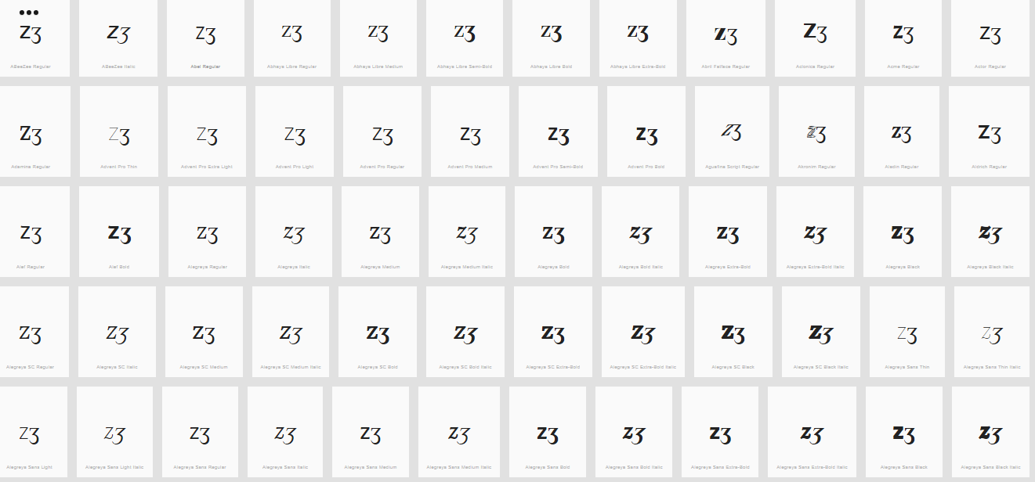

Findings:
Glyphs are distinguishable. In a large number of fonts, the two letters are consistently different.

Conclusion:
These code points are not variants.

D.1.4 Latin Small Letter V with Hook vs. Latin Small Letter V

Code Points Considered:

Code Points | Glyph | Name
028B | ʋ | LATIN SMALL LETTER V WITH HOOK
0076 | v | LATIN SMALL LETTER V

Sequence ʋv (028B 0067) compared using Google Fonts in https://wordmark.it/ :

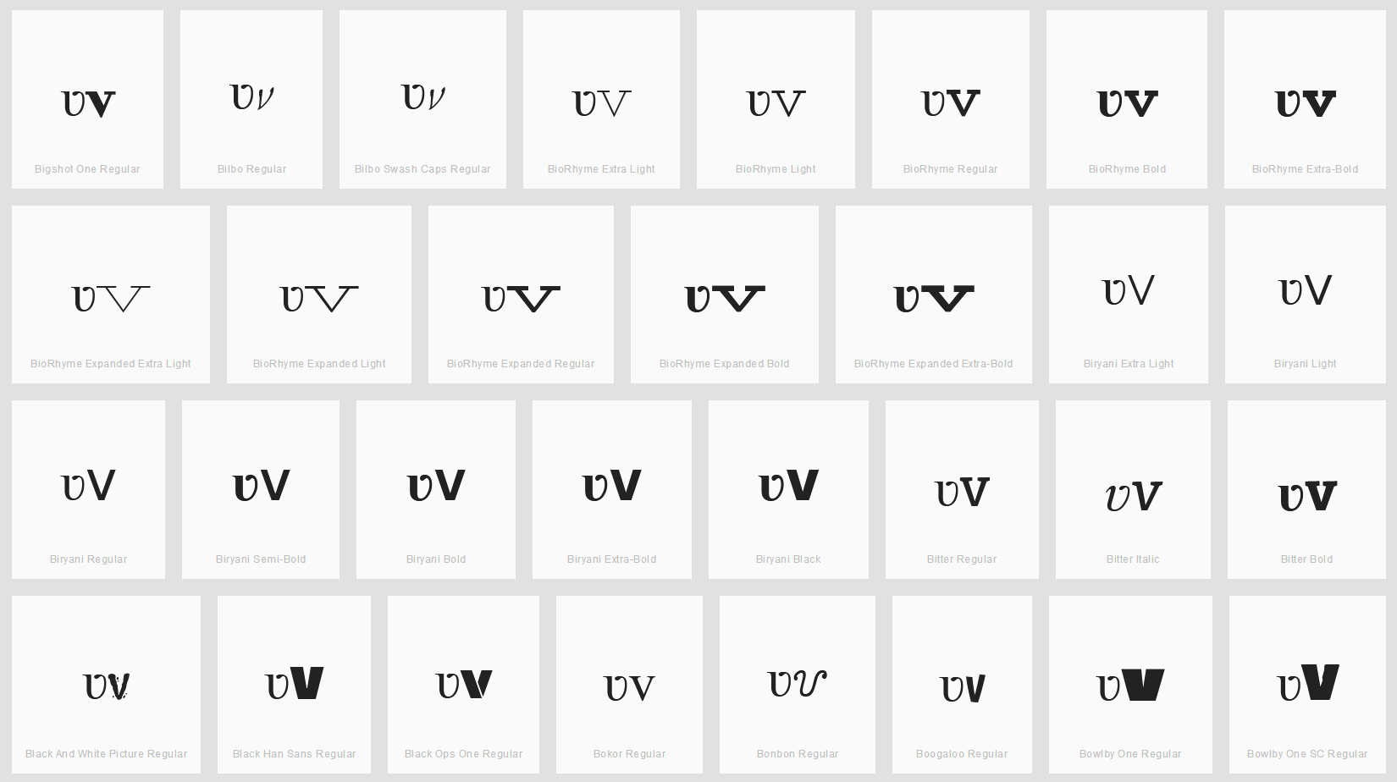

Findings:
All cases I viewed on wordmark.it looked more or less similar to the above screenshot. In particular the ʋ looks more like a u than a v at the bottom in the sense that it never has a sharp angle, but always a curve (whereas v has almost always a sharp angle). Furthermore, the top right corner of the ʋ is always turned visibly to the left. Even in cases where the v has some serif this is distinguishable from the ʋ hook as the serif is always in both directions (left and right).

Conclusion:
These code points are not variants.

D.1.5 Latin Small Letter I vs. Latin Small Letter Dotless I vs. Latin Small Letter Iota

Latin Small Letters I, Dotless I and Iota may be considered equivalent by readers and writers, since the dot of the I is frequently omitted in hand-writing, and since the shape of Iota is a typical style of writing the shape of the I.

Code Points Considered:

Code Points | Glyph | Name
0069 | i | LATIN SMALL LETTER I
0131 | ı | LATIN SMALL LETTER DOTLESS I
0269 | ɩ | LATIN SMALL LETTER IOTA

Sequence iıɩ ( 0069 0131 0269) compared using Google Fonts in https://wordmark.it/ :

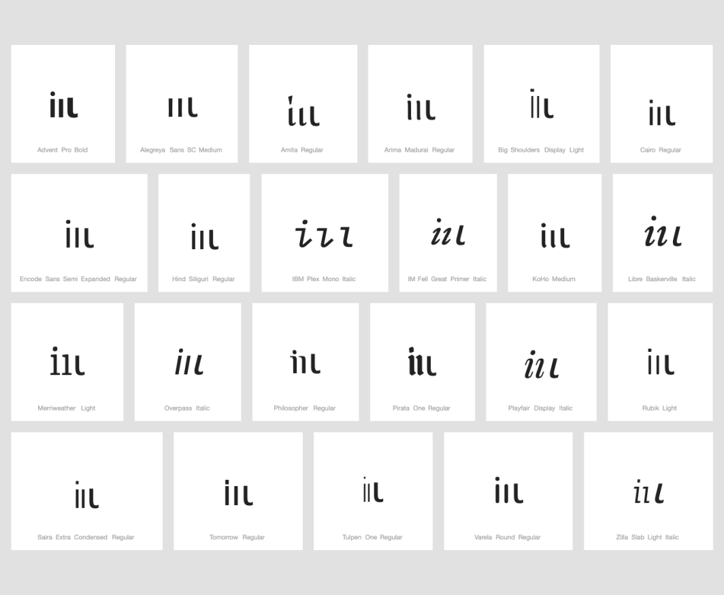

Findings:
Glyphs are distinguishable when written in lower case.

Sequence ıɩ (0131 0269) compared using Google Fonts in https://wordmark.it/

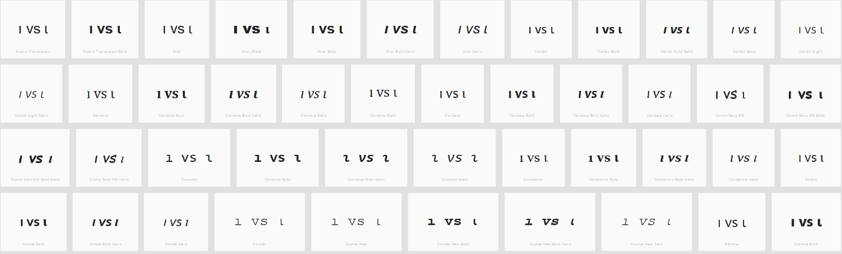

Findings:
In the italic versions of any of the serif fonts (e.g., Times New Roman or Consolas) these are identical.

Conclusions:
Latin Small Letter Iota (0269) and Latin Small Letter Dotless I (0131) are variants.

D.1.6 Latin Small Letter E vs. Latin Small Letter Open E

Latin Small Letter E and Latin Small Letter Open E may be considered equivalent by readers and writers, since Open E is a typical shape in writing e in word-initial positions.

Code Points Considered:

Code Points | Glyph | Name
0065 | e | LATIN SMALL LETTER E
025B | ɛ | LATIN SMALL LETTER OPEN E

Glyph Representations per https://wordmark.it/:
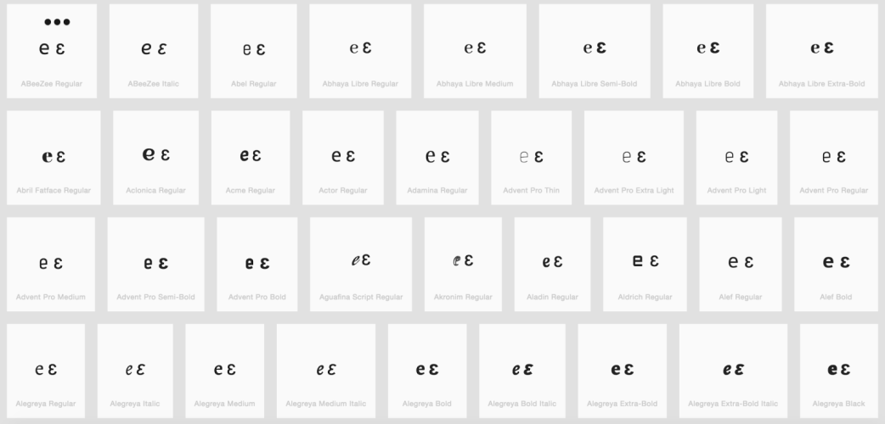

Findings:
Glyphs are distinguishable. In a large number of fonts, the two letters are consistently different.

D.1.7 Latin Small Letter K vs. Latin Small Letter K with Hook

Latin Small Letter K and Latin Small Letter K with Hook may be considered equivalent by readers and writers, since the extended hook is a frequent variation encountered in hand-writing.

Code Points Considered:

Code Points | Glyph | Name
006B | k | LATIN SMALL LETTER K
0199 | ƙ | LATIN SMALL LETTER K WITH HOOK

Sequence 006B and 0199 compared using Google Fonts in https://wordmark.it/:
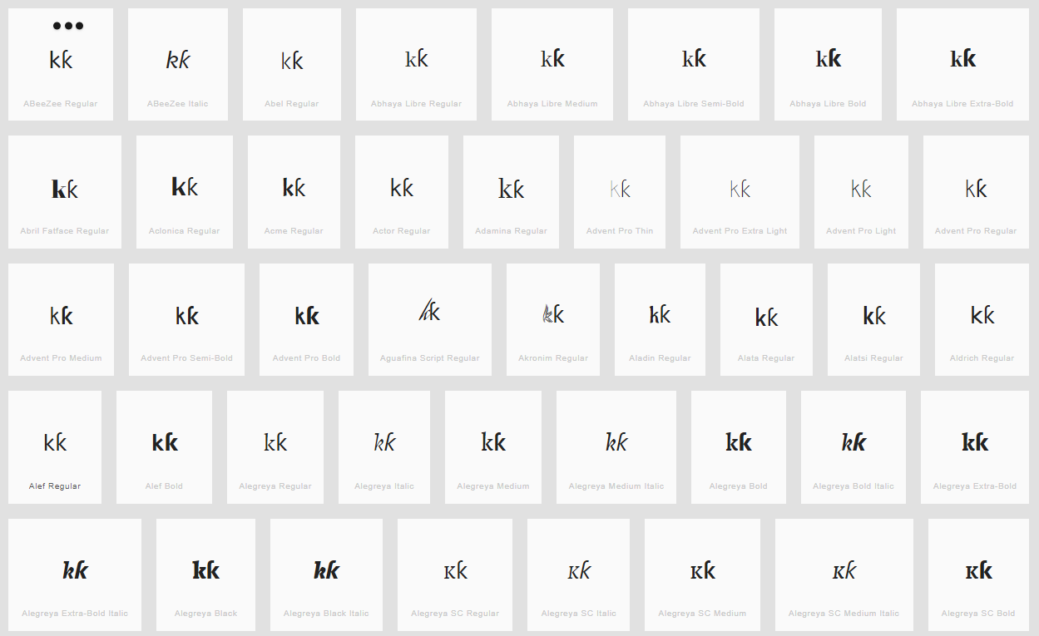

Findings:
Variant – indistinguishable in some fonts

D.1.8 Latin Small Letter Y vs. Latin Small Letter Y with Hook

Latin Small Letter Y and Latin Small Letter Y with Hook may be considered equivalent by readers and writers, since the extended hook is a frequent variation encountered in hand-writing.

Code Points Considered:

Code Points | Glyph | Name
01B4 | ƴ | LATIN SMALL LETTER Y WITH HOOK
0079 | y | LATIN SMALL LETTER Y

Sequence yyƴy (0079 + 0079 + 01B4 + 0079) compared using Google Fonts in https://wordmark.it/:

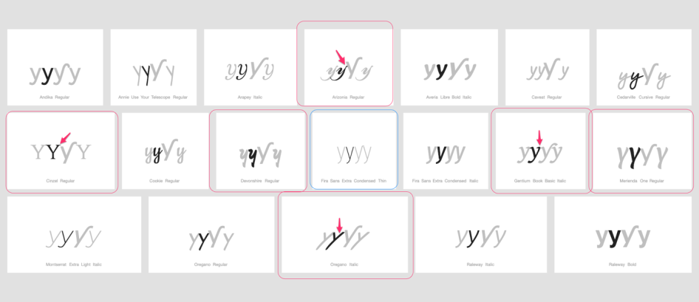

Findings:
As expected, there is a large degree in variation in the rendering of the glyphs of 0079.
Two essential differences between 01B4 and 0079 are recognized. 01B4 tends to be tilted or italicized and the key difference is the extended diagonal line turning into a right hand side hook.
As demonstrated by the examples, a number of fonts show a similar tilting, not only in italic fonts, as well as an extension of lines.

However, no example was found where the right hand-side line is extended right-wards (but only left-wards - generally also in cursive handwriting the letter doesn’t connect right-wards at the top to following letter), and only one font (highlighted in blue) was shown where the two renderings are visually (nearly) identical.

Conclusions:
Since the two code-points are different in a large number of fonts (albeit inconsistently) no variant pair is warranted in this case.

D.1.9 Latin Small Letter D with Caron vs. Latin Small Letter D with Hook

Latin Small Letter D and Latin Small Letter D with Hook may be considered equivalent by readers and writers, since the extended hook may be another style of writing the Caron in cursive hand-writing. Additionally, the Caron may become indistinguishable from an apostrophe.
Code Points Considered:

Code Points | Glyph | Name
010F | ď | LATIN SMALL LETTER D WITH CARON
0257 | ɗ | LATIN SMALL LETTER D WITH HOOK
02BC | ʼ | MODIFIER LETTER APOSTROPHE
0064 | d | LATIN SMALL LETTER D
006C | l | LATIN SMALL LETTER L
013E | ľ | LATIN SMALL LETTER L WITH CARON

Sequence (ɗďdʼ) (0257 010F 0064 02BC) compared using Google Fonts in https://wordmark.it/:
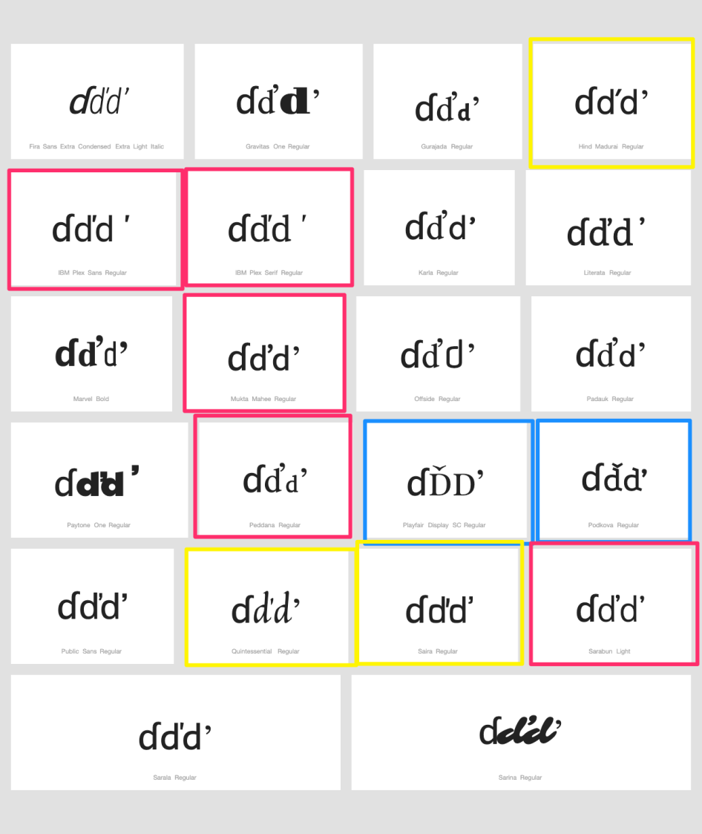

Sequence (l'ľ) (006C 02BC 013E) compared using Google Fonts in https://wordmark.it/:
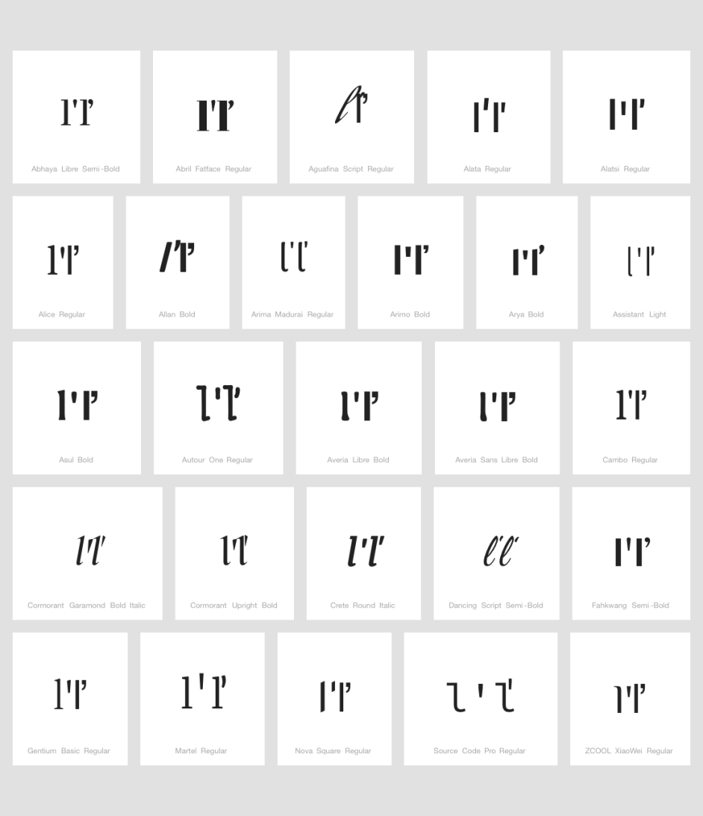
Findings:
While the differences between 0257 and 010F seem rather stable, this is not the case for 010F vs 0064 + 02BC as well as 006C + 02BC vs 013E. Accordingly, 010F vs 0064 + 02BC as well as 006C + 02BC vs 013E are indistinguishable in a significant number of fonts and homoglyphs in a minority of fonts. However, as the apostrophe (02BC) is not included in the repertoire, this variant relationship is not applicable.

Conclusions:
010F ď Letter D with Caron and 0257 ɗ Letter D with Hook are not variants. And the variant relationship between Caron and apostrophe is not applicable as the apostrophe is not included in the repertoire.

D.1.10 Latin Small Letter T vs. Latin Small Letter L with Stroke

Latin Small Letter T and Latin Small Letter L with Stroke may become confusable in casual hand-writing, italic fonts or fonts which do not slant the stroke of the l.

Code Points Considered:

Code Points | Glyph | Name
0074 | t | LATIN SMALL LETTER T
0142 | ł | LATIN SMALL LETTER L WITH STROKE
01AD | ƭ | LATIN SMALL LETTER T WITH HOOK (See D.1.17)

Sequence (t ł) (0074 0142) compared using Google Fonts in https://wordmark.it/:

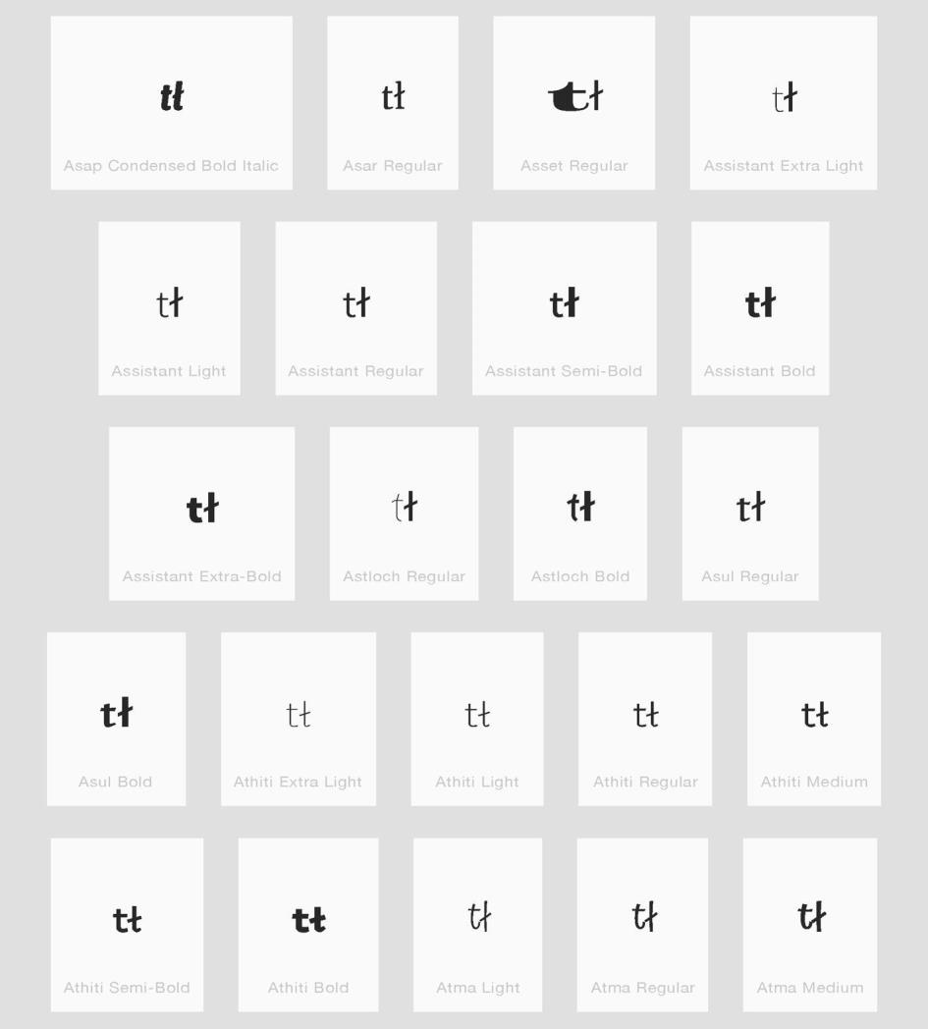

Findings:
Glyphs are distinguishable

Conclusions:
These are not variants.

D.1.11 Latin Small Letter J vs. Latin Small Letter I with Ogonek

Latin Small Letter J and Latin Small Letter I with Ogonek may become confusable in some font designs, since the ogonek may be mistaken for the extension of the j-shape below the baseline for less careful readers.

Code Points Considered:

Code Points | Glyph | Name
006A | j | LATIN SMALL LETTER J
012F | į | LATIN SMALL LETTER I WITH OGONEK

Sequence jį (006A 012F) compared using Google Fonts in https://wordmark.it/:
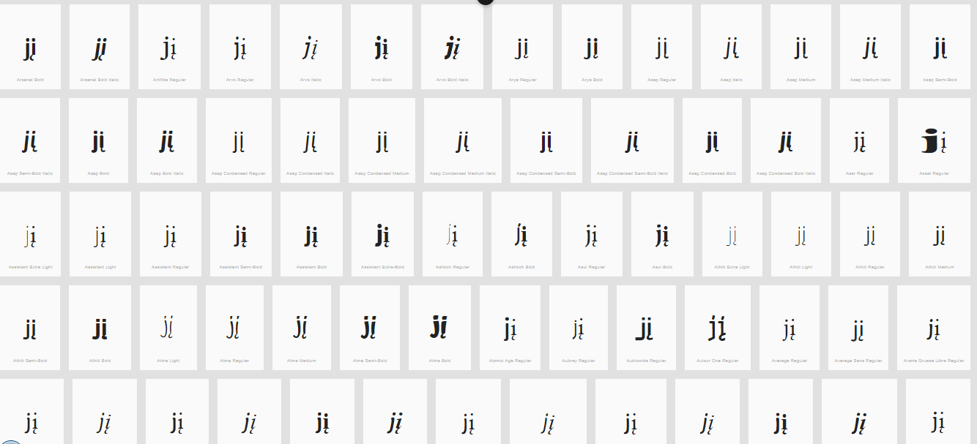

Findings:
Glyphs are distinguishable. In a large number of fonts, the two letters are consistently different.

Conclusions:
These are not variants.

D.1.12 Latin Small Letter B vs. Latin Small Letter Thorn vs. Latin Small Letter P

Latin Small Letter Thorn may become nearly identical to either Latin Small Letter B or Latin Small Letter P depending on font designs, context, and reader since the former is essentially an overlay of the latter two shapes and serifs may appear in either of the extensions of the round shape above and below the baseline.

Code Points Considered:

Code Points | Glyph | Name
00FE | þ | LATIN SMALL LETTER THORN
0062 | b | LATIN SMALL LETTER B
0070 | p | LATIN SMALL LETTER P
01A5 | ƥ | LATIN SMALL LETTER P WITH HOOK

Sequence þb (00FE 0062) compared using Google Fonts in https://wordmark.it/ :
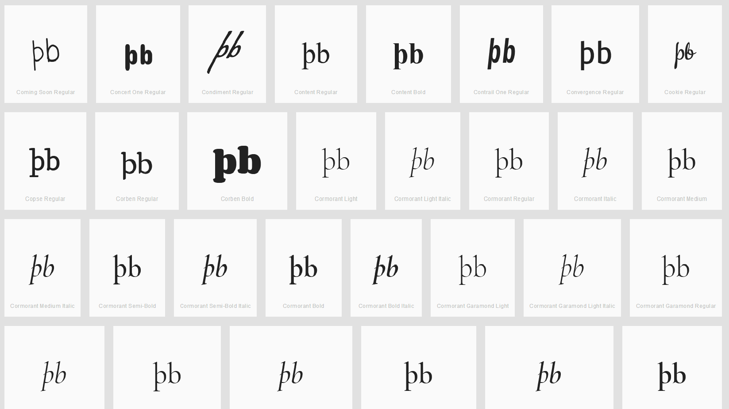

Findings:
All cases on wordmark.it looked similar to the above screenshot. The þ and b always appear quite distinguishable as the þ always has a stroke below the base line and the b never crosses the baseline.

Conclusion:
These code points are not variants.

Sequence (p þ) (0070 00FE) compared using Google Fonts in https://wordmark.it/:

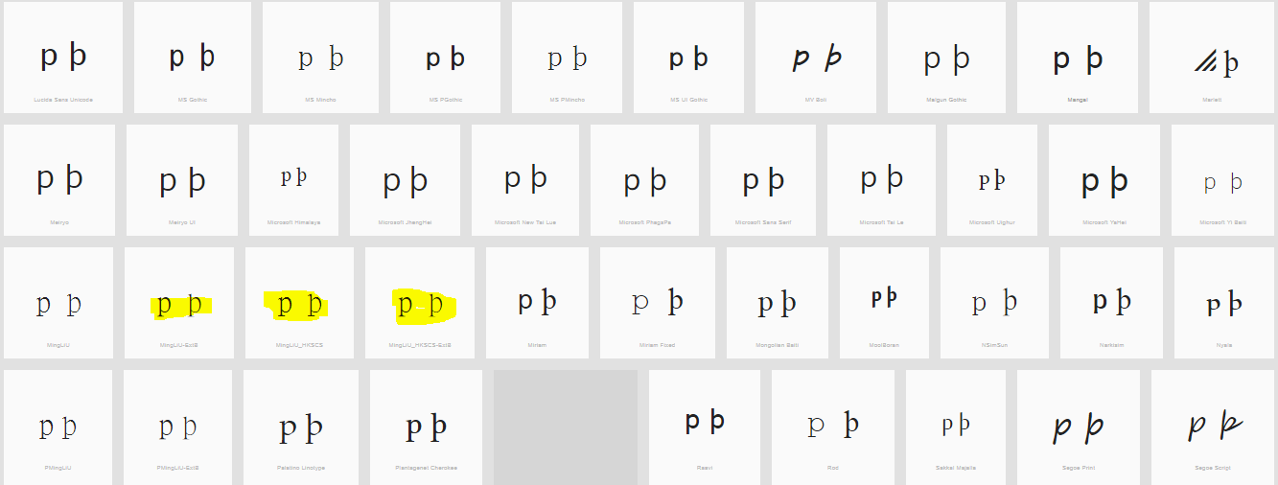
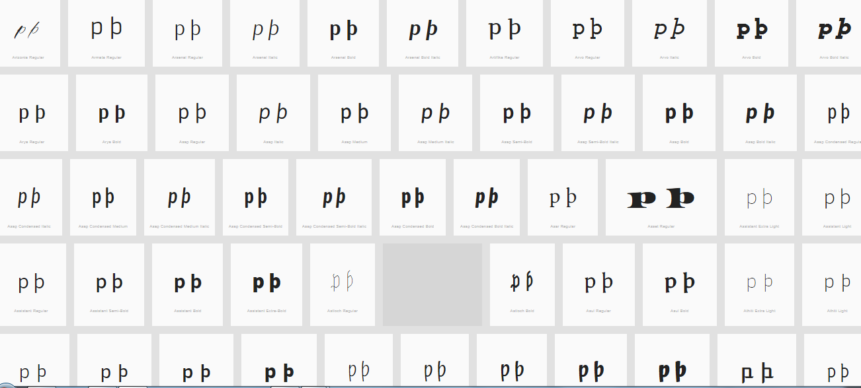

Findings:
The upper leg of the Thorn is visible in most fonts (except those highlighted) can be somewhat unclear.

Conclusion:
These code points are not variants.

The analysis between the Latin Small Letter Thorn and the Small Letter P with Hook

Findings:
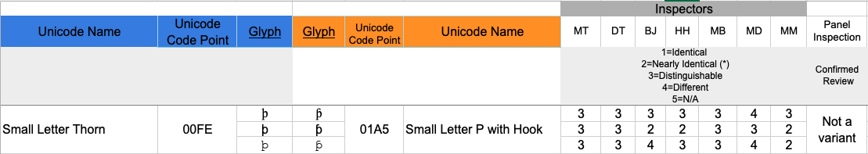

Conclusion:
These code points are not variants.

D.1.13 Letter Eth Versus Letter D with Stroke

Letter Eth and Letter D with Stroke may appear nearly identical depending on font design, context, and rendering since the former is essentially the same shape as the latter in a cursive or italic style.

Code Points Considered:

Code Points | Glyph | Name
00F0 | ð | LATIN SMALL LETTER ETH
0111 | đ | LATIN SMALL LETTER D WITH STROKE

Sequence (ðđ) (00F0 0111) compared using Google Fonts in https://wordmark.it/:
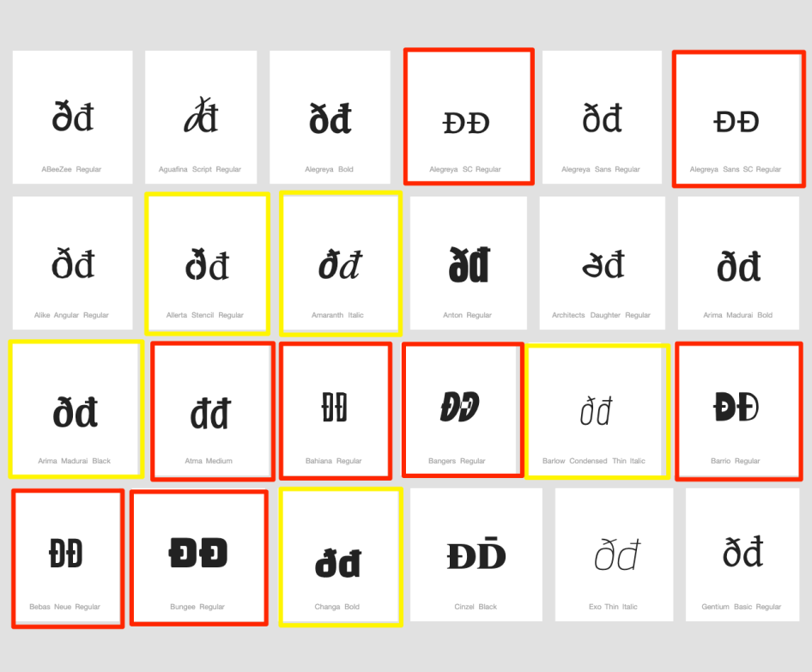

Findings:
The two letters are distinguishable in a majority of fonts. In italic or bold fonts, they may become difficult to distinguish (highlighted in yellow), while in few fonts they are represented identically (highlighted in red). A minority of fonts represents both codepoints in uppercase forms, in which they are homoglyphs (highlighted in red).

Conclusions:
The characters should be suggested to be highlighted in the string-similarity check, since they may be confusingly similar or even homoglyphs in a minority of fonts.

D.1.14 Latin Small Letter Schwa vs. Latin Small Letter Turned E

Code Points Considered:
Code Points | Glyph | Name
0259 | ə | LATIN SMALL LETTER SCHWA
01DD | ǝ | LATIN SMALL LETTER TURNED E

Sequence əǝ (0259 01DD) compared using Google Fonts in https://wordmark.it/:
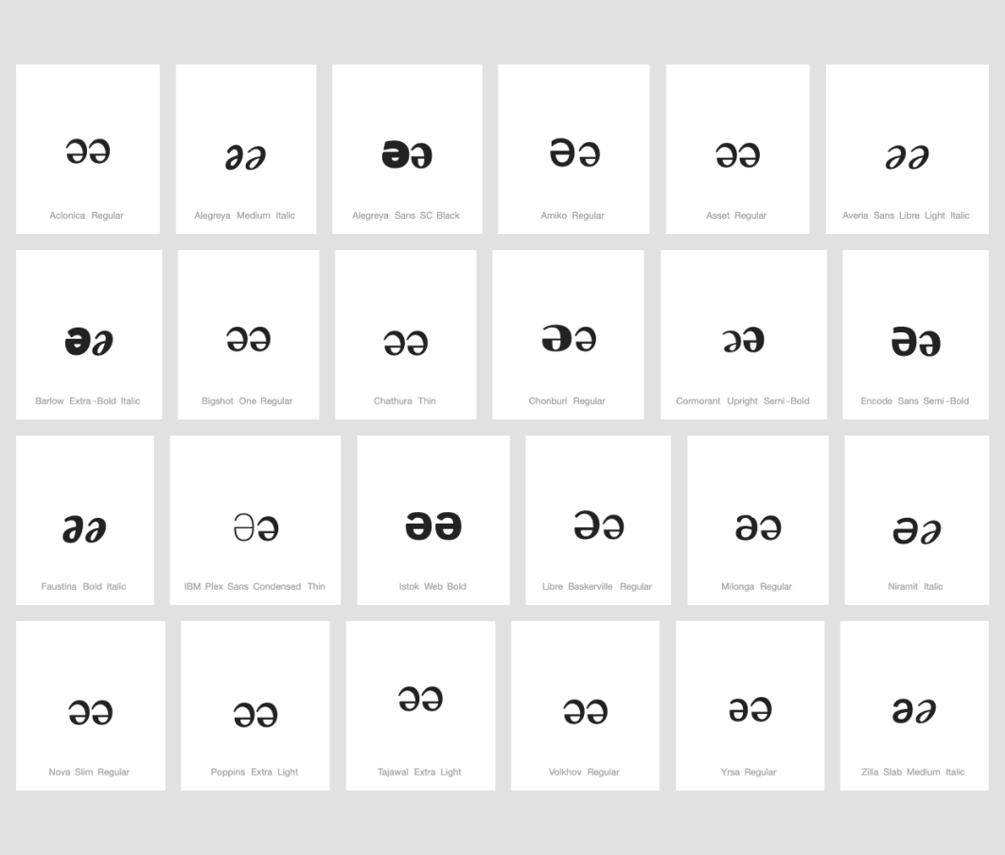

Findings:
Shapes of code points are mostly identical. In some font shapes of code points are different in size but there is no possibility to know which shape corresponds to which code point.

Conclusions:
These two code points are variants.

D.1.15 Latin Small Letter C with Hook

Code Points Considered:
Code Points | Glyph | Name
0063 | c | LATIN SMALL LETTER C
0107 | ć | LATIN SMALL LETTER C WITH ACUTE
0188 | ƈ | LATIN SMALL LETTER C WITH HOOK

Findings:
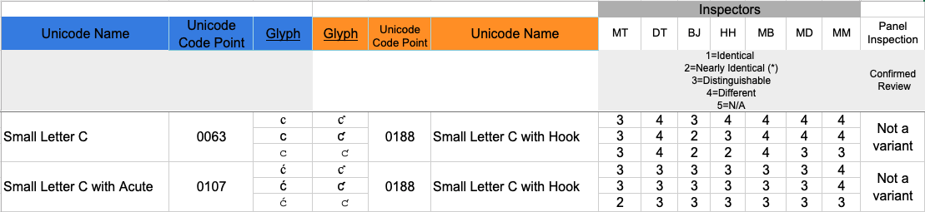

Conclusions:
These code points are not variants.

D.1.16 Latin Small Letter G with Hook

Code Points Considered:
Code Points | Glyph | Name
0067 | g | LATIN SMALL LETTER G
0123 | ģ | LATIN SMALL LETTER G WITH ACUTE
0260 | ɠ | LATIN SMALL LETTER G WITH HOOK

Findings:
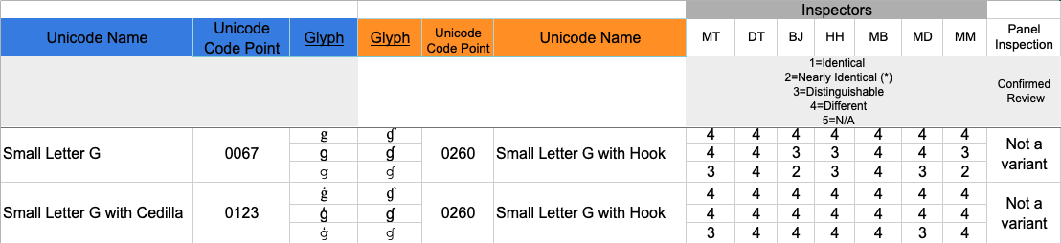

Conclusions:
These code points are not variants.

D.1.17 Latin Small Letter T with Hook

Code Points Considered:
Code Points | Glyph | Name
0066 | f | LATIN SMALL LETTER F
0074 | t | LATIN SMALL LETTER T
0165 | ť | LATIN SMALL LETTER T WITH CARON
0192 | ƒ | LATIN SMALL LETTER F WITH HOOK
01AD | ƭ | LATIN SMALL LETTER T WITH HOOK

Findings:
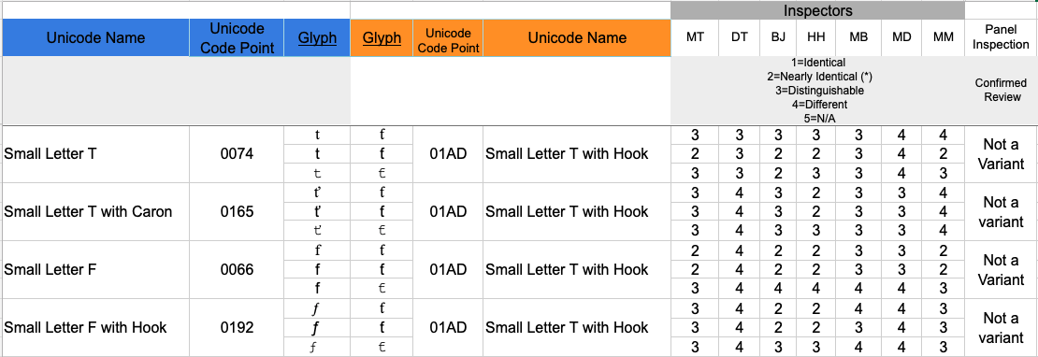

Conclusions:
These code points are not variants.

