Underlining Tests
Meikal Mumin

Roundcube on Safari on OSX
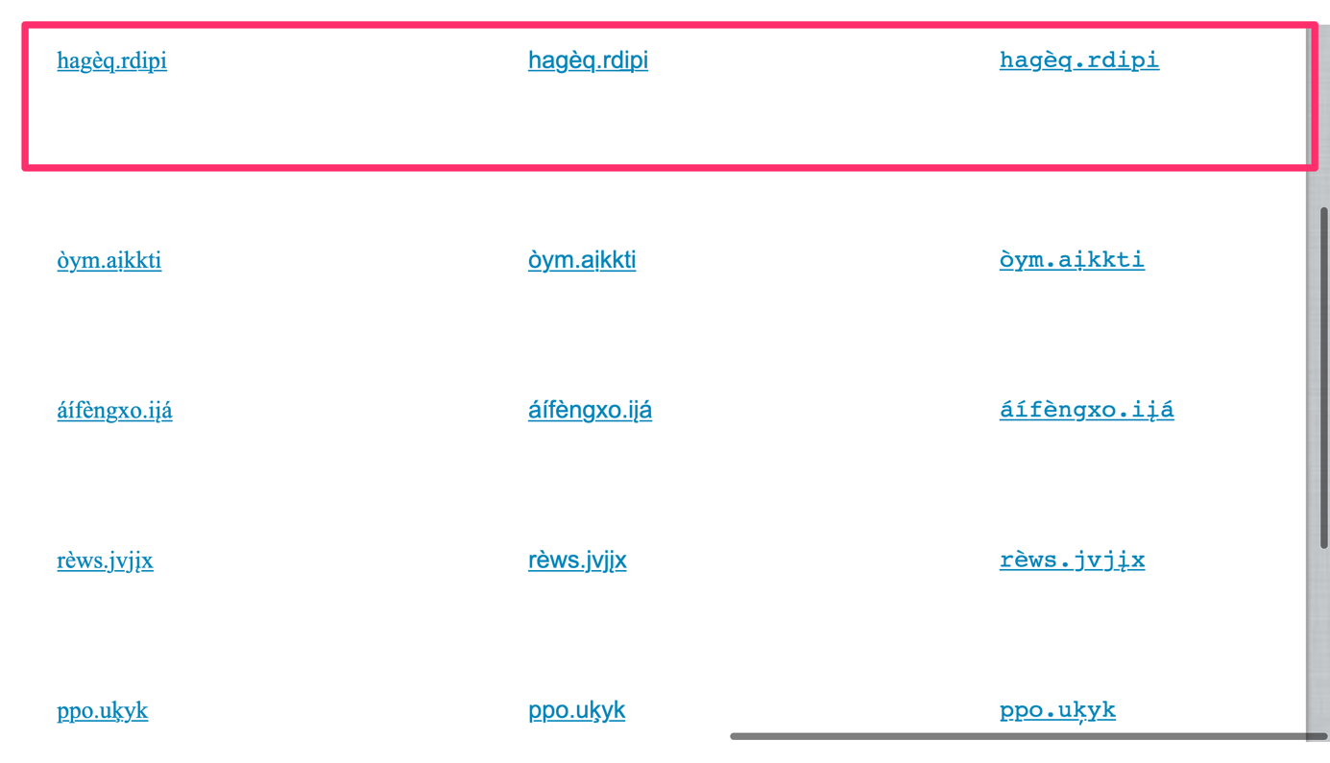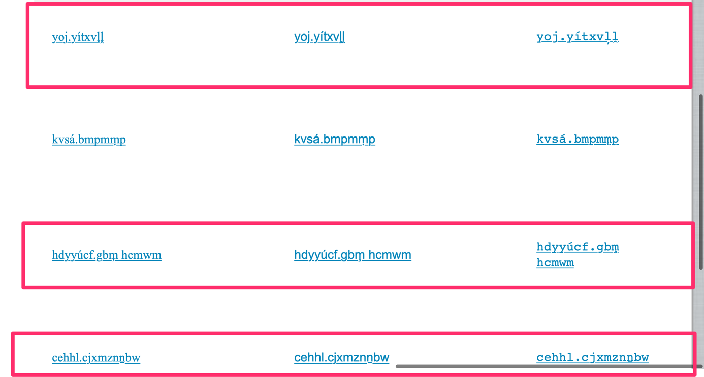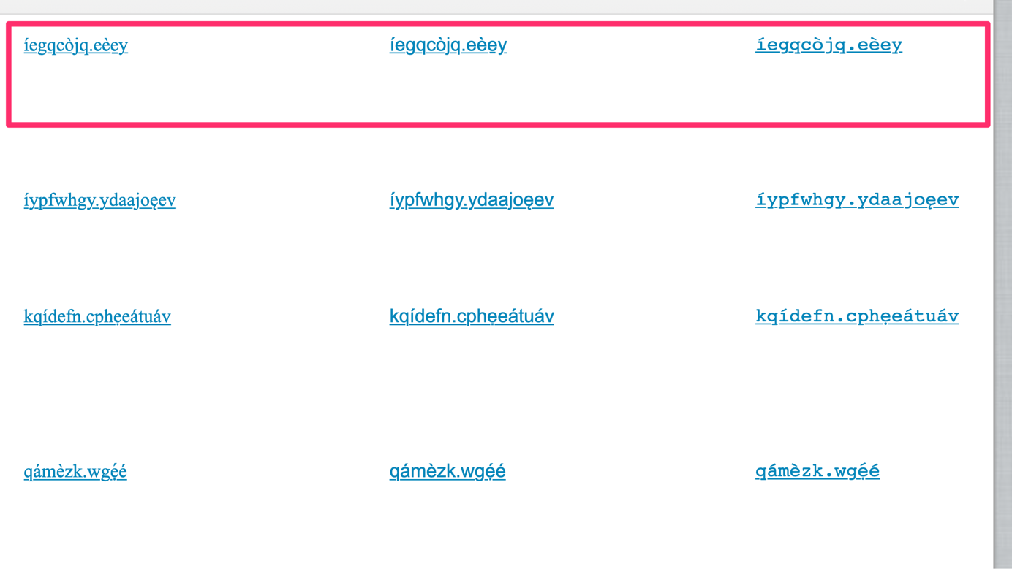
Results:
Generally, underline ‘skips’ where modifiers below the line occur. However, in Courier underlining is overlaid with modifiers below the line, and rarely adjacent modifiers below the line overlap, where the base character stand next to each other.

Roundcube on Chrome on OSX
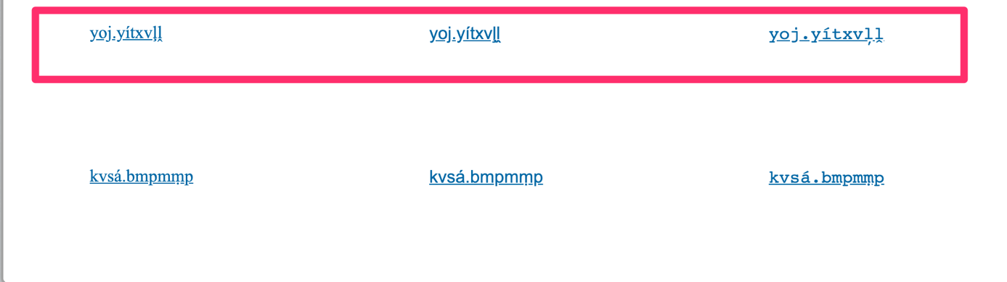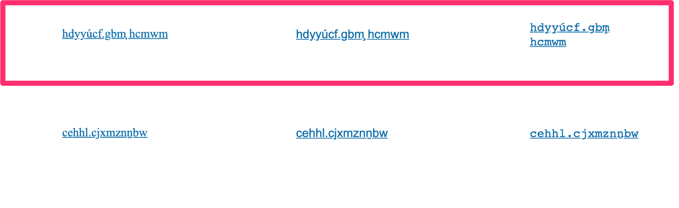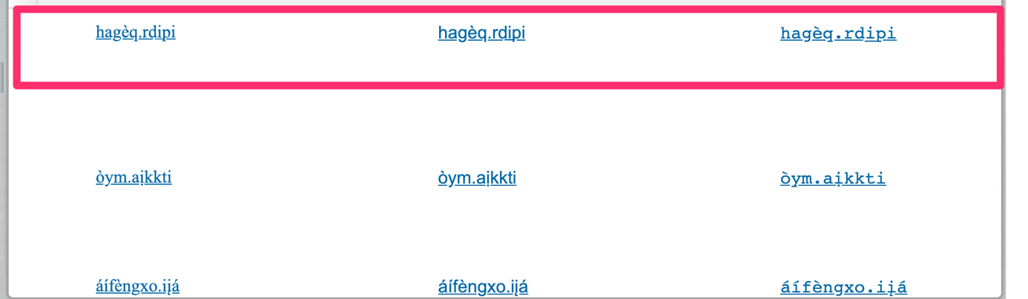

Results:
Generally, the underline is ‘skipped’, however irregularities occur as in the previous case. In one case, the underline is ‘skipped’ without a visible modifier below the base character.

Apple Mail on OSX

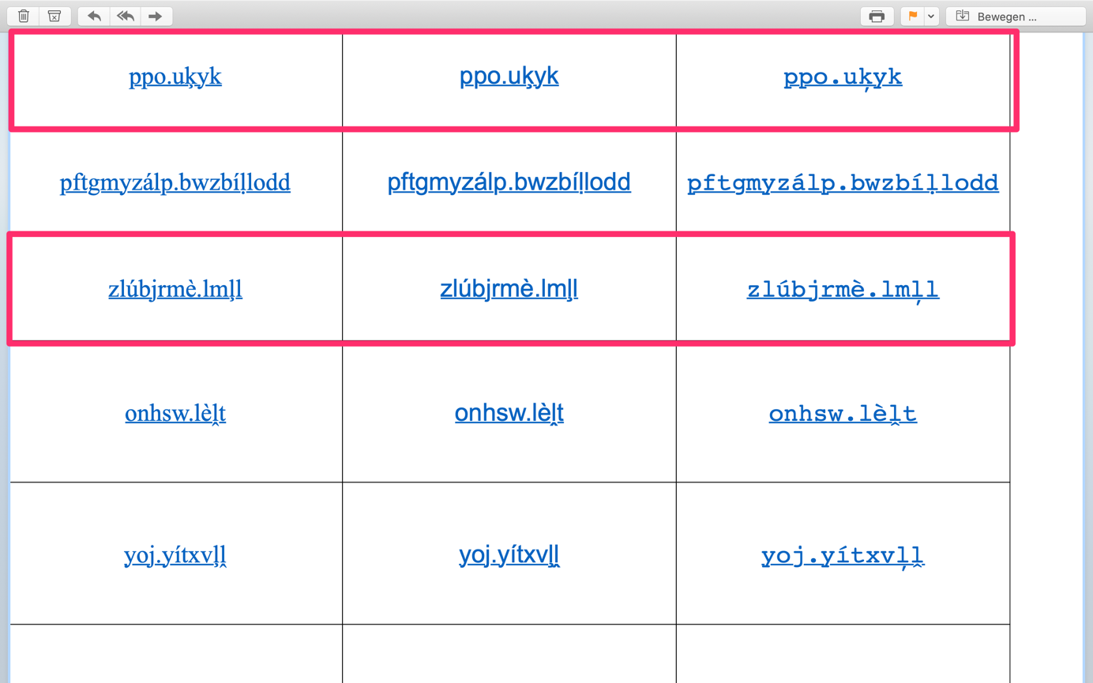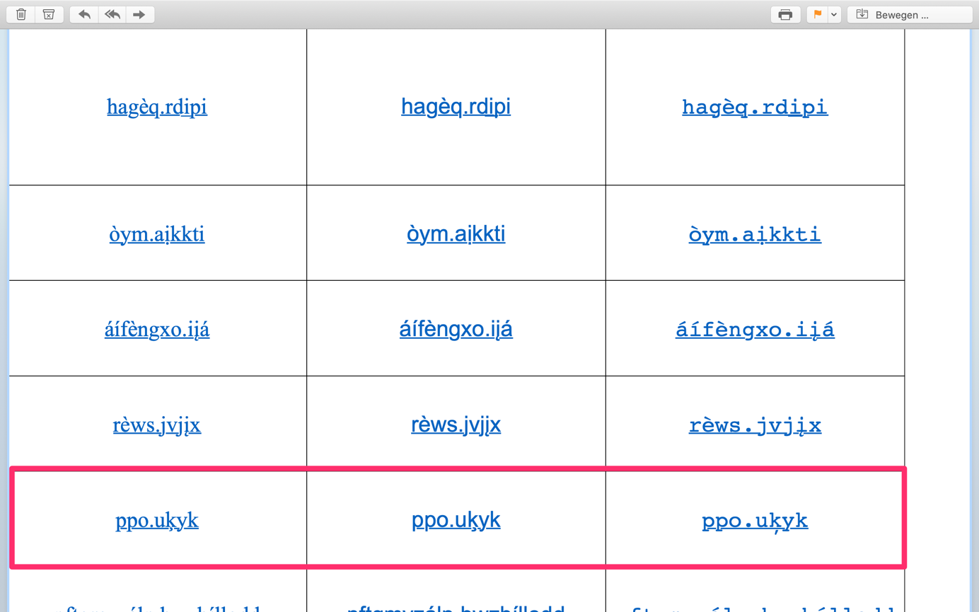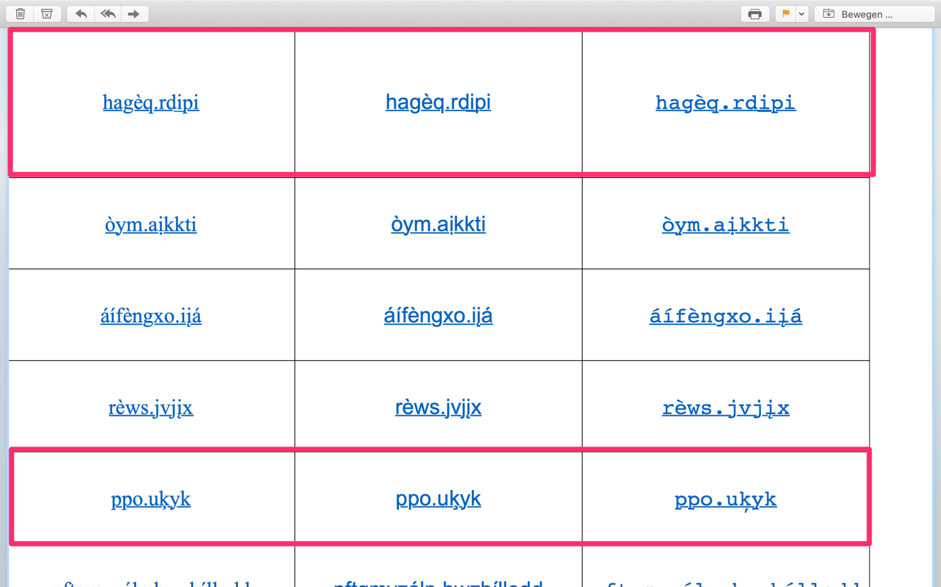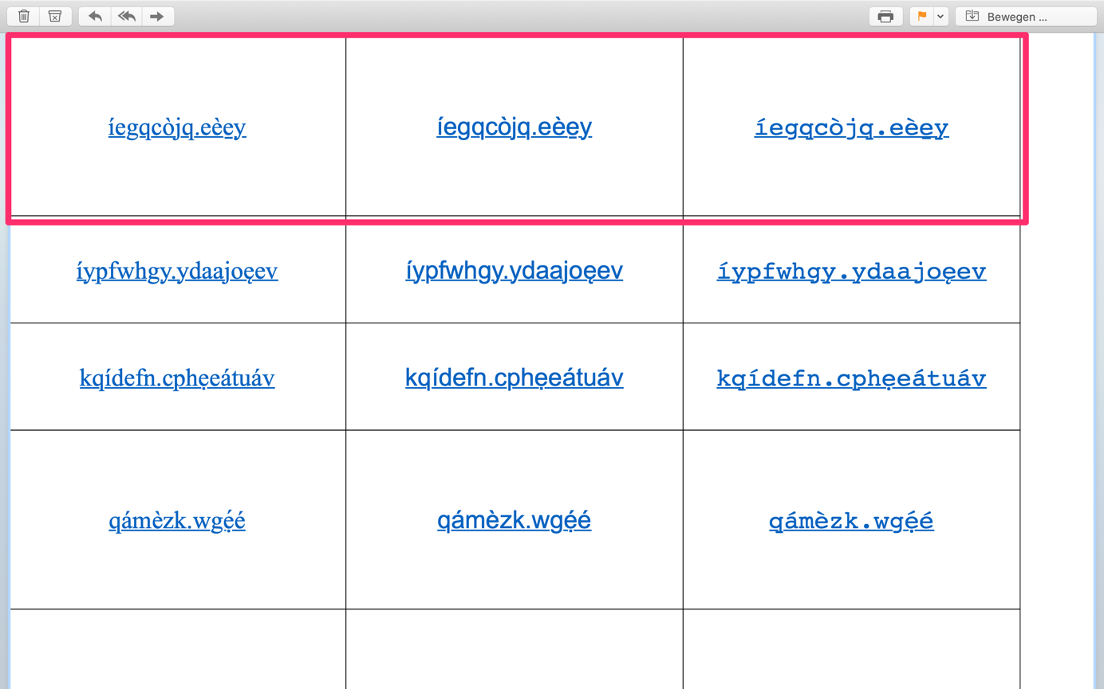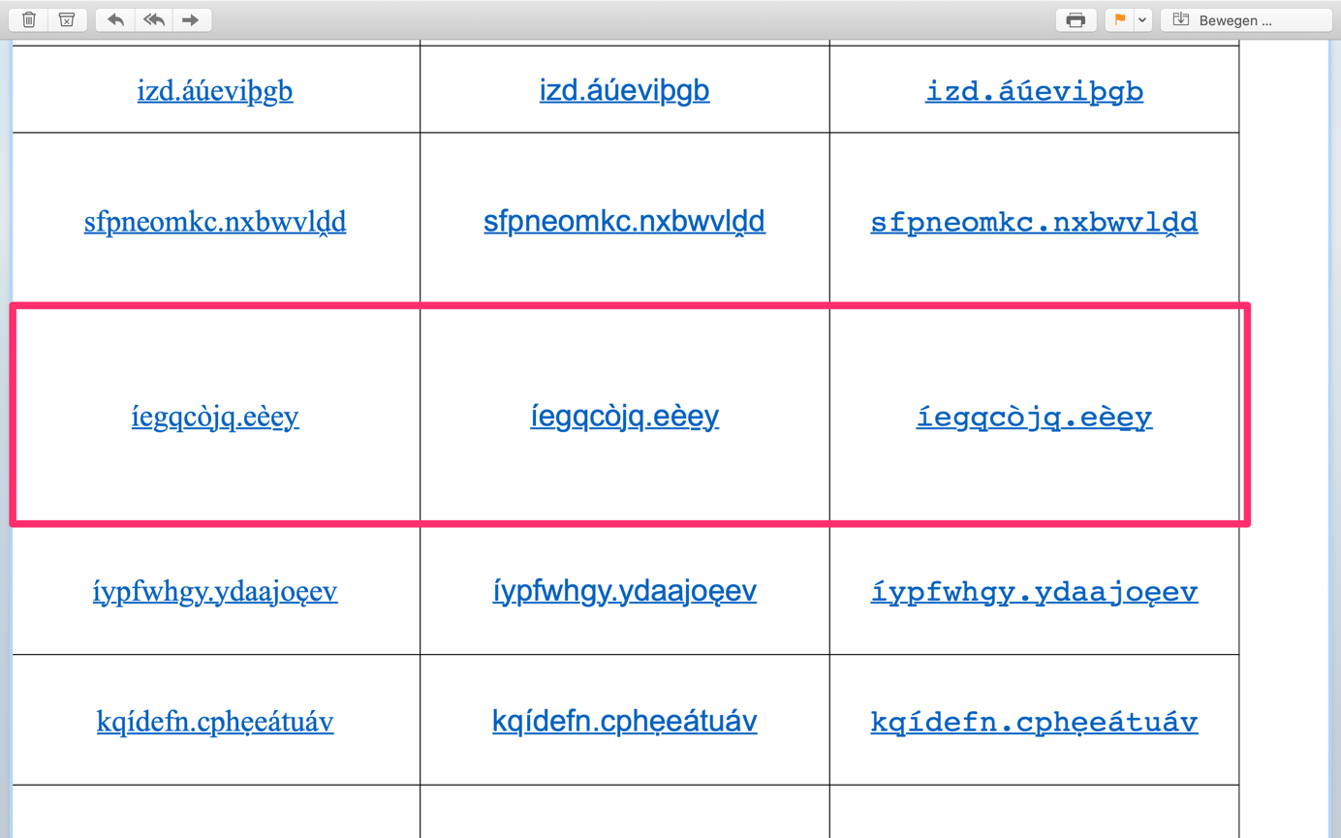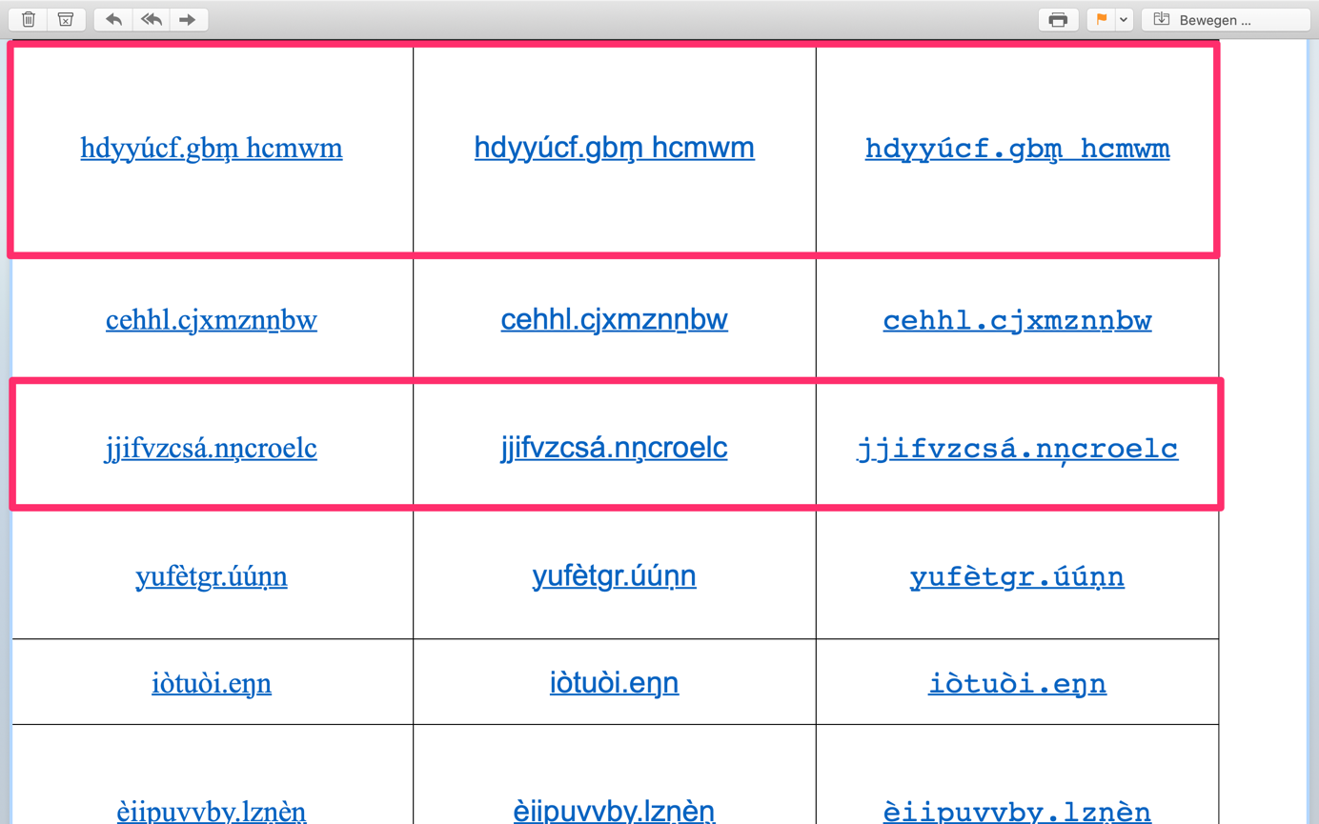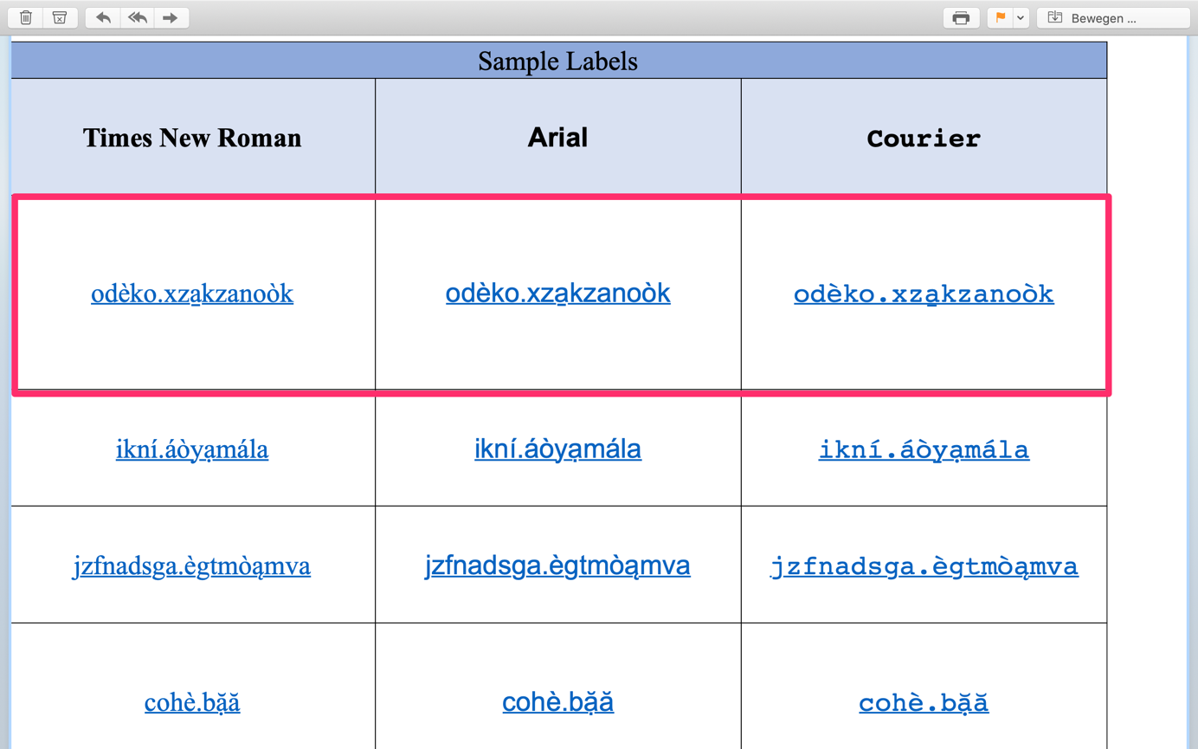
Results:
Generally, underlining is ‘skipped’, however there are numerous exceptions in Courier, where this is not the case or where the modifier below the line overlaps with the underline. Occasionally, strange spacing can be observed after characters with modifiers below the baseline.

Chrome on OSX
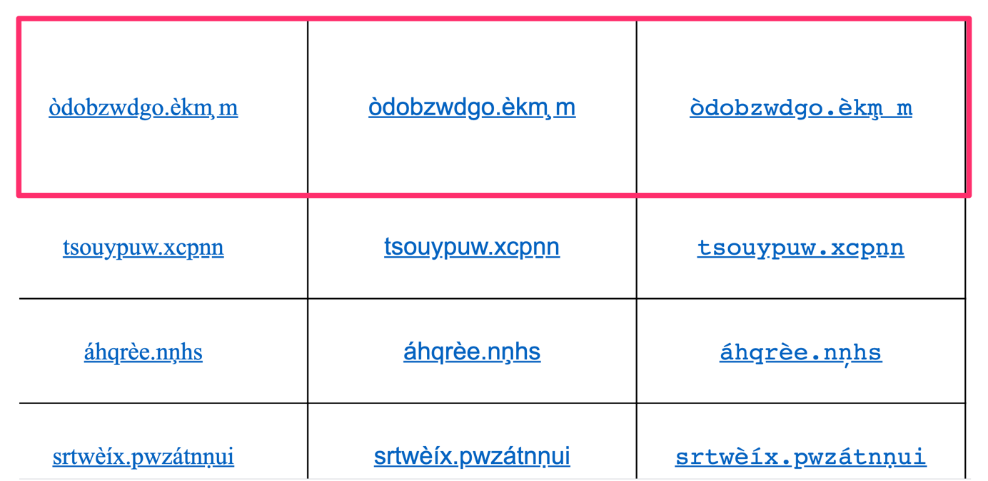
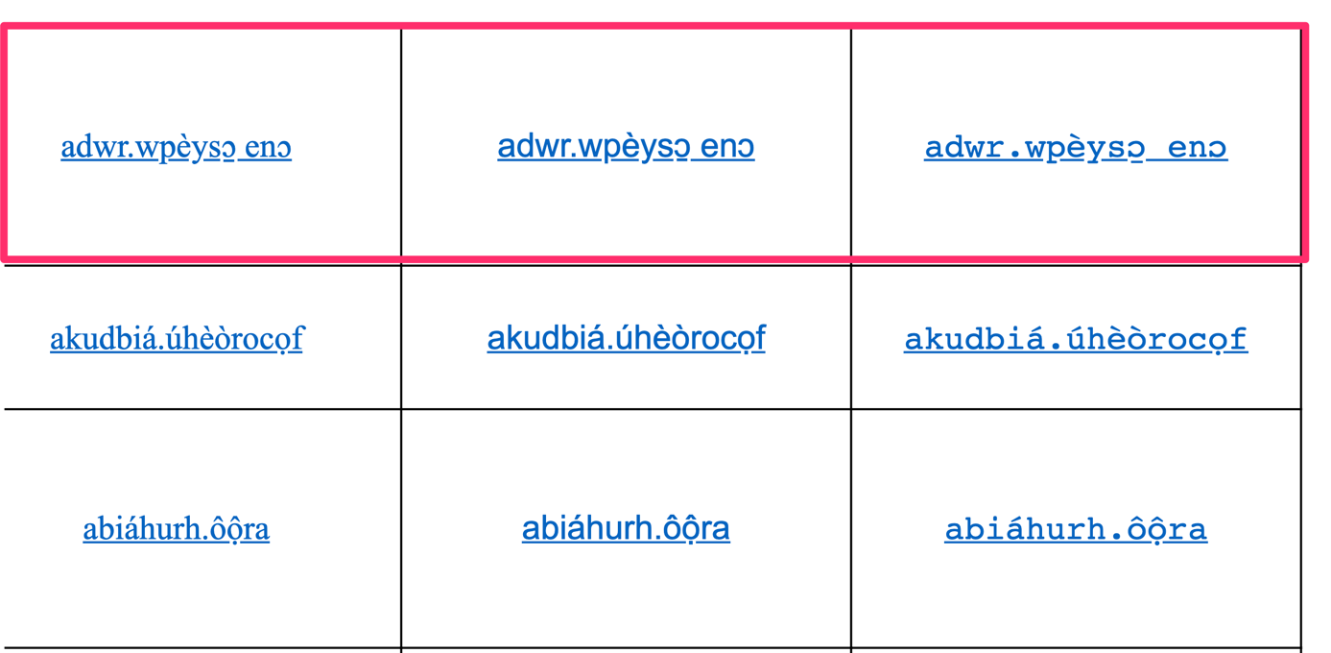

Results:

Generally, underlining is ‘skipped’, however occasionally irregular spacing and irregular shapes of modifiers below the baseline occur in all fonts.

Mail on iOS

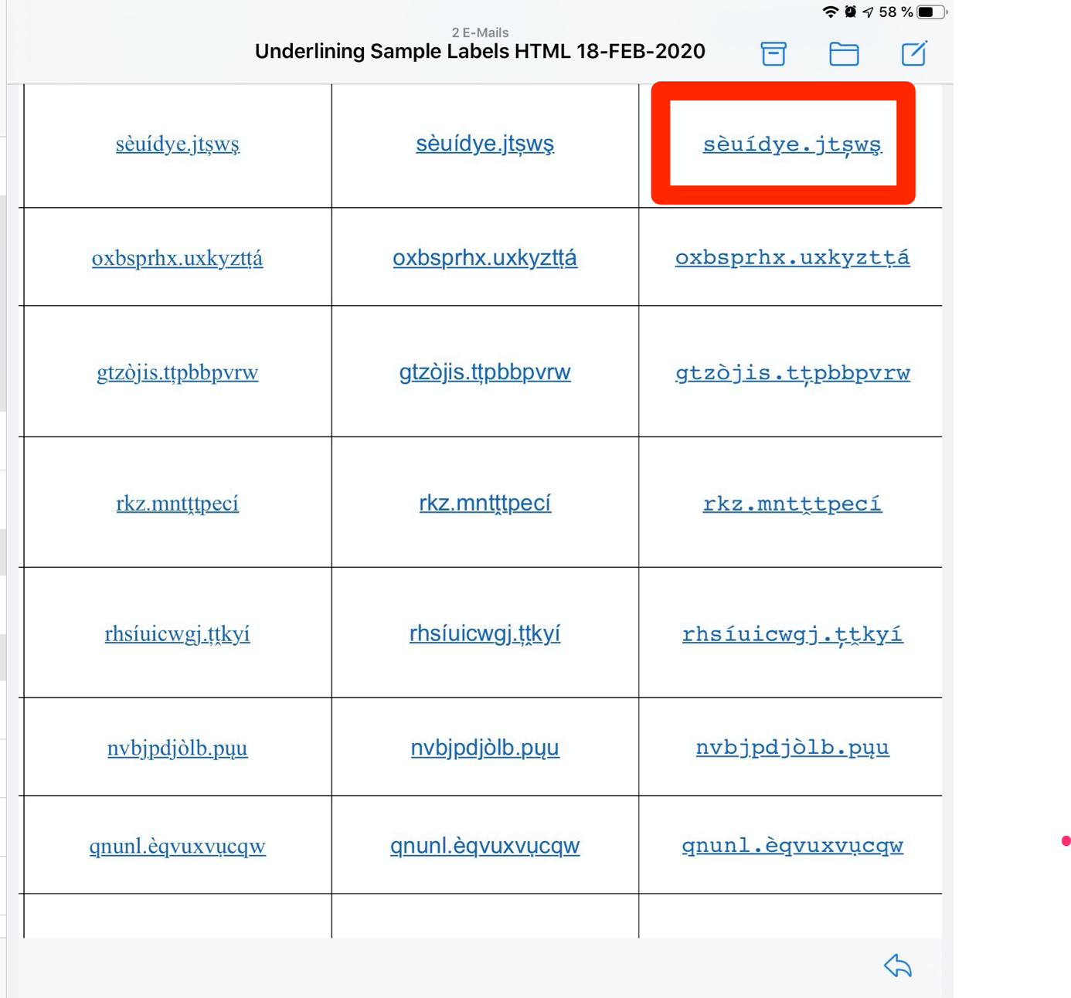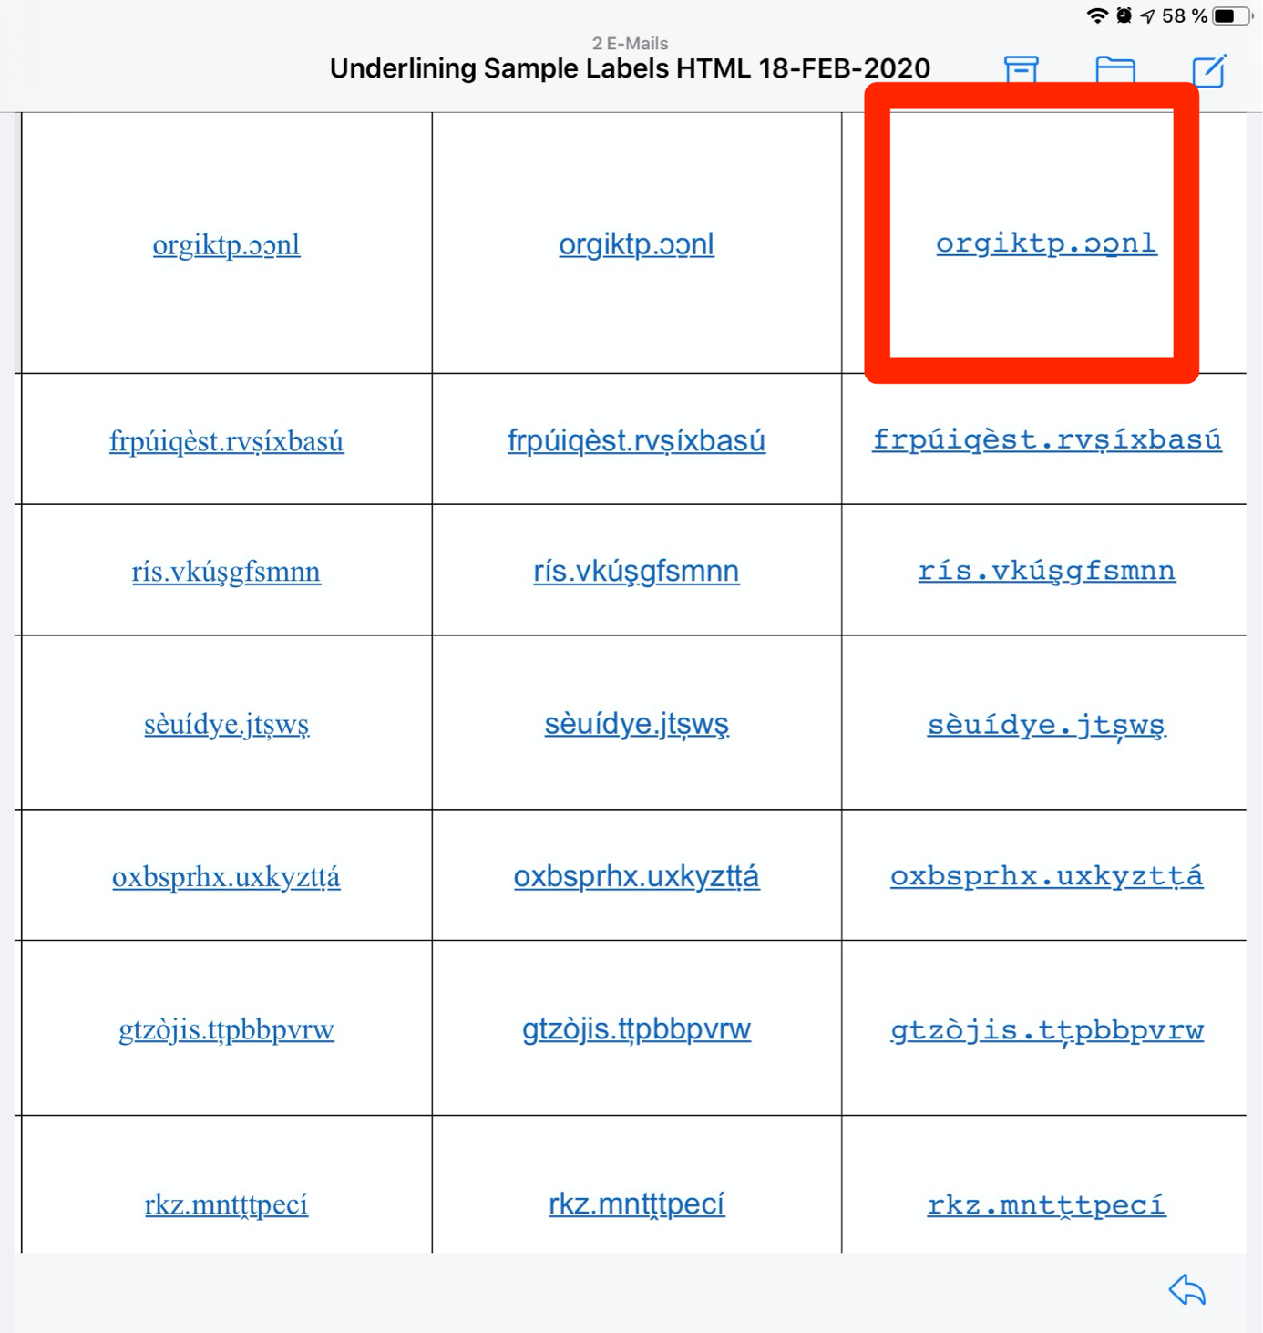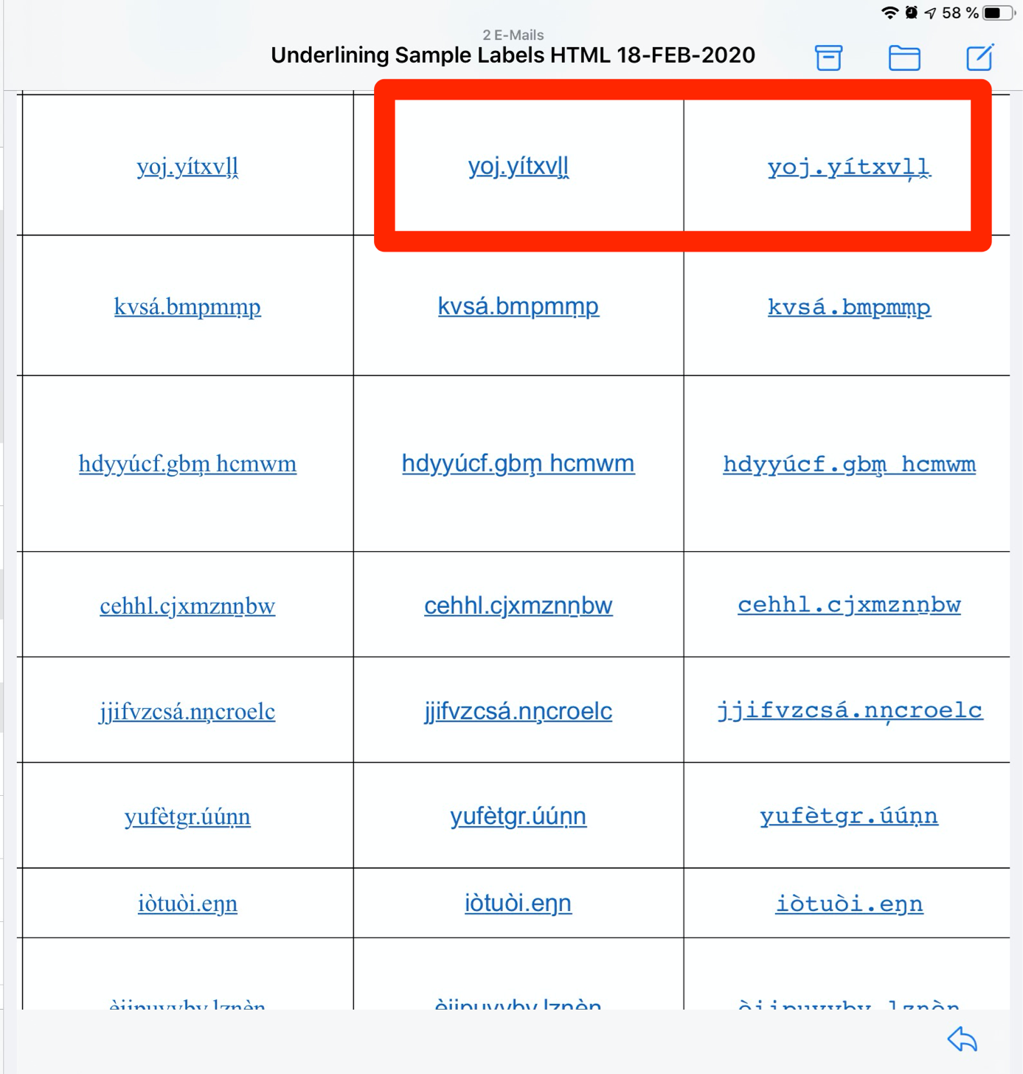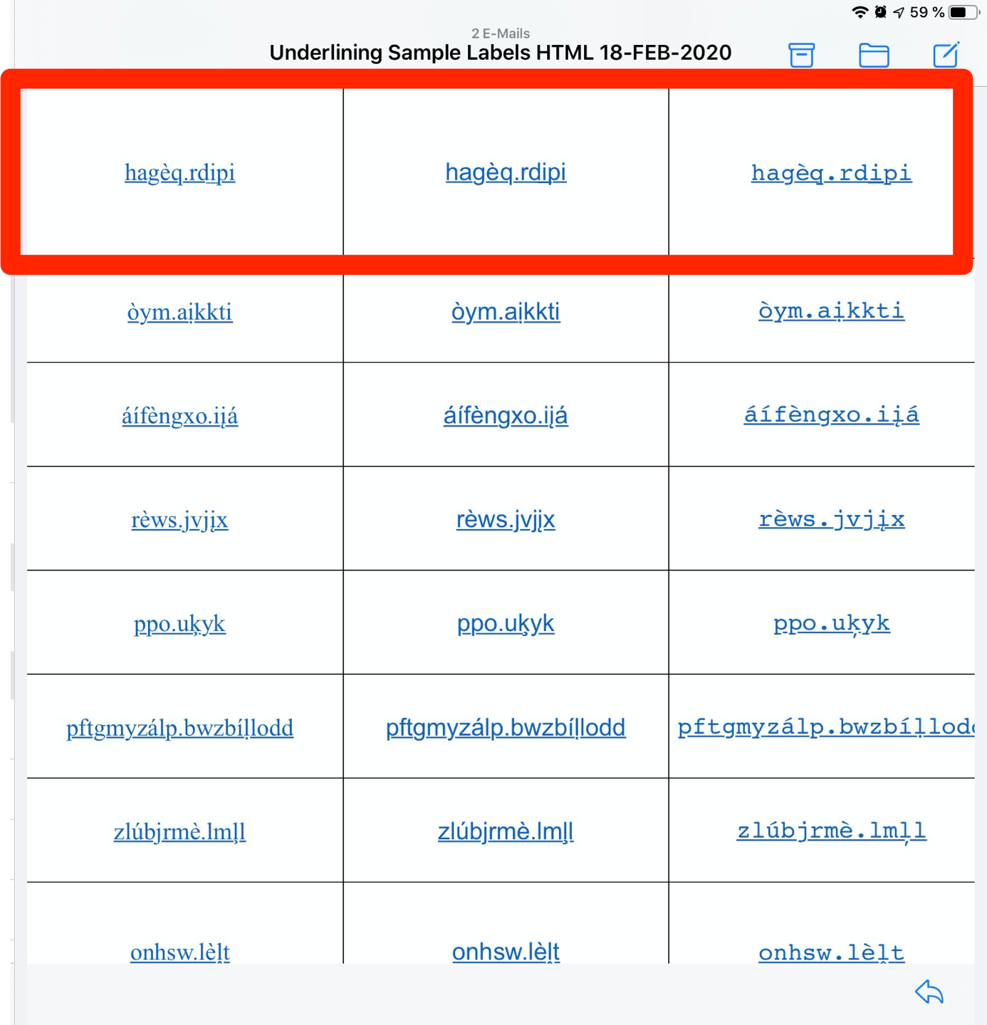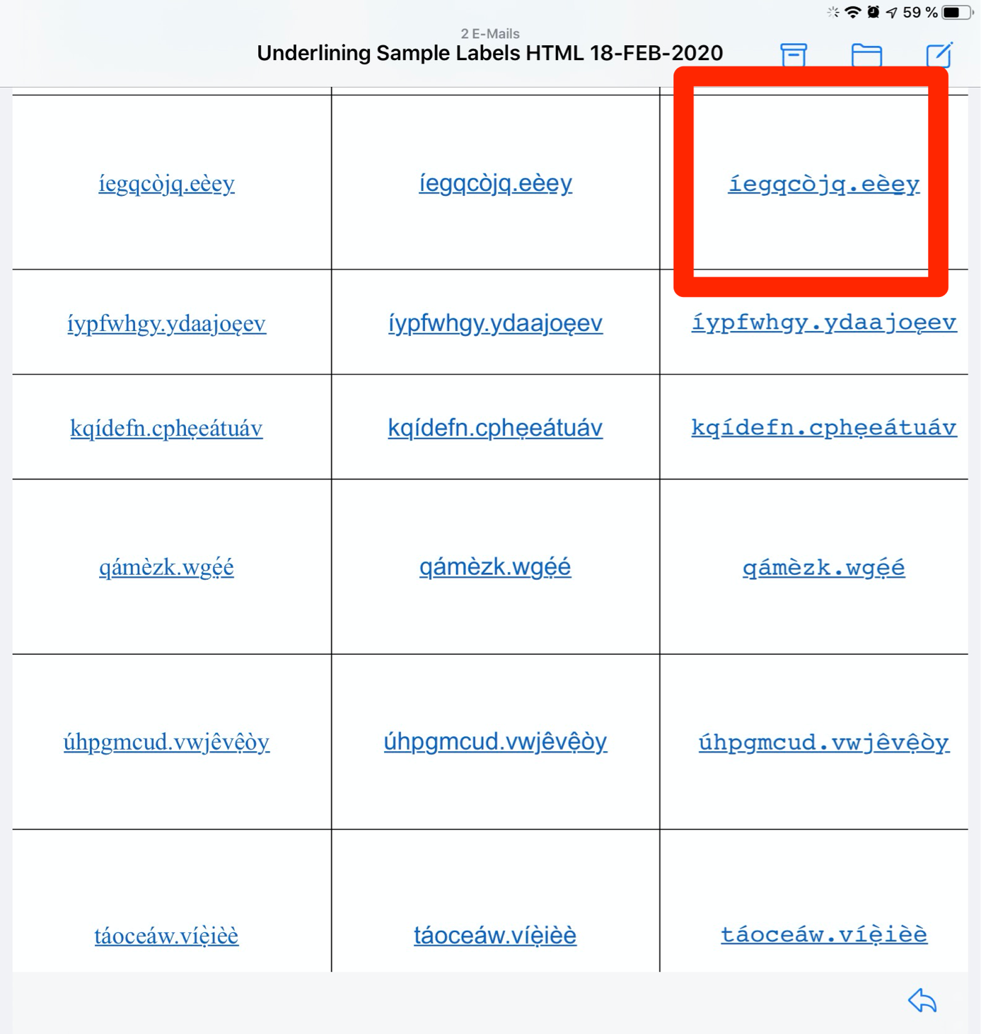
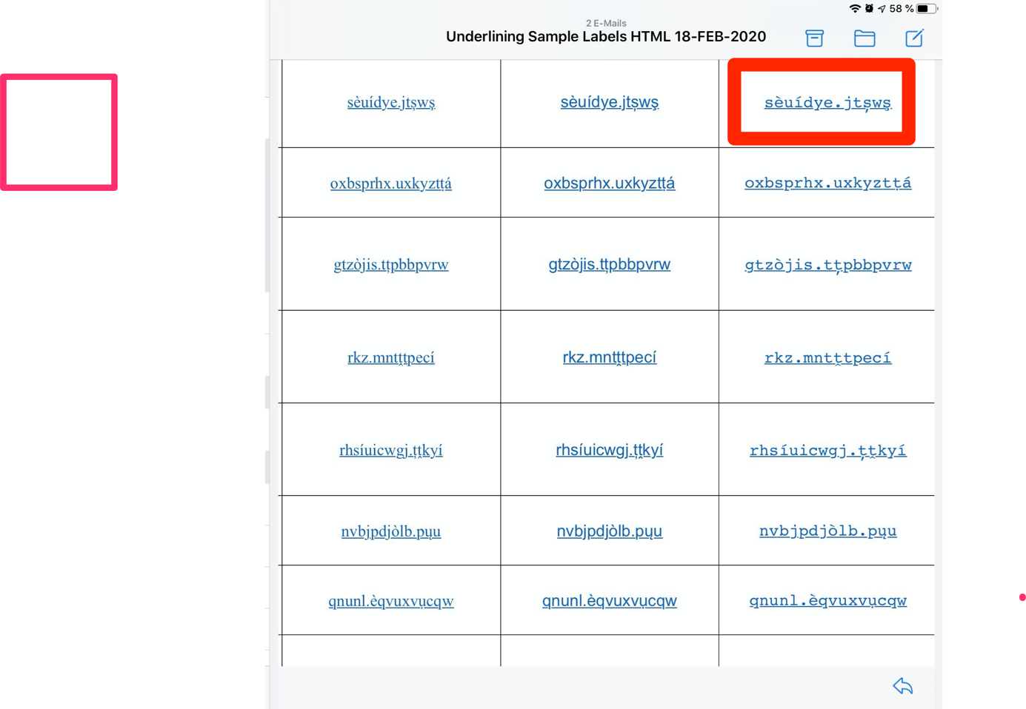
Results:

Generally, underlining is ‘skipped’, however in Courier modifiers below the line overlay with the underline in several cases and irregular shapes of modifiers below the baseline are encountered occasionally in all fonts.

Roundcube on Safari on iOS

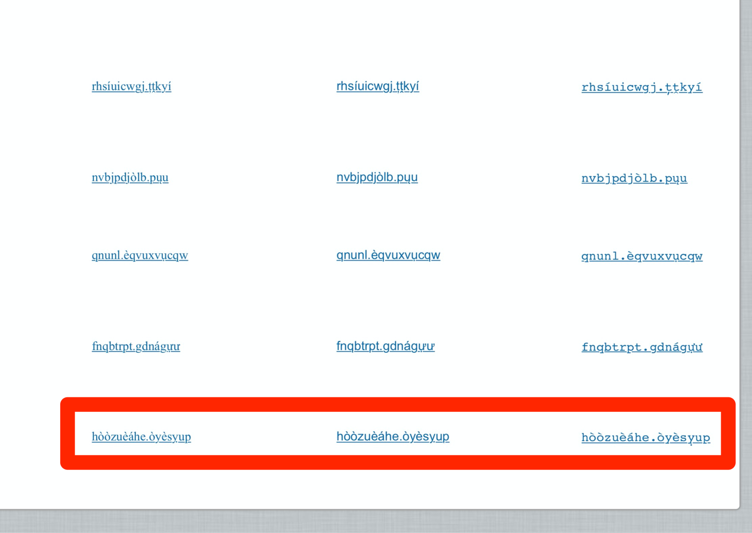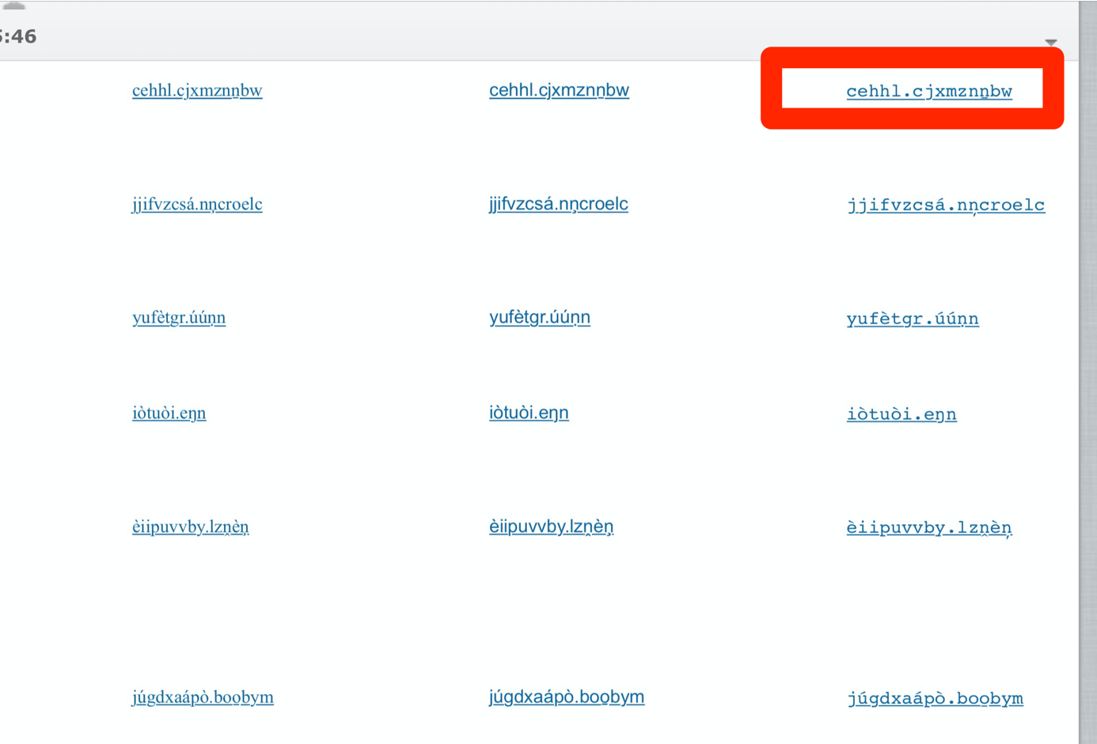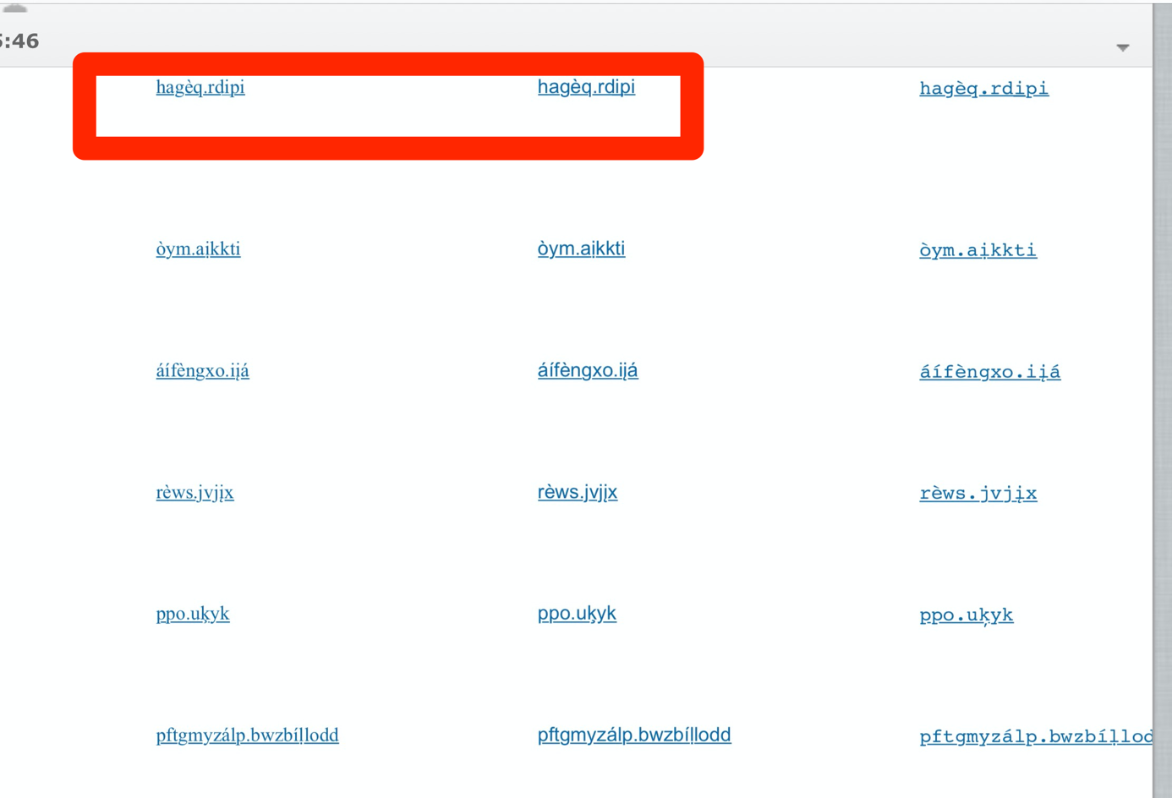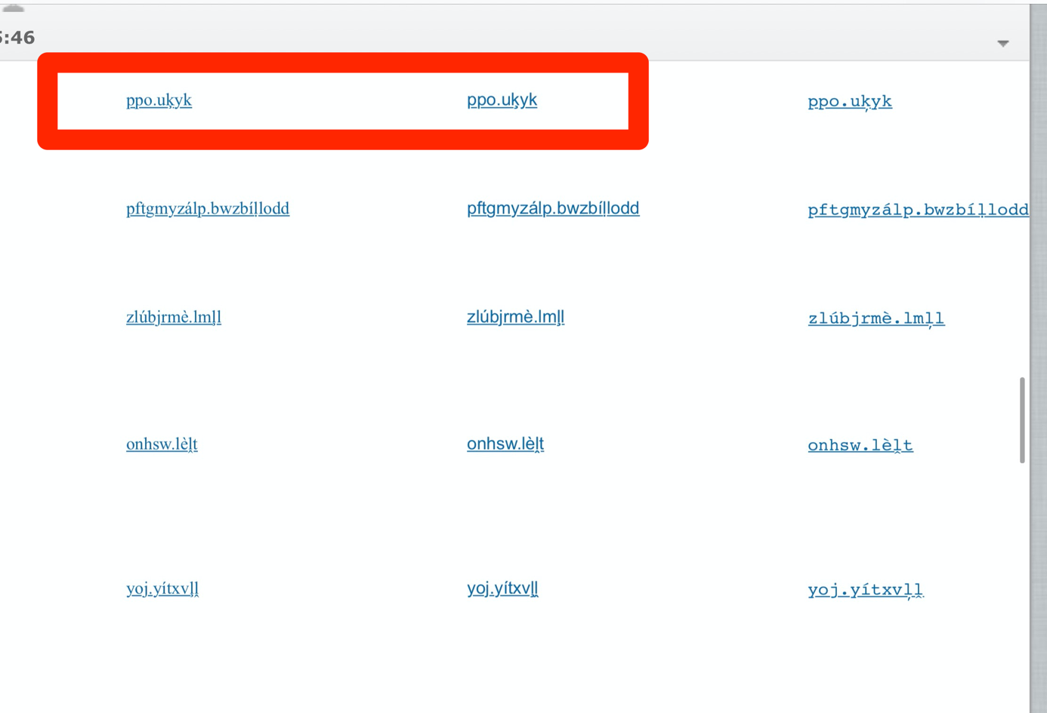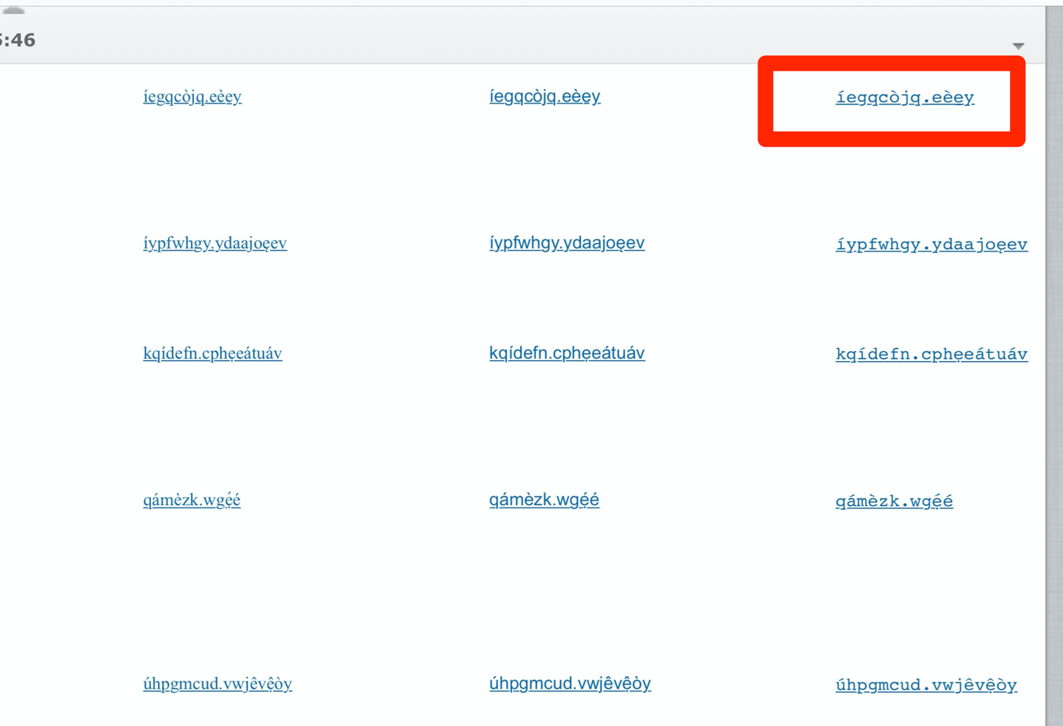

Results:

Generally, underlining is ‘skipped’, however in Courier modifiers below the line overlay with the underline in several cases and irregular shapes of modifiers below the baseline as well as irregular ‘skipping’ of the underlining are encountered occasionally in other fonts.

