Summary

Input &  A-Label | Output | Chrome  Version 83.0.4103.61 (Official Build) (64-bit) | Sarafi  Version 13.1 (15609.1.20.111.8) | Firefox  76.0.1 (64-bit)
zil.test  zil.test | Copy from URL bar and paste | http://zil.test/ | http://zil.test | http://www.zil.test/
zil.test  zil.test | As seen on URL bar | zil.test | zil.test | www.zil.test
zil.test  zil.test | As seen in error message | zil.test | zil.test | www.zil.test
zıl.test  xn--zl-hpa.test | Copy from URL bar and paste | http://xn--zl-hpa.test/ | http://zıl.test | http://www.zıl.test/
zıl.test  xn--zl-hpa.test | As seen on URL bar | zıl.test | zıl.test | www.zıl.test
zıl.test  xn--zl-hpa.test | As seen in error message | zıl.test | xn--zl-hpa.test | www.xn--zl-hpa.test
ZİL.test  xn--zil-9dc.test | Copy from URL bar and paste | http://xn--zil-9dc.test/ | http:// zi̇l.test | http://www.zi̇l.test/
ZİL.test  xn--zil-9dc.test | As seen on URL bar | xn--zil-9dc.test | zi̇l.test | www.zi̇l.test
ZİL.test  xn--zil-9dc.test | As seen in error message | xn--zil-9dc.test | xn--zil-9dc.test | www.xn--zil-9dc.test
ZIL.test  ZIL.test | Copy from URL bar and paste | http://zil.test/ | http://zil.test | http://www.zil.test/
ZIL.test  ZIL.test | As seen on URL bar | zil.test | zil.test | www.zil.test
ZIL.test  ZIL.test | As seen in error message | zil.test | zil.test | www.zil.test

Data shows

Input | Expected Output | Test Result
ZİL.test | zil.test | zi̇l.test (xn--zil-9dc.test)
ZIL.test | zıl.test (xn--zl-hpa.test) | zil.test

Example. In the case of two Turkish words using different letter Is. User can enters a URL with one capitalized form and reach the other website.
Words A-Label Turkish Uppercase
dış (adj., external) xn--d-fka2l DIŞ.TEST
diş (n., tooth) xn--di-gta DİŞ.TEST

Input | Expected Output | Test Result
DIŞ.TEST  external.test | dış.test  (xn--d-fka2l.test)  external.test | diş.test  (xn--di-gta.test)  tooth.test
DİŞ.TEST  tooth.test | diş.test  (xn--di-gta.test)  tooth.test | di̇ş.test  (xn--di-gta90o.test)  N/A.test
Source of Turkish words: https://tureng.com/

Testing Environment Information
- Testing OS: macOS Catalina Version 10.15.4 (19E287)
- Locale setting: tr_TR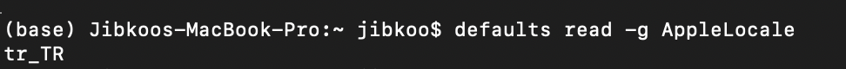
- Chrome for macOS: Version 83.0.4103.61 (Official Build) (64-bit)
- Safari for macOS: Version 13.1 (15609.1.20.111.8)
- Firefox for maxOS: 76.0.1 (64-bit)

A-Label
IDNA conversion https://www.punycoder.com/
User Input  Copy and Paste into “Text” box, then “Convert to Punycode” | zil | zıl | ZİL | ZIL
Output  Register output string in “Punycode” box | zil | xn--zl-hpa | xn--zil-9dc | ZIL

Screenshots
- Chrome

User Input  Copy and Paste in URL address Bar | zil.test | zıl.test | ZİL.test | ZIL.test
Output URL Bar  Register returned label in address bar | http://zil.test/ | http://xn--zl-hpa.test/ | http://xn--zil-9dc.test/ | http://zil.test/
Output  As seen on URL bar | zil.test | zıl.test | xn--zil-9dc.test | zil.test
Output  As seen in error message | zil.test | zil.test | xn--zil-9dc.test | zil.test

Press Enter

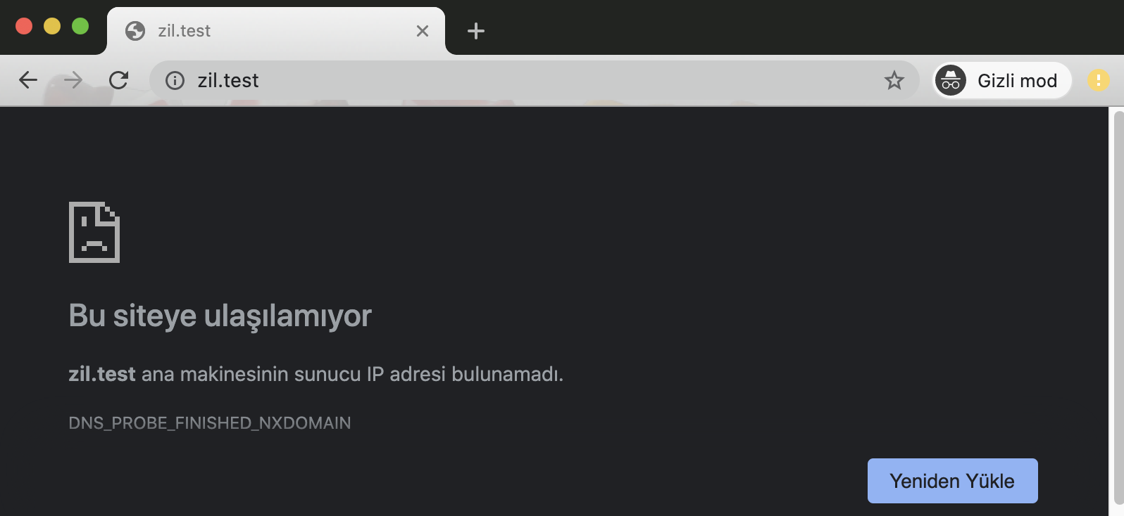
Figrue 1.1 Chrome output of zil.test

Press Enter

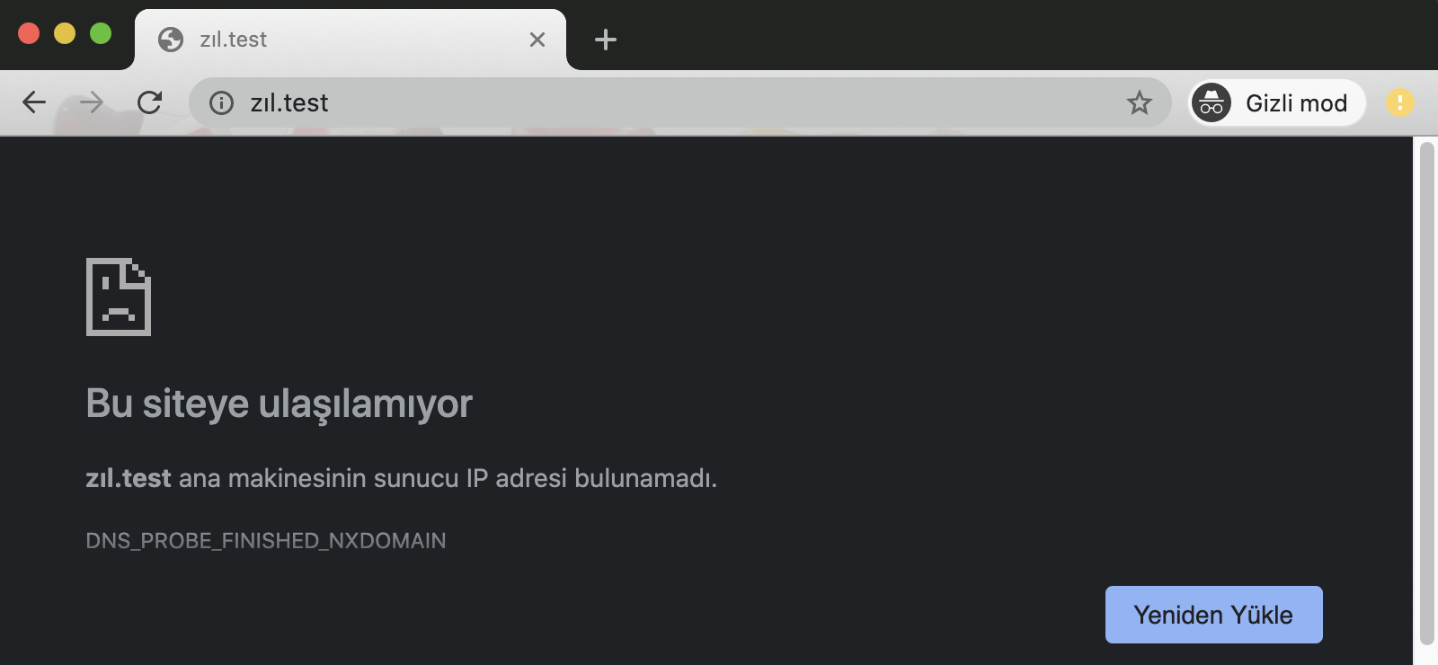
Figrue 1.2 Chrome output of zıl.test

Press Enter

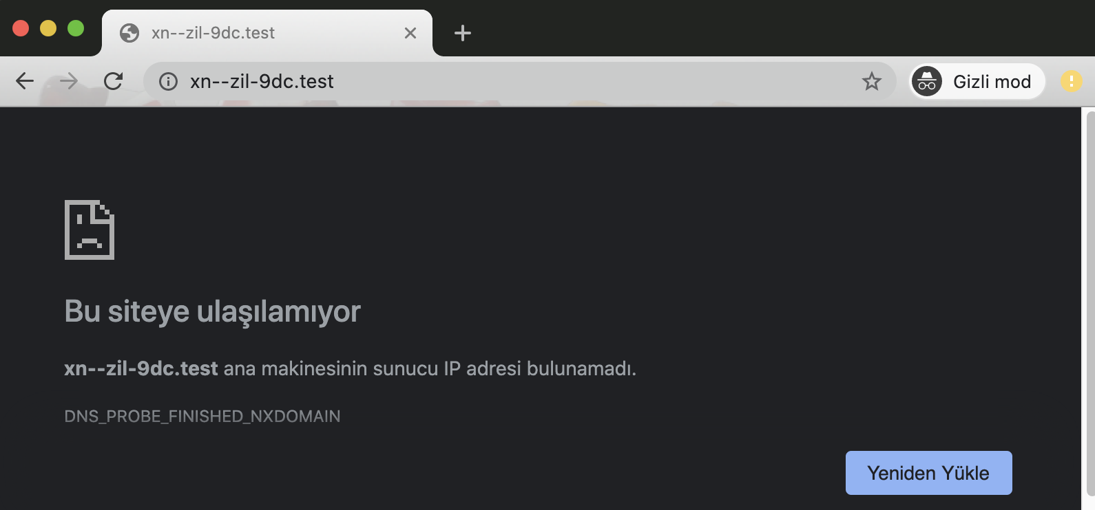
Figrue 1.3 Chrome output of ZİL.test

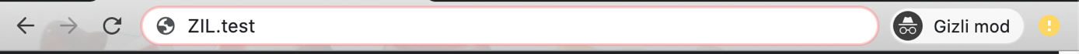
Press Enter

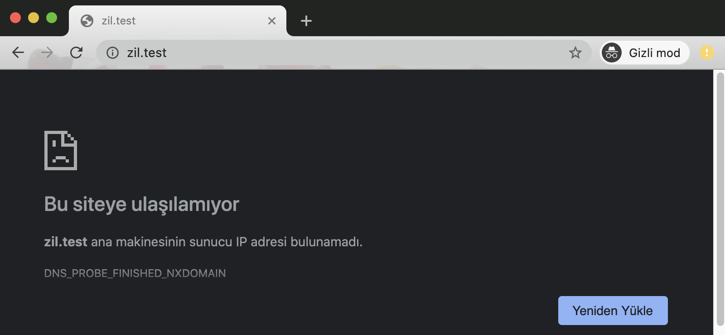
Figrue 1.4 Chrome output of ZIL.test

- Safari

User Input  Copy and Paste in URL address Bar | zil.test | zıl.test | ZİL.test | ZIL.test
Output URL Bar  Register returned label in address bar | http://zil.test | http://zıl.test | http://zi̇l.test | http://zil.test
Output  As seen on URL bar | zil.test | zıl.test | zi̇l.test | zil.test
Output  As seen in error message | zil.test | xn--zl-hpa.test | xn - zil-9dc.test | zil.test

Press Enter

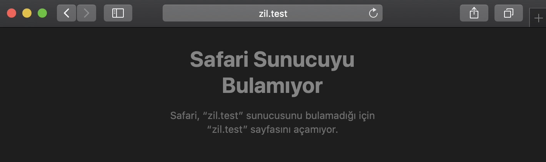
Figrue 2.1 Safari output of zil.test

Press Enter

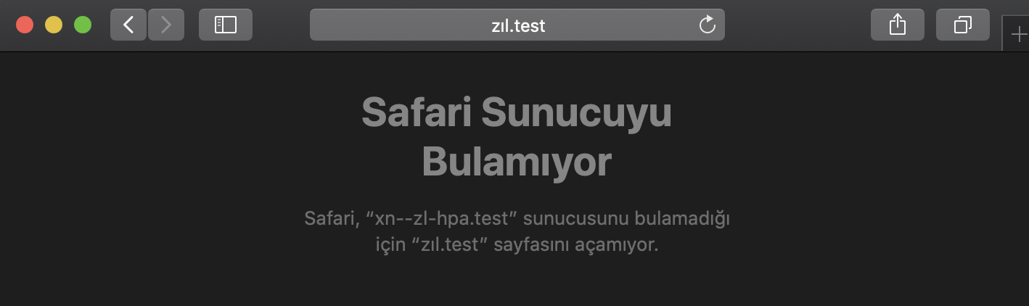
Figrue 2.2 Safari output of zıl.test

Press Enter

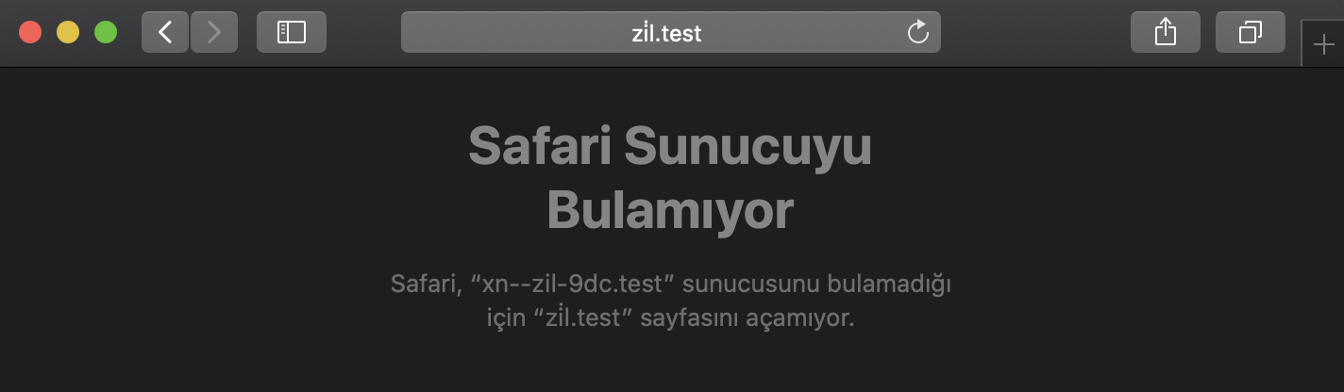
Figrue 2.3 Safari output of ZİL.test

Press Enter

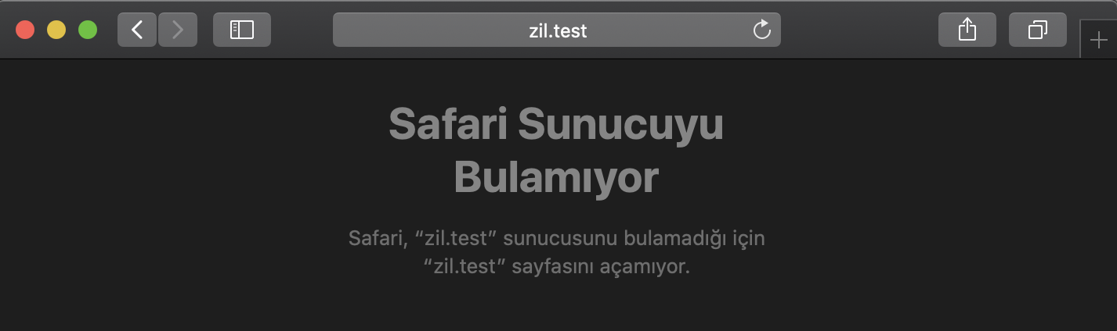
Figrue 2.4 Safari output of ZIL.test

- Firefox

User Input  Copy and Paste in URL address Bar | zil.test | zıl.test | ZİL.test | ZIL.test
Output URL Bar  Register returned label in address bar | http://www.zil.test/ | http://www.zıl.test/ | http://www.zi̇l.test/ | http://www.zil.test/
Output  As seen on URL bar | www.zil.test | www.zıl.test | www.zi̇l.test | www.zil.test
Output  As seen in error message | www.zil.test | www.xn--zl-hpa.test | www.xn--zil-9dc.test. | www.zil.test

Press Enter

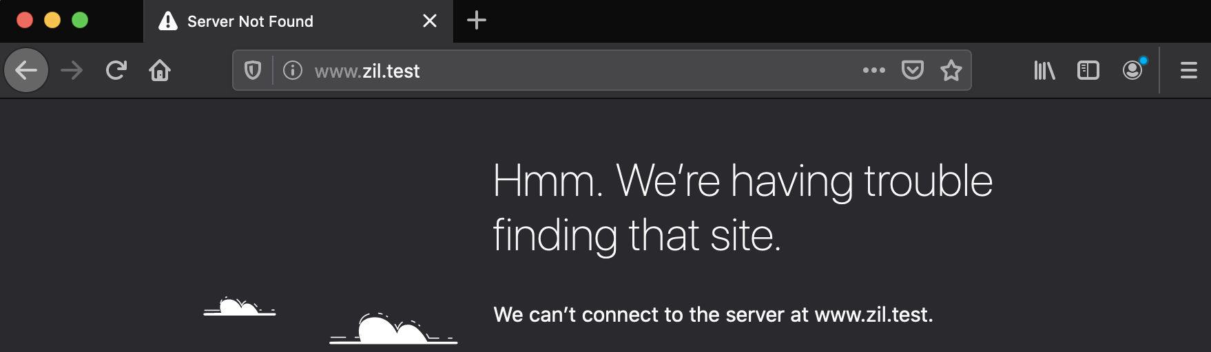
Figrue 3.1 Firefox output of zil.test

Press Enter

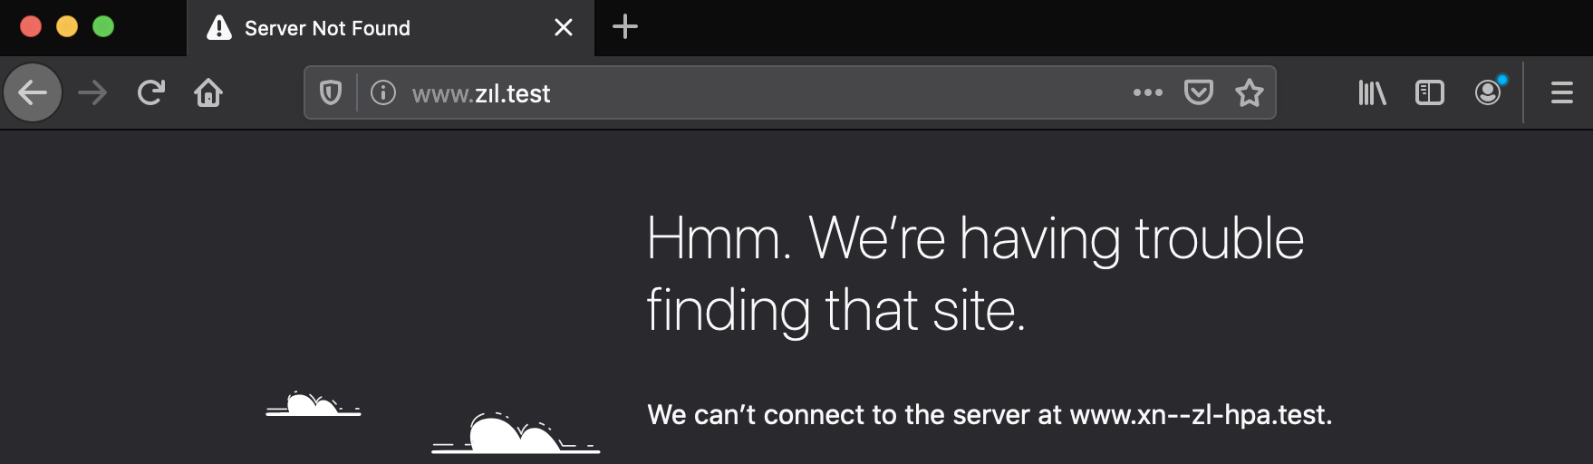
Figrue 3.2 Firefox output of zıl.test

Press Enter

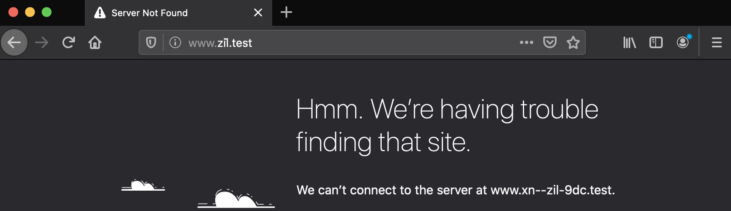
Figrue 3.3 Firefox output of ZİL.test

Press Enter

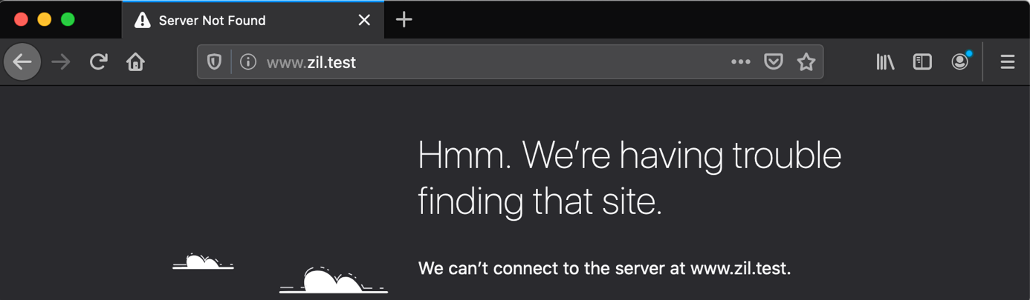
Figrue 3.4 Firefox output of ZIL.test

