Chrome Version 80.0.3987.132 on Windows 10 Version 1903 (18362.720)

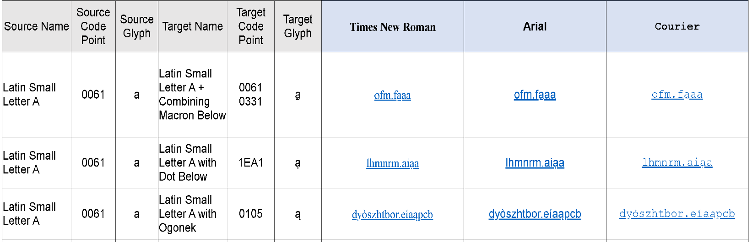

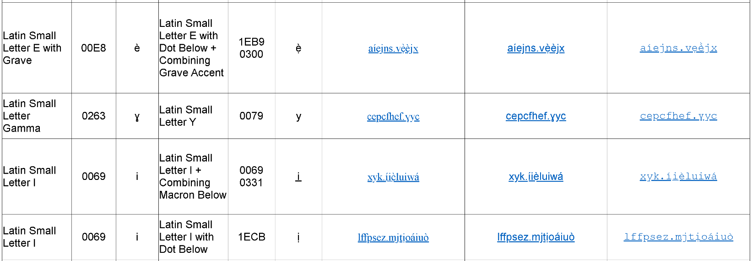

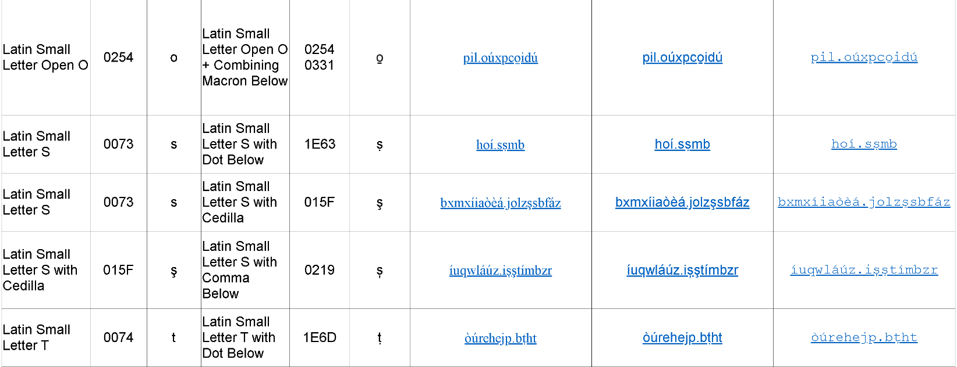

Latin Small Letter Gamma and Latin Small Letter Y not distinguishable in Courier font.
Latin Small Letter S with Cedilla and Latin Small Letter S with Comma Below are not distinguishable.

Yahoo Mail App Version 6.2.4 on Android Version 7.1.1

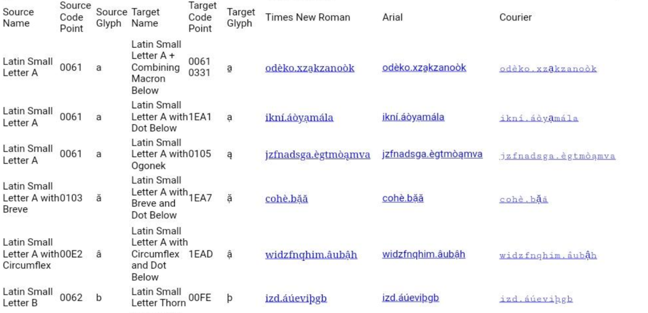

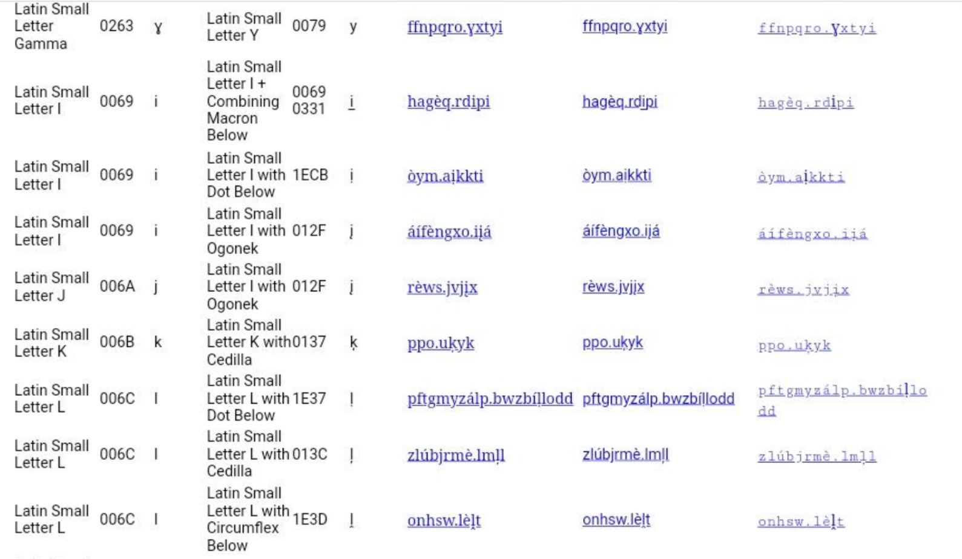

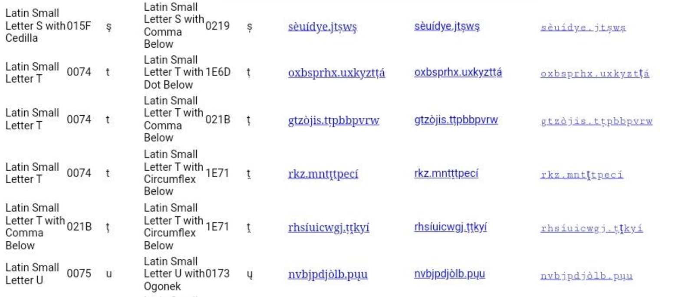

Latin Small Letter Gamma and Latin Small Letter Y are not distinguishable in Courier font.
Latin Small Letter J and Latin Small Letter I with Ogonek are not distinguishable.
Latin Small Letter S with Cedilla and Latin Small Letter S with Comma Below are not distinguishable.

Gmail on Chrome Version 80.0.3987.132 on Windows 10 Version 1903 (18362.720)

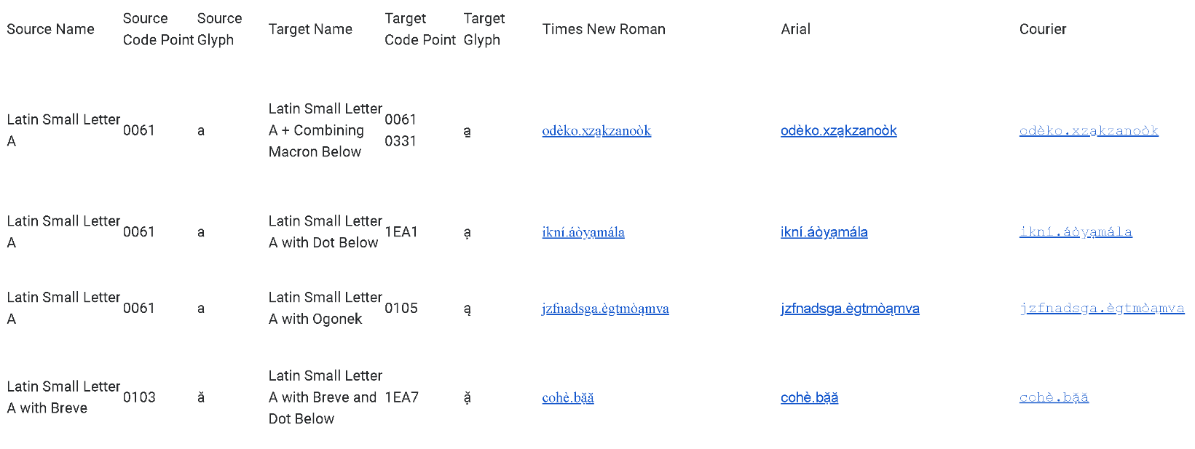

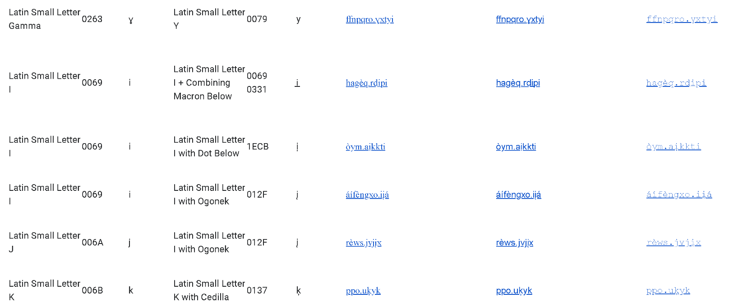

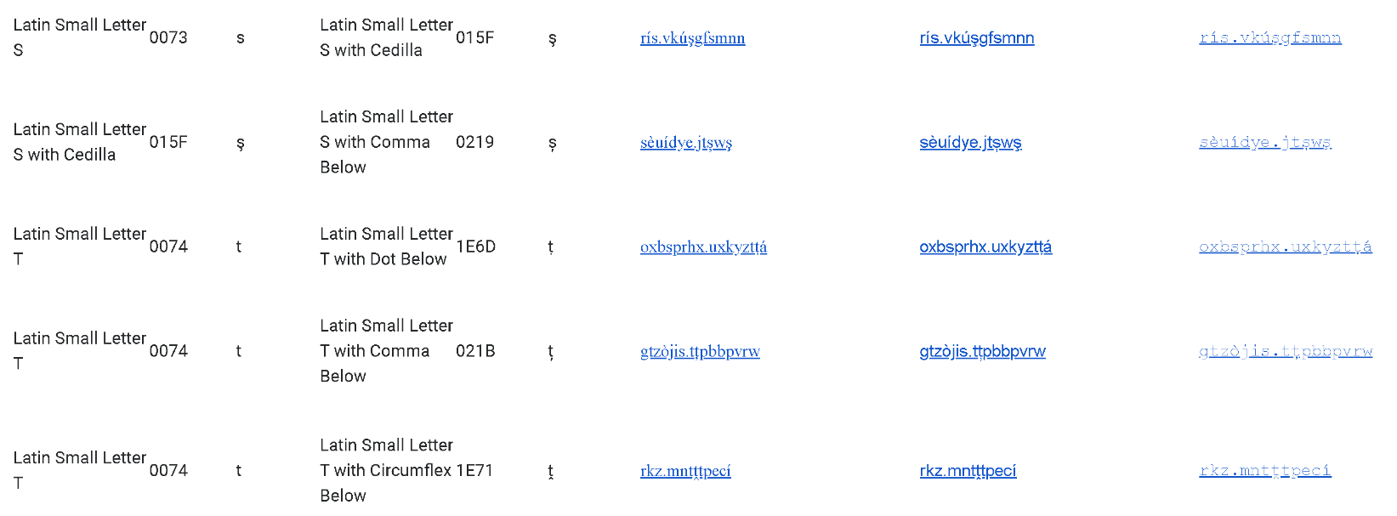

Latin Small Letter Gamma and Latin Small Letter Y are not distinguishable.
Latin Small Letter J and Latin Small Letter I with Ogonek are not distinguishable.
Latin Small Letter S with Cedilla and Latin Small Letter S with Comma Below are not distinguishable.

Yahoo mail on Chrome Version 80.0.3987.132 on Windows 10 Version 1903 (18362.720)

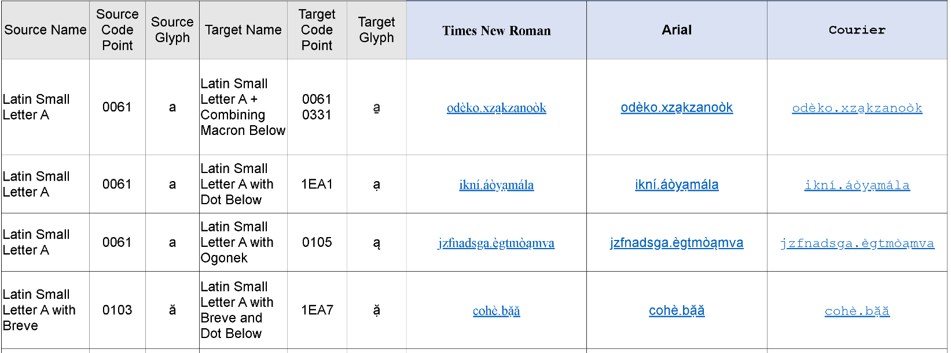
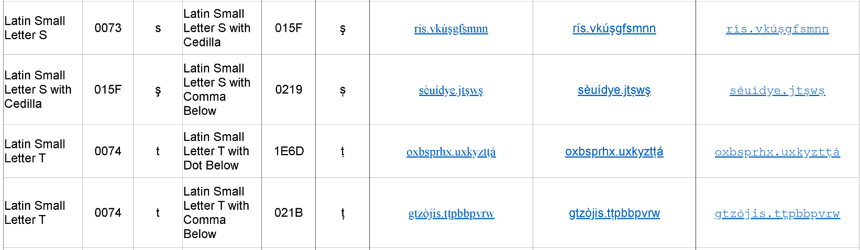

Latin Small Letter S with Cedilla and Latin Small Letter S with Comma Below not distinguishable.

Yahoo mail on Firefox 74.0 (64 bit) on Windows 10 Version 1903 (18362.720)

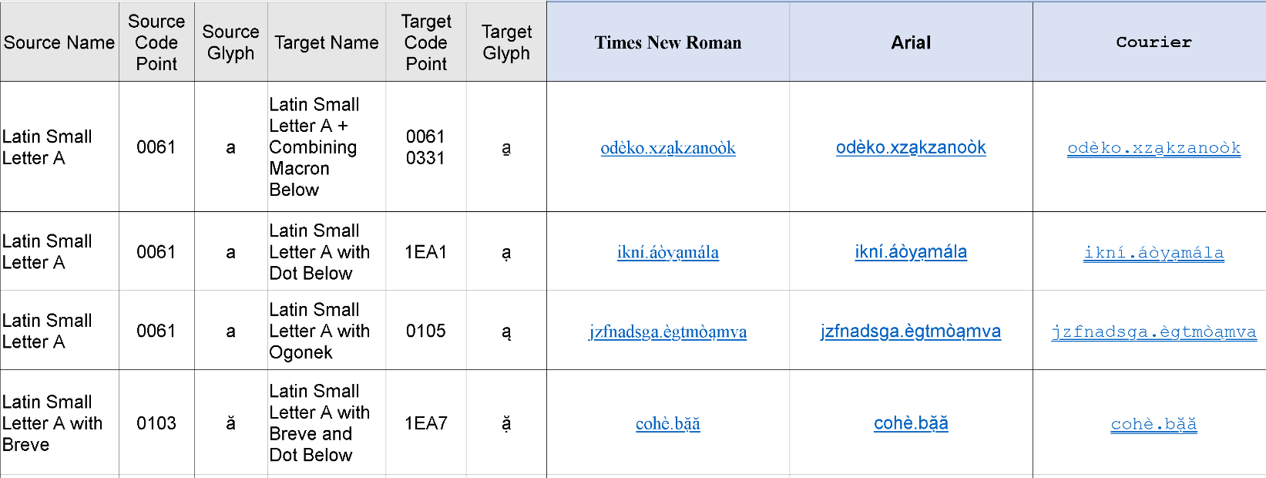

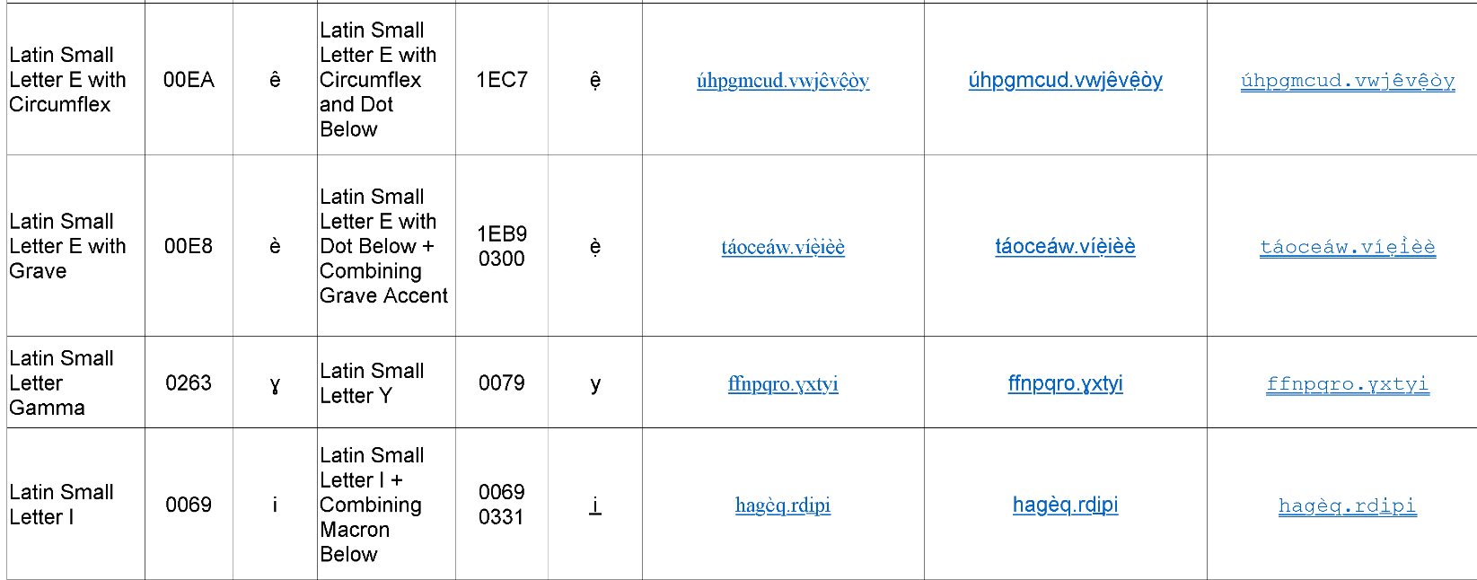

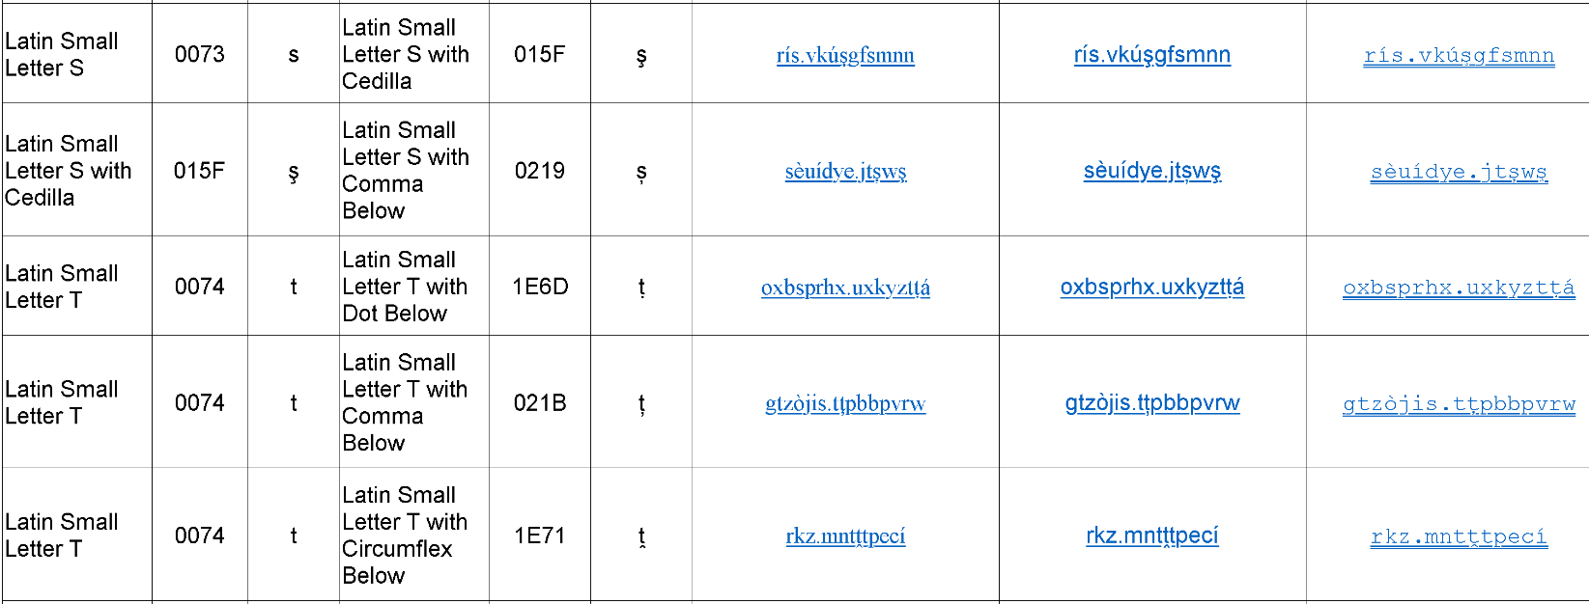

Latin Small Letter Gamma and Latin Small Letter Y not distinguishable.
Latin Small Letter S with Cedilla and Latin Small Letter S with Comma Below not distinguishable.

NOTE: Courier font produces a double underline. As a result, below-the-line diacritics are generally indistinguishable.

