Dear NPOC Communnity,

I was thinking, what things I can show you, to know more about me.
And I imagine, the best I can show is what was the activity and commitment with policies into ICANN environment in the first round of New gTLDs time.

So, I decide to do a brief resume on my participations on that time, what gave me an enormous experience, experience what I want to give to add to the policy coordinator position, if you finally vote by me.

On this order, and because I didnt remember my participations, I ask to the AI the follow question:
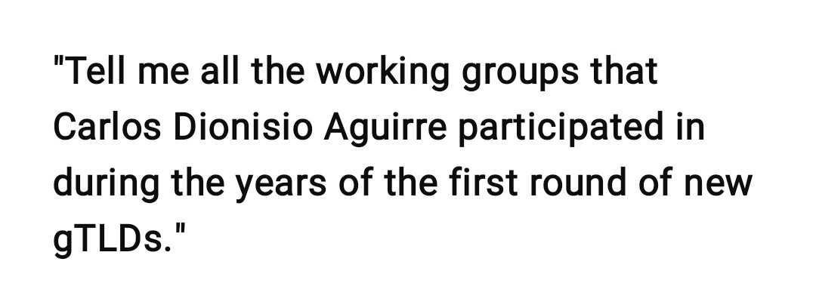

My surprise was the answer to this question :

Carlos Dionisio Aguirre actively participated in various ICANN working groups during the years of the first round of new gTLDs (2008–2012). His experience focused on representing end users and developing policies related to the expansion of the domain name system. Below are the groups in which

he was involved:

Working Groups and Key Roles

1. New gTLD Working Group (WG)
Aguirre was an active member of this group, which addressed critical issues such as morality and public order (MAPO) in the evaluation process for new gTLD applications. He participated in discussions on process transparency and the need to avoid confusion among end users.

2. Joint Applicant Support Working Group (JAS WG)
This group focused on developing support mechanisms for new gTLD applicants from underserved or developing communities. Aguirre

actively contributed to the group’s discussions and recommendations.

3. ALAC – NCUC Liaison
As a liaison between the At-Large Advisory Committee (ALAC) and the Non-Commercial Users Constituency (NCUC) of the GNSO, Aguirre facilitated communication and coordination between these bodies, ensuring that end-user concerns were considered in policy development.

4. Chair of the Participation and Engagement Working Group
In this role, Aguirre led initiatives to increase participation and engagement of the At-Large community in ICANN processes.

5. GNSO Councilor (2011–2012)
Appointed by the Nominating Committee (NomCom), Aguirre served as a GNSO councilor, participating in the oversight and development of policies related to new gTLDs.

6. GNSO Policy Implementation Drafting Team
Aguirre was part of this team responsible for drafting policies for the effective implementation of GNSO decisions, including those related to new gTLDs.

7. Consumer Trust, Consumer Choice and Competition Working Group
This group evaluated the impact of new gTLDs on consumer trust, choice, and competition. Aguirre contributed his

perspective on these key areas.

8. ICANN Academy Working Group
He participated in this group dedicated to training and capacity building within the ICANN community, promoting a deeper understanding of processes and policies.

9. ALAC Capacity Building Steering Committee
As a member of this committee, Aguirre helped design and oversee programs aimed at strengthening the skills and knowledge of At-Large participants.

10. LACRALO Capacity Building Initiative
As a member of LACRALO, Aguirre supported capacity-building initiatives in the Latin America and Caribbean region,

promoting more effective participation in ICANN processes.

In addition to these roles, Aguirre has been a strong advocate for civil society inclusion in Internet governance, representing organizations such as AGEIA DENSI and ADIAR. His participation in more than 30 international ICANN meetings underscores his commitment to the global Internet community.

Well, I expect now you are sure what kind of candidate I am and you feel your vote is a vote for a better future of NPOC.

Carlos Dionisio Aguirre.
Professor of "Economy" and "Internet Law and Economy" at Law School of Córdoba's National University.

