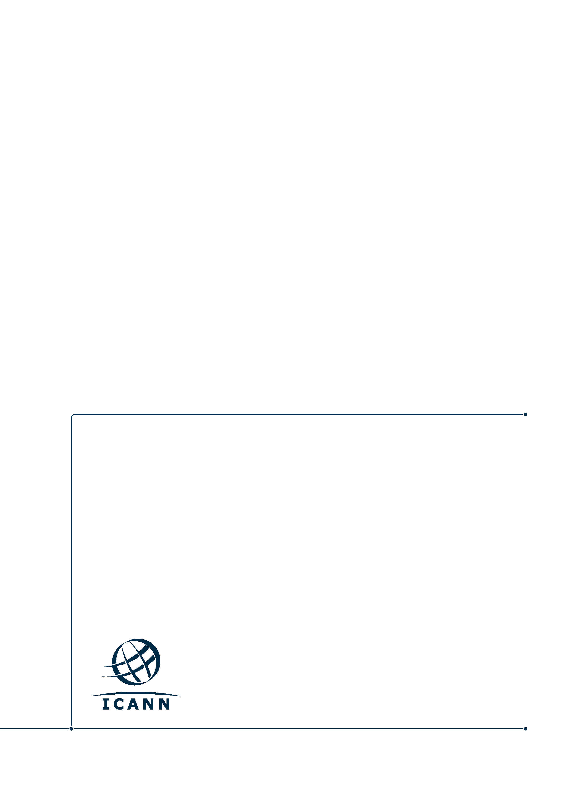
Proposed Subgroup Report Structure
Insert subtitle here (75 characters maximum)
Name
[XX Month Year]

Table of Contents
1 Topic 3
2 Summary of Relevant Research 3
3 Analysis & Findings 3
4 Problem/Issue 3
5 Recommendations 3

Topic
[Introduce objective and explain why it was considered.]

Summary of Relevant Research
[Include methodology that was employed, list of relevant materials, briefings received, reading, input from meetings (as appropriate)]

Analysis & Findings
[Provide overview of Review Team Findings (including materials of reference).]

Problem/Issue
[What observed fact-based issue is the recommendation intending to solve? What is the “problem statement”?]

Recommendations
Recommendation: xxx

Findings: [what are the findings that support the recommendation]

Rationale:
[What is Intent of recommendation and envisioned outcome?
How did the finding lead to this recommendation?
How significant would impact be if recommendation not addressed?
Is it aligned with ICANN’s Strategic Plan and Mission?
Is it in compliance with scope Review Team set?]

Impact of Recommendation: [What are the impacted areas, e.g. security, transparency, legitimacy, efficiency, diversity etc. Which group/audience will be impacted by this recommendation]

Feasibility of Recommendation: [Document feasibility of recommendation]

Implementation:
[Who are responsible parties that need to be involved in implementation? Community/ICANN org/combination)
What is the target for a successful implementation?
Is related work already underway and how will that dovetail with recommendation?
What is the envisioned implementation timeline? Within 6 months/12 months/more than 12 months]

Priority: [If only 5 recommendations could be implemented due to community bandwidth and other resource constraints, would this recommendation be one of the top 5? Why or why not?]

Consensus:

