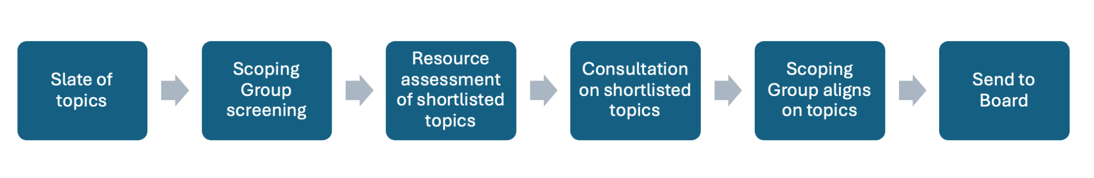
The Scoping Group comprises SO/AC leadership teams (to be more specifically defined), plus Board and staff/org representation.

- Slate of topics - SO/AC Leadership reaches out to its SO/ACs requesting suggestions of topics for ATR. Each SO and AC can use their own process to solicit topics (e.g. SO could set up an ATR topic working group). Any suggested topic should be documented with rationale. Each SO or AC leadership settles on a slate of topics they believe have consensus in their SO or AC.

- Scoping Group screening - SO/AC leaders bring their slates. Using transparent deliberations, and assisted by org, Scoping Group meets to review and rationalize the topics. Overlapping topics streamlined and tested against the following criteria to create a shortlist:
  - In scope of ICANN’s Mission as defined in Bylaws
  - No duplication of existing work or initiative
  - Not a topic for policy development
  - Topic defined with enough precision to define what would be reviewed
  - Feasibility, (e.g. is data available, are there any dependencies?)
  - In the public and collective interest

- Resource assessment of shortlisted topics - Scoping Group together with additional org input where required assess the level of effort required to review the shortlisted topics, including expertise or skills that would be desirable for each, the need for professional services, budget and timing constraints. Depending on resourcing parameters, the set of topics could be affected.

- Consultation on shortlisted topics - SO/AC Leaders solicit comments on shortlisted topics from their SO/AC and report back to the Scoping Group.

- Scoping Group aligns on topics (threshold to be discussed) - Using transparent deliberations, Scoping Group agrees on the final set of topics.

- Send to Board - List of topics is sent to the Board for action.

