[Letter head – WHOIS Review Team]
[date]

To: ICANN Compliance
Admiralty Way
Marina del Rey
CA

Dear Compliance Team

ICANN’s compliance effort, detailed feedback
Over the past 12 months, the WHOIS Review Team (formed pursuant to the Affirmation of Commitments) has been engaged in assessing the extent to which ICANN’s existing WHOIS policy and its implementation is effective, meets the legitimate needs of law enforcement and promotes consumer trust.
As part of that exercise, we have looked closely at the work of the Compliance Team, and have greatly appreciated your willingness to engage positively in this exercise.
We have met on a number of occasions (detailed in appendix 1 to this letter), most recently in Dakar, October 2011. During that meeting, we gave some detailed feedback on our findings and impressions to date. We discussed that, for the purposes of our published report, much of this feedback and suggested improvements would be too detailed for inclusion. Our aim in the report will be to keep our recommendations reasonably high level so that it is straightforward for the community to monitor progress against targets, and that the operational detail of how to implement various recommendations be left to those charged with making the improvements.
However, we discussed that it might be helpful for your programme of continual improvement to have our detailed feedback, and suggestions for improvements. This letter will be appended to our published report, but it is emphasised that the suggestions here are for your own management purposes. They do not form the recommendations of the WHOIS Review Team.
This letter is structured as follows:
- It sets the scene with some high level comments and observations
- It reviews your operating principles
- It provides an inventory of the ICANN compliance team’s activities as reported in their web pages (ie the view available to interested stakeholders), and by the compliance team themselves.
- It highlights gaps between the compliance team’s stated objectives (embodied in its operational plan) and its implementation
- It suggests some actions and priorities that may be undertaken in order to effect improvements.
It should be noted that much of our analysis was done in the summer of 2011. From our most recent interactions, we understand that you have already identified areas for improvement, and started to implement them. For example, we note that the web site experience has now changed. However, we have retained our analysis as a snapshot at a point in time, against which improvements can be measured.

Some high level comments
In order for a policy to be effective, it must not only be implemented, but also communicated effectively. Communication of policy is important because it feeds a public awareness of the norms and standards expected. Without effective communication, the legitimate expectations of the distinct stakeholder groups who rely on WHOIS will remain unmanaged, leading to sometimes unnecessary conflict, or complaints.
Our analysis of your website, and the effectiveness of your programme endorsed what you yourselves told us – ICANN’s compliance effort has historically been overstretched, and under resourced. It has struggled to obtain priority (in terms of strategy, budget or visibility) within the organisation, and to fill vacant positions.
As we are poised for the launch of new gTLDs, bringing a larger landscape, and new actors, this is a matter of deep concern to the WHOIS Review Team, which the entire community should share. For industry self-regulation to continue, it should be effective, impartial and seen to be so.

Compliance – operating principles
We have based our analysis around your operating principles, which are:
- Work constructively with registrars and registries to foster a culture of compliance.
- Proactively monitor compliance by contracted parties
- Resolve contractual compliance matters informally, if appropriate
- Aggressively pursue cases of non-compliance
- Maintain the highest standards of integrity and professionalism
- Continue to develop and enhance procedures for consistent handling of compliance matters
- Analyse WDPRS reports and consumer complaint data to analyse trends
- Provide timely reporting of Contractual Compliance activities
The principles themselves are strong, and sensible. They emphasise partnership with registries and registrars, as well as fostering a culture of compliance – the softer, normative controls which are essential in situations where the responsibility for a successful outcome is spread across a number of organisations, through to the individual registrant.
The use of jargon and operational detail is out of place in such a high level statement. We therefore suggest that you review the 7th principle, and provide for a more high level description of your aims in relation to responding to consumer complaints.
Overall, we recommend that the operating principles form the basis for your strategic planning, communication, and allocation of resources. If internalized through staff training, they will also provide a roadmap to empower staff and decentralize decision-making on the front-line.

Inventory of compliance activity

What do the public see? ICANN’s website
In reviewing the effectiveness of ICANN’s implementation of WHOIS policy, the WRT considered what a member of the public, or other interested stakeholder would learn from ICANN’s website.
In general, strengths are the publication of the compliance team’s operating place, reports of its activities, and of studies on Data Accuracy and Privacy/Proxy.
Areas for improvement are that locating information is extremely difficult: compliance pages are hidden away, heavy with jargon (eg WDPRS), and assume a level of knowledge by users which may not exist in practice. The home compliance page is a jumble of news links, mixed in with explanatory pages, and a user has to scroll down the page to find out what the compliance team is.
While the presentation of the pages may be thought of secondary importance compared to the work of the team itself, the WRT heard from compliance team staff that users tended to ‘misunderstand’ their role, what they could and could not do.

Detailed comments on the website as at July 2011
Our review of the ICANN website in July 2011 found that it is difficult to locate the pages relating to contractual compliance from the home page:

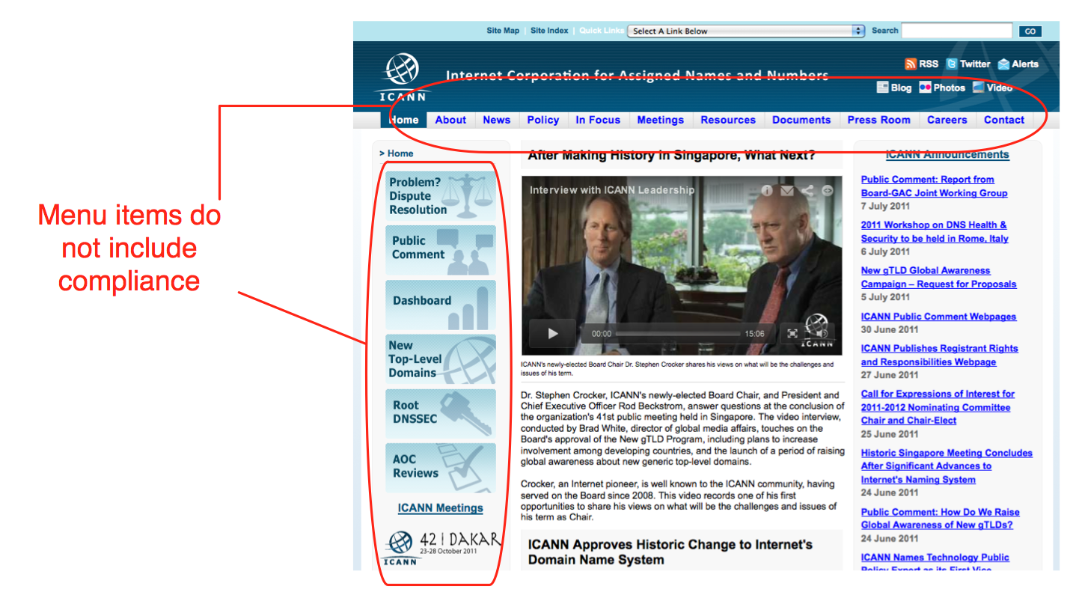
A user can find the contractual compliance pages in two ways: first by following the “In focus” link (whose contents are not obvious from the label) from the top menus, and finding contractual compliance amongst an alphabetical list of ICANN’s activities; second, by following a single link located at the bottom of the home page:

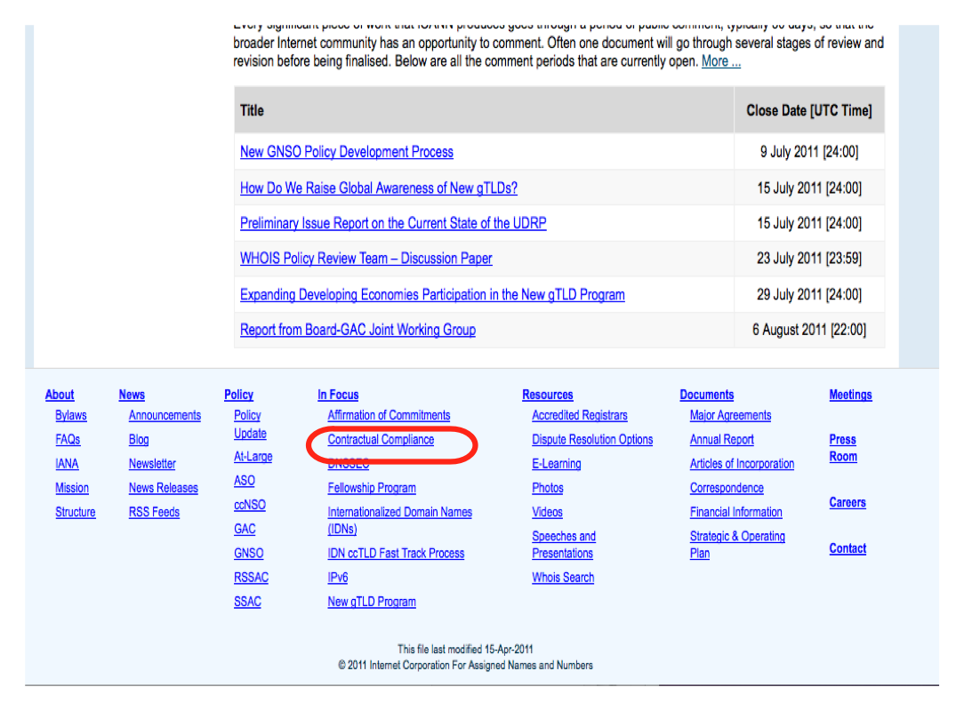
Having located the compliance pages, the user is presented with a jumble of news items (Notices of Breach, Termination and Non-Renewal, Compliance related correspondence, Updates to Notices). Only underneath this, is a heading “What is the ICANN Contractual Compliance Program?” which explains that “ICANN has a limited technical and policy coordination role” – an important piece of information for stakeholders, and one which the compliance team members observe has not filtered through into the minds of people who contact them asking for help.
Only further down is the Compliance team’s “Operating Plan”, which enunciates the 8 principles set out above.

Communication – keep your promises, manage expectations
We observed that the website carries the vestiges of initiatives or programmes which may no longer be current. This is unfortunate, as it creates a first impression of broken promises and inefficiency. The reality may simply be that initiatives have been discontinued but the website has not been updated. For example:
- The ICANN contractual compliance newsletters began in 2008 and are stated to be “monthly”. Indeed, there were 6 monthly newsletters between April-September 2008. Thereafter publication dropped off. There was a further newsletter in December 2008, one in October 2009 and then in April and October 2010. There have been no monthly newsletters published in 2011 (as of July 2011).
- Likewise, the “Semi-Annual” reports were published once in 2007, and 2008, twice in 2009 and there have been none since.
It may be that these newsletters and semi-annual reports have been superseded with other forms of communications. But this is not clear to a casual user with no knowledge of ICANN’s inner workings.

How does ICANN describe its compliance work relating to WHOIS?
According to ICANN’s web pages relating to compliance, the Compliance Team’s work spans a range of ten areas, including functional and performance specifications, equivalent access to registry services, and data escrow. ICANN describes its WHOIS work as follows:
“This is a multi-level area and the subject of an ongoing PDP. Registries are required to provide a public Whois service, containing required data elements. They must also provide access to the Whois data to ICANN and to a third-party operator in the event that a centralized Whois system is developed. Compliance questions include whether the registry is providing appropriate access, meeting update frequency requirements, and following bulk access provisions. We will continue to enforce any Whois policies which may be developed and adopted as a consensus policy as a result of the PDP. We are also working to coordinate with registries the use of compatible formats (as an example, the Whois Data Problem Report System which encompasses all registries but requires several mapping tables which must be maintained and corrected by staff).”

Focus on specific compliance activities:
At the WRT’s meeting in January 2011, the compliance team presented a helpful review of their work, and highlighted the activities set out below. Your communication with the WRT was characterized by openness, professionalism, and candour. You summarized their work as:
- Conducting audits to assess compliance with RAA provisions
- Investigating complaints of non-compliance
- Escalating cases in which registrars do not comply after informal efforts to bring those parties into compliance fail.

Audits
You informed us that the following WHOIS-related audits have been undertaken since 2008:
2010 – Registrar Whois Data Access Audit
2010 – Registrar Whois Data Reminder Policy Audit
2009 – Registrar Whois Data Reminder Policy Survey
2008 – Registrar Whois Data Reminder Policy Survey
2008 – Registrar Whois Data Inaccuracy Investigation Audit

WHOIS Data Access Audit 2010
The 2010-11 Registrar WHOIS Data Access Audit concluded that 99% of registrars comply with their contractual obligations to provide Port 43 access to WHOIS services. The Audit gave rise to 11 compliance interventions by the ICANN team, of which 10 were resolved through dialogue. In the single outstanding case, the registrar accreditation agreement was terminated for breach.
This is an example of a successful compliance intervention, and should be used as a model for future programmes:
- The parameters were limited, and reflected a contractual obligation which is clear to both registrars and ICANN.
- The follow-up action is well documented
- Compliance demonstrably improved as a result of the intervention.
Overall, this programme exemplifies ICANN compliance’s first operating principle: working constructively with registrars.
Areas for improvement include communication, sustaining the momentum and developing performance measures/goals over time.
This is a successful compliance intervention, but the message is hidden amongst a plethora of links, updates (which assume pre-existing knowledge on the part of the user) and background information.

WHOIS Data Reminder Policy Audits 2008-2010.
Three of the above interventions relate to ICANN’s WHOIS Data Reminder Policy. Confusingly, the acronym for this, WDRP, is nearly identical to one of the few other key compliance activities, the WHOIS Data Problem Reporting System, WDPRS – and ICANN is giving itself an unnecessary communications challenge in this regard.
At the time of writing, the 2010 WHOIS Data Reminder Policy Audit Report has not yet been published for comment.
The WHOIS Data Reminder Policy requires every registrar to send a notice to each registrant at least annually and remind the registrant that the provision of false data can be grounds for cancellation of a registration. Registrants must review their WHOIS data and make any necessary corrections.
Registrars told the WHOIS Review Team that the costs of sending the notices are substantial, eg:
- Support load is generated by registrants questioning why they received the notices;
- Disruption to business eg by being mistakenly blacklisted for spam as a result of sending out the notices.
According to the 2009 report (the 6th annual report on registrar compliance), 93% of registrars participated, of which 99% were found to be in compliance.
However, 83% of registrars who responded said that they were unable to track the changes resulting from the WHOIS Data Reminder notices. Therefore, it is impossible to measure the impact of this flagship policy on improving data accuracy.

Registrar Whois Data Inaccuracy Investigation Audit, 2008
Our main report will deal extensively with the issue of data accuracy, and set out targets for improvement. In brief, this ought to be the highest priority area for the Compliance Team in targeting resources, crafting effective interventions.

Investigate complaints of non-compliance

WHOIS Data Problem Report System (WDPRS)
ICANN introduced the WHOIS Data Problem Report System (WDPRS) in 2002, and is described as “one of the tools developed to assist registrars in carrying out their responsibility to investigate WHOIS data inaccuracy claims”. The goal of the WDPRS is to streamline the process for receiving and tracking complaints about inaccurate and incomplete WHOIS data, and thereby help improve the accuracy of WHOIS data.
Its purpose is to receive and track complaints about inaccurate or incomplete Whois data entries. Users can raise problems by completing an online form, which the compliance team then forwards to the registrar of record for appropriate action.
In your presentation to us in London, January 2011, you told us that the number of WDPRS Reports received by ICANN since 2004 is as follows:
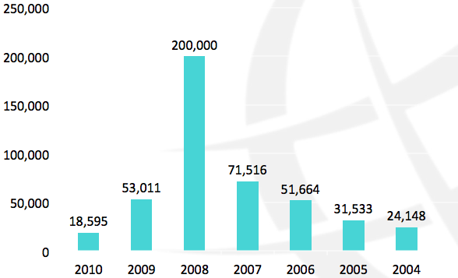
Source: ICANN Compliance, January 2011
Considering the WHOIS Data Accuracy Study’s finding that there was some inaccuracy in 77% of gTLD domain name records (equating to approximately 98 million gTLD inaccurate domain name records), and near total failure in 21% (equating to 26.9 million), the number of WDPRS reports is small, and the base of complainants is tiny.
In 2007, 10 people were responsible for 87% of all WHOIS inaccuracy reports. This indicates that the programme is not widely known, and informal feedback indicates that it may be used in bad faith by those targeting particular “valued” domain names.
In 2007, approximately 53% of the reports indicated “spam”, “phishing” or “fraud” in the comments accompanying the report, indicating a correlation between fraudulent or antisocial use and inaccurate WHOIS data.
As for follow-up, the WDPRS requires the registrar to report back to ICANN after 15 days. The compliance team provides provides a pro-forma template for the registrar to indicate what action was taken, as follows:
a) registrar verified contact info is correct
b) domain suspended, deleted or expired (system automatically closes ticket)
c) contact info updated
d) more time requested (one time option)
This is helpful, because it provides the opportunity to quantify the response, and provide metrics for success.
In 2007, ICANN reported that an estimated 35% of reported domain names with bad data were corrected, suspended, or no longer registered. An additional 28% of domains with clearly bad information were not changed. For the remaining 37% of reported domains, the WHOIS data was without obvious errors.

Given the prevalence of inaccuracy found in 2010, the significant drop in WDPRS in the same year is of concern. However, the follow up (measured by ICANN Compliance Team’s indicator of “registrars terminated or non-renewed”) has improved. 26% of terminations/non-renewals since 2007 reference WHOIS Non-compliance. While the improvement is positive, the low overall numbers of interventions relating to data accuracy are a totally inadequate response to the high levels of inaccurate data in WHOIS.

Other WHOIS Related Work and Efforts – Studies and what to do with them.
In addition, you highlighted in your presentation (January 2011) the following WHOIS related work and efforts. Our report will consider the studies on Privacy/Proxy and WHOIS Accuracy in detail, and will note our general concern at the recent trend within ICANN for commissioning expensive reports, and then doing nothing with them. This is a comment directed at the highest levels of the organisation and community. Whilst it is laudable to adopt an evidence based approach, there must be tangible, measurable follow up in order to capitalize on the investment made in the reports.
From the compliance team’s perspective, we would expect to see your response to any study which relates to your core areas of activity within 3 months of publication of the study, together with measurable targets for improvement.
It is of concern, for example, that new senior compliance staff whom we met in Dakar seemed unaware of the existence of the WHOIS Accuracy Study 2010, and that no follow-up action had been undertaken within the compliance team since its publication, nearly two years previously.

What the stakeholders told us

Our report will review in detail the responses from across the ICANN community, and consumers with regard to the effectiveness of WHOIS policy and its implementation. Here, we highlight a few key points from our interactions from yourselves, the IP constituency and registries and registrars.
- All stakeholders, including you, told us that ICANN’s compliance effort had historically been poorly resourced and has struggled for organisational priority.
- You told us that lack of adequate contractual powers hamper your effectiveness. This view was not shared by others eg by the intellectual property constituency – who told us that the contracts provided adequate powers, but “no one is enforcing them”.
- You felt that people do not understand the role of the compliance team.
- All stakeholders we spoke to supported the introduction of progressive remedies for failure to comply.
- In striking contrast to the comments received from other constituencies, including ICANN’s Compliance Team, the Registrars and Registries were extremely positive about the effectiveness of the implementation of WHOIS policy.
- The gap in perceptions between the Registries and Registries (the contracted parties who are regulated by ICANN’s Compliance Team) and all the other constituencies we spoke to merits further exploration.

Gap analysis

- Communication

- Locating information on the website is extremely difficult, compliance pages are hidden away, laden with jargon, and assume a level of knowledge by users which may not exist in practice. Documents referred to in the compliance team’s answers to the WRT as plain English guides should be front and centre to the user experience. Poor or ineffective communication generates costs, inefficiency and support load. It also creates frustration for everyone.
- Operating principles are generally good, but the use of jargon is out of place in high level principles.
- Reporting of contractual compliance activities is far from timely (operating principle 8), eg “monthly” newsletters and “semi-annual” reports have not been published at all in 2011. If these have been replace by other forms of communication, this is not clear.
- Key documents (eg the Privacy/Proxy study 2009) are missing, or only possible to locate with specific URLs.

- Audits

- The 2010-11 Registrar WHOIS Data Access Audit is an example of a successful compliance intervention. Areas for improvement include communication, sustaining the momentum and delivering performance measures/goals over time. A summary of the detailed report would be helpful to the new comer. This should also be linked to the operating principles, as a successful example of working in partnership with registrars to foster a culture of compliance.
- The acronyms WDRP and WDPRS are confusingly similar, especially as they are two of the most significant ongoing compliance activities undertaken by the compliance team. The use of the acronyms without explanation gives ICANN an unnecessary communications challenge.
- The WHOIS Data Reminder Policy is an example of a poorly thought through compliance effort. It involves both ICANN and its registrars engaging in significant economic activity and disruption. The effect on WHOIS data quality is unknown, and 83% of registrars are unable to track any changes resulting from WHOIS Data Reminder Notices. Therefore it is impossible to measure the impact of this flagship policy for improving data accuracy.
- Investigating complaints of non-compliance
- Given the prevalence of inaccurate WHOIS data, both the number of Whois Data Problem Reports, and the number of individual reporters (in 2007, 10 people were responsible for 87% of all WHOIS inaccuracy reports) are unacceptably low, indicating a low awareness level of this service amongst the target users of the system – consumers. It was striking that members of the WHOIS Review Team, whose daily job involves conducting hundreds of WHOIS queries, were unaware of the service or how to report inaccurate data to ICANN.
- The system for WHOIS Data Problem Reporting generates a high level of duplicates. ICANN’s compliance staff have inadequate workflow systems or automation to enable them to keep on top of their existing workload – this provides a disincentive to ensuring that the system is better known and more widely used.
- Other WHOIS Related work and efforts – Data Accuracy

- Data accuracy – the low level of accurate WHOIS data is unacceptable, and decreases consumer trust in the WHOIS, in the industry of which ICANN is a quasi-regulator, and therefore in ICANN itself. The organisation’s priority in relation to WHOIS should be to improve WHOIS data accuracy and sustain improvement over time. It should publish performance targets, and develop incentives for registrars and registrants to improve data accuracy.
- Just as there is no shared understanding, or statement of the purpose of WHOIS, key concepts, such as “data accuracy” mean different things to different stakeholders. Further work is required, involving all interested stakeholders, to develop a common understanding and statements of the purpose of WHOIS and key concepts within it.
- The WHOIS Data Accuracy Study identified that a key cause of inaccuracy was confusion amongst registrants when completing WHOIS data. If the industry wants to improve accuracy of data, it is necessary to think through the core WHOIS data set from the perspective of a commonly understood WHOIS Purpose, and creating a streamlined, understandable data set for registrants to complete. A number of stakeholder groups, notably SSAC, have been thinking deeply about these issues for a number of years.
- The WRT is aware that over the next 12-18 months, four independent studies on WHOIS will be published, representing an investment of [ $xxx,000,000]. It is hoped that these will improve understanding of key elements of the WHOIS environment, and provide an evidence base for the effectiveness of ICANN’s WHOIS policy and implementation. However, this effort and investment will be worthless if there is no follow-up. Regrettably, that is the impression given by the failure on ICANN’s part to publish an action plan and targets in response to Data Accuracy Study, 2010.
- It is unclear what the response of the Compliance team to the Data Accuracy Study has been. This leads to the impression that expensive, time consuming studies are being undertaken, and then left to languish. An action plan should already have been published by now, including measurable targets, and key performance indicators. If this has happened, the WRT is unaware of it.

Suggested actions

Making the operating plan operational. Overarching recommendations:

- To foster a culture of compliance, through dialogue with registries and registrars, explore how to create incentives to reward good behaviour, rather than focus exclusively on punishing bad actors.
- As demand will always exceed the available resources, the compliance effort must be strategic, focus on achieving measurable, stated objectives, and should be pro-active rather than reactive.

- Communication

- Review operating principles to ensure that the importance of effective communication of policy and compliance activities is reflected.

- Review the compliance section of the ICANN website, to ensure that communicates to the newcomer. Aim to communicate the purpose of the compliance effort, its operating principles, and in relation to WHOIS the basics of the service, and the role and responsibilities of all the actors in the supply chain.

- Use the operating principles as the benchmark for performance targets, and the first priority to eliminate gaps. For example, do not promise “monthly” newletters and “semi-annual” reports, if they are not going to be delivered.

- Ensure that all key documents are readily accessible by ordinary users.

- Audits

- Use successful compliance interventions (such as the WHOIS Data Access Audit 2010) to develop key performance indicators. Create summaries of the detailed reports, aimed at the new comer, and expressly link the compliance activity back to the operating principles. Ensure that key documents are easy to locate on the website.

- Eliminate jargon and acronyms, and address the use of two confusingly similar acronyms – WDRP and WDPRS – for two different WHOIS compliance activities.

- Either abolish the WHOIS Data Reminder Policy, or develop (in partnership with registrars) metrics to track the impact of the annual data reminder notices to registrants. Use the metrics to develop and publish performance targets, to improve data accuracy over time. If this is impossible with the current system, develop a different one in consultation with registrars that achieves the objective of improving data quality, in a measurable way.

- Investigating complaints of non-compliance

- Improve consumer awareness of existing systems for reporting problems with WHOIS data. Develop performance targets based on consumer awareness, and increased use of the system.

- Ensure that the compliance team has adequate workflow systems and automation to handle an increased workload.

- Investigate the reasons why reporting of inaccurate WHOIS data has fallen, despite continuing high levels of inaccurate WHOIS data. Report on the findings.

- Other WHOIS Related work and efforts

- Data accuracy – identify easy wins from the 2010 Data Accuracy study. These include tardiness in keeping data up to date. Working in partnership with registrars, ICANN should plan effective communications plans or other interventions to address and improve registrant data accuracy.

- Further policy development work is required to identify the Purpose of WHOIS, and a realistic understanding of “accuracy” (ie does it mean 100% accuracy, or “contactability”).

- Further policy development work is required, involving all interested stakeholders together, to identify incentives for registrants to keep their data accurate, the adverse consequences for failure, and adequate communication aimed at consumers of WHOIS services, rather than industry insiders.

- Fundamental work is required to agree a standardized, streamlined data set for WHOIS. The WRT recommends that SSAC undertake this work, in consultation with other stakeholders.

- Within 3 months, of the publication of this report, ICANN should publish its response and action plan to the WHOIS Data Accuracy Study 2010, together with measurable, achievable targets for improvement over a 3-5 year period, together with budgetary implications. In response to future WHOIS studies, ICANN should publish its response and action plan within 6 months of the publication of the relevant study.

Appendix – Interaction with compliance team and other stakeholders.

In approaching its task to understand the effectiveness of ICANN’s implementation of its existing WHOIS policy, the Review Team undertook the following consultations:
- ICANN’s contractual compliance team:
  - Presentation at London meeting (January 2011)
  - Face to face meeting in Singapore (June 2011)
  - Visit to Marina del Rey offices (July 2011)
  - Informal interactions
  - Face to face meeting in Dakar (October 2011)
- Registries and registrars
  - Face to face meeting, focused on compliance (June 2011), see Appendix [ ] for list of questions covered.
- Other stakeholders
  - Law enforcement (January 2011)
  - ICANN’s Intellectual Property Constituency (IPC) (telecon, May 2011)
  - ICANN’s Business Constituency, ISPs’ Constituency and IPC face to face meeting (June 2011)
  - ICANN’s At Large Advisory Committee (ALAC) face to face meeting (June 2011)
  - ICANN’s Non-Commercial Users’ Constituency (NCUC) face to face meeting (June 2011).
- Public comment
  - The Review Team’s discussion paper, published in June 2011, raised 7 questions relating to implementation.

In July 2009, members of the WRT visited the Marina del Rey offices for a 2 day meeting with the ICANN compliance team. Also present was a member of ICANN’s legal team. The WRT were unclear as to the reason why ICANN felt it was necessary to have one of their in-house Counsel present at this meeting. Although the WRT would not put it as strongly as the Accountability and Transparency Review Team, that some members of the staff were “laboring under an attitude of inordinate defensiveness and distrust of the review team and the review process” the presence of legal counsel a meeting essentially concerned with operational practices contributed of management discomfort about having members of the WRT interact with staff in this way.

Otherwise, the WRT found that:

- There is no shortage of activity within the Compliance team. The staff work hard, are committed to their task within their meager resources.
- The Compliance team regard their “toolbox” of available sanctions / actions as limited (ie termination of contract), and see the need for progressive remedies.
- The Compliance team is small in number, and is currently overstretched on its current workload. Without a significant injection of resources, and more strategic focus on priorities, ICANN’s compliance effort will continue to fall short of expectations.
- Compliance efforts appear to be focused exclusively on registrars. The WRT members were unable to identify any compliance efforts focused on registries.
- Compliance efforts appeared to be reactive, complaint driven, without a sense of focusing on bad actors, or of normalizing complaint levels to take account of the diversity of user bases served by different registrars.

April 2008: “Each month, the newsletter will cover….”
See http://www.icann.org/en/compliance/newsletter/
See http://www.icann.org/en/compliance/reports-archive-en.htm, accessed 8 July 2011
http://www.icann.org/en/compliance/gtld-compliance.htm, accessed 11 July 2011.
http://www.icann.org/en/compliance/archive/update-wdprs-enhancements-09mar11-en.htm, accessed 11 July 2011.
www.icann.org/en/whois/whois-data-accuracy-program-27apr07.pdf, accessed 11 July 2011
Source: ICANN Compliance Team, presentation to WHOIS RT, January 2011.
Derived from VeriSign Domain Name Industry Brief, May 2011 issue, which reports that the total number of domains registered is 209.8 million, with the ccTLD base being 81.7 million. Therefore the total of gTLDs is 128.1 million. If 23% are completely accurate (29.5 m) then 77% are in some way inaccurate (98.7 m). See http://www.verisigninc.com/en_US/why-verisign/research-trends/domain-name-industry-brief/index.xhtml

