Thailand UA Local Initiative
Progress Report
Feb 2023 -Apr 2023

Project Summary

The Thai UA local initiative aims to increase the awareness of UA and EAI significance among related stakeholders, especially software/web developers and system administrators, to ensure IDNs and EAI email addresses can be accepted and used faultlessly by their systems. The intended outcomes of the implemented deliverables are the following:

- Targeted local stakeholders will be aware of UA and its benefits for end-users
- Relevant groups will engage in discussions on different development platforms, pointing out gaps and preparing for EAI readiness
- Software/web developers and system administrators will be able to develop software and configure systems that support EAI
- Targeted local stakeholders will have the tools to be EAI Ready

Dates of performance | 1 October 2022 – 30 June 2023
Reporting period | 1 Feb 2022 – 30 Apr 2023

C2 - Organize 1-day face-to-face event in collaboration with Thai organizations or communities under UA-Day

On 28 Mar, as a part of Thailand UA Local Initiative 2022, the THNIC Academy organized a one-day in-person UA-Day event that had a workshop in the morning and a seminar in the afternoon respectively:

Morning workshop: “Setting Up an Email Server with EAI Support on Ubuntu”
    - In this workshop, we have 50 participants from developers, students, and business owners who are interested in UA at The Quarter Hotel Ladprao.
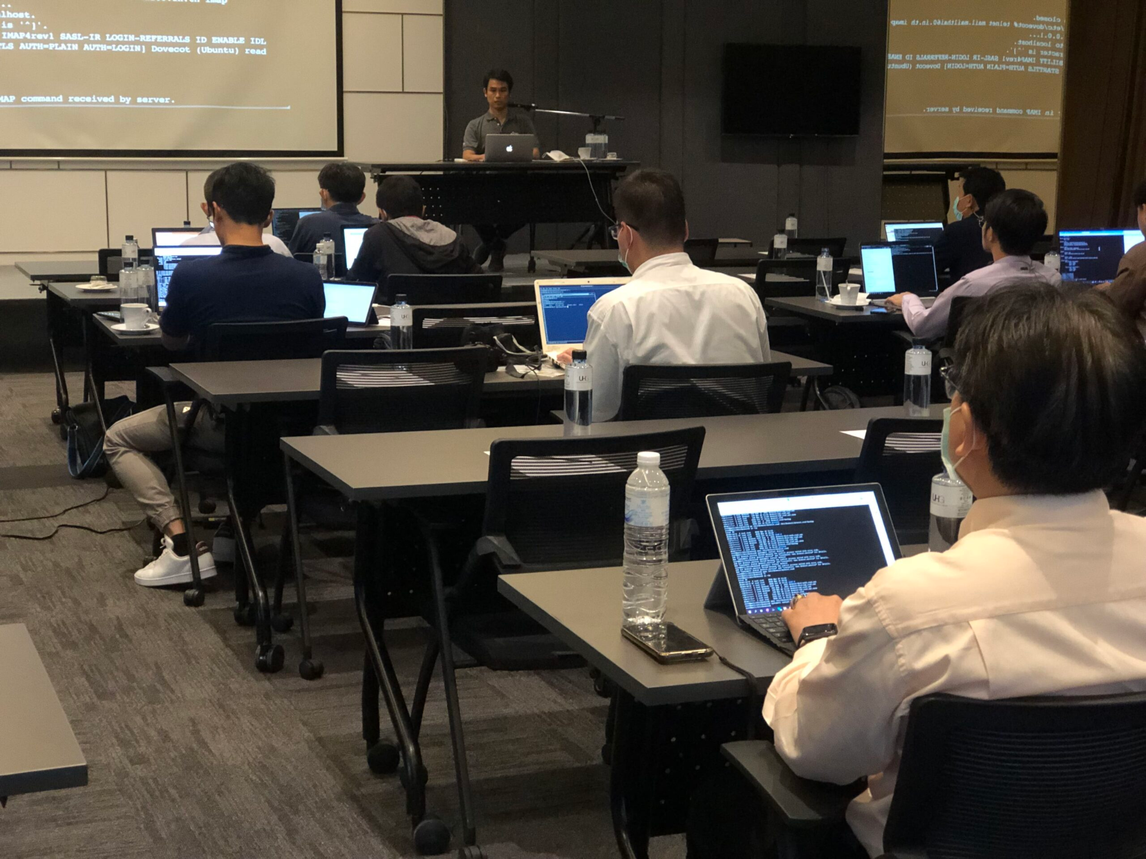

Link: https://thnic.or.th/news-workshop-eai-2023/

Afternoon seminar: “Create Business Digital Identity Unlock from Social Platform”
    - In this seminar, we have 53 participants from developers, students, and
business owners at Digital Economy Promotion Agency. The main purpose is to discuss the advantages and disadvantages of using the social platform and why we need to have a website and the importance of IDN and EAI and why we need to use them
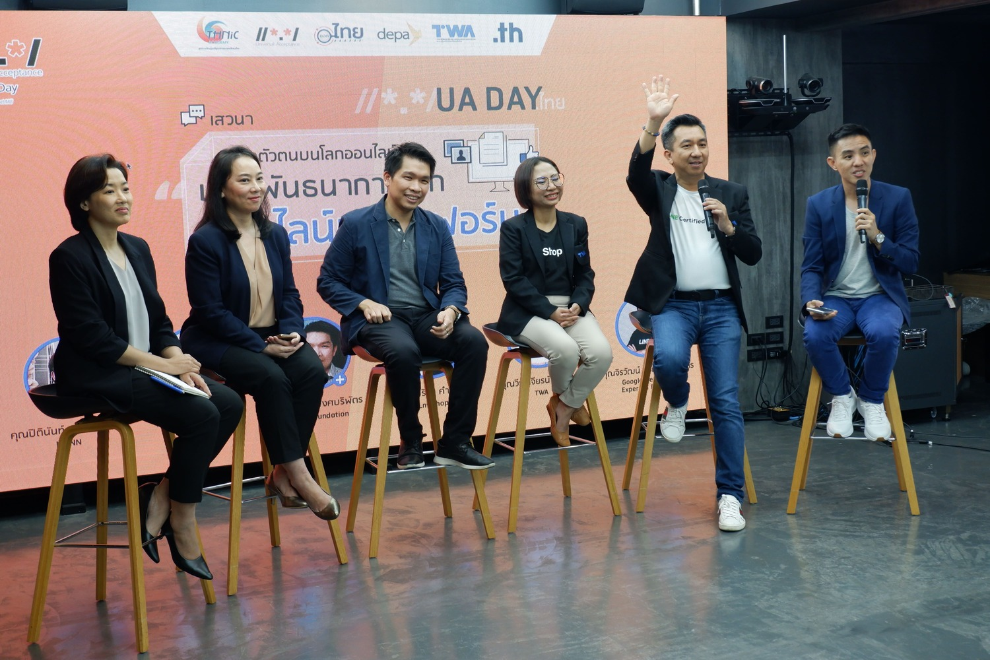

Link: https://thnic.or.th/news-ua-day/
- Youtube: https://youtu.be/LPpBpf2y61c

E1 - Prepare and Develop EAI self-certification Guide for email service providers in Thailand

- THNIC Foundation has conducted the self-certification guide for our email service ******** and the result is shown below:
  - Email Service Provider1
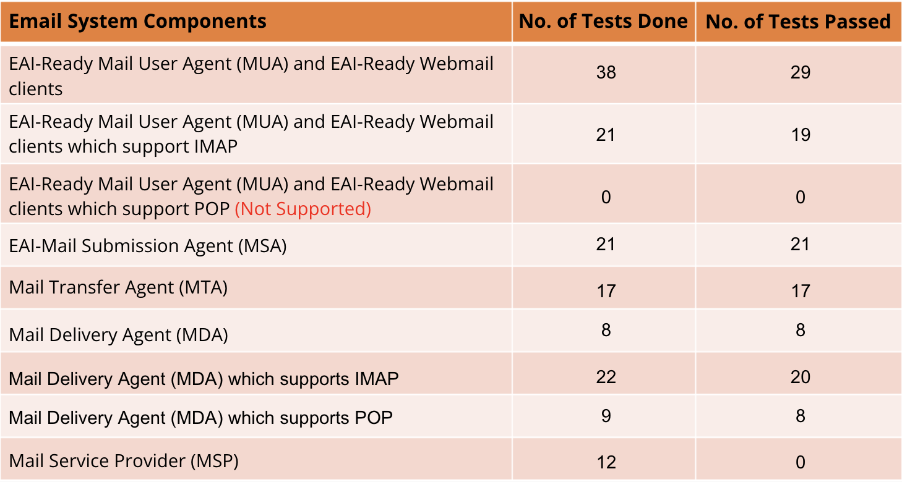

  - Email Service Provider2
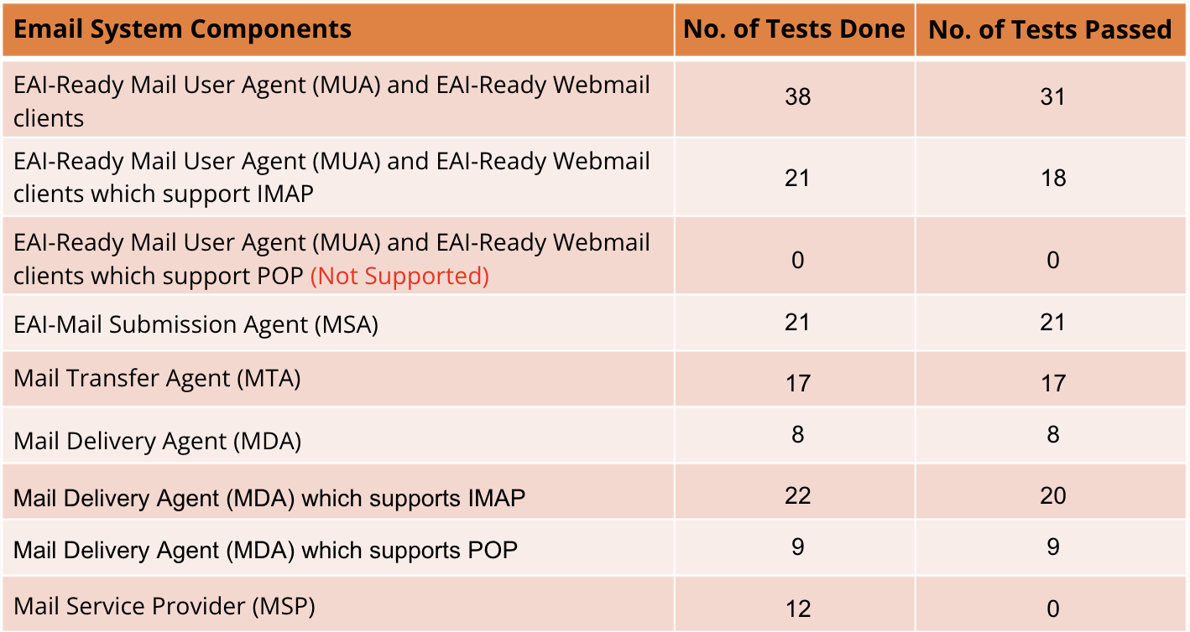

  - Email Service Provider3
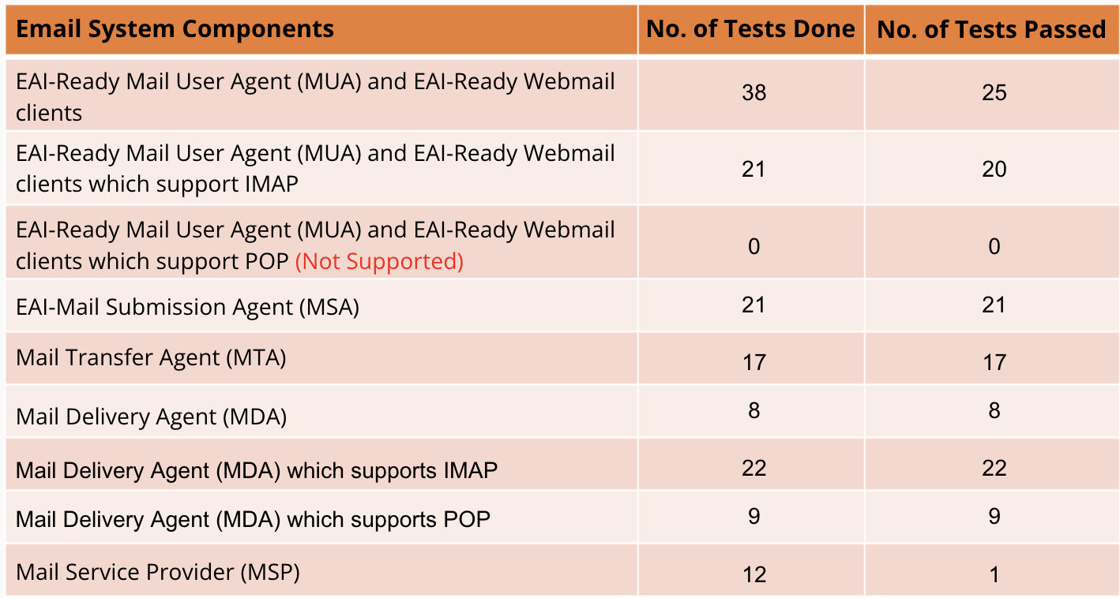

T4 - Organize a workshop to develop UA-Ready applications
T1 - Organize a hackathon to develop UA-Ready applications

On 2-7 Apr, as a part of Thailand UA Local Initiative 2022, the THNIC Academy organized 5 days workshop to teach students to develop a website and 2 days hackathon to develop a website with UA-Ready. There are 30 students attending this event. In this event, THNIC teaches them to develop a website starting from setting up a server, registering the domain, Wordpress, and how to develop Wordpress to be UA-Ready. As a result, all of them can build WordPress websites with UA-Ready.
- Link: https://academy.thnic.or.th/baengpuncamp4/
